INTERNATIONAL CONFERENCE ON RECENT TRENDS IN ADVANCED COMPUTING 2019, ICRTAC 2019

**Abstract**

Credit card frauds are easy and friendly targets. Ecommerce and many other online sites have increased the online payment modes, increasing the risk for online frauds. Increase in fraud rates, researchers started using different machine learning methods to detect and analyse frauds in online transactions. The main aim of the paper is to design and develop a novel fraud detection method for Streaming Transaction Data, with an objective, to analyse the past transaction details of the customers and extract the behavioural patterns. Where cardholders are clustered into different groups based on their transaction amount. Then using sliding window strategy [1], to aggregate the transaction made by the cardholders from different groups so that the behavioural pattern of the groups can be extracted respectively. Later different classifiers [3],[5],[6],[8] are trained over the groups separately. And then the classifier with better rating score can be chosen to be one of the best methods to predict frauds. Thus, followed by a feedback mechanism to solve the problem of concept drift [1]. In this paper, we worked with European credit card fraud dataset.

# Introduction

Credit card generally refers to a card that is assigned to the customer (cardholder), usually allowing them to purchase goods and services within credit limit or withdraw cash in advance. Credit card provides the cardholder an advantage of the time, i.e., it provides time for their customers to repay later in a prescribed time, by carrying it to the next billing cycle.

Credit card frauds are easy targets. Without any risks, a significant amount can be withdrawn without the owners knowledge, in a short period. Fraudsters always try to make every fraudulent transaction legitimate, which makes fraud detection very challenging and difficult task to detect.

In 2017, there were 1,579 data breaches and nearly 179 million records among which Credit card frauds were the most common form with 133,015 reports, then employment or taxrelated frauds with 82,051 reports, phone frauds with 55,045 reports followed by bank frauds with 50,517 reports from the statics released by FTC [10].

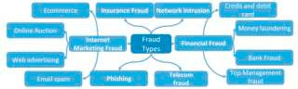

Fig. 1: Taxonomy for Frauds

With different frauds mostly credit card frauds, often in the news for the past few years, frauds are in the top of mind for most the worlds population. Credit card dataset is highly imbalanced because there will be more legitimate transaction when compared with a fraudulent one.

As advancement, banks are moving to EMV cards, which are smart cards that store their data on integrated circuits rather than on magnetic stripes, have made some oncard payments safer, but still leaving cardnotpresent frauds on higher rates.

According to 2017 [10], the US Payments Forum report, criminals have shifted their focus on activities related to CNP transactions as the security of chip cards were increased. Fig 2, shows the number of CNP frauds cases that were registered in respective years.

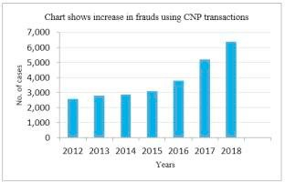

Fig. 2: Frauds Using Card Not Present Transaction

Even then there are chances for thieves to misuse the credit cards. There are many machine learning techniques to overcome this problem.

# Literature Survey

Multiple Supervised and SemiSupervised machine learning techniques are used for fraud detection [8], but we aim is to overcome three main challenges with card frauds related dataset i.e., strong class imbalance, the inclusion of labelled and unlabelled samples, and to increase the ability to process a large number of transactions.

Different Supervised machine learning algorithms [3] like Decision Trees, Naive Bayes Classification, Least Squares Regression, Logistic Regression and SVM are used to detect fraudulent transactions in realtime datasets. Two methods under random forests [6] are used to train the behavioural features of normal and abnormal transactions. They are Randomtreebased random forest and CARTbased. Even though random forest obtains good results on small set data, there are still some problems in case of imbalanced data. The future work will focus on solving the abovementioned problem. The algorithm of the random forest itself should be improved.

Performance of Logistic Regression, KNearest Neighbour, and Naive Bayes are analysed on highly skewed credit card fraud data where Research is carried out on examining metaclassifiers and metalearning approaches in handling highly imbalanced credit card fraud data.

Through supervised learning methods can be used there may fail at certain cases of detecting the fraud cases. A model of deep Autoencoder and restricted Boltzmann machine (RBM) [2] that can construct normal transactions to find anomalies from normal patterns. Not only that a hybrid method is developed with a combination of Adaboost and Majority Voting methods [4].

# Proposed Method

Card transactions are always unfamiliar when compared to previous transactions made the customer. This

unfamiliarity is a very difficult problem in realworld when are called concept drift problems [1]. Concept drift can be said as a variable which changes over time and in unforeseen ways. These variables cause a high imbalance in data. The main aim of our research is to overcome the problem of Concept drift to implement on realworld scenario. Table 1, [1] shows basic features that are captured when any transaction is made.

Table 1: Raw features of credit card transactions

|  |  |
| --- | --- |
| Attribute name | Description |
| Transaction id | Identification number of a transaction |
| Cardholder id | Unique Identification number given to the cardholder |
| Amount | Amount transferred or credited in a particular transaction by the customer |
| Time | Details like time and date, to identify when the transaction was made |
| Label | To specify whether the transaction is genuine or fraudulent |

* 1. *Dataset Description*

The dataset [11] contains transactions made by a cardholder in a duration in 2 days i.e., two days in the month of September 2013. Where there are total 284,807 transactions among which there are 492 i.e., 0.172% transactions are fraudulent transactions. This dataset is highly unbalanced. Since providing transaction details of a customer is considered to issue related to confidentiality, therefore most of the features in the dataset are transformed using principal component analysis (PCA). V1, V2, V3,..., V28 are PCA applied features and rest i.e., time, amount and class are nonPCA applied features, as shown in table 2.

Table 2: Attributes of European dataset

|  |  |  |
| --- | --- | --- |
| S. No. | Feature | Description |
| 1. | Time | Time in seconds to specify the elapses between the current transaction and first transaction. |
| 2. | Amount | Transaction amount |
| 3. | Class | 1. not fraud 2. fraud |

Fig. 3 shows the correlation matrix of the dataset. This matrix explains that attribute class is independent of both the amount and time of the transaction was made. It is even clear from the matrix, the class of the transaction is depending on PCA applied attributes.

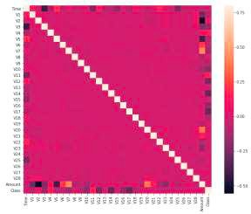

Fig. 3: Correlation Matrix for Attributes (both the X and Y axis show different attributes present in dataset)

# Methodology

* Firstly, we use clustering method to divide the cardholders into different clusters/groups based on their transaction amount, i.e., high, medium and low using range partitioning.
* Using SlidingWindow method, we aggregate the transactions into respective groups, i.e., extract some features from window to find cardholders behavioural patterns. Features like maximum amount, minimum amount of transaction, followed by the average amount in the window and even the time elapsed.
* Every time a new transaction is fed to the window the old once are removed and step2 is processed for each group of transactions. (Algorithm for SlidingWindow based method to aggregate are referred from [1]).
* After preprocessing, we train different classifiers on each group using the cardholders behavioural patterns in that group and extract fraud features. Even when we apply classifiers on the dataset, due to imbalance (shown in fig 4) in the dataset, the classifiers do not work well on the dataset.

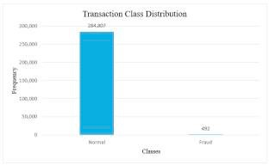

Fig. 4: Transaction Class Distribution in Dataset

* Thus, we perform SMOTE (Synthetic Minority OverSampling Technique) operation on the dataset.
* Oversampling does not provide any good results.
* Thus, there are two different ways of dealing with imbalance dataset i.e., consider Matthew Coefficient Correlation of the classifier on the original dataset or we make use of oneclass classifiers.
* Finally, the classifier that is used for training the group is applied to each cardholder in that group. The classifier

with highest rating score is considered as cardholders recent behavioural pattern.

* Once the rating score [1] is obtained, now we append a feedback system, wherein the current transaction and updated rating score are given back to the system (for further comparison) to solve the problem of concept drift.
  1. *Formula*

In our proposed system we use the following formulae to evaluate, accuracy and precision are never good parameters for evaluating a model. But accuracy and precision are always considered as the base parameter to evaluate any model.

The Matthews Correlation Coefficient (MCC) is a machine learning measure which is used to check the balance of the binary (twoclass) classifiers. It takes into account all the true and false values that is why it is generally regarded as a balanced measure which can be used even if there are different classes,

# Experimental Results

(3)

We have experimented few models on original as well as SMOTE dataset. The results are tabulated, which shows great differences in accuracy, precision and MCC as well. We even used oneclass SVM which can be best used for binary class datasets. Since we have 2 classes in our dataset we can use oneclass SVM as well.

Table 3, shows the results on the dataset before applying SMOTE and fig 5, shows the same results graphically.

Table 3: Accuracy, Precision and MCC values before applying SMOTE,

|  |  |  |  |
| --- | --- | --- | --- |
| Methods | Accuracy | Precision | MCC |
| Local Outlier factor | 0.8990 | 0.0038 | 0.0172 |
| Isolation forest | 0.9011 | 0.0147 | 0.1047 |
| Support vector machine | 0.9987 | 0.7681 | 0.5257 |
| Logistic regression | 0.9990 | 0.875 | 0.6766 |
| Decision tree | 0.9994 | 0.8854 | 0.8356 |
| Random forest | 0.9994 | 0.9310 | 0.8268 |

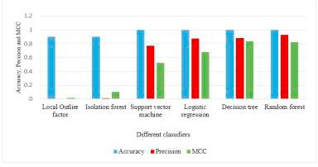

Fig 5: chart showing results on original dataset

# OneClass SVM

Accuracy: 0.7009

Precision: 0.7015

Table 4, shows the results on the dataset after applying SMOTE and fig 6, shows the same results graphically.

Table 4: Accuracy, Precision and MCC values after applying SMOTE,

|  |  |  |  |
| --- | --- | --- | --- |
| Methods | Accuracy | Precision | MCC |
| Local Outlier factor | 0.4582 | 0.2941 | 0.1376 |
| Isolation forest | 0.5883 | 0.9447 | 0.2961 |
| Logistic regression | 0.9718 | 0.9831 | 0.9438 |
| Decision tree | 0.9708 | 0.9814 | 0.9420 |
| Random forest | 0.9998 | 0.9996 | 0.9996 |

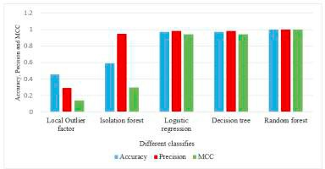

Fig 6: chart showing results on updated dataset

Fig 7, shows the comparison between the values of MCC on dataset before and after applying SMOTE.

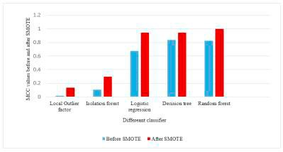

Fig 7: MCC parameter comparison between original and updated dataset

# Conclusion

In this paper we developed a novel method for fraud detection, where customers are grouped based on their transactions and extract behavioural patterns to develop a profile for every cardholder. Then different classifiers are applied on three different groups later rating scores are generated for every type of classifier. This dynamic changes in parameters lead the system to adapt to new cardholders transaction behaviours timely. Followed by a feedback mechanism to solve the problem of concept drift. We observed that the Matthews Correlation Coefficient was the better parameter to deal with imbalance dataset. MCC was not the only solution. By applying the SMOTE, we tried balancing the dataset, where we found that the classifiers were performing better than before. The other way of handling imbalance dataset is to use oneclass classifiers like oneclass SVM. We finally observed that Logistic regression, decision tree and random forest are the algorithms that gave better results.