1. Introduction

Coronavirus is one of the major pathogens that primarily targets the human respiratory system. Previous outbreaks of coronaviruses (CoVs) include the severe acute respiratory syndrome (SARS)CoV and the Middle East respiratory syndrome (MERS)CoV which have been previously characterized as agents that are a great public health threat. In late December 2019, a cluster of patients was admitted to hospitals with an initial diagnosis of pneumonia of an unknown etiology. These patients were epidemiologically linked to a seafood and wet animal wholesale market in Wuhan, Hubei Province, China [1,2]. Early reports predicted the onset of a potential Coronavirus outbreak given the estimate of a reproduction number for the 2019 Novel (New) Coronavirus (COVID19, named by WHO on Feb 11, 2020) which was deemed to be significantly larger than 1 (ranges from 2.24 to 3.58) [3].

The chronology of COVID19 infections is as follows. The first cases

were reported in December 2019 [4]. From December 18, 2019 through December 29, 2019, five patients were hospitalized with acute respiratory distress syndrome and one of these patients died[5]. By January 2, 2020, 41 admitted hospital patients had been as having laboratory COVID19 infection, less than half of these patients had underlying diseases, including diabetes, hypertension, and

cardiovascular disease [6]. These patients were presumed to be infected in that hospital, likely due to nosocomial infection. It was concluded that the COVID19 is not a superhot spreading virus (spread by one patient to many others), but rather likely spread due to many patients getting infected at various locations throughout the hospital through unknown mechanisms. In addition, only patients that got clinically sick were tested, thus there were likely many more patients that were presumably infected. As of January 22, 2020, a total of 571 cases of the 2019new coronavirus (COVID19) were reported in 25 provinces (districts and cities) in China [7]. The China National Health Commission reported the details of the first 17 deaths up to January 22, 2020. On January 25, 2020, a total of 1975 cases were to be infected with the COVID19 in mainland China with a total of 56 deaths [8]. Another report on January 24, 2020 estimated the cumulative incidence in China to be 5502 cases [9]. As of January 30, 2020, 7734 cases have been in China and 90 other cases have also been reported from a number of countries that include Taiwan, Thailand, Vietnam, Malaysia, Nepal, Sri Lanka, Cambodia, Japan, Singapore, Republic of Korea, United Arab Emirates, United States, The Philippines, India, Australia, Canada, Finland, France, and Germany. The case fatality rate was calculated to be 2.2% (170/7824) [10]. The first case of COVID19 infection in the United States led to the

description, diagnosis, clinical course, and management of this case. This includes the patients initial mild symptoms at presentation and progression to pneumonia on day 9 of illness [11]. Further, the first case of humantohuman transmission of COVID19 was reported in the US on January 30, 2020 ([https://www.cdc.gov/media/](https://www.cdc.gov/media/releases/2020/p0130) [releases/2020/p0130](https://www.cdc.gov/media/releases/2020/p0130)). The CDC has so far screened > 30,000 passengers arriving at US airports for the novel coronavirus. Following such initial screening, 443 individuals have been tested for coronavirus infection in 41 states in the USA. Only 15 (3.1%) were tested positive, 347 were negative and results on the remaining 81 are pending ([https://](https://www.cdc.gov/coronavirus/2019-ncov) [www.cdc.gov/coronavirus/2019ncov](https://www.cdc.gov/coronavirus/2019-ncov)). A report published in Nature revealed that Chinese health authorities concluded that as of February 7, 2019, there have been 31,161 people who have contracted the infection in China, and more than 630 people have died ([http://www.](http://www.nature.com/articles/d41586-020-00154) [nature.com/articles/d4158602000154](http://www.nature.com/articles/d41586-020-00154)) of infection. At the time of preparing this manuscript, the World Health Organisation (WHO) reported 51,174 cases including 15, 384 severe cases and 1666 death cases in China. Globally, the number of cases as of this writing (February 16, 2020) has reached 51,857 in 25 countries ([https://www.who.int/docs/defaultsource/coronaviruse/situation](https://www.who.int/docs/default-source/coronaviruse/situation-reports) [reports](https://www.who.int/docs/default-source/coronaviruse/situation-reports)) (Fig. 1).

1. Symptoms

The symptoms of COVID19 infection appear after an incubation period of approximately 5.2 days [12]. The period from the onset of COVID19 symptoms to death ranged from 6 to 41 days with a median of 14 days [8]. This period is dependent on the age of the patient and status of the patients immune system. It was shorter among patients > 70years old compared with those under the age of 70 [8]. The most common symptoms at onset of COVID19 illness are fever, cough, and fatigue, while other symptoms include sputum production, headache, haemoptysis, diarrhoea, dyspnoea, and lymphopenia [5,6,8,13]. Clinical features revealed by a chest CT scan presented as pneumonia, however, there were abnormal features such as RNAaemia, acute respiratory distress syndrome, acute cardiac injury, and incidence of grandglass opacities that led to death [6]. In some cases, the multiple peripheral groundglass opacities were observed in subpleural regions of both lungs [14] that likely induced both systemic and localized immune response that led to increased inflammation. Regrettably, treatment of some cases with interferon inhalation showed no clinical and instead appeared to worsen the condition by progressing pulmonary opacities [14] (Fig. 2).

It is important to note that there are similarities in the symptoms

between COVID19 and earlier betacoronavirus such as fever, dry cough, dyspnea, and bilateral groundglass opacities on chest CT scans [6]. However, COVID19 showed some unique clinical features that include the targeting of the lower airway as evident by upper respiratory tract symptoms like rhinorrhoea, sneezing, and sore throat [15,16]. In addition, based on results from chest radiographs upon

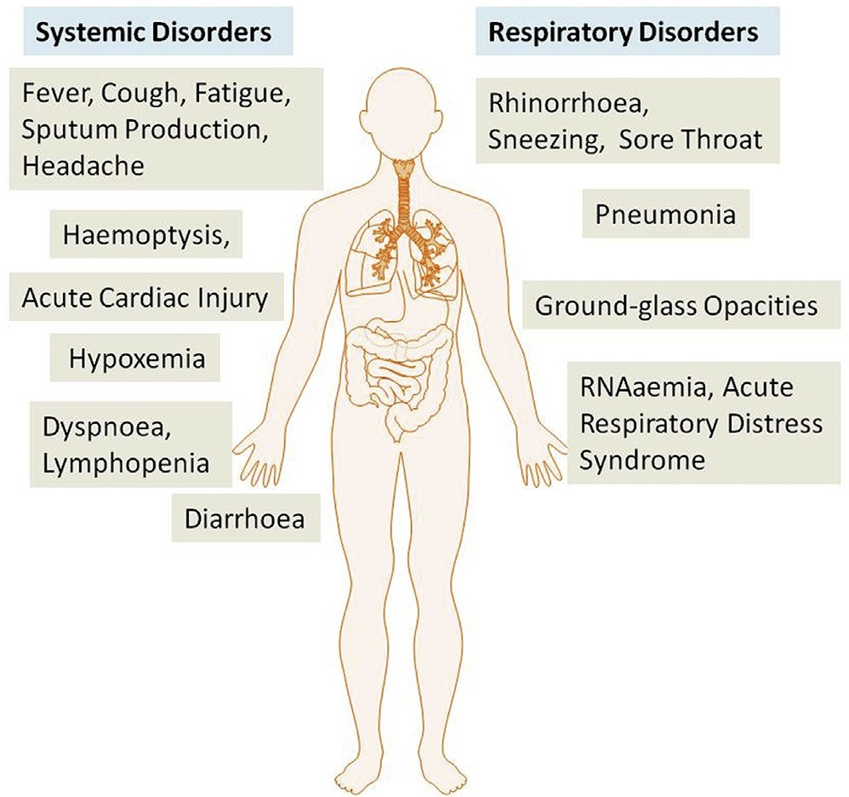

Fig. 2. The systemic and respiratory disorders caused by COVID19 infection. The incubation period of COVID19 infection is approximately 5.2 days. There are general similarities in the symptoms between COVID19 and previous betacoronavirus. However, COVID19 showed some unique clinical features that include the targeting of the lower airway as evident by upper respiratory tract symptoms like rhinorrhoea, sneezing, and sore throat. Additionally, patients infected with COVID19 developed intestinal symptoms like diarrhoea only a low percentage of MERSCoV or SARSCoV patients exhibited diarrhoea.

admission, some of the cases show an in the upper lobe of the lung that is associated with increasing dyspnea with hypoxemia [17]. Importantly, whereas patients infected with COVID19 developed gastrointestinal symptoms like diarrhoea, a low percentage of MERSCoV or SARSCoV patients experienced similar GI distress. Therefore, it is important to test faecal and urine samples to exclude a potential alternative route of transmission, specifically through health care workers, patients etc (Fig. 2) [15,16]. Therefore, development of methods to identify the various modes of transmission such as feacal and urine samples are urgently warranted in order to develop strategies to inhibit and/or minimize transmission and to develop therapeutics to control the disease.

1. Pathogenesis

The severe symptoms of COVID19 are associated with an increasing numbers and rate of fatalities specially in the epidemic region of China. On January 22, 2020, the China National Health Commission reported the details of the first 17 deaths and on January 25, 2020 the death

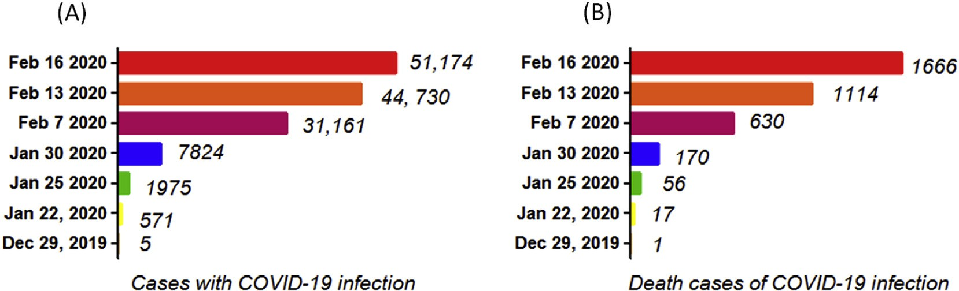

Figure 1. The chronological incidence of COVID19 infections and death cases in China. Infections with COVID19 appears in December 2019. At the time of preparing this manuscript, February 16, 2020 there have been 51,174 people who have contracted the infection in China, and more than 1666 people have died.

cases increased to 56 deaths [8]. The percentage of death among the reported 2684 cases of COVID19 was approximately 2.84% as of Jan 25, 2020 and the median age of the deaths was 75 (range 48 89) years [8].

Patients infected with COVID19 showed higher leukocyte numbers, abnormal respiratory findings, and increased levels of plasma proinflammatory cytokines. One of the COVID19 case reports showed a patient at 5 days of fever presented with a cough, coarse breathing sounds of both lungs, and a body temperature of 39.0 C. The patients sputum showed positive realtime polymerase chain reaction results that COVID19 infection [14]. The laboratory studies showed leucopenia with leukocyte counts of 2.91 10 9 cells/L of which 70.0% were neutrophils. Additionally, a value of 16.16 mg/L of blood Creactive protein was noted which is above the normal range

(0 10 mg/L). High erythrocyte sedimentation rate and Ddimer were also observed [14]. The main pathogenesis of COVID19 infection as a

respiratory system targeting virus was severe pneumonia, RNAaemia, combined with the incidence of groundglass opacities, and acute cardiac injury [6]. Significantly high blood levels of cytokines and chemokines were noted in patients with COVID19 infection that included IL1, IL1RA, IL7, IL8, IL9, IL10, basic FGF2, GCSF, GMCSF, IFN , IP10,

MCP1, MIP1, MIP1, PDGFB, TNF, and VEGFA. Some of the severe

cases that were admitted to the intensive care unit showed high levels of proinflammatory cytokines including IL2, IL7, IL10, GCSF, IP10, MCP1, MIP1, and TNF that are reasoned to promote disease severity [6].

1. Transmission

Based on the large number of infected people that were exposed to the wet animal market in Wuhan City where live animals are routinely sold, it is suggested that this is the likely zoonotic origin of the COVID

19. have been made to search for a reservoir host or intermediate carriers from which the infection may have spread to humans. Initial reports two species of snakes that could be a possible reservoir of the COVID19. However, to date, there has been no consistent evidence of coronavirus reservoirs other than mammals and birds [10,18]. Genomic sequence analysis of COVID19 showed 88% identity with two batderived severe acute respiratory syndrome (SARS)like coronaviruses [19,20], indicating that mammals are the most likely link between COVID19 and humans. Several reports have suggested that persontoperson transmission is a likely route for spreading COVID19 infection. This is supported by cases that occurred within families and among people who did not visit the wet animal market in Wuhan [13,21]. Persontoperson transmission occurs primarily via direct contact or through droplets spread by coughing or sneezing from an infected individual. In a small study conducted on women in their third trimester who were to be infected with the coronavirus, there was no evidence that there is transmission from mother to child. However, all pregnant mothers underwent cesarean sections, so it remains unclear whether transmission can occur during vaginal birth. This is important because pregnant mothers are relatively more susceptible to infection by respiratory pathogens and severe pneumonia

The binding of a receptor expressed by host cells is the first step of

viral infection followed by fusion with the cell membrane. It is reasoned that the lung epithelial cells are the primary target of the virus. Thus, it has been reported that humantohuman transmissions of SARSCoV occurs by the binding between the receptorbinding domain of virus spikes and the cellular receptor which has been as angiotensinconverting enzyme 2 (ACE2) receptor [20,22]. Importantly, the sequence of the receptorbinding domain of COVID19 spikes is similar to that of SARSCoV. This data strongly suggests that entry into the host cells is most likely via the ACE2 receptor [20].

1. Phylogenetic analysis

World Health Organisation (WHO) has COVID19 as a CoV of group 2B [23]. Ten genome sequences of COVID19 obtained from a total of nine patients exhibited 99.98% sequence identity [19].

Another study showed there was 99.8 99.9% nucleotide identity in

isolates from five patients and the sequence results revealed the presence of a new betaCoV strain [5]. The genetic sequence of the COVID19 showed more than 80% identity to SARSCoV and 50% to the MERSCoV [5,19], and both SARSCoV and MERSCoV originate in bats [24]. Thus, the evidence from the phylogenetic analysis indicates that the COVID19 belongs to the genus betacoronavirus, which includes SARSCoV, that infects humans, bats, and wild animals [25].

COVID19 represents the seventh member of the coronavirus family that infects humans and has been under the orthocoronavirinae subfamily. The COVID19 forms a clade within the subgenus sarbecovirus [25]. Based on the genetic sequence identity and the phylogenetic reports, COVID19 is sufficiently from SARSCoV and it can thus be considered as a new betacoronavirus that infects humans. The COVID19 most likely developed from bat origin coronaviruses. Another piece of evidence that supports the COVID19 is of bat origin is the existence of a high degree of homology of the ACE2 receptor from a diversity of animal species, thus implicating these animal species as possible intermediate hosts or animal models for COVID19 infections [20]. Moreover, these viruses have a single intact open reading frame on gene 8, which is a further indicator of batorigin CoVs. However, the amino acid sequence of the tentative receptorbinding domain resembles that of SARSCoV, indicating that these viruses might use the same receptor [5].

1. Therapeutics/treatment options

The persontoperson transmission of COVID19 infection led to the isolation of patients that were administered a variety of treatments. At present, there are no specific antiviral drugs or vaccine against COVID19 infection for potential therapy of humans. The only option available is using broadspectrum antiviral drugs like Nucleoside analogues and also HIVprotease inhibitors that could attenuate virus infection until the specific antiviral becomes available [7]. The treatment that have so far been attempted showed that 75 patients were administrated existing antiviral drugs. The course of treatment included twice a day oral ad

ministration of 75 mg oseltamivir, 500 mg lopinavir, 500 mg ritonavir and the intravenous administration of 0 25 g ganciclovir for 3 14 days [26]. Another report showed that the broadspectrum antiviral remdesivir and chloroquine are highly ive in the control of 2019

nCoV infection in vitro. These antiviral compounds have been used in human patients with a safety track record. Thus, these therapeutic agents can be considered to treat COVID19 infection [27]. Furthermore, there are a number of other compounds that are in development. These include the clinical candidate EIDD2801 compound that has shown high therapeutic potential aganist seasonal and pandemic influenza virus infections and this represents another potential drug to be considered for the treatment of COVID19 infection [28]. Along those lines, until more specific therapeutics become available, it is reasonable to consider more broadspectrum antivirals that provide drug treatment options for COVID19 infection include