## ABSTRACT

The water footprint in terms of the sum of both direct and indirect water cost of wastewater treatment is accounted for the first time in this paper. Based on the hybrid method as a combination of process analysis and inputoutput analysis, a detailed water footprint accounting procedure is provided to cover the supply chain of a wastewater treatment plant. A set of indices intending to reveal the efficiency as well as renewability of wastewater treatment systems are devised as parallels of corresponding indicators in net energy analysis for energy supply systems. A case study is carried out for the Beijing Space City wastewater treatment plant as a landmark project. The high WROI (water return on investment) and low WIWP (water investment in water purified) indicate a high efficiency and renewability of the case system, illustrating the fundamental function of wastewater treatment for wastewater reuse. The increasing of the wastewater and sludge treatment rates is revealed in urgent need to reduce the water footprint of China and to

# INTRODUCTION

Water footprint, also regarded as virtual water or embodied water, is defined as the volume of total freshwater directly and indirectly required to produce a commodity or service.1 Given the rapidly growing water consumption and water resources scarcity, abundant studies on water footprint accounting have been carried out.28 Wastewater treatment plays a vital role in peoples daily life as to purify the wastewater and discharge readyforreuse water to human society. Due to its significant ecological implication in water reuse, the resource uses and environmental emissions of wastewater treatment are quantified in different categories, such as greenhouse gas emission, energy consumption and land use.911 However, no study on assessing the water footprint as an important indicator of a specific wastewater treatment system has been reported yet. In a few

studies, the inputoutput analysis, as a topdown method comparing to the process analysis, has been relied on to calculate the average water footprint of the water industry within a nation or region.8, 12 These studies are considered meaningful and helpful to guide the policy making on industry level. Subjected to the aggregation level of statistic data, however, most of inputoutput analyses can only give an average sector resolution and usually do not allow for detailed discussions of a specific product, especially industryatypical products. At the meantime, in most countries wastewater treatment is not listed as an individual industry in relevant statistics, which prevents us from assessing the water footprint of wastewater treatment just based on inputoutput analysis.

Under these circumstances, the accounting of the water footprint of a specific wastewater treatment system is performed for the first time in this paper. A processbased method supported by the averaged macroeconomy data provided by inputoutput analysis (termed as the hybrid method hereafter) is employed to estimate the water footprint of a specific wastewater treatment system. The hybrid method has many successful applications in assessing environmental impacts of various systems including the wastewater treatment plant after its proposal in l970s.11, 1315 It is employed not only to avoid the systematic truncation errors inherent in process analysis, but also to make the inputoutput analysis applicable for specific micro systems.

Based on the calculation of water footprint, a comprehensive evaluation of purification efficiency and renewability of wastewater treatment necessitates some

indicators. A wastewater treatment plant is exactly like the energy supply system with regard to the fact that their common essence is to deliver available resources to human society. As the net energy analysis is a mature and wildly used method to compare the amount of total energy directly and indirectly required by an energy supply system to the energy it has delivered,13 the proposed indices can be transplanted to assess the water purification efficiency of a wastewater treatment system. As a renewable system of water recourse, the renewability assessment of wastewater treatment can also draw lessons from the cases of renewable energy technologies, of which the renewability has been extensively discussed in the last decade.16, 17

This paper aims at providing an explicit accounting procedure to calculate the water footprint as an environmental impact of a wastewater treatment system. A set of indices are also devised to reveal the purification efficiency and renewability of a wastewater treatment system. Besides the practical implication in providing clear guidance for designing water saving strategies as well as prioritizing options of wastewater treatment technologies, this study can also contribute to estimation of water footprint of wastewater treatment industry in China. In order to demonstrate the method, a case study has been carried out by systematically calculating the water footprint of a typical conventional wastewater treatment system in Beijing on the basis of detailed inventories and latest embodied water intensity database for the Chinese economy.

# METHODS AND MATERIALS

## The hybrid method

The process analysis as a bottomup method has been relied on to trace individual environmental impact of a wastewater treatment plant through its lifecycle by a lot of studies.9, 10 Although it can provide detailed process information, it is timeconsuming and has been suffered from the truncation error. The inputoutput analysis is a topdown method comparing to the process analysis. It is relatively fast and deemed to be complete as can model all transaction activities within an economy. However, due to the high level of aggregation in industry or commodity classifications of inputoutput table, the results of inputoutput analysis is often too rough for concrete assessments of some particular technologies or products in an economic sector. Therefore, the hybrid method intending to combine the strengths and reduce the weaknesses of both methods has been advocated. So far there are several alternative models of the hybrid method, e.g., tiered hybrid analysis, inputoutput based hybrid analysis and integrated hybrid analysis.18, 19 The simplest model of tiered hybrid analysis contributed by Bullard et al.13 is adopted in this study. The approach is simple, quick, and does not require any additional data.18 By more or less modification of the inputoutput table, other hybrid methods are complex and suffer from high data requirements,20 which are far from realizable in water footprint accounting, especially for the assessment of wastewater treatment in China.

To evaluate the virtual water of an individual wastewater treatment system reflected

by some process model as a microsystem in the macroeconomy, the indirect fluxes originated outside the process boundary can be well traced by averaged sectoral intensities provided by proper inputoutput analysis of the economy. A wastewater treatment plant shares a tiny part of the whole wastewater treatment industry, which would avoid the possible double counting of tiered hybrid method. The simplest model of the tiered hybrid analysis assumes that the product of interest is well approximated by its industry sector. Therefore the water footprint of an input can be easily obtained by simply multiplying the monetary cost to the water footprint intensity of the sector.

## Diagram for water footprint assessment of a wastewater treatment system

The freshwater withdrawal during the whole lifetime of the wastewater treatment system is set as the accounting goal of this study. Besides the usual functional unit as 1 m of treated wastewater, the water footprints of 1 kg removed pollutant (BOD and COD) and of ten thousand Chinese Yuan (1E04 CNY) output value are also calculated. Water footprint assessment for a wastewater treatment system is diagrammed in Figure 1. As shown in the figure, the inputs of wastewater treatment are classified into three categories as material inputs, machinery inputs and tap water inputs. Material inputs are directly provided by other industries and consumed by wastewater treatment. The water footprint of material inputs are the virtual water content of the products. The machinery refers to the involved equipment that can be used in other place. For instance, the rooter and truck used to dig and delivery soil in construction stage are machineries. But the pump and

aerator used to draw and aerate wastewater during the operation stage are materials. By assuming that the virtual water embedded in the machinery is uniformly distributed along its lifecycle, the water footprint of machinery inputs can be estimated as the water footprint of the product times its work time and divided by its total life time.21 The life time here indeed refers to the total work time. As for the fuel consumption of machinery, they are classified as materials.

Tap water is indeed a kind of material input. It is listed as a distinctive category to avoid possible misunderstanding by simply regarding the volume of tap water as its water footprint in water footprint accounting. Tap water is the typical and major product of water supply industry which needs a lot of inputs from other industries in its production just like the secondary energy. Therefore water footprint of tap water should be the virtual water embodied in its life time, not its direct water volume. The data source of inputs inventory of the wastewater treatment system should be reliable and exhaustive. A

firsthand project data provided by the builder is preferred.

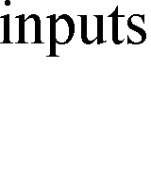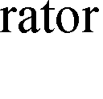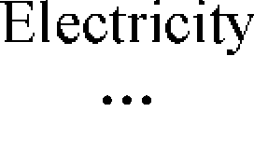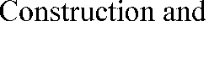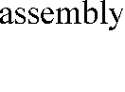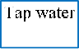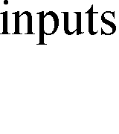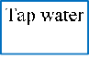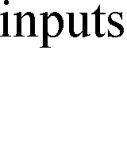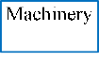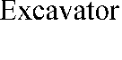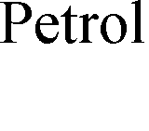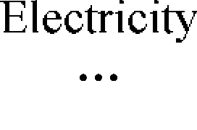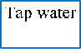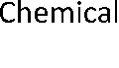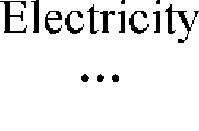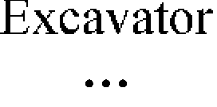

**Figure 1. Diagram for water footprint assessment of a wastewater treatment system**

## Procedure of water footprint assessment for a wastewater treatment system

By employing the hybrid method as an integration of process analysis and inputoutput analysis, the framework of water footprint