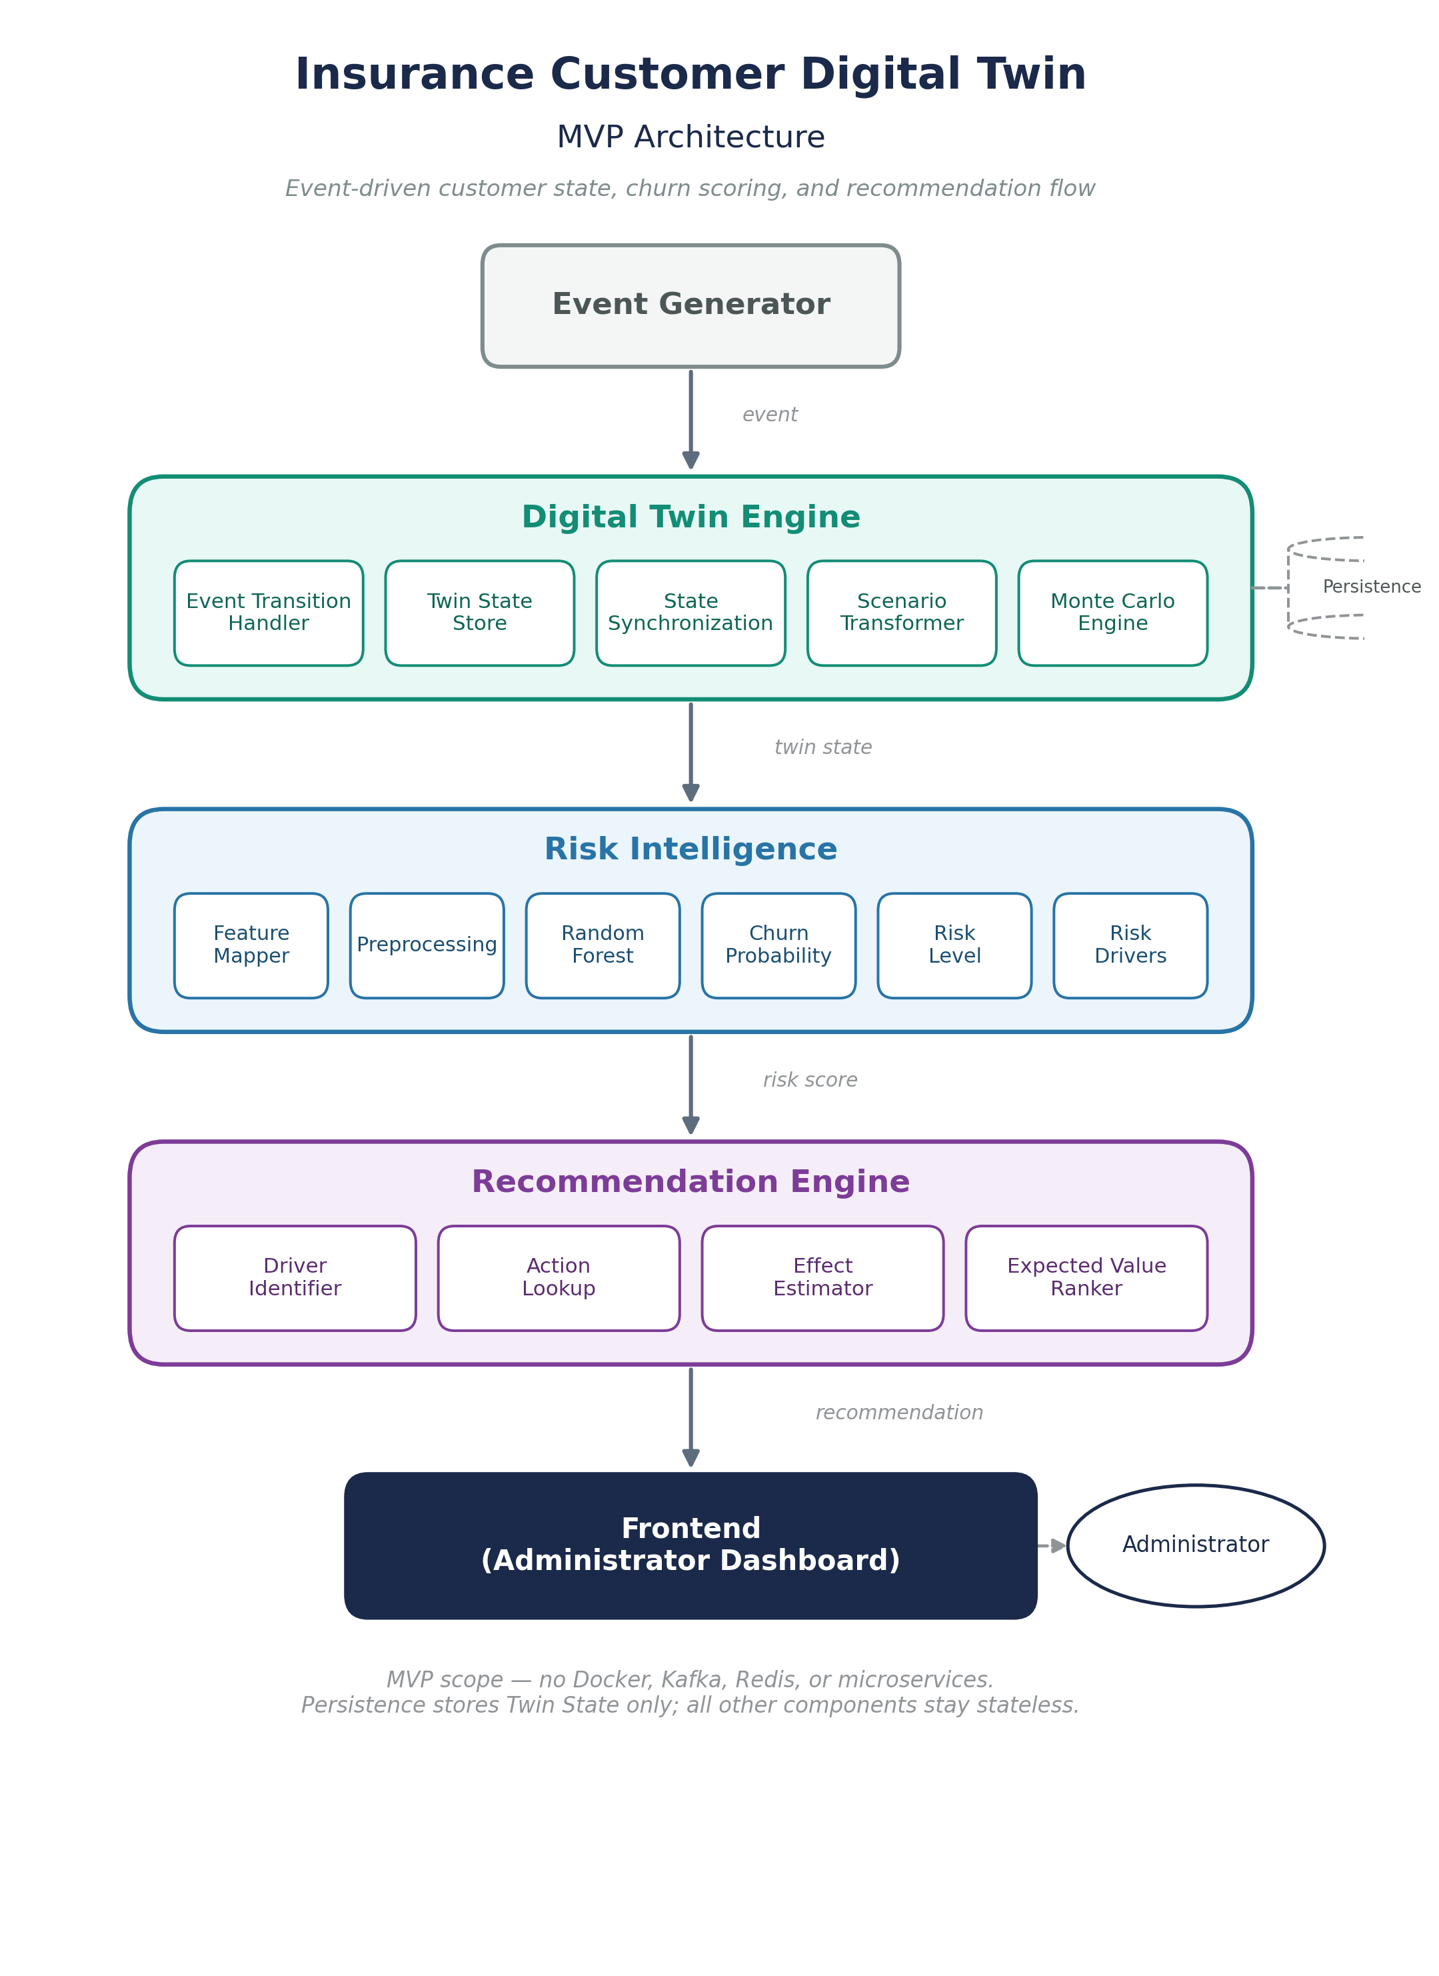

Component Roles
Grouped by architecture component. Colors match the diagram on page 1.
Event Generator | Role
Event Generator | Produces simulated customer events so the Twin has something to react to during the MVP.
Event | A single fact about a customer (e.g. payment missed, policy renewed) that can change their state.

Digital Twin Engine | Role
Event Transition Handler | Applies an incoming event to a customer's Twin State, producing the updated state.
Twin State | The current, structured snapshot of one customer — the thing being simulated and scored.
Twin State Store | Persists every customer's Twin State and its history so it survives beyond a single run.
State Synchronization | Keeps the stored Twin State consistent with the latest processed event.
Scenario Transformer | Clones the current Twin State and applies a hypothetical change without touching the real state.
Monte Carlo Engine | Runs a scenario many times under randomised assumptions to produce a distribution of outcomes.

Risk Intelligence | Role
Feature Mapper | Converts a Twin State into the exact feature vector the churn model expects.
Preprocessing | Applies the same fitted imputers/encoders used in training so inference matches training exactly.
Random Forest | The trained classifier that turns a preprocessed feature vector into a churn probability.
Churn Probability | The model's output: the likelihood that a given customer churns.
Risk Level | A simple Low/Medium/High label derived from the churn probability, for easy reading.
Risk Drivers | The features that most influenced a given risk score, used to explain the prediction.

Recommendation Engine | Role
Driver Identifier | Reads the risk drivers and selects which ones are actionable.
Action Lookup | Maps an actionable driver to one or more candidate retention actions.
Effect Estimator | Estimates how much a candidate action would be expected to reduce churn risk.
Expected Value Ranker | Ranks candidate actions by estimated benefit and picks the recommendation shown to the Administrator.

Frontend | Role
Frontend | Presents Twin state, risk, drivers, recommendations, and simulation results to the Administrator.

Customer Churn ML Model — Brief
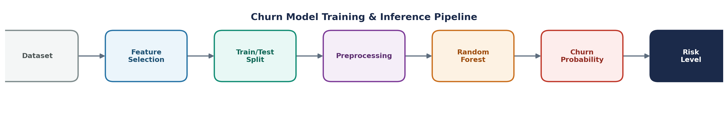
Objective
Predict the probability that a policyholder churns at renewal, and identify the main risk drivers behind that prediction, so Risk Intelligence can feed a churn probability into the Digital Twin.
● Dataset & Target
• 50,000-row synthetic insurance policyholder dataset, used as a proxy for real Insurise data.
• Target: churn_flag (1 = churned at renewal, 0 = retained). Class balance: ~70% retained / 30% churned.
● Feature Selection
• 30 numerical + 4 categorical features covering tenure, premium/pricing history, payment behaviour, claims history, and customer contact/complaint history.
• Excluded: customer_id and as_of_date (no predictive signal), age_band (duplicate of age), and churn_type / churn_probability_true — both removed as data leakage, since they encode the outcome itself.
● Train/Test Split
• 80/20 stratified train/test split (random_state = 42) — 40,000 training rows, 10,000 test rows.
● Preprocessing
• Numerical features: missing-value imputation (median).
• Categorical features: missing-value imputation (most frequent) + one-hot encoding.
• Built as a single scikit-learn ColumnTransformer, fitted only on the training set, and saved so inference always applies the exact same transformation used in training.
● Random Forest
• Model: RandomForestClassifier — 300 trees, min_samples_leaf = 5, class_weight = balanced (to counter the 70/30 imbalance).
• predict_proba() returns the churn probability; predict() (threshold 0.5) returns the churn/retain class.
● Churn Probability — Evaluation (actual results, test set)
Metric | Value (test set)
Accuracy | 0.749
Precision | 0.587
Recall | 0.564
F1-score | 0.576
ROC-AUC | 0.786
Metrics were checked for suspiciously high performance (a sign of leakage) — none was found; results are realistic for this dataset.
● Feature Importance
Random Forest feature importance ranks which inputs the model relies on most (e.g. payment and pricing behaviour). This reflects association learned by the model, not a causal claim.
● Risk Level — Integration with the Digital Twin
Twin State → Feature Mapper → preprocessing.joblib → churn_model.joblib → churn probability → Risk Level → Risk Drivers. The Feature Mapper exists so Risk Intelligence never has to know the internal shape of the Twin State — only the fixed feature schema the model expects.

