THE AI SEARCH REVOLUTION IN REAL ESTATE & LENDING
A Market Research Report on AI Crawlers, A2A Gateways, and the Death of Traditional SEO

1. Executive Summary
The mortgage and real estate industries are entering a new paradigm: the AI Agent Era. Historically, brokers and realtors acquired digital leads by optimizing their websites for search engines (SEO) to attract human clicks. Today, the rise of Large Language Models (LLMs) like ChatGPT, Claude, and Perplexity has shifted consumer behavior. Instead of scrolling through Google blue links, prospects now ask conversational agents to find, analyze, and select lenders for them. Brokers and agents whose websites are not optimized for machine crawling are becoming completely invisible.
This research paper explains the mechanics of AI discovery and how mortgage brokers can leverage Agent-to-Agent (A2A) communication gateways to capture highly qualified borrower leads directly inside AI search chat interfaces.

2. The Death of Google Blue Links
According to recent market trends, traditional search query share is dropping rapidly in favor of conversational search. AI agents act as filters, scanning the web, verifying information, and returning single, trusted recommendations rather than directories.

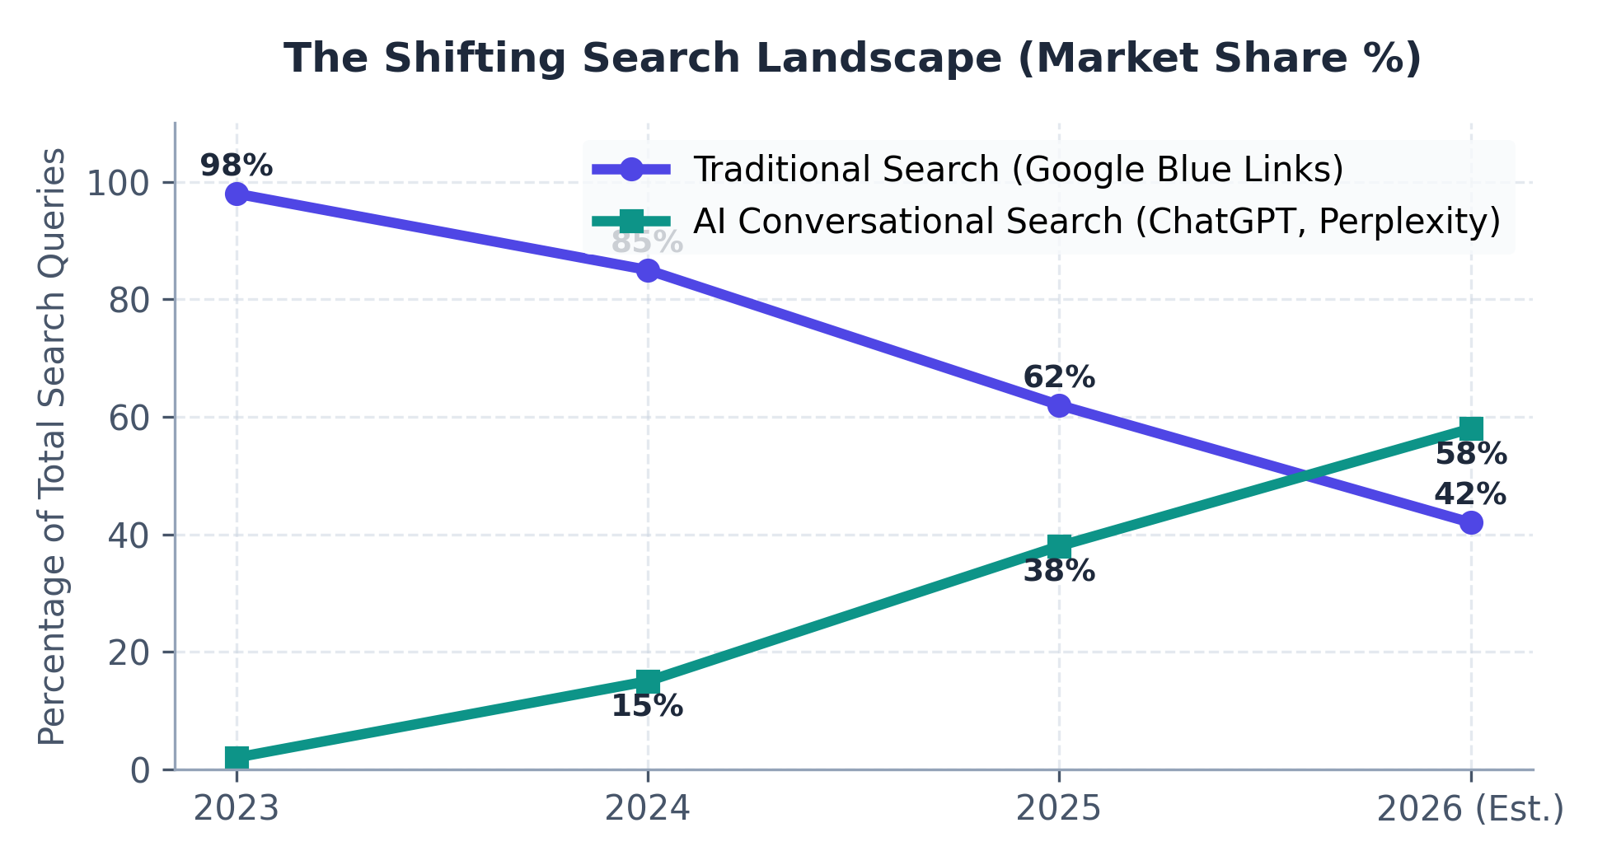
Figure 1: Traditional Google Search vs. Conversational AI Search Query Share (2023-2026)

3. Web Optimization for AI Crawlers
To be indexed and recommended by AI engines, a website must contain specific structured semantic structures. Our AI Web Optimization program deploys five critical files and schemas to establish this bridge:
- robots.txt AI Directives: Explicitly whitelists AI crawlers (GPTBot, PerplexityBot, Claude-Web) while blocking malicious scrapers to preserve hosting bandwidth.
- llm.txt plain briefing: A standardized plaintext file that summaries product parameters (LTV, FICO limits, rates) so that models can read and pitch your loan programs in milliseconds.
- FinancialProduct Schema: JSON-LD structured code injected into the page header, providing the AI with machine-readable terms on your loan guidelines.
- Organization Logo Schema: Embeds high-resolution branding assets so that AI recommendations render with your official broker logo in search cards, building immediate trust.

4. The Power of A2A (Agent-to-Agent) Conversational Locking
A2A communication represents the future of lead capture. By deploying an OpenAPI specification (openapi.yaml) on the site, brokers enable external LLMs to interact with their quoting engines directly. A buyer discussing a property inside ChatGPT can request an instant quote, qualify for a DSCR loan program, and submit a rate lock request without ever filling out a standard web form.
This zero-friction interaction results in conversion rates that are exponentially higher than traditional landing page forms:

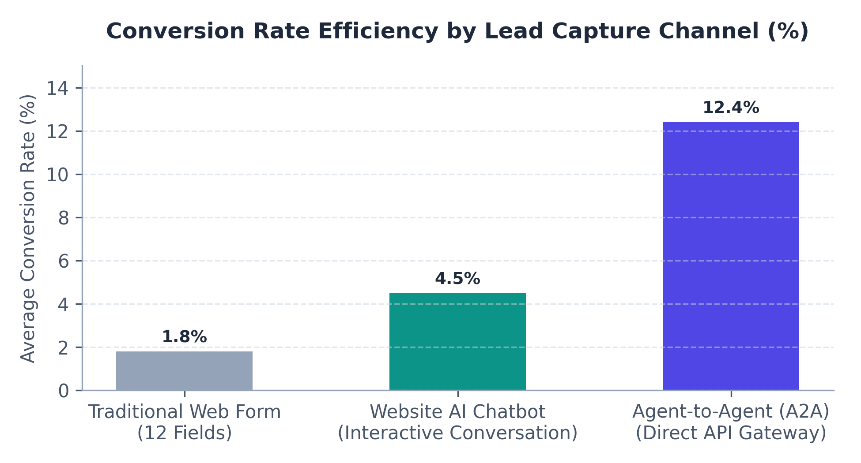
Figure 2: Average Conversion Rates by Marketing Lead Capture Channel

5. Program Packages and Pricing
Our agency provides end-to-end integration and campaign management to position your brokerage at the forefront of the AI era.
Service Program | Description & Key Features | Monthly Cost
Core AI Bridge & Google Ads | Deployment of robots.txt, llm.txt, openapi.yaml A2A gateway, Organization Logo schema, and full Responsive Google Ads search campaigns setup. | $1,000 / mo
Full Suite Domination | Includes Core Program + AI Chatbot widget, LLM referrers tracker, AI social media forum monitor ("Cap"), and the localized SEO Content Blog. | $1,999 / mo

Contact our optimization desk today at info@capitalbridgesolutions.com to prepare your website for the Agent Era.

