THE AI AGENT REVOLUTION IN REAL ESTATE
How AI Search is Replacing Zillow, Redfin, and the MLS Listing Paradigm

1. Executive Summary
For the last decade, realtors have operated under a portal-dominant lead paradigm: buyers searched on portals like Zillow, Trulia, and Redfin, and realtors purchased these leads at high markups via premier agent programs. With the emergence of Large Language Models (LLMs) and conversational search engines, buyer behavior is pivoting. Modern homebuyers are increasingly delegating the discovery phase to conversational AI search tools. These models do not return list arrays of generic links; they read home listings, compare localized school ratings, check zoning regulations, and make specific recommendations directly to the homebuyer.
To capture market share in this new landscape, realtors must optimize their digital profiles and listing pages specifically for AI discovery and semantic search bots.

2. The Shifting Discovery Channel
Instead of scrolling through hundreds of filtered property cards, buyers now describe their lifestyle and budget directly to an AI agent. The AI agent searches the web, interprets the description, and recommends the top three properties that match the criteria.

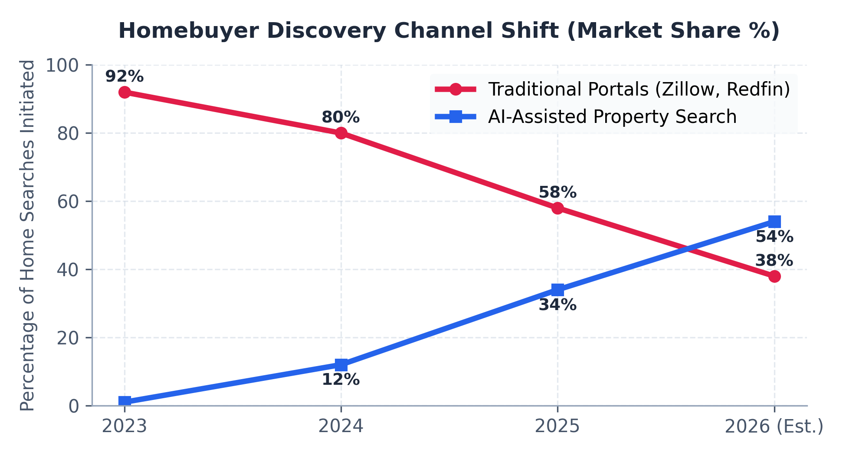
Figure 1: Homebuyer Portal Searches vs. Conversational AI-Assisted Property Search (2023-2026)

3. Web Optimization for AI Listing Discovery
To ensure your listings are recommended when buyers query AI models, your digital assets must be structured for machine comprehension. We implement four crucial optimization layers on your listing pages and profiles:
- RealEstateAgent Schema Markup: Injects structured JSON-LD into your agent bio page, letting AI systems index your specialties, licensing areas, and contact routes.
- SingleFamilyResidence Schema: Enriches listing pages with structured metadata (square footage, heating type, HOA terms, school zoning) that bots read instantly.
- Plaintext Listing Brief (`llm.txt`): Generates machine-friendly summaries of property features, community highlights, and seller incentives to allow conversational bots to pitching your property in chat threads.
- Brand Logo Organization Schema: Maps your agency logo to search index files, rendering rich graphical cards in AI search results next to your listing recommendation.

4. Interactive Listing Chatbots vs. Portals
By replacing static contact forms with listing-specific interactive chatbots, realtors capture leads at a higher rate. Rather than clicking 'Contact Agent' to get cold-called by random portal partners, the buyer chats with a virtual agent trained on the listing details, scheduling private tours and receiving instant property deal sheets.

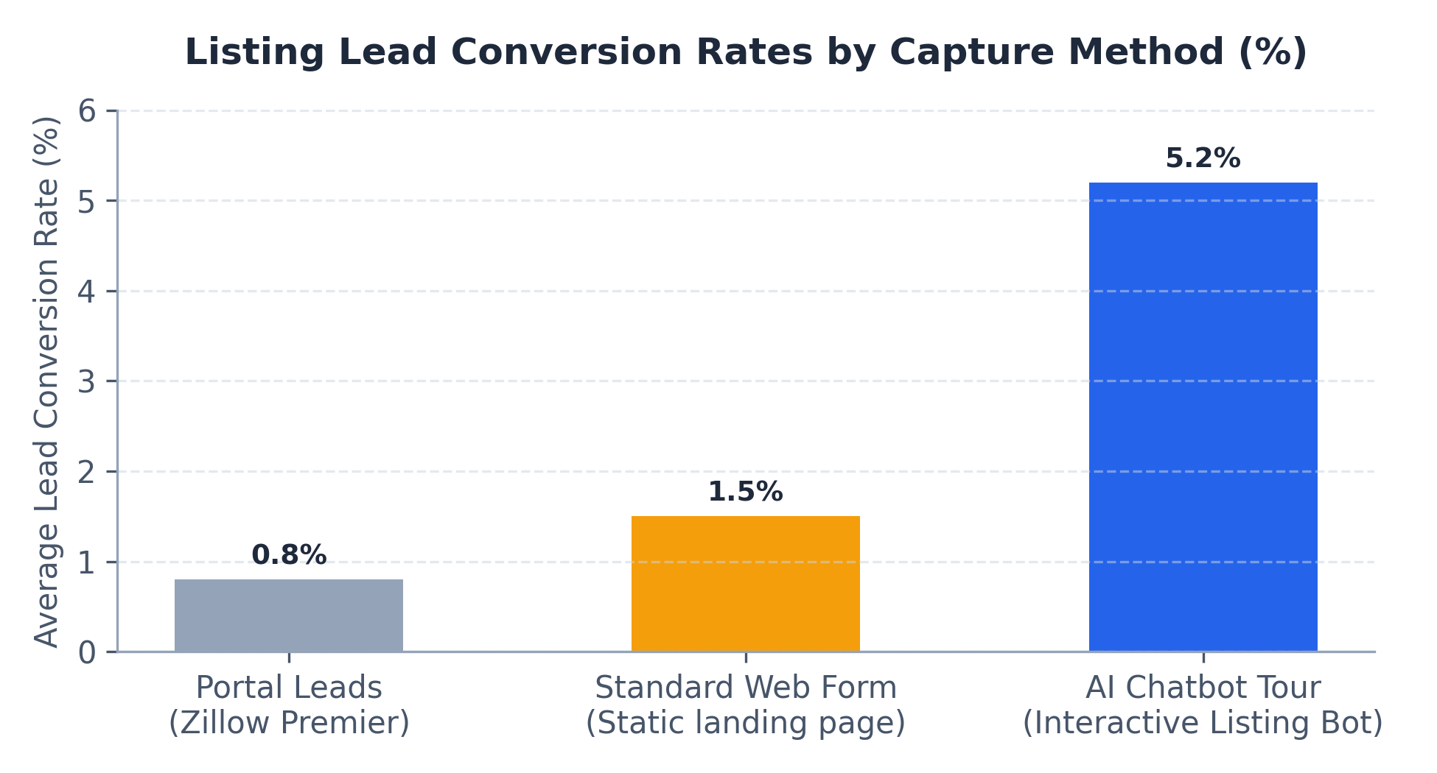
Figure 2: Lead Conversion Efficiency by Capture Interface

5. Program Packages and Pricing
Our agency provides end-to-end integration to prepare realtors and listings for conversational AI search channels.
Service Program | Description & Key Features | Monthly Cost
Core Realtor Bridge & Ads | Implementation of RealEstateAgent schema, robots.txt bot rules, Organization Logo mapping, and targeted Google search ad management for active seller/buyer search terms. | $1,000 / mo
Full realtor Suite Domination | Core Program + interactive listing AI assistant widget, BiggerPockets/Reddit social listener thread generator, and local content engine blog. | $1,999 / mo

Contact our real estate optimization desk today at info@capitalbridgesolutions.com to prepare your listings for the AI Agent Era.

