8. Class Based Modeling
Class-based modeling defines the static structure of the IPOS system by identifying its objects, the attributes and operations of each class, the relationships between classes, and the collaborations that occur between them. The elements of the class-based model below include classes and objects, attributes, operations, Class-Responsibility-Collaborator (CRC) cards, and a collaboration diagram.

8.1 General Characteristics
Candidate classes are categorized based on the seven general classifications below. An analysis class typically manifests itself in one of the following ways. A candidate class is selected for special consideration if it fulfils three or more of these characteristics.
- 1. External Entities
- 2. Things
- 3. Occurrence/Events
- 4. Organizational Unit
- 5. Role
- 6. Places
- 7. Structures
List of Nouns:
Sl. No. | Noun | P / S | General Classification
1 | IPOS (the system) | S | 4
2 | User | S | 4,5,7
3 | Student | S | 4,5,7
4 | Staff | S | 4,5,7
5 | Company | S | 1,6
6 | Position | S | 2,7
7 | Name | S | 2
8 | Phone number | S | 2
9 | Email | S | 1
10 | Notification | S | 3
11 | Preference | S | 7
12 | Skillset | S | 7
13 | CV | S | 2
14 | CGPA | S | 2
15 | Roll number | S | 2
16 | Registration number | S | 2
17 | Session | S | 2
18 | Designation | S | 2
19 | User ID | S | 2
20 | Password | S | 2
21 | Role | S | 2
22 | Allocation | S | 3
23 | Letter | S | 2
24 | Status | S
25 | Priority | S | 2
26 | Availability | S
27 | Company HR | S | 5
28 | IPO Head | S | 4,5,7
29 | IPOC Member | S | 4,5,7
30 | RPO | S | 4,5,7
31 | XYZ Institute | S | 6
32 | Internship | S | 3
33 | Notice | S | 3
34 | Selection process | S | 3
35 | Override | S | 3

Possible Classes:
- 1. User
- 2. Student
- 3. Staff
- 4. Company
- 5. Position
- 6. Preference
- 7. Skillset
- 8. CV
- 9. Allocation
- 10. Letter
- 11. EmailGenerator
- 12. LetterGenerator

8.2 Selection Criteria:
- 1. Retained Information
- 2. Needed Service
- 3. Multiple Attributes
- 4. Common Operation
- 5. Common Attributes
- 6. Essential Requirements
No. | Classes | Selection Criteria
1 | User | 1, 3, 5, 6
2 | Student | 1, 3, 5, 6
3 | Staff | 1, 3, 5, 6
4 | Company | 1, 2, 3, 6
5 | Position | 1, 2, 3, 6
6 | Preference | 6
7 | Skillset | 6
8 | CV | 6
9 | Allocation | 1, 2, 6
10 | Letter | 1, 2, 6
11 | EmailGenerator | 6
12 | LetterGenerator | 6
Analysis:
Student and Staff are removed as separate classes because their identifying attributes (Name, Phone No, Email, Password) and core operations (register, login) already exist in the User class — the Role attribute distinguishes a Student from Admin at runtime. Preference, Skillset, CV, and Allocation are also removed as standalone classes because they carry no independent behaviour beyond what is already expressed as attributes and methods of User, Position, and Admin, the same way LMS folded Borrowing, Payment, and Clearance into its User/Admin/Book classes rather than giving them their own class.

8.3 List of Verbs:
No. | Verbs | No. | Verbs
1 | Send | 26 | Override
2 | Take | 27 | Finalize
3 | Preside | 28 | Update
4 | Enter | 29 | Sort
5 | Provide | 30 | Rank
6 | Include | 31 | Register
7 | Notify | 32 | Login
8 | Fill out | 33 | Logout
9 | View | 34 | Verify
10 | Select | 35 | Confirm
11 | Assign | 36 | Archive
12 | Upload | 37 | Request
13 | Mention | 38 | Submit
14 | Receive | 39 | Display
15 | Allocate | 40 | Search
16 | Match | 41 | Filter
17 | Check | 42 | Download
18 | Generate | 43 | Trigger
19 | Sign | 44 | Track
20 | Preserve | 45 | Manage
21 | Issue | 46 | Create
22 | Forward | 47 | Delete
23 | Approve | 48 | Review
24 | Reject | 49 | Depend
25 | Save | 50 | Complete
Selected Classes:
1. User
Attributes | Methods
● Name | ● register()
● Phone No | ● login()
● Email | ● updateProfile()
● User Id | ● submitPreference()
● Password | ● uploadCV()
● Role | ● enterSkillset()
 | ● viewAllocationResult()
 | ● receiveNotification()

2. Admin
Attributes | Methods
● Name | ● login()
● Phone No | ● enterCompanyInfo()
● Email | ● sendChoiceFormNotice()
● Admin Id | ● verifyStudentData()
● Password | ● enterCGPA()
● Designation | ● allocateStudents()
 | ● overrideAllocation()
 | ● generateAllocationLetter()
 | ● archiveRecord()

3. Company
Attributes | Methods
● companyId | ● submitInterest()
● name | ● offerPosition()
● address | ● receiveAllocationLetter()
● hrName | ● issueOfferLetter()
● hrEmail

4. Position
Attributes | Methods
● positionId | ● updateAvailability()
● title | ● matchSkillset()
● responsibility | ● checkPreferenceMatch()
● availabilityStatus

5. LetterGenerator
Attributes | Methods
● letterId | ● generateAllocationLetter()
● pdf | ● generateOfferRecord()
● generatedDate | ● exportPDF()

6. EmailGenerator
Attributes | Methods
● email | ● sendCompanyNotificationEmail()
● date | ● sendStudentNotificationEmail()
 | ● sendRPOCopyEmail()

8.4 CRC:
1. User
Attributes | Methods
Name | register()
Phone No | login()
Email | updateProfile()
User Id | submitPreference()
Password | uploadCV()
Role | enterSkillset()
 | viewAllocationResult()
 | receiveNotification()

Responsibilities | Collaborator
Register and log in with role-specific details | Admin
Submit company preference and enter skillset details | Position
Upload CV as part of the internship application | Admin
Receive allocation and offer-letter notifications | EmailGenerator

2. Admin
Attributes | Methods
Name | login()
Phone No | enterCompanyInfo()
Email | sendChoiceFormNotice()
Admin Id | verifyStudentData()
Password | enterCGPA()
Designation | allocateStudents()
 | overrideAllocation()
 | generateAllocationLetter()
 | archiveRecord()

Responsibilities | Collaborator
Enter and manage company and position details | Company, Position
Send notice and verify student submissions | User
Enter student CGPA up to 3rd year 1st semester | User
Allocate or override a student's placement | Position, User
Request the formal allocation letter | LetterGenerator

3. Company
Attributes | Methods
companyId | submitInterest()
name | offerPosition()
address | receiveAllocationLetter()
hrName | issueOfferLetter()
hrEmail

Responsibilities | Collaborator
Submit interest and offer available positions | Admin
Receive the formal allocation letter | LetterGenerator, EmailGenerator
Issue the offer letter to the selected intern | User

4. Position
Attributes | Methods
positionId | updateAvailability()
title | matchSkillset()
responsibility | checkPreferenceMatch()
availabilityStatus

Responsibilities | Collaborator
Maintain title, responsibility and availability | Admin
Get matched against a student's preference and skillset | User

5. LetterGenerator
Attributes | Methods
letterId | generateAllocationLetter()
pdf | generateOfferRecord()
generatedDate | exportPDF()

Responsibilities | Collaborator
Generate the allocation letter and offer record | Admin
Hand off the generated PDF for dispatch | EmailGenerator

6. EmailGenerator
Attributes | Methods
email | sendCompanyNotificationEmail()
date | sendStudentNotificationEmail()
 | sendRPOCopyEmail()

Responsibilities | Collaborator
Send the allocation email to Company HR | Company
Send a record copy to RPO | Admin
Notify the student of allocation/offer status | User

8.5 CRC Diagram:
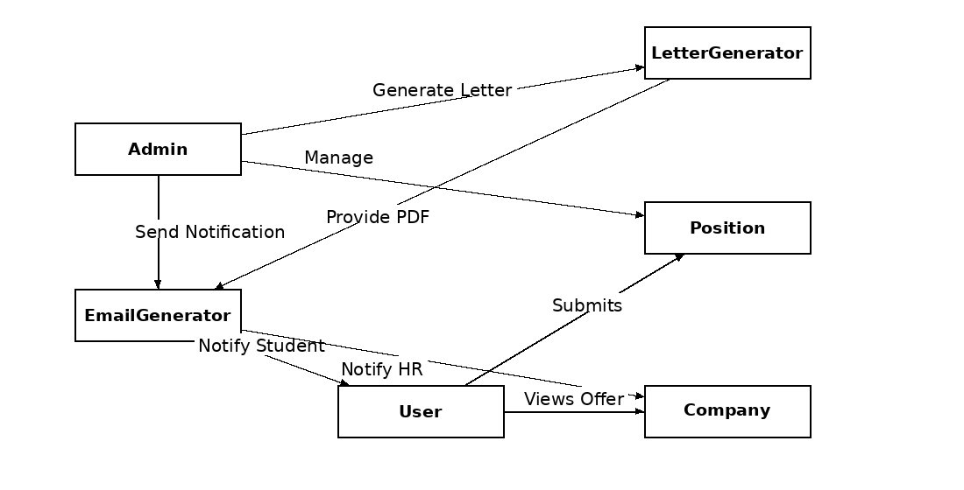
Figure: Class Responsibility Collaborator Diagram

9. Behavioral Modeling

9.1 Introduction
The behavioral model predicts how IPOS will react to events or stimuli outside its control. Two distinct characterizations of state must be taken into account while modeling behaviour: (1) the state of each class as the system executes its function, and (2) the state of the system as a whole as seen from the outside as it executes its function.

9.2 State Transition
List of Events:
No. | Initiator | Event | Event Name | Collaborator
1 | Company HR | Send interest in taking interns | Interest Submitted | Admin
2 | Admin (Head) | Receive interest and forward to IPOC-1 | Entry Requested | Admin
3 | Admin (IPOC-1) | Enter company name, positions, responsibilities, address, HR email | Company Added | Position
4 | Admin (IPOC-2) | Send choice-form notice to BSSE 4th year students | Choice Notice Sent | User
5 | User | View available company information | Company Info Viewed | Position
6 | User | Select companies and assign priority | Preference Submitted | Position
7 | User | Upload CV | CV Uploaded | User
8 | User | Enter skillset with competency rank | Skillset Entered | User
9 | Admin (IPOC-3) | Enter student CGPA | CGPA Entered | User
10 | Admin (IPOC-2) | Verify all student data is complete | Data Verified | User
11 | Admin | Sort students by CGPA (highest first) | List Sorted | Position
12 | Admin | Auto-allocate by preference, skill and availability | Allocation Generated | Position
13 | Admin (Head) | Review the generated allocation list | Allocation Reviewed | Admin
14 | Admin (Head) | Manually override an allocation | Allocation Overridden | Position
15 | Admin (Head) | Finalize and save the allocation report | Allocation Finalized | LetterGenerator
16 | Admin (Head) | Generate the formal allocation letter | Letter Generated | LetterGenerator
17 | EmailGenerator | Send allocation email to Company HR | HR Notified | Company
18 | EmailGenerator | Send a copy of the letter to RPO | Record Archived | Admin
19 | Company | Receive the allocation letter | Letter Received | Admin
20 | Company | Issue the offer letter to the selected intern | Offer Letter Issued | User
21 | Company | Send the offer letter copy to IPO Head | Offer Copy Sent | Admin
22 | Admin (Head) | Preserve the offer letter for record keeping | Record Preserved | Admin
23 | User | Register and log in to IPOS | User Logged In | Admin
24 | Admin | Log in to IPOS | Admin Logged In | Admin
25 | User | Log out | User Logged Out | Admin
26 | Admin | Log out | Admin Logged Out | Admin

9.2.1 User
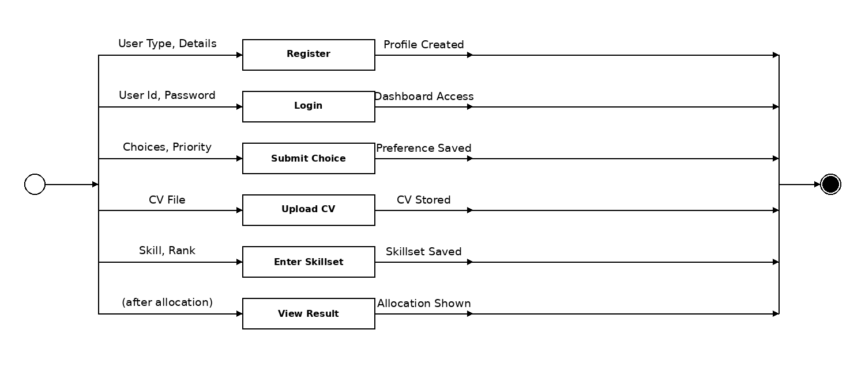
Figure: State Transition of User Class

9.2.2 Admin
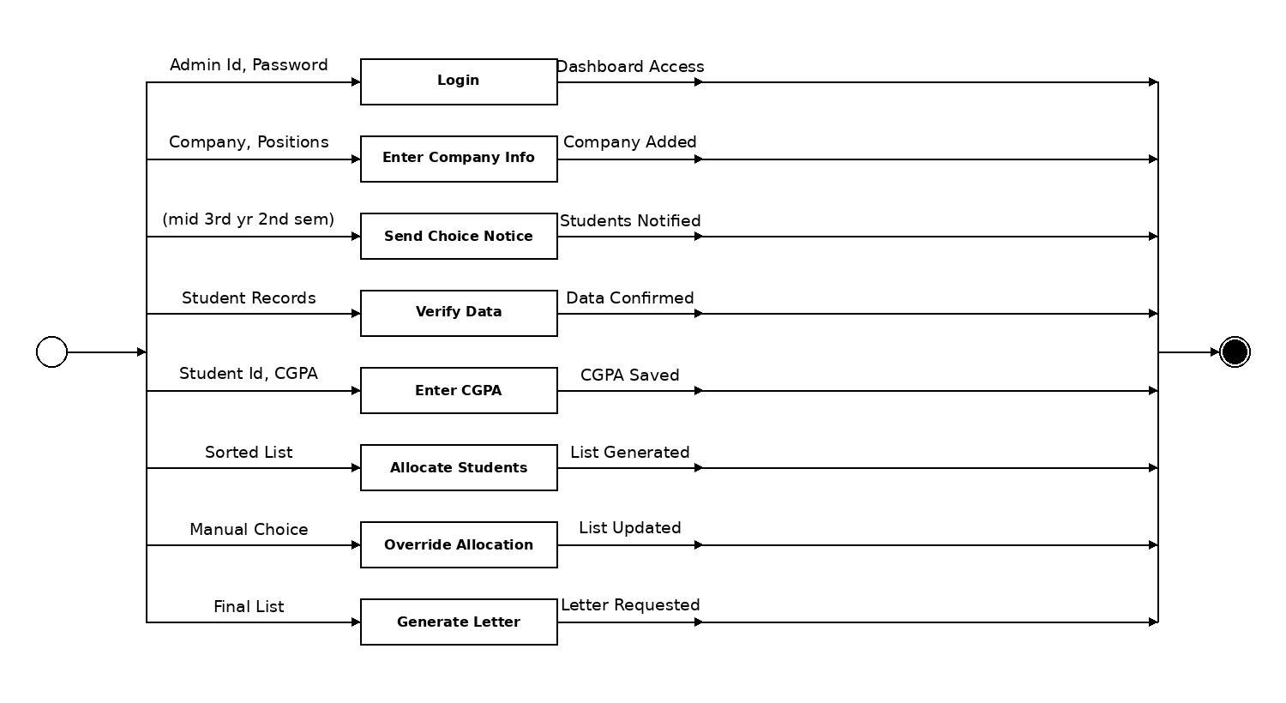
Figure: State Transition of Admin Class

9.2.3 Company
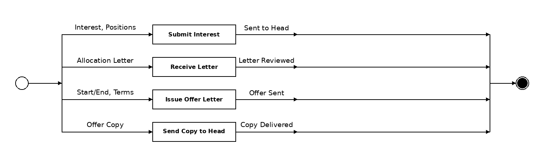
Figure: State Transition of Company Class

9.2.4 Position
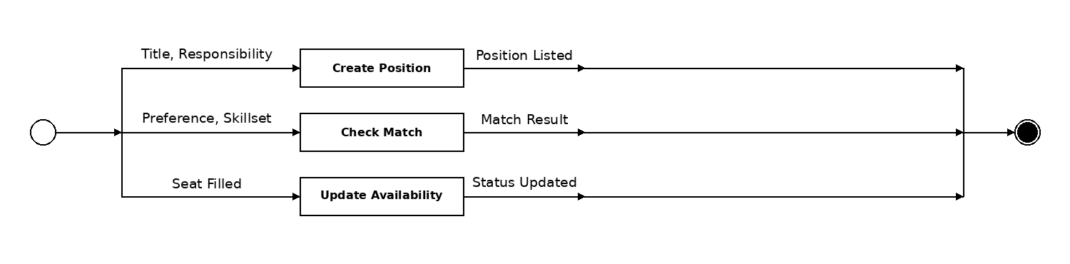
Figure: State Transition of Position Class

9.2.5 LetterGenerator
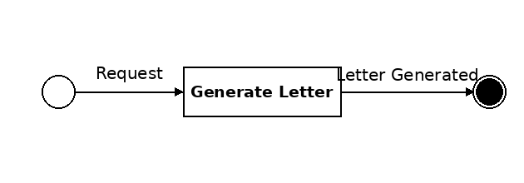
Figure: State Transition of LetterGenerator Class

9.2.6 EmailGenerator
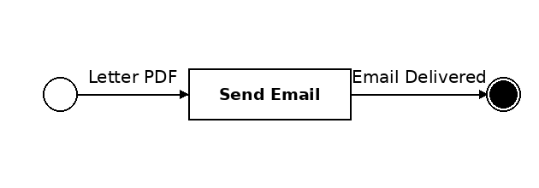
Figure: State Transition of EmailGenerator Class

