Author: Mayur Hamirani Web url: <http://mayurhamirani.me/>

**Web Page Components**

1. Sticky Navigation – Designed using javascript to navigate through various modules on the web page.

Desktop View:



Mobile View:

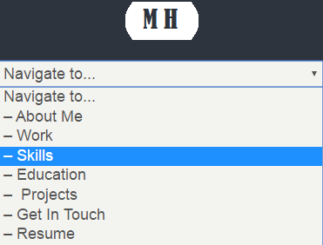

1. Cover Banner Area: This section displays title, role and introduction text Scalable

Desktop View:



Mobile View:

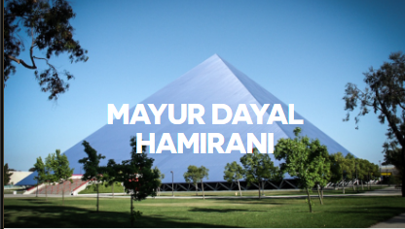

1. JumpLink webparts – Provides an image, title, description and an link to other web page.
2. Normal Jumplink – Simple web part with the target link.



1. Shadow Effect Jumplink – Web part with hover effect- Automatically hides text when viewed in mobile view.

Desktop View:

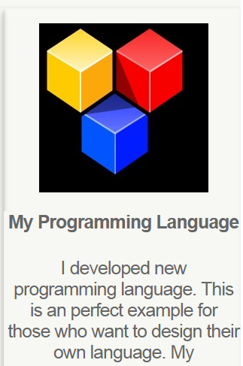

Mobile View:

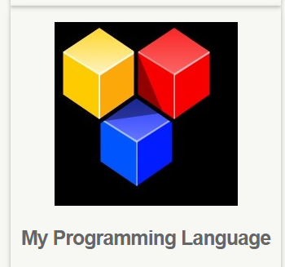

1. Graph Sliders: Sliders designed using JS dynamically displays the skill proficiency level to end user.

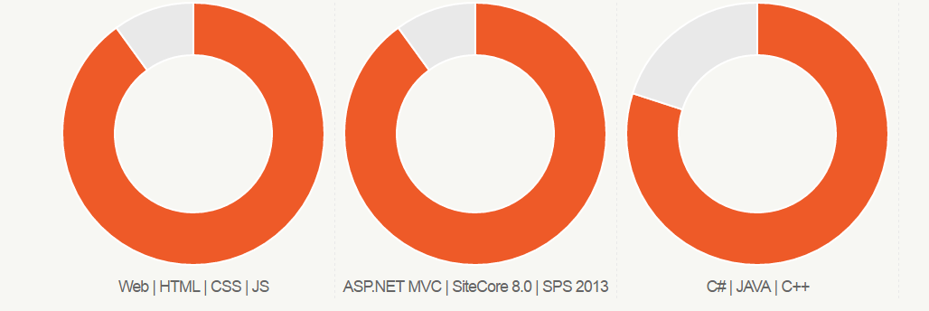

1. Contact Section: Input form to enable user to send email in-case of any queries.

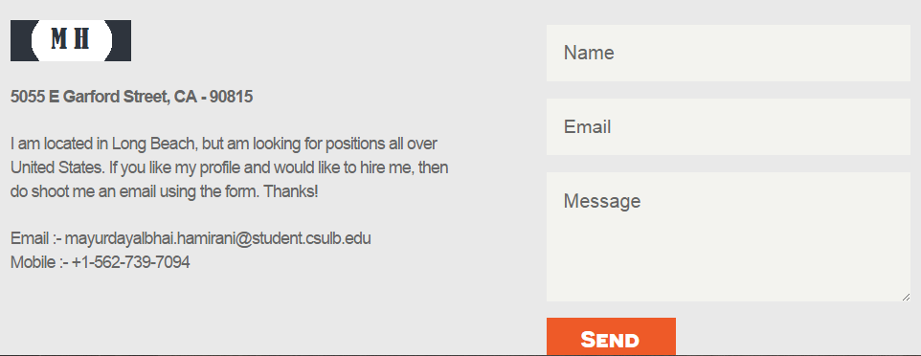

Technologies Used: Bootstrap, CSS3, HTML, JavaScript, JQuery.  
Supported Devices: Mobile, Tablet and Desktop