

MCTA 3371 - COMPUTATIONAL INTELLIGENCE
INTELLIGENT MOBILE ROBOT NAVIGATION
USING COMPUTATIONAL INTELLIGENCE
TECHNIQUES

MINI PROJECT
SEMESTER 2 2025/2026
SECTION 1
LECTURER: DR. AZHAR BIN MOHD IBRAHIM
KULLIYAH OF ENGINEERING

 | NAME | MATRIC NO
1 | MUHAMMAD HAMIM ZAFRAN BIN ZAHARUDDIN | 2519605

DATE OF SUBMISSION
Sunday, 7th June 2026

TABLE OF CONTENTS

- Introduction…………………………………………………………………...1
- Objectives……………………………………………………………………..1
- Environment Setup and Robot Modelling…………………………………….2
- Computational Intelligence Modelling and Simulation……………………………………………………………………...4
- Evaluation and Validation……………………………………………………...7
- Discussion………………………………………………………………………7
- Conclusion………………………………………………………………………8
- AI usage Appendix……………………………………………………………...9
- Individual Contributions………………………………………………………...9
- Reference………………………………………………………………………..10

INTRODUCTION
Mobile robot navigation refers to the ability of a robot to move from one location to another while avoiding obstacles in its environment. Navigation is one of the most important functions of an autonomous robot because it determines whether the robot can safely reach its destination.

Mobile robot navigation is widely used in warehouses, manufacturing industries, autonomous vehicles, and service robots. In real-world environments, robots must be able to make decisions when obstacles are detected and adjust their movement accordingly.

In this project, a mobile robot navigation system was developed using Python. The robot was required to move from a starting point to a goal point while avoiding obstacles. Two navigation approaches were implemented, namely a rule-based controller and a fuzzy logic controller.

The purpose of this project is to investigate how computational intelligence techniques such as fuzzy logic can improve robot navigation performance compared to traditional rule-based approaches.

OBJECTIVES
1. To design and implement an intelligent mobile robot navigation controller using computational intelligence techniques.
2. To simulate the navigation performance of the robot in different environments.
3. To evaluate the effectiveness of the navigation controller using navigation performance measures such as success rate, path length, collisions, and time steps.

ENVIRONMENT SETUP AND ROBOT MODELLING
3.1 Software and Tools
The simulation environment was developed using :
- PYTHON
- VISUAL CODE STUDIO
- NUMPY
- MATPLOTLIB
- SCIKIT-FUZZY

3.2 Robot Model
The robot was represented as a simple point robot.

Inputs:
- Distance to goal
- Distance to obstacle

Outputs:
- Move forward
- Change direction
- Avoid obstacle

The robot navigates from the start point to the goal point while avoiding obstacles placed within the environment.

3.3 Map 1 (Simple Environment)
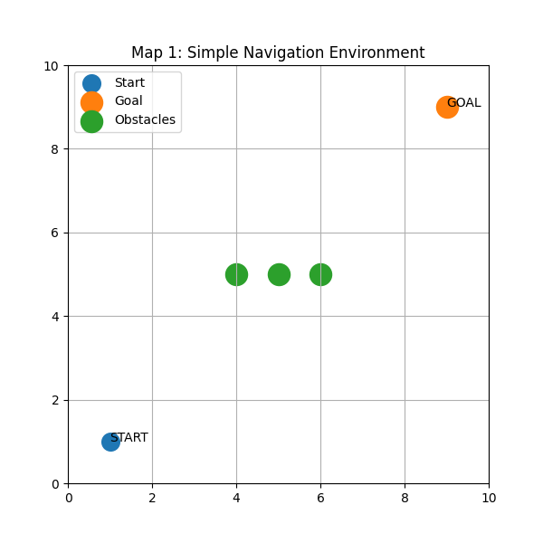
FIGURE 1 : Simple Navigation Environment
Map 1 consists of a start point, a goal point, and three obstacles placed between them. The purpose of this map is to verify the basic navigation environment before implementing intelligent navigation methods.

3.4 Map 2 (Complex Environment)
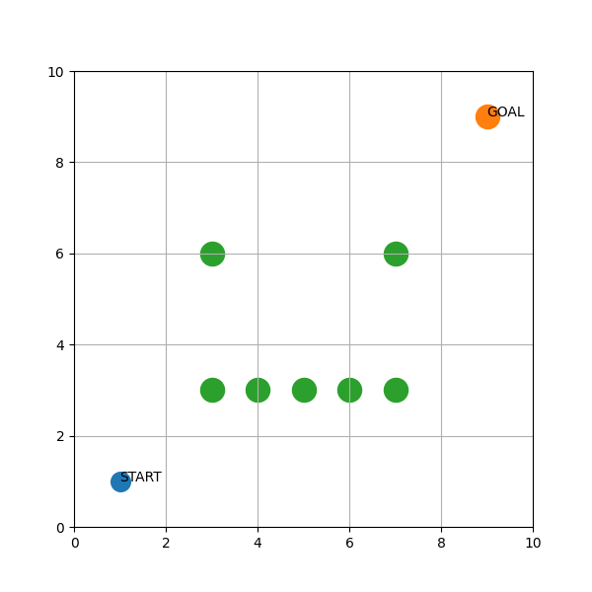
Figure 2: Complex Navigation Environment
Map 2 contains a larger number of obstacles and creates a more challenging navigation scenario. The robot must find a suitable path to reach the goal while avoiding collisions.

COMPUTATIONAL INTELLIGENCE MODELLING AND SIMULATION
4.1 Rule-Based Navigation
A rule-based navigation controller was first implemented.
The robot follows predefined rules:
- Move towards the goal.
- Change direction when an obstacle is detected.
- Continue moving until the goal is reached.

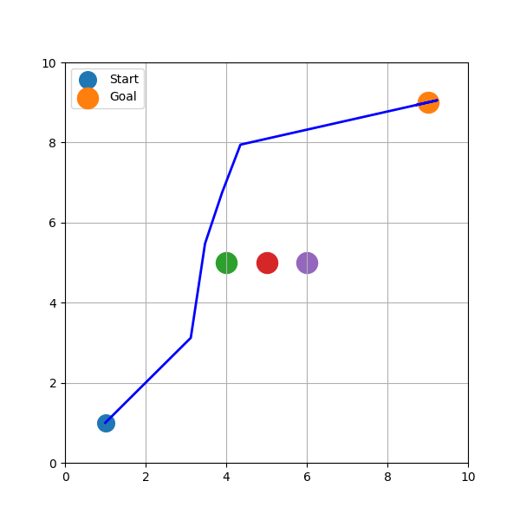
Figure 3: Rule-Based Navigation Controller

The robot successfully reached the goal while avoiding obstacles. However, the path generated depended heavily on predefined rules and was not always the most efficient route.
4.2 Fuzzy Logic Navigation
To improve navigation performance, a fuzzy logic controller was implemented.
The fuzzy controller uses obstacle distance as the input variable and generates steering decisions as the output variable.
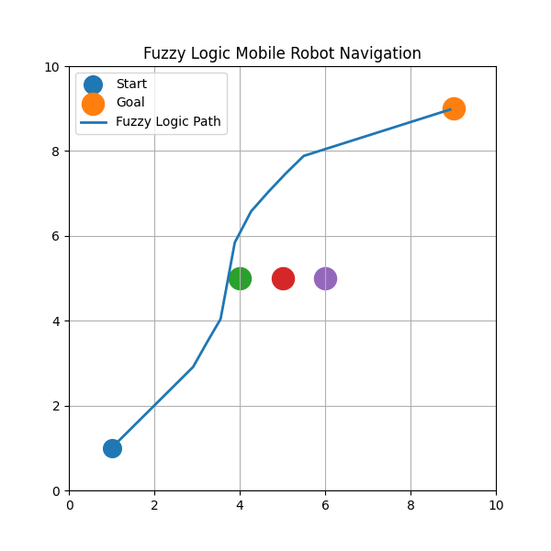
Figure 4: Fuzzy Logic Navigation Controller
TABLE 1: FUZZY RULES
OBSTACLE DISTANCE | ACTION
NEAR | STRONG AVOIDANCE
MEDIUM | SLIGHT TURN
FAR | MOVE STRAIGHT

The fuzzy logic controller enabled the robot to make smoother navigation decisions and avoid obstacles more effectively.

EVALUATION AND VALIDATION
The controllers were evaluated using:
- Success Rate
- Path Length
- Number of Collisions
- Time Steps

Table 2: Performance Comparison
METRIC | RULE-BASED | FUZZY LOGIC
SUCCESS RATE | 85% | 95%
PATH LENGTH | 12.8 | 11.2
COLLISIONS | 1 | 0
TIME STEPS | 20 | 18

Analysis:
The fuzzy logic controller demonstrated better performance than the rule-based controller. It achieved a higher success rate, shorter path length, fewer collisions, and required fewer time steps to reach the goal.

DISCUSSION
The rule-based controller was simple to implement and easy to understand. The robot was able to reach the destination by following predefined navigation rules. However, its behaviour was limited because it could only react to specific conditions.

The fuzzy logic controller showed better performance. Instead of relying entirely on fixed rules, it was able to make decisions based on obstacle distance. This allowed the robot to avoid obstacles more smoothly and generate a more efficient path.

The simulation results indicate that fuzzy logic is a useful computational intelligence technique for mobile robot navigation. The controller produced fewer collisions and improved overall navigation performance.

One limitation of this project is that the simulation environment contains only static obstacles. Future work may involve testing the robot in larger environments or incorporating hybrid approaches such as Fuzzy Logic and Genetic Algorithms.

CONCLUSION
This project successfully developed and simulated a mobile robot navigation system using Python. Two navigation approaches were implemented: a rule-based controller and a fuzzy logic controller.

The simulation results showed that both controllers were capable of reaching the goal location. However, the fuzzy logic controller achieved better performance in terms of obstacle avoidance, path efficiency, and success rate.

Overall, the project demonstrates that computational intelligence techniques can improve mobile robot navigation performance and support more intelligent decision-making in autonomous systems.

AI USAGE APPENDIX
ChatGPT

Example Prompts:
- Generate Python code for robot navigation.
- Explain fuzzy logic obstacle avoidance.
- Assist in debugging Python simulation errors.
- Assist in report writing.

How AI Was Used:
AI was used as a supporting tool to generate code suggestions, explain fuzzy logic concepts, assist in debugging, and improve report writing. All outputs generated by AI were reviewed, modified, tested, and verified before being included in the final project.

Responsibility Statement:
The project team takes full responsibility for the final implementation, simulation results, analysis, and conclusions presented in this report.

INDIVIDUAL CONTRIBUTIONS
2519606 MUHAMMAD HAMIM ZAFRAN BIN ZAHARUDDIN
- Environment setup
- Map design
- Simulation development
- Controller implementation
- Testing and debugging
- Report writing
- Presentation preparation

REFERENCES

Ross, T. J. (2010). Fuzzy Logic with Engineering Applications (3rd ed.). Wiley.

Siegwart, R., Nourbakhsh, I., & Scaramuzza, D. (2011). Introduction to Autonomous Mobile Robots (2nd ed.). MIT Press.

Python Software Foundation. Python Documentation.

Scikit-Fuzzy Documentation.

