CFL CW3

|  |  |
| --- | --- |
| Stmt -> | Skip | Id:=AExp | If BExp then Block else Block | While BExp do Block  | Read Id | Write String | Write Id |
| Stmts -> | Stmt ; Stmt | Stmt |
| Block -> | { Stmts } | Stmt |
| AExp -> | Te + AExp | Te – Aexp | Te |
| Te -> | Fa * Te | Fa / Te | Fa % Te | Fa |
| Fa -> | ( AExp ) | Var | Num | Str |
| BExp -> | AExp == AExp | AExp != AExp | AExp < AExp | AExp > AExp | true | false | (BExp) | AExp <= AExp | AExp >= AExp |

**if** (a **<** b) **then skip else** a :**=** a * b + 1

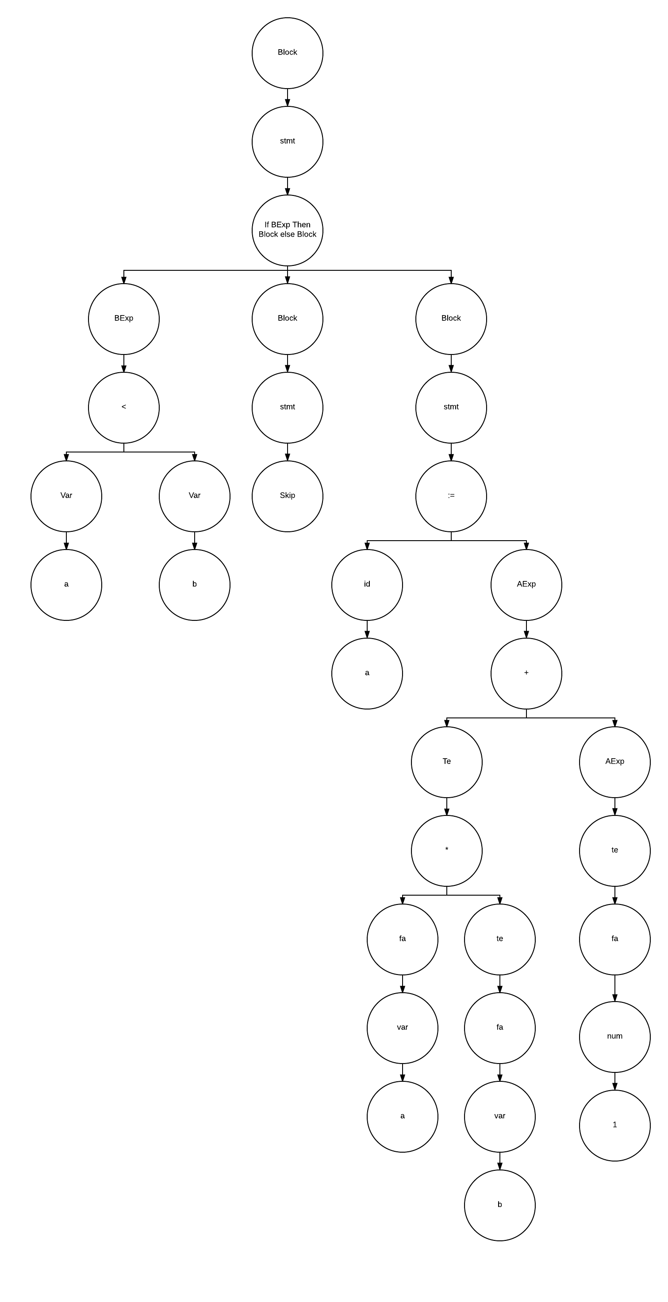

|  |  |
| --- | --- |
| Input Size | Time Needed (s) |
| 1000 | 97.034140645 |
| 500 | 13.361693916 |
| 100 | 0.393853588 |
| 840 | 63.378678683 |