Project Walk: Europe

Installation

1. Setting up Google Maps API Key
2. For Mac OS follow on,
3. Open terminal,
4. Copy and paste the following command

keytool -list -v -keystore ~/.android/debug.keystore -alias androiddebugkey -storepass android -keypass android

1. Here’s an example of what your terminal window should look like:

|  |
| --- |
| YourDevice:~ YH$ keytool -list -v -keystore ~/.android/debug.keystore -alias androiddebugkey -storepass android -keypass android  Alias name: androiddebugkey  Creation date: 27-Oct-2015  Entry type: PrivateKeyEntry  Certificate chain length: 1  Certificate[1]:  Owner: CN=Android Debug, O=Android, C=US  Issuer: CN=Android Debug, O=Android, C=US  Serial number: 30c59c40  Valid from: Tue Oct 27 20:32:27 GMT 2015 until: Thu Oct 19 21:32:27 BST 2045  Certificate fingerprints:  MD5: ___________________________________________  SHA1: ______________________________________________  SHA256: ______________________________________________  Signature algorithm name: __________________________________  Version: 3 |

1. Copy the key at SHA1.
2. If this does not work then try the alternate method located at the ned of this document
3. Go to: <https://console.developers.google.com/>
4. Log in if you aren’t already logged in and on the top of the window click on “Select a project” and then create a new project.

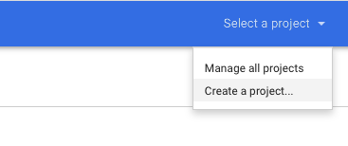

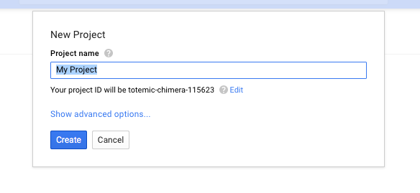

1. Name the project to your liking. Click on that project when it has been created. Your dashboard should look like the following.

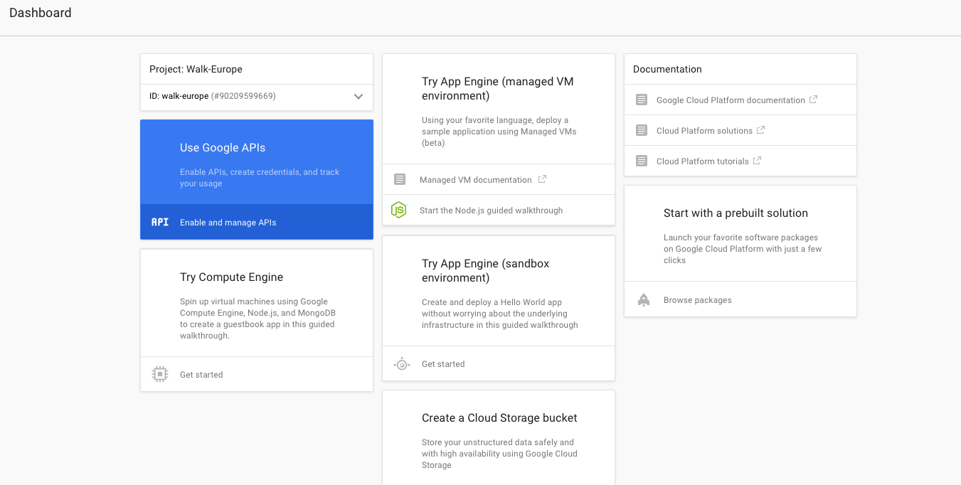

1. Click on “Enable and manage APIs”. This will open a new page.
2. Look for “Google Maps API” and in that section click on “Google Maps Android API”.
3. This will open a new page and on the top of the dashboard there should be a button labelled “Enable API”, click that.
4. When the API gets enabled it should say “Go to credentials”, click on that.
5. A new page will open and the API being used should be “Google Maps Android API” for where the API will be called from select “Android” and then click “Cancel”.
6. The credentials page will open now. Click on “New credentials” and then click on “API Key” and then “Android Key”.

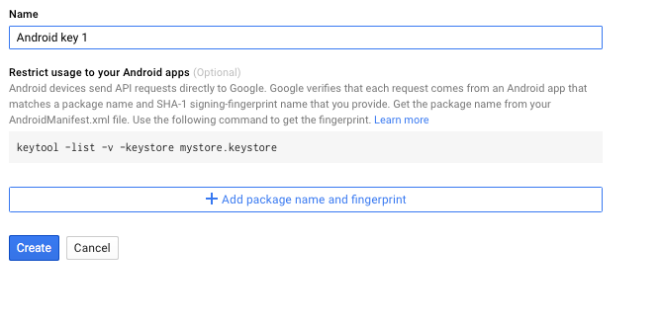

1. Name the key to your liking and click on “Add package name and fingerprint”.
2. Paste the SHA1 key you obtained earlier into SHA-1 certificate fingerprint and in package name add “boysenberry.europe” and click “Create”

Alternate way to get SHA1 key

1. Open the project in android studio
2. Build the project
3. Click the gradle tab on the right
4. Go to the following path: Europe/Europe (root)/Tasks/android and run signingReport



1. Copy the SHA1 key