Title:
An emission scenario weighting framework to improve the use of scenario ensembles of opportunity

Authors:
Hamish Beath¹, Chris Smith^{2,3}, Jarmo Kikstra^{1,3,4}, Matthew J. Gidden^{3,5}, Joeri Rogelj^{1,3,4}

Affiliations:
¹Centre for Environmental Policy, Faculty of Natural Sciences, Imperial College, London, United Kingdom
²Department of Water and Climate, Vrije Universiteit Brussel, Brussels, Belgium
³International Institute for Applied Systems Analysis (IIASA), Laxenburg, Austria
⁴The Grantham Institute for Climate Change and the Environment, Imperial College London, London, United Kingdom
⁵Climate Analytics, Berlin, Germany

Abstract:
Integrated assessment models (IAMs) produce large ensembles of socioeconomic scenarios that are used profusely in climate change research. Assessments by the Intergovernmental Panel on Climate Change (IPCC), analysis by non-governmental organisations or advice by national climate committees often rely on them to identify mitigation strategies and set climate targets. A key limitation of using such evidence is the opportunistic nature of these scenario ensembles: they are an unstructured, serendipitous collection of evidence. Drawing on concepts from physical climate science and the analysis of ensembles of climate model data, we here present a novel approach for the flexible, multidimensional weighting of emission scenario data that accounts for scenario relevance, quality, and diversity. We illustrate its use by applying it to the latest IPCC scenario assessment database. Our illustrative analysis indicates that bias-correction reveals more stringent emission milestones for net-zero and fossil-fuel phase-out targets than originally reported. Our framework provides a starting point to further improve scenario-based climate assessments.

Keywords:
Integrated Assessment Modelling, climate change, socioeconomics, mitigation, scenarios, bias correction

Main text:
Since the publication of the IPCC Special Report on Emissions Scenarios¹ in 2000, integrated assessment models (IAM) have become central tools for exploring emissions and climate futures in climate research. Despite already being part of the IPCC Third² and Fourth³ Assessments in 2001 and 2007, it was the IPCC’s Fifth Assessment⁴, the Special Report on Global Warming of 1.5°C⁵ (SR1.5) and the IPCC Sixth Assessment⁶ (AR6) that solidified the use of large scenario ensembles for the assessment of global mitigation strategies. With their expanded use also came an improved understanding and communication of their limitations^{7,8}.
Scenarios that are collected as part of IPCC or other exercises^{9–11} represent ensembles of opportunity: a serendipitous collection of scenario data that is unstructured⁷ and in which the scenarios that are ultimately included vary in their purpose, design, comprehensiveness, coverage, quality and other characteristics. One key limitation of the use of large emission scenario ensembles is that shortcomings or biases present in the collected ensemble can be propagated by subsequent secondary analysis^{7,8}. Unless adequately corrected for, this would lead to spurious or biased results.
Typical shortcomings or biases in scenario ensembles of opportunity relate to three main issues: scenario relevance, quality, and diversity. Relevance refers to whether a scenario, through the structural properties of the underlying model, its design, and outcome characteristics is relevant to the question that is being investigated by the secondary analysis. This can include the estimated level of global warming avoided by the scenario¹², assessments of the feasibility of its described transitions¹³, or even subjective – but transparently communicated – preferences about technologies or strategies. Quality refers to whether the implementation and execution of the modelling lives up to pre-defined quality standards set out by the secondary analysis. These standards typically refer to technical modelling aspects such as the accuracy of historical data, time resolution, or plausibility of near-term trends and resource use. Diversity, finally, refers to the degree of additional information a scenario communicates compared to other members in the ensemble of opportunity. Not accounting for the latter can result in statistics across a scenario ensemble being too narrow or overconfident towards the results of a single model, modelling team or modelling exercise.
In the past, such issues have been dealt with on an ad-hoc basis. For example, the IPCC SR1.5⁵ checked for the completeness of variables available in scenarios, whether data is reported until 2100, or whether reported historical- or near-future data is consistent with observations^{9,14}. For the assessment of global emission characteristics of pathways aligned with 1.5°C, SR1.5 also excluded 13 scenarios submitted by a single modelling group¹⁵ because they included virtually no variation in emissions and their inclusion would have biased descriptive emission statistics. Criteria for including or excluding scenarios depend on context, which explains why these 13 scenarios were still included in the analysis of aspects other than the evolution of emissions in the SR1.5 report. Similar well-informed, but ad-hoc considerations were applied in the latest AR6 mitigation assessment of the IPCC^{6,8}.
Other climate research communities have also grappled with similar issues, and the Earth System Modelling community has established methods to down-weight models based on their similarity to other models^{16–18}, as well as for model quality measured as performance relative to historical observations^{18,19}. In emission scenario ensemble analysis, issues of scenario similarity have been considered²⁰, but as of yet not systematically addressed.
In this paper, we use efforts from various communities^{16–20} as a starting point to develop and present a scenario-weighting method that addresses issues of scenario relevance, quality and diversity, and provide a systematic approach that unifies and expands on ad-hoc scenario assessment decisions that were made in the past^{1–6}. We apply it to the latest available IPCC AR6 scenario ensemble of opportunity¹⁰ to illustrate its use in practice. We discuss the strengths and weaknesses of such an approach, with a view to further research and refinement of the approach in future.

A generalised scenario weighting framework
Our starting point takes a generalised view that each scenario in an ensemble of opportunity must be assigned a weight for subsequent analysis. In the past, re-analysis of scenario ensembles would decide to include or exclude scenarios from their analysis, effectively assigning weights of 1 or 0. Here we formalise this step. Each scenario i contributing to the assessment and member of the ensemble of opportunity E is assigned a generalized weight gw_{i}:
$$\begin{aligned}gw_{i}=\frac{R\left(i\right).Q\left(i\right)}{D\left(i\right)}\#\left(1\right)\end{aligned}$$
where 0 ≤ R(i) ≤ 1 is a measure of how relevant a scenario is to answer a specific question (relevance weighting), 0 ≤ Q(i) ≤ 1 is a metric of scenario quality (quality weighting) and D(i) >= 1 is a metric of scenario uniqueness (diversity weighting). This ensures gw_{i} has a weight between 0 and 1. Scenarios with lower weights are less relevant, of lower quality, or very similar to others, and hence contribute less towards the final statistics of the ensemble. Figure 1 provides a schematic of the framework.

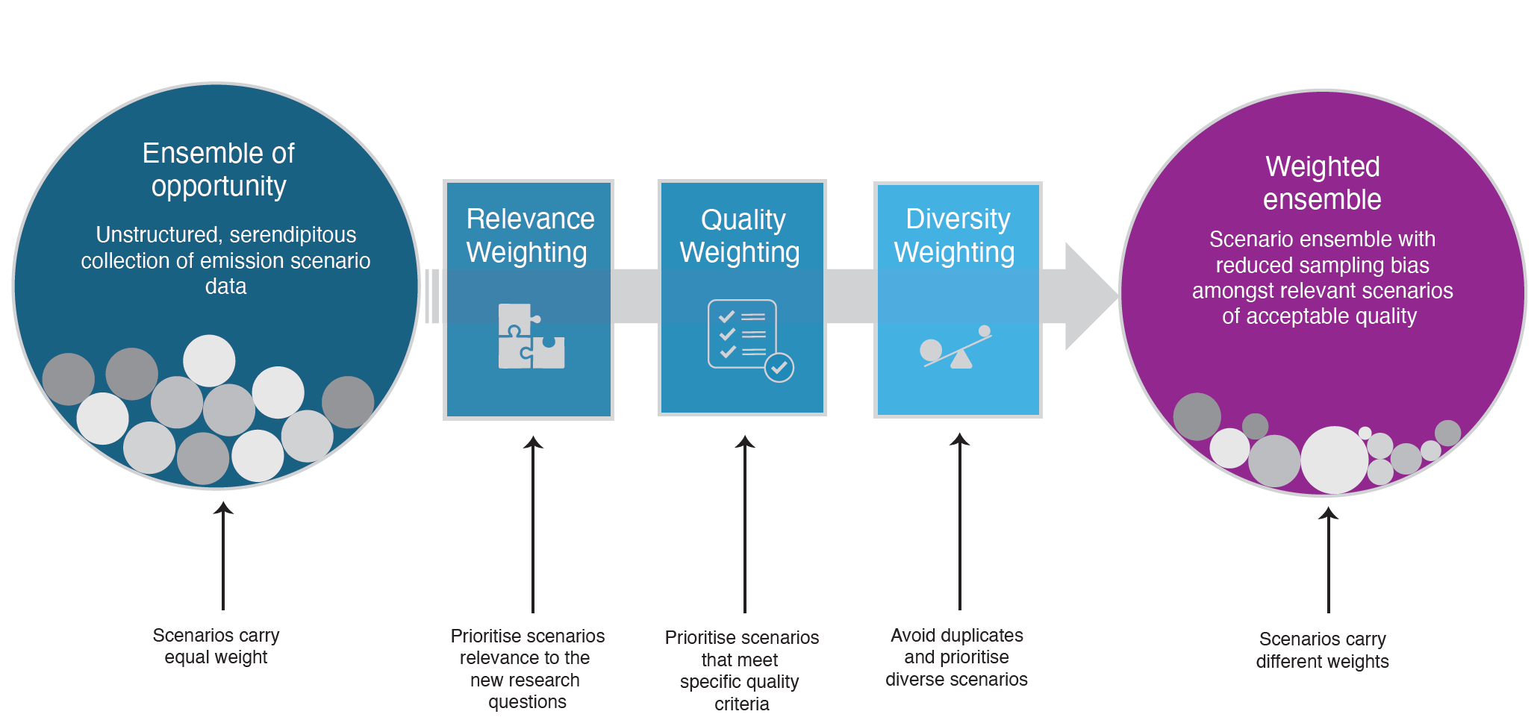
Figure 1 | A scenario weighting framework for the analysis of scenario ensembles of opportunity. Schematic showing how the unstructured, serendipitous collection of evidence in a scenario ensemble of opportunity can be translated in a weighted ensemble, accounting for a scenario’s relevance, quality and diversity.

Relevance weighting
Analysing and re-using scenario data is only sensible once a corresponding research question is defined. A key step in generalized scenario weighting is therefore to define question-specific relevance weights R(i) (Eq. 1). This relevance-weighting term R(i) can take multiple forms depending on the question being asked. For example, it could be strictly binary such that it is a weighting that includes or excludes scenario i based on meeting the question-specific condition C:
$$\begin{aligned}R\left(i\right)=\left\{\begin{aligned}1 if C \\ 0 else\end{aligned}\right.\#\left(2\right)\end{aligned}$$
A straightforward example of such a condition is whether a scenario limits global warming to between specific temperature bounds¹². This condition is critical if the intention is to explore characteristics in line with keeping global warming well below 2°C or 1.5°C with a specific likelihood^{12,21,22}.
However, binary weighting of scenarios based on their temperature outcome is only fully defensible if uncertainty around a scenario’s climate outcome can be unambiguously quantified with a single probability distribution. This is typically never the case²³. Under such conditions, R(i) could also take the form of a continuous function. Consider an example with a threshold ϑ provided for a given scenario metric m_{i}. R(i) can be constructed in a way such that scenarios within the threshold are weighted with unity, and scenarios beyond the threshold are weighted based on their distance to the threshold, for example, using a stretched exponential function with scaling factor α and stretching exponent β to determine the relevance weight:
$$\begin{aligned}R\left(i\right)=\left\{\begin{aligned}1 if m_{i}<ϑ \\ e^{-\left({\left(α.\frac{m_{i}-ϑ}{ϑ}\right)}^{β}\right)} else\end{aligned}\right.\#\left(3\right)\end{aligned}$$

Alternatively, scenarios that are within a defined threshold ϑ, could be weighted based on their distance from it. For example, a user may have strict requirements to specific temperature boundaries but may want to apply a risk-based weighting. In this instance, scenarios further from category boundaries achieve a higher weighting as they are deemed to have a lower risk of breaching temperature thresholds.

Scenario quality weighting
The quality of a scenario is central to consider whether to continue using its information for secondary analysis. However, an assessment of quality is subjective and depends on the research question that is being explored. For example, the accuracy of a scenario’s historical emissions might be important when one aims to understand how emissions relate to global warming targets, while the accuracy of historical energy system capacities might become important in addition if characteristics of the energy transformation are gleaned from these pathways. Alternatively, for specific research questions, quality weighting may be derived from the characteristics or structure of certain models or model types. For example, their treatment of, or omission of specific technologies of interest. Quality weighting could also be assigned using quantifiable feasibility criteria. Practically, this could mean excluding or downweighting scenarios with technology pathways or societal changes known to be outside plausible achievability [cite brutchkin, framework paper]. Therefore, quality weights must be assigned as a function of the question or questions being addressed.
Methods that have earlier been applied to account for climate data projection quality^{16–19} can be adapted to our new context, by comparing emissions and energy trends in scenarios to recent observations. Scenario quality can be accounted for by implementing a continuous weighting Q_{j}(i) between 0 and 1 for each scenario i, based on a set of j distance criteria f_{j}(d) of k quality metrics defined between a scenario’s modelled data for a metric (v_{k,i}) and an expert assessments of a set of measures of quality (E_{k}) (Eq. 4).
$$\begin{aligned}Q\left(i\right)=\prod_{j,k}{f_{j}\left(d\left(v_{k,i},E_{k}\right)\right)}\#\left(4\right)\end{aligned}$$
The IPCC SR1.5 and AR6 assessments did not use a formal method of scenario weighting but applied a scenario quality filtering^{7,8,14,24}, with each scenario effectively assigned Q(i) = 0 (excluded) or Q(i) = 1 (included). For example, SR1.5 excluded scenarios with negative CO₂ emissions from agriculture, forestry and other land-use (AFOLU) in 2020 due to the perceived implausibility of AFOLU CO₂ emissions becoming negative within two years of the report’s publication^{7,14}. In addition, SR1.5 excluded a further 30 scenarios from its analysis of global and sectorial emissions evolutions (see Table 2.4 and Figure SPM.3 in ref. 5) for having greenhouse gas emissions in 2010 outside the range of historical estimates. Other parts of the report that explore scenario dimensions orthogonal to global and sectorial emissions evolutions, include all scenarios. In both above-mentioned cases, f_{j}(d) would take a functional form that returns 1 when a scenario variable in a given year falls inside a set range and zero when not.

Weighting based on scenario diversity
Scenario diversity is the last dimension in our weighting framework, and provides a metric of distance or proximity between scenarios. It equally requires expert judgment and a clear research question to identify relevant variables. For example, to explore emissions statistics consistent with limiting global warming to a specific level, considering the diversity in scenarios’ emission evolutions could be sufficient. However, to explore questions about the range of energy system configurations compatible with a specific climate goal, another set of variables could be selected for determining that diversity.
We use an adapted version of the method to estimate effective repetitions in Earth System Model projections^{16,17} that uses a Gaussian function:
$$\begin{aligned}D\left(i\right)=\left(1+\sum_{i'≠i}{exp\left(-\frac{S_{ii'}^{2}}{σ_{S}^{2}}\right)}\right)\#\left(5\right)\end{aligned}$$
where S_{ii’} is a similarity distance metric between two scenarios i and i' for a single variable, and is taken as a root-mean-square difference between two time series. If two scenarios i and i' are exactly the same, S_{ii’} = 0 and D(i) = 2, weighting each model as 1/2. The “radius of scenario similarity”¹⁷ σ_{S} defines how close models need to be to be effectively down-weighted and is an assessment choice. Eq. (5) can be generalised to compare scenario similarity across N variables:
$$\begin{aligned}D_{n}\left(i\right)=1+\sum_{n=1}^{N}{\sum_{i'≠i}{b_{n}exp\left(-\frac{S_{ii',n}^{2}}{σ_{S,n}^{2}}\right)}}\#\left(6\right)\end{aligned}$$
where b_{n} are relative contributions of each variable to the total diversity weighting that sum to 1 across all variables n. Besides selecting σ_{S,n} for each variable n, Equation 6 also requires the selection of the appropriate constants b_{n}. The simplest case could be to set b_{n} = 1/N, but some variables may be more important than others in relative terms (e.g. several variables of the energy system compared to one variable of the food system).
Other ways of defining D(i) could also draw on an analysis of the underlying energy model fingerprint of mitigation scenarios²⁵ or alternative ways of conceptualising distance, for example, through principal component analysis [cite dekker pca paper].

Dependencies between weighting applications
Our method uses multiple weights which can interact with one another. For instance, the definition and calculation of quality Q(i) and diversity D(i) weights is informed by the scope of relevance weights R(i) being applied. In addition, quality and relevance can be multidimensional and individual dimensions can be weighted differently. As a result, a set of final scenario weights and the analysis outcomes of the weighted dataset may change based on the scope of the research question being asked. Our weighting method allows this dependency to be communicated in a structured and transparent way.
Consider two analyses of interest. The first interrogates a scenario dataset based on temperature outcomes. In this case, Q(i) may comprise weights based on proximity to historical emissions inventories. However, for a research question focused on investments needed to achieve a given temperature limit, Q(i)′ would additionally weight scenarios based on their historical investment and near-term investment outcomes. In this case, Q(i) differs from Q(i)′ and secondary analysis outcomes will reflect these different research demands.

Application to IPCC AR6 database

To illustrate the application and usefulness of our weighting framework, we apply it to the scenarios included in the IPCC AR6 Scenario Database¹⁰ and look at the influence on some of the key scenario assessment outcomes of the AR6⁶. We focus this illustrative application on scenarios that limit warming to 1.5°C with no or limited overshoot (IPCC category C1), the subset of C1 scenarios also reaching net zero greenhouse gas (GHG) emissions over the course of the 21st century²² (IPCC category C1a), and scenarios that return warming to 1.5°C after a high overshoot (IPCC category C2). We apply binary question-specific relevance weights R(i) to select the desired scenarios. We describe an example of an alternative relevance weighting approach in Supplementary Results 1. We apply a continuous quality weighting, Q(i), based on the IPCC AR6 vetting procedure²⁴ (see Methods). Diversity weighting D(i) considers the similarities between scenarios in four key dimensions (emissions, economy, mitigation strategy, and energy) and a total of 15 variables (Methods Table 1). The results presented here represent one set of weighting inputs; further examples and their impact on outcomes are discussed in the Supplementary Information.

Illustrative reweighting indicate changes to emission milestones
Applying question-specific relevance, quality, and diversity weighting to the IPCC AR6 database reveals a range of final weights across scenarios (Fig. 2a). Higher-emission scenarios in the IPCC AR6 scenario database (IPCC categories C3 and higher) show less relative diversity than mitigation scenarios in the C1 and C2 categories and hence see a larger number of scenarios with lower weights. This feature can be understood when considering that the scenario compilation by IPCC AR6 aimed to explore diverse mitigation futures. Quality weights (Fig 2d) have a spikey distribution, as scenarios from specific projects have common input data (see Supplementary Results _)
Visually, 2050 CO₂ emission and peak warming ranges of C1 and C2 show small changes (Figs. 2b, c e and f). This diversity reweighting procedure sees small but visible reductions in the median for peak temperature, with a widening of uncertainty. For quality weighting, the impact varies between temperature categories.
Figure 2 | Diversity weighting of scenarios available in the IPCC AR6 scenario database. a. Diversity weights D(i) for scenarios per IPCC scenario category; b. unweighted and diversity weighted distributions for 2050 CO_{2;} c. unweighted and diversity weighted distributions for median peak temperature (MAGICCC); d Quality weights Q(i) for scenarios per IPCC scenario category; e. unweighted and diversity weighted distributions for 2050 CO₂ f. unweighted and quality weighted distributions for median peak temperature (MAGICCC). For panels b, c e and f, the darker coloured distributions for each temperature represented weighted ones. The widest shaded ranges represent the 5th and 95th percentiles, with the tighter ones the interquartile range.

Key assessment quantities, including net-zero years (Fig. 3a), the near-term evolution of primary energy of oil and gas (Fig. 3b), energy demand growth over the course of the 21st century (Fig. 3c) and compatible GHG emissions reductions for the years 2035 and 2050 (Fig. 3d), all suggest a strengthening of climate action in the weighted scenario set compared to the unweighted approach. In some cases, this shift is small in relative terms or negligible, but the tendency is consistent across most assessment quantities considered here.
In the scenario category compatible with limiting warming to 1.5°C with no or limited overshoot (C1) the median year of reaching net-zero GHG emissions is advanced by more than a decade (from 2098 to 2084) while in the scenario category returning warming to 1.5 ( by 2100 after a high overshoot (C2) the net-zero CO₂ date is also advanced. These shifts indicate that a more balanced consideration of the diversity of the scenario evidence suggests more stringent climate action benchmarks. In this context, the IPCC AR6 scenario assessment should be understood as conservative regarding the mitigation action compatible with stringent mitigation targets aligned with the Paris Agreement.
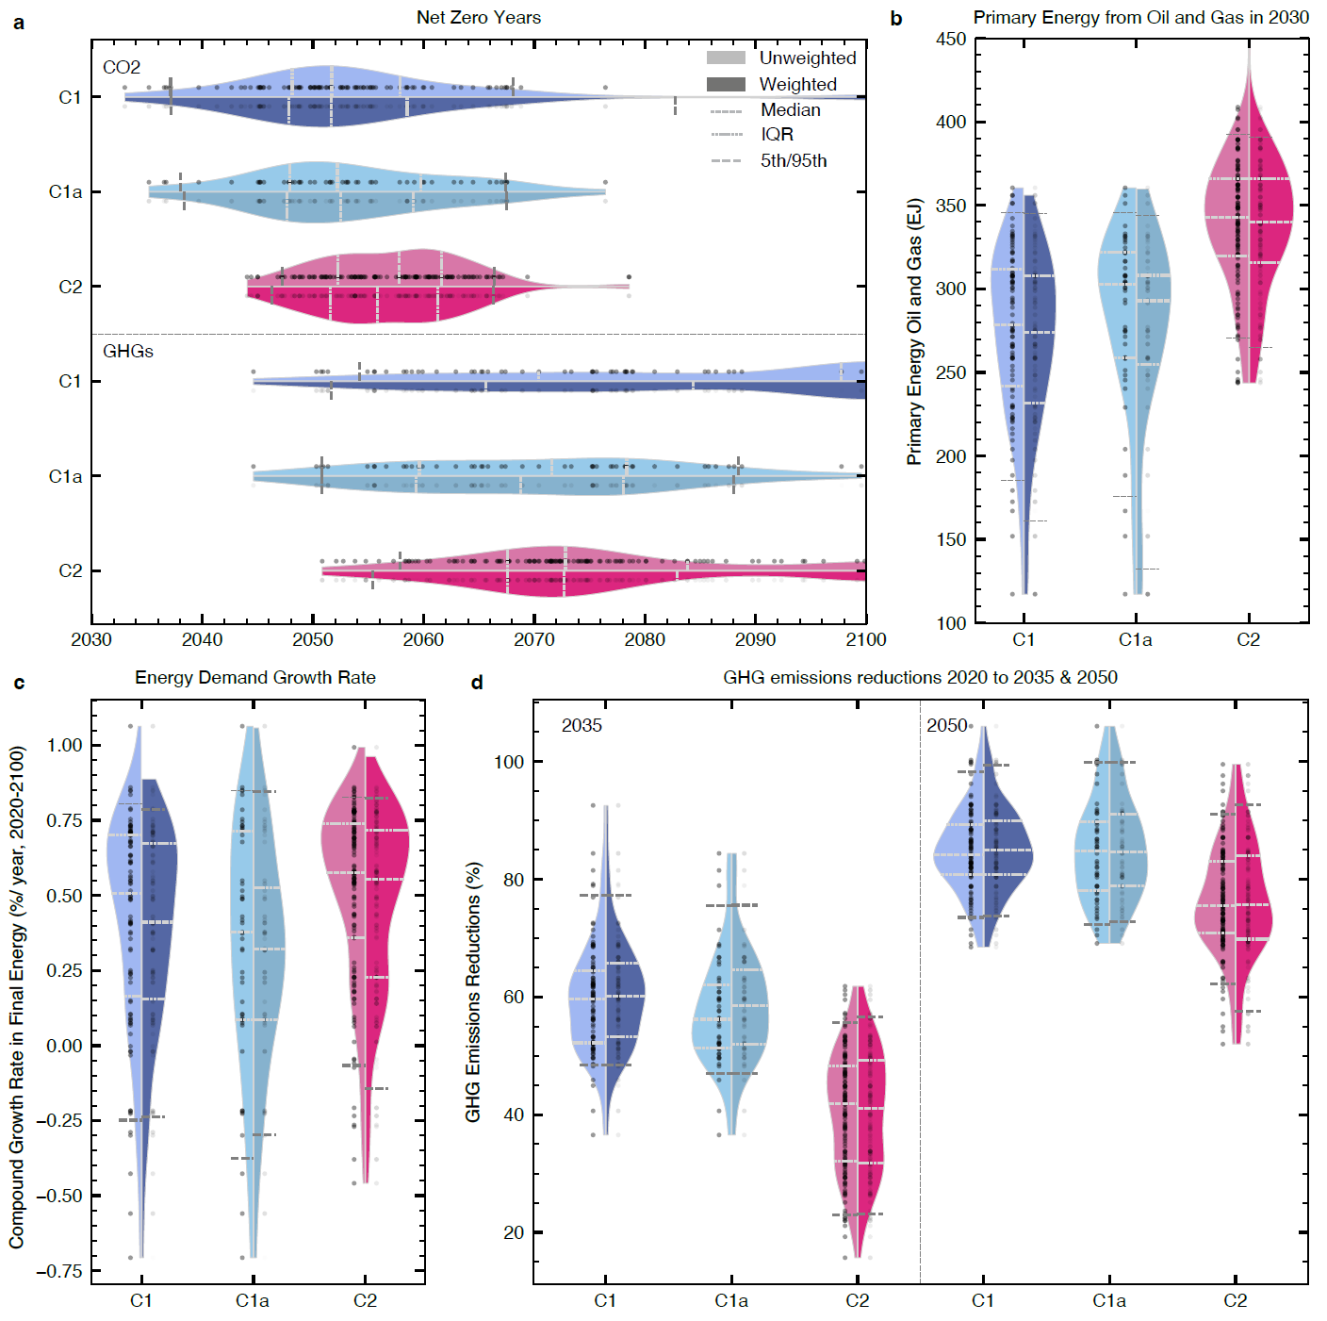
Figure 3 | Key assessment quantities in weighted and unweighted scenario category ranges from the IPCC AR6 scenario database. a. Net zero CO₂ and greenhouse gas (GHG) years; b. primary energy use of oil and gas in 2030; c. annual growth rate of final energy demand between 2020 and 2100; d. GHG emissions reductions between 2020 and the years 2035 and 2050, respectively. Data is shown for three scenario categories: scenarios limiting warming to 1.5°C with no or limited overshoot (IPCC AR6 category C1), the subset of these scenarios also reaching net zero GHG emissions in the second half of the century (IPCC AR6 category C1a), and scenarios returning warming to below 1.5°C in 2100 after a high (0.1–0.3°C) overshoot (IPCC AR6 category C2). Individual scenarios are shown as dots. Violins show unweighted and weighted distributions, respectively, which are distinguished through lighter and darker areas. Dashed and dotted lines in the plots indicate key distribution statistics as defined by the legend in panel a.

Exploring robustness
It is well-established that the behaviour of IAMs is to a large degree determined by their model framework logic and model structure^{26,27}. Equally, model intercomparison studies use harmonised scenario design assumptions which dominate key scenario insights²⁸. Understanding whether insights or diagnosed scenario characteristics are robust across model typographies, structures and scenario design assumptions is therefore important. Jack-knife resampling allows to estimate bias of a test statistic and has been applied to scenario ensembles of opportunity in the past.²⁹ It was implemented here to quantify the robustness of our insights. Such a test calculates how outcomes V_{d} vary across the ensemble of opportunity E when iteratively removing scenarios according to each instance d in resampling dimension D (e.g., removing specific modelling frameworks or intercomparison studies, or specific types of models such as recursive-dynamic and intertemporal optimisation models).
We carry out two jack-knife resampling tests to see how outcomes are affected by the reweighting of scenarios in the ensemble. In the first resampling test, we assess the sensitivity to unbalanced contributions by model frameworks, and in the second, the sensitivity to contributions by specific projects (Fig. 4, and Supplementary Tables S1 and S2). Both tests show that the shift in net-zero GHG years in C1 scenarios as a result of scenario weighting is robust. Equally, the results indicate that the median and interquartile estimates of net-zero GHG years is rather an underestimate for C2 scenarios than an overestimate (Fig. 4a). For primary energy from oil and gas in 2030, the jack-knife resampling illustrates a much larger variation when model frameworks are excluded compared to the exclusion of individual studies (Fig. 4b), highlighting the importance of each model’s fingerprint on their projected scenarios^{25,30}.
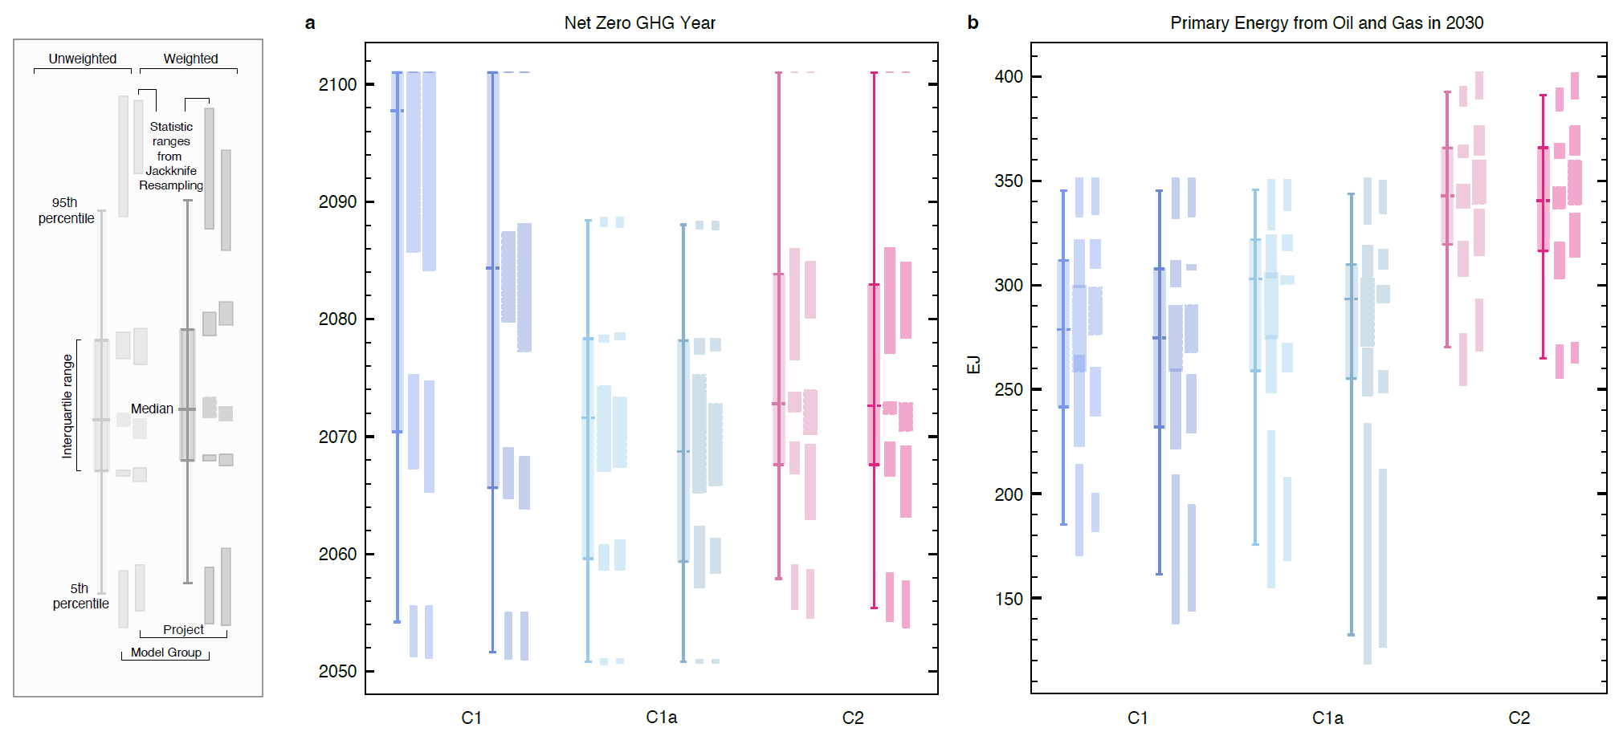
Figure 4 | Interplay between weighting of scenario ensembles and jack-knife resampling outcomes. a. Net zero CO₂ years; b. primary energy use of oil and gas in 2030. Statistics are documented in the figure legend. For each statistic of the unweighted and the weighted ensemble, the jackknife resampling illustrates the potential variation in the estimators. The jack-knife resampling based on “Model Group” iteratively excludes each respective larger modelling framework group as reported in the IPCC AR6 database. The resampling based on “Project” iteratively excludes each respective contributing project or individual study. See Supplementary Tables S1 and S2 for a list.

An improved scenario assessment
This paper presents a weighting framework as a tool to support scenario assessment but provides no silver bullet. Expert judgment remains necessary in the identification and choice of the weighting approaches, distance metrics or relevant indicators, and in the subsequent assessment of the results of weighted ensembles. The structured nature of the framework, however, helps to ensure the necessary expert judgment is well-guided and transparent. Transparency is of critical importance. Re-weighting scenario ensembles could enable parties with interests to present ensemble statistics in a way that supports their preferred narrative.

The framework could be applied to explore further dimensions. Scenario quality or relevance weighting could be used to integrate questions around sustainable development within pathway assessments, for example, with practical limits being suggested for biomass or carbon-dioxide removal as part of a the broader United Nations Sustainable Development Agenda^{5,31,32}. It could also be used to explore questions that account for present-day and future feasibility of scenario pathways across multiple dimensions^{13,33}. Finally, although not illustrated in this paper, reweighting of scenario ensembles can also be useful to improve methods that derive relationships from scenario ensembles, such as for the completion of missing species of greenhouse gas emissions³⁴.
While providing clear benefits, our weighting approach also presents potential limitations. First, the framework provides a way forward to adjust for biases in scenario evidence available in the ensemble but does not provide a tool to identify gaps in the explored solution space. A critical reflection therefore still needs to accompany its use. Second, as similar scenarios are down-weighted, a balance must be struck between accounting for repeated instances of scenarios that are fundamentally similar, whilst retaining useful information from areas in which they differ. Scenarios that push the boundaries of conventional thinking and are less similar to more traditional modelled pathways, including emerging efforts to implement circular economy and degrowth storylines or those that focus on low energy demand^{35,36} are likely to be weighted higher and contribute more to category statistics under a weighted assessment. The drawback of this is that potential novel and emerging scenario approaches might over-emphasize scenarios with technologies at the boundaries of realism. This highlights the importance of careful consideration of all three aspects of the weighting framework that jointly cover aspects of relevance, quality and diversity.
The role of experts in the assessment of the scenario literature will, therefore, remain as important as ever. We here present a first approach to account for scenario similarity and feasibility that can contribute to a larger toolbox of improved methods for scenario assessment.

Methods
Here we provide the weighting specifications for the illustrative application of the framework to the IPCC AR6 database¹⁰. Integrating expressions for all weighting components, the application-specific scenario weighting equation becomes:
$$\begin{aligned}gw_{i}=\frac{R\left(i\right).Q\left(i\right)}{D\left(i\right)}=R\left(i\right).Q\left(i\right)/\left(1+\sum_{n=1}^{N}{\sum_{i'≠i}{b_{n}exp\left(-\frac{S_{ii',n}^{2}}{σ_{S,n}^{2}}\right)}}\right)\#\left(7\right)\end{aligned}$$

Relevance Weighting
For analysis of scenarios that limit global warming to 1.5°C with no or limited overshoot (IPCC AR6 category C1), or scenarios that return warming to 1.5°C after a high overshoot (IPCC AR6 category C2), respectively, we apply binary question-specific relevance weights R(i) that select scenarios with the specific global warming characteristics as defined in IPCC AR6⁶.
$$\begin{aligned}R_{C1}\left(i\right)=\left\{\begin{aligned}1, P(dT_{21st century}>1.5°C)≤67\% &&&&&∧P(dT_{2100}<1.5°C)>50\% & \\ 0, else\end{aligned}\right.\#\left(8\right)\end{aligned}$$
And separately:
$$\begin{aligned}R_{C2}\left(i\right)=\left\{\begin{aligned}1, P(dT_{21st century}>1.5°C)>67\% &&&&&∧P(dT_{2100}<1.5°C)>50\% & \\ 0, else\end{aligned}\right.\#\left(9\right)\end{aligned}$$
C1a scenarios are a subset of C1 scenarios in which net GHG emissions reach zero levels in the second half of the century.

Quality Weighting
We apply a continuous quality weighting Q(i), adapted from the IPCC AR6 procedures and reported in Table 11 in ref. 24 (reproduced in Supplementary Table S3). For each quality criterion, j, that specified a range, we use the distance of the modelled value, k for each scenario i from the reference value, dk,i ,normalising by the interquartile range, IQR, of the scenarios
dk,i= dk,iIQR(dk)
We then use a Guassian function to produce the continuous weight, w, for each criterion, j,:
wj(i)=exp-dk,i2
This yields a weight of 1 when there is perfect agreement with the reference value. We treat each criterion evenly and combining to give a single quality weighting:

Qi= jwj(i)
In our application of the weighting procedure, our relevance weighting considers only vetted scenarios adhering to specific temperature outcomes. In practice we are therefore only applying it to scenarios that to meet other vetting criteri that do not provide an acceptable range.

Diversity Weighting
Diversity weighting D(i) accounts for variations in 15 variables across four key dimensions (emissions, economy, mitigation strategy, and energy, Methods Table 1). These 15 variables are part of the minimum data requirement for a scenario to be considered as part of the IPCC AR6 ensemble and therefore available for each scenario. The illustrative variable weights b_{n} for each variable are a subjective choice and here chosen to put equal weights on each of the four key dimensions. Sub-weighting of the variables in each group attempts to limit the overall influence of variables that are similar in nature and could bias the total, or puts weight on more important variables. For example, in the Energy category, the six Primary Energy variables combined are worth the same as the single variable of Final Energy. In the Emissions category, the aggregate weighting of all non-CO₂ emissions variables equals that of CO₂, recognising that CO₂ is the primary anthropogenic driver of climate change³⁷.
Although not applicable here, scenarios that do not report all variables can also be included by rescaling coefficients b_{n} for the variables that are available. This rescaling is first achieved within each variable group, or across all remaining groups if one variable group would end up having no reported variables. The sum of b_{n} is always unity.
Acknowledging both the subjectivity in our variable weighting, and correlations that may exist between our chosen variables, we explore alternative weighting approaches. We tested using only energy variables, as well excluding emissions variables from our selection (Supplementary Results __). To account for correlation between variables, we adjusted our variable weights using a correlation matrix and hierarchical clustering (Supplementary Methods 1).
Our conceptual choice of σ_{S,n} (radius of similarity) between two scenarios is guided by expert judgment and should be seen as an informed yet illustrative choice rather than a conclusive one. We define σ_{S,n} as the root mean square difference between different IAMs running the same SSP-RCP combination available from ref. 9 using 10-year timesteps from 2020 to 2100. This choice is made on the basis that two independent IAMs running the same scenario are structurally different yet subject to a set of common constraints (exogenously provided population and GDP projections, and year-2100 radiative forcing). We explore a range of values between the minimum and maximum of the SSP-RCP model differences, selecting a value that maximises the median spread in diversity weights across our variables (Supplementary Results 2). For no-policy, no-mitigation or “business-as-usual” scenarios, we remove the Mitigation group variables from determining the distances of σ_{S,n} as these are zero by definition in these scenarios.

Table 1 | Variable for estimation of scenario similarity or diversity. The 15 variables used from the IPCC AR6 Database¹⁰ to determine the scenario similarity. For each variable the importance weighting $b_{n}$ assigned to each is shown (equation 6) along with the radius of scenario similarity $σ_{S, n}$. The group that each variable applies to is shown, with each group having a total weight of 1/4.
Variable | $b_{n}$ expert | bncorrelation adjusted | $$σ_{S, n}$$ | Group
CO₂ Emissions | 1/8 | 1/8 | 1.42 GtCO₂ yr⁻¹ | Emissions
CH₄ Emissions | 1/24 | 0 | 11.6 MtCH₄ yr⁻¹
N₂O Emissions | 1/24 | 1/8 | 0.301 MtN₂O yr⁻¹
Sulphur Emissions | 1/24 | 0 | 5.05 MtSO₂ yr ⁻¹
Consumption | 1/8 | 1/8 | $1284 bn (2010) | Economy
GDP (PPP) | 1/8 | 1/8 | $441 bn (2010)
Carbon Capture & Storage | 1/8 | 1/8 | 198 MtCO₂ yr⁻¹ | Mitigation
Carbon Price | 1/8 | 1/8 | $6.79 (2010)
Primary Energy: Oil | 1/48 | 0 | 10.2 EJ yr⁻¹ | Energy
Primary Energy: Gas | 1/48 | 0 | 9.55 EJ yr⁻¹
Primary Energy: Coal | 1/48 | 0 | 13.5 EJ yr⁻¹
Primary Energy: Nuclear | 1/48 | 1/8 | 0.651 EJ yr⁻¹
Primary Energy: Biomass | 1/48 | 0 | 4.80 EJ yr⁻¹
Primary Energy: Non-Biomass Renewables | 1/48 | 1/8 | 2.83 EJ yr⁻¹
Final Energy | 1/8 | 0 | 10.6 EJ yr⁻¹

Acknowledgments
H.B. acknowledges funding from the Hitachi-Imperial Centre for Decarbonisation and Natural Climate Solutions. C.J.S. was supported by a NERC/IIASA collaborative research fellowship (NE/T009381/1). J.S.K. was supported by the Natural Environment Research Council under grant agreement NE/S007415/1. M.J.G. was supported by funding from the European Research Council (ERC) under the European Union’s Horizon 2020 research and innovation programme (GENIE – grant agreement No 951542). J.R. was supported by the European Union’s Horizon 2020 research and innovation programme (ESM2025 – grant agreement No 101003536 and PROVIDE – grant agreement No 101003687).

References
1. Nakicenovic, N. & Swart, R. IPCC Special Report on Emissions Scenarios. (Cambridge University Press, Cambridge, United Kingdom, 2000).
2. Morita, T. et al. Greenhouse Gas Emission Mitigation Scenarios and Implications. in Climate Change 2001: Mitigation. A Report of Working Group III of the Intergovernmental Panel on Climate Change (eds. Chadwick, M. & Parikh, J. K.) 115–166 (Cambridge University Press, Cambridge, UK, 2001).
3. Fisher, B. et al. Issues related to mitigation in the long term context. in Climate Change 2007: Mitigation. Contribution of Working Group III to the Fourth Assessment Report of the Inter-governmental Panel on Climate Change (eds. Metz, B., Davidson, O. R., Bosch, P. R., Dave, R. & Meyer, L. A.) 169–250 (Cambridge University Press, Cambridge, UK, 2007).
4. Clarke, L. et al. Assessing Transformation Pathways. in Climate Change 2014: Mitigation of Climate Change. Contribution of Working Group III to the Fifth Assessment Report of the Intergovernmental Panel on Climate Change (eds. Edenhofer, O. et al.) 413–510 (Cambridge University Press, Cambridge, United Kingdom and New York, NY, USA, 2014).
5. Rogelj, J. et al. Mitigation pathways compatible with 1.5°C in the context of sustainable development. in Global Warming of 1.5 °C: an IPCC special report on the impacts of global warming of 1.5 °C above pre-industrial levels and related global greenhouse gas emission pathways, in the context of strengthening the global response to the threat of climate change, sustainable development, and efforts to eradicate poverty (eds. Flato, G., Fuglestvedt, J., Mrabet, R. & Schaeffer, R.) 93–174 (IPCC/WMO, Geneva, Switzerland, 2018).
6. Riahi, K. et al. Mitigation pathways compatible with long-term goals. in IPCC, 2022: Climate Change 2022: Mitigation of Climate Change. Contribution of Working Group III to the Sixth Assessment Report of the Intergovernmental Panel on Climate Change (eds. Shukla, P. R. et al.) (Cambridge University Press, Cambridge, UK and New York, NY, USA, 2022). doi:10.1017/9781009157926.005.
7. Huppmann, D., Rogelj, J., Kriegler, E., Krey, V. & Riahi, K. A new scenario resource for integrated 1.5 °C research. Nat. Clim. Change 8, 1027–1030 (2018).
8. Guivarch, C. et al. Using large ensembles of climate change mitigation scenarios for robust insights. Nat. Clim. Change 12, 428–435 (2022).
9. Huppmann, D. et al. IAMC 1.5°C Scenario Explorer and Data Hosted by IIASA. (Integrated Assessment Modeling Consortium & International Institute for Applied Systems Analysis, 2018). doi:10.22022/SR15/08-2018.15429.
10. Byers, E. et al. AR6 Scenarios Database. Zenodo https://doi.org/10.5281/zenodo.5886912 (2022).
11. Nakicenovic, N., Victor, N. & Morita, T. Emissions Scenarios Database and Review of Scenarios. Mitig. Adapt. Strateg. Glob. Change 3, 95–120 (1998).
12. Rogelj, J. et al. Emission pathways consistent with a 2°C global temperature limit. Nat. Clim Change 1, 413–418 (2011).
13. Brutschin, E. et al. A multidimensional feasibility evaluation of low-carbon scenarios. Environ. Res. Lett. 16, 064069 (2021).
14. Forster, P. et al. Mitigation Pathways Compatible with 1.5°C in the Context of Sustainable Development Supplementary Material. in Global Warming of 1.5 °C: an IPCC special report on the impacts of global warming of 1.5 °C above pre-industrial levels and related global greenhouse gas emission pathways, in the context of strengthening the global response to the threat of climate change, sustainable development, and efforts to eradicate poverty (World Meteorological Organisation, Geneva, Switzerland, 2018).
15. Liu, J.-Y. et al. Socioeconomic factors and future challenges of the goal of limiting the increase in global average temperature to 1.5°C. Carbon Manag. 1–11 (2018) doi:10.1080/17583004.2018.1477374.
16. Knutti, R. et al. A climate model projection weighting scheme accounting for performance and interdependence. Geophys. Res. Lett. 44, 1909–1918 (2017).
17. Sanderson, B. M., Knutti, R. & Caldwell, P. A Representative Democracy to Reduce Interdependency in a Multimodel Ensemble. J. Clim. 28, 5171–5194 (2015).
18. Brunner, L. et al. Reduced global warming from CMIP6 projections when weighting models by performance and independence. Earth Syst. Dyn. Discuss. 1–23 (2020) doi:https://doi.org/10.5194/esd-2020-23.
19. Tokarska, K. B. et al. Past warming trend constrains future warming in CMIP6 models. Sci. Adv. 6, eaaz9549 (2020).
20. Gütschow, J., Jeffery, M. L., Schaeffer, M. & Hare, B. Extending Near-Term Emissions Scenarios to Assess Warming Implications of Paris Agreement NDCs. Earths Future 6, 1242–1259 (2018).
21. Kikstra, J. S. et al. The IPCC Sixth Assessment Report WGIII climate assessment of mitigation pathways: from emissions to global temperatures. Geosci. Model Dev. 15, 9075–9109 (2022).
22. Schleussner, C.-F., Ganti, G., Rogelj, J. & Gidden, M. J. An emission pathway classification reflecting the Paris Agreement climate objectives. Commun. Earth Environ. 3, 1–11 (2022).
23. Nicholls, Z. et al. Cross-Chapter Box 7.1: Physical emulation of Earth System Models for scenario classification and knowledge integration in AR6. in Climate Change 2021: The Physical Science Basis. Contribution of Working Group I to the Sixth Assessment Report of the Intergovernmental Panel on Climate Change (eds. Masson-Delmotte, V. et al.) (Cambridge University Press, 2021).
24. Guivarch, C. et al. IPCC, 2022: Annex III: Scenarios and modelling methods. in IPCC, 2022: Climate Change 2022: Mitigation of Climate Change. Contribution of Working Group III to the Sixth Assessment Report of the Intergovernmental Panel on Climate Change (Cambridge University Press, Cambridge, UK and New York, NY, USA, 2022).
25. Dekker, M. M. et al. Identifying energy model fingerprints in mitigation scenarios. Nat. Energy 8, 1395–1404 (2023).
26. Kriegler, E. et al. Diagnostic indicators for integrated assessment models of climate policy. Technol. Forecast. Soc. Change 90, Part A, 45–61 (2015).
27. Harmsen, M. et al. Integrated assessment model diagnostics: key indicators and model evolution. Environ. Res. Lett. 16, 054046 (2021).
28. Rogelj, J. et al. A new scenario logic for the Paris Agreement long-term temperature goal. Nature 573, 357–363 (2019).
29. Rogelj, J. et al. Zero emission targets as long-term global goals for climate protection. Environ. Res. Lett. 10, 105007 (2015).
30. Dekker, M. M. et al. Spread in climate policy scenarios unravelled. Nature 624, 309–316 (2023).
31. Roy, J. et al. Sustainable Development, Poverty Eradication and Reducing Inequalities. in Global Warming of 1.5 °C: an IPCC special report on the impacts of global warming of 1.5 °C above pre-industrial levels and related global greenhouse gas emission pathways, in the context of strengthening the global response to the threat of climate change, sustainable development, and efforts to eradicate poverty (eds. Krakovska, S., Madruga, R. P. & Sanchez, R.) (World Meteorological Organisation, Geneva, Switzerland, 2018).
32. Deprez, A. et al. Sustainability limits needed for CO2 removal. Science 383, 484–486 (2024).
33. Warszawski, L. et al. All options, not silver bullets, needed to limit global warming to 1.5 °C: a scenario appraisal. Environ. Res. Lett. 16, 064037 (2021).
34. Lamboll, R. D., Nicholls, Z. R. J., Kikstra, J. S., Meinshausen, M. & Rogelj, J. Silicone v1.0.0: an open-source Python package for inferring missing emissions data for climate change research. Geosci. Model Dev. 13, 5259–5275 (2020).
35. Grubler, A. et al. A low energy demand scenario for meeting the 1.5 °C target and sustainable development goals without negative emission technologies. Nat. Energy 3, 515–527 (2018).
36. Millward-Hopkins, J. Inequality can double the energy required to secure universal decent living. Nat. Commun. 13, 5028 (2022).
37. IPCC. Summary for Policymakers. Climate Change 2021: The Physical Science Basis. Contribution of Working Group I to the Sixth Assessment Report of the Intergovernmental Panel on Climate Change 3−32 (2021) doi:10.1017/9781009157896.001.

SUPPLEMENTARY INFORMATION

Supplementary Table S1 | Entities used for jack-knife resampling along the model group dimension. Models are identified as in the IPCC AR6 scenario database’s meta data¹⁰ and model groups as indicated in this table.
Model Group | Model
AIM | AIM/CGE 2.1
AIM | AIM/CGE 2.2
AIM | AIM/Hub-Global 2.0
C-ROADS | C-ROADS-5.005
COFFEE | COFFEE 1.1
GCAM | GCAM 4.2
GCAM | GCAM 5.3
GEM | GEM-E3_V2021
IMAGE | IMAGE 3.2
MESSAGE | MESSAGE-GLOBIOM 1.0
MESSAGE | MESSAGEix-GLOBIOM 1.0
MESSAGE | MESSAGEix-GLOBIOM_1.1
MESSAGE | MESSAGEix-GLOBIOM_1.2
POLES | POLES ADVANCE
POLES | POLES EMF33
REMIND | REMIND 1.7
REMIND | REMIND 2.1
REMIND | REMIND-MAgPIE 1.5
REMIND | REMIND-MAgPIE 1.7-3.0
REMIND | REMIND-MAgPIE 2.1-4.2
REMIND | REMIND-MAgPIE 2.1-4.3
WITCH | WITCH 5.0
WITCH | WITCH-GLOBIOM 3.1
WITCH | WITCH-GLOBIOM 4.4

Supplementary Table S2 | Entities used for jack-knife resampling along the project dimension. Projects and studies are identified as in the IPCC AR6 scenario database’s meta data¹⁰.
Project
COMMIT
CD-LINKS
ENGAGE
Fujimori 2020
Holz 2018
SSP
Ou 2021
van Vuuren 2021
ADVANCE
EMF30
EMF33
Grubler 2018
NGFS2
Kikstra 2021
Strefler 2018
Strefler 2021a
Schultes 2021
Baumstark 2021
Kriegler 2018
Bertram 2018
Strefler 2021b
Soergel 2021
Luderer 2021
Levesque 2021
Guo 2021

Supplementary Table S3 | Summary of vetting criteria applied in IPCC AR6 and in this study. Adapted from Table 11 in ref. 24.
 | Reference Value | Range (IP range)
Historical emissions (2019 values)
CO₂ total (EIP + AFOLU) Emissions | 44251 MtCO₂yr⁻¹ | ±40% (±20%)
CO₂ EIP emissions | 37646 MtCO₂yr⁻¹ | ±20% (±10%)
CH₄ emissions | 379 MtCH₄yr⁻¹ | ±20% (±20%)
CO₂ emissions EIP 2010-2020 % change | - | +0% to +50%
CCS from energy 2020 | - | 0-250 (100) MtCO₂yr⁻¹
Historical energy production (2020 values)
Primary Energy | 578 EJ | ±20% (±10%)
Electricity: nuclear | 9,77 EJ | ±30% (±20%)
Electricity: solar and wind | 8.51 EJ | ±50% (±25%)

Supplementary Results 1 | Implementation of Risk-Averse Relevance Weighting Variation
In the main text, our relevance weighting application to AR6 scenarios adopts a binary weighting based on assessed temperature category. Here we present an illustrative example of a weighting approach that maintains categorisation by temperature outcomes but places a higher weighting on ‘lower-risk’ scenarios within each. Here, our definition of risk is focused on global warming outcomes and is based only to the metric(s) used for temperature categorisation. Our risk-averse relevance weighting Ri is defined by
Ri=ICi⋅j=1nwj⋅11+expk⋅mij-mj
where ICi is a binary indicator (1 if scenario i is within the temperature category, 0 otherwise), wj is the weight of the assessment metric for categorisation, j; and mij is the scenario value of the assessment metric. This uses an S-curve, with the slope defined by k, greater downweighting occurs closer to the category threshold, and reduced upweighting further away from the median, mj.
We apply this relevance weighting approach to scenarios in the C1 and C2 temperature categories, both of which use the same temperature categorisation metrics (P33 peak warming and median warming in 2100) but differ based on their level of overshoot (Supplementary Figure 1). Under this example, we assume that a user wishes to main integrity of existing temperature categorisation; hence the explicit division between C1 and C2. When we apply a risk-averse relevance weighting, as would be expected, a more stringent CO₂ emissions trajectory is seen for both categories (Supplementary Figure 1c and f).
This is an illustrative example of how a continuous relevance weighting based on a user’s needs could be applied. This could be further adapted based on the context, for example placing more weight on a particular temperature categorisation metric.

Supplementary Figure 1 | Figures showing implementation of risk-averse relevance weighting. Panels a and b shows C1 scenarios overall relevance weighting plotted against peak warming and median peak warming respectively. Panel c shows the weighted and unweighted CO₂ emissions trajectories for C1 scenarios. Panels d, e and f mirror the preceding panels but for the C2 scenario subset.

Supplementary Results 2 | Impact of different sigma values on spread of diversity weights
The choice for what constitutes scenario similarity is crucial for how the diversity weighting approach operates in practice. Sigma values that are very small relative to ensemble variation, will see only very few scenarios fall within it, this will result in no or minimal reweighting for most scenarios. Conversely, large sigma values relative to ensemble variation will result in scenarios effectively not being reweighted as they are all treated as similar.
Sigma choice will reflect the needs of the user in their application of the weighting procedure. A user may want to implement a specific and known set of sigma values informed by a definition of scenario similarity. This could be guided by distances between certain scenarios. In this context, even if the sigmas are small in relation to ensemble variation, it could be applied as a robustness check across an ensemble. However, an alternative approach is to testing the impact of a range of sigma values with the final choice determined by the impact on the ensemble.
Here, we perform an illustrative example of the latter approach, exploring the impact of a range of sigma values on the spread of weights, by variable. To do this, we stay with our conceptual definition of scenario similarity: the RMS of SSP-RCP combinations, run by different models. We test a range of sigma values between the minimum and the maximum of the SSP-RCP combinations, at 10 percentile intervals to explore the impact on the spread of diversity weights (Supplementary Figure 2).
Supplementary Figure 2 | Impact of sigma values on spread of diversity weights by weighting variable. Swarm plots showing the interquartile range in the variable-specific diversity weights at a range of sigma values between the maximum and minimum of RMS difference of SSP-RCP combinations run by the same model. Values were taken at 10 percentile intervals and adjusted in tandem with each other. We also show fractions of the minimum, in a log-spaced grid from 0.1*min to 1*min (6 intervals). Median lines shown by grey dotted lines.
As would be expected, the IQR in the diversity weights varies by variable, with the highest median IQR at our 0.46*min set of values (Supplementary Figure 2). The median IQR declines sharply towards the 0.1*min values, however the range increases with some variables (e.g., CH_{4,} N2O) with IQR appearing to be increasing beyond our minimum sigma values. Above the 30th percentile of SSP-RCP model differences, the medians steadily decline, with all variables declining by the max values. Although the maximum median IQR 0.46*min, there is a large range in the IQR values, with some variables, e.g., Carbon Price and CCS where the respective values at this interval have minimal reweighting effect as they are too small. At a higher interval, around the 20th and 30th percentiles, although there is a lower median IQR, the data indicate that all variables are seeing some reweighting. This test of sigma values within a specified range and definition of scenario similarity allows us to stick with the conceptual choice but ensure that the values used will lead to effective reweighting.
Next, taking the diversity weights calculated for each of our variables, before combining, we can explore the impact at the variable level for each set of sigma values. This is important for understanding how sigma values influence each variable and the final reweighted outcomes in the ensemble. Looking at C1 and C2 scenarios (Supplementary Figure 3), we can see that for many variables, regardless of which sigma values used, reweighting would indicate moves likely to represent a strengthening of mitigation action (e.g., more low carbon primary energy and CCS (Supplementary Figure 3, panels j, l, m and f). However, this is not universally true, for example for primary energy from gas and coal, the lower sigma values see the median gas trajectory higher than the unweighted ensemble median.

the root mean square difference between different IAMs running the same SSP-RCP combination
Supplementary Figure 3 | Impact of sigma values on median timeseries for all C1 and C2 scenarios, applying variables weights to specific variables. Panels a-o show each of our weighting variables comparing the median of reweighted variables across a range of sigma values, with the unweighted median. Coloured lines represent the reweighted median lines, with the minimum to the maximum of the RCP-SSP model differences shown at each 10 percentile intervals and fractions of the minimum, in a log-spaced grid from 0.1*min to 1*min (6 intervals)

Supplementary Methods 1 | Calculation of Correlation Adjusted Variable Weights
Some variables in the database are correlated, meaning that a set of weights might amplify certain signals. Here we perform some simple analysis to derive a set of illustrative variable weights that reduce this effect. To adjust for correlation between our variables, we computed the correlation between our pairs of variables across all vetted scenarios at decadal intervals (2020-2100). We used the mean of the decadal correlations to provide single correlation values for all variable pairs.
Supplementary Table | Weighting variable pairs with correlations high than 0.6.
Pair | Correlation
Emissions|CH4 - Emissions|CO2 | 0.756
Emissions|CH4 - Emissions|Sulfur | 0.624
Emissions|CO2 - Final Energy: 0.663 | 0.663
Emissions|CH4 - Primary Energy|Coal | 0.776
Emissions|CO2 - Primary Energy|Coal | 0.801
Emissions|CO2 - Primary Energy|Gas: | 0.659
Emissions|CO2 - Primary Energy|Oil | 0.671
Emissions|Sulfur - Primary Energy|Coal | 0.608

The absolute correlations were converted into distance metric (Distance = 1- |correlation|) to be used in the hierarchical clustering process. We used the Scipy hierarchical clustering package to perform clustering [cite]. Clusters were formed using the average linkage method, merging clusters on the mean pairwise distance between cluster members. Looking at clusters between thresholds of 0.4 and 0.5, 0.4 provides only one cluster of more strongly correlated variables, whilst raising the threshold to 0.5 adds further variables to clusters (Supplementary Figure _ ). We adopt 0.5 for our illustrative use case as it represents greater redundancy removal to be observed in our diversity reweighting results. For each cluster with multiple variables, we select an illustrative variable for each cluster, using the one with the highest weighting in our original weighting scheme (Table _ ). The result is a set of variable weights that reduce redundancy and for variables present, adopt an even weighting across the variables
Supplementary Figure __
Supplementary Figure _ | Timeseries of variables C1 diversity reweighted

Supplementary Figure __
Supplementary Figure _ | Timeseries of variables C2 diversity reweighted

Supplementary Results 3 | Impact of diversity weighting on database characteristics and exploration of scenario weights
Here, we explore how a range of reweighting approaches impact the distribution of projects, model types and model frameworks and policy category.
Firstly, visualising how database characteristics change in unweighted and weighted ensembles, we show a some two examples of weighting procesdures for our 1.5 degrees scenarios and the database as a whole. We show sigma using the 20th percentile of RMS RCP-SSP model differences, identified as having a weighting impact across variables (see Supplementary Results 2). We combine it with our ‘expert’ variable weighting (see Table 1) (Supplementary Figure 4 panels a-c) and our correlation adjusted weighting (panels d-f) (Supplementary Methods 1). For these weighting schemes, there are modest but visible differences in the unweighted and weighted proportions of project, model type and model framework. Although not universal, it appears the reweighting procedure under these conditions results in more balanced representation of project, model type and model frameworks. For example, for all subset examples and both the expert and correlation adjusted weights, we see the REMIND model framework with a reduced share of scenarios. For project representation there is a reduction in the share of the ‘ENGAGE’ project in all but one of our examples. Under our correlation adjusted variable weights, across the whole database, the share of ENGAGE scenarios increases slightly.
Supplementary Figure 4 | How diversity reweighting impacts distribution of projects, model types and model frameworks in C1-C8, C1, and C2 scenarios. Each panel displays the unweighted and weighted proportions of each project, model type and model framework for a subset of scenarios, and for a reweighting procedure. Panels a and d show C1-8 scenarios; panels b and e show C1 scenarios; and panels c and f show C2 scenarios. The top row of panels show sigma of 20th percentile of RCP-SSP model differences, see Supplementary Results 2) with our expert variable weighting. The second row of panels show the same sigma values but with our correlation adjusted variable weighting (see Supplementary Methods 1).

