WMT River System Development

Comparison of Available Devices and Protocols

Sensor Types
This is a subset of the various sensor types that have been identified, but includes all of the viable types that do not cost more than a few tens of pounds to implement.

Note: Analogue to Digital Converters (A/Ds) are available as detailed in the Section on Sensor Interfaces below. Unless a home made A/D is employed the costs of the commercial types must be added to the prices given in the Table below.
Device - > | HC-SR04 | Probe Rods | Capacitance | Float | Pressure | Weight
Type | Level | Level | Level | Level | Level | Level
Technology | Ultrasonic Range | Conduction | Change of C | Microswitch | Air pressure | Weight of Butt
Pros | Cheap, simple, linear, existing Libraries | Cheap, simple, can use GPIO | Fairly cheap | Cheap, simple, can use GPIO | Fairly cheap, linear. | Fairly cheap, linear.
Cons | Difficult to protect from moisture/ice. | Coarse Measurement | Needs RF stimulus | Coarse Measurement | Needs pre-amp and A/D | Needs pre-amp and A/D
Price | £1.57 | Home-made. A few pounds for materials. Use in case primary sensor fails. | Home-made; cost difficult to estimate. AD7745 24-bit dual capacitance conv £11. | £5 to £25, depending on the number of floats. Use in case primary sensor fails. | ~£10 + A/D. | ~£10 + A/D.
Order of Preference | 3 | 1 | 2 | 1 | 1 | 4

Sensor Types (Continued)

Device - > | VL53L0X | Paddle | Paddle | Vane | Paddle
Type | Level | Flow | Flow | Flow | Flow
Technology | Laser Range Finder | Hall Effect | Tacho-gen | Potentiometer | Optical Shaft Encoder
Pros | Linear, existing Libraries | Linear | Linear | Simple, cheap | Linear
Cons | Difficult to protect from moisture/ice |  | Probably have to make generator. | Non-linear, pot can wear. Needs A/D
Price | £15 | ~£5 | ? | ~ £1 + A/D | ~£20
Order of Preference | 3 | 1 | 5 | 5 | 1

Devices for Sensor Interfaces and Data Processing
The original version of this document suggested the Raspberry Pi A/D 'HATs' and the Arduino, which includes A/D converters as one of its many functions. After discussion on Tuesday 16th May 2017, all of these A/D devices were rejected because they are expensive and because the Arduino has far more functions than are needed for this application. The document includes them for completeness.

It was agreed that the A/D requirements could be achieved using the MCP3008 Converter (currently ~£2 as shown after the table below.
Device - > | Raspberry Pi Zero | Raspberry Pi 3 | Arduino Uno | ADC Pi Plus | ADC Pi Plus | RaspIO Analog Zero
Microcontroller | BCM2835 | BCM2837 (Quad Core) | Atmega328 | NS | Ditto | Ditto
Operating Voltage | 5 V | 5 V | 5V | GPIO Header | Ditto | Ditto
Input Voltage (recd) | N/A | N/A | 7-9V | NS | Ditto | Ditto
Input Voltage (limits) | N/A | N/A | 6-20V | NS | Ditto | Ditto
Digital I/O Pins | 26 | 26 | 14 (6 provide PWM) | GPIO (pass through) | Ditto | Ditto
Analogue Input Pins | 0 | 0 | 6 | 8 | Ditto | Ditto
Analogue Voltage Range | N/A | N/A | 0 to 5 V (can be extended) | 0 to 5 V | Ditto | 0 to 3.3 V
Resolution (bit) | N/A | N/A | 10 | 17 | Ditto | 10 (can ext to 12)
Conversion time | N/A | N/A |  | 240 SPS | Ditto | NS
DC Current per I/O Pin | N/A | N/A | 40 ma | 2 mA | Ditto | NS
DC Current for 3.3V Pin | N/A | N/A | 50 mA | N/A | Ditto | NS
Flash Memory | N/A | N/A | 32 KB (0.5 KB bootloader) | N/A | Ditto | Ditto
SRAM | 512 MB | 1 GB | 2 KB | N/A | Ditto | Ditto
EEPROM | NS | NS | 1 KB | N/A | Ditto | Ditto
Clock Speed | 1 Gb/s | 1.2 Gb/s | 16 MHz | NS | Ditto | Ditto
Other Features | HDMI, 1 USB Port, Camera Port | HDMI, 4 USB, Port, Camera Port, Audio Jack | 2 hardware Interupts, 6 8-bit PWM O/Ps | On board Programmable Amplifier (up to 8 X) | Ditto | Small prototyping area.
Comms | 1-Wire, I2C, SPI, GPIO | 1-Wire, I2C, SPI, GPIO, Ethernet, 802.11n WiFi | UART, I2C, SPI | I2C | Ditto | SPI
Price | £4 | £30 | £11 | £15.99 | £14.99 | £10
Order of Preference | 1 as Sensor I/F | 1 as Controller | X | X | X | X
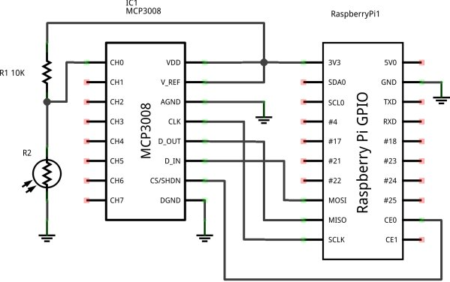

Devices for Controlling Water Movement
This table lists all of the known options for controlling the movement of water around the river system. It includes devices that are currently part of the system and other devices that might be utilised to expand the control system.

Device - > | New Sump Pump | Old Sump Pump | Solenoid Valves  (DC) | Solenoid Valves  (DC) | Solenoid Valves  (240 V AC)
Function | Move Water | Move Water | Stop Water | Divert water | Divert water
Type | Mains | Mains | 2-port | 3-port | 3-port
Technology | PWM | Mains On-Off?? | On-Off | Motorised | Motorised
Pros | Fine control possible | Free | Relatively cheap | Finer control | Finer control, Readily available
Cons |  | Bang-Bang control | Bang-Bang control | Not many around. | Mains
Price | Already bought | Free | £5 to £25 | ~£25 + | £30 to £70
Order of Preference

Notes:

1. If solenoid valves alone are used to control the movement of water, then any pumps will need to be turned off when the butts or the sump are full.

2. If a PWM pumps are used to control the movement of water, then it will be possible to reduce the flow of water to zero, when the butts or the sump are full. However, simple on-off valves will probably still be needed at key points in the system to prevent water draining backwards theough the pipes when the pump(s) are idle.

