WIMBORNE MODEL TOWN
DEVELOPMENT
RIVER SYSTEM MASTER & REMOTE PI ASSEMBLY
DESIGN AND INSTALLATION SPECIFICATION
Issue 0.2
9th May 2019



This work is licensed under the Creative Commons Attribution-NonCommercial-ShareAlike 4.0 International License. To view a copy of this license, visit http://creativecommons.org/licenses/by-nc-sa/4.0/.

Table of Contents
1 INTRODUCTION 4
1.1 General 4
1.2 Purpose of Assembly 4
2 RELATED DOCUMENTS 4
3 DESIGN 5
3.1 Electrical and Electronic 5
3.1.1 Electrostatic Sensitive Devices 5
3.1.2 Elements Comprising the Master and Remote Pis Assembly 5
3.1.3 System Circuit Diagram 6
3.1.4 System Description 8
3.1.4.1 Raspberry Pi Zero 8
3.1.4.2 DC/DC Converter 8
3.1.4.3 Custom Veroboard 8
3.1.4.4 Analogue to Digital Converter Board 9
3.1.4.5 RASClock Real Time Clock Assembly 9
3.1.4.6 Peripheral Devices 10
3.1.4.6.1 Hall Effect Probe 10
3.1.5 Reliability and Maintainability 10
3.1.5.1 Reliability 10
3.1.5.2 Maintainability 10
3.1.5.2.1 Documentation 10
3.2 Mechanical 11
4 CONSTRUCTION AND INSTALLATION 12
4.1 Hardware 12
4.1.1 Construction 12
4.1.1.1 Veroboard 12
4.1.1.2 Internal Wiring 14
4.1.1.3 Final Assembly 17
4.1.1.4 Testing 18
5 USER INSTRUCTIONS 19
5.1 Operational 19
5.1.1 Powering Up and Down 19
5.1.2 Spares and Repairs 19
6 SAFETY 19
7 ASSUMPTIONS 19
Index of Tables
Table 1: Related Documents 4

Table of Figures
Illustration 3.1: Master and Remote Pi Assembly – Circuit Diagram 7
Illustration 3.2: Low Pass Filter – Circuit Diagram 8
Illustration 3.3: Master and Remote Pi Assembly – Overall Layout 11
Illustration 4.1: Master and Remote Pi Assembly – Veroboard Layout 12
Illustration 4.2: Master and Remote Pi Assembly – Veroboard Layout- Underside 13
Illustration 4.3: Master and Remote Pi Assembly – Wiring 16

Annexes
A Hardware Identity
B Spares

INTRODUCTION

General
This document provides design, build and installation details of the Wimborne Model Town River System Master and Remote Pi Assembly. The document covers the electrical, mechanical and electronic design and the assembly and installation of the device. The software for the device forms part off the River System Software Framework and details of this may be found in the Software Design Specification.
The overall requirements for the River System may be found in various documents which have all been published on the project forum (see Reference 2.1 below) and these requirements have been interpreted in this design to realise this device.
The document provides a full description of the installed system for use by future developers and maintainers.

Purpose of Assembly
The main purpose of the assembly is to take water depth measurements from a Hall-Effect probe located in the Sump or a Water Butt and to turn on two water pumps via Solid State Relays (SSRs). A Float Switch to monitor for full Butts is also provided for. This is a common design that may be utilised throughout the River System.

RELATED DOCUMENTS
The following documents are related to this document.
Table 1: Related Documents
No | Requirement | Iss
1 | WMT – Development – River System Requirements (see https://wmtprojectsforum.altervista.org/forum/viewforum.php?f=4) | Various
2 | WMT – Development - River System Software Requirements | 0.2
3 | WMT – Development - River System Software Design | 0.7
4 | Project GitLab Repository (see https://gitlab.com/wmtprojectsteam/rivercontrolsystem) | Various

DESIGN

Electrical and Electronic

Electrostatic Sensitive Devices
CAUTION Electronic devices used in the system are sensitive to static electricity. Precautions should be taken when handling these devices in order to prevent permanent damage.
The Raspberry Pi Zero and other electronic assemblies contain devices that can be damaged if they are exposed to static electricity. Static Electricity is readily generated when people walk over dry floors, rub against furniture or simply rub against their clothing. Although rarely noticed, the level generated is sufficient to damage devices if precautions are not taken. It is therefore recommended that no work be undertaken on these devices without taking one of the following actions:
- If possible an ESD workstation be employed. An ESD workstation includes an Antistatic Mat, a conductive wrist band and a means of earthing the mat and band, usually via a three-pin mains plug with a resistive earth pin.
- It is recognised that the WMT is not conducive to setting up an ESD workstation, so maintainers should endeavour to earth themselves by touching an earthed metal object at intervals during the work, especially after it has been necessary to leave the work area and return. A good compromise would be to use a wrist band clipped to a convenient earth point.

Elements Comprising the Master and Remote Pis Assembly
The assembly consists of a the following hardware modules:
- Raspberry Pi Zero.
- DC/DC Converter.
- A/D Converter
- Custom Veroboard containing buffer devices.
- USB to Ethernet Adaptor
- RASClock Real Time Clock Assembly (SumpPi installation only)
Power for the assembly is +12 V with at least 1 A current capacity.

System Circuit Diagram
Illustration 3.1 at the end of this section shows the Circuit Diagram of the Master and Remote Pi Assembly. The following notes are relevant to this drawing:
Pi Connections:
- SDA and SCL on the Pi are also called Broadcom GPIO Pins 2 and 3 respectively and are labelled ‘Clock’ and ‘Data’.
- GPIO Pins 5 and 18 are programmed as outputs and provide for control of the two Solid State Relays (SSRs). SSR1 controls the Butts Return Pump and SSR2 controls the Main Circulation Pump.
- GPIO Pin 18 is the hardware PWM pin and will eventually be used to control the Main Circulation Pump when PWM is introduced during further development. At present, the pin controls SSR2, which in turn, controls the mains supply to the pump.
- The Ethernet Adaptor is not shown in this diagram and is connected to the Raspberry Pi (USB Data).
ADS1115 Board:
- The A/D Board is capable of being powered by voltages up to 5 V, but the value of Vdd determines the Logic Levels. The Pi cannot withstand more than 3.3 V on its GPIO pins, so that sets the limit in this application.
- A common 0 V point is located on the Veroboard at the point where the 0 V for the 12 V O/P is connected. This is necessary to maximise accuracy of measurement.
Terminations:
- Terminal Block TB1 is attached to a strip of Veroboard. Where multiple destinations are required, individual GPIO Header Pins are soldered to the same strip as the termination.
- There are insufficient colours available to uniquely identify the individual wires. To overcome this, wires routed to common points will all be the same colour (eg green for 0 V, etc). Other wires will carry rings of heat-shrink to aid identification.
All assemblies will be constructed to this design, but will perform a subset of functions, depending on the location within the River System.
Key to circuit symbols:
GPIO, A/D or Veroboard Contact
Veroboard Terminal block on veroboard
Illustration 3.1: Master and Remote Pi Assembly – Circuit Diagram
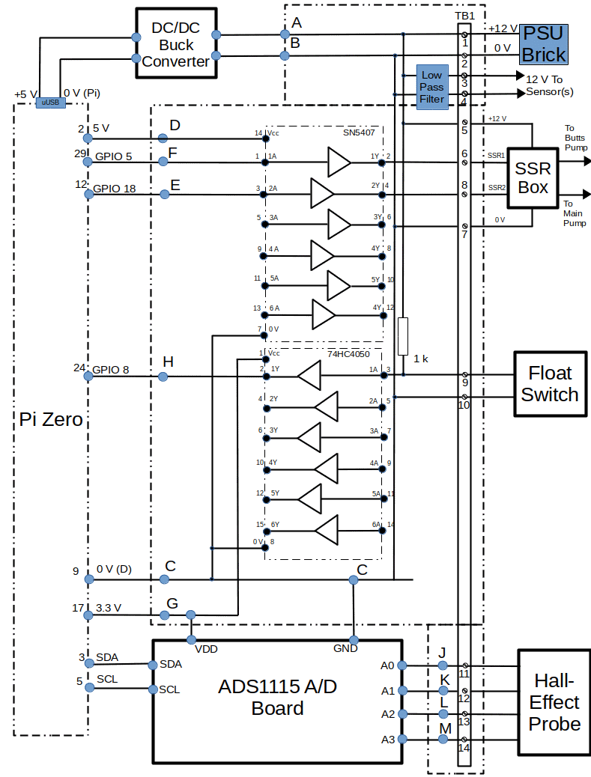

System Description

Raspberry Pi Zero
This small single board computer has a 40 pin connector that carries 26 General Purpose Input/Output (GPIO) channels, plus power and an I2C bus. Additionally the device has a single microUSB data connector, a single microUSB power connector and a microHDMI connector. A Micro SD Card slot is provided to carry the Operating System and program code.

DC/DC Converter
This is a Switching Regulator device known as a ‘buck’ converter. It uses an LM2596 integrated circuit to provide the following performance:
- Conversion efficiency: Up to 92%.
- Potentiometer output voltage adjustment.
- Switching frequency: 150KHz.
- Short circuit protection: Current limiting, self-recovery.
- Operating temperature: Industrial grade (-40 to +85 degrees Celsius) (output power 10W or less).
- Load regulation: +/- 0.5%.
- Voltage regulation: +/- 2.5%.
- Dynamic response speed: 5% 200uS.
In this application, the input voltage is provided by a +15 V PSU brick and the output voltage is adjusted to give +5 V (+0.1 /-0V) to power the Pi.

Custom Veroboard
This has two active devices. The first is a 74HC4050 Buffer Translator, which translates the Float Switch High signal (which is pulled-up to 12 V with a resistor) to 3.3 V to remain within the Pi GPIO specification. The second device is an SN5407 (or SN7407) Hex Buffer which is used to switch the Solid State Relays that control the pumps.
In addition to the active devices. a Low Pass Filter (LPF) is mounted on the Veroboard to remove noise and ripple from the power routed to the sensor(s). The design is shown in Illustration 3.2 below.
Illustration 3.2: Low Pass Filter – Circuit Diagram
Veroboard
10n F
12 V from PSU Brick
100 n F
100 uF
+
Laird 28C0236-0JW-10
1
2
3
4
12 V to Sensor

In the LPF circuit, the ceramic capacitors and inductor help to suppress high frequency spikes and the electrolytic capacitor smooths lower frequency changes on the output voltage.
The remaining function of the Veroboard Assembly is to route signals from the peripheral devices to the other electronic assemblies.

Analogue to Digital Converter Board
This module uses an ADS1115 ADC device to provide the following performance:
- Wide Supply Range: 2.0 V to 5.5 V.
- Low Current Consumption - Continuous Mode; 150 µA.
- Internal Low-Drift Voltage Reference.
- Internal Oscillator.
- Internal Programmable Gain Amplifier.
- I2C Interface: Pin-Selectable Addresses between 0x48-0x4B.
- Four Single-Ended or Two Differential Inputs.
- Programmable Comparator.

RASClock Real Time Clock Assembly
This is a highly accurate real-time clock that fits on to Pins 1 to 6 of the Raspberry Pi and uses a battery backup to retain the time. It has the following features:
- Very accurate timekeeping (typically ±3ppm or <2 minutes deviation per year).
- An Integrated crystal that compensates for temperature and age.
- A 36mA 3V CR1220 battery that will keep time for around two years if the device isn't used and considerably longer if it is.
This device is only fitted to the SumpPi. If used, it is necessary to solder additional header pins to it in order to utilise the I2C interface in the Pi for the A/D Converter, See Section 4 below.

Peripheral Devices
As already stated, this assembly monitors or controls a number of peripheral devices, depending upon its role. This section describes these devices and how the assembly interfaces to them.

Hall Effect Probe
The Hall Effect Probe utilises chains of Hall-Effect sensors to detrmine the depth of water in the Sump or in the Butts. It comprises the following components:
- There are 4 resistor chains, each connected to provide an analogue output proportional to 10 water levels, as follows:
  - Upper chain (violet wire) covering the range 75 mm to 975 mm in 100 mm steps.
  - Mid-upper chain (yellow wire)covering the range 50 mm to 950 mm in 100 mm steps.
  - Mid-lower chain (white wire) covering the range 25 mm to 925 mm in 100 mm steps.
  - Lower chain (brown wire) covering the range 0 mm to 900 mm in 100 mm steps.
- Each discrete level generates an analogue voltage which is converted to digital.
- Each measured value is compared to provide the actual level.

Reliability and Maintainability

Reliability
- All components carrying powers in excess of 1 W have been derated by at least 20 % for power supplies and 50 % for other components.
- The SD Card has been protected from corruption by being made Read-only.
- Adequate ventilation has been provided. (The system is installed in an IP65 rated equipment case which is has adequate circulation of air within it.)

Maintainability

Documentation
Full documentation will be provided by this document and by the documents referenced in Section 2.

Mechanical
The Veroboard and the other electronic modules are mounted using M2.5 pillars and screws onto a plastic baseboard specifically designed and 3D printed for the River System hardware. For the Master and Remote Pi the baseboard is printed as a flat plate.
Illustration 3.3 below shows the mechanical layout of the modules on the baseboard.
Illustration 3.3: Master and Remote Pi Assembly – Overall Layout
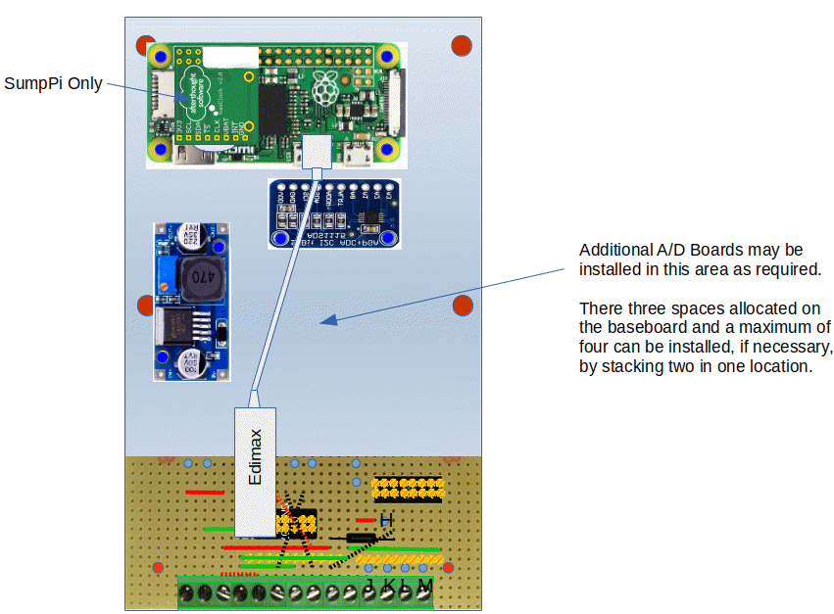
Note: The pillars 3D-Printed onto the baseboard require tapping M2.5 before assembly, unless it is intended to use self-tapping screws. Tapped holes are the preferred method, because all of the holes are blind and there is insufficient depth to accommodate the screw and the swarf, so it is likely that the screws will not go fully home. Tapping will be easier if a tapered tap is used to start the cut and a full-depth tap is used to complete it.

CONSTRUCTION AND INSTALLATION

Hardware

Construction

Veroboard
The Veroboard is assembled using lead-free solder and wire links where necessary. The Screw Terminal Blocks and Header Pins provide for interconnection with the other electronic assemblies.
Illustration 4.1 shows the Veroboard layout and Illustration shows a representation of the underside of the board, to aid track cutting and placement of wiring.
Illustration 4.1: Master and Remote Pi Assembly – Veroboard Layout
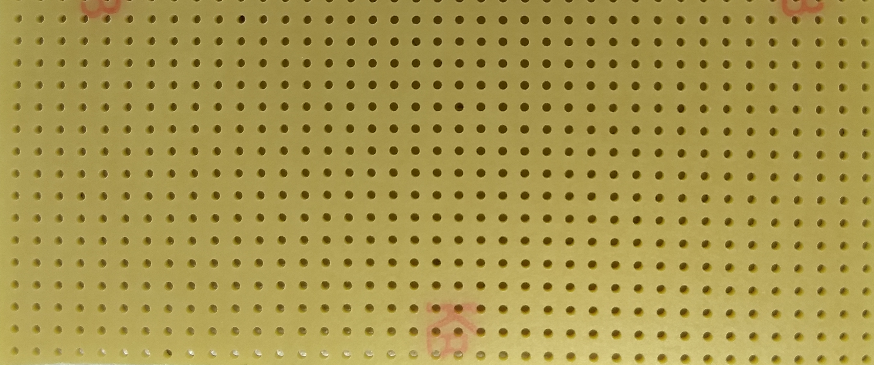
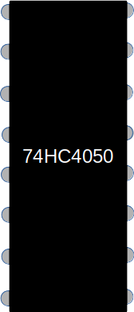
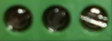
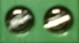
H
SN5407
J
K
M
L
+
Illustration 4.2: Master and Remote Pi Assembly – Veroboard Layout- Underside
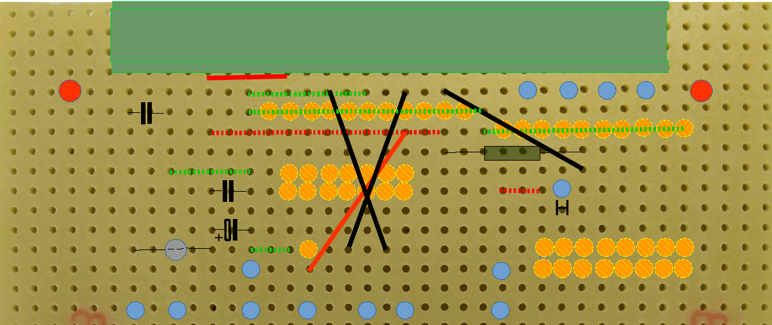
1 2 3 4 5 6 7 8 9 10 11 12 13 14
B
E
F
C
G
D
A
J
K
M
L

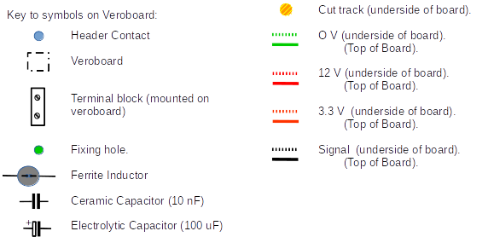

Internal Wiring
All internal links are made using jumper wires with male or female header pins. The exception to this is the link between the DC/DC Converter and the Pi (+5 V), which includes a microUSB connector on the end of it. Illustration 4.2 shows the wiring:
Notes on Terminations:
- Terminal Block TB1 is attached to a strip of Veroboard. Where multiple destinations are required, individual GPIO Header Pins are soldered to the same strip as the termination.
- There are insufficient colours available to uniquely identify the individual wires. To overcome this, wires routed to common points will all be the same colour (eg green for 0 V, etc). Other wires will carry rings to aid identification.
The terminations on TB1 are as follows:
1 | 12 V (from PSU Brick)
2 | 0 V (from PSU Brick)
3 | 12 V (to sensor(s)) (Red)
4 | 0 V (to sensor(s)) (Black)
5 | SSR +12 V
6 | SSR1 Control
7 | SSR 0 V
8 | SSR 2 Control
9 | Float Switch I/P.
10 | 0 V (to Float Switch)
11 | Hall-effect Sensor (100s) (Brown).
12 | Hall-effect Sensor (25s) (White).
13 | Hall-effect Sensor (50s) (Yellow).
14 | Hall-effect Sensor (75s) (Purple).

Header Pins are numbered as follows:
A. | 12 V (to DC/DC Converter) (Red).
B. | 0 V (to DC/DC Converter) (Black).
C. | Common 0 V point (to A/D Converter & Pi Pin 9) (Black).
D. | +5 V (from Pi Pin 1 or RASClock) (Orange with stripe)
E. | Logic I/P (from Pi pin 29) (Purple).
F. | Logic I/P (from Pi pin 12) (Grey).
G. | 3.3 V (from Pi Pin 17 and to A/D Converter) (Orange).
H. | Logic O/P (to Pi Pin 24) (White with stripe).
J. | Hall Effect Probe 100s (to A/D A0) (Brown).
K. | Hall Effect Probe 25s (to A/D A1) (White).
L. | Hall Effect Probe 50s (to A/D A2) (Yellow).
M. | Hall Effect Probe 75s (to A/D A3) (Purple).

Notes:
- During assembly, route links beneath electronic assemblies where possible.
- Bundle adjacent links together using tie-wraps or looming cord.
- Where wire colours are re-used mark the duplicate with black or white stripes as follows:
  - Wiring for SDA and SCL on the Pi are yellow with one and two black rings respectively.
  - The wire for for the Float Switch is white with one black ring.
  - The wire for for +5 V is red with one black ring.
Illustration 4.3: Master and Remote Pi Assembly – Wiring
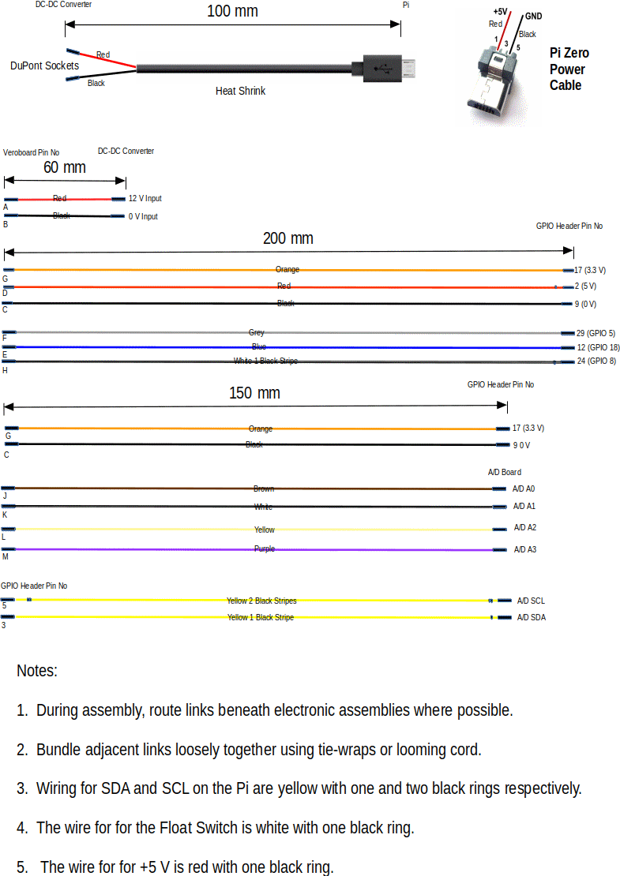

Final Assembly
The following procedure indicates the best way to assemble the system.

Prior to full assembly, the following items should be constructed and made ready:

- The Veroboard Assembly. Do not fit the ICs at this stage.
- Solder header pins to the DC/DC Converter, the A/D Converter and the Pi Zero if an unpopulated item has been procured. (It is not necessary to fully populate the GPIO pins.)
- All wires; cut to length, crimped/soldered and labelled where necessary.
- With reference to the Mechanical Layout Drawing, identify the positions of all of the components.
- Tap the mounting pillars that are to be used with M2.5 tapered and straight fluted taps.
- Perform a visual inspection of the Veroboard Assembly paying particular attention to solder splashes and shorts between tracks.
- With reference to the Circuit Diagram, check the routing of the circuit using an Ohmmeter.
Build the full assembly as follows:
- Connect all wiring to the Raspberry Pi, but leave the other ends of the wires unconnected.
- Tie-wrap the wiring close to the Pi GPIO connector and lead the wiring beneath the Pi.
- Mount the Pi with four 2.5 mm screws onto the four long pillars provided.
- Mount the Veroboard Assembly onto the two short pillars provided using two 2.5 mm screws.
- Mount the DC / DC Converter onto the two short pillars provided using two 2.5 mm screws.
- Connect all wires between the Veroboard Assembly, the Pi and the DC / DC Converter.
Note: Do not connect the red and black wires to the output of the DC / DC Converter at this stage.
- Connect all wiring to the ADC, picking up the two from the Pi, but leaving the other ends of the wires unconnected.
- Tie-wrap the wiring close to the ADC connector and lead the remaining wiring beneath the ADC.
- Mount the ADC onto the two short pillars provided using two 2.5 mm screws.
- If multiple ADCs are to be installed, repeat Steps 7 to 9 above.
- Connect all wires between the Veroboard Assembly and the ADC(s).
- Mount the completed Assembly to the backplate of the Equipment Box using four 3 mm screws. (It may be necessary to remove one screw and loosen the other on the DC / DC Converter to gain access to one of the retaining screws.
- Connect the Probes and PSU to the Electronics Assembly using the Terminal Block (see below).

Testing
The completed assembly should be tested as much as possible to eliminate any faults before it is installed into the River System. Perform the following tests:

- Apply 12 V DC to pins 1 and 2 of the Terminal Block.
- Connect a voltmeter across the output terminals of the DC-DC Converter. Adjust the output voltage to 5.1 V + 0 / - 0.1 V using the potentiometer on the DC-DC Converter.
- Remove the 12 V DC and connect the red and black wires.
- Re-apply the 12 V DC to pins 1 and 2 of the Terminal Block and check the following voltages:
  - 5.0 V + 0.1 / - 0 V on Pin 14 of the SN5407 WRT Pin 7. Adjust the potentiometer on the DC-DC Converter if necessary.
  - 3.3 V + 0.165 / - 0.165 V on Pin 1 of the 74HC4050 WRT Pin 8. (This voltage is generated by the Pi and should be OK. If it is out of limits, then there may be a fault on the Veroboard layout.)
- Remove the 12 V DC and fit the two ICs into the sockets on the Veroboard.
- Insert a fully configured SD Card (see Installation Manual).
- Connect a sample Hall Effect Probe to the relevant Pins on the Terminal Block.
- Re-apply the 12 V DC and run the test program Hall_Effect_Probe2.py in the tests directory of rivercontrolsystem.
- Move the magnet on the Hall Effect Probe to various positions, such as 100 mm, 325 mm and 750 mm. Check that the expected levels are obtained.
- Temporarily connect two 100 k pull-up resistors between TB1 Pins 5 & 6 and 5 & 8.
- Temporarily connect a link between TB1 Pins 9 & 10.
- Run the test program level_shifter.py in the tests directory of rivercontrolsystem.
- Monitor across the two resistors and check that they are switching between 0 V and 12 V as follows:
  - When Butts Pump is On – 5 & 6 = 12 V, When Butts Pump is Off – 5 & 6 = 0 V.
  - When Sump Pump is On – 5 & 8 = 12 V, When Sump Pump is Off – 5 & 8 = 0 V.
- Temporarily connect and reconnect the link between TB1 Pins 9 & 10 and check that the program responds as follows:
  - When link connected – “Float Switch Low”.
  - When Sump Pump is On – “Float Switch High”.

USER INSTRUCTIONS

Operational

Powering Up and Down
The Operator is able to:
- Start the system by switching on the supply at the mains socket.
- Stop the system by switching off the supply at the mains socket. This is achieved safely by the use of the Read-only file system (TBC).

Spares and Repairs
Spares of the major modules have been procured and these may be found in the TBD. A full list is given in Annex C.
No special tools are required to repair the system, other than standard items normally found in a general purpose tool kit.
Full backups of all software developed have been provided.

SAFETY
With the exception of the power supply inputs, all circuits operate at less than 20 V. The mains inputs to the PSUs are inaccessible to the public.

ASSUMPTIONS
The following assumptions are made.
- Future system developers will have a working knowledge of Linux and Python programming.
- System maintainers will be sufficiently skilled in general maintenance, electronics, electrical systems and software, as appropriate to be able to follow the diagnostic instructions provided in the User Manual.
Annex A
Hardware Identity
This Annex defines the hardware required for system implementation. Many of these items are free delivery and some attract a delivery charge of a few pounds. Assume £10-15 total delivery. A list of spares may be found in Annex C. These were procured at the same time as the Development items, so attracted no additional delivery costs.
Computing Devices
Item | Identity | Qty | Cost Each | Total Cost
Computer | Raspberry Pi Zero(Raspberry Pi Foundation). | 1 | £5 | £5

Interfaces and Accessories

Item | Identity | Qty | Cost Each | Total Cost
DC/DC Converter | LM2596 Buck Converter (available on eBay, and from Banggood or Gearbest at the price shown). | 1 | ~£2 | ~£2
RASClock | Real Time Clock assembly (available from ModMyPi at the price shown). (Only needed for SumpPi.) | 1 | ~£9 | ~£9
A/D Converter | ADS1115 ADC Assembly (available on eBay, and from Banggood or Gearbest at the price shown) | 1 | ~£3 | ~£3
Veroboard Assy | Includes one 74HC4050 Buffer/Translators and one SN5407 plus sundry resistors, connectors etc. | 1 | ~£15 | ~£15

Power Supplies

Item | Identity | Qty | Cost Each | Total Cost
PSU | Any +12 V, PSU of at least 1 A current availability (available online at approx prices shown). | 1 | ~£15 | ~£15

Miscellaneous

Item | Identity | Qty | Cost Each | Total Cost
74HC4050 | Hex Buffer / Translator (see Note below). | 1 | ~30p | ~30p
SN7407 | Hex Buffer (available from RS Components, Farnell or eBay). | 1 | ~£1 | ~£1
Jumper Wires | Manufactured using DuPont connectors in various colours. | A/R | ~£1 | ~£1
Terminal Block | PCB Mount Screw Terminal Connector (available on eBay, and from Banggood or Gearbest at the price shown) | 8 x 2 ways | ~12p | ~£1
Inductor | Laird 28C0236-0JW-10 | 1 | ~70p | ~70p
Capacitor | Electrolytic 100 uF, 25 V. | 1 | ~40p | ~40p
Capacitor | Ceramic 10 nF, 250 V RMS | 2 | ~40p | ~£1

Note: The 74HC4050 Buffer / Translator in DIL Socket configuration is no longer manufactured, although they are available from Farnell or eBay while stocks last. A batch of these has been purchased to cover the requirements of the project, but if additional devices are required it may necessary to find an alternative device.

Annex B
Spares
This Annex defines the spares required for system maintenance.
Item | Identity | Qty | Cost Each | Total Cost
Computer | Raspberry Pi Zero(Raspberry Pi Foundation). | 1 | £5 | £5
DC/DC Converter | LM2596 Buck Converter (available on eBay, and from Banggood or Gearbest at the price shown). | 1 | ~£2 | ~£2
A/D Converter | ADS1115 ADC Assembly (available on eBay, and from Banggood or Gearbest at the price shown) | 1 | ~£3 | ~£3
RASClock | Real Time Clock assembly (available from ModMyPi at the price shown). (Only needed for SumpPi.) | 1 | ~£9 | ~£9

