WIMBORNE MODEL TOWN
DEVELOPMENT
RIVER SYSTEM SENSOR AND CONTROL ASSEMBLY
DESIGN SPECIFICATION AND ASSEMBLY INSTRUCTIONS
Issue 0.7
29th May 2020



This work is licensed under the Creative Commons Attribution-NonCommercial-ShareAlike 4.0 International License. To view a copy of this license, visit http://creativecommons.org/licenses/by-nc-sa/4.0/.

Table of Contents
1 INTRODUCTION 4
1.1 General 4
1.2 Purpose of Assembly 4
2 RELATED DOCUMENTS 4
3 DESIGN 5
3.1 Electrical and Electronic 5
3.1.1 Electrostatic Sensitive Devices 5
3.1.2 Elements Comprising the Sensor and Controls Assembly 5
3.1.3 System Circuit Diagram 6
3.1.3.1 Standard Configuration 6
3.1.3.1.1 Pi Connections: 6
3.1.3.1.2 ADS1115 Board: 7
3.1.3.2 Lady Hanham Configuration 7
3.1.3.3 Symbols: 7
3.1.4 System Description 12
3.1.4.1 Raspberry Pi Zero 12
3.1.4.2 DC/DC Converter 12
3.1.4.3 Custom Veroboard (Standard SAC) 12
3.1.4.4 Mezzanine Veroboard (Lady Hanham SAC) 13
3.1.4.5 Analogue to Digital Converter Board 14
3.1.4.6 RASClock Real Time Clock Assembly 14
3.1.4.7 Peripheral Devices 14
3.1.4.7.1 Hall Effect Probe 14
3.1.4.8 Float Switches 14
3.1.5 Reliability and Maintainability 15
3.1.5.1 Reliability 15
3.1.5.2 Maintainability 15
3.1.5.2.1 Documentation 15
3.2 Mechanical 16
4 CONSTRUCTION 17
4.1 Hardware 17
4.1.1 Custom Veroboard 17
4.1.1.1 Veroboard Terminations - General 20
4.1.1.2 Veroboard Terminations - Main Board 20
4.1.1.3 Veroboard Terminations – Mezzanine Board 22
4.1.2 Internal Wiring 24
4.1.2.1 SAC Wiring - Standard Configuration 25
4.1.2.2 SAC Wiring – Lady Hanham Configuration 26
4.1.3 Final Assembly 28
4.1.4 Testing 30
5 USER INSTRUCTIONS 32
5.1 Operational 32
5.1.1 Powering Up and Down 32
5.1.2 Spares and Repairs 32
6 SAFETY 32
7 ASSUMPTIONS 32

Index of Tables
Table 1: Related Documents 4
Table 2: Main Board Screw Terminations 20
Table 3: Main Board Solder Terminations 21
Table 4: Mezzanine Board Screw Terminations 22
Table 5: Mezzanine Board Solder Terminations 23

Table of Figures
Illustration 3.1: Sensor and Control Assembly (Stand-alone Version) – Circuit Diagram 9
Illustration 3.2: SAC Assembly (Lady Hanham Version) – Circuit Diagram Sheet 1 10
Illustration 3.3: SAC Assembly (Lady Hanham Version) – Circuit Diagram Sheet 2 11
Illustration 3.4: Low Pass Filter – Circuit Diagram 13
Illustration 3.5: Sensor and Control Assembly – Overall Layout 16
Illustration 4.1: Custom Veroboard Upper Side (Standard SAC) – Layout 18
Illustration 4.2: Custom Veroboard Underside (Standard SAC) – Layout 18
Illustration 4.3: Custom Veroboard Upper Side (Lady Hanham Mezzanine) – Layout 19
Illustration 4.4: Custom Veroboard Upper Side (Lady Hanham Mezzanine) – Layout 19
Illustration 4.5: Standard SAC Assembly – Wiring 25
Illustration 4.6: Lady Hanham SAC Assembly – Wiring Sheet 1 26

Annexes
A Hardware Identity
B Spares

INTRODUCTION

General
This document provides design and construction details of the Wimborne Model Town River System Sensor and Control Assembly (SAC). The document covers the electrical, mechanical and electronic design and the assembly of the device. The software for the device forms part of the River System Software Framework and details of this may be found in the Software Design Specification.
The overall requirements for the River System may be found in various documents which have all been published on the project fileserver (see Reference 2.1 below) and these requirements have been interpreted in this design to realise this device.
The project forum provides a useful history of the development of the project and the reasons for the decisions made (see Reference 2.2 below).
The document provides a full description of the installed system for use by future developers and maintainers.

Purpose of Assembly
The main purpose of the assembly is to take water depth measurements from a Hall-Effect probe located in the Sump or a Water Butt and to turn on two water pumps via Solid State Relays (SSRs). A Float Switch to monitor for full Butts is also provided for. This is a common design that may be utilised throughout the River System.

RELATED DOCUMENTS
The following documents are related to this document.
Table 1: Related Documents
No | Requirement | Iss
1 | WMT – Development – River System Requirements (see https://wmtprojectsforum.altervista.org/files/?dir=WMT%20River%20System%20Files/Requirements) | Various
2 | WMT – Development – River System Forum (see https://wmtprojectsforum.altervista.org/forum/viewforum.php?f=3) | N/A
4 | Project GitLab Repository (see https://gitlab.com/wmtprojectsteam/rivercontrolsystem) | Various

DESIGN

Electrical and Electronic

Electrostatic Sensitive Devices
CAUTION Electronic devices used in the system are sensitive to static electricity. Precautions should be taken when handling these devices in order to prevent permanent damage.
The Raspberry Pi Zero and other electronic assemblies contain devices that can be damaged if they are exposed to static electricity. Static Electricity is readily generated when people walk over dry floors, rub against furniture or simply rub against their clothing. Although rarely noticed, the level generated is sufficient to damage devices if precautions are not taken. It is therefore recommended that no work be undertaken on these devices without taking one of the following actions:
- If possible an ESD workstation be employed. An ESD workstation includes an Antistatic Mat, a conductive wrist band and a means of earthing the mat and band, usually via a three-pin mains plug with a resistive earth pin.
- It is recognised that the WMT is not conducive to setting up an ESD workstation, so maintainers should endeavour to earth themselves by touching an earthed metal object at intervals during the work, especially after it has been necessary to leave the work area and return. A good compromise would be to use a wrist band clipped to a convenient earth point.

Elements Comprising the Sensor and Controls Assembly
The assembly consists of a the following hardware modules:
- Raspberry Pi Zero.
- DC/DC Converter.
- A/D Converter (3-off for Lady Hanham Butts Configuration).
- Custom Veroboard containing buffer devices (2-off for Lady Hanham Butts installation).
- USB to Ethernet Adaptor
- RASClock Real Time Clock Assembly (SumpPi installation only)
Power for the assembly is +12 V with at least 1 A current capacity (1.5 A for the Lady Hanham Configuration).

System Circuit Diagram
There are two configuration of the SAC; the Standard Configuration and the Lady Hanham Configuration.

Standard Configuration
Illustration 3.1 at the end of this section shows the Circuit Diagram of the Sensor and Control Assembly (SAC) for all installations except the Lady Hanham Butts. The following notes are relevant to both these drawings:

Pi Connections:
- SDA and SCL on the Pi are also called Broadcom GPIO Pins 2 and 3 respectively and are labelled ‘Clock’ and ‘Data’.
- In the Standard Configuration, GPIO Pins 5 and 18 are programmed as outputs and provide for control of external devices as follows:
  - At the Sump installation, these pins control two Solid State Relays. SSR1 (GPIO 5) controls the Butts Return Pump and SSR2 controls the Main Circulation Pump. GPIO Pin 18 is the hardware PWM pin and will eventually be used to control the Main Circulation Pump when PWM is introduced during further development. At present, the pin controls SSR2, which in turn, controls the mains supply to the pump.
  - In the Lady Hanham installation, GPIO 5 drives a Metal Oxide Silicon Field Effect Transistor (MOSFET) which energises a Mains Water Solenoid to allow automatic topping up of the system from the mains supply.
  - Other uses of these pins at the Gazebo Butts for example are currently TBD.
- GPIO Pins 6, 7, 8, 13, 19 and 26 are programmed as inputs and provide for the monitoring of Composite Float Switches:
  - At locations where there is only one device, ie, the Wendy, Stage or Gazebo Butts. GPIO Pin 7 is connected to the ‘Butts Empty’ switch and GPIO Pin 8 is connected to the the ‘Butts Full’ switch.
  - At the Lady Hanham Butts, GPIO Pins 7 and 8 monitor levels in Butt G1, Pins 6 and 13 monitor levels in Butts G2 and Pins 19 and 26 levels in Butts G3. In each case, the former Pin is connected to the the ‘Butts Empty’ switch and the latter Pin is connected to the the ‘Butts Full’ switch.
- The Ethernet Adaptor is not shown in this diagram and is connected to the Raspberry Pi (USB Data) via a microUSB to USB Type A Adaptor.

ADS1115 Board:
- The A/D Board is capable of being powered by voltages up to 5 V, but the value of Vdd determines the Logic Levels. The Pi cannot withstand more than 3.3 V on its GPIO pins, so that sets the limit in this application.
- A common 0 V point is located on the Veroboard at the point where the 0 V for the 12 V O/P is connected. This is necessary to maximise accuracy of measurement.

Lady Hanham Configuration
Illustration 3.2 at the end of this section shows the Circuit Diagram of the Sensor and Control Assembly (SAC) for the Lady Hanham Butts. There are two main differences between the two installations; both have a single Pi, a DC/DC Converter, a Custom Veroboard and one or three A/D Converters, as described above. The main differences are:
- The Lady Hanham Butts uses three A/D Boards instead of one; these are addressed by the level on Pin ‘ADDR’.
- A Mezzanine Veroboard caters for the connections to additional sensors.

Symbols:
The following symbols apply to both types of SAC Configuration.
- Terminal Block TB1 is attached to the main Custom Veroboard and is used in both Configurations. Where multiple destinations are required, individual Vero Pins are soldered to the same strip as the termination.
- Terminal Block TB2 is attached to the mezzanine Custom Veroboard and is used only in the Lady Hanham Configuration.
- There are insufficient colours available to uniquely identify the individual wires. To overcome this, wires routed to common points will all be the same colour (eg green for 0 V, etc). Other wires will carry rings of heat-shrink to aid identification.
All assemblies will be constructed to this design, but will perform a superset or subset of functions, depending on the location within the River System. For example:
- The Sump site has no High/Low Float Switch and has a single Hall Effect Probe Level Sensor.
- The Wendy and Stage Butts site each have a single High/Low Float Switch and a single Hall Effect Probe Level Sensor.
- The Lady Hanham site has three High/Low Float Switches and three Hall Effect Probe Level Sensors (one of each for each Butts Group).
Key to symbols on circuit diagrams, layouts and wiring diagrams:

DuPont Header Pin (used on GPIO, A/D Board and some of the Motor Drive Board contacts.)

Veropin (used on Veroboard)

Veropin only used for Lady Hanham Installation.

Ferrite Bead

Veroboard

Terminal block (mounted on veroboard)

Wire with stripped and tinned end

10 nF Ceramic Capacitor

100 uF Electrolytic Capacitor

+
Illustration 3.1: Sensor and Control Assembly (Stand-alone Version) – Circuit Diagram
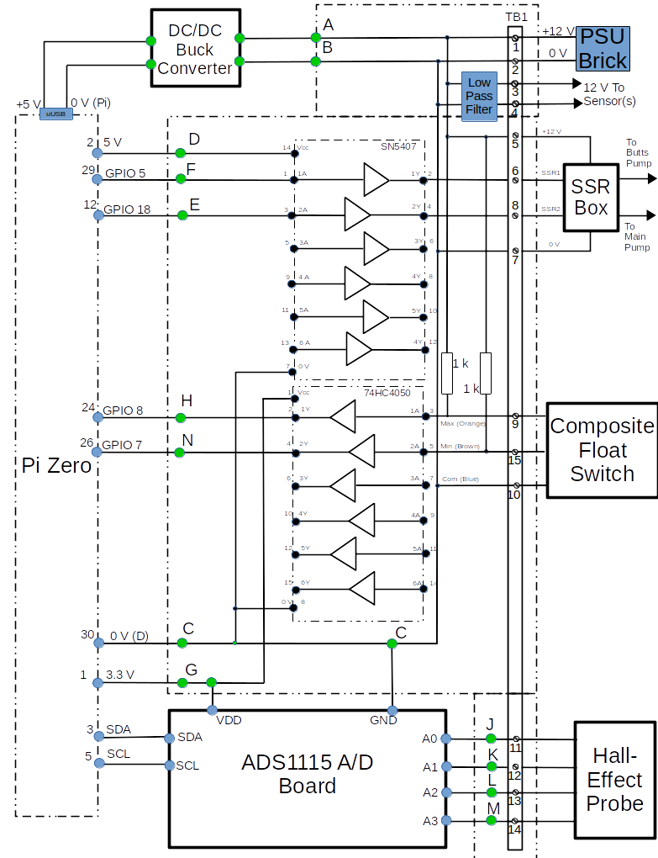
Illustration 3.2: SAC Assembly (Lady Hanham Version) – Circuit Diagram Sheet 1
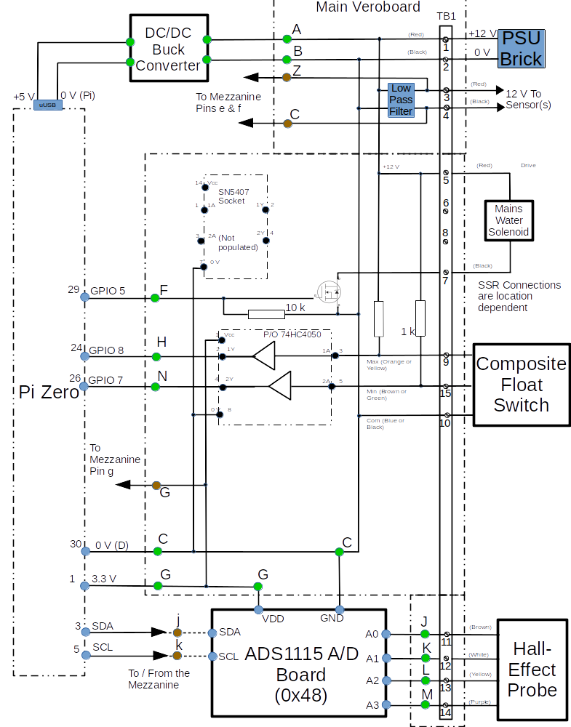

Illustration 3.3: SAC Assembly (Lady Hanham Version) – Circuit Diagram Sheet 2
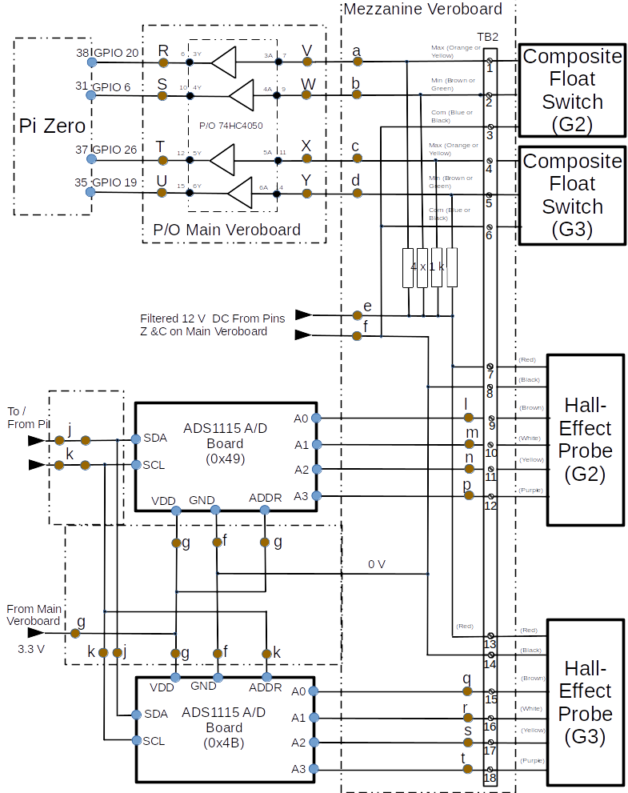

System Description

Raspberry Pi Zero
This small single board computer has a 40 pin connector that carries 26 General Purpose Input/Output (GPIO) channels, plus power and an I2C bus. Additionally the device has a single microUSB data connector, a single microUSB power connector and a microHDMI connector. A Micro SD Card slot is provided to carry the Operating System and program code.

DC/DC Converter
This is a Switching Regulator device known as a ‘buck’ converter. It uses an LM2596 integrated circuit to provide the following performance:
- Conversion efficiency: Up to 92%.
- Potentiometer output voltage adjustment.
- Switching frequency: 150KHz.
- Short circuit protection: Current limiting, self-recovery.
- Operating temperature: Industrial grade (-40 to +85 degrees Celsius) (output power 10W or less).
- Load regulation: +/- 0.5%.
- Voltage regulation: +/- 2.5%.
- Dynamic response speed: 5% 200uS.
In this application, the input voltage is provided by a +15 V PSU brick and the output voltage is adjusted to give +5 V (+0.1 /-0V) to power the Pi.

Custom Veroboard (Standard SAC)
The main function of this board is to route the signals to and from the sensors installed at each site. The board has two active devices. The first is a 74HC4050 Buffer Translator, which translates the Composite Float Switch High signals (which are pulled-up to 12 V with a resistor) to 3.3 V to remain within the Pi GPIO specification. The second device is an SN5407 (or SN7407) Hex Buffer which is used to switch the Solid State Relays that control the pumps.
In addition to the active devices. a Low Pass Filter (LPF) is mounted on the Veroboard to remove noise and ripple from the power routed to the sensor(s). The design is shown in Illustration 3.2 below.
In the LPF circuit, the ceramic capacitors and inductor help to suppress high frequency spikes and the electrolytic capacitor smooths lower frequency changes on the output voltage.
The remaining function of the Veroboard Assembly is to route signals from the peripheral devices to the other electronic assemblies, such as Hall Effect Sensors and Float Switches.
Illustration 3.4: Low Pass Filter – Circuit Diagram
Veroboard
10n F
12 V from PSU Brick
100 n F
100 uF
+
Laird 28C0236-0JW-10
1
2
3
4
12 V to Sensor

Mezzanine Veroboard (Lady Hanham SAC)
This has no active devices and is installed as a daughter board on the main Custom Verioboard. The main function of this board is to route the signals to and from the additional sensors installed at the Lady Hanham Butts. Functions provided are as follows:
- 3.3 V DC power is routed from the Custom Veroboard using jumper wires soldered to Veropins on both boards. From there it is routed to the Hall Effects Sensors in G2 and G3 Butts and to their associated A/D Boards.
- The I2C signals for all three A/D Boards are routed to the Mezzanine Veroboard where SCA and SCL are bussed together. The A/D Boards for G2 and G3 are addressed by connecting the ADDR line to VDD or SCL as follows:
  - Butts Group G1 – No connection (the default in the Python Library Module is 0x48).
  - Butts Group G2 – ADDR connected to VDD (address 0x49).
  - Butts Group G3 – ADDR connected to SCL (address 0x4B).
- The four analogue inputs from the G1, G2 and G3 Hall Effect Sensors are routed via TB2 to the associated A/D Boards.
- The two logic signals from the G1, G2 and G3 Composite Float Switches are routed to their respective GPIO Pins.

Analogue to Digital Converter Board
This module uses an ADS1115 ADC device to provide the following performance:
- Wide Supply Range: 2.0 V to 5.5 V.
- Low Current Consumption - Continuous Mode; 150 µA.
- Internal Low-Drift Voltage Reference.
- Internal Oscillator.
- Internal Programmable Gain Amplifier.
- I2C Interface: Pin-Selectable Addresses between 0x48-0x4B.
- Four Single-Ended or Two Differential Inputs.
- Programmable Comparator.

RASClock Real Time Clock Assembly
This is a highly accurate real-time clock that fits on to Pins 1 to 6 of the Raspberry Pi and uses a battery backup to retain the time. It has the following features:
- Very accurate timekeeping (typically ±3ppm or <2 minutes deviation per year).
- An Integrated crystal that compensates for temperature and age.
- A 36mA 3V CR1220 battery that will keep time for around two years if the device isn't used and considerably longer if it is.
This device is only fitted to the SumpPi. If used, it is necessary to solder additional header pins to it in order to utilise the I2C interface in the Pi for the A/D Converter, See Section 4 below.

Peripheral Devices
As already stated, this assembly monitors or controls a number of peripheral devices, depending upon its role. This section describes these devices and how the assembly interfaces to them.

Hall Effect Probe
The Hall Effect Probe utilises chains of Hall-Effect sensors to determine the depth of water in the Sump or in the Butts. It comprises the following components:
- There are 4 resistor chains, each connected to provide an analogue output proportional to 10 water levels, as follows:
  - Upper chain (violet wire) covering the range 75 mm to 975 mm in 100 mm steps.
  - Mid-upper chain (yellow wire)covering the range 50 mm to 950 mm in 100 mm steps.
  - Mid-lower chain (white wire) covering the range 25 mm to 925 mm in 100 mm steps.
  - Lower chain (brown wire) covering the range 0 mm to 900 mm in 100 mm steps.
- Each discrete level generates an analogue voltage which is converted to digital.
- Each measured value is compared to provide the actual level.

Float Switches
The Float Switch has two contacts which are arranged to be normally open. The inputs are therefore pulled up to provide a high at the GPIO pin unless the contact closes.

Reliability and Maintainability

Reliability
- All components carrying powers in excess of 1 W have been derated by at least 20 % for power supplies and 50 % for other components.
- The SD Card has been protected from corruption by being made Read-only.
- Adequate ventilation has been provided. (The system is installed in an IP65 rated equipment case which is has adequate circulation of air within it.)

Maintainability

Documentation
Full documentation will be provided by this document and by the documents referenced in Section 2.

Mechanical
The Veroboard and the other electronic modules are mounted using M2.5 pillars and screws onto a plastic baseboard specifically designed and 3D printed for the River System hardware. For the Sensor and Control the baseboard is printed as a flat plate.
Illustration 3.3 below shows the mechanical layout of the modules on the baseboard.
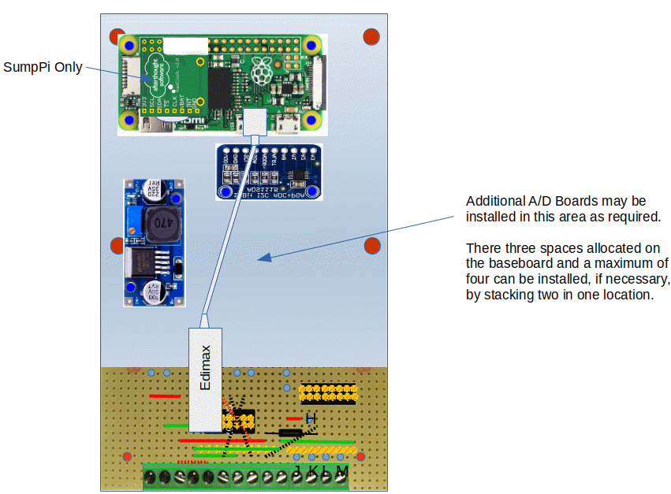
Illustration 3.5: Sensor and Control Assembly – Overall Layout

Notes:
1. The pillars 3D-Printed onto the baseboard require tapping M2.5 before assembly, unless it is intended to use self-tapping screws. Tapped holes are the preferred method, because all of the holes are blind and there is insufficient depth to accommodate the screw and the swarf, so it is likely that the screws will not go fully home. Tapping will be easier if a tapered tap is used to start the cut and a full-depth tap is used to complete it.
2. For the Lady Hanham Butts, the SAC will have three A/D Boards and an additional ‘Mezzanine’ Veroboard mounted on pillars above the main Veroboard shown. See Illustrations 3.1 to 3.3 and 4.1 to 4.4 above and below.

CONSTRUCTION

Hardware

Custom Veroboard
The Veroboard is assembled using lead-free solder and wire links where necessary. The Screw Terminal Blocks and Header Pins provide for interconnection with the other electronic assemblies.
Illustrations 4.1 and 4.2 show the Custom Veroboard layout for the Standard SAC. For clarity the underside of the board is shown, to aid track cutting and placement of wiring.
Illustrations 4.3 and 4.4 show the upper sides of the Mezzanine Veroboard and the main Veroboard for the Lady Hanham site respectively.
Note that in when creating these circuits the following information will aid the placement of holes:
Cut Links as follows:
(Strip and tin 5 mm at each end.)

Illustration 4.1: Custom Veroboard Upper Side (Standard SAC) – Layout
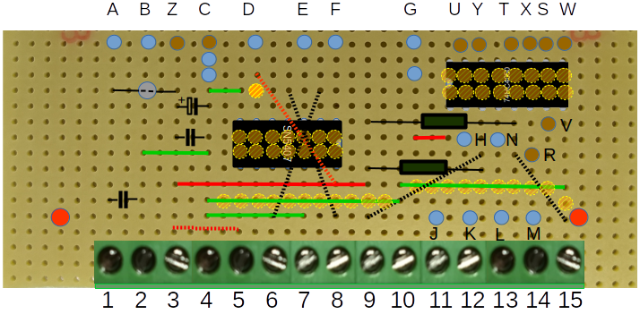
Illustration 4.2: Custom Veroboard Underside (Standard SAC) – Layout
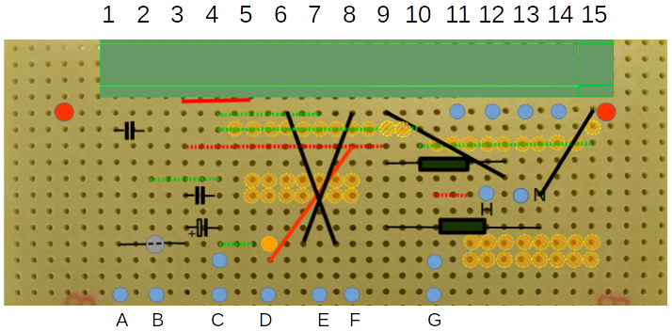
Note: Tracks that are carrying 12 V should use two adjacent strips; eg +12 V (Pin 1 to A and Pin 3 to Z) and 0 V (Pin 2 to B and Pin 4 to C).
Illustration 4.3: Custom Veroboard Upper Side (Lady Hanham Mezzanine) – Layout

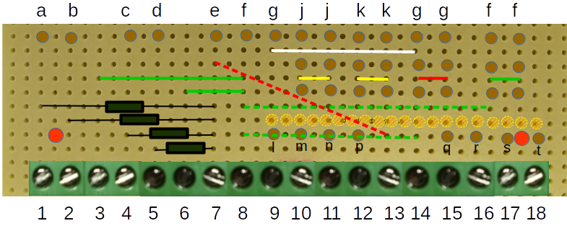
Illustration 4.4: Custom Veroboard Upper Side (Lady Hanham Mezzanine) – Layout
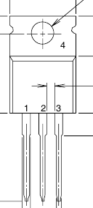
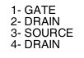
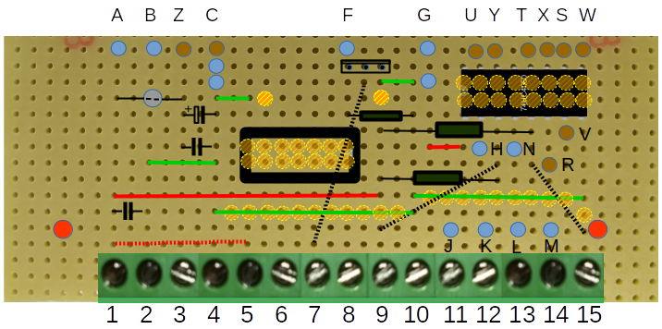
1 2 3
4
1 2 3
4

Veroboard Terminations - General
- Terminal Blocks TB1 and TB2 are attached to strips of Veroboard. Where multiple destinations are required, individual GPIO Header Pins or Vero Pins are soldered to the same strip as the termination.
- There are insufficient colours available to uniquely identify the individual wires. To overcome this, wires routed to common points will all be the same colour (eg green for 0 V, etc). Other wires will carry rings to aid identification.

Veroboard Terminations - Main Board
The terminations on TB1 are as detailed in Table 2 below:
Table 2: Main Board Screw Terminations
1 | 12 V (from PSU Brick)
2 | 0 V (from PSU Brick)
3 | 12 V (to sensor(s)) (Red)
4 | 0 V (to sensor(s)) (Black)
5 | SSR +12 V (Water Solenoid for Lady Hanham Configuration)
6 | SSR1 Control
7 | SSR 0 V (Water Solenoid for Lady Hanham Configuration)
8 | SSR 2 Control
9 | Composite Float Switch I/P (Low Level)
10 | 0 V (to Composite Float Switch)
11 | Hall-effect Sensor (100s) (Brown).
12 | Hall-effect Sensor (25s) (White).
13 | Hall-effect Sensor (50s) (Yellow).
14 | Hall-effect Sensor (75s) (Purple).
15 | Composite Float Switch I/P (High Level)

Header Pins are numbered as detailed in Table 3 below:
Table 3: Main Board Solder Terminations
A. | 12 V (to DC/DC Converter) (Red).
B. | 0 V (to DC/DC Converter) (Black).
C. | Common 0 V point (to A/D Converter & Pi Pin 9) (Black). (To Mezzanine for Lady Hanham Configuration.)
D. | +5 V (from Pi Pin 1 or RASClock) (Orange with stripe)
E. | Logic I/P (from Pi pin 29) (Purple).
F. | Logic I/P (from Pi pin 12) (Grey).
G. | 3.3 V (from Pi Pin 17 and to A/D Converter) (Orange).
H. | Logic O/P (to Pi Pin 24) (White with stripe)
J. | Hall Effect Probe 100s (to A/D A0) (Brown).
K. | Hall Effect Probe 25s (to A/D A1) (White).
L. | Hall Effect Probe 50s (to A/D A2) (Yellow).
M. | Hall Effect Probe 75s (to A/D A3) (Purple).
N | Logic O/P (to Pi Pin 26) (White with two stripes).
R. | Logic O/P (to Pi Pin 20) (Lady Hanham Configuration only).
S. | Logic O/P (to Pi Pin 6) (Lady Hanham Configuration only).
T. | Logic O/P (to Pi Pin 26) (Lady Hanham Configuration only).
U. | Logic O/P (to Pi Pin 19) (Lady Hanham Configuration only).
V. | Logic I/P (from Mezzanine pin a).
W. | Logic I/P (from Mezzanine pin b).
X. | Logic I/P (from Mezzanine pin c).
Y. | Logic I/P (from Mezzanine pin d).
Z | +12 V to Mezzanine (Lady Hanham Configuration only).
j | SDA to Mezzanine (Lady Hanham Configuration only).
k | SCL to Mezzanine (Lady Hanham Configuration only).

Veroboard Terminations – Mezzanine Board
The terminations on TB1 are as above. The Terminations on TB2 are as detailed in Table 4 below:
Table 4: Mezzanine Board Screw Terminations
1 | Composite Float Switch I/P (G2 Max Level)
2 | Composite Float Switch I/P (G2 Low Level)
3 | 0 V (to G2 Composite Float Switch)
4 | Composite Float Switch I/P (G3 Max Level)
5 | Composite Float Switch I/P (G3 Low Level)
6 | 0 V (to G3 Composite Float Switch)
7 | +12 V to G2 Hall Effect Sensor
8 | 0 V to G2 Hall Effect Sensor
9 | G2 Hall-effect Sensor (100s) (Brown).
10 | G2 Hall-effect Sensor (25s) (White).
11 | G2 Hall-effect Sensor (50s) (Yellow).
12 | G2 Hall-effect Sensor (75s) (Purple).
13 | +12 V to G3 Hall Effect Sensor
14 | 0 V to G3 Hall Effect Sensor
15 | G3 Hall-effect Sensor (100s) (Brown).
16 | G3 Hall-effect Sensor (25s) (White).
17 | G3 Hall-effect Sensor (50s) (Yellow).
18 | G3 Hall-effect Sensor (75s) (Purple).

Header Pins on TB2 are numbered as detailed in Table 5 below:
Table 5: Mezzanine Board Solder Terminations
a. | Logic O/P (to Main Board Pin V)
b. | Logic O/P (to Main Board Pin W)
c. | Logic O/P (to Main Board Pin X)
d. | Logic O/P (to Main Board Pin Y)
e. | 12 V (from Main Board) (Red).
f. | 0 V (from Main Board and to A/D Converters) (Black).
g. | 3.3 V (from from Main Board) (Orange).
j. | SDA from Main Board and to A/D Converters).
k. | SCL from Main Board and to A/D Converters).
l. | Hall Effect Probe 100s (to A/D A0, Address 0x49) (Brown).
m. | Hall Effect Probe 25s (to A/D A1, Address 0x49) (White).
n. | Hall Effect Probe 50s (to A/D A2, Address 0x49) (Yellow).
p. | Hall Effect Probe 75s (to A/D A3, Address 0x49) (Purple).
q. | Hall Effect Probe 100s (to A/D A0, Address 0x4B) (Brown).
r. | Hall Effect Probe 25s (to A/D A1, Address 0x4B) (White).
s. | Hall Effect Probe 50s (to A/D A2, Address 0x4B) (Yellow).
t | Hall Effect Probe 75s (to A/D A3, Address 0x4B) (Purple).

Internal Wiring
Internal Wiring uses a number of different techniques:
- Many internal links are made using jumper wires with female header contacts on each end. Where possible ganged header shrouds are used to aid retention.
- Other links may have female header contacts on one end and solder terminations on the other. This is mainly used where GPIO Pins, A/D Pins or 0 V connections are connected to the Veroboard.
- Finally connections to the DC/DC Converter are solder terminals to solder terminals at the input and solder terminals to a microUSB connector for the Pi power input (+5 V).
Illustration 4.5 below shows the wiring for the Standard SAC and Illustrations 4.6 and 4.7 show the wiring for the Lady Hanham SAC.
Notes:
1. Terminal Posts shown in brown in Illustrations 3.2 and 3.3 and designated (Lady Hanham Configuration only) in the Tables above need not be fitted unless a Lady Hanham Configuration is being built. (the Wiring Diagrams reflect this).
2. There are a limited number of colours available for the wiring, so identification of wires makes use of black stripes adjacent to the terminations.
3. Signals that are common make no attempt to use this ID scheme and wire-lengths therefore become the determining factor, eg:
a. Orange wire is used for the +3.3 V routing with one long wire between the Pi and the Veroboard and one or three shorter wires to connect between the A/D Converters and the Veroboard.
b. Similarly the 0 V routing uses one long black wire and one or three shorter ones.
4. Wiring between the Pi and the Veroboard that carry signals to and from GPIO pins re-use colours with the addition of one or two black stripes to identify the channels.
5. The remaining wiring, between the A/D Converters and the Veroboard and between the two Veroboards are shorter and use one to four black stripes to identify the channels.
6. Other approaches could have been used, but the above was adopted to avoid changing the identities of SACs that had already been built and deployed.
7. Pin D (5 V) is not used in the Lady Hanham SAC because the SN5407 IC is replaced with a MOSFET which requires 12 V.

SAC Wiring - Standard Configuration
Illustration 4.5: Standard SAC Assembly – Wiring
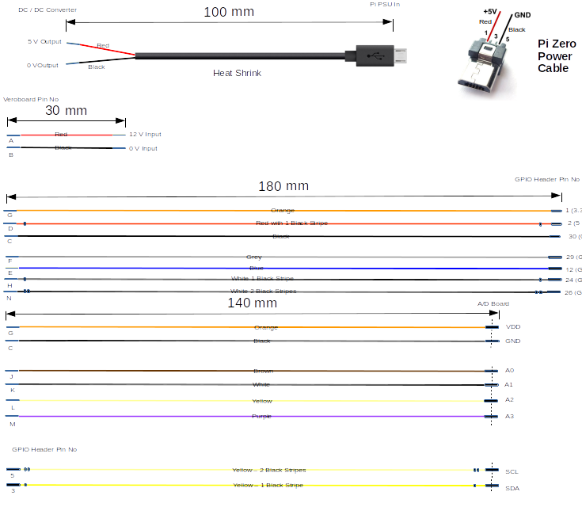

SAC Wiring – Lady Hanham Configuration
Illustration 4.6: Lady Hanham SAC Assembly – Wiring Sheet 1
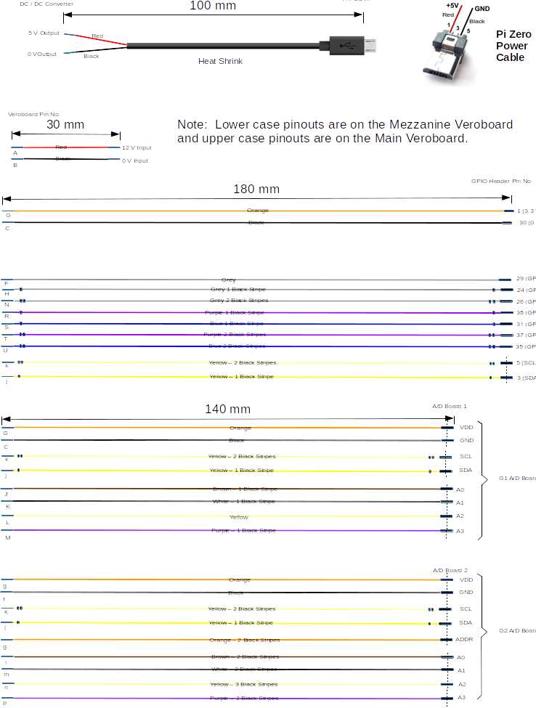
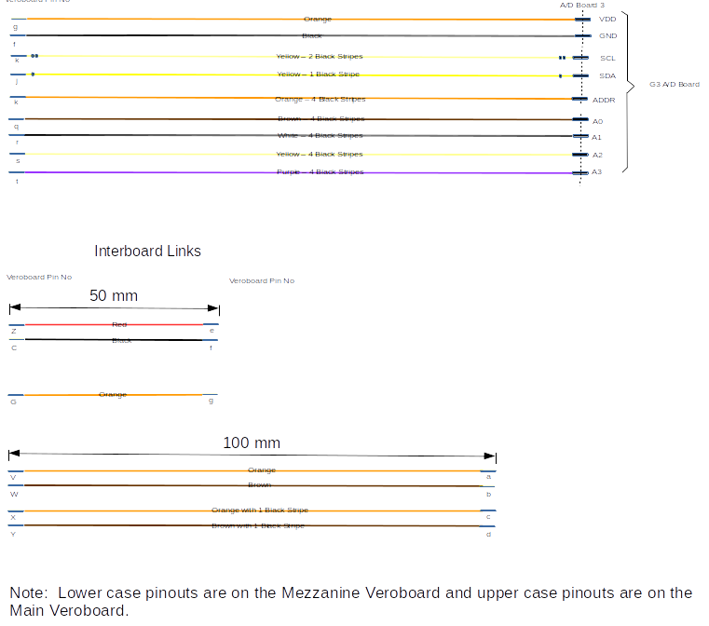

Final Assembly
The following procedure indicates the best way to assemble the system.
- During assembly, route links over electronic assemblies.
- Bundle adjacent links together using tie-wraps or looming cord.
- Use a 6-way DuPont Header shroud for Pi Pins 1, 2, 3 and 5. Leave the shroud unpopulated for Pins 4 and 6, which are not used.
- Use a 2-way DuPont Header shroud for Pi Pins 24 and 26.
- Use a 2-way DuPont Header shroud for Pi Pins 29 and 30.
- Use a single-way DuPont Header shrouds for Pi Pin 12.
- Use a 4-way DuPont Header shroud for A/D pins SCA, SCL, GND and VDD.
- Use a 4-way DuPont Header shroud for A/D pins A3, A2, A1 and A0.
- Where wire colours are re-used mark the duplicate with black or white stripes as follows:
  - Wiring for SDA and SCL on the Pi are yellow with one and two black rings respectively.
  - The wires for for the Float Switch is white with one and two black rings respectively.
  - The wire for for +5 V is red with one black ring.
Prior to full assembly, the following items should be constructed and made ready:

- The Veroboard Assembly. Do not fit the ICs at this stage.
- Solder header pins to the DC/DC Converter, the A/D Converter and the Pi Zero if an unpopulated item has been procured. (It is not necessary to fully populate the GPIO pins.) If the build is for Sump Pi, then header pins also need to be soldered to the 5 V, SDA and SDC pins on the RASClock (Real Time Clock) assembly into the holes provided (see Illustration 3.3 above).
Note: When soldering header pins to the RASClock, the pins must protrude upwards when the RASClock is installed on the Pi, ie, the pins are soldered on the component side of the board.
- All wires; cut to length, crimped/soldered and labelled where necessary.
- With reference to the Mechanical Layout Drawing, identify the positions of all of the components.
- Tap the mounting pillars that are to be used with M2.5 tapered and straight fluted taps.
- Perform a visual inspection of the Veroboard Assembly paying particular attention to solder splashes and shorts between tracks.
- With reference to the Circuit Diagram, check the routing of the Veroboard circuit using an Ohmmeter.
Build the full assembly as follows:
- Mount all of the modules using M2.5 screws and washers:
        - Four screws each for the Pi and Motor Drive Board.
        - Two screws each for the DC/DC Converter, the A/D Converter and the Veroboard.
- Connect all wiring to the Raspberry Pi, but leave the other ends of the wires unconnected. These are:
        - Four ganged contacts (Pins 1, 2, 3 & 5).
        - Two ganged contacts (Pins 24 & 26).
        - Two ganged contacts (Pins 29 and 30).
        - One contact (Pin 12).
- Tie-wrap the wiring close to the Pi GPIO connector and lead the wiring over the Pi.
- Solder all wires between the Veroboard Assembly and the Pi and DC / DC Converter.
Note: Do not connect the red and black wires to the output of the DC / DC Converter at this stage.
- Connect all wiring to the ADC, picking up the two from the Pi, but leaving the other ends of the wires unconnected.
- Tie-wrap the wiring close to the ADC connector and lead the remaining wiring over the ADC.
- If multiple ADCs are to be installed, repeat Steps 5 and 6 above.
- Solder all wires between the Veroboard Assembly and the ADC(s).
- Mount the completed Assembly to the backplate of the Equipment Box using four 3 mm screws. (It may be necessary to remove one screw and loosen the other on the DC / DC Converter to gain access to one of the retaining screws.
- Connect the Probes and PSU to the Electronics Assembly using the Terminal Block (see below).

Testing
The completed assembly should be tested as much as possible to eliminate any faults before it is installed into the River System. Perform the following tests:
- With reference to the Circuit Diagram, check the routing of the circuit using an Ohmmeter.
- Ensure that the output of the DC / DC Converter is not connected to the PSU microUSB cable.
- Apply 12 V DC to pins 1 and 2 of the Terminal Block.
- Connect a voltmeter across the output terminals of the DC-DC Converter. Adjust the output voltage to 5.1 V + 0 / - 0.1 V using the potentiometer on the DC-DC Converter.
- Remove the 12 V DC and connect the red and black wires.
- Re-apply the 12 V DC to pins 1 and 2 of the Terminal Block and check the following voltages:
  - 5.0 V + 0.1 / - 0 V on Pin 14 of the SN5407 WRT Pin 7. Adjust the potentiometer on the DC-DC Converter if necessary.
  - 3.3 V + 0.165 / - 0.165 V on Pin 1 of the 74HC4050 WRT Pin 8. (This voltage is generated by the Pi and should be OK. If it is out of limits, then there may be a fault on the Veroboard layout.)
- Remove the 12 V DC and fit the two ICs into the sockets on the Veroboard.
- Insert a fully configured SD Card (see Installation Manual).
- Connect a sample Hall Effect Probe to the relevant Pins on the Terminal Block.
- For a Lady Hanham SAC only, connect a sample Hall Effect Probe to the relevant Pins on the Terminal Block for address 0x49 and 0x4B.
- Reapply the 12 v dc and run sac.py in the tests directory of rivercontrolsystem.
- Select Menu Item 1 and move the magnet on the Hall Effect Probe to various positions, such as 100 mm, 325 mm and 750 mm. Check that the expected levels are obtained.
- For a Lady Hanham SAC only, select Menu Item 2 and repeat Step 13, for the probe at address 0x49.
- For a Lady Hanham SAC only, select Menu Item 3 repeat Step 13, for the probe at address 0x4B.
- Temporarily connect two 100 k pull-up resistors between TB1 Pins 5 & 6 and 5 & 8.
- Temporarily connect links as follows:
  - Between TB1 Pins 9 & 10.
  - Between TB1 Pins 15 & 10.
- For Standard Configuration only, select Menu Item s and monitor across the two resistors and check that they are switching between 0 V and 12 V as follows:
  - When Butts Pump is On – 5 & 6 = 12 V, When Butts Pump is Off – 5 & 6 = 0 V.
  - When Sump Pump is On – 5 & 8 = 12 V, When Sump Pump is Off – 5 & 8 = 0 V.
- For Lady Hanham Configuration only, connect a 12 Ohm (or nearest preferred value), 10 W resistor between TB1 Pins 5 and 7, select Menu Item v and check that the voltage across the resistor is switching between 12 V and 0 V.

- Select Menu Item f and temporarily connect and reconnect the link between TB1 Pins 9 & 10. Check that the program responds as follows:
  - When link connected – “Standard Butts Group Full Float Switch Low”.
  - When Sump Pump is On – “Standard Butts Group Full Float Switch High”.
- Temporarily connect and reconnect the link between TB1 Pins 15 & 10. Check that the program responds as follows:
  - When link connected – “Standard Butts Group Empty Float Switch Low”.
  - When Sump Pump is On – “Standard Butts Group Empty Float Switch High”.
- For Lady Hanham Configuration only, temporarily connect links as follows:
  - Between TB2 Pins 1 & 3.
  - Between TB2 Pins 2 & 3.
  - Between TB2 Pins 4 & 6.
  - Between TB2 Pins 5 & 6.
- For Lady Hanham Configuration only, temporarily connect and reconnect the link between TB2 Pins 1 & 3. Check that the program responds as follows:
  - When link connected – “G2 Butts Group Full Float Switch Low”.
  - When Sump Pump is On – “G2 Butts Group Full Float Switch High”.
- For Lady Hanham Configuration only, temporarily connect and reconnect the link between TB2 Pins 2 & 3. Check that the program responds as follows:
  - When link connected – “G3 Butts Group Full Float Switch Low”.
  - When Sump Pump is On – “G3 Butts Group Full Float Switch High”.
- For Lady Hanham Configuration only, temporarily connect and reconnect the link between TB2 Pins 4 & 6. Check that the program responds as follows:
  - When link connected – “G3 Butts Group Full Float Switch Low”.
  - When Sump Pump is On – “G3 Butts Group Full Float Switch High”.
- For Lady Hanham Configuration only, temporarily connect and reconnect the link between TB2 Pins 5 & 6. Check that the program responds as follows:
  - When link connected – “G3 Butts Group Full Float Switch Low”.
  - When Sump Pump is On – “G3 Butts Group Full Float Switch High”.

USER INSTRUCTIONS

Operational

Powering Up and Down
The Operator is able to:
- Start the system by switching on the supply at the mains socket.
- Stop the system by switching off the supply at the mains socket. This is achieved safely by the use of the Read-only file system (TBC).

Spares and Repairs
Spares of the major modules have been procured and these may be found in the TBD. A full list is given in Annex C.
No special tools are required to repair the system, other than standard items normally found in a general purpose tool kit.
Full backups of all software developed have been provided.

SAFETY
With the exception of the power supply inputs, all circuits operate at less than 20 V. The mains inputs to the PSUs are inaccessible to the public.

ASSUMPTIONS
The following assumptions are made.
- Future system developers will have a working knowledge of Linux and Python programming.
- System maintainers will be sufficiently skilled in general maintenance, electronics, electrical systems and software, as appropriate to be able to follow the diagnostic instructions provided in the User Manual.
Annex A
Hardware Identity
This Annex defines the hardware required for system implementation. Many of these items are free delivery and some attract a delivery charge of a few pounds. Assume £10-15 total delivery. A list of spares may be found in Annex C. These were procured at the same time as the Development items, so attracted no additional delivery costs.
Computing Devices
Item | Identity | Qty | Cost Each | Total Cost
Computer | Raspberry Pi Zero(Raspberry Pi Foundation). | 1 | £5 (£10 with GPIO Pins) | £5  (£10)

Interfaces and Accessories

Item | Identity | Qty | Cost Each | Total Cost
DC/DC Converter | LM2596 Buck Converter (available on eBay, and from Banggood or Gearbest at the price shown). | 1 | ~£2 | ~£2
RASClock | Real Time Clock assembly (available from ModMyPi at the price shown). (Only needed for SumpPi.) | 1 | ~£9 | ~£9
A/D Converter | ADS1115 ADC Assembly (available on eBay, and from Banggood or Gearbest at the price shown). Three for Lady Hanham SCA, | 1  (3) | ~£3 | ~£3
Veroboard Assy | Includes one 74HC4050 Buffer/Translators and one SN5407 plus sundry resistors, connectors etc. | 1 | ~£15 | ~£15
Mezzanine Veroboard Assy | Carries only resistors and header pins. (Lady Hanham SAC only.) | 1 | ~£10 | ~£10

Power Supplies

Item | Identity | Qty | Cost Each | Total Cost
PSU | Any +12 V, PSU of at least 1 A current availability (available online at approx prices shown). | 1 | ~£15 | ~£15

Miscellaneous

Item | Identity | Qty | Cost Each | Total Cost
74HC4050 | Hex Buffer / Translator (see Note below). | 1 | ~30p | ~30p
SN7407 | Hex Buffer (available from RS Components, Farnell or eBay). | 1 | ~£1 | ~£1
Jumper Wires | Manufactured using DuPont connectors in various colours. | A/R | ~£1 | ~£1
Terminal Block | PCB Mount Screw Terminal Connector (available on eBay, and from Banggood or Gearbest at the price shown) | 3 x 3 way & 3 x 2 way | ~15p | ~90p
Terminal Block | PCB Mount Screw Terminal Connector (available on eBay, and from Banggood or Gearbest at the price shown) | 4 x 3 way & 3 x 2 way | ~15p | ~£1
Inductor | Laird 28C0236-0JW-10 | 1 | ~70p | ~70p
Capacitor | Electrolytic 100 uF, 25 V. | 1 | ~40p | ~40p
Capacitor | Ceramic 10 nF, 250 V RMS | 2 | ~40p | ~£1

Note: The 74HC4050 Buffer / Translator in DIL Socket configuration is no longer manufactured, although they are available from Farnell or eBay while stocks last. A batch of these has been purchased to cover the requirements of the project, but if additional devices are required it may necessary to find an alternative device.

Annex B
Spares
This Annex defines the spares required for system maintenance.
Item | Identity | Qty | Cost Each | Total Cost
Computer | Raspberry Pi Zero(Raspberry Pi Foundation). | 1 | £5 | £5
DC/DC Converter | LM2596 Buck Converter (available on eBay, and from Banggood or Gearbest at the price shown). | 1 | ~£2 | ~£2
A/D Converter | ADS1115 ADC Assembly (available on eBay, and from Banggood or Gearbest at the price shown) | 1 | ~£3 | ~£3
RASClock | Real Time Clock assembly (available from ModMyPi at the price shown). (Only needed for SumpPi.) | 1 | ~£9 | ~£9

