WIMBORNE MODEL TOWN
DEVELOPMENT
RIVER SYSTEM: SYSTEM SOFTWARE DESIGN DOCUMENT
Issue 0..2
619^{h} October 2017



This work is licensed under the Creative Commons Attribution-NonCommercial-ShareAlike 4.0 International License. To view a copy of this license, visit http://creativecommons.org/licenses/by-nc-sa/4.0/.

Table of Contents
1 INTRODUCTION 4
2 RELATED DOCUMENTS 4
3 DESIGN PHILOSOPHY 5
3.1 Object Oriented Design 5
3.2 Software Installation 5
4 OUTLINE DESIGN 5
5 DETAILED DESIGN 6
5.1 Devices 6
5.2 Processing Algorithm 6
5.2.1 Master Pi Processing 6
5.2.2 Butts Pi Processing 6
5.3 Software Components 7
5.3.1 Main Program Files 7
5.3.1.1 main.py 7
5.3.1.2 universal_standalone_monitor.py 7
5.3.1.3 universal_standalone_monitor_config.py 8
5.3.2 Program Files used for Testing and Basic System Setup 8
5.3.2.1 __init__.py 8
5.3.2.2 coretools.py 8
5.3.2.3 standalone_shared_functions.py 9
5.3.2.4 sensorobjects.py 9
5.3.2.5 monitortools.py 9
5.3.2.6 sockettools.py 9
5.3.3 Interface classes and methods required to use the software. 10
5.3.3.1 sensorobjects.py 10
5.3.3.1.1 Classes 10
5.3.3.2 sockettools.py 12
5.3.3.2.1 Classes: 12
5.3.3.3 monitortools.py 13
5.3.3.3.1 Classes: 13
5.3.3.4 coretools.py 14
5.3.3.4.1 Functions: 14
6 SYSTEM STARTUP 14
6.1 Network Configuration 14
6.2 Sump Pi Configuration 15
6.3 Butts Pi Configuration 15
7 PROGRAMMING LANGUAGE 15
8 DEVELOPMENT TOOLS 15
9 SAFETY 15
10 ASSUMPTIONS 16
Index of Tables
Table 1: Related Documents 4
Annexes
A Requirements Cross Reference
B Software Identity
C Sump Pi Processing Diagram
D Butts Pi Processing Diagram

INTRODUCTION
This document details the design of the software for proposed enhancements to the Wimborne Model Town River System. The design has been created to meet the requirements contained in Reference 1 of Table 1 below and a Cross-reference between each requirement and the design elements that fulfil it is given in Annex A.
Reference 2 of Table 1 provides a design description of the enhancements to be carried out during Phase 4 of the programme of work
This issue of the document covers the requirements of the October deployment of the system. Details of the hardware environment in which the software has to run may be found in Reference 1.
The document provides a full description of the installed system to realise Phase 4 for use by future developers and maintainers.

RELATED DOCUMENTS
The following documents are related to this document.
Table 1: Related Documents
No | Requirement | Iss
1 | WMT – Development – River System Software Requirements | 0.1
2 | WMT – Development – River System Phase 4 Design Document | 0.4

DESIGN PHILOSOPHY

Object Oriented Design
An object-oriented design philosophy has been used for this project, to simplify further development as the project grows and functionality is added.
A framework has been created to build the software on:
- This framework is designed to simplify the use of more complex software features, such as sockets.
- This framework is flexible and extendible, such that more features can be added to it without disrupting existing functionality.
- The framework is capable of automatic error handling and self-monitoring, making use of advanced concepts such as threads to dynamically manage and fix problems it encounters, with no repercussions for higher layers of the software suite.
The framework includes a lot of components in the current deployment and it is expected that more will be created as it grows and matures into what will become the production software.

Software Installation
The complete framework, which includes all the files identified in the next Section has been installed on both the Master and the Remote Pis. The different functionality for each device is achieved by starting the appropriate program at boot-up, (see Section ??).

OUTLINE DESIGN
Annex A of Reference 1 of Table 1 provides a system diagram of the hardware in the deployed system and this design has been developed to operate within that system.
Reference 2 of Table 1 provides high level details of the design.

DETAILED DESIGN

Devices
For this deployment, two programmable devices have been installed; one at the sump and one at the butts. The Master Pi and its associated hardware has been identified as sumppi and the Remote Pi has been identified as buttspi.

Processing Algorithm
Annexes C & D of this document provides a diagram showing the high-level algorithm that describes the processing carried out by each Pi when the system is operating. A brief description of these algorithms is provided below.

Master Pi Processing
Referring to Annex C, the processing sequence is as follows:
- Check arguments and output an error message if they are not correct. Also output usage information to help correct the error.
- In a separate thread, setup and check the connection for the clients to connect to on port number 30000.
- Create the Results file and open it to write.
- Create the Python objects for the devices sump_probe and butts_pump using the sensor objects class.
- Setup the devices (GPIO pins, direction and state).
- Setup the Reading Interval for the hall-effect sensor.
- Start taking readings from the hall-effect sensor and the float switch state reported by the buttspi. Wait until the system has synchronised (about 10 seconds).
- Enter a monitor loop. At each iteration:
  - Check for a new reading and write the value to the file and stdout.
  - If the sump water level is between 400 mm and 600 mm, do nothing.
  - If the sump water level is over 600 mm, start the Butts Pump.
  - Continue to pump water to the Butts until the sump level falls below 600 mm or the buttspi reports that the Float Switch has activated. Stop the Butts Pump.

Butts Pi Processing
Referring to Annex D, the processing sequence is as follows:
- Check arguments and output an error message if they are not correct. Also output usage information to help correct the error.
- In a separate thread, setup and check the connection for the clients to connect to on port number 30000.
- Create the Results file and open it to write.
- Create the Python objects for the Float Switch device and set up the Reading Interval from the universal_standalone_monitor_config.py file.
- Setup the device (GPIO pin, direction and state).
- Start taking readings from the float switch.
- Enter a monitor loop. At each iteration:
  - Check for a new reading and write the value to the file and stdout.
  - Broadcast the float switch state to sumppi.

Software Components

Main Program Files
The complete framework contains various files but the three main files are main.py, universal_standalone_monitor.py, and universal_standalone_monitor_config.py. The remainder of the files provide supporting classes and methods for these main programs.

The following Python files have been installed:

main.py
Arguments
-h, --help | Help on arguments
-f, --file | Filename to contain the Results

Description
This is the main part of the control software, and it currently manages balancing water between the butts and the sump using a magnetic probe and a solid state relay to control the butts pump. This software runs on sumppi. It communicates with buttspi over the network to gather float switch readings.

universal_standalone_monitor.py
Arguments
-h, --help | Shows a help message with basic detail on commandline options.
-t, type=(str) | Type of probe this monitor is for. Must be one of “Resistance Probe”, “Hall Effect”, “Hall Effect Probe”, “Capacitive Probe”, “Float Switch”. Mandatory.
-f, --file | Filename to contain the Results. If not specified, the program will ask interactively.
-c, --controlleraddress | IP address/DNS Name of the Master Pi/any other system running main.py. If not specified, the program will run without a connection to a server.
-n, --num=(int) | The number of readings to take. Forever if 0 (exi with CRTL-C in that case).

Description
This file is run to provide the single monitors that communicate with the master pi (in this case sumppi). On buttspi, this software is run in "Float Switch" mode, and so it configures itself to take readings from a float switch which is connected using the settings found in universal_standalone_monitor_config.py. It then sends these readings over the network to the master pi (sumppi).

universal_standalone_monitor_config.py

Description
This file holds the configuration for universal_standalone_monitor. This includes pin numbers, reading intervals, and some framework-specific settings which are discussed below.

Program Files used for Testing and Basic System Setup
A number of basic system tests are included. Note that these are used to check the system setup, rather than for unit testing. These will be provided during full development.
The other files found in the "Tools" folder are as follows:

__init__.py
Arguments
None
Description
This is used to initialise the python package and is not a part of the framework.

coretools.py

Description
This file holds:
- "greet_and_get_filename", A function to greet the user and get a file name to save readings to. This is used by the universal monitor and main.py
- "do_control_logic", The function that is given the readings ad control of the devices. It does all the decision-making for the main control software (main.py).

sensorobjects.py
This file holds all of the classes for different device types. It makes use of class derivation to reduce code duplication. As such, all the classes have a common base, and then build on it for functionality specific to the device (e.g. a capacitive probe, or an SSR-controlled motor)

monitortools.py
This file holds the universal monitor. This is essentially a separate thread that takes readings when required and makes them available in a queue for the rest of the program to read when it desires. A separate thread is used because otherwise readings would delay execution of the rest of the code, and the rest of the code would be made much more complicated.

sockettools.py
A collection of tools, including a handler thread, to make it easier to use sockets. This was originally a port of some C++ code I (Hamish) was writing for my latest project, Stroodlr. This works in a very similar way to the monitor, except it is two-way communication taking place here. The handler thread handles disconnections and reconnections once started, and the socket can be used easily by pushing messages to an "outgoing" queue, and checking for messages on the "incoming" queue, using methods provided by the interface class. All of the underlying complexity and error handling is hidden from the user.

Interface classes and methods required to use the software.
Constructors, methods, and functions are discussed here with the following format:
<return-type> name(<type> arg1, <type> arg2, <type1>/<type2> arg3, <type> arg4=<default-value> [, <type> optional-arg6])

sensorobjects.py
All the constructors in this module take one argument: str name.
For example:
my_probe = FloatSwitch("butts_switch")

Classes
The following classes are provided in sensorobjects.py:
- BaseDeviceClass
  - Is the base class for all of the devices.
  - Everything else here inherits from this.
  - Interface methods:
    - none set_pins(int/list pins, bool _input=True).
      - Sets the pins the device will use (from low to high if resistance probe).
    - str get_name().
      - Returns the name of the device this object is representing.
    - tuple get_pins().
      - Returns the pins of the device (from low to high if a resistance probe).
- Motor
  - Used to represent and control a motor using a solid-state relay.
  - Interface Methods:
    - none set_pwm_available(bool pwm_available, int pwm_pin).
      - Enables/Disables PWM support for this motor, and sets PWM pin. If disabling, set pin to -1.
    - bool pwm_supported().
      - Returns True if PWm supports, else False.
    - bool enable().
      - Turns the motor on. Return True if successful, else False.
    - bool disable().
      - Turns the motor off. Returns True if successful, else False.
- FloatSwitch
  - Used to represent and get readings from a float switch.
  - Interface Methods:
    - none set_active_state(bool state).
      - Sets the active state for the pin(s). True for active high, False for active low.
    - tuple get_reading().
      - Returns the state of the switch. True = triggered, else False.
      - First part of tuple is bool, 2nd str.
- Capacitive Probe
  - Used to represent and get readings from a capacitive probe.
  - Interface methods:
    - tuple get_reading().
      - Returns the frequency from the probe and status text.
      - Will eventually return level in mm, but not calibrated yet.
      - Fault detection not yet implemented so status text is always "OK".
      - First part of tuple is int, 2nd part is str.
- ResistanceProbe
  - Used to represent and get readings from a resistance probe.
  - Interface methods:
    - none set_active_state(bool state).
      - Sets the active state for the pins. True = active high, else false.
    - bool get_active_state().
      - Returns the active state for the pins. As above.
    - tuple get_reading().
      - Gets the level of water in the probe.
      - First part of tuple is an int, 2nd is a str.
      - Includes fault detection.
- HallEffectDevice.
  - Used to represent and get readings from a hall effect device (frequency as RPM only).
  - Interface classes:
    - tuple get_reading().
      - Returns the rate at which a water-wheel is rotating in RPM.
      - First part of tuple is int, 2nd is str.

sockettools.py
This is file contains a Constructor for Sockets:
Usage:
Sockets(str the_type)
the_type *_MUST_* be "Plug" or "Socket".
A "Plug" is used with a client, a "Socket" is used with a server. With a plug, the server address must be declared using the relevant method (see below).
For example:
ServerSocket = Socket("Socket")
or
ClientSocket = Socket("Plug")

Classes:
The following classes are provided in sockettools.py:
- Sockets
  - High level representation of a socket.
  - Used to hide complexity of underlying socket from programmer, and provide convenience classes.
  - Interface methods:
    - none set_portnumber(int port_number).
      - Sets the port number for the socket.
    - none set_server_address(str server_address).
      - Sets the server address for the socket.
      - Only required if creating a client socket, a "Plug" using my terminology.
    - none set_console_output(bool state).
      - Used to silence/reveal cmdline messages from the sockets handler.
      - If not used, we default to showing them.
    - none reset()
      - used to bring the socket back to pre-connection config.
      - Useful when closing the socket.
      - Used used internally when handling disconnection/reconnection.
    - bool is_ready()
      - Returns True if socket is ready to transmit, else false.
    - bool just_reconnected().
      - Returns True if socket just reconnected to server, else false.
    - none wait_for_handler_to_exit().
      - Makes the current thread wait until the handler has exited.
      - NOTE: Doesn't ask the handler to exit by itself.
    - bool handler_has_exited()
      - Returns true if handler has exited.
    - none start_handler()
      - Starts the handler thread and the returns.
    - none request_handler_exit.
      - Asks the handler to exit, and then returns immediately.
    - none write(str data)
      - Queues some data to be sent over the socket.
    - none send_to_peer(str data)
      - Sends data to peer, and waits for confirmation of delivery.
      - Currently not used or supported.
    - bool has_data
      - Returns True if there's data to read from the socket's incoming queue.
    - str read().
      - Returns the next element from the incoming queue.
    - none pop().
      - Removes the oldest message from the incoming queue.
- SocketHandlerThread
  - Used to handle socket r/w and connection/disconnection.
  - Used internally only.
  - Do _NOT_ call this directly.
  - Only use it through <Sockets-obj>.start_handler().

monitortools.py
This is file contains a Constructor for Monitor:
Usage:
Monitor(str type, <probe-obj> probe, int num_readings, int reading_interval)
For example to monitor a float switch every 5 mins, 50 times:
monitor = Monitor("Float Switch", probe_instance, 50, 300)

or to monitor a resistance probe every 10 mins for ever:
monitor = Monitor("Resistance Probe", another_instance_of_a_probe, 0, 600)

Classes:
The following classes are provided in monitortools.py
- BaseMonitorClass
Base class for the monitors.
  - All monitors derive from this.
  - Interface methods:
    - bool is_running().
      - Returns True if monitor is running, else False.
    - bool has_data.
      - Returns True if the monitor has new data on the queue to be read.
    - str get_reading()
      - Returns a reading from the queue, and deletes it from the queue.
    - none set_reading_interval(int interval)
      - Sets the reading interval for this monitor.
      - Takes immediate effect.
    - none request_exit([wait=False]).
      - Asks the monitor thread to exit.
      - Waits before returning if specified.
- Monitor
  - A universal monitor for all devices.
  - No interface methods.

coretools.py

Functions:
The following functions are provided in coretools.py:
- file-obj greet_and_get_filename(str module_name[, str file_name])
  - Used to greet the user and get a filename if not specified.
  - Returns a file handle if it could open the file, otherwise exits the program.
- none do_control_logic()
  - Not yet documented (presently subject to rapid change).
  - Handles decision making and setting reading intervals.
  - This function is currently setup for the October deployment.

SYSTEM STARTUP

Network Configuration
In the final deployment there will be no DHCP server available, so each Pi will need to be given a static IP Address. The following link provides the method of doing this on a Raspberry Pi:
https://www.modmypi.com/blog/how-to-give-your-raspberry-pi-a-static-ip-address-update

The following IP addresses should be used for the current deployment:
sumppi - 192.168.0.2
buttspi - 192.168.0.3

Sump Pi Configuration
After boot up, the program main.py is launched by including the following code in .bashrc for the Pi user:
if [ $(tty) == /dev/tty1 ]; then
cd rivercontrolsystem-master
./main.py -f <filename>
fi

Where <filename> is the name of the file that will contain the results.

Butts Pi Configuration
After boot up, the system clock is synchronised and the program universal_standalone_monitor.py is launched by including the following code in .bashrc for the Pi user:
if [ $(tty) == /dev/tty1 ]; then
rdate -v 192.168.0.2
cd rivercontrolsystem-master
./universal_standalone_monitor.py -f <filename> -t “Float Switch” -c 192.168.0.2
fi

Where <filename> is the name of the file that will contain the results.
It will be necessary to install rdate on the Pi before this can be executed, since it it not part of the default installation.

PROGRAMMING LANGUAGE
The programming language will be Python 3. For this deployment Version 3.4 has been used and earlier versions should not be utilised.

DEVELOPMENT TOOLS
The following development tools have been used for the development of the October deployment software. Suitable alternatives may be used to maintain this software
- Editor - Xed/Gedit.
- Syntax Checker – pylint.
- Source Control System - Git, with github.com. The github repository for this project is at https://github.com/wmtprojectsteam/rivercontrolsystem.

SAFETY
All hazardous voltages are converted to safe DC levels before being presented to the deployed hardware and this software will have no control over their application. The application of the mains supply will be by an Operator operating a switch.

ASSUMPTIONS
The following assumptions are made.
- Future system developers will have a working knowledge of Linux and Python programming.

Annex A
Requirements Cross-Reference

Paragraph Numbers in Column 1 refer to Reference 1 in Section 2.
Functional
No | Requirement | Para
Operational
No | Requirement | Para

Environmental
No | Requirement | Para

Reliability
No | Requirement | Para

Maintainability
No | Requirement | Para

Safety
No | Requirement

Documentation
No | Requirement | Para

Annex B
Software Identity
This Annex defines the software required for system implementation.
Item | Identity | Qty
Operating System | Raspbian for development and deployment . | 2

Annex C
Sump Pi Processing Diagram
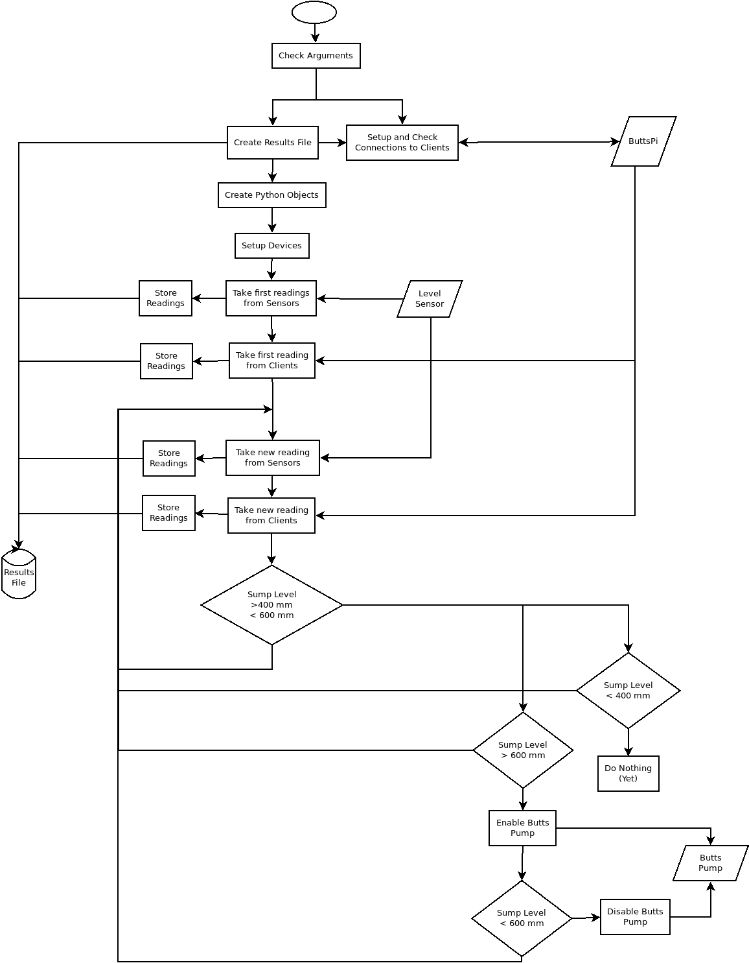
Annex D
Butts Pi Processing Diagram
