WIMBORNE MODEL TOWN
DEVELOPMENT
RIVER SYSTEM: SYSTEM SOFTWARE DESIGN DOCUMENT
Issue 0.5
22nd November2017



This work is licensed under the Creative Commons Attribution-NonCommercial-ShareAlike 4.0 International License. To view a copy of this license, visit http://creativecommons.org/licenses/by-nc-sa/4.0/.

Table of Contents
1 INTRODUCTION 3
2 RELATED DOCUMENTS 3
3 DESIGN PHILOSOPHY 4
3.1 Object Oriented Design 4
3.2 Software Installation 4
4 OUTLINE DESIGN 4
5 DETAILED DESIGN 5
5.1 Devices 5
5.2 Processing Algorithm 5
5.2.1 Master Pi Processing 5
5.2.2 Butts Pi Processing 6
6 SYSTEM STARTUP 7
6.1 Network Configuration 7
6.2 Sump Pi Configuration 7
6.3 Butts Pi Configuration 7
7 PROGRAMMING LANGUAGE 7
8 DEVELOPMENT TOOLS 8
9 SAFETY 8
10 ASSUMPTIONS 8
Index of Tables
Table 1: Related Documents 3
Annexes
A Requirements Cross Reference
B Software Identity
C Sump Pi Processing Diagram
D Butts Pi Processing Diagram

INTRODUCTION
This document details the design of the software for proposed enhancements to the Wimborne Model Town River System. The design has been created to meet the requirements contained in Reference 1 of Table 1 below and a Cross-reference between each requirement and the design elements that fulfil it is given in Annex A.
Reference 2 of Table 1 provides a design description of the enhancements to be carried out during Phase 4 of the programme of work
This issue of the document covers the requirements of the October deployment of the system. Details of the hardware environment in which the software has to run may be found in Reference 1.
The document provides a full description of the installed system to realise Phase 4 for use by future developers and maintainers.

RELATED DOCUMENTS
The following documents are related to this document.
Table 1: Related Documents
No | Requirement | Iss
1 | WMT – Development – River System Software Requirements | 0.1
2 | WMT – Development – River System Phase 4 Design Document | 0.4
3 | WMT – Software API Documentation | For software v0.9.1 (In active development)

DESIGN PHILOSOPHY

Object Oriented Design
An object-oriented design philosophy has been used for this project, to simplify further development as the project grows and functionality is added.
A framework has been created to build the software on:
- This framework is designed to simplify the use of more complex software features, such as sockets.
- This framework is flexible and extendible, such that more features can be added to it without disrupting existing functionality.
- The framework is capable of automatic error handling and self-monitoring, making use of advanced concepts such as threads to dynamically manage and fix problems it encounters, with no repercussions for higher layers of the software suite.
The framework includes a lot of components in the current deployment and it is expected that more will be created as it grows and matures into what will become the production software.

Software Installation
The complete framework, which includes all the files identified in the next Section has been installed on both the Master and the Remote Pis. The different functionality for each device is achieved by starting the appropriate program at boot-up, (see Section 6).

OUTLINE DESIGN
Annex A of Reference 1 of Table 1 provides a system diagram of the hardware in the deployed system and this design has been developed to operate within that system.
Reference 2 of Table 1 provides high level details of the design.

DETAILED DESIGN

Devices
For this deployment, two programmable devices have been installed; one at the sump and one at the butts. The Master Pi and its associated hardware has been identified as sumppi and the Remote Pi has been identified as buttspi.

Processing Algorithm
Annexes C & D of this document provides a diagram showing the high-level algorithm that describes the processing carried out by each Pi when the system is operating. A brief description of these algorithms is provided below.

Master Pi Processing
Referring to Annex C, the processing sequence is as follows:
- Check arguments and output an error message, including usage information to help correct the error, if they are not correct..
- In a separate thread, setup and check the connection for the clients to connect to on port number 30000.
- Create the Results file and open it to write.
- Create the Python objects for the devices sump_probe and butts_pump using the sensor objects class.
- Setup the devices (ID, GPIO pins, direction and state).
- Setup the initial Reading Interval for the hall-effect sensor.
- Start taking readings from the hall-effect sensor and the float switch state reported by the buttspi. Wait for the system has syncronised, and then wait approximately 10 seconds more for butts pi to connect.
- Enter a monitor loop. At each iteration:
  - Check for a new reading and write the value to the file and stdout.
  - Check for any readings from butts pi, and log them if there are any.
  - If the sump water level is between 400 mm and 600 mm, do nothing.
  - If the sump water level is over 600 mm, start the Butts Pump.
  - Continue to pump water to the Butts until the sump level falls below 400 mm or buttspi reports that the Float Switch has activated. Stop the Butts Pump.
  - Wait until it is time to take a new reading (for reading_interval seconds).

Butts Pi Processing
Referring to Annex D, the processing sequence is as follows:
- Check arguments and output an error message, including usage information to help correct the error, if they are not correct.
- In a separate thread, setup and check the connection for the clients to connect to on port number 30000.
- Create the Results file and open it to write.
- Create the Python objects for the Float Switch device, and the Magnetic Probe and set the initial Reading Interval from the universal_standalone_monitor_config.py file.
- Setup the devices (ID, GPIO pin, direction and state).
- Start taking readings from each device.
- Wait until the system has synchronised.
- Enter a monitor loop. At each iteration:
  - Check for new readings and write the value to the file and stdout.
  - Broadcast the readings to sumppi.
  - Wait until it is time to take a new reading (for reading_interval seconds).
    - While waiting, keep checking for a new reading interval from the master pi, so that we can respond immediately.
The API documentation for the software components is provided in reference 3 in Table 1.

SYSTEM STARTUP

Network Configuration
In the final deployment there will be no DHCP server available, so each Pi has been given a static IP Address. The following link provides the method of doing this on a Raspberry Pi:
https://www.modmypi.com/blog/how-to-give-your-raspberry-pi-a-static-ip-address-update

The following IP addresses should be used for the current deployment:
sumppi - 192.168.0.2
buttspi - 192.168.0.3

Sump Pi Configuration
After boot up, the program main.py is launched by including the following code in .bashrc for the Pi user:
if [ $(tty) == /dev/tty1 ]; then
cd rivercontrolsystem-master
./main.py -f <filename>
fi

Where <filename> is the name of the file that will contain the results.

Butts Pi Configuration
After boot up, the system clock is synchronised and the program universal_standalone_monitor.py is launched by including the following code in .bashrc for the Pi user:
if [ $(tty) == /dev/tty1 ]; then
rdate -v 192.168.0.2
cd rivercontrolsystem-master
./universal_standalone_monitor.py -f <filename> -t “Float Switch” -c 192.168.0.2
fi

Where <filename> is the name of the file that will contain the results.
It will be necessary to install rdate on the Pi before this can be executed, since it it not part of the default installation.

PROGRAMMING LANGUAGE
The programming language will be Python 3. For this deployment Version 3.5 has been used and earlier versions should not be utilised.

DEVELOPMENT TOOLS
The following development tools have been used for the development of the October deployment software. Suitable alternatives may be used to maintain this software
- Editor - Xed/Gedit.
- Syntax Checker – pylint.
- Source Control System - Git, with github.com. The github repository for this project is at https://github.com/wmtprojectsteam/rivercontrolsystem.

SAFETY
All hazardous voltages are converted to safe DC levels before being presented to the deployed hardware and this software will have no control over their application. The application of the mains supply will be by an Operator operating a switch.

ASSUMPTIONS
The following assumptions are made.
- Future system developers will have a working knowledge of Linux and Python programming.

Annex A
Requirements Cross-Reference

Paragraph Numbers in Column 1 refer to Reference 1 in Section 2.
Functional
No | Requirement | Para
Operational
No | Requirement | Para

Environmental
No | Requirement | Para

Reliability
No | Requirement | Para

Maintainability
No | Requirement | Para

Safety
No | Requirement

Documentation
No | Requirement | Para

Annex B
Software Identity
This Annex defines the software required for system implementation.
Item | Identity | Qty
Operating System | Raspbian for development and deployment . | 2

Annex C
Sump Pi Processing Diagram
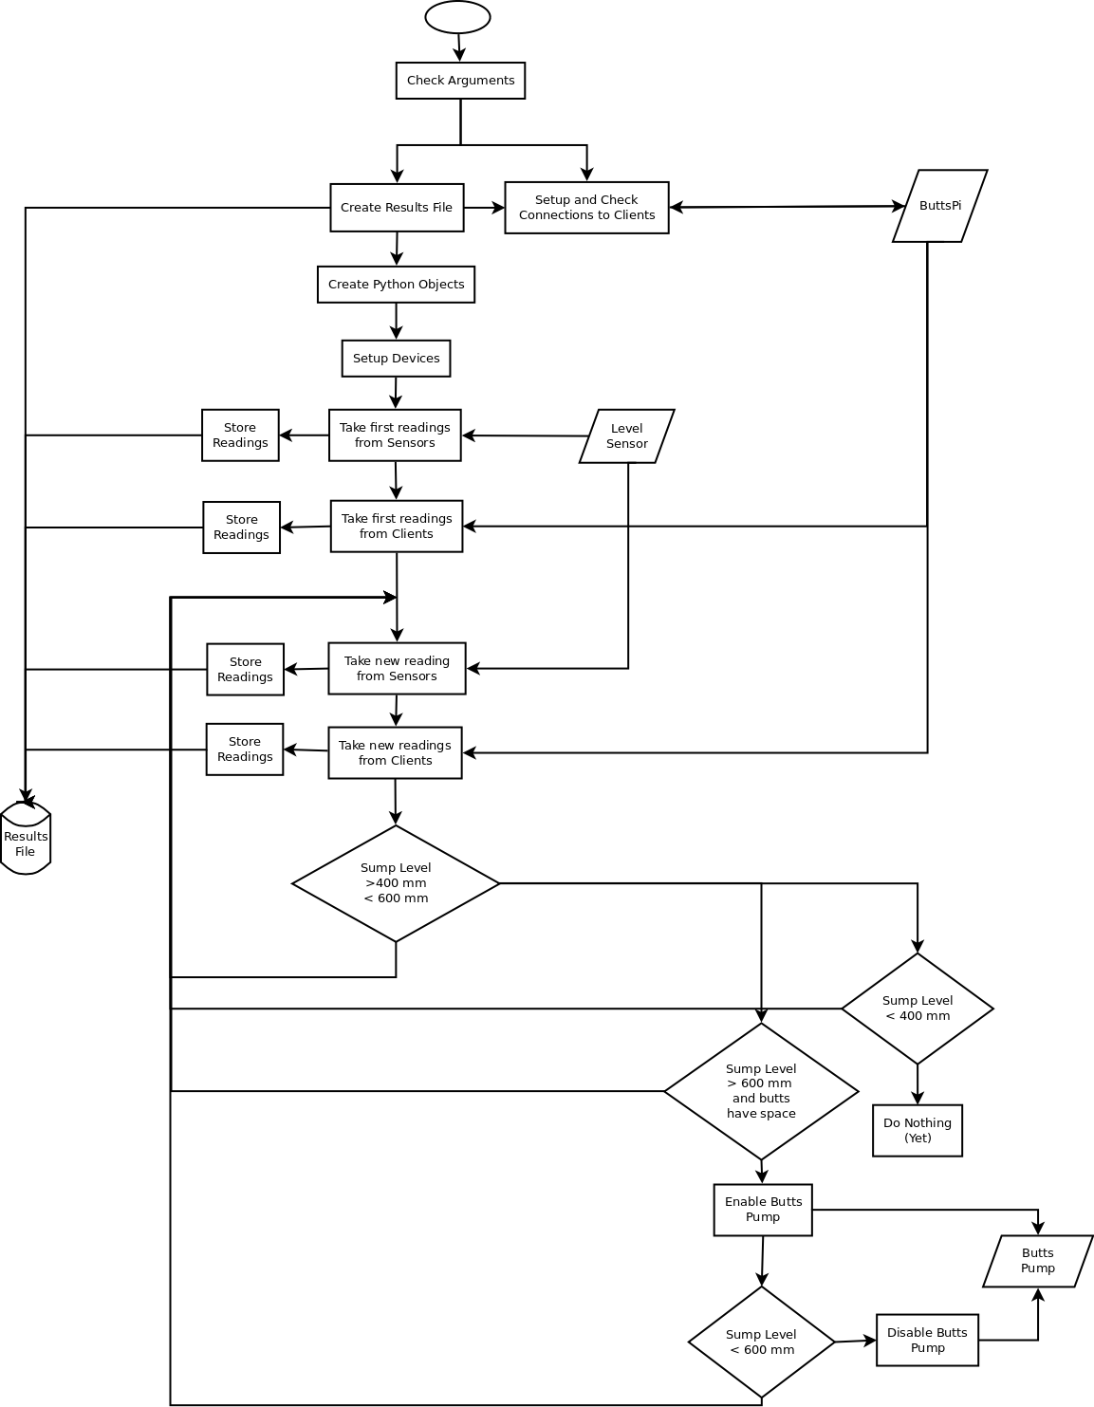
Annex D
Butts Pi Processing Diagram
