WIMBORNE MODEL TOWN
DEVELOPMENT
RIVER SYSTEM: SYSTEM SOFTWARE DESIGN DOCUMENT
Issue 0.9
12th July 2020



This work is licensed under the Creative Commons Attribution-NonCommercial-ShareAlike 4.0 International License. To view a copy of this license, visit http://creativecommons.org/licenses/by-nc-sa/4.0/.

Table of Contents
1 INTRODUCTION 3
2 RELATED DOCUMENTS 3
3 DESIGN PHILOSOPHY 4
3.1 Object Oriented Design 4
3.2 Software Installation 4
4 OUTLINE DESIGN 4
5 DETAILED DESIGN 4
5.1 Devices 4
5.2 Processing Algorithm 9
5.2.1 Master Pi Processing 9
5.2.2 Butts Pi(s) Processing 10
5.2.3 Gate Pi(s) Processing 10
6 SYSTEM STARTUP 11
6.1 Network Configuration 11
6.2 Sump Pi Configuration 11
6.2.1 Time Synchronisation 11
6.2.2 Autostart of River System Software 11
6.3 Gate and Butts Pi(s) Configuration 11
6.3.1 Time Synchronisation 11
6.3.2 Autostart of River System Software 11
7 PROGRAMMING LANGUAGE 11
8 DEVELOPMENT TOOLS 12
9 SAFETY 12
10 ASSUMPTIONS 12
Index of Tables
Table 1: Related Documents 3
Table 2: River System Devices 5
Annexes
A Requirements Cross Reference
B Software Identity
C Sump Pi Processing Diagram
D Butts Pi Processing Diagram

INTRODUCTION
This document details the design of the software for proposed enhancements to the Wimborne Model Town River System. The design has been created to meet the requirements contained in Reference 1 of Table 1 below and a Cross-reference between each requirement and the design elements that fulfil it is given in Annex A.
Reference 2 of Table 1 provides a design description of the enhancements to be carried out during Phase 4 of the programme of work
This issue of the document covers the requirements of the October deployment of the system. Details of the hardware environment in which the software has to run may be found in Reference 1.
The document provides a full description of the installed system to realise Phase 4 for use by future developers and maintainers.

RELATED DOCUMENTS
The following documents are related to this document.
Table 1: Related Documents
No | Requirement | Iss
1 | WMT – Development – River System Software Requirements | 0.1
2 | WMT – Development – River System Phase 4 Design Document | 0.4
3 | WMT – Software API Documentation | For software v0.11.0~pre3 (In active development)
4 | WMT – Development – River System Phase 4 Installation Specification | 0.8

DESIGN PHILOSOPHY

Object Oriented Design
An object-oriented design philosophy has been used for this project, to simplify further development as the project grows and functionality is added.
A framework has been created to build the software on:
- This framework is designed to simplify the use of more complex software features, such as sockets.
- This framework is flexible and extendible, such that more features can be added to it without disrupting existing functionality.
- The framework is capable of automatic error handling and self-monitoring, making use of advanced concepts such as threads to dynamically manage and fix problems it encounters, with no repercussions for higher layers of the software suite.
The framework includes a lot of components in the current deployment and it is expected that more will be created as it grows and matures into what will become the production software.

Software Installation
The complete framework, which includes all the files identified in the next Section has been installed on both the Master and the Remote Pis. The different functionality for each device is achieved by starting the appropriate program at boot-up, (see Section 6).

OUTLINE DESIGN
Annex A of Reference 1 of Table 1 provides a system diagram of the hardware in the deployed system and this design has been developed to operate within that system.
Reference 2 of Table 1 provides high level details of the design.

DETAILED DESIGN

Devices
For this deployment, three programmable devices have been installed; one at the sump to monitor levels and control the system. one at the Wendy Street Butts to monitor levels and one at the Wendy Street Butts to control the gate valve. The Master Pi and its associated hardware has been identified as sumppi and the Remote Pi has been identified as buttspi. The Gate Valve has been designated g4gatepi.
Once the preliminary work has been completed, the devices shown in Table 2 below will comprise the complete system.
Table 2: River System Devices
Location | Device | Hostname | Device Name | IP Address  (I2C Address) | Port Number | Socket ID
Sump | Raspberry Pi Zero | sumppi | SUMP | 192.168.0.2 | 30002 | SOCK2
 | Hall Effect (magnetic) Probe |  | M0 | (0x48)
 | Butts return Pump |  | P0 | - | - | -
 | Main circulation Pump |  | P1 | -
Lady Hanham Room | Raspberry Pi Zero | lhbuttspi | G3 | 192.168.0.3 | 30003 | SOCK3
 | G1 Hall Effect (magnetic) Probe |  | G3:M0 | (0x48)
 | G1 Float Switch (High) |  | G3:FS0 | -
 | G1 Float Switch (Low) |  | G3:FS1 | -
 | G2 Hall Effect (magnetic) Probe |  | G2:M1 | (0x49)
 | G2 Float Switch (High) |  | G2:FS2 | -
 | G2 Float Switch (Low) |  | G2:FS3 | -
 | G3 Hall Effect (magnetic) Probe |  | G3:M2 | (0x4B)
 | G3 Float Switch (High) |  | G3:FS4 | -
 | G3 Float Switch (Low) |  | G3:FS5 | -
Wendy Street | Raspberry Pi Zero | wbuttspi | G4 | 192.168.0.4 | 30004 | SOCK4
 | Hall Effect (magnetic) Probe |  | G4:M0 | (0x48)
 | Float Switch (High) |  | G4:FS0 | -
 | Float Switch (Low) |  | G4:FS1 | -
Gazebo | Raspberry Pi Zero | gbuttspi | G5 | 192.168.0.5 | 30005 | SOCK5
 | Hall Effect (magnetic) Probe |  | G5:M0 | (0x48)
 | Float Switch (High) |  | G5:FS0 | -
 | Float Switch (Low) |  | G5:FS1 | -
Stage | Raspberry Pi Zero | sbuttspi | G6 | 192.168.0.6 | 30006 | SOCK6
 | Hall Effect (magnetic) Probe |  | G6:M0 | (0x48)
 | Float Switch (High) |  | G6:FS0 | -
 | Float Switch (Low) |  | G6:FS1 | -
Lady Hanham G1 | Raspberry Pi Zero | g1gatepi | V1 | 192.168.0.11 | 30011 | SOCK11
Lady Hanham G2 | Raspberry Pi Zero | g2gatepi | V2 | 192.168.0.12 | 30012 | SOCK12
Lady Hanham G3 | Raspberry Pi Zero | g3gatepi | V3 | 192.168.0.13 | 30013 | SOCK13
Wendy Street | Raspberry Pi Zero | g4gatepi | V4 | 192.168.0.14 | 30014 | SOCK14
Gazebo | Raspberry Pi Zero | g5gatepi | V5 | 192.168.0.15 | 30015 | SOCK15
Matrix Pump | Raspberry Pi Zero | m6gatepi | V6 | 192.168.0.16 | 30016 | SOCK16
Matrix Pump | Raspberry Pi Zero | m7gatepi | V7 | 192.168.0.17 | 30017 | SOCK17
Matrix Pump | Raspberry Pi Zero | m8gatepi | V8 | 192.168.0.18 | 30018 | SOCK18
Matrix Pump | Raspberry Pi Zero | m9gatepi | V9 | 192.168.0.19 | 30009 | SOCK19
TBD Gate Valve | Raspberry Pi Zero | TBD10gatepi | V10 | 192.168.0.20 | 30020 | SOCK20
TBD Gate Valve | Raspberry Pi Zero | TBD11gatepi | V11 | 192.168.0.21 | 30021 | SOCK21
Stage Butts G6 | Raspberry Pi Zero | g6gatepi | V12 | 192.168.0.22 | 30022 | SOCK22
Railway Room | Raspberry Pi 3 | WMT-Webserver | - | 192.168.0.1 | - | -
TBD Staff & Visitor GUI | Raspberry Pi Zero | guipi | GUI | 192.168.0.9 | - | -
Database Server | D-Link DNS320L NAS Box | river-nas | NAS | 192.168.0.25 | - | -
VPN Server | Raspberry Pi 3 | VPN-Server | - | 192.168.0.30 | - | -

Notes:
1. Remote probes are monitored using the configuration too – the master pi (sumppi) just reads the configuration for the other pis to set this up. No extra configuration is needed.
2. Any section of the configuration can be omitted if, for example, there are no devices to control at a particular site (like the G4 site). This is accepted and will "just work".
3. The code to actually make decisions and decide what to do with the devices to control is not here - it's in coretools.py. At the moment. only sumppi controls anything, so the method is called do_control_logic(), but later on there will be methods for each site, and they will be mapped to each site here in this config file.
4. The Webserver Pi is not a part of the River System, but shares an Ethernet network. It has therefore been allocated an IP Address that will not conflict with the system. It is expected that it will serve the Visitor & Staff GUI.
5. The Device Name, Port Number and Socket ID of each device will be included in Config.py, to allow the software framework to set up network communication. In this installation, the River System server is always sumppi and this IP Address is then used by each remote host. The server uses the information contained in the socket to identify the source of the data and to direct commands to when sumppi is requesting an action (such as setting a Gate Valve).
6. The WMT Webserver is a pre-existing resource and is not strictly part of the River System software. However, it is expected that it will be utilised to serve up the web pages for viewing on the Staff & Visitor GUI.
7. Database Server is a pre-existing resource which is being upcycled from a home media server. The original software has been re-compiled and upgraded to perform the required River System functions.

Processing Algorithm
Annexes C & D of this document provides a diagram showing the high-level algorithm that describes the processing carried out by each Pi when the system is operating. A brief description of these algorithms is provided below.

Master Pi Processing
Referring to Annex C, the processing sequence is as follows:
- Check arguments and output an error message, including usage information to help correct the error, if they are not correct..
- In a separate thread, setup and check the connection for the clients to connect to on port numbers 3000x as defined in the Table above.
- Create the Results file and open it to write.
- Create the Python objects for the devices sump_probe and butts_pump using the sensor objects class.
- Setup the devices (ID, GPIO pins, direction and state).
- Setup the initial Reading Interval for the hall-effect sensor.
- Start taking readings from the hall-effect sensor and the float switch state reported by the buttspi. Wait for the system has syncronised, and then wait approximately 10 seconds more for butts pi to connect.
- Enter a monitor loop. At each iteration:
  - Check for a new reading and write the value to the file and stdout.
  - Check for any readings from butts pi, and log them if there are any.
  - If the sump water level is between 400 mm and 600 mm, do nothing.
  - If the sump water level is over 600 mm, start the Butts Pump, providing that there is space in the Butts, maintain the Main Circulation Pump and ensure that the Gate Valve is closed.
  - Continue to pump water to the Butts until the sump level falls below 400 mm or buttspi reports that the Float Switch has activated. Stop the Butts Pump and open the Gate Valve, providing that there is sufficient water in the Butts.
  - Wait until it is time to take a new reading (for reading_interval seconds).

Butts Pi(s) Processing
Referring to Annex D, the processing sequence is as follows:
- Check arguments and output an error message, including usage information to help correct the error, if they are not correct.
- In a separate thread, setup and check the connection for the clients to connect to on port number 3000x as defined in the Table above.
- Create the Results file and open it to write.
- Create the Python objects for the Float Switch device, and the Magnetic Probe and set the initial Reading Interval from the universal_standalone_monitor_config.py file.
- Setup the devices (ID, GPIO pin, direction and state).
- Start taking readings from each device.
- Wait until the system has synchronised.
- Enter a monitor loop. At each iteration:
  - Check for new readings and write the value to the file and stdout.
  - Broadcast the readings to sumppi.
  - Wait until it is time to take a new reading (for reading_interval seconds).
    - While waiting, keep checking for a new reading interval from the master pi, so that we can respond immediately.

Gate Pi(s) Processing
The processing within the Gate Pi(s) is similar in many respects to the Butts Pi(s), except that only one reading is taken (the current valve position) and the software listens for commands from the master to change the postion of the valve.
The API documentation for the software components is provided in reference 3 in Table 1.

SYSTEM STARTUP

Network Configuration
In the final deployment there may be no DHCP server available, so each Pi must be given a static IP Address.
The IP addresses defined in Table 2 above are used for the current deployment and the following login credentials used for all Pis:
Username: Pi
Password: river17

Details of how to perform this configuration is given in Reference 1.1.4

Sump Pi Configuration

Time Synchronisation
The Master Pi, (currently sumppi) will have a physical Real Time Clock installed on GPIO Pins 1 to 6 rdate will be used on all Pi’s to synchronise all local clocks to the Real Time Clock installed in sumppi.
It will be necessary to configure the Pi to read and use this clock.

Autostart of River System Software
After boot up, the relevant program is launched by including code in .bashrc for the Pi user.
Details of how to perform this configuration is given in Reference 1.1.

Gate and Butts Pi(s) Configuration

Time Synchronisation
For simplicity and speed rdate will be used on all Pi’s to synchronise all local clocks to the Real Time Clock installed in sumppi. To enable this, install rdate on all Pis and and on all clients synchronise the clock at startup using code in rc.local.
Details of how to perform this configuration is given in Reference 1.1.4

Autostart of River System Software
After boot up, the relevant program is launched by including code in .bashrc for the Pi user,
Details of how to perform this configuration is given in Reference 1.1.

PROGRAMMING LANGUAGE
The programming language will be Python 3. For this deployment Version 3.5 has been used and earlier versions should not be utilised.

DEVELOPMENT TOOLS
The following development tools have been used for the development of the October deployment software. Suitable alternatives may be used to maintain this software
- Editor - Xed/Gedit.
- Syntax Checker – pylint.
- Source Control System - Git, with github.com. The github repository for this project is at https://github.com/wmtprojectsteam/rivercontrolsystem.

SAFETY
All hazardous voltages are converted to safe DC levels before being presented to the deployed hardware and this software will have no control over their application. The application of the mains supply will be by an Operator operating a switch.

ASSUMPTIONS
The following assumptions are made.
- Future system developers will have a working knowledge of Linux and Python programming.

Annex A
Requirements Cross-Reference

Paragraph Numbers in Column 1 refer to Reference 1 in Section 2.
Functional
No | Requirement | Para
Operational
No | Requirement | Para

Environmental
No | Requirement | Para

Reliability
No | Requirement | Para

Maintainability
No | Requirement | Para

Safety
No | Requirement

Documentation
No | Requirement | Para

Annex B
Software Identity
This Annex defines the software required for system implementation.
Item | Identity | Qty
Operating System | Raspbian for development and deployment . | 2

Annex C
Sump Pi Processing Diagram
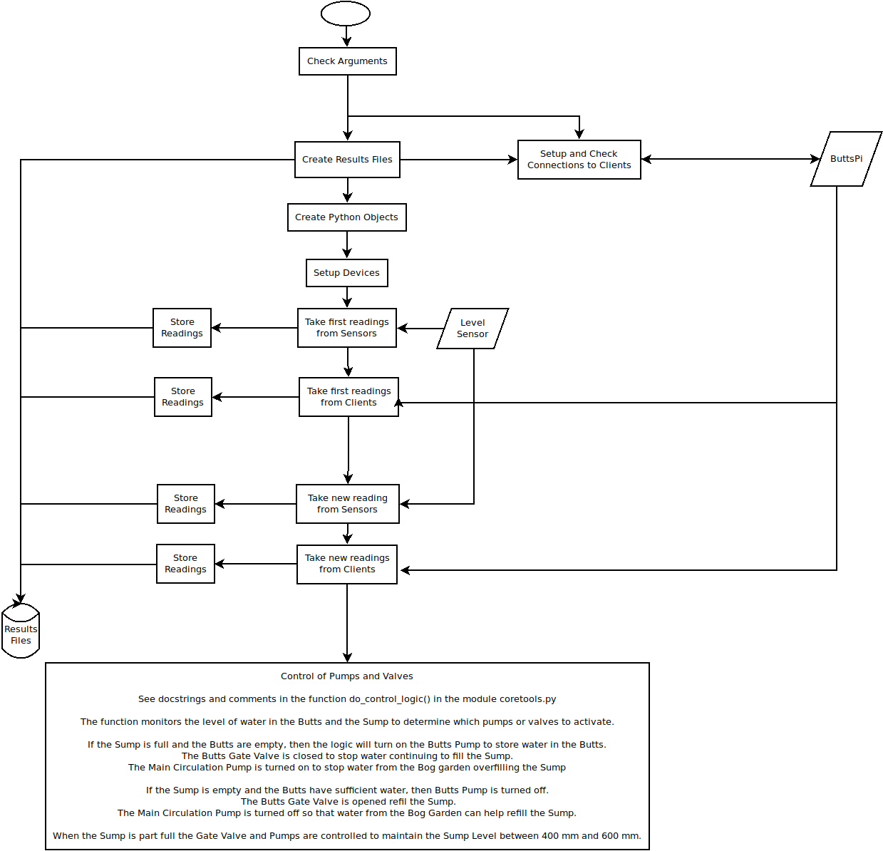
Annex D
Butts Pi Processing Diagram
