WIMBORNE MODEL TOWN
DEVELOPMENT
RIVER SYSTEM: PHASE 4 DESIGN DOCUMENT
Issue 0.5
29th December 2017



This work is licensed under the Creative Commons Attribution-NonCommercial-ShareAlike 4.0 International License. To view a copy of this license, visit http://creativecommons.org/licenses/by-nc-sa/4.0/.

Table of Contents
1 INTRODUCTION 4
2 RELATED DOCUMENTS 4
3 OUTLINE DESIGN 5
3.1 Main Path of Water 5
3.2 Sump Management 5
3.3 Water Butt Management 7
4 DETAILED DESIGN 7
4.1 Hardware 7
4.1.1 Automated Control of the River System 7
4.1.1.1 System Master Controller 7
4.1.1.1.1 Raspberry Pi 3 or Raspberry Pi Zero 7
4.1.1.2 Remote Sensor Controller 8
4.1.1.2.1 Raspberry Pi Zero 8
4.1.1.3 Remote Sensors 8
4.1.1.3.1 Level Sensors 8
4.1.1.3.1.1 Pressure Sensors 8
4.1.1.3.1.2 Capacitive Sensors 9
Illustration 4.2: Capacitive Sensors – Principle of Operation 10
4.1.1.3.1.3 Conductive Probe Sensors 10
4.1.1.3.2 Flow Sensors 11
4.1.1.3.2.1 Hall Effect Devices 11
4.1.1.3.2.2 Opto-Coupler Devices 11
4.1.2 Control Devices 12
4.1.2.1 Variable Speed Pumps 12
4.1.2.2 Fixed Speed Pumps 12
4.1.3 Water Control Valves 12
4.1.3.1 2-Port Solenoid Valves 12
4.1.3.2 3-Port Solenoid or Motorised Valves 12
4.1.4 Miscellaneous Hardware 12
4.1.4.1 Ethernet Adaptors 12
4.1.4.2 Ethernet Switch 13
4.1.4.3 Analogue to Digital Converter 13
4.1.4.4 Level Translators 13
4.1.4.5 Relays 13
4.1.5 Power Supplies 14
4.1.5.1 Distributed DC 14
4.1.6 Graphical User Interface Hardware 14
4.1.6.1 WMT Staff Interface 14
4.1.6.2 Visitor Interface 14
4.2 Software 15
4.2.1 Master Pi 15
4.2.1.1 Software Functions 15
4.2.1.1.1 Monitoring 15
4.2.1.1.2 Control 15
4.2.2 Remote Pis 16
4.2.2.1 Software Functions 16
4.2.2.1.1 Monitoring 16
4.2.2.1.2 Control 16
4.2.3 Graphical User Interface 17
4.2.3.1 Web GUI Server 17
4.2.4 Operating System 17
4.2.5 Software Documentation 18
5 ENVIRONMENTAL 18
6 OPERATIONAL 19
6.1.1 Powering Up and Down 19
6.2 Reliability and Maintainability 19
6.2.1 Reliability 19
6.2.2 Maintainability 19
6.2.2.1 Documentation 19
6.2.3 Spares and Repairs 20
7 EDUCATIONAL 20
8 SAFETY 20
9 ASSUMPTIONS 20
10 SUMMARY OF CHANGES TO THIS DOCUMENT 21
Index of Tables
Table 1: Related Documents 4
Table 2: Summary of Changes to this Document 21
Illustration Index
Illustration 3.1: River System – Outline Phase 4 Layout 6
Illustration 4.1: Pressure Sensors – Principle of Operation 9
Illustration 4.2: Capacitive Sensors – Principle of Operation 10
Illustration 4.3: Conductive Probe Sensors – Principle of Operation 10
Illustration 4.4: Hall Effect Sensor – Principle of Operation 11
Illustration 4.5: Opto-Coupler Sensor – Principle of Operation 11
Illustration 4.6: Analogue to Digital Converter 13
Annexes
A Requirements Cross Reference
B Hardware Identity
C Software Identity
D Spares
E System Diagram – Automatic Water Controller

INTRODUCTION
This document details the design of proposed enhancements to the Wimborne Model Town River System. The design has been created to meet the requirements contained in References 1 and 2 of Table 1 below and a Cross-reference between each requirement and the design elements that fulfil it is given in Annex A.
This issue of the document covers the requirements of Phase 4 of the work, as defined in Reference 2; the automation of the system. Phases 1 and 2 of the development are largely complete. Phase 3 is in progress and it is believed that a Design Document will not be needed to complete the work. When Phases 5 and 6 commence, an update to this document will be provided, if necessary.
The document provides a full description of the installed system to realise Phase 4 for use by future developers and maintainers.
Note: It is a requirement of this Project that development shall be ‘agile’ in nature (Requirement 8.3 in Reference 1). What this means in practice is that elements of work from one phase may be brought forward or delayed as circumstances and funding dictate. This means that some of the work described in Phases 5 and 6 might be included in this Phase, should time and funding allow.

RELATED DOCUMENTS
The following documents are related to this document.
Table 1: Related Documents
No | Requirement | Iss
1 | WMT – Development – River System Requirements | 0.5
2 | WMT – Development – River System Phased Requirements | 0.5.2
3 | WMT – Development – River System Installation Specification | TBD
4 | WMT – Development – River System User Manual | TBD

OUTLINE DESIGN
Illustration 3.1 below shows the proposed layout of the River System for Phase 4. At this stage of development, it does not include the locations of all the sensors and some of the control devices. Also the two branches of the river are shown as one. This drawing will be updated as the project progresses.

Main Path of Water
Water from the sump will be returned to the bog garden using the existing sump pump, as it is at the time of writing. During development, the manual pump control box, located adjacent to the sump, will be replaced by an automated system which will drive the pump with a 5 V PWM signal to its existing Controller.
In addition to the natural river flow from bog to sump, rainwater from parts of the Main building and the Lady Hanham building roofs is directed into the river (as and when it rains).
At some point in the river, the flow will be measured and the depth of water in the sump will be monitored to ensure that the river depth is maintained at the optimum level by exchanging water with the butts.

Sump Management
The water level in the sump will be managed. There is an existing soak away located towards the top of the sump, when water reached that level it is lost to the river system. Any excess water in the sump, that is more water than is required to maintain an effective river flow, needs to be pumped into the Water Butts for storage. Conversely as the sump water level drops, particularly if the butts have insufficient reserves to top it up, the sump pump must be controlled to manage river flow to a lower level; in the extreme, when sump water level drops below a minimum the pump must be stopped and an alarm raised. Attempts will be made by the management system to ensure the sump water level stays sufficient prior to turning the pump off.

Illustration 3.1: River System – Outline Phase 4 Layout
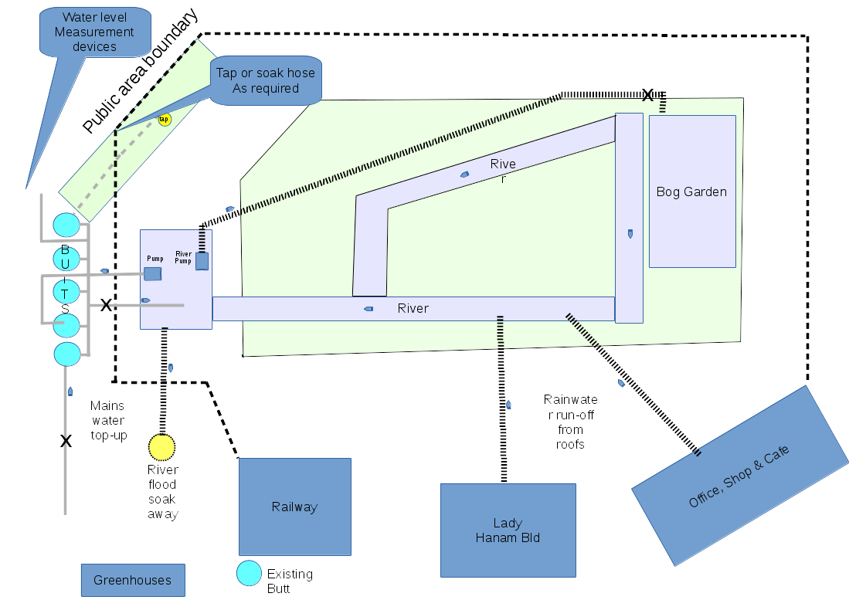

Water Butt Management
Water collected in the butts will be held in reserve until needed to replenish the river or supply irrigation to the gardens. The level of water in the butts will be monitored and if it becomes too high or too low then an alarm will be raised. As a fallback an overflow pipe will be included to conduct excess water to a soakaway.

DETAILED DESIGN

Hardware
The full identification and quantities of all hardware items may be found in Annex B.

Automated Control of the River System

System Master Controller

Raspberry Pi 3 or Raspberry Pi Zero
Overall control of the system will be implemented using a Raspberry Pi 3 (the Master Pi). This small single board computer has a 40 pin connector that carries 26 GPIO channels, including 1-wire, SPI and an I²C buses. Additionally the device has four USB connectors, and one each of Ethernet, HDMI and power. The device also has a Wireless and Bluetooth adaptor built in, but this will not be needed for this project other than during development. A Micro SD Card slot is provided to carry the Operating System and program code.
The Master Pi will ‘listen’ to the remote devices and read back sensor values, such as water levels and flow. The software, described in Section 3.2.1 (below) will process the monitored values to predict when water will need to be moved around the site, to ensure adequate levels in the river and to detect flooding. When it is required to move water, the Master Pi, either directly, or via the remote devices, will turn on pumps and control valves as necessary.
During development, the Master Pi will be accessed via a monitor, mouse and keyboard and integrated with the system. Once integration is complete, the Master Pi will be run 'headless'.
The Master Pi will be housed in an equipment case installed in a location to be determined during development.
Note: The above description assumes the function of Master Pi will be combined with the WebGUI server, (see below). If this proves impractical, due to physical constraints for example, then Master Pi could be implemented using a Raspberry Pi Zero. See the next Section for a description of the Pi Zero’s capabilities.

Remote Sensor Controller

Raspberry Pi Zero
Interfacing to remote sensors (and possibly controlled devices) will be implemented using one or more Raspberry Pi Zeros (Remote Pis). This small single board computer has a 40 pin connector that carries 26 GPIO channels, plus 1-wire, SPI and an I²C bus. Additionally the device has one micro-USB connector, and one each of HDMI and power connectors. A Micro SD Card slot is provided to carry the Operating System and program code.
The Remote Pis will interface with the remote devices and process sensor values, to make them available to the Master Pi when required. The software, described in Section 3.2.1 (below) will process the monitored values to predict when water will need to be moved around the site, to ensure adequate levels in the river and to avoid flooding. Also, the Remote Pis may be called upon to turn on pumps and control valves as necessary, under the direction of the Master Pi.

Remote Sensors
There will be two main types of Remote Sensor; Level Sensors and Flow Sensors.

Level Sensors
A number of types of level Sensor are available and at the time of writing are being evaluated.

Pressure Sensors
If selected, Pressure Sensors will be used to provide a linear readout of the level of the water in the butts and possibly in the sump. Illustration 4.1 below shows the principle of operation.
The sensor is actually an air pressure sensor and it will be mounted at the top of a standpipe which is connected to the base of the butt. Water in the butt will create air pressure in the standpipe which will produce an electrical signal from the sensor. This signal will be quite small (of the order of tens of millivolts), so it will be necessary to amplify this before converting the resulting value to digital. This value will be read over the SPI Bus. It is expected that during Phase 4, all five butts will remain installed in their present position behind the Wendy House. The butts will be linked together at the base, as shown, so the level reading will provide an indication of the volume of water in all five butts.
During Phases 5 and 6 of development, rainwater storage will be expanded to collect water from the roofs of the main WMT buildings. More sensors will then be required, but the description of these sensors is beyond the scope of this document at the present stage of development.

Illustration 4.1: Pressure Sensors – Principle of Operation
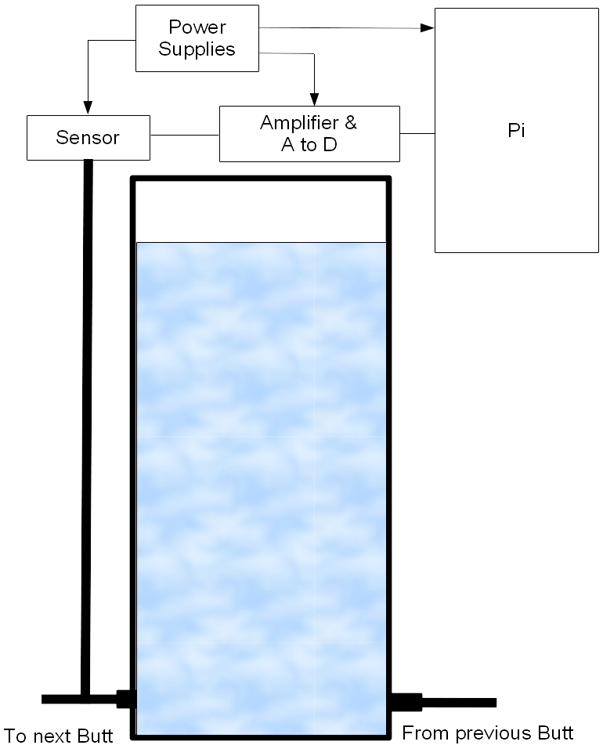

Capacitive Sensors
Capacitive Level Sensors work on the principle of measuring the capacitance of a probe immersed in the fluid. As the water depth increases, so the capacitance varies and this change may be measured in a number of ways.
At the time of writing this technique has been prototyped and is under evaluation. The measurement technique being trialled is to use the capacitance as part of an oscillator circuit and then measure the frequency generated.

Illustration 4.2: Capacitive Sensors – Principle of Operation

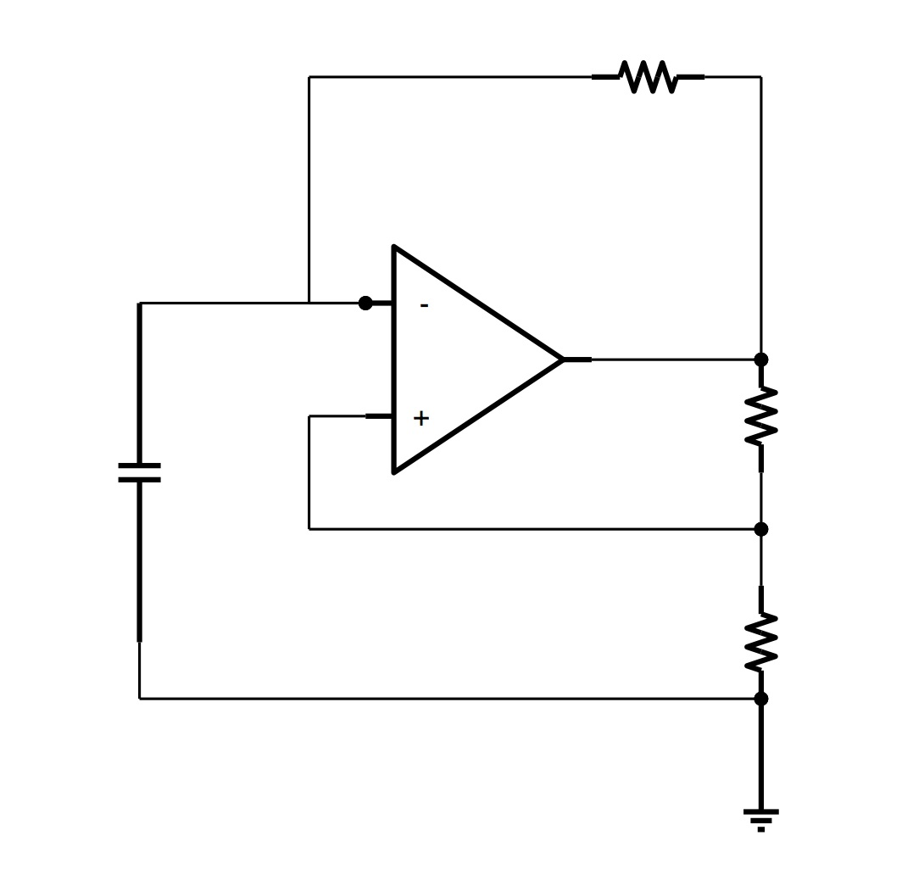
Conductive Probe Sensors
Conductive Probe Sensors use a much simpler technique to measure water level and will be used as a fall-back to mitigate against the risk of the main level sensors failing.
Illustration 4.2 shows the principle of operation.
Illustration 4.3: Conductive Probe Sensors – Principle of Operation
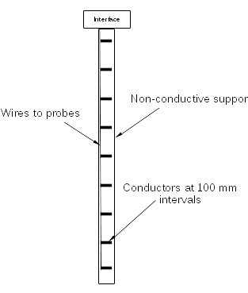

The probes will be arranged as shown and inserted into the butts in a similar manner to the air pressure sensor. Probes will be connected to GPIO pins on the Remote Pi so that as the water progressively shorts them out, the associated pin will go low, signalling that the level has been passed.

Flow Sensors
There will be at least one Flow sensor installed in the system to monitor the volume of water being handled by the river system. Exact installation locations will be determined during development and the devices selected will either be based on a hall-effect device or an opto-coupler, depending on the constraints imposed by installation. Whichever device is chosen, the associated Remote Pi will count the pulse and calculate the flow rate ready for uploading to the Master Pi.
The design of the paddle is TBD.

Hall Effect Devices
A Hall Effect sensor relies on a magnetic field passing the device to generate a current, so if used, the Remote Pi would count pulses to determine the speed of rotation. Illustration 4.3 below shows how it would work in practice.
Illustration 4.4: Hall Effect Sensor – Principle of Operation
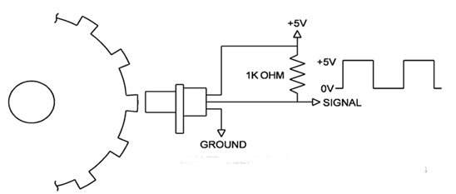

The toothed wheel will be mounted in a river-side building or a tethered boat and will be driven by the paddle wheel.

Opto-Coupler Devices
An Opto-coupler sensor relies on light passing through a slotted wheel generate a current in the sensor, but is otherwise similar in operation to the Hall-effect sensor. Illustration 4.5 below shows how it would work in practice.
Illustration 4.5: Opto-Coupler Sensor – Principle of Operation
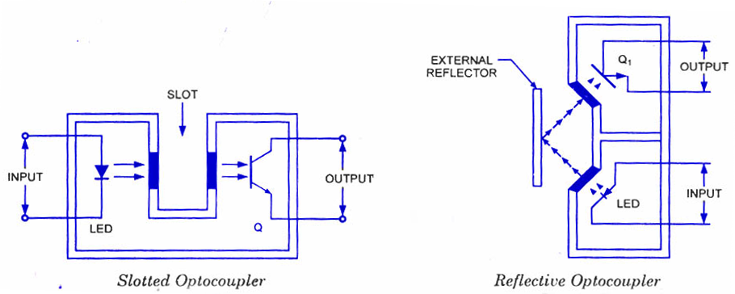

The slotted wheel or reflector will be mounted in a river-side building or a tethered boat and will be driven by the paddle wheel.

Control Devices
There will be two groups of devices utilised to control the movement of water within the rivers system; pumps and valves.

Variable Speed Pumps
This type of pump is already in use in the system; the sump pump is controlled by a PWM drive signal, currently controlled by a manual control box. This pump will remain in place but be brought under the control of the Master Pi, either directly or via a Remote Pi, depending on the physical location of the Master Pi. A Level Translator (see below) will be used to protect the Pi’s GPIO pins and to boost the PWM voltage to 5 V.
Additional variable speed pumps may be needed for future phases of the project.

Fixed Speed Pumps
The WMT already has one of these pumps in that the old sump pump was fixed speed. It is expected that this pump will be recycled to move water from the sump to the butts. This pump will be under the control of the Master Pi, either directly or via a Remote Pi, depending on the physical location of the Master Pi. A relay will be used to carry the mains voltage needed for the pump.

Water Control Valves

2-Port Solenoid Valves
2-port solenoid valves will be used as a remote stop-tap to control the flow of water within a pipe. These valves will be under the control of the Master Pi, either directly or via a Remote Pi, depending on the physical location of the Master Pi. A relay or MOSFET Driver will be used to carry the current required by the solenoid.

3-Port Solenoid or Motorised Valves
3-port solenoid valves will be used as to divert the flow of water from one destination to another. Some types of these valves are actuated using solenoids and some by a motorised mechanism. Whichever type is ultimately selected, these valves will be under the control of the Master Pi, either directly or via a Remote Pi, depending on the physical location of the Master Pi.

Miscellaneous Hardware
The following additional items of hardware will be used to realise the River System.

Ethernet Adaptors
The Master Pi (a Pi 3) already has an Ethernet port, but the Remote Pis do not. Each Remote Pi will therefore be provided with an Ethernet Adaptor to allow remote communication. This device will either be a USB to Ethernet Adaptor or a daughter board device.

Ethernet Switch
An Ethernet Switch will be provided to allow interconnection of the various Pis. This device will be installed at a convenient location; probably adjacent to the Master Pi or the WebGUI Pi.

Analogue to Digital Converter
Measurements that result in a small DC signal will be converted to digital using the circuit shown in Illustration 4.5 below.
Illustration 4.6: Analogue to Digital Converter
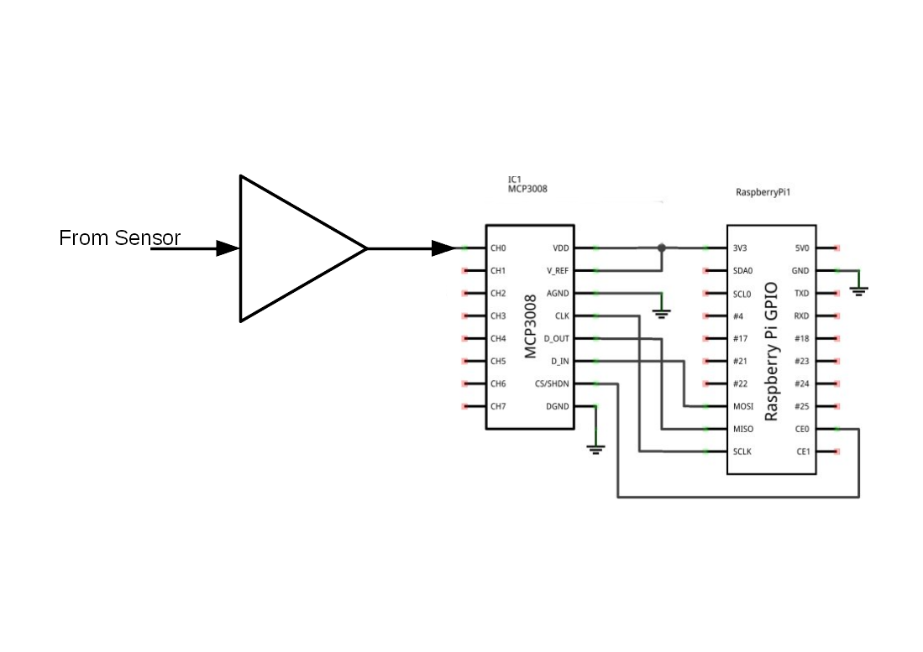

Level Translators
Level Translators will be needed to avoid the need to distribute too many power supply voltages. The Raspberry Pis will need a 5 V supply but expect 3.3 V logic levels. Similarly the Raspberry Pis deliver 3.3 V at the GPIO outputs, but the Motor Drive Board needs 5 V PWM.
The exact method of performing this level translation is still being evaluated at the time of writing, but is expected to be based on non-inverting buffers.

Relays
At this stage of development, it is uncertain whether relays will be required. MOSFET Drivers will probably suffice for most applications, but if mains voltages or very high DC voltages have to be switched, then relays will be considered. A Relay Board was utilised for the Model Railway Lighting Project, but it contains 8 10 A relays, so may physically be too large for the River System requirements if there is only one device that requires a relay. In this case then a stand-alone relay switched by a MOSFET Driver would be considered. The relay could be a solid state type.

Power Supplies
The following power supplies will be provided:
- Mains for pumps, PSUs, etc
- 24V for Sump Pump.
- 12 V, TBD A for valves and pumps.
- 5 V, 2.5 A – Master Pi and PWM signal, if used at that location.
- 5 V, 2 A – Each Remote Pi and PWM signal, if used at that location.
The exact method of providing these supplies and distributing them around the system is still under evaluation, but one technique that is being evaluated is described below.

Distributed DC
This technique will use the following arrangement:
- Mains power will be made available at a central location such as the sump pump controller, where it is already provided.
- Mains will be switched to the butts pump using a relay.
- 24 V DC will be derived from the mains supply and used to drive the main sump pump.
- 24 V DC will be injected into one or more Power over Ethernet (PoE) injectors. Each injector will be connected to a remote site using Cat 5 Ethernet cable.
- At each remote site a DC-DC Converter will produce 5 V DC to drive the Raspberry Pi and PWM Level Translator if required.

Graphical User Interface Hardware

WMT Staff Interface
The WMT Staff interface will be provided by a Web GUI Server and it is expected that this function will be fulfilled by the Master Pi. Either way, a Raspberry Pi 3 will be required, to ensure sufficient overhead to serve data to remote clients and the Visitor Interface.
The Web GUI server will provide a control display to allow WMT staff to monitor water levels and flow rates to ensure the correct functioning of the system. A manual override facility will also be provided.

Visitor Interface
The goal is to utilise the existing Audio Guide and Town Quiz web server to perform this function. A subset of the Web GUI will be provided to allow remote monitoring only of the water levels and flow in the river system, plus some educational material.

Software
The full identification and quantities of all software items may be found in Annex B.

Master Pi

Software Functions

Monitoring
Code will be written in Python and will implement the following functions:
- Continuously monitor the following values received from Remote Pis :
  - Water levels in:
    - Butts.
    - Sump.
  - Flow in the river.
- Monitor health / presence of Remote Pis
- Automatic start-up on application of power
The above functions will continue until a manual override is detected or the power is removed.

Control
Code will be written in Python and will implement the following functions:
- Using the data gathered by the sensors and received from the Remote Pis, determine the likely outcome of rising and falling water levels and flow rates to:
  - Control the speed of the sump pump to maintain the level and flow of water needed in the river.
  - Automatically open and close valves to allow the flow of water to and from the butts.
  - Turn on the butts pump to lower the level in the sump if it becomes too great.

Remote Pis

Software Functions

Monitoring
Code will be written in Python and will implement the following functions:
- Monitor the following sensor values, convert them from raw data and transmit results to the Master Pi:
  - Water levels in:
    - Butts.
    - Sump.
  - Flow in the river.
- Automatic start up on application of power, under control of Master Pi.
- A Watchdog function will be provided in each device to signal faults to the Master Pi.
The above functions will continue until a manual override is detected or the power is removed.

Control
Code will be written in Python and will implement the following functions if required:
- Respond to commands from the Master Pi to control:
  - Pumps.
  - Valves.

Graphical User Interface

Web GUI Server
The Graphical User Interface will be implemented by running a webserver on the Master Pi, or a separate Web GUI Pi if needed. The following standard software will be installed on the server:
- Webserver - nginx plus modules.
- DNS server -dnsmasq.
Server code will be written in HTML and Javascript and / or Python and will implement the following functions:
- Provide buttons and other GUI elements to allow the user to:
  - View the status of the automatic control system.
  - Provide a simulation of the system so that visitors may understand the operation of the system.
  - Show the results of monitoring the:
    - Water levels in:
      - Butts.
      - Sump.
    - Flow in the river
  - For WMT Staff only, provide controls for the user to select:
    - Master On-Off for the system.
    - Manual control of the:
      - Sump Pump.
      - Butts pump.
      - Individual valves.

Operating System
The Operating System used for the Master and Remote Pis will be Raspbian. During development, the Operating System will be run normally, but during deployment, the Master Pi and Remote Pis will be run in Read-only mode, to allow for uncontrolled shutdowns and restarts.

Software Documentation
Comments will be included in all software developed specifically for the WMT to allow future developers to maintain the code.
A full description of the implementation of code that provides the River System will be provided in the Installation Manual (see Reference 2 in Section 2).

ENVIRONMENTAL
All system hardware will be contained within equipment cases.
Note: The final installation locations have yet to be determined, so the following is provided as a starting point
Any electronic equipment will be installed within a benign environment or an IP65 case to ensure that it is protected from the elements. The equipment case will also function to protect the equipment from unauthorised access.
For equipment installed in sealed cases, attention will be paid to the housing of the hardware, particularly the need to keep the equipment cool and dry. It may become necessary for this case to include an internal heatsink to conduct heat from the air inside the case and therefore keep the internal environment below 35º C.
The Master Pi will be installed at any convenient location with good access to power and the Ethernet based network.
The Remote Devices will be installed adjacent to where they are used.
Outside advice will be sought during development to ensure that none of the River Systems functions causes any harm to the environment and provides the maximum environmental enhancement.

OPERATIONAL

Powering Up and Down
The Operator will be able to:
- Start either of the systems by switching on the supply at the mains socket.
- Stop either of the systems by switching off the supply a the mains socket. This will be achieved safely by the use of Read-only file systems or a Uninterruptible Power Supply.

Reliability and Maintainability

Reliability
- All components carrying powers in excess of 1 W will be derated by at least 20 % for power supplies and 50 % for other components.
- The SD Card will be protected from corruption by the methods defined in Sections 6.1.1.
- Adequate ventilation will be provided. It is not believed that forced cooling will be required, but if necessary, a fan will be incorporated to cool the components.

Maintainability

Documentation
- Full documentation will be provided as follows:
  - Design (this document).
  - Installation (to describe how to create the software and write it to the SD Card). See Reference 2 in Section 2.
  - User Manual showing the removal and replacement of components, where the procedure is not straightforward. See Reference 4 in Section 2.
All development must be documented sufficiently so that a person with reasonable electrical / electronic / software competence, as appropriate, can fault find, repair and maintain the system; typical requirements:
- Block diagram.
- Wiring Diagram.
- Circuit Diagram.
- Digital photographs.
- All software will be documented with comments.
- Description of any novel or unusual software.
The documents should be sufficiently annotated to allow a competent person to build, test and set-up the component, assembly or sub-system in question.

Spares and Repairs
- Spares will be provided as defined in Annex D.
- No special tools will be required to repair the system, other than standard items normally found in a general purpose tool kit.
- Full backups of all software developed will be provided.
- Tamper proof fixings and locks will be utilised for any equipment that is accessible to the public.

EDUCATIONAL
Outside advice will be sought during development to ensure that the system provides the maximum educational value to Visitors to the WMT.

SAFETY
With the exception of the power supply inputs and the main and subsidiary water pumps, all circuits will operate at less than 20 V. The mains inputs to the PSUs and pumps will be contained within a protective case.

ASSUMPTIONS
The following assumptions are made.
- Future system developers will have a working knowledge of Linux, Python programming and Web development.
- System maintainers will be sufficiently skilled in general maintenance, electronics, electrical systems and software, as appropriate to be able to follow the diagnostic instructions provided in the User Manual.

SUMMARY OF CHANGES TO THIS DOCUMENT
The Table below details the changes made to this document for each revision.
Table 2: Summary of Changes to this Document

Issue | Section | Summary of Change
0.1 | - | First draft.
0.2 | - | Initial Comments
0.3 | - | Further Comments
0.4 | - | Version archived as basis for Summer 2017 development
0.5 | - | Changed all styles to sans-serif and accepted earlier changes.

Annex A
Requirements Cross-Reference

Paragraph Numbers in Column 1 refer to Reference 1 in Section 2.
Functional
No | Requirement | Para
 | TBD
Operational
No | Requirement | Para

Environmental
No | Requirement | Para

Reliability
No | Requirement | Para

Maintainability
No | Requirement | Para

Safety
No | Requirement

Documentation
No | Requirement | Para

Miscellaneous
No | Requirement | Para

Annex B
Hardware Identity
This Annex defines the hardware required for system implementation. Many of these items are free delivery and some attract a delivery charge of a few pounds. Assume £10-15 total delivery. A list of spares may be found in Annex D. These would be procured at the same time as the Development items, so would attract no additional delivery costs.
River System Phase 4 Development
Computing Devices
Item | Identity | Qty | Cost Each | Total Cost
Master Computer | Raspberry Pi 3 (Raspberry Pi Foundation). | 1 | £30 | £30
Remote Computers | Raspberry Pi Zero (Raspberry Pi Foundation). | TBD | £4 | £4

Interfaces and Accessories

Item | Identity | Qty | Cost Each | Total Cost

Power Supplies

Item | Identity | Qty | Cost Each | Total Cost

Miscellaneous

Item | Identity | Qty | Cost Each | Total Cost

Annex C
Software Identity
This Annex defines the software required for system implementation.
Item | Identity | Qty
Operating System | Raspbian for development and deployment . | TBD

Annex D
Spares
This Annex defines the spares required for system maintenance.
Item | Identity | Qty | Cost Each | Total Cost
 | TBD

