WIMBORNE MODEL TOWN
DEVELOPMENT
RIVER SYSTEM: INSTALLATION SPECIFICATION
Issue 0.9
14th May 2020



This work is licensed under the Creative Commons Attribution-NonCommercial-ShareAlike 4.0 International License. To view a copy of this license, visit http://creativecommons.org/licenses/by-nc-sa/4.0/.

Table of Contents
1 INTRODUCTION 5
1.1 Development Documents 5
1.2 Referenced Documents and Resources 5
2 ABBREVIATIONS 6
3 PROJECT ARCHIVES 6
4 SYSTEM FUNCTIONS 7
4.1 Hardware 7
4.1.1 Installation 7
4.1.2 Electrostatic Sensitive Devices 7
4.1.3 Hardware Environment 7
4.1.4 System Layout 7
4.2 Software 8
4.2.1 Software Environment 8
4.2.2 Development Tools 8
4.3 Detailed Description Of Software Functions 8
4.3.1 General 8
4.4 Deployment 8
4.4.1 Software Environment 8
4.4.1.1 Prepare the Basic Installation 9
4.4.1.1.1 Initial Setup 9
4.4.1.1.2 Common Software Installation 10
4.4.2 Prepare SD Cards for Specific Pis 10
4.4.2.1 Additional Network Configuration 10
4.4.2.1.1 Setup a Static IP Address 11
Save the changes (Crtl O, <Enter>, Ctrl X). 11
4.4.2.2 Setting the Hostname 11
4.4.2.3 Adding the Software Framework 11
4.4.2.3.1 Changes to Consider Before Adding the Software Framework 12
4.4.3 Additional Sump Pi Configuration 12
4.4.3.1 Time Synchronisation 12
4.4.3.2 Installation and Configuration of Software Specific to SumpPi 13
4.4.3.3 Autostart of the Sump Pi Software 13
4.4.4 Butts Pi(s) Configuration 13
4.4.4.1 Autostart of the Butts Pi(s) Software 13
4.4.5 Gate Pi(s) Configuration 13
4.4.5.1 Autostart of the Gate Pi Software 14
4.4.5.2 Making the SD Card Read-Only 14
4.4.6 NAS Box Configuration 14
4.4.6.1 Logging In 15
4.4.6.2 Changing the Admin Password 15
4.4.6.3 Firmware Updates 16
4.4.6.4 Installing Custom Settings 18
4.4.6.4.1 Temporarily enabling built-in SSH server 19
4.4.6.5 Installing phpMyAdmin using D-Link’s package 20
4.4.6.6 Upgrading phpMyAdmin 21
4.4.6.7 Installing Custom Start-Up Scripts and Sysroot 23
4.4.6.8 Adding SSH Keys 24
Creating an SSH Key Pair for User Authentication 24
Copying the Public Key to the Server 25
4.4.6.9 Disabling built-in SSH server 25
4.4.6.10 How to Build the Cross-compiler 25
4.4.6.10.1 Environment 25
4.4.6.10.2 Ready-built Cross-compiler 26
4.4.6.10.3 Reproducing the Original Cross-compiler 26
Links to Resources: 26
Dependencies 26
4.4.6.10.4 Downloading the Cross compiler 26
4.4.6.10.5 Configuring the cross compiler 27
4.4.6.10.6 Menu configuration 27
4.4.6.10.7 Patching the Build Scripts 29
Linux Kernel Download Location 29
MPC download location 29
DUMA download location 29
4.4.6.10.8 Starting the Build 30
4.4.6.10.9 Cross-compiling and Building the Updated NAS Software 30
4.4.6.10.10 Extra feature: Running armv5 binaries in the Build Environment 30
5 TESTING 31
5.1 Unit Testing 31
5.1.1 Hardware 31
5.1.2 Software 31
5.2 System Testing 31
5.2.1 Virtualisation 31
5.2.2 Cut-down Pi Configuration. 32
Illustration 1: River System – System Test Diagram 32
6 GENERAL MAINTENANCE ACTIVITIES 35
6.1 Backing Up and Restoring SD Cards 35
6.1.1 Backing Up 35
6.1.1.1 From Within Raspbian 35
6.1.1.2 From a Linux Computer 35
6.1.1.2.1 Identify the Device 35
6.1.1.2.2 Writing an Image 36
6.1.2 Restoring 36
6.1.2.1 Using Etcher 36
6.1.2.2 From a Linux Computer 36
Index of Tables
Table 1.1: Related Documents - Development 5
Table 1.2: Related Documents -River System Project 5

Table of Figures
Illustration 1: River System – System Test Diagram 32

ANNEXES
A Using Virtual Machines to Test the Software - Creating the Virtual Machines
B Using Virtual Machines to Test the Software - Configuring the Virtual Machines
C Using Virtual Machines to Test the Software - Using the Virtual Machines5

INTRODUCTION
This specification provides information for future developers of the River Control System at Wimborne Model Town.
Where possible, the system has been designed to be as easy as possible to operate, maintain and upgrade.
This document should be read in conjunction with the Design Specification and the User Manual.

Development Documents
The following documents were generated as part of this development.
Table 1.1: Related Documents - Development
No | Document | Iss
1 | Wimborne Model Town – River System - Requirements | ?
2 | Wimborne Model Town – River System - Design | ?
3 | Wimborne Model Town – River System – User Manual | ?
4 | Wimborne Model Town – River System – Software Design Specification | ?

Referenced Documents and Resources
The following documents and resources are useful for supporting development.
Table 1.2: Related Documents -River System Project

No | Resource | Ref
1 | Python Tutorial | https://docs.python.org/3.7/tutorial/index.html
2 | Python Documentation | https://docs.python.org/3.7/index.html
3 | Raspberry Pi GPIO Tutorials | http://raspi.tv/
4 | Deleted
5 | Setting a static IP Address | https://www.modmypi.com/blog/how-to-give-your-raspberry-pi-a-static-ip-address-update
6 | Make the SD Card Read-only | https://learn.adafruit.com/read-only-raspberry-pi/
7 | How To Autorun A Python Script On Raspberry Pi Boot | Run as Another User
8 | GitLab Project – River System | River System Project
9 | Etcher – SD Card copier. | https://etcher.io/
10 | Tutorial on backing up and restoring SD Cards. | http://thepihut.com/blogs/raspberry-pi-tutorials/17789160-backing-up-and-restoring-your-raspberry-pis-sd-card
11 | Tutorial on shrinking image files. | https://softwarebakery.com//shrinking-images-on-linux

ABBREVIATIONS
- AP - Access Point
- ESD - Electrostatic Sensitive Device
- GPIO - General Purpose Input / Output
- IDE - Integrated Development Environment
- PCB - Printed Circuit Board

PROJECT ARCHIVES
A copy of all project documentation, code and software environments may be found at the relevant GitLab Project, (see References 1.2.1.8).

SYSTEM FUNCTIONS

Hardware

Installation
Installation of the hardware is covered in the User Manual and this document is confined to work that will only need to take place if the system has been revised and upgraded; an activity that might trigger a need to strip the system out or redesign some elements.

Electrostatic Sensitive Devices
CAUTION Electronic devices used in the system are sensitive to static electricity. Precautions should be taken when handling these devices in order to prevent permanent damage.
The Raspberry Pis and the other Printed Circuit Boards (PCBs) contain devices that can be damaged if they are exposed to static electricity. Static Electricity is readily generated when people walk over dry floors, rub against furniture or simply rub against their clothing. Although rarely noticed, the level generated is sufficient to damage devices if precautions are not taken. It is therefore recommended that no work be undertaken on these devices without taking one of the following actions:
- If possible an ESD workstation be employed. An ESD workstation includes an Antistatic Mat, a conductive wrist band and a means of earthing the mat and band, usually via a three-pin mains plug with a resistive earth pin.
- It is recognised that the WMT is not conducive to setting up an ESD workstation, so maintainers should endeavour to earth themselves by touching an earthed metal object at intervals during the work, especially after it has been necessary to leave the work area and return. A good compromise would be to use a wrist band clipped to a convenient earth point.

Hardware Environment
The hardware in this system was developed and assembled before final debugging was carried out, since this proved to be the only feasible method in the time available. However, this is not essential, and a breadboard and local Ethernet could be employed for future enhancements.

System Layout
Full details of the physical and electrical layout of the system may be found in the User Manual.

Software

Software Environment
Much of the development of the software for the River System Functions may be performed on any computing device, but will be simplified if suitable tools are available as detailed below. Debugging must be performed on the target device, with suitable hardware attached (see Section 4.1.3 above) in order that the Python Interpreter may import all the necessary libraries and the software functions may be observed in operation. During the original development Raspberry Pi Model Zeros, running the Raspbian Operating System, were used for final development, with a Pi 3 being used for initial coding.

Development Tools
Raspbian includes all of the tools necessary to write and develop the program. Much of the original development was carried out using the IDLE Integrated Development Environment, but other development toolsets such as Thonny or Eclipse may be used if desired.

Detailed Description Of Software Functions
A detailed functional description of the River System software design may be found in the automatically generated documentation.

General
The River System Functions code was written using Python Version 3.7.x. For simple code constructs and approaches, a good start would be the Python Tutorial at Reference 1.2.1. The full documentation for Python 3.x may be found in the Python Docs at Reference 1.2.2 and may be needed to interpret the detailed descriptions provided below.
Similarly, the RPi.GPIO Library was used to control the input and output functions and a series of Tutorials may be found at Alex Eames site (Reference 1.2.3).

Deployment

Software Environment
The deployed image on the SD Card is Raspbian Lite, run in ‘read-only root’ mode. Details of how to prepare the SD Card for deployment are given below. The Initial Setup stage is easiest to perform if a separate PC is used.
Note: The Basic Installation described in Section 4.4.1.1 below assumes that there is no existing deployed software or it is intended to fully upgrade the underlying Operating System. If a deployed system is operating and it is necessary to add an additional device, then a backup should be taken of SD Card of one of the deployed devices and that image burned to a new SD Card (see Section 5 below). This ensures that all devices are running the same software.

Prepare the Basic Installation
Download the appropriate version of Raspbian Lite from https://www.raspberrypi.org/downloads/raspbian/ and unzip the image using the host PC’s native tool. Burn the image file to an 8 GB SD Card (using an appropriate adaptor) as described in Section 5 below. Remove the SD Card from the PC.

Initial Setup
Insert the SD Card into a Raspberry Pi computer and apply power.
Note: Any Raspberry Pi will do for this and many of the the subsequent steps, but access to the Internet will be needed and it is less likely that issues will subsequently be encountered if a Raspberry Pi Zero is used.
After the system has booted, log in using the Username ‘Pi’ and the password ‘raspberry’.
Type the following at the command line:
sudo raspi-config

Using raspi-config’s menu items setup the following:
- Change the password to ‘river17’.
- If a plugin WiFi adaptor is being used during this process, then enter ‘Network Options’ and setup the SSID and Passphrase.
- Enter ‘Boot Options’ and set the Pi to boot into the CLI and automatically log in to the Pi User.
- Under ‘Localisation Options’, check that:
  - The ‘Locale’ and ‘Keyboard’ settings match the keyboard type that is intended to be used for the River System setup.
  - If a plugin WiFi adaptor is being used during this process, then setup the WiFi Channel.
  - In the ‘Timezone’ setting, select ‘UTC’.
- Under Interfacing Options’, enable ‘SSH’ and ‘I2C’.
- Select ‘Finish’ and ‘Reboot’.

Common Software Installation
Use the following command to install the additional Python modules needed for execution of the Software Framework:
sudo apt update
sudo apt upgrade
sudo apt install rdate
sudo apt install RPi.GPIO
sudo apt install python3
sudo apt install python3-pip
pip3 install adafruit-circuitpython-ads1x15
pip3 install psutil
pip3 install mysqlclient

Note: Depending on the version of Raspbian used, some of the above may be already installed.
Shutdown the Pi:
sudo shutdown now

Remove power from the Pi and remove the SD Card.
Backup the SD Card, as described in Section 5.1, giving the image file the name:
YYYY-MM-DD_River_System_Base_SD-Card.img

This ‘Base’ image subsequently be used to create SD Card for specific Pis unless a copy of the SD Card installed in the deployed system is to be used.
Note: If the SD Card image that was used to create the new card has been marked as ‘Read-Only’, then all configuration will need to be done with the card mounted in another computer, such as a PC.

Prepare SD Cards for Specific Pis
From this point onwards, it is assumed that all the preceding steps in Section 4.4.1 above have been carried out or that the SD Card image created at an earlier time has been used to create the new SD Card.

Additional Network Configuration
In the final deployment there may be no DHCP server available, so each Pi has been given a static IP Address. Reference 1.2.5 provides a method of doing this on a Raspberry Pi and the following sections detail the procedure.

Setup a Static IP Address
To set a static IP address, enter a shell and type:
sudo nano /etc/dhcpcd.conf

At the bottom of the file add:
interface eth0
static ip_address=192.168.0.2/24
static routers=192.168.0.254
static domain_name_servers=192.168.0.1

Save the changes (Crtl O, <Enter>, Ctrl X).
Note: In the example above, the allocated IP Address applies to sumppi. Remote Pis will have their static IP Address updated during the specific configurations described below. A full list of assigned IP Addresses may be found in Reference 1.1.4 and the auto-generated software documentation, under ‘config.py’.

Setting the Hostname
Run ‘raspi-config’, enter ‘Network Options’, and set the hostname to the name chosen for the device, eg ‘sumppi’. See Reference 1.1.4 for a full list of the configuration data of all devices.

Adding the Software Framework
On a suitable PC and copy the latest version of the Software Framework from the WMT repository at https://gitlab.com/wmtprojectsteam/rivercontrolsystem/tree/master. This may be done in a number of ways and if the git repository is already installed on the PC, and up to date with the referenced repository, then the ‘rivercontrolsystem‘ directory may be copied directly to the ‘pi’ directory on the SD Card (plugged into an adaptor). Alternatively, the code may be downloaded from the referenced site, unzipped and copied in the same way.
If the new SD Card is to replace a faulty, already deployed, card, then this step will be all that is necessary. Otherwise, it will almost certainly be necessary to update the software before copying it as shown in the following Section.

Changes to Consider Before Adding the Software Framework
If the device is being deployed in that location for the first time, eg a new Pi Interface or Gate Valve to expand the system, then changes to the Software Framework will probably be needed before it is added. Changes that should be considered include:
- Definition of the Device in SITE_SETTINGS (config.py):
  - Under “SUMP”, add the socket “ID”, “Name” and “PortNumber”, the Probe definitions and the device definitions, as applicable.
  - Under ‘clients’, add the Probe and Device definitions and the “ServerAddress”, “ServerPort” and “ServerName”.
- Update the control algorithm as appropriate, eg ‘do_control_logic() to use the new device.

Additional Sump Pi Configuration
Note: If the card has been marked Read-Only, then it will not be possible to complete this Section unless the card was copied from an original SumpPi SD Card. In that case, this section should be unnecessary.

Time Synchronisation
The Master Pi, (currently sumppi) has a physical Real Time Clock installed on GPIO Pins 1 to 6 rdate will be used on all Pi’s to synchronise all local clocks to the Real Time Clock installed in sumppi. Configure Sump Pi to read and use this clock as detailed below:
Edit the file /boot/config.txt as follows:
sudo nano config.txt

add:
dtoverlay=i2c-rtc,pcf2127

After restarting, the RasClock should be recognised and can be controlled with the hwclock command. Edit the file /lib/udev/hwclock-set
Comment out or remove the three lines
if [ -e /run/sadaystemd/system ] ; then
exit 0
fi
Comment out or remove the two lines which contain –systz.

Installation and Configuration of Software Specific to SumpPi
In a shell issue the following command:
sudo apt install xinetd
sudo nano etc/xinetd.d/time

In two places, change ‘disable = yes’ to ‘disable = no’

Autostart of the Sump Pi Software
After boot up, the relevant program is launched by including the following code in .bashrc for the Pi user:
if [ $(tty) == /dev/tty1 ]; then
cd rivercontrolsystem
./main.py --id "SUMP”
fi

Where <ID> is the identity of the Pi as given in Table 2 of Reference 1.1.4.
This will ensure that the program is only ever launched once and prevents subsequent logins via SSH from starting a new instance.

Butts Pi(s) Configuration
Note: In the current design there are four Butts Pis; eg, behind the Wendy House, behind the Stage, behind the Lady Hanham Building and behind the Gazebo. Configuration is identical for all of these apart from the hostname Section 4.4.2.3), the IP Address (Section 4.4.2.2) and the Autostart command (Section 4.4.4.1).

Autostart of the Butts Pi(s) Software
This is achieved in a similar way to the Sump Pi configuration. Add the following lines at the bottom of the file home/pi/.bashrc:
if [ $(tty) == /dev/tty1 ]; then
cd rivercontrolsystem
./main.py --id "ID"
fi
Where ‘ID’ is the Device Name as detailed in Reference 1.1.4.

Gate Pi(s) Configuration
Note: In the current design there are eleven Gate Valvess; eg, V6-V9 (the Matrix Pump) plus V4, V5 and V11 behind the Wendy House, V1, V2, V3 behind the Lady Hanham Building and V5 behind the Gazebo. Configuration is identical for all of these apart from the hostname Section 4.4.2.3), the IP Address (Section 4.4.2.2) and the Autostart command (Section 4.4.5.1.

Autostart of the Gate Pi Software
This is achieved in a similar way to the Sump Pi configuration. Add the following lines at the bottom of the file home/pi/.bashrc:
if [ $(tty) == /dev/tty1 ]; then
cd rivercontrolsystem
./main.py --id "ID"
fi

Where ‘ID’ is the Device Name as detailed in Reference 1.1.4.

Making the SD Card Read-Only
This procedure is not reversible, and will prevent the Readings and Log files being written to the SD Card, so should only be carried out when a strategy for storing this information has been agreed and implemented. Setting the SD Card to Read-Only mode may be done using the procedure in the following web page https://learn.adafruit.com/read-only-raspberry-pi/. This involves running a script to create a protected run-time environment.

NAS Box Configuration
Note: At the time of writing, the NAS box isn’t actually installed in the system, and not all procedures are finalised so this documentation is somewhat incomplete.
The D-Link DNS-320L provides details of many of the procedures described in this Section, in particular those that are not specific to the River System installation.
Notes:
1. Performing a factory reset will NOT delete data from the hard drive(s), so it should not be necessary to perform all these configuration steps again after a factory reset.
2. After a factory reset, the IP address of the NAS Box is not fixed by default. It may be necessary to run the software CD on a computer running Windows XP or higher to perform initial setup of the NAS Box. A copy of the CD Image may be found at https://wmtprojectsforum.altervista.org/files/wmt%20river%20system%20files/nas%20box/software%20cd.iso.xz.
3. After a factory reset, the administrator password is blank and will need to be changed (see Section 4.4.6.1 below).
4. Once set, the administrator password should be recorded and stored in a safe place, because the only way to recover if the password is forgotten is by performing a factory reset.
5. During the procedures that follow, newer updated software is built using a Cross-compiler and installed onto the device. Ensure these steps are carried out in the order stated to avoid being locked out of SSH Login.

Logging In
The initial configuration of the NAS Box is performed via the standard D-Link Admin page. This is obtained as follows:
- Using a standard browser, navigate to the NAS Box’s web address (https://192.168.0.25 when deployed), log in with the administrator password, and tick “Use SSL”.
Note: This may create a security warning in the browser. It should be possible to bypass the error, but if not, untick “Use SSL” and try logging in again.

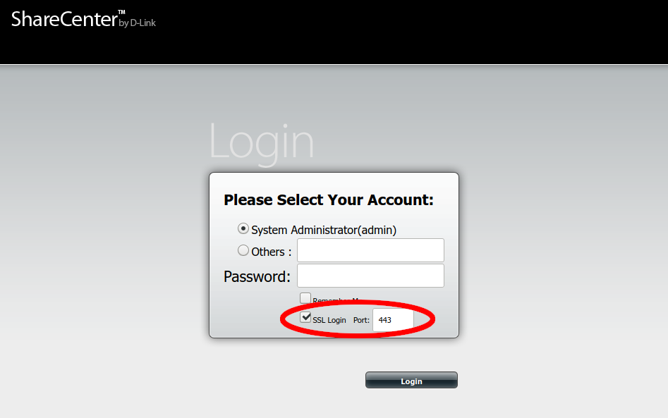

Changing the Admin Password
After the login has been successfully achieved, the administrator password may be changed on the “Account Management” page:
- Click on “Management”.
- Click on the “Account Management” icon.
- Select the “Admin Password” item in the sidebar.
- Enter the existing administrator password (blank after a factory reset), then the new password and then repeat the new password.

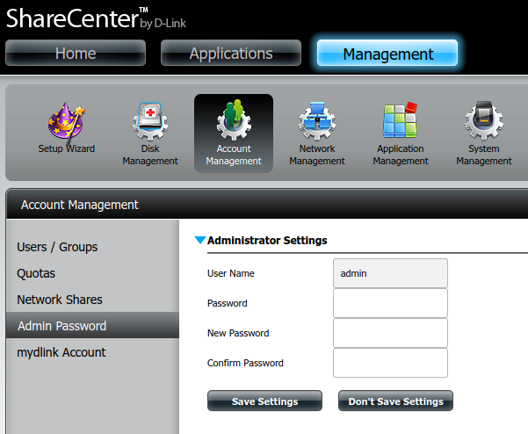

Firmware Updates
It is not envisioned that there will be future firmware updates to the NAS Box, but to ensure the firmware used remains available, it has been uploaded to https://wmtprojectsforum.altervista.org/files/WMT%20River%20System%20Files/NAS%20Box/DNS-320L_fw_revA3_1-11_eu_multi_20180709.zip. If this file becomes unavailable, download version 1.11 revision A3 from https://eu.dlink.com/uk/en/products/dns-320l-sharecenter-2-bay-cloud-storage-enclosure#support instead.
WARNINGS:
1. No other firmware version should be used unless the software has been tested to work with it.
2. Be aware that updating the firmware may mean that the whole NAS box has to be set up again!

The process for reinstalling the firmware is as follows.
- Download the firmware using the above link.
- Log in the the device as described in Section 4.4.6.1.
- Click the “Management” button at the top of the dashboard.
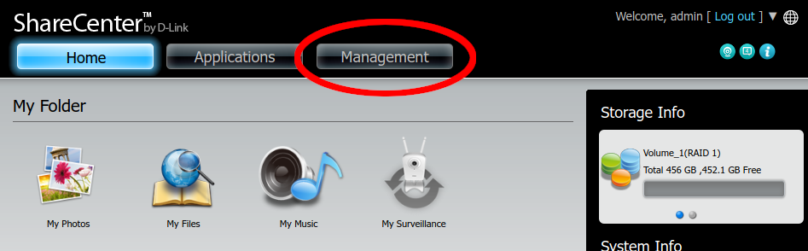
- Click on the “System Management” icon.
- Select “Firmware Upgrade” from the sidebar.
- Use the browse button on the resulting screen to select the firmware downloaded earlier and click “Apply” to update.
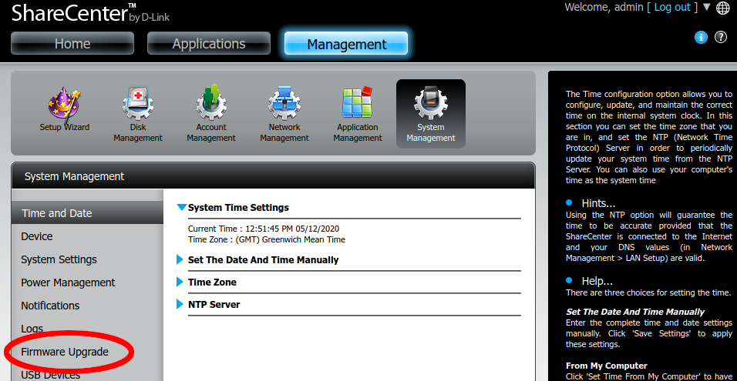

Installing Custom Settings
The NAS box provides an easy way to restore custom configuration. This won’t work for everything, but it will allow easy restoring of most system settings.
- Download the file called “custom_settings.tar.gz” from https://wmtprojectsforum.altervista.org/forum/viewtopic.php?f=36&t=152.
- Navigate to System Management as described above.
- Next, click “System Settings”, expand “Configuration Settings”, browse for the file downloaded, and click “Load”.
- The NAS box will restart.
- From now on, the IP address of the NAS box will be 192.168.0.25.
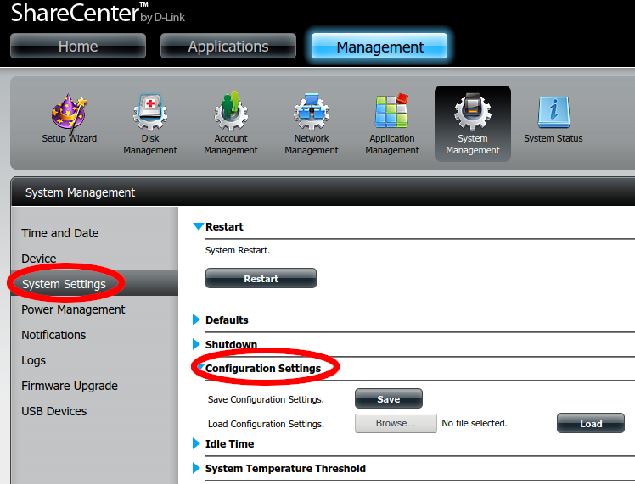

Temporarily enabling built-in SSH server
In order to complete the rest of the setup process, the built-in SSH server needs to be temporarily enabled. This will be disabled later, as the custom software provides a newer and more secure SSH server.
- Click the “Management” button and then navigate to “Network Management”.
- Click “SSH”, tick “Allow SSH connection” and enter “2222” into the Port number field.
- Click “Save Settings”.
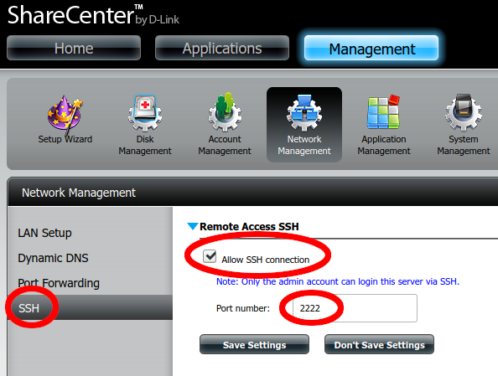

Installing phpMyAdmin using D-Link’s package
The tool phpMyAdmin (https://www.phpmyadmin.net/) is required on the NAS Box for database management and is also used to bootstrap the rest of the custom software on the NAS box. The easiest way to install phpMyAdmin is to use D-Link’s official package. This is available for download at https://wmtprojectsforum.altervista.org/files/wmt%20river%20system%20files/nas%20box/packages/dns-320l%20phpmyadmin%20package%20v1.02_09212015.tar. To install this:
- Download phpMyAdmin.
- Click the “Applications” button at the top of the dashboard.
- Click the “Add-on Center” button.
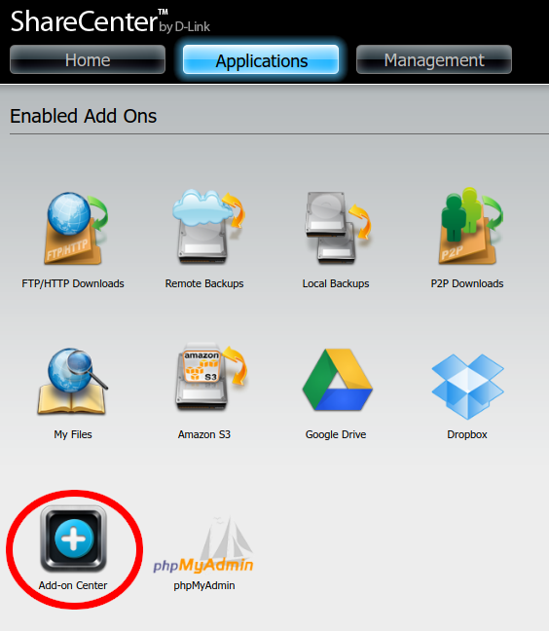
- Click the “Install Manually” button and then browse to the phpMyAdmin file downloaded earlier.
- Click “Install”.
- The NAS box will install phpMyAdmin and then reboot.

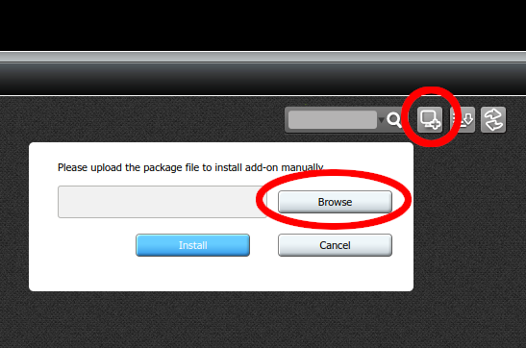
Upgrading phpMyAdmin
The version of phpMyAdmin provided by the package works, but is old and can be updated to improve security. The other old software on the NAS box is a limitation, so version 4.0.10 should be run.
A modified version of 4.0.10 is available at https://wmtprojectsforum.altervista.org/files/WMT%20River%20System%20Files/NAS%20Box/Packages/new-phpmyadmin.tar.gz and contains all the modifications that are needed to get the custom startup scripts working.
In order to deploy this on the NAS box, a USB stick formatted as FAT32 will be needed. It will be necessary to SSH into the NAS box, so detailed instructions are provided.
- Download phpMyAdmin using the link above, and place it on the USB stick.
- Safely remove the USB stick and plug it into the back of the NAS box.
- Click the “Management” button at the top of the NAS box’s admin dashboard.
- Go to “System Management” as before.
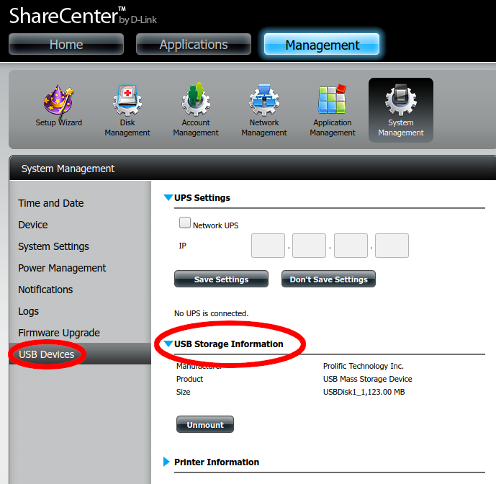
- Click on “USB Devices”, then expand “USB Storage Information”.
- Verify that the device is recognised, and click “Mount” if needed. Please note it can take a few minutes for devices to be recognised, and it may be neccessay to refresh the page.
To SSH in to the NAS box open a terminal and type:
ssh-keygen -f "$HOME/.ssh/known_hosts" -R "[192.168.0.25]:2222"
ssh admin@192.168.0.25 -p 2222 -oHostKeyAlgorithms=+ssh-dss

This should ask for the administrator password. After providing it, the prompt should look like this:
/home/admin #

Now execute the following commands, one line at a time.
cd /mnt/HD/HD_a2/Nas_Prog/
rm -r ./phpMyAdmin
tar xf /mnt/USB/USB1_c1/new-phpmyadmin.tar.gz
sync
umount /mnt/USB/USB1_c1
exit

phpMyAdmin is now up to date. The USB stick can now safely be unplugged.

Installing Custom Start-Up Scripts and Sysroot
The startup scripts are available at https://wmtprojectsforum.altervista.org/files/WMT%20River%20System%20Files/NAS%20Box/nas-other-root-files.tar.xz and the sysroot (which contains all the cross-compiled programs) is available at https://wmtprojectsforum.altervista.org/files/WMT%20River%20System%20Files/NAS%20Box/nas-sysroot.tar.xz.
This will also configure the built-in SSH server with public keys for the users at the time of the original build. Follow procedures below to add your public keys for new users.
In order to deploy this on the NAS box, a USB stick formatted as FAT32 of at least 1 GB capacitywill be needed. It will be necessary to SSH into the NAS box, so detailed instructions are provided.
- Download both files.
- The files need to be decompressed before being loaded on to the NAS box:
  - xz -d nas-sysroot.tar.xz
  - xz -d nasother-root-files.tar.xz

- Copy the files to the USB stick.
SSH in to the NAS box. Open a terminal and type:
ssh-keygen -f "$HOME/.ssh/known_hosts" -R "[192.168.0.25]:2222"
ssh admin@192.168.0.25 -p 2222 -oHostKeyAlgorithms=+ssh-dss

This should ask for the administrator password. After providing it, the prompt should look like this:
/home/admin #

Now execute the following commands, one line at a time. Note that these commands may take a few minutes to run, and they will not output any status information during that time.
cd /mnt/HD/HD_a2/
tar xf /mnt/USB/USB1_c1/nas-other-root-files.tar.gz
tar xf /mnt/USB/USB1_c1/nas-sysroot.tar
echo "/mnt/HD/HD_a2/setup.sh" >> /mnt/HD/HD_a2/Nas_Prog/phpMyAdmin/init.sh
sync
umount /mnt/USB/USB1_c1
reboot

Everything is now installed. The USB stick can now safely be unplugged while the NAS box restarts.
NOTE: The first boot after doing this is likely to be very slow as the setup scripts run for the first time.

Adding SSH Keys
The NAS Box is configured to allow SSH login, but users will need to add their Public SSH Key to the NAS Box. This Section describes how to create an SSH Key Pair and upload the resulting public half of the pair to the correct location on the Box.
This Section is based on the information provided at https://www.ssh.com/ssh/keygen/.

Creating an SSH Key Pair for User Authentication
The simplest way to generate a key pair is to run ssh-keygen without arguments. The user will be prompted for the file in which to store keys, but the default can be taken. As an example:
klar (11:39) ~>ssh-keygen
Generating public/private rsa key pair.
Enter file in which to save the key: (/home/ylo/.ssh/id_rsa):
Enter passphrase (empty for no passphrase):
Enter same passphrase again:
Your identification has been saved in /home/ylo/.ssh/id_rsa.
Your public key has been saved in /home/ylo/.ssh/id_rsa.pub.
The key fingerprint is:
SHA256:Up6KjbnEV4Hgfo75YM393QdQsK3Z0aTNBz0DoirrW+c ylo@klar
The key's randomart image is:
+---[RSA 2048]----+
| . ..oo..|
| . . . . .o.X.|
| . . o. ..+ B|
| . o.o .+ ..|
| ..o.S o.. |
| . %o= . |
| @.B... . |
| o.=. o. . . .|
| .oo E. . .. |
+----[SHA256]-----+
klar (11:40) ~>

Copying the Public Key to the Server
To use public key authentication, the public key must be copied to a server and installed in an authorized_keys file. This can be conveniently done using the ssh-copy-id tool. Run:
ssh-keygen -f "$HOME/.ssh/known_hosts" -R "[192.168.0.25]:2222"
ssh-copy-id i ~/.ssh/id_rsa.pub user@host -p 2222 -oHostKeyAlgorithms=+ssh-dss

Where ‘user@host’ is ‘admin@192.168.0.25’.
It should now be possible to log in, but because of the way the NAS box works, these changes will be lost on a reboot unless copied to the HDDs. Run:
ssh admin@192.168.0.25 -p 2222 -oHostKeyAlgorithms=+ssh-dss
cp .ssh/authorized_keys /mnt/HD/HD_a2/.ssh/
exit

Disabling built-in SSH server
The built-in SSH server can now be disabled.
Note: The user’s own public key must be added before doing this, as otherwise the user will be unable to log in.
Login in the NAS Box as ‘admin’.
- Click the “Management” button and then navigate to “Network Management”.
- Click “SSH” and untick “Allow SSH connection”.
- Click “Save Settings”.
Note: Once the built-in server has been disabled, SSH login can be achieved using the new SSH code installed above by typing:
ssh admin@192.168.0.25

This will allow additional SSH Keys to be installed as described above.

How to Build the Cross-compiler
To build custom applications for the NAS Box, it is necessary to set up a cross compiler on another computer. This section details the procedure to do this using the tool ‘crosstool-NG’ installed on a copy of Ubuntu in a Virtual Machine.

Environment
The required version of crosstool-NG will not build on anything newer than Ubuntu 14.04. As a result, a Ubuntu 14.04 Virtual Machine has been set up using the instructions below.
An internet connection will be required to create the cross-compilation toolchain, as well as plenty of RAM and disk space. For the original build, 4GB of RAM and 30GB of disk space was allocated to the VM, which seems to be adequate.

Ready-built Cross-compiler
As an alternative to building the Cross-compiler from scratch a pre-configured, minimal virtual machine image with the Cross-compiler ready to use has been produced and can be downloaded from https://wmtprojectsforum.altervista.org/files/WMT%20River%20System%20Files/NAS%20Box/64-bit%20NAS%20Cross-compile%20Env.7z.
Once the download is complete, extract the archive, and import the OVF file into a Virtual Machine tool, such as VirtualBox or VMWare. The archive is very highly compressed, so this may take a while.
Create the user ‘wmt’ during the installation.
Also included in the download is the associated OVF file containing the machine specification for use if it is necessary to re-compress this machine later.

Reproducing the Original Cross-compiler
If it is necessary to re-reproduce this virtual machine, then the instructions to do so are given in the following Sections.

Links to Resources:
Website: http://crosstool-ng.github.io/
Documentation: http://crosstool-ng.github.io/docs/.
The documentation of this tool is a bit light, so additional notes have been provided as an aid memoir to assist when setting it up.
Files used in this Section: https://wmtprojectsforum.altervista.org/files/?dir=WMT%20River%20System%20Files/NAS%20Box/

Dependencies
The following dependencies must be installed as follows:
sudo apt install -y subversion gcc g++ gcj-4.8 gperf bison cvs flex expat texinfo help2man make libncurses5-dev python3-dev autoconf automake libtool gawk wget bzip2 xz-utils unzip patch libstdc++6

The list can be found in the docker configurations inside the ‘testing’ folder in the tarball (in newer versions of crosstool-NG).

Downloading the Cross compiler
The latest version of crosstool-NG does not support the glibc, binutils, and kernel versions that the NAS Box uses. However, V1.17.0 of the tool is fairly recent, and produces a newer version of GCC (V4.7.2) than the cross compilation tools provided by D-Link.
These instructions are aimed at configuring crosstool-NG v1.17.0 to build for armv5te. Proceed as follows:
- Download crosstool-NG 1.17.0 from https://wmtprojectsforum.altervista.org/files/?dir=WMT%20River%20System%20Files/NAS%20Box or http://crosstool-ng.org/download/crosstool-ng/ and verify the download with the SHA-512 sum (available from same location):
sha512sum -c /path/to/checksum-file
Next, extract the tarball:
tar -xf /path/to/tarball

Configuring the cross compiler
The original build followed 'The Hacker's Way' for the install method, on the basis that this would be easier. This builds the cross-compiler in the same directory as the source, rather than installing it into system folders:
./configure --enable-local
make

This doesn't take very long, as it simply builds the tools needed for the menu configuration. The remainder of the process is similar to building a Linux kernel. Run the following command for help with the build:
./ct-ng help

Menu configuration
Run
./ct-ng menuconfig

to get started with this.
Next load the saved configuration that has been found to work found to work:
Download the latest version of the configuration from https://wmtprojectsforum.altervista.org/files/?dir=WMT%20River%20System%20Files/NAS%20Box/Settings/config-1.17-FINAL.txt copy it to a convenient place and run:
./ct-ng menuconfig

as above. Then:
- Select the 'Load an Alternate Configuration File' option and
- Type in the full path to, and name of, the configuration file, and press ENTER.
- Select the 'Save an Alternate Configuration File' option.
- Enter '.config', and press ENTER.
- Press TAB to select the 'Exit' option at the bottom of the screen and press ENTER.
- If asked to save configuration, confirm the save operation.

Patching the Build Scripts
The original build scripts attempt to download tarballs from sources that have moved, so the following changes need to be made:

Linux Kernel Download Location
The kernel is no longer available where the script attempts to download it. Open the file:
scripts/build/kernel/linux.sh

and change the line in the do_kernel_get() function:
korg_base='http://ftp.kernel.org/pub/linux/kernel/${rel_dir}'

To read:
korg_base='http://mirrors.edge.kernel.org/pub/linux/kernel/${rel_dir}'

MPC download location
MPC is no longer available where the script attempts to download it. Open the file:
scripts/build/companion_libs/mpc.sh

and change the line in the do_mpc_get() function:
http://www.multiprecision.org/mpc/download

To read:
http://www.multiprecision.org/downloads

DUMA download location
The 'duma' package is no longer available where the script is looking for it. Open the file:
scripts/build/debug/200-duma.sh

and change the line near the top of the file:
dl_base='http://downloads.sourceforge.net/project/duma/duma'

To read:
dl_base='https://sourceforge.net/projects/duma/files/duma'

Now the build is ready to be started.
NOTE: The above files have also been uploaded (and all the other dependencies) to https://wmtprojectsforum.altervista.org/files/?dir=WMT%20River%20System%20Files/NAS%20Box/Cross%20Compiler%20Dependencies in case the download locations change again.

Starting the Build
Run:
./ct-ng build

This will take a while. On an Intel Core i5-4440 CPU and 16GB RAM, it took around 20-30 minutes to build, in addition to downloading the files.
After the build has finished the cross-compiler will be found in ~/x-tools/arm-unknown-linux-gnueabi/bin. In order to make using these tools easier, it is advisable to add them to the PATH variable, by adding the following to the end of ~/.bashrc:
export PATH=$PATH:~/x-tools/arm-unknown-linux-gnueabi/bin

These changes will take effect after the terminal session has been restarted. To make them apply immediately, run:
source ~/.bashrc

Cross-compiling and Building the Updated NAS Software
This Section will be added when the procedure has been completed

Extra feature: Running armv5 binaries in the Build Environment
ARM Binaries can be run using the emulator tool QEMU. Run the command:
sudo apt install qemu-user-static

and then add:
export QEMU_LD_PREFIX=/home/wmt/nas-sysroot
export LD_LIBRARY_PATH='/home/wmt/nas-sysroot/lib:/home/wmt/nas-sysroot/usr/local/lib'

To the .bashrc file. This is useful for running test suites for programs.
It may be necessary to add the following snippet of code before running binaries built for the NAS box:
LD_LIBRARY_PATH='/home/wmt/nas-sysroot/lib:/home/wmt/nas-sysroot/usr/local/lib'

This is required for certain things, such as building NSPR and python-mysqlclient.

TESTING

Unit Testing

Hardware
When hardware construction is complete, then Unit Testing of the hardware may be carried out using the Unit Test software to be found in the
/home/rivercontrolsystem/tests

Use ‘gate_valve.py’ for testing a Gate Valve and ‘sac.py’ for testing any SAC.

Software
Software for Unit Testing elements of the Software Framework may be found in the:
/home/rivercontrolsystem/UnitTests/Tools

directory. The programs are intended for use during the development and maintenance of the software.

System Testing
Unless a complete WMT River System hardware installation is replicated off site, the full System Testing can only be carried at WMT site because of the number of devices installed. However, it is not very efficient to simply complete Unit Testing and then install the updated Software Framework in the hope that it will work without major issues. Instead there are two approaches that may be used:

Virtualisation
It is possible to perform a partial system test of the software only by using two or more virtual machines on a PC. The technique may be broadly described as:
- Create a Virtual Machine for each device at each site using VirtualBox. Examples have been uploaded to WMT VMs.
- Open the VMs using VirtualBox, see (Annex A).
This has the advantage of needing no physical hardware (either Pis or Interfacing), but cannot identify faults where the wrong information is provided by the sensors in the complete system.
Annex A provides details of how these VMs may be created, configured and used.

Cut-down Pi Configuration.
The minimum hardware configuration needed to do a partial system test is a Pi to represent SumPi and the hardware which has completed Unit Testing, eg a completed SAC or Gate Valve. The hardware should be configured as shown in Illustration 1 below:

Illustration 1: River System – System Test Diagram
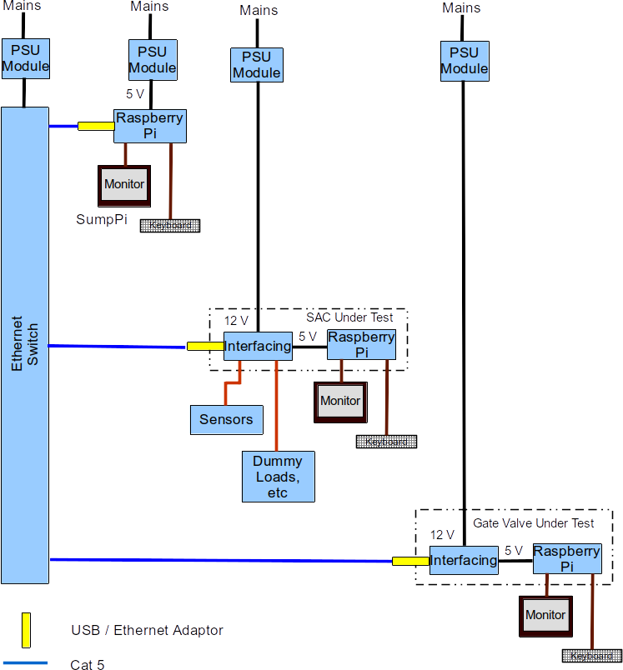
This test circuit can contain as many or as few Units Under Test as required, but will normally be used to test how a newly completed unit behaves in the system. The following factors should be considered:
- The Ethernet Switch is only needed if more than two Pis are to be connected. The UUT may be connected to the SumpPi (or another SAC or a Gate Valve as appropriate).
- A Sump Pi is always required. This can be a Raspberry Pi equipped with nothing more than a USB / Ethernet Adaptor The monitor and keyboard is optional unless the UUT is a Sump SAC.
Note: If the SumpPi is not equipped with an SAC (specifically the A/D Board), then the software will generate an error 'ADS (I2C) device not found!'. This is not critical and can be ignored since the object of the test is to ensure that communication with the UUT takes place.
- The Sump Pi may be equipped with a Real Time Clock (RTC) module, but it is not essential unless the UUT is a Sump SAC. Without the RTC the recorded times will be wrong, but the functionality of SACs or Gate Valves under test will be unaffected.
- If the UUT is a Sump SAC, then connect another Pi to simulate another SAC or a Gate Valve. This is to enable communications to be tested.
- If the UUT is an SAC then:
  - Connect one or more Hall Effect Probes (normally one, but three for a Lady Hanham SAC).
  - Connect jumpers for simulating the state of all Float Switches.
  - Connect an appropriate Dummy Loads to:
    - The Solenoid output (approx 16 Ohms, 20 W) for a Lady Hanham SAC.
    - To the SSR outputs (approx 1 k) for a Sump SAC.
Testing should be carried out as follows:
- Construct the test circuit shown in Illustration 1.
- Build an SD Card for the UUT and the other Pi in the system as described in Section 4 above.
- Temporarily modify the code in config.py on SumpPi to remove or comment out all devices that are not included in the test system.
- Turn on the power to all devices and wait for the Pis to finish booting.
- Observe the messages on the Monitor and ensure that:
  - Communication is established between the SumpPi and the UUT (or the UUT and ‘other’ Pi if the UUT is a Sump SAC.
  - For SACs Under Test:
    - Correct depth readings are observed when the float on a Hall Effect Probe is moved to different positions.
    - The correct response is logged when the jumpers are attached to the Float Switch inputs.
    - 12 V DC is measured across SSR outputs or the solenoid output when commanded by the system.
After Testing shutdown each Pi using the command:
sudo shutdown now

Any Pis in the test system without keyboard and monitor may be shutdown using SSH from the UUT.
Notes:
1. It may not be easy to achieve Step 5.b.c unless the Sump Pi is part of a Sump SAC complete with Sensors, but provided the SAC has passed its own hardware Unit Tests then the likelihood of failure is much reduced when installed on site.
2. Similarly if the UUT is a Gate Valve, it may not be easy to observe movement of the valve, unless the Sump SAC has sensors. Again, providing that communication has been established and the UUT has passed its own hardware Unit Tests then the likelihood of failure is much reduced when installed on site.
3. The test arrangement and the tests detailed above will change when the River System architecture is updated to:
  - Include the NAS Box, with its database of readings instead of Results files on the SD Card.
  - The segmentation of control into zones as is currently proposed.

GENERAL MAINTENANCE ACTIVITIES

Backing Up and Restoring SD Cards
There are several methods of backing up SD Cards. Two are described below:

Backing Up

From Within Raspbian
Boot the system in the normal way, but interrupt execution of the river system program by pressing CTRL-C several times. Start the Pixel Desktop by typing ‘startx’ at the prompt and pressing <RET>.
Once the desktop is running, insert a blank SD Card into a USB to SD Card adaptor and select Accessories – SD Card Copier from the main Menu. Follow the on-screen instructions.
Note: This method can be a bit slow because the Pi has a relatively slow processor, which has to manage the copying at the same time as running the GUI.

From a Linux Computer

Identify the Device
In order to carry out this operation, it is necessary to identify the mounted SD Card. Insert the SD Card into a USB to SD Card adaptor, but do not plug it into the Linux machine yet.
Issue the following command in a shell:
df -h

Filesystem Size Used Avail Use% Mounted on
udev 3.9G 0 3.9G 0% /dev
tmpfs 794M 9.5M 785M 2% /run
/dev/sda1 58G 18G 38G 32% /
tmpfs 3.9G 38M 3.9G 1% /dev/shm
tmpfs 5.0M 4.0K 5.0M 1% /run/lock
tmpfs 3.9G 0 3.9G 0% /sys/fs/cgroup
/dev/sdb1 286G 160G 112G 59% /home
tmpfs 794M 36K 794M 1% /run/user/1000
Insert the SD Card into a USB slot and re-issue the df command.
df -h
Filesystem Size Used Avail Use% Mounted on
udev 3.9G 0 3.9G 0% /dev
tmpfs 794M 9.5M 785M 2% /run
/dev/sda1 58G 18G 38G 32% /
tmpfs 3.9G 38M 3.9G 1% /dev/shm
tmpfs 5.0M 4.0K 5.0M 1% /run/lock
tmpfs 3.9G 0 3.9G 0% /sys/fs/cgroup
/dev/sdb1 286G 160G 112G 59% /home
tmpfs 794M 36K 794M 1% /run/user/1000
/dev/sdc2 6.8G 5.4G 1.1G 84% /media/terry/7f593562-9f68-4bb9-a7c9-2b70ad620873
/dev/sdc1 63M 21M 43M 34% /media/terry/boot
Two new devices are now visible sdc1 and sdc2. These are the two partitions on the Raspbian SD Card; it is the device that is of interest (eg, sdc) not the full partition name.

Writing an Image
To backup up an SD Card in Linux, issue the following commands in a shell to backup an SD card:
sudo dd if=/dev/sdc of=~/<Identifier>_SDCardBackup.img

Note1: The source of the backup, (in the example sdc) should be changed to suit the Linux installation in use.
Note2: The destination may be anywhere on the Linux installation and it is suggested that the filename reflects the contents and the date of the backup.
Note 3: The dd command does not show any feedback so wait until the command prompt re-appears.
Note 4: After the backup is completed, the image may be compressed if desired, using the ‘zip’ utility. (This is not installed by default on many Linux systems.) Compress the image using the following command:
zip <Identifier>_SDCardBackup.zip <Identifier>_SDCardBackup.img

Where the filename of the zipped up file and the original image reflect the date and content of the image, eg: zip 2019-05-01_V4_Gate_Valve_Backup.zip 2019-05-01_V4_Gate_Valve_Backup.img.

Restoring
There are several ways to restore an image that was previously backed-up.
Note: If the original image has been expanded within Raspbian, it is likely that it will not fit onto the SD Card. Images may be shrunk using the procedure detailed on Reference 1.2.11.

Using Etcher
Etcher is a cross-platform graphical SD Card writing tool which takes much of the complexity out of writing an image to an SD Card. The tool may be downloaded from the Etcher Website.

From a Linux Computer
After establishing the identity of the device it needs be unmounted. However, this must be done partition by partition by using the partition number as well. Issue the following commands for each partition:
sudo umount /dev/sdc1
sudo umount /dev/sdc2

etc….

Write the original image to the SD Card:
sudo dd bs=4M if=~/SDCardBackup.img of=/dev/sdc

Note1: The bs=4M option sets the 'block size' on the SD card to 4Meg. If you get any warnings, then change this to 1M instead, but that will take a little longer to write.
Note2: Wait until the command completes because ‘dd’ provides no feedback on progress.

Before ejecting the SD card, ensure that the Linux machine has completed writing to it by issuing the command:
sudo sync

See The Pi Hut for more information, including details of how to backup and restore SD cards on Windows or a Macintosh.

ANNEX A
Using Virtual Machines to Test the Software
Creating the Virtual Machines
Preparation
A full list of the current packages on Raspbian Buster may be found at Default Packages on Raspbian Buster-lite.
The following points are relevant:
- VDI and VMDK are both fully supported, but VMDK is more open, so probably a better choice in most cases
- When using a dynamically sized disk image, the image never shrinks. Once a sector has been written for the first time, its contents are forever recorded. This is necessary because unless the OS supports TRIM, the hypervisor cannot know which sectors are unused.
- To allow the disk image to shrink as well as grow, it needs to be in VDI format and mounted with the --discard option. To do this, the storage should be detached from the VM and then reattached using the command:
VBoxManage" storageattach "[GuestOsMachineName]" --storagectl "SATA" --port 1 --device 0 --nonrotational on --discard on --medium "[file.vdi]" --type hdd

Creating the Base Image VM
First make a VM that represents the 'base image' that all of the other Pis are based on:
- Initial configuration:
  - 8GB disk [default].
  - 512MB RAM.
  - 1 64-bit CPU core (no execution cap) [default].
  - SATA for both main disk and optical drive.
  - No audio.
  - Two network adapters, both of type paravirtualised network:
    - One attached to host-only network with subnet 192.168.0.0/24 and no DHCP.
    - One attached to NAT
  - Everything else default
- Special steps for Debian installation:
  - Install the distro as a non X system (do not use Graphical Install).
  - Set the Hostname to ‘pi’.
  - Set No root password.
  - Set User to ‘Pi’, username to ‘pi’, password to ‘river17’.
  - Configure *no* swap space in the partitioner.
Note: At this point visual glitches may be observed in the installer, probably due to low memory.
  - Select and install software:
    - NO desktop environment.
    - NO print server.
    - SSH server
- Package installation/deinistallation:
  - Compare the initial package selection of Debian and Raspbian lite:
    - dpkg -l | awk '{print $1 $2}' > debian-buster-packages.txt
    - $ wget https://downloads.raspberrypi.org/raspbian_lite/images/raspbian_lite-2019-06-24/2019-06-20-raspbian-buster-lite.info
    - awk '{sub(/:armhf/," "); print $1 $2}' 2019-06-20-raspbian-buster-lite.info > raspbian-buster-lite-packages.txt
    - diff debian-buster-packages.txt raspbian-buster-lite-packages.txt | less
Notes:
1. There are quite a few differences, some of which need to be preserved. For example, it makes no sense to remove debian-archive-keyring because we are using Debian packages.
2. It is suggested that a separate file is made noting which packages to install and which to remove.
3. It is suggested that anything that looked like it might be remotely relevant to Python development or which might affect the way the system behaves or operates in normal use should be installed.
4. Avoid modifying the way the network is configured because not all of the packages used for networking in Raspbian can be installed in Debian, so it would never be a perfect match.

  - Using Section 4.4.1.1.2 of this document as a guide install any package present in Debian. (Obviously it’s not possible to install RPi.GPIO or any ARM only packages.)
  - Install mysqlclient, by first installing default-libmysqlclient-dev from the Debian repositories:
    - sudo apt install default-libmysqlclient-dev
  - Edit /etc/fstab to add the discard option to the root filesystem, to reduce the size of the virtual disk image when files have been deleted.
Note: Trimming reduced the size of the virtual disk by about 700MB.

  - Add a basic network configuration to the base image, assigning it the IP address 192.168.0.251, to make it easier to modify for each individual Pi. The network configuration is in /etc/network/interfaces and /etc/resolv.conf. See Debian Network Configuration.
  - Since there is only one operating system, disable the grub menu by editing /etc/default/grub so that GRUB_TIMEOUT=0.
Creating VMs to Represent Each Individual Pi
Once the basic image exists, it is possible to mount it as a 'multi-use' image in each individual VM. Each VM will add its own differencing image to the underlying image. Since this involves detaching and reattaching the disk image on the 'base image' VM, remember to re-attach it using the VBoxManage command with the --detach=on option, as above.
Having created the base image VM and configured the base disk image as multi-use, it's then possible to clone the VM. Select the option to reinitialise the MAC addresses of the nework interfaces, and create a Linked clone. This automatically almost everything needed, and preserves the discard=true configuration on the storage. However, it results in a chain of snapshots on the base image VM. These cannot be easily removed afterwards.
Note: It might be better to create a new VM without a disk, configure it as required, clone it and then attach the disks.
To remove the unwanted snapshots from the base image VM, detach the storage from all the cloned VMs, then remove the extra snapshots belonging to those clones by using the Virtual Media Manager. Only then can the snapshots be deleted on the original VM. The storage can then be reattached to the clones in the same way as it was attached to the base image VM.
Set the basic configurations for each Pi:
- The IP address of each Pi in /etc/network/interfaces.
- The hostname of each Pi can be set using hostnamectl set-hostname [new-hostname]. It's also necessary to edit the hostname in /etc/hosts.
Hostnames are specified in Reference 1.1.4.
The software should not be loaded onto the Pis at this stage; first package the VMs for distribution.

Creating the NAS Box VM
The NAS Box VM needs to respond to SQL Queries from the Raspberry Pi VMs, but (at present) doesn’t need to provide anything more than a running instance of MySQL and other supporting packages. Creating this VM is very similar to the method used to create the Base Image VM for the Pis:
- Initial configuration:
  - 20 GB disk.
  - 256 MB RAM.
  - 1 64-bit CPU core (no execution cap) [default].
  - SATA for main disk.
  - No audio.
  - Two network adapters, both of type paravirtualised network:
    - One attached to host-only network with subnet 192.168.0.0/24 and no DHCP.
    - One attached to NAT.
  - Everything else default.
- Special steps for Debian installation:
  - Install the distro as a non X system (do not use Graphical Install).
  - Set the Hostname to ‘nasbox’.
  - Set No root password.
  - Set User to ‘nas’, username to ‘nas’, password to ‘river17’.
  - Configure *no* swap space in the partitioner.
- Ensure that the following software packages are installed:
  - binutils.
  - eGlibc.
  - PHP.
  - MySQL.
  - OpenSSH.
- Use fstrim to minimise the size of the disk.
Note: Trimming reduced the size of the virtual disk by about 700MB.
- Edit /etc/fstab to add the discard option to the root filesystem, to reduce the size of the virtual disk image when files have been deleted.
- Add a basic network configuration to the image, assigning it the IP address 192.168.0.25. The network configuration is in /etc/network/interfaces and /etc/resolv.conf. See Debian Network Configuration.
- Since there is only one operating system, disable the grub menu by editing /etc/default/grub so that GRUB_TIMEOUT=0.
Packaging VMs for Distribution
The option to export a virtual appliance in .ova format exists. However, this converts all the disk images to .vmdk format, each its own copy. Multi-attach does not seem to get carried over. Nevertheless, the images are smaller than other methods. For distribution, they are compressed to about 500MB per VM, but they expand to about 1.5GB per VM. The resulting .ova file is 5.5GB and would need to be transported on a medium with a filesystem that supports files that large. (i.e. not FAT32).
Another option would be to copy the machine files themselves, manually, into a compressed archive. This might not carry over to another system well; it needs to be tested.
Final Activities
It is suggested that a copy of the VMs without the software installed is preserved, then I the software is installed and used for test and development.
In the process of preserving a copy of the VMs, it is useful to organise them into a single folder. In so doing, the XML definition of the location of the VDI files needs to be edited. All of the VDI files are referenced from the base image VM's XML, and they can be set to be relative references using '..' to go up a level in the directory hierarchy. As a result, the VMs can be made completely portable.
Notes:
1. Close VirtualBox completely while making manual edits to the XML virtual machine definition files.
2. The use of paravirtualised network adaptors is much more resource-efficient and has higher performance than emulated network adaptors.

ANNEX B
Using Virtual Machines to Test the Software
Configuring the Virtual Machines
Installing the Software Framework on the Pi VMs
The following procedure illustrates the process:
- Make a snapshot of each VM without the framework. The new snapshot for the current state was added to the basic image's XML definition with an absolute reference, so this needs to be changed to relative for distribution.
- Fetch the latest version of the Software Framework from GitLab. Use scp to copy it into each VM's 'pi' home directory.
Note: If a graphical file manager was used to move the files, ensure that it hasn’t left ‘.desktop’ files on the Pi. If so, use find -name '.desktop' to find them and then use rm to remove them.
- Using ssh, configure autostart of the software in .bashrc, according to Section 4.4.3.3, 4.4.4.1 or 4.4.5.1 above, eg.
  - ssh pi@192.168.0.2 'echo -e "# Autostart river control system software\nif [ \$(tty) == /dev/tty1 ]; then\n cd rivercontrolsystem\n ./main.py --testing --id "SUMP"\nfi\n" >> ~/.bashrc'
Note: The command to start main.py in .bashrc needs to launch it in testing mode, so add:
--testing
- Setup auto-login as the user pi. The following references describe this:
  - http://forums.debian.net/viewtopic.php?f=16&t=123694
  - https://wiki.archlinux.org/index.php/getty
- Run:
  - systemctl edit getty@tty1.service and add the lines
  - [Service]
  - ExecStart=
  - ExecStart=-/sbin/agetty --autologin pi %I $TERM
Once everything is up and running, make another snapshot of each VM. Once again, the new snapshots resulted in non-relative paths in the .vbox XML, which needs to be changed to relative.

Installing the Database Schema on the NAS Box VM
A copy of the schema for the database may be found where?
- Fetch the latest version of the NAS Box Database Schema. Use scp to copy it into the VM's ??? directory.

ANNEX C
Using Virtual Machines to Test the Software
Using the Virtual Machines
Instructions
To install the virtual machines:
- If these virtual machines have already been installed at a previous version, remove the existing copies of them from VirtualBox.
- Place the ‘WMT River System’ directory in a location where you intend to run the machines from. For example, you could place it in ~/.VirtualBox/Machines/, or on an external hard drive.
- Create a 'Host-only Network' 'vboxnet1' in VirtualBox. Use the IPv4 address 192.168.0.1 and IPv4 subnet mask 255.255.255.0. In the GUI, go to File > Host Network Manager and click the button to add a new host-only network.
Notes:
1. If you already have a 'vboxnet1' host-only network in use for some other purpose, then your new network will need to have a different name. You can change the settings on each machine to match it.
2. IMPORTANT: If your host is already connected to a network with the same subnet as the Raspberry Pi network, then you should set up an Internal Network instead, else there may be address conflicts or routing problems.
- Open the WMT River System/River system base image/River system base iamge.vbox file in VirtualBox. Typically, this will be the default file open action for .vbox files on a desktop system with VirtualBox installed. This will load the disk images for all of the other VMs.
- Only after loading the base image VM into VirtualBox, open all the remaining .vbox files from the other WMT River System/ subdirectories.
- Check the network adapter settings of the virtual machines. For the NAS Box, the first adapter should be connected to NAT, and the second to Host-only Network 'vboxnet1'. For the Pis, the first adapter is connected to 'vboxnet1' and the second to NAT. (Sorry for the inconsistency.)
Note: If you are not using vboxnet1, select the appropriate network instead.

To Use the virtual machines:
The Pi VMs are configured to be as similar as possible to the equivalent real Raspberry Pis (see Annex B). They will autostart the river system software in testing mode.
Notes:
1. The 'headless start' and 'detachable start' options may be useful.
2. If you use the suggested Host-only Network configuration, you can SSH into the Pis using their 192.168.0.x IP addresses using an ordinary terminal window on the host machine. On the virtual network, the host machine has the IP address specified in the Host-only Network configuration. (i.e. 192.168.0.1)
3. If you do not use the suggested Host-only network configuration, you can still access the Pi VMs through their consoles in the VirtualBox GUI. Kill the river control system software to drop to a bash prompt.
4. Alternatively, you could swap the second interface of each Pi from NAT to the default vboxnet0 Host-only network, which has a DHCP server handing out IP addresses. Find out what subnet it is using (e.g. 192.168.56.0/24) and then run:

nmap -A -T4 192.168.56.0/24

To reveal the IP addresses of the Pis. (Or run `ip addr show` on the console of a specific Pi.)
Example VMs
At Smaller VMs a information supporting this document and a link to complete set of machines created by Patrick Wigmore may be found. As time goes on, these are likely to become more and more out of date, nevertheless they provide an excellent resource to show how the machines may be used.
Within the compressed file provided are ten virtual machines (VMs) representing components in the Wimborne Model Town River Control System.
One of the virtual machines represents the NAS box. This is more or less a headless instance of Debian running the appropriate software to simulate the physical NAS Box installed on site.
The other nine VMs represent the Raspberry Pis. They are configured to be as similar to the real Raspberry Pis as is reasonably practicable, so that they can be used for test and development of the river control system software.
The Raspberry Pi VMs are all based on the VM named 'River system base image', which is fairly similar in concept to the base SD card image described in the installation specification.
Due to the amount of duplication involved in cloning the base image eight times, the other eight VMs make use of VirtualBox's multi-attach storage feature. This allows multiple virtual machines to share the same disk image file, which is treated as immutable. Any changes made to the individual virtual disk of each machine are stored in a differencing image associated with that machine, so each machine has its own state. Since the VMs differ very little from the base image, this saves a lot of disk space on the host machine.
In addition to using multi-attach, the disk images are also attached using VirtualBox's 'discard=on' option and the guest filesystems mounted with the 'discard' option. This means that the disk image files on the host can shrink instead of only ever growing.
See GitHub for more indormation.

