WIMBORNE MODEL TOWN DEVELOPMENT
STATEMENT OF REQUIREMENTS
FOR THE RIVER SYSTEM SENSORS
Issue 0.1
16th December 2017



This work is licensed under the Creative Commons Attribution-NonCommercial-ShareAlike 4.0 International License. To view a copy of this license, visit http://creativecommons.org/licenses/by-nc-sa/4.0/.

Table of Contents
1 INTRODUCTION 3
1.1 BACKGROUND TO THE REQUIREMENTS 3
1.2 Related Documents 4
1.3 Related Tools 4
1.4 Definitions 4
2 HARDWARE CONFIGURATION 5
2.1.1 Main River Circulation 5
2.1.2 Water Collection 5
2.1.3 Raspberry Pi Computer 5
3 FUNCTIONAL REQUIREMENTS 6
3.1 Level Probe Requirements 6
3.2 Flow Measurement Requirements 7
4 MECHANICAL REQUIREMENTS 8
4.1 Level Probes 8
4.2 Flow Sensors 8
5 NON-FUNCTIONAL REQUIREMENTS 9
5.1 Environmental 9
5.2 Documentation 10
6 ASSUMPTIONS 10
7 SUMMARY OF CHANGES TO THIS DOCUMENT 10
Index of Tables
Table 1: Related Documents 4
Table 2: Related Tools 4
Table 3: Level Functional Requirements 6
Table 4: Level Functional Requirements 7
Table 5: Mechanical Requirements for Level Probes 8
Table 6: Mechanical Requirements for Flow Sensors 8
Table 7: Environmental Requirements 9
Table 8: Documentation Requirements 10
Table 9: Summary of Changes to this Document 10

Illustration Index
Illustration 1: River System – Proposed Deployment – Main River and Sump Arrangement 12
Illustration 2: River System – Proposed Deployment – Water Collection System 13
Annexes
A Illustrations
B Sensors Developed Prior to December 2017

INTRODUCTION
This document details the requirements for the development of sensors to monitor water levels and flow rates in the Wimborne Model Town (WMT) River System. Some preliminary work has already been carried out on this requirement and prototype level probes and a water wheel have already been produced and in some case tried out. This Statement of Requirements is intended to formalise the definition of the capabilities required.
Annex A of this document provides two Illustrations that show the configuration of the Model River and the associated elements of the River System. Section 2 of this document provides an description of these diagrams.
There are two main Requirements:
- Level Sensors are needed to measure:
  - The water in the Sump.
  - The water in each group of butts in the Butts Farms.
- A Flow Sensor is needed to measure:
  - The flow rate of water in the river.
Once the River System development is complete, then it will be required to operate 24 hours a day for 365 days each year. It is important that any measurements taken are reliable and provide readings that are sufficiently accurate to allow the control software to properly function.
Any failure within the system could result in a significant loss of water and the eventual drying out of the river. This would need significant remedial action on the part of the staff or gardeners to replenish the water. This would not only be time consuming but also ecologically detrimental. In addition, the WMT has to pay for any water taken from the mains supplies, so there would be an economic cost resulting from any significant water loss.
The intention is therefore to develop the WMT River System using dual-redundant sensors to ensure that if any sensor fails, then measurements from other sensors at the location and / or elsewhere in the system may be used by the controlling software to determine the correct value of the measurement. Furthermore, to reduce the effect of systematic failures, it is intended to utilise more than one type of sensor where possible, especially for level measurements.
Annex B provides details of the prototype sensors already evaluated and the associated interfacing electronics that has been developed. The current requirement is to propose sensors that bring improvements to those developed.

BACKGROUND TO THE REQUIREMENTS
Full details of the background to the Requirements for the enhancements to the river system as a whole may be found in Reference 1 in Section 1.2.

Related Documents
The following documents are relevant to these Requirements.
Table 1: Related Documents

No | Requirement | Issue / Date
1 | WMT River System Requirements | 0.5
2 | WMT River System Design | 0.4
3 | Wimborne Model Town Projects Forum | -
4 | Met Office - Climate at WMT | -
5 | Creative Commons Attribution-ShareAlike International License | 4.0

Related Tools
The following tools are relevant to these Requirements.
Table 2: Related Tools

No | Requirement | Issue / Date
1 | Raspberry Pi Computer | -

Definitions
GPIO | General Purpose Digital Input / Output
master | The Raspberry Pi that is controlling the system.
remote | Any Raspberry Pi that is under the control of the master.
PoE | Power over Ethernet
River System | This term is used to describe all elements of the WMT model river and it’s associated control and monitoring components.
WMT | Wimborne Model Town

HARDWARE CONFIGURATION

Main River Circulation
Figure 1 in Annex A shows the way in which the water is circulated within the river elements that are part of the WMT model, eg the Bog Garden and the two branches of the River Allen.
The Sump is located at the southern end of the river and contains approximately 1000 litres of water. A pump (the Sump Pump) recirculates this water through an underground pipe to the Bog Garden which is at the other end of the site, adjacent to the Main Entrance. Water then flows down the two river beds and back into the sump, turning the Water Wheel just before it re-enters the Sump. The Master Pi will control the operation of the Sump Pump to maintain the river flow based on the measured flow rate.
Also shown on this diagram is the configuration of the water collection system as of December 2017; this includes collection of water from the roofs of some of the buildings and storage in five water butts behind the Wendy Houses . These details should make it easier to understand the full description of this system in the next Section below.
It should be noted that the river and Bog Garden contain a combined total of some 15,000 litres of water, so if the Sump Pump stops for some reason then a large quantity of this water will continue to flow into the Sump, resulting in considerable water loss through the Soakaway.

Water Collection
Figure 2 in Annex A shows the proposed layout of the water collection system.
Water collected from the buildings will either flow into the river or directly into water butts located at various points around the site. These water butts will be grouped together in sets of five butts, each designated with a Group Number. Water levels in the Sump and in each of the Butts Groups will be monitored and water will be pumped to and from Sump to ensure that it does not overflow into the Soakaway or run out of water during dry periods.
Each Butts Group will be monitored by sensors connected to a Raspberry Pi (a Remote Pi) and the Master Pi will decide when to operate valves and pumps to optimise water usage.
The Gardeners Butts Group at G5 will not be used to refill the Sump or take water from it. Instead, this Butts Group will provide water to ‘Leaky Hoses’ (and a manual tap) to water the gardens overnight, when water loss due to evaporation will be minimised.

Raspberry Pi Computer
Full details of the Raspberry Pi computer may be found at Reference 1 in Section 1.3. Apart from being a fully specified computer, it also has a number of General Purpose Digital Input / Output (GPIO) lines which can be programmed to be discrete inputs, discrete outputs and (for some of the lines) serial interfaces. To interface to the GPIO lines, additional circuits may be required. Some work has been done on this and a description of the current capabilities is given in Annex B.

FUNCTIONAL REQUIREMENTS

Level Probe Requirements
Table 3 below details the Functional Requirements for any Level Probe developed for the WMT River System.
Table 3: Level Functional Requirements

No | Requirement
3.1 | The probe shall provide a signal that can be decoded by a Raspberry Pi Computer to measure the level of water in a receptacle.
3.1.2 | The signal provided by the probe shall require the minimum number of digital lines possible.
3.1.3 | The probe resolution shall be the maximum possible commensurate with the constraints imposed by Requirement 3.1.2.
3.1.4 | If possible, the probe should provide a continuous readout of level, commensurate with the constraints imposed by Requirement 3.1.2.
3.1.5 | For probes that provide discrete signals at fixed levels Probe, the trigger signal shall occur not less than x/2 mm after the level passes the sensor on a rising or falling level, where x is the distance between the levels.
3.1.6 | Probe accuracy shall not be less than ±10 mm for continuous reading probes.

Notes:
1. In order to meet the conflicting Requirements above, the developer shall consider the different technologies available and methods of compressing the digital signal into the minimum number of digital lines.

Flow Measurement Requirements
Table 3 below details the Functional Requirements for any Flow Measurement device developed for the WMT River System.
Table 4: Level Functional Requirements

No | Requirement
3.2 | The sensor shall provide a signal that can be decoded by a Raspberry Pi Computer to measure the flow rate of water in the river.
3.2.2 | The signal provided by the sensor shall require the minimum number of digital lines possible.
3.2.3 | The sensor resolution shall be the maximum possible commensurate with the constraints imposed by Requirement 3.2.2.
3.2.4 | The sensor shall provide a continuous readout of flow.
3.2.5 | Sensor accuracy shall not be less than ±TBD litres/minute.

Notes:
1. In order to meet the conflicting Requirements above, the developer shall consider different technologies available and methods of compressing the digital signal into the minimum number of digital lines.

MECHANICAL REQUIREMENTS

Level Probes
Table 5 below details the mechanical requirements for any level probe developed for the WMT.
Table 5: Mechanical Requirements for Level Probes

No | Requirement
4.1 | Any level probe developed for the Sump shall easily fit into the Sump.
4.2 | Any level probe developed for the Butts shall easily fit into the Butts stand-pipe provided (see Note 3 below).

Notes:
1. The Depth of the Sump is approximately 1 metre deep by 1 metre front to back.
2. The Butts standpipes are ?? mm diameter and ?? metre high.
4. Some technologies may result in probes that are too wide to fit into the Butts standpipes. Exceptionally, these may be lowered directly into one of the butts, providing that they can be adequately secured.

Flow Sensors
Table 5 below details the mechanical requirements for any flow sensor developed for the WMT.
Table 6: Mechanical Requirements for Flow Sensors

No | Requirement
4.2 | Any flow sesnsor developed for the WMT shall easily fit into the river bed.

Notes:
1. The river bed is approximately ? Metre wide and ?? deep at the entrance to the Sump.

NON-FUNCTIONAL REQUIREMENTS

Environmental
Table 4 below details the environmental requirements for any sensor developed for the WMT.
Table 7: Environmental Requirements

No | Requirement
5.1 | The developer consider all environmental aspects when developing a sensor.
5.1.1 | Any proposed sensor solution shall be designed to operate reliably when fully immersed in water.
5.1.2 | Any proposed sensor solution shall be designed to operate reliably when exposed to the weather conditions expected at the WMT.
5.1.3 | No sensor shall harm the environment when deployed.

Notes:
1. In order to meet the conflicting Requirements above, the developer shall consider approaches to protecting the sensor and the environment. This may include avoiding the use of polluting materials, eg copper which corrodes rapidly when immersed in water, or protecting the sensor from the environment using cases or covers.
2. The weather conditions at the WMT are assumed to be normal UK meteorological climate (see Reference 4 in Section 1.2).

Documentation
The Table below details the documentation requirements for the sesnsor.
Table 8: Documentation Requirements

No | Requirement
5.2.1 | A comprehensive design specification shall be produced (see Note 1).
5.2.2 | The design specification shall include high-level descriptions of all functionality of all components of the sensor.
5.2.3 | A specification of the signal(s) provided by the sensor shall be included to allow the measurements to be read by a Raspberry Pi computer.
5.2.4 | All documentation shall be Copyright Wimborne Model Town and licensed under the Creative Commons Attribution-NonCommercial-ShareAlike 4.0 International License (see Reference 5 in Section 1.2).

Note 1: An example of a design specification will be provided.

ASSUMPTIONS
The following assumptions are made.
- Developers will have the pre-requisite knowledge to design and implement the harfware required to realise this part of the project.

SUMMARY OF CHANGES TO THIS DOCUMENT
The Table below details the changes made to this document for each revision.
Table 9: Summary of Changes to this Document

Issue | Section | Summary of Change
0.1 | - | First draft.

ANNEX A – ILLUSTRATIONS

Illustration 1 – Main Main River and Sump Arrangement

Illustration 2 – Water Collection System
Illustration 1: River System – Proposed Deployment – Main River and Sump Arrangement

Illustration 2: River System – Proposed Deployment – Water Collection System
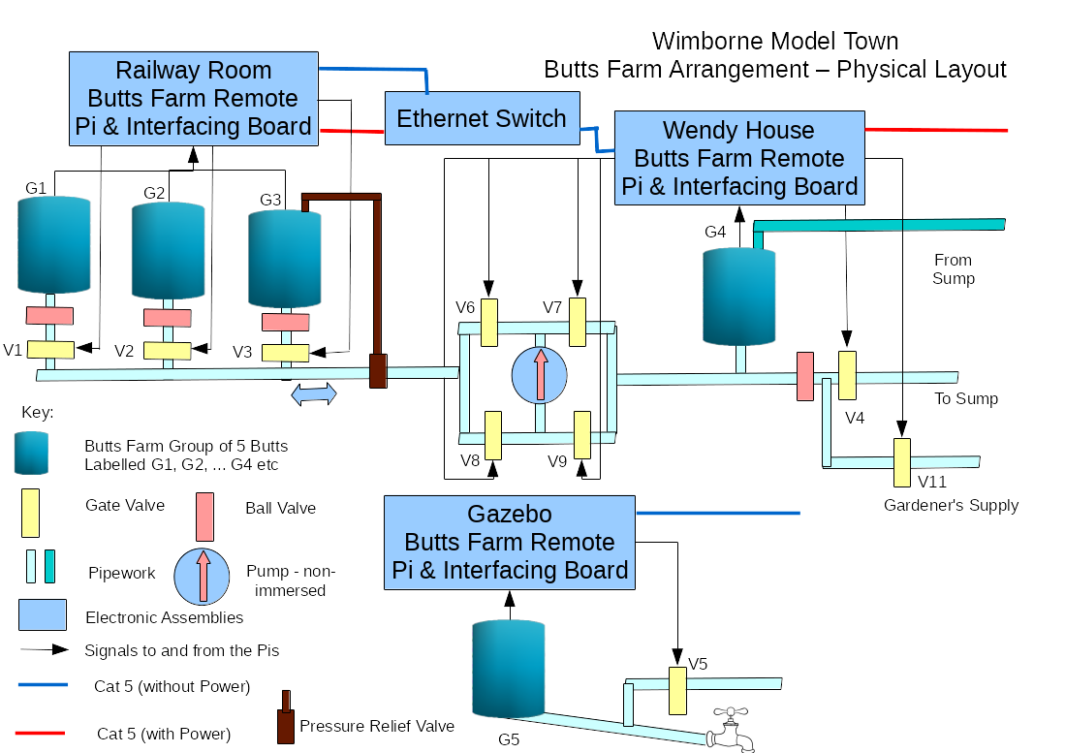
ANNEX A
SENSORS DEVELOPED PRIOR TO DECEMBER 2017
GENERAL
Background details of the design of sensors produced to date may be found on the Wimborne Model Town Projects Design Document (see Reference 2 in Section 1.2) and full details of the development activities carried out for each of the sensors summarised below and the associated interfacing electronics may be found on the Wimborne Model Town Projects Forum (see Reference 3 in Section 1.2). The following Sections provide a summary of the work done and the results.
LEVEL SENSORS
Capacitive Probe
Principle of Operation
Capacitive Level Sensors work on the principle of measuring the capacitance of a probe immersed in the fluid. As the water depth increases, so the capacitance varies and this change may be measured in a number of ways.
Results of Evaluation
A prototype of this probe was constructed in June 2017 and used the variable capacitance generated by the probe as the water level changed in an oscillator circuit. It was tested in a tank of water at the developers home, but there was considerable instability experienced with the design used and development was curtailed in favour of the Resistance Probe.
Advantages and Disadvantages of the Type
This type of probe has the advantage of providing a continuous readout of depth, although the frequency change is non-linear and so has to be corrected in software before use.
Resistance Probe
Principle of Operation
Resistance (or Conductive) Level Sensors work on the principle of measuring the resistance between a common point and a series of conductive contacts mounted on a probe immersed in the fluid. As the water depth increases, so the contacts are successively covered.
Results of Evaluation
A prototype of this probe was constructed in June 2017 and used the current through each contact to pull a digital line low. The software simply monitored the state of each contact’s line (eg pulled-high or low) to determine the depth of water covered. It was tested in the sump and initially worked well, but it was found that the contacts were attacked by corrosion and / or electrolysis in the water, causing the affected contact to cease conducting or to permanently conduct. A second probe was constructed in August 2017, but eventually this too succumbed to corrosion and development was curtailed in favour of the Magnetic Probe.
Advantages and Disadvantages of the Type
This type of probe has the advantage of simplicity but the measurement resolution is poor because it needs a digital line for each level, which necessarily limits the number of contacts that can be supported. The probes developed and tested both had 100 mm resolution, which needed 10 bits (10 digital lines) plus one more for return.
Magnetic Probe
Principle of Operation
A magnetic probe relies on a device called a Hall Effect sensor. A Hall Effect sensor relies on a magnetic field being adjacent to the device to generate a current. A level probe that utilises this effect has a series of sensors inside a protected tube and a magnet in the form of a ‘collar’ on a float that moves up and down the outside of the tube. When the magnetic collar is adjacent to a sensor, current flows and this can be turned into a digital signal.
Results of Evaluation
A prototype of this probe was constructed in September 2017 and used the current through each sensor to pull a digital line low. The software simply monitored the state of each sensor’s line (eg pulled-high or low) to determine the depth of water covered. It was tested in sump and worked well.
Advantages and Disadvantages of the Type
This type of probe has the advantage of simplicity and the electronics are fully protected from the water. However the measurement resolution is poor because it needs a digital line for each level, which necessarily limits the number of probes that can be supported. The probe developed and tested has 100 mm resolution, which needed 10 bits (10 digital lines) plus one more for return.
Additionally, the probes produce no signal when the water level is between sensors, so the software had to keep track of the last level passed to ascertain the current level. Nevertheless, it worked well.
FLOW SENSORS
Water Wheel
Principle of Operation
A Water Wheel Flow Sensor takes the form of a ‘paddle wheel’ placed in the river bed. Some form of sensor, such as optical or magnetic, then detects the speed of rotation of the wheel by counting pulses from a gap or reflective portion of the wheel.
Results of Evaluation
A mechanical prototype of this sensor was constructed in July 2017 and placed in the river bed immediately before the ‘fall’ into the Sump. This was then monitored visually to assess its efficiency. It was noticed however that debris in the water frequently became trapped between the bottom of the vanes and the river bed, causing it to jam. It was ascertained that this was caused by the fact that the wheel was an undershot type.
A second prototype was developed in August 2017 with a ‘mid-shot’ approach. This version included two optical sensors and was tested in air (using a hair-dryer to rotate the wheel). The outputs from the sensors were displayed on an oscilloscope. It appeared to work well, but has yet to be tested in situ.
Advantages and Disadvantages of the Type
This type of sensor has the advantage of being less prone to jamming, but the optical path may need cleaning from time to time.
INTERFACING BOARD
The Interfacing Board was developed in parallel with the sensors described above to enable them wto work with the Raspberry Pi as described below.
Input Level Shifting
The Raspberry Pi GPIO pins operate at 3.3 V and for most of the sensors only 5 V or more was available to drive the signal lines. A total of 12 level translators have therefore been made available on the Interfacing Board to convert the input voltages to the correct level for the Pi.
Output Level Shifting
Some of the devices that the Pi needed to control required a higher voltage than 3.3 V so two channels of output level shifting have been provided. One of these is used to switch the Butts Pump solid state relay and the other will probably be used to control the main recirculation Sump Pump.
DC-DC Converter
A number of different voltages are needed to drive the various electronic assemblies, so a DC-DC Converter has been included on the Interfacing Board. A main supply of +19 V DC is made available (using Power over Ethernet (PoE)) and +5 V DC is derived from this to drive the electronics on the Interfacing Board and the Pi.
Real Time Clock Provision
The connector used to connect the Interfacing Board to the GPIO pins on the Pi covered pins 1 to 6 on the Pi, which were needed to connect a Real Time Clock daughter board. The 6 pins have therefore been mirrored on the board.
Resource Utilisation
The current system has used nearly all of the spare Input Level Shifting channels and (eventually) both of the Output Level Shifting channels. Any new sensor designs should therefore take cognisance of Requirements 3.1.2 and 3.2.2 to free up some of these channels, if redesign of the Interfacing Board is to be avoided.

