WIMBORNE MODEL TOWN
DEVELOPMENT
RIVER SYSTEM GATE VALVE
DESIGN AND INSTALLATION SPECIFICATION
Issue 0.1
7th April 2019



This work is licensed under the Creative Commons Attribution-NonCommercial-ShareAlike 4.0 International License. To view a copy of this license, visit http://creativecommons.org/licenses/by-nc-sa/4.0/.

Table of Contents
1 INTRODUCTION 4
2 RELATED DOCUMENTS 4
3 DESIGN 5
3.1 Electrical and Electronic 5
3.1.1 Electrostatic Sensitive Devices 5
3.1.2 Elements Comprising the Gate Valve Assy 5
3.1.3 System Circuit Diagram 6
3.1.4 System Description 8
3.1.4.1 Raspberry Pi Zero 8
3.1.4.2 DC/DC Converter 8
3.1.4.3 Motor Drive Board 8
3.1.4.4 Custom Veroboard 8
3.1.4.5 Analogue to Digital Converter Board 9
3.1.4.6 Actuator Valve Assembly 9
3.1.5 Reliability and Maintainability 9
3.1.5.1 Reliability 9
3.1.5.2 Maintainability 9
3.1.5.2.1 Documentation 9
3.2 Mechanical 10
4 CONSTRUCTION AND INSTALLATION 11
4.1 Hardware 11
4.1.1 Construction 11
4.1.1.1 Veroboard 11
4.1.1.2 Internal Wiring 12
4.1.1.3 Final Assembly 14
4.1.1.4 Testing 15
5 USER INSTRUCTIONS 15
5.1 Operational 15
5.1.1 Powering Up and Down 15
5.1.2 Spares and Repairs 15
6 SAFETY 16
7 ASSUMPTIONS 16
Index of Tables
Table 1: Related Documents 4

Table of Figures
Illustration 3.1: Gate Valve Assembly – Circuit Diagram 7
Illustration 3.2: Actuator Valve Assembly – Circuit Diagram 9
Illustration 3.3: Gate Valve Assembly – Overall Layout 10
Illustration 4.1: Gate Valve Assembly – Veroboard Layout 11
Illustration 4.2: Gate Valve Assembly – Wiring 13

Annexes
A Hardware Identity
B Spares

INTRODUCTION
This document provides design, build and installation details of the Wimborne Model Town River System Gate Valve Assembly. The document covers the electrical, mechanical and electronic design and the assembly and installation of the device. The software for the device forms part off the River System Software Framework and details of this may be found in the Software Design Specification.
The overall requirements for the River System may be found in various documents which have all been published on the project forum (see Reference 2.1 below) and these requirements have been interpreted in this design to realise this device.
The document provides a full description of the installed system for use by future developers and maintainers.

RELATED DOCUMENTS
The following documents are related to this document.
Table 1: Related Documents
No | Requirement | Iss
1 | WMT – Development – River System Requirements (see https://wmtprojectsforum.altervista.org/forum/viewforum.php?f=4) | Various
2 | Project GitLab Repository (see https://gitlab.com/wmtprojectsteam/rivercontrolsystem) | Various
3
4

DESIGN

Electrical and Electronic

Electrostatic Sensitive Devices
CAUTION Electronic devices used in the system are sensitive to static electricity. Precautions should be taken when handling these devices in order to prevent permanent damage.
The Raspberry Pi Zero and other electronic assemblies contain devices that can be damaged if they are exposed to static electricity. Static Electricity is readily generated when people walk over dry floors, rub against furniture or simply rub against their clothing. Although rarely noticed, the level generated is sufficient to damage devices if precautions are not taken. It is therefore recommended that no work be undertaken on these devices without taking one of the following actions:
- If possible an ESD workstation be employed. An ESD workstation includes an Antistatic Mat, a conductive wrist band and a means of earthing the mat and band, usually via a three-pin mains plug with a resistive earth pin.
- It is recognised that the WMT is not conducive to setting up an ESD workstation, so maintainers should endeavour to earth themselves by touching an earthed metal object at intervals during the work, especially after it has been necessary to leave the work area and return. A good compromise would be to use a wrist band clipped to a convenient earth point.

Elements Comprising the Gate Valve Assy
The system consists of a the following hardware modules:
- Raspberry Pi Zero.
- DC/DC Converter.
- Motor Drive Board.
- A/D Converter
- Custom Veroboard.
- USB to Ethernet Adaptor
- Actuator Valve Assembly.
Power for the assembly is +12 V with at least 1 A current capacity.

System Circuit Diagram
Illustration 3.1 at the end of this section shows the Circuit Diagram of the Gate Valve Assembly.
The following notes are relevant to this drawing:
Pi Connections:
- SDA and SCL on the Pi are also called Broadcom GPIO Pins 2 and 3 respectively and are labelled ‘Clock’ and ‘Data’.
- GPIO Pins 17, 19 and 27 are programmed as outputs and provide direction control of the motor and enable the clutch.
- The Ethernet Adaptor is not shown in this diagram and is connected to the Raspberry Pi (USB Data).
Motor Drive Board:
- En 1 and / or En 2 may be driven by GPIO pins if needed with the links removed. They can double as PWM inputs, but not in this application. The Motor B outputs are driving the Clutch, so will never be PWM.
- 5 V is available at the 5 V pin to power external logic devices if needed. However, it has not been possible to positively establish the current capability. Similar circuits from other suppliers appear to use a CX1117 regulator which has a maximum output current of 800 mA. This is insufficient for a Pi, so a DC / DC Converter has been included.
ADS1115 Board:
- The A/D Board is capable of being powered by voltages up to 5 V, but the value of Vdd determines the Logic Levels. The Pi cannot withstand more than 3.3 V on its GPIO pins, so that sets the limit in this application.
- Vdd is used at the top of the Position Potentiomenter, with the slider being routed to Input A0 on the board.
Terminations:
- Terminal Block TB1 is attached to a strip of Veroboard. Where multiple destinations are required, individual GPIO Header Pins are soldered to the same strip as the termination. GPIO Pins 17, 19 and 27 are programmed as outputs and provide direction control of the motor and enable the clutch.
- There are insufficient colours available to uniquely identify the individual wires. To overcome this, wires routed to common points will all be the same colour (eg green for 0 V, etc). Other wires will carry rings of heat-shrink to aid identification.

Key to circuit symbols:
GPIO, A/D or Veroboard Contact
Veroboard Terminal block on veroboard
Illustration 3.1: Gate Valve Assembly – Circuit Diagram

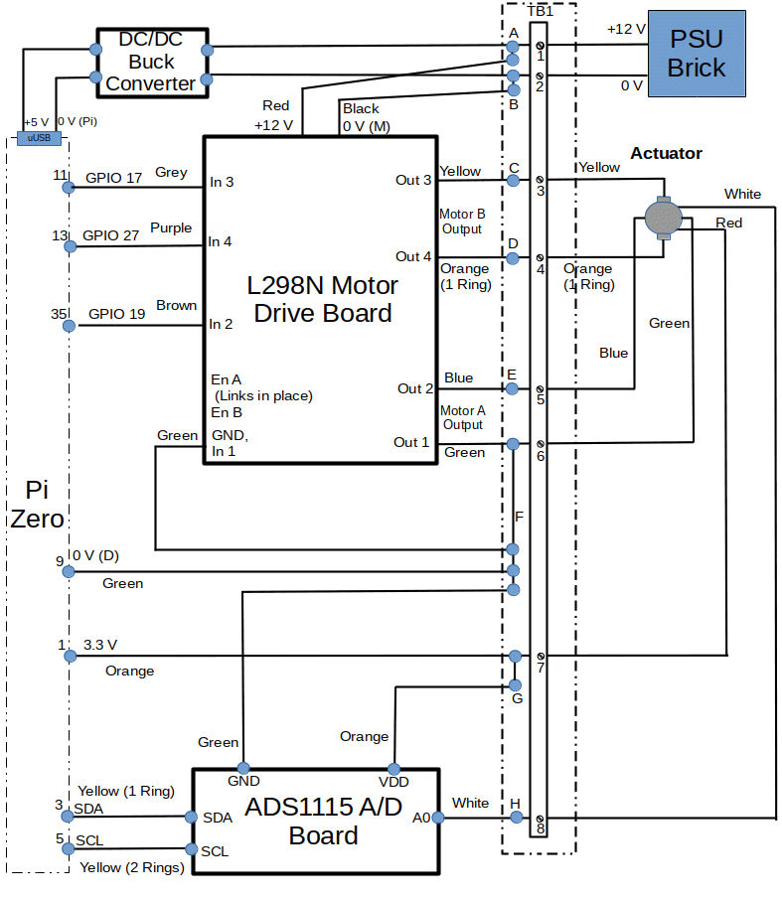

System Description

Raspberry Pi Zero
This small single board computer has a 40 pin connector that carries 26 General Purpose Input/Output (GPIO) channels, plus power and an I2C bus. Additionally the device has a single microUSB data connector, a single microUSB power connector and a microHDMI connector. A Micro SD Card slot is provided to carry the Operating System and program code.

DC/DC Converter
This is a Switching Regulator device known as a ‘buck’ converter. It uses an LM2596 integrated circuit to provide the following performance:
- Conversion efficiency: Up to 92%.
- Potentiometer output voltage adjustment.
- Switching frequency: 150KHz.
- Short circuit protection: Current limiting, self-recovery.
- Operating temperature: Industrial grade (-40 to +85 degrees Celsius) (output power 10W or less).
- Load regulation: +/- 0.5%.
- Voltage regulation: +/- 2.5%.
- Dynamic response speed: 5% 200uS.

In this application, the input voltage is provided by a +15 V PSU brick and the output voltage is adjusted to give +5 V (+0.1 /-0V) to power the Pi.

Motor Drive Board
This module uses an L298N and onboard regulator to provide the following performance:
- Double H bridge drive.
- Logical voltage 5V.
- Drive voltage 5V-35V.
- Logical current 0mA-36mA.
- Drive current 2A (MAX single bridge).
- Storage temperature -20 to +135 ℃.
- Max power 25W.

Custom Veroboard
This has no active devices and simply serves to route wiring from the Actuator Valve Assembly to the modules in the electronics assembly via Header Pins.

Analogue to Digital Converter Board
This module uses an ADS1115 ADC device to provide the following performance:
- Wide Supply Range: 2.0 V to 5.5 V.
- Low Current Consumption - Continuous Mode; 150 µA.
- Internal Low-Drift Voltage Reference.
- Internal Oscillator.
- Internal Programmable Gain Amplifier.
- I2C Interface: Pin-Selectable Addresses between 0x48-0x4B.
- Four Single-Ended or Two Differential Inputs.
- Programmable Comparator.

Actuator Valve Assembly
The Actuator Valve Assembly comprises of a motor driven shaft with a shaft-driven potentiometer. Illustration 3.2 below shows the electrical arrangement.
Illustration 3.2: Actuator Valve Assembly – Circuit Diagram
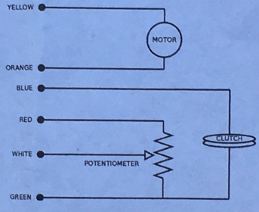

The drive shaft is highly geared so the motor is able to exert considerable force on the shaft. The clutch must be engaged by applying +12 V to the Blue wire in order for the shaft to move.

Reliability and Maintainability

Reliability
- All components carrying powers in excess of 1 W have been derated by at least 20 % for power supplies and 50 % for other components.
- The SD Card has been protected from corruption by being made Read-only.
- Adequate ventilation has been provided. (The system is installed in an open frame which is protected by a water proof cover, but is open to the free passage of air.)

Maintainability

Documentation
Full documentation will be provided by this document and by the documents referenced in Section 2.

Mechanical
The Veroboard and the other electronic modules are mounted using M2.5 pillars and screws onto a plastic baseboard specifically designed for the River System Hardware. For the Gate Valve the baseboard is printed as a box.
Illustration 3.2 below shows the mechanical layout of the modules on the baseboard.
Illustration 3.3: Gate Valve Assembly – Overall Layout
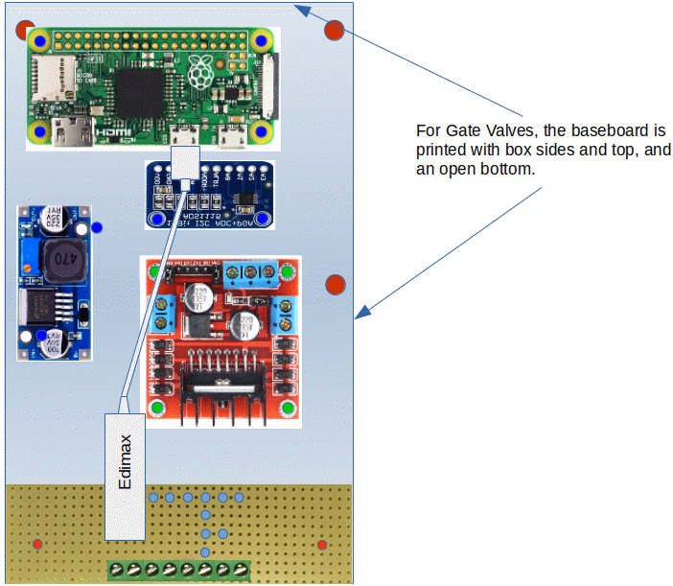

CONSTRUCTION AND INSTALLATION

Hardware

Construction

Veroboard
The Veroboard is assembled using lead-free solder and wire links where necessary. The Screw Terminal Blocks and Header Pins provide for interconnection with the other electronic assemblies.
Illustration 4.1 shows the Veroboard layout.
Illustration 4.1: Gate Valve Assembly – Veroboard Layout
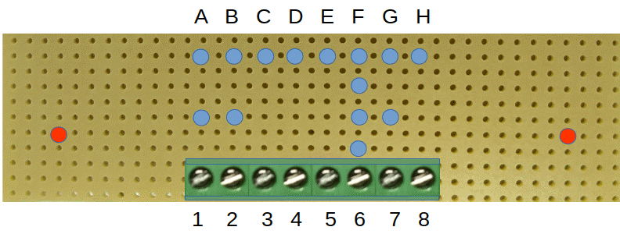
Notes on Terminal Block TB1:
- The Terminal Board is viewed from the bottom of the assembly.
- Header pins are soldered to the Veroboard in the locations shown thus:
The terminations on TB1 are as follows:
Pin | Signal
1 | 12 V (from PSU)
2 | 0 V (from PSU)
3 | Motor B Out 3 (from Actuator Yellow)
4 | Motor B Out 4 (from Actuator Orange)
5 | Motor A Out 2 (from Actuator Blue - Clutch)
6 | Motor A Out 1 (from Actuator Green – Common Ground)
7 | 3.3 V (from Actuator Red - Top of Potentiometer)
8 | A/D Board A0 (from Actuator White - Slider of Potentiometer)

Header Pins are numbered as follows:
Pin | Signal
A. | 12 V (to DC/DC Converter and Motor +12 V terminal).
B. | Common 0 V point (to DC/DC Converter and Motor 0 V terminal).
C. | From Motor Drive Board B Out 3 (Yellow)
D. | From Motor Drive Board B Out 4 (Orange)
E. | From Motor Drive Board A Out 2 (Blue)
F. | From Motor Drive Board A Out 1 & Common 0 V (Green))
G. | 3.3 V (from Pi Pin 1 and to A/D Vdd)
H. | To A/D A0 (White)

Internal Wiring
All internal links are made using jumper wires with male or female header pins. The exception to this is the link between the DC/DC Converter and the Pi (+5 V), which includes a microUSB connector on the end of it. Illustration 4.2 shows the wiring:

Illustration 4.2: Gate Valve Assembly – Wiring
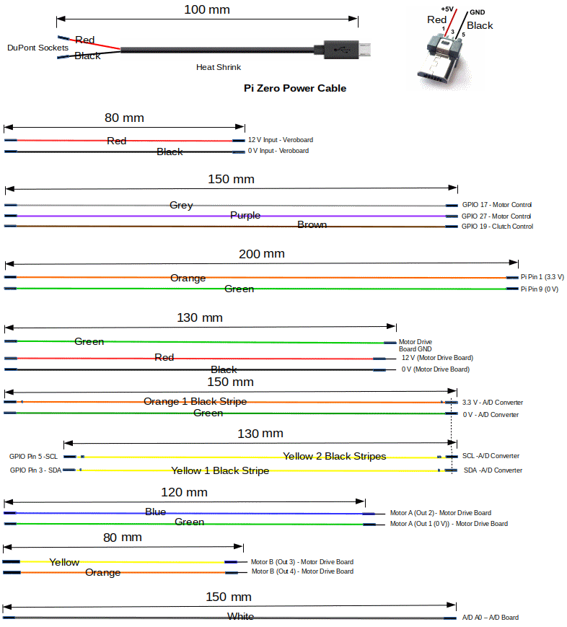
Notes:
- During assembly, route links beneath electronic assemblies where possible.
- Bundle adjacent links together using tie-wraps or looming cord.
- Where wire colours are re-used mark the duplicate with black or white stripes.

Final Assembly
The following procedure indicates the best way to assemble the system. Prior to full assembly, the following items should be constructed and made ready:
- The Veroboard Assembly.
- Solder header pins to the DC/DC Converter, the A/D Converter and the Pi Zero if an unpopulated item has been procured. (It is not necessary to fully populate the GPIO pins.)
- All wires; cut to length, crimped/soldered and labelled where necessary.
- With reference to the Mechanical Layout Drawing, identify the positions of all of the components.
Build the full assembly as follows:
- Connect all wiring to the Raspberry Pi, but leave the other ends of the wires unconnected.
- Tie-wrap the wiring close to the Pi GPIO connector and lead the wiring beneath the Pi.
- Mount the Pi with four 2.5 mm screws onto the four long pillars provided.
- Mount the Veroboard Assembly onto the two short pillars provided using two 2.5 mm screws.
- Mount the DC / DC Converter onto the two short pillars provided using two 2.5 mm screws.
- Connect all wires between the Veroboard Assembly, the Pi and the DC / DC Converter (for convenience (leave the USB power connector off until all wiring is completed).
- Connect all wiring to the ADC, picking up the two from the Pi, but leaving the other ends of the wires unconnected.
- Tie-wrap the wiring close to the ADC connector and lead the remaining wiring beneath the ADC.
- Mount the ADC onto the two short pillars provided using two 2.5 mm screws.
- Connect all wires between the Veroboard Assembly and the ADC.
- Connect all wiring to the Motor Drive Board, picking up the three from the Pi, but leaving the other ends of the wires unconnected.
- Tie wrap the Motor Drive Board wiring loosely, taking care not restrict the ability to connect the loose ends to the correct terminations on the Veroboard.
- Mount the Motor Drive Board onto the four short pillars provided using two 2.5 mm screws.
- Connect the remaining wiring to the Veroboard.
- Mount the completed Gate Valve Electronics Assembly to the backplate of the Gate Valve Assembly using four 3 mm screws. (It may be necessary to remove one screw and loosen the other on the DC / DC Converter to gain access to one of the retaining screws.
- Connect the Actuator and PSU to the Electronics Assembly using the Terminal Block.

Testing
The completed assembly should be tested as much as possible to eliminate any faults before it is installed into the River System.
Perform the following tests:
- Insert a fully configured SD Card (see Installation Manual).
- Run the test program gate_valve.py in the tests directory of rivercontrolsystem_master.
- Follow the on-screen instructions to setup various valve positions, such as 1%, 50% and 99%. Check that the expected positions are obtained. (Note: There is a 10 second delay between iterations.)

USER INSTRUCTIONS

Operational

Powering Up and Down
The Operator is able to:
- Start the system by switching on the supply at the mains socket.
- Stop the system by switching off the supply at the mains socket. This is achieved safely by the use of the Read-only file system (TBC).

Spares and Repairs
Spares of the major modules have been procured and these may be found in the TBD. A full list is given in Annex C.
No special tools are required to repair the system, other than standard items normally found in a general purpose tool kit.
Full backups of all software developed have been provided.

SAFETY
With the exception of the power supply inputs, all circuits operate at less than 20 V. The mains inputs to the PSUs are inaccessible to the public.

ASSUMPTIONS
The following assumptions are made.
- Future system developers will have a working knowledge of Linux and Python programming.
- System maintainers will be sufficiently skilled in general maintenance, electronics, electrical systems and software, as appropriate to be able to follow the diagnostic instructions provided in the User Manual.
Annex A
Hardware Identity
This Annex defines the hardware required for system implementation. Many of these items are free delivery and some attract a delivery charge of a few pounds. Assume £10-15 total delivery. A list of spares may be found in Annex C. These were procured at the same time as the Development items, so attracted no additional delivery costs.
Computing Devices
Item | Identity | Qty | Cost Each | Total Cost
Computer | Raspberry Pi Zero(Raspberry Pi Foundation). | 1 | £5 | £5

Interfaces and Accessories

Item | Identity | Qty | Cost Each | Total Cost
DC/DC Converter | LM2596 Buck Converter (available on eBay, and from Banggood or Gearbest at the price shown). | 1 | ~£2 | ~£2
Motor Drive Board | L298N Double-H-Bridge motor driver (available on eBay, and from Banggood or Gearbest at the price shown). | 1 | ~£1 | ~£1
A/D Converter | ADS1115 ADC Assembly (available on eBay, and from Banggood or Gearbest at the price shown) | 1 | ~£3 | ~£3
Veroboard Assy | Includes two 74HC4050 Buffer/Translators and sundry resistors, connectors etc. | 1 | ~£10 | ~£10

Actuator Assembly

Item | Identity | Qty | Cost Each | Total Cost
Actuator | The WMT has a stock of these. | 1 | - | -

Power Supplies

Item | Identity | Qty | Cost Each | Total Cost
PSU | Any +12 V, PSU of at least 1 A current availability (available online at approx prices shown). | 1 | ~£15 | ~£15
Miscellaneous

Item | Identity | Qty | Cost Each | Total Cost
Jumper Wires | Manufactured using DuPont connectors in various colours. | A/R | ~£1 | ~£1
Terminal Block | PCB Mount Screw Terminal Connector (available on eBay, and from Banggood or Gearbest at the price shown) | 8 x 2 ways | ~12p | ~£1

Annex B
Spares
This Annex defines the spares required for system maintenance.
Item | Identity | Qty | Cost Each | Total Cost
Computer | Raspberry Pi Zero(Raspberry Pi Foundation). | 1 | £5 | £5
DC/DC Converter | LM2596 Buck Converter (available on eBay, and from Banggood or Gearbest at the price shown). | 1 | ~£2 | ~£2
A/D Converter | ADS1115 ADC Assembly (available on eBay, and from Banggood or Gearbest at the price shown) | 1 | ~£3 | ~£3
Motor Drive Board | L298N Double-H-Bridge motor driver (available on eBay, and from Banggood or Gearbest at the price shown). | 1 | ~£1 | ~£1

