WIMBORNE MODEL TOWN
DEVELOPMENT
RIVER SYSTEM: INSTALLATION SPECIFICATION
Issue 0.20
26th August 2022



This work is licensed under the Creative Commons Attribution-NonCommercial-ShareAlike 4.0 International License. To view a copy of this license, visit http://creativecommons.org/licenses/by-nc-sa/4.0/.

Table of Contents
1 INTRODUCTION 5
1.1 Development Documents 5
1.2 Referenced Documents and Resources 5
1.3 Understanding the referencing system 6
2 ABBREVIATIONS 6
3 PROJECT ARCHIVES 7
4 SYSTEM FUNCTIONS 8
4.1 Hardware 8
4.1.1 Installation 8
4.1.2 Electrostatic Sensitive Devices 8
4.1.3 Hardware Environment 8
4.1.4 System Layout 8
4.2 Software 9
4.2.1 Software Environment 9
4.2.2 Development Tools 9
4.3 Detailed Description Of Software Functions 9
4.3.1 General 9
4.4 Deployment 10
4.4.1 Software Environment 10
4.4.1.1 Install and Update Raspberry Pi OS Lite 10
4.4.1.1.1 Initial Setup 11
4.4.1.1.2 Common Software Installation 12
4.4.2 Prepare SD Cards for Specific Pis 12
4.4.2.1 Additional Network Configuration 12
4.4.2.1.1 Setup a Static IP Address 14
Save the changes (Crtl O, <Enter>, Ctrl X). 14
4.4.2.2 Setting the Hostname 14
4.4.2.3 Adding the Software Framework 14
4.4.2.3.1 Changes to Consider Before Adding the Software Framework 15
4.4.3 Additional Sump Pi Configuration 15
4.4.3.1 Time Synchronisation 15
4.4.3.2 Installation and Configuration of Software Specific to SumpPi and the NAS box 16
4.4.3.3 Autostart of the Sump Pi Software 16
4.4.4 Butts Pi(s) Configuration 16
4.4.4.1 Autostart of the Butts Pi(s) Software 16
4.4.5 Gate Pi(s) Configuration 16
4.4.5.1 Autostart of the Gate Pi Software 17
4.4.5.2 Making the SD Card Read-Only 17
4.4.6 NAS Box Configuration 17
4.4.6.1 Logging In 17
4.4.6.2 Changing the Admin Password 18
4.4.6.3 Firmware Updates 19
4.4.6.4 Installing Custom Settings 21
4.4.6.4.1 Temporarily enabling built-in SSH server 22
4.4.6.5 Installing phpMyAdmin using D-Link’s package 23
4.4.6.6 Upgrading phpMyAdmin 24
4.4.6.7 Installing Custom Start-Up Scripts and Sysroot 27
4.4.6.8 Adding SSH Keys 28
Creating an SSH Key Pair for User Authentication 28
Copying the Public Key to the Server 29
4.4.6.9 Disabling built-in SSH server 29
4.4.6.10 Deploying backup and restore software 29
4.4.6.11 How to Build the Cross-compiler 30
4.4.6.11.1 Environment 30
4.4.6.11.2 Ready-built Cross-compiler 30
4.4.6.11.3 Reproducing the Original Cross-compiler 30
Links to Resources: 30
Dependencies 31
4.4.6.11.4 Downloading the Cross compiler 31
4.4.6.11.5 Configuring the cross compiler 31
4.4.6.11.6 Menu configuration 32
4.4.6.11.7 Patching the Build Scripts 32
Linux Kernel Download Location 32
MPC download location 32
DUMA download location 33
4.4.6.11.8 Starting the Build 33
4.4.6.11.9 Cross-compiling and Building the Updated NAS Software 33
4.4.6.11.10 Extra feature: Running armv5 binaries in the Build Environment 33
4.4.6.11.11 Shutting down safely 34
4.4.6.11.12 Rebooting safely 34
5 TESTING 35
5.1 Unit Testing 35
5.1.1 Hardware 35
5.1.2 Software 35
5.2 System Testing 35
5.2.1 Virtualisation 35
5.2.2 Cut-down Pi Configuration. 36
Illustration 1: River System – System Test Diagram 36
6 GENERAL MAINTENANCE ACTIVITIES 39
6.1 Backing Up and Restoring SD Cards 39
6.1.1 Backing Up 39
6.1.1.1 From Within the Running Pi 39
6.1.1.2 From Another Linux Computer 40
6.1.1.2.1 Identify the Device 40
6.1.1.2.2 Writing to an Image 41
6.1.2 Restoring 41
6.1.2.1 Using Etcher 41
6.1.2.2 Using the Raspberry Pi Imager 41
6.1.2.3 From a Linux Computer 41
Index of Tables
Table 1.1: Related Documents - Development 5
Table 1.2: Related Documents -River System Project 5

Table of Figures
Illustration 1: River System – System Test Diagram 36

ANNEXES
A Using Virtual Machines to Test the Software - Creating the Virtual Machines
B Using Virtual Machines to Test the Software
- Configuring the Virtual Machines
C Using Virtual Machines to Test the Software
- Using the Virtual Machines Created in Annex A.
D Using Virtual Machines to Test the Hardware
- Using the Virtual Machines Created in Annex A.

INTRODUCTION
This specification provides information for future developers of the River Control System at Wimborne Model Town.
Where possible, the system has been designed to be as easy as possible to operate, maintain and upgrade.
This document should be read in conjunction with the Design Specification and the User Manual.

Development Documents
The following documents were generated as part of this development.
Table 1.1: Related Documents - Development
No | Document | Iss
1 | Wimborne Model Town – River System - Requirements | 0.5.1
2 | Wimborne Model Town – River System - Design | 0.5
3 | Wimborne Model Town – River System – User Manual | 3.0
4 | Wimborne Model Town – River System – Software Design Specification | 0.11

Referenced Documents and Resources
The following documents and resources are useful for supporting development.
Table 1.2: Related Documents -River System Project

No | Resource | Ref
1 | Python Tutorial | https://docs.python.org/3.7/tutorial/index.html
2 | Python Documentation | https://docs.python.org/3.7/index.html
3 | Raspberry Pi GPIO Tutorials | http://raspi.tv/
4 | Raspberry Pi OS Downloads | https://www.raspberrypi.org/downloads/
5 | Setting a static IP Address | https://www.modmypi.com/blog/how-to-give-your-raspberry-pi-a-static-ip-address-update
6 | Make the SD Card Read-only | https://learn.adafruit.com/read-only-raspberry-pi/
7 | How To Autorun A Python Script On Raspberry Pi Boot | Run as Another User
8 | GitLab Project – River System | River System Project
9 | Etcher – SD Card copier. | https://etcher.io/
10 | Tutorial on backing up and restoring SD Cards. | http://thepihut.com/blogs/raspberry-pi-tutorials/17789160-backing-up-and-restoring-your-raspberry-pis-sd-card
11 | Tutorial on shrinking image files. | https://softwarebakery.com//shrinking-images-on-linux

Understanding the referencing system
References will be referred to in text by the Section Reference number followed by the Item number in the Table, eg:
‘This procedure is documented in reference 1.2.5’ means Section 1.2 and the 5th entry in the table. In this case this is the link to www.modmypi.com for setting a static IP address.

ABBREVIATIONS
- AP - Access Point
- ESD - Electrostatic Sensitive Device
- GPIO - General Purpose Input / Output
- IDE - Integrated Development Environment
- PCB - Printed Circuit Board

PROJECT ARCHIVES
A copy of all project documentation, code and software environments may be found at the relevant GitLab Project, (see References 1.2.1.8).

SYSTEM FUNCTIONS

Hardware

Installation
Installation of the hardware is covered in the User Manual and this document is confined to work that will only need to take place if the system has been revised and upgraded; an activity that might trigger a need to strip the system out or redesign some elements.

Electrostatic Sensitive Devices
CAUTION Electronic devices used in the system are sensitive to static electricity. Precautions should be taken when handling these devices in order to prevent permanent damage.
The Raspberry Pis and the other Printed Circuit Boards (PCBs) contain devices that can be damaged if they are exposed to static electricity. Static Electricity is readily generated when people walk over dry floors, rub against furniture or simply rub against their clothing. Although rarely noticed, the level generated is sufficient to damage devices if precautions are not taken. It is therefore recommended that no work be undertaken on these devices without taking one of the following actions:
- If possible an ESD workstation be employed. An ESD workstation includes an Antistatic Mat, a conductive wrist band and a means of earthing the mat and band, usually via a three-pin mains plug with a resistive earth pin.
- It is recognised that the WMT is not conducive to setting up an ESD workstation, so maintainers should endeavour to earth themselves by touching an earthed metal object at intervals during the work, especially after it has been necessary to leave the work area and return. A good compromise would be to use a wrist band clipped to a convenient earth point.

Hardware Environment
The hardware in this system was developed and assembled before final debugging was carried out, since this proved to be the only feasible method in the time available. However, this is not essential, and a breadboard and local Ethernet could be employed for future enhancements.

System Layout
Full details of the physical and electrical layout of the system may be found in the User Manual.

Software

Software Environment
Much of the development of the software for the River System Functions may be performed on any computing device, but will be simplified if suitable tools are available as detailed below. Debugging must be performed on the target device, with suitable hardware attached (see Section 4.1.3 above) in order that the Python Interpreter may import all the necessary libraries and the software functions may be observed in operation. During the original development Raspberry Pi Model Zeros, running the Raspberry Pi OS Operating System, were used for final development, with a Pi 3 being used for initial coding.

Development Tools
Raspberry Pi OS includes all of the tools necessary to write and develop the program. Much of the original development was carried out using the IDLE Integrated Development Environment, but other development toolsets such as Thonny or Eclipse may be used if desired.

Detailed Description Of Software Functions
A detailed functional description of the River System software design may be found in the automatically generated documentation.

General
The River System Functions code was written using Python Version 3.7.x. For simple code constructs and approaches, a good start would be the Python Tutorial at Reference 1.2.1. The full documentation for Python 3.x may be found in the Python Docs at Reference 1.2.2 and may be needed to interpret the detailed descriptions provided below.
Similarly, the RPi.GPIO Library was used to control the input and output functions and a series of Tutorials may be found at Alex Eames site (Reference 1.2.3).

Deployment

Software Environment
The deployed image on the SD Card is Raspberry Pi OS Lite, run in ‘read-only root’ mode. Details of how to prepare the SD Card for deployment are given below. The Initial Setup stage is easiest to perform if a separate PC is used.
Notes:
1. The Basic Installation described in Section 4.4.1.1 below assumes that there is no existing deployed software or it is intended to fully upgrade the underlying Operating System. If a deployed system is operating and it is necessary to add an additional device, then a backup should be taken of SD Card of one of the deployed devices and that image burned to a new SD Card (see Section 5 below). This ensures that all devices are running the same software.
2. At the time of writing none of the devices are running in ‘read-only root’ mode because of the amount of development currently taking place. Once the NAS Box is fully deployed and a solution is identified for the backup results files, then this mode will be implemented.

Install and Update Raspberry Pi OS Lite
The easiest way to install Raspberry Pi OS is to use the tools provided by the Raspberry Pi Foundation. Reference 1.2.4 provides a link on where to download the Raspberry Pi OS Imager for Windows, Linux or MacOS. Once the Imager has been installed proceed as follows:
- Insert a USB to MicroSD Card Adaptor into a USB Socket on the computer, with a MicroSD Card of at least 8 GB inserted.
- Launch the Imager.
- Click the ‘Choose OS’ button, select ‘Raspberry Pi OS Other’ then ‘Raspberry Pi OS Lite’ and follow the on screen prompts. The latest version of the selected image will be downloaded and copied to the SD Card, then verified.
- When copying is complete, use your computer’s usual method of ejecting the adaptor with the SD Card inserted.
- Insert the SD Card into the target Pi and apply power.
- After boot-up is complete, log in using default username ‘Pi’ and the default password ‘raspberry’.
- Run the following commands from the shell:
sudo apt update
sudo apt upgrade

This will download any updates and install them.
Note: Internet access is needed for the above exercise. If possible perform the updates using an Ethernet cable connected to the Pi because this prevents the WiFi having to be disabled again after the updates are completed. (For Webserver and VPN Server Pis use eth1.)

The Pi is now ready for configuration and code installation.

Initial Setup
Insert the SD Card into a Raspberry Pi computer and apply power.
Note: Any Raspberry Pi will do for this and many of the the subsequent steps, but access to the Internet will be needed and it is less likely that issues will subsequently be encountered if a Raspberry Pi Zero is used.
After the system has booted, log in using the Username ‘Pi’ and the password ‘raspberry’.
Type the following at the command line:
sudo raspi-config

Using raspi-config’s menu items setup the following:
- Change the password to ‘river17’.
- If a plugin WiFi adaptor is being used during this process, then enter ‘Network Options’ and setup the SSID and Passphrase.
- Enter ‘Boot Options’ and set the Pi to boot into the CLI and automatically log in to the Pi User.
- Under ‘Localisation Options’, check that:
  - The ‘Locale’ and ‘Keyboard’ settings match the keyboard type that is intended to be used for the River System setup.
  - If a plugin WiFi adaptor is being used during this process, then setup the WiFi Channel.
Note: If possible, the WiFi facility should not be used since the OS will then lock out the WiFi saving the necessity of doing this after software installation has been completed.
  - In the ‘Timezone’ setting, select ‘UTC’.
- Under Interfacing Options’, enable ‘SSH’ and ‘I2C’.
- Select ‘Finish’ and ‘Reboot’.

Common Software Installation
Use the following command to install the additional Python modules needed for execution of the Software Framework:
sudo apt update
sudo apt upgrade
sudo apt install rdate
sudo apt install RPi.GPIO
sudo apt install python3
sudo apt install python3-pip
sudo apt install python3-psutil
sudo apt install libmariadbclient-dev
sudo pip3 install adafruit-circuitpython-ads1x15

pip3 install mysqlclient==2.0.1
Note: Depending on the version of Raspberry Pi OS used, some of the above may be already installed.
Note: mysqlclient must be at version 2.0.1 (pending confirmation) in order to work with the old database software on the NAS box.

Shutdown the Pi:
sudo shutdown now

Remove power from the Pi and remove the SD Card.
Backup the SD Card, as described in Section 5.1, giving the image file the name:
YYYY-MM-DD_River_System_Base_SD-Card.img

This ‘Base’ image subsequently be used to create SD Card for specific Pis unless a copy of the SD Card installed in the deployed system is to be used.
Note: If the SD Card image that was used to create the new card has been marked as ‘Read-Only’, then all configuration will need to be done with the card mounted in another computer, such as a PC.

Prepare SD Cards for Specific Pis
From this point onwards, it is assumed that all the preceding steps in Section 4.4.1 above have been carried out or that the SD Card image created at an earlier time has been used to create the new SD Card.

Additional Network Configuration
In the final deployment there may be no DHCP server available, so each Pi has been given a static IP Address. Reference 1.2.5 provides a method of doing this on a Raspberry Pi and the following sections detail the procedure.

Setup a Static IP Address
To set a static IP address, enter a shell and type:
sudo nano /etc/dhcpcd.conf

At the bottom of the file add:
interface eth0
static ip_address=192.168.0.2/24
static routers=192.168.0.30
static domain_name_servers=192.168.0.1

Save the changes (Crtl O, <Enter>, Ctrl X).
Note: In the example above, the allocated IP Address applies to sumppi. Remote Pis will have their static IP Address updated during the specific configurations described below. A full list of assigned IP Addresses may be found in Reference 1.1.4 and the auto-generated software documentation, under ‘config.py’.

Setting the Hostname
Run ‘raspi-config’, enter ‘Network Options’, and set the hostname to the name chosen for the device, eg ‘sumppi’. See Reference 1.1.4 for a full list of the configuration data of all devices.

Adding the Software Framework
On a suitable PC and copy the latest version of the Software Framework from the WMT repository at https://gitlab.com/wmtprojectsteam/rivercontrolsystem/tree/master. This may be done in a number of ways and if the git repository is already installed on the PC, and up to date with the referenced repository, then the ‘rivercontrolsystem‘ directory may be copied directly to the ‘pi’ directory on the SD Card (plugged into an adaptor). Alternatively, the code may be downloaded from the referenced site, unzipped and copied in the same way.
If the new SD Card is to replace a faulty, already deployed, card, then this step will be all that is necessary. Otherwise, it will almost certainly be necessary to update the software before copying it as shown in the following Section.

Changes to Consider Before Adding the Software Framework
If the device is being deployed in that location for the first time, eg a new Pi Interface or Gate Valve to expand the system, then changes to the Software Framework will probably be needed before it is added. Changes that should be considered include:
- Definition of the Device in SITE_SETTINGS (config.py):
  - Under “SUMP”, add the socket “ID”, “Name” and “PortNumber”, the Probe definitions and the device definitions, as applicable.
  - Under ‘clients’, add the Probe and Device definitions and the “ServerAddress”, “ServerPort” and “ServerName”.
- Update the control algorithm as appropriate, eg ‘do_control_logic() to use the new device.

Additional Sump Pi Configuration
Note: If the card has been marked Read-Only, then it will not be possible to complete this Section unless the card was copied from an original SumpPi SD Card. In that case, this section should be unnecessary.

Time Synchronisation
The Master Pi, (currently sumppi) has a physical Real Time Clock installed on GPIO Pins 1 to 6 rdate will be used on all Pi’s to synchronise all local clocks to the Real Time Clock installed in sumppi. Configure Sump Pi to read and use this clock as detailed below:
Edit the file /boot/config.txt as follows:
sudo nano config.txt

add:
dtoverlay=i2c-rtc,pcf2127

After restarting, the RasClock should be recognised and can be controlled with the hwclock command. Edit the file /lib/udev/hwclock-set
Comment out or remove the three lines
if [ -e /run/sadaystemd/system ] ; then
exit 0
fi
Comment out or remove the two lines which contain –systz.

Installation and Configuration of Software Specific to SumpPi and the NAS box
In a shell issue the following command:
sudo apt install xinetd
sudo nano /etc/xinetd.d/time

In two places, change ‘disable = yes’ to ‘disable = no’

Autostart of the Sump Pi Software
After boot up, the relevant program is launched by including the following code in .bashrc for the Pi user:
if [ $(tty) == /dev/tty1 ]; then
cd rivercontrolsystem
./main.py --id "SUMP”
fi

Where <ID> is the identity of the Pi as given in Table 2 of Reference 1.1.4.
This will ensure that the program is only ever launched once and prevents subsequent logins via SSH from starting a new instance.

Butts Pi(s) Configuration
Note: In the current design there are four Butts Pis; eg, behind the Wendy House, behind the Stage, behind the Lady Hanham Building and behind the Gazebo. Configuration is identical for all of these apart from the hostname Section 4.4.2.3), the IP Address (Section 4.4.2.2) and the Autostart command (Section 4.4.4.1).

Autostart of the Butts Pi(s) Software
This is achieved in a similar way to the Sump Pi configuration. Add the following lines at the bottom of the file home/pi/.bashrc:
if [ $(tty) == /dev/tty1 ]; then
cd rivercontrolsystem
./main.py --id "ID"
fi
Where ‘ID’ is the Device Name as detailed in Reference 1.1.4.

Gate Pi(s) Configuration
Note: In the current design there are eleven Gate Valves; eg, V6-V9 (the Matrix Pump) plus V4, V5 and V11 behind the Wendy House, V1, V2, V3 behind the Lady Hanham Building and V5 behind the Gazebo. Configuration is identical for all of these apart from the hostname Section 4.4.2.3), the IP Address (Section 4.4.2.2) and the Autostart command (Section 4.4.5.1.

Autostart of the Gate Pi Software
This is achieved in a similar way to the Sump Pi configuration. Add the following lines at the bottom of the file home/pi/.bashrc:
if [ $(tty) == /dev/tty1 ]; then
cd rivercontrolsystem
./main.py --id "ID"
fi

Where ‘ID’ is the Device Name as detailed in Reference 1.1.4.

Making the SD Card Read-Only
This procedure is not reversible, and will prevent the Readings and Log files being written to the SD Card, so should only be carried out when a strategy for storing this information has been agreed and implemented. Setting the SD Card to Read-Only mode may be done using the procedure in the following web page https://learn.adafruit.com/read-only-raspberry-pi/. This involves running a script to create a protected run-time environment.

NAS Box Configuration
Note: At the time of writing, the NAS box isn’t actually installed in the system, and not all procedures are finalised so this documentation is somewhat incomplete.
The D-Link DNS-320L provides details of many of the procedures described in this Section, in particular those that are not specific to the River System installation.
Notes:
1. Performing a factory reset will NOT delete data from the hard drive(s), so it should not be necessary to perform all these configuration steps again after a factory reset.
2. After a factory reset, the IP address of the NAS Box is not fixed by default. It may be necessary to run the software CD on a computer running Windows XP or higher to perform initial setup of the NAS Box. A copy of the CD Image may be found at https://wmtprojectsforum.altervista.org/files/wmt%20river%20system%20files/nas%20box/software%20cd.iso.xz.
3. After a factory reset, the administrator password is blank and will need to be changed (see Section 4.4.6.1 below).
4. Once set, the administrator password should be recorded and stored in a safe place, because the only way to recover if the password is forgotten is by performing a factory reset.
5. During the procedures that follow, newer updated software is built using a Cross-compiler and installed onto the device. Ensure these steps are carried out in the order stated to avoid being locked out of SSH Login.

Logging In
The initial configuration of the NAS Box is performed via the standard D-Link Admin page. This is obtained as follows:
- Using a standard browser, navigate to the NAS Box’s web address (https://192.168.0.25 when deployed), log in with the administrator password, and tick “Use SSL”.
Note: This may create a security warning in the browser. It should be possible to bypass the error, but if not, untick “Use SSL” and try logging in again.

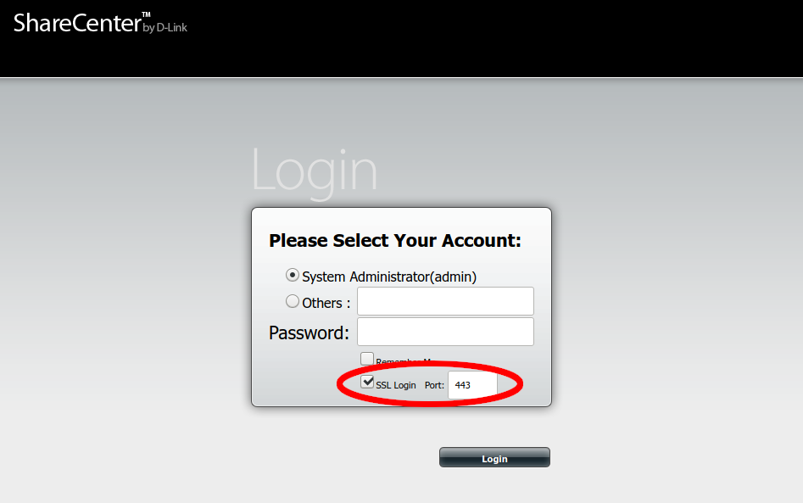

Changing the Admin Password
After the login has been successfully achieved, the administrator password may be changed on the “Account Management” page:
- Click on “Management”.
- Click on the “Account Management” icon.
- Select the “Admin Password” item in the sidebar.
- Enter the existing administrator password (blank after a factory reset), then the new password and then repeat the new password.

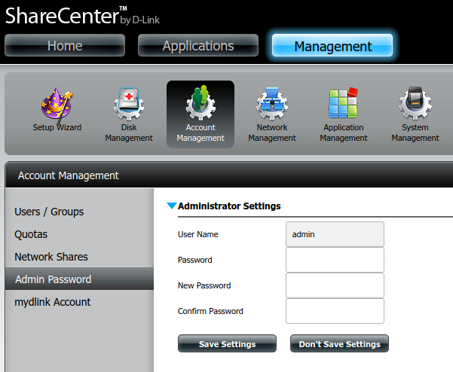

Firmware Updates
It is not envisioned that there will be future firmware updates to the NAS Box, but to ensure the firmware used remains available, it has been uploaded to https://wmtprojectsforum.altervista.org/files/WMT%20River%20System%20Files/NAS%20Box/DNS-320L_fw_revA3_1-11_eu_multi_20180709.zip. If this file becomes unavailable, download version 1.11 revision A3 from https://eu.dlink.com/uk/en/products/dns-320l-sharecenter-2-bay-cloud-storage-enclosure#support instead.
WARNINGS:
1. No other firmware version should be used unless the software has been tested to work with it.
2. Be aware that updating the firmware may mean that the whole NAS box has to be set up again!

The process for reinstalling the firmware is as follows.
- Download the firmware using the above link.
- Log in the the device as described in Section 4.4.6.1.
- Click the “Management” button at the top of the dashboard.
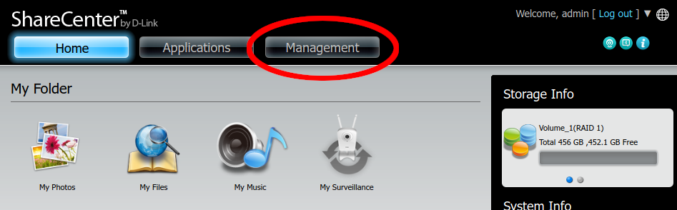
- Click on the “System Management” icon.
- Select “Firmware Upgrade” from the sidebar.
- Use the browse button on the resulting screen to select the firmware downloaded earlier and click “Apply” to update.
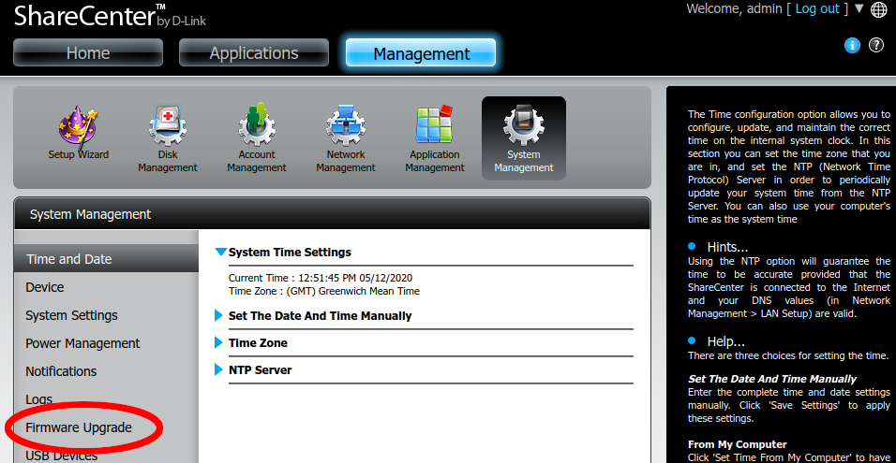

Installing Custom Settings
The NAS box provides an easy way to restore custom configuration. This won’t work for everything, but it will allow easy restoring of most system settings.
- Download the file called “custom_settings.tar.gz” from https://wmtprojectsforum.altervista.org/forum/viewtopic.php?f=36&t=152.
- Navigate to System Management as described above.
- Next, click “System Settings”, expand “Configuration Settings”, browse for the file downloaded, and click “Load”.
- The NAS box will restart.
- From now on, the IP address of the NAS box will be 192.168.0.25.
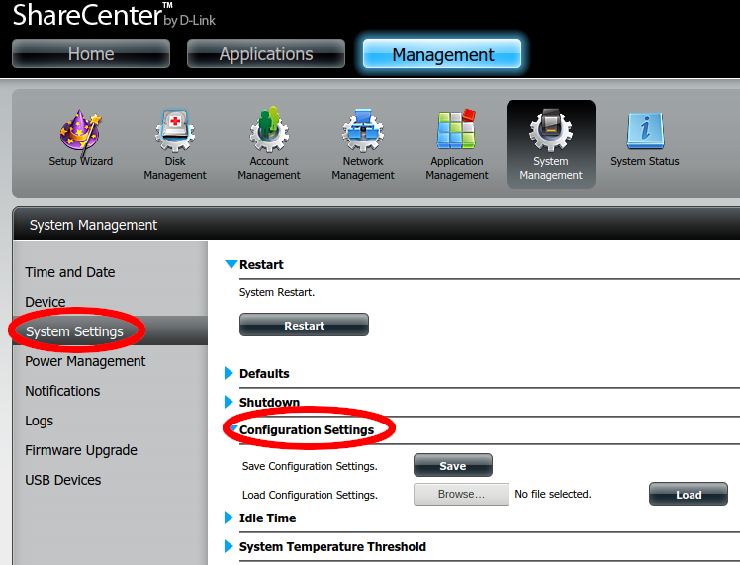

Temporarily enabling built-in SSH server
In order to complete the rest of the setup process, the built-in SSH server needs to be temporarily enabled. This will be disabled later, as the custom software provides a newer and more secure SSH server.
- Click the “Management” button and then navigate to “Network Management”.
- Click “SSH”, tick “Allow SSH connection” and enter “2222” into the Port number field.
- Click “Save Settings”.
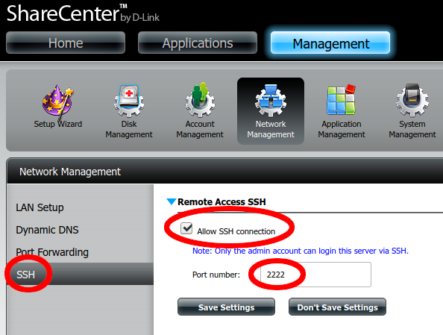

Installing phpMyAdmin using D-Link’s package
The tool phpMyAdmin (https://www.phpmyadmin.net/) is required on the NAS Box for database management and is also used to bootstrap the rest of the custom software on the NAS box. The easiest way to install phpMyAdmin is to use D-Link’s official package. This is available for download at https://wmtprojectsforum.altervista.org/files/wmt%20river%20system%20files/nas%20box/packages/dns-320l%20phpmyadmin%20package%20v1.02_09212015.tar. To install this:
- Download phpMyAdmin.
- Click the “Applications” button at the top of the dashboard.
- Click the “Add-on Center” button.
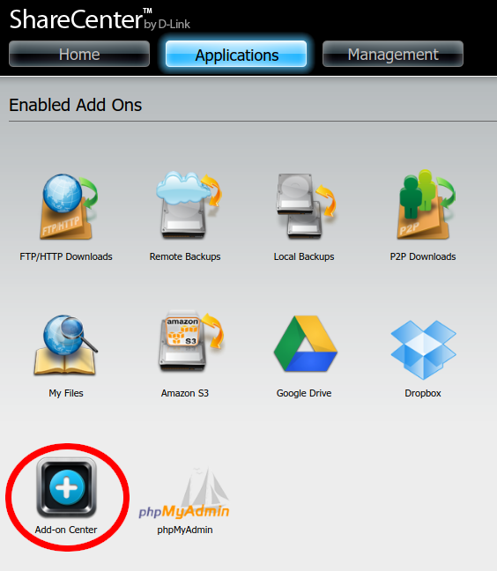
- Click the “Install Manually” button and then browse to the phpMyAdmin file downloaded earlier.
- Click “Install”.
- The NAS box will install phpMyAdmin and then reboot.

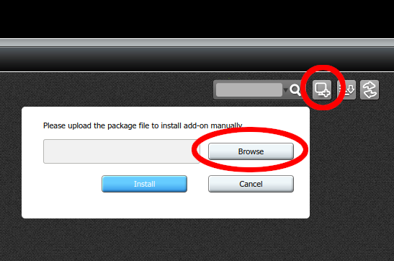
Upgrading phpMyAdmin
The version of phpMyAdmin provided by the package works, but is old and can be updated to improve security. The other old software on the NAS box is a limitation, so version 4.0.10 should be run.
A modified version of 4.0.10 is available at https://wmtprojectsforum.altervista.org/files/WMT%20River%20System%20Files/NAS%20Box/Packages/new-phpmyadmin.tar.gz and contains all the modifications that are needed to get the custom startup scripts working.
In order to deploy this on the NAS box, a USB stick formatted as FAT32 will be needed. It will be necessary to SSH into the NAS box, so detailed instructions are provided.
- Download phpMyAdmin using the link above, and place it on the USB stick.
- Safely remove the USB stick and plug it into the back of the NAS box.
- Click the “Management” button at the top of the NAS box’s admin dashboard.
- Go to “System Management” as before.
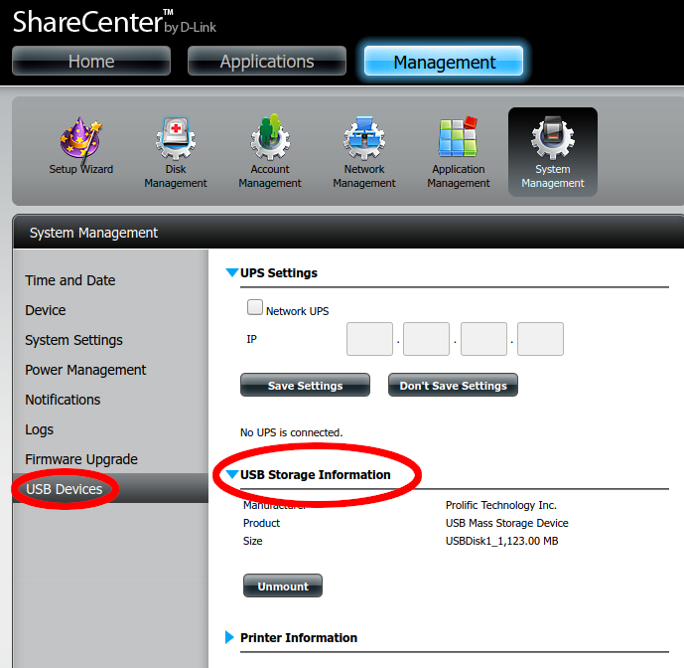
- Click on “USB Devices”, then expand “USB Storage Information”.
- Verify that the device is recognised, and click “Mount” if needed. Please note it can take a few minutes for devices to be recognised, and it may be necessary to refresh the page.
To SSH in to the NAS box open a terminal and type:
ssh-keygen -f "$HOME/.ssh/known_hosts" -R "[192.168.0.25]:2222"
ssh admin@192.168.0.25 -p 2222 -oHostKeyAlgorithms=+ssh-dss

This should ask for the administrator password. After providing it, the prompt should look like this:
/home/admin #

Now execute the following commands, one line at a time.
cd /mnt/HD/HD_a2/Nas_Prog/
rm -r ./phpMyAdmin
tar xf /mnt/USB/USB1_c1/new-phpmyadmin.tar.gz
sync
umount /mnt/USB/USB1_c1
exit

phpMyAdmin is now up to date. The USB stick can now safely be unplugged.

Installing Custom Start-Up Scripts and Sysroot
The startup scripts are available at https://wmtprojectsforum.altervista.org/files/WMT%20River%20System%20Files/NAS%20Box/nas-other-root-files.tar.xz and the sysroot (which contains all the cross-compiled programs) is available at https://wmtprojectsforum.altervista.org/files/WMT%20River%20System%20Files/NAS%20Box/nas-sysroot.tar.xz.
This will also configure the built-in SSH server with public keys for the users at the time of the original build. Follow procedures below to add your public keys for new users.
In order to deploy this on the NAS box, a USB stick formatted as FAT32 of at least 4 GB capacity will be needed. It will be necessary to SSH into the NAS box, so detailed instructions are provided.
- Download both files.
- The files need to be decompressed before being loaded on to the NAS box:
  - xz -d nas-sysroot.tar.xz
  - xz -d nasother-root-files.tar.xz

- Copy the files to the USB stick.
SSH in to the NAS box. Open a terminal and type:
ssh-keygen -f "$HOME/.ssh/known_hosts" -R "[192.168.0.25]:2222"
ssh admin@192.168.0.25 -p 2222 -oHostKeyAlgorithms=+ssh-dss

This should ask for the administrator password. After providing it, the prompt should look like this:
/home/admin #

Now execute the following commands, one line at a time. Note that these commands may take a few minutes to run, and they will not output any status information during that time.
cd /mnt/HD/HD_a2/
tar xf /mnt/USB/USB1_c1/nas-other-root-files.tar.gz
tar xf /mnt/USB/USB1_c1/nas-sysroot.tar
echo "/mnt/HD/HD_a2/setup.sh" >> /mnt/HD/HD_a2/Nas_Prog/phpMyAdmin/init.sh
sync
umount /mnt/USB/USB1_c1
reboot

Everything is now installed. The USB stick can now safely be unplugged while the NAS box restarts.
NOTE: The first boot after doing this is likely to be very slow as the setup scripts run for the first time.

Adding SSH Keys
The NAS Box is configured to allow SSH login, but users will need to add their Public SSH Key to the NAS Box. This Section describes how to create an SSH Key Pair and upload the resulting public half of the pair to the correct location on the Box.
This Section is based on the information provided at https://www.ssh.com/ssh/keygen/.

Creating an SSH Key Pair for User Authentication
The simplest way to generate a key pair is to run ssh-keygen without arguments. The user will be prompted for the file in which to store keys, but the default can be taken. As an example:
klar (11:39) ~>ssh-keygen
Generating public/private rsa key pair.
Enter file in which to save the key: (/home/ylo/.ssh/id_rsa):
Enter passphrase (empty for no passphrase):
Enter same passphrase again:
Your identification has been saved in /home/ylo/.ssh/id_rsa.
Your public key has been saved in /home/ylo/.ssh/id_rsa.pub.
The key fingerprint is:
SHA256:Up6KjbnEV4Hgfo75YM393QdQsK3Z0aTNBz0DoirrW+c ylo@klar
The key's randomart image is:
+---[RSA 2048]----+
| . ..oo..|
| . . . . .o.X.|
| . . o. ..+ B|
| . o.o .+ ..|
| ..o.S o.. |
| . %o= . |
| @.B... . |
| o.=. o. . . .|
| .oo E. . .. |
+----[SHA256]-----+
klar (11:40) ~>

Copying the Public Key to the Server
To use public key authentication, the public key must be copied to a server and installed in an authorized_keys file. This can be conveniently done using the ssh-copy-id tool. Run:
ssh-keygen -f "$HOME/.ssh/known_hosts" -R "[192.168.0.25]:2222"
ssh-copy-id i ~/.ssh/id_rsa.pub user@host -p 2222 -oHostKeyAlgorithms=+ssh-dss

Where ‘user@host’ is ‘admin@192.168.0.25’.
It should now be possible to log in, but because of the way the NAS box works, these changes will be lost on a reboot unless copied to the HDDs. Run:
ssh admin@192.168.0.25 -p 2222 -oHostKeyAlgorithms=+ssh-dss
cp .ssh/authorized_keys /mnt/HD/HD_a2/.ssh/
exit

Disabling built-in SSH server
The built-in SSH server can now be disabled.
Note: The user’s own public key must be added before doing this, as otherwise the user will be unable to log in.
Login in the NAS Box as ‘admin’.
- Click the “Management” button and then navigate to “Network Management”.
- Click “SSH” and untick “Allow SSH connection”.
- Click “Save Settings”.
Note: Once the built-in server has been disabled, SSH login can be achieved using the new SSH code installed above by typing:
ssh admin@192.168.0.25

This will allow additional SSH Keys to be installed as described above.

Deploying backup and restore software
The software needed to perform these actions may be found at https://wmtprojectsforum.altervista.org/files/WMT%20River%20System%20Files/NAS%20Box/backupandrestore.tar.gz.
Download and extract the archive onto the USB stick used earlier, and plug it in to the NAS box. Use the following commands on the NAS box to install the software:
cd /mnt/HD/HD_a2/
tar xf /mnt/USB/USB1_c1/backupandrestoretar.gz
./reboot.sh
The NAS box will then reboot. Now you need to prepare a USB stick for the automated backups. It is recommended that a USB stick of at least 4 GB in size is used. Note that all data on this USB stick will be destroyed.
Plug the USB stick in to the NAS Box, log back in and run:
mke2fs /dev/sdc1
mount -t ext2 /dev/sdc1 /mnt/USB/USB1
touch /mnt/USB/USB1/is_backupdrive
The NAS will now automatically back up its database to the USB stick at 1 AM on Monday morning every week.

How to Build the Cross-compiler
To build custom applications for the NAS Box, it is necessary to set up a cross compiler on another computer. This section details the procedure to do this using the tool ‘crosstool-NG’ installed on a copy of Ubuntu in a Virtual Machine.

Environment
The required version of crosstool-NG will not build on anything newer than Ubuntu 14.04. As a result, a Ubuntu 14.04 Virtual Machine has been set up using the instructions below.
An internet connection will be required to create the cross-compilation toolchain, as well as plenty of RAM and disk space. For the original build, 4GB of RAM and 30GB of disk space was allocated to the VM, which seems to be adequate.

Ready-built Cross-compiler
As an alternative to building the Cross-compiler from scratch a pre-configured, minimal virtual machine image with the Cross-compiler ready to use has been produced and can be downloaded from https://wmtprojectsforum.altervista.org/files/WMT%20River%20System%20Files/NAS%20Box/64-bit%20NAS%20Cross-compile%20Env.7z.
Once the download is complete, extract the archive, and import the OVF file into a Virtual Machine tool, such as VirtualBox or VMWare. The archive is very highly compressed, so this may take a while.
Create the user ‘wmt’ during the installation.
Also included in the download is the associated OVF file containing the machine specification for use if it is necessary to re-compress this machine later.

Reproducing the Original Cross-compiler
If it is necessary to re-reproduce this virtual machine, then the instructions to do so are given in the following Sections.

Links to Resources:
Website: http://crosstool-ng.github.io/
Documentation: http://crosstool-ng.github.io/docs/.
The documentation of this tool is a bit light, so additional notes have been provided as an aid memoir to assist when setting it up.
Files used in this Section: https://wmtprojectsforum.altervista.org/files/?dir=WMT%20River%20System%20Files/NAS%20Box/

Dependencies
The following dependencies must be installed as follows:
sudo apt install -y subversion gcc g++ gcj-4.8 gperf bison cvs flex expat texinfo help2man make libncurses5-dev python3-dev autoconf automake libtool gawk wget bzip2 xz-utils unzip patch libstdc++6

The list can be found in the docker configurations inside the ‘testing’ folder in the tarball (in newer versions of crosstool-NG).

Downloading the Cross compiler
The latest version of crosstool-NG does not support the glibc, binutils, and kernel versions that the NAS Box uses. However, V1.17.0 of the tool is fairly recent, and produces a newer version of GCC (V4.7.2) than the cross compilation tools provided by D-Link.
These instructions are aimed at configuring crosstool-NG v1.17.0 to build for armv5te. Proceed as follows:
- Download crosstool-NG 1.17.0 from https://wmtprojectsforum.altervista.org/files/?dir=WMT%20River%20System%20Files/NAS%20Box or http://crosstool-ng.org/download/crosstool-ng/ and verify the download with the SHA-512 sum (available from same location):
sha512sum -c /path/to/checksum-file
Next, extract the tarball:
tar -xf /path/to/tarball

Configuring the cross compiler
The original build followed 'The Hacker's Way' for the install method, on the basis that this would be easier. This builds the cross-compiler in the same directory as the source, rather than installing it into system folders:
./configure --enable-local
make

This doesn't take very long, as it simply builds the tools needed for the menu configuration. The remainder of the process is similar to building a Linux kernel. Run the following command for help with the build:
./ct-ng help

Menu configuration
Run
./ct-ng menuconfig

to get started with this.
Next load the saved configuration that has been found to work found to work:
Download the latest version of the configuration from https://wmtprojectsforum.altervista.org/files/?dir=WMT%20River%20System%20Files/NAS%20Box/Settings/config-1.17-FINAL.txt copy it to a convenient place and run:
./ct-ng menuconfig

as above. Then:
- Select the 'Load an Alternate Configuration File' option and
- Type in the full path to, and name of, the configuration file, and press ENTER.
- Select the 'Save an Alternate Configuration File' option.
- Enter '.config', and press ENTER.
- Press TAB to select the 'Exit' option at the bottom of the screen and press ENTER.
- If asked to save configuration, confirm the save operation.

Patching the Build Scripts
The original build scripts attempt to download tarballs from sources that have moved, so the following changes need to be made:

Linux Kernel Download Location
The kernel is no longer available where the script attempts to download it. Open the file:
scripts/build/kernel/linux.sh

and change the line in the do_kernel_get() function:
korg_base='http://ftp.kernel.org/pub/linux/kernel/${rel_dir}'

To read:
korg_base='http://mirrors.edge.kernel.org/pub/linux/kernel/${rel_dir}'

MPC download location
MPC is no longer available where the script attempts to download it. Open the file:
scripts/build/companion_libs/mpc.sh

and change the line in the do_mpc_get() function:
http://www.multiprecision.org/mpc/download

To read:
http://www.multiprecision.org/downloads

DUMA download location
The 'duma' package is no longer available where the script is looking for it. Open the file:
scripts/build/debug/200-duma.sh

and change the line near the top of the file:
dl_base='http://downloads.sourceforge.net/project/duma/duma'

To read:
dl_base='https://sourceforge.net/projects/duma/files/duma'

Now the build is ready to be started.
NOTE: The above files have also been uploaded (and all the other dependencies) to https://wmtprojectsforum.altervista.org/files/?dir=WMT%20River%20System%20Files/NAS%20Box/Cross%20Compiler%20Dependencies in case the download locations change again.

Starting the Build
Run:
./ct-ng build

This will take a while. On an Intel Core i5-4440 CPU and 16GB RAM, it took around 20-30 minutes to build, in addition to downloading the files.
After the build has finished the cross-compiler will be found in ~/x-tools/arm-unknown-linux-gnueabi/bin. In order to make using these tools easier, it is advisable to add them to the PATH variable, by adding the following to the end of ~/.bashrc:
export PATH=$PATH:~/x-tools/arm-unknown-linux-gnueabi/bin

These changes will take effect after the terminal session has been restarted. To make them apply immediately, run:
source ~/.bashrc

Cross-compiling and Building the Updated NAS Software
This Section will be added when the procedure has been completed

Extra feature: Running armv5 binaries in the Build Environment
ARM Binaries can be run using the emulator tool QEMU. Run the command:
sudo apt install qemu-user-static

and then add:
export QEMU_LD_PREFIX=/home/wmt/nas-sysroot
export LD_LIBRARY_PATH='/home/wmt/nas-sysroot/lib:/home/wmt/nas-sysroot/usr/local/lib'

To the .bashrc file. This is useful for running test suites for programs.
It may be necessary to add the following snippet of code before running binaries built for the NAS box:
LD_LIBRARY_PATH='/home/wmt/nas-sysroot/lib:/home/wmt/nas-sysroot/usr/local/lib'

This is required for certain things, such as building NSPR and python-mysqlclient.
Safely shutting down and restarting the NAS box.
Due to the use of a swap file, the normal methods of shutting down and restarting the NAS box (pressing the power button on the front and using D-Link's web GUI) can not be used safely. The following commands can be used to shutdown or reboot the NAS Box safely.

Shutting down safely
To shut down safely, log in via SSH (requires that your public key is on the NAS box) and run the command:
/home/admin/shutdown.sh

Once the NAS Box has logged you out, wait 2 minutes before removing power to complete the shutdown.

Rebooting safely
To reboot safely, log in via SSH and run the command:
/home/admin/reboot.sh

The NAS box will log you out and it should have rebooted successfully in 2-3 minutes.

TESTING

Unit Testing

Hardware
When hardware construction is complete, then Unit Testing of the hardware may be carried out using the Unit Test software to be found in the
/home/rivercontrolsystem/tests

Use ‘gate_valve.py’ for testing a Gate Valve and ‘sac.py’ for testing any SAC.

Software
Software for Unit Testing elements of the Software Framework may be found in the:
/home/rivercontrolsystem/UnitTests/Tools

directory. The programs are intended for use during the development and maintenance of the software.

System Testing
Unless a complete WMT River System hardware installation is replicated off site, the full System Testing can only be carried at WMT site because of the number of devices installed. However, it is not very efficient to simply complete Unit Testing and then install the updated Software Framework in the hope that it will work without major issues. Instead there are two approaches that may be used:

Virtualisation
It is possible to perform a partial system test of the software only by using two or more virtual machines on a PC. The technique may be broadly described as:
- Create a Virtual Machine for each device at each site using VirtualBox. Examples have been uploaded to WMT VMs.
- Open the VMs using VirtualBox, see (Annex A).
This has the advantage of needing no physical hardware (either Pis or Interfacing), but cannot identify faults where the wrong information is provided by the sensors in the complete system.
Annex A provides details of how these VMs may be created, configured and used.

Cut-down Pi Configuration.
The minimum hardware configuration needed to do a partial system test is a Pi to represent SumPi and the hardware which has completed Unit Testing, eg a completed SAC or Gate Valve. The hardware should be configured as shown in Illustration 1 below:

Illustration 1: River System – System Test Diagram
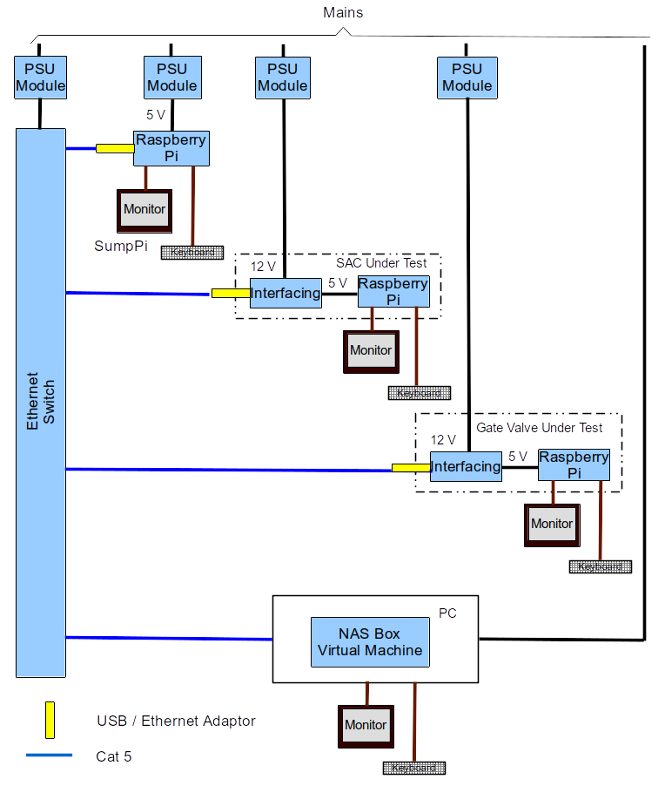
This test circuit can contain as many or as few Units Under Test as required, but will normally be used to test how a newly completed unit behaves in the system. The following factors should be considered:
- A Sump Pi is always required. This can be a Raspberry Pi equipped with nothing more than a USB / Ethernet Adaptor The monitor and keyboard is optional unless the UUT is a Sump SAC.
- The NAS Box Virtual Machine, (see Annex D) is needed to simulate the database which runs in the real NAS Box. It also provides the Real Time Clock data for all the Pis in the system.
- If the UUT is a Sump SAC, then connect another Pi to simulate another SAC or a Gate Valve. This is to enable communications to be tested.
- If the UUT is an SAC then:
  - Connect one or more Hall Effect Probes (normally one, but three for a Lady Hanham SAC).
  - Connect jumpers for simulating the state of all Float Switches.
  - Connect an appropriate Dummy Loads to:
    - The Solenoid output (approx 16 Ohms, 20 W) for a Lady Hanham SAC.
    - To the SSR outputs (approx 1 k) for a Sump SAC.
Testing should be carried out as follows:
- Construct the test circuit shown in Illustration 1.
- Build an SD Card for the UUT and the other Pi in the system as described in Section 4 above.
- Temporarily modify the code in config.py on SumpPi to remove or comment out all devices that are not included in the test system.
- Turn on the power to all devices and wait for the Pis to finish booting.
- Observe the messages on the Monitor and ensure that:
  - Communication is established between the SumpPi and the UUT (or the UUT and ‘other’ Pi if the UUT is a Sump SAC.
  - For SACs Under Test:
    - Correct depth readings are observed when the float on a Hall Effect Probe is moved to different positions.
    - The correct response is logged when the jumpers are attached to the Float Switch inputs.
    - 12 V DC is measured across SSR outputs or the solenoid output when commanded by the system.
Notes:
- If the SumpPi is not equipped with an SAC (specifically the A/D Board), then the software will generate an error 'ADS (I2C) device not found!'. This is not critical and can be ignored since the main object of the test is to ensure that communication with the UUT takes place.
- If desired, the monitors and keyboards may be omitted and SSH used to log in to each Pi and monitor the system. However, in order to do this, it will be necessary to ‘kill’ all Python instances running on each Pi and then launch the software as detailed in Section 4.4.
- It may not be easy to achieve Step 5.b.c unless the Sump Pi is part of a Sump SAC complete with Sensors, but provided the SAC has passed its own hardware Unit Tests then the likelihood of failure is much reduced when installed on site.
- Similarly if the UUT is a Gate Valve, it may not be easy to observe movement of the valve, unless the Sump SAC has sensors. Again, providing that communication has been established and the UUT has passed its own hardware Unit Tests then the likelihood of failure is much reduced when installed on site.
- The test arrangement and the tests detailed above will change when the River System architecture is updated to:
    - Include the NAS Box, with its database of readings instead of Results files on the SD Card.
    - The segmentation of control into zones as is currently proposed.

After Testing shutdown each Pi using the command:
sudo shutdown now

Any Pis in the test system without keyboard and monitor may be shutdown using SSH from the UUT or the NAS Box PC.

GENERAL MAINTENANCE ACTIVITIES

Backing Up and Restoring SD Cards
There are several methods of backing up SD Cards. Two are described below:

Backing Up

From Within the Running Pi
There can be a problem with many methods of creating an image of the SD Card, either from within the running system using the backup tool that is part of The Raspberry Pi OS or using the card mounted in a second computer as described in the next Section. The physical size of SD Cards vary from manufacturer to manufacturer and if the original system was written to a card larger than the one being used to contain the copy, the image will not fit.
This problem may be avoided by using utility called image-utils which contains a tool called image-backup which shrinks the image as it is created.
To use image-backup, download the latest version from the Forum page in Reference 1.1.4.3 copy the file to the home directory of the Pi as follows:
scp image-utils.zip <username>@192.168.1.25:/home/<username>

and unzip the tools into a convenient folder, (eg /home//bin as below). Make the utilities executable as follows:
unzip image-utils.zip
Check that the contents of the zipped file have been extracted (seven utilities and a README file). At this point the original zipped file may be deleted.
Plug in a USB Memory stick of at least 8 GB capacity then proceed by typing the following commands (the response to the first command is typical and the subsequent commands should be adjusted to correspond to the device names):
ls -l /dev/disk/by-uuid/
total 0
lrwxrwxrwx 1 root root 15 Feb 14 2019 bed55575-24b3-4bb6-821e-e85aa623a981 -> ../../mmcblk0p2
lrwxrwxrwx 1 root root 15 Feb 14 2019 BFC1-6F89 -> ../../mmcblk0p1
lrwxrwxrwx 1 root root 10 Jun 28 11:48 F277-FDDE -> ../../sda1
sudo mkdir /media/usb
sudo chown -R <username>:<username> /media/usb
sudo mount /dev/sda1 /media/usb -o uid=<username>,gid=<username>
cd /media/usb/ # <<< Check this works
cd ~/bin/
chmod +x image*
sudo ./image-backup -i /media/usb/backup.img

When the backup is complete dismount and remove the USB Stick.
sudo umount /media/usb

Notes:
1. An incremental backup may be made by repeating the above command with the original image on the destination media.
2. If desired, the image file may be compressed. Remove the USB stick from the Pi and insert it into a USB port on a PC. The compression may be carried out by the native tools of the computer in use, but sometimes the process fails due to the size of the file. In a Linux shell the following method will normally work:

zip <Date>_<Name of Backup>.zip backup.img

From Another Linux Computer

Identify the Device
In order to carry out this operation, it is necessary to identify the mounted SD Card. Insert the SD Card into a USB to SD Card adaptor, but do not plug it into the Linux machine yet.
Issue the following command in a shell:
df -h

Filesystem Size Used Avail Use% Mounted on
udev 3.9G 0 3.9G 0% /dev
tmpfs 794M 9.5M 785M 2% /run
/dev/sda1 58G 18G 38G 32% /
tmpfs 3.9G 38M 3.9G 1% /dev/shm
tmpfs 5.0M 4.0K 5.0M 1% /run/lock
tmpfs 3.9G 0 3.9G 0% /sys/fs/cgroup
/dev/sdb1 286G 160G 112G 59% /home
tmpfs 794M 36K 794M 1% /run/user/1000
Insert the SD Card into a USB slot and re-issue the df command.
df -h
Filesystem Size Used Avail Use% Mounted on
udev 3.9G 0 3.9G 0% /dev
tmpfs 794M 9.5M 785M 2% /run
/dev/sda1 58G 18G 38G 32% /
tmpfs 3.9G 38M 3.9G 1% /dev/shm
tmpfs 5.0M 4.0K 5.0M 1% /run/lock
tmpfs 3.9G 0 3.9G 0% /sys/fs/cgroup
/dev/sdb1 286G 160G 112G 59% /home
tmpfs 794M 36K 794M 1% /run/user/1000
/dev/sdc2 6.8G 5.4G 1.1G 84% /media/terry/7f593562-9f68-4bb9-a7c9-2b70ad620873
/dev/sdc1 63M 21M 43M 34% /media/terry/boot
Two new devices are now visible sdc1 and sdc2. These are the two partitions on the Raspberry Pi OS SD Card; it is the device that is of interest (eg, sdc) not the full partition name.

Writing to an Image
To backup up an SD Card in Linux, issue the following commands in a shell to backup an SD card:
sudo dd if=/dev/sdc of=~/SDCardBackup.img

Note1: The source of the backup, (in the example sdc) should be changed to suit the Linux installation in use.
Note2: The destination may be anywhere on the Linux installation and it is suggested that the filename reflects the contents and the date of the backup.
Note 3: The dd command does not show any feedback so wait until the command prompt re-appears.

Restoring

Using Etcher
Etcher is a cross-platform graphical SD Card writing tool which takes much of the complexity out of writing an image to an SD Card. The tool may be downloaded from the Etcher Website.

Using the Raspberry Pi Imager
The Raspberry Pi Imager is a cross-platform graphical SD Card writing tool which takes much of the complexity out of writing an image to an SD Card. The tool may be downloaded from the Raspberry Pi Website.

From a Linux Computer
After establishing the identity of the device it needs be unmounted. However, this must be done partition by partition by using the partition number as well. Issue the following commands for each partition:
sudo umount /dev/sdc1
sudo umount /dev/sdc2

etc….

Write the original image to the SD Card:
sudo dd bs=4M if=~/SDCardBackup.img of=/dev/sdc

Note1: The bs=4M option sets the 'block size' on the SD card to 4Meg. If you get any warnings, then change this to 1M instead, but that will take a little longer to write.
Note2: Wait until the command completes because ‘dd’ provides no feedback on progress.

Before ejecting the SD card, ensure that the Linux machine has completed writing to it by issuing the command:
sudo sync

See The Pi Hut for more information, including details of how to backup and restore SD cards on Windows or a Macintosh.

ANNEX A
Using Virtual Machines to Test the Software
Creating the Virtual Machines
Note: These instructions are complicated. Make sure to read all of the instructions through at least once before creating the VMs.
Preparation
The following points are relevant:
- Install the latest version of VirtualBox from https://www.virtualbox.org/. Version 6.1.34 was the version last used to make these VMs.
- Before creating the VMs, make sure the nonfree VirtualBox Extension Pack is not installed, as the pack is only free to use for personal use. If the extension pack is installed, certain features may be used automatically, producing VM images that are not suitable for use by WMT.
- Debian 10 “Buster” x86_64 is used for the VMs. This may change to Debian 11 “Bullseye” in a future version of the VMs, but as documented elsewhere, there are barriers to adopting newer versions of Debian for this system. Debian can be downloaded from https://www.debian.org/. A copy of the last used installer is available at: https://wmtprojectsforum.altervista.org/files/?dir=WMT%20River%20System%20Files/River%20System%20VMs.
- The VDI format for disks (the default) is required for the features used with these VMs.
- On newer versions of VirtualBox, a configuration change is needed to make the host only network work correctly for WMT. As per https://www.virtualbox.org/manual/ch06.html#network_hostonly, add “* 192.168.0.0/24” to /etc/vbox/networks.conf.
- When using a dynamically sized disk image, the image never shrinks. Once a sector has been written for the first time, its contents are forever recorded. This is necessary because unless the OS supports TRIM, the hypervisor cannot know which sectors are unused.
- To allow the disk image to shrink as well as grow, it needs to be in VDI format and attached with the --discard option. To do this, the storage should be detached from the VM and then reattached using the command:
VBoxManage storageattach "[GuestOsMachineName]" --storagectl "SATA" --port 0 --device 0 --nonrotational on --discard on --medium "[file.vdi]" --type hdd
Creating the Base Image VM
First make a VM that represents the 'base image' that all of the other Pis are based on:
- Initial configuration:
  - 8GB disk in VDI format [default].
  - 512MB RAM.
  - 1 64-bit CPU core (no execution cap) [default].
  - SATA for the HDD and an optical drive (the defaults). Enable ‘Use Host I/O Cache’ for the HDD.
  - No audio.
  - Two network adapters, both of type paravirtualised network:
    - One attached to host-only network with subnet 192.168.0.0/24 and no DHCP. This can be configured using the “Host Network Manager” in VirtualBox’s file menu.
    - One attached to NAT
  - Everything else default
Before installing Debian, detach the virtual disk image from the new VM and then re-attach it to the same VM with the –discard on option, using the command described above.
Special steps for Debian installation
  - Install the distro as a non X system (do not use Graphical Install).
  - Set the Hostname to ‘pi’ (no domain name).
  - Set no root password.
  - Set User Full Name to ‘Pi’, username to ‘pi’, password to ‘river17’.
  - Configure *no* swap space in the partitioner (delete the swap partition during the “Guided” partitioning setup).
  - Ignore the warning about low memory, and proceed anyway. The installation will be slow, but it will succeed.
Note: At this point visual glitches may be observed in the installer, probably due to low memory.
  - Select and install software:
    - DESELECT Debian desktop environment.
    - DESELECT print server.
    - Select SSH server
    - Select standard system utilities (default)
After a few minutes, and after installing the GRUB bootloader, the system will restart. Log in and complete the following tasks.
Install any available updates:
sudo apt update
sudo apt upgrade
sudo apt dist-upgrade
Install Git, net-tools and xinetd (for time syncing):
sudo apt install git net-tools xinetd

Install the packages indicated in Section 4.4.1.1.2 of this document, except for RPi.GPIO and adafruit-circuitpython-ads1x15.
Configuration
Set up passwordless sudo:
  - On Raspbian/Raspberry Pi OS, sudo is passwordless by default, and the time syncing part of the river control system assumes this is so.
  - Run “sudo visudo”, and find the line that starts with:
  - %sudo ALL=(ALL:ALL) ALL
  - Change this to:
  - %sudo ALL=(ALL:ALL) NOPASSWD: ALL
Setup auto-login as the user pi. The following references describe this:
  - http://forums.debian.net/viewtopic.php?f=16&t=123694
  - https://wiki.archlinux.org/index.php/getty
Run:
sudo systemctl edit getty@tty1.service
and edit the configuration to add the lines:
[Service]
ExecStart=
ExecStart=-/sbin/agetty --autologin pi %I $TERM

Edit /etc/fstab to add the discard option to the root filesystem, to reduce the size of the virtual disk image when files have been deleted.
Add a basic network configuration to the base image, assigning it the IP address 192.168.0.251, to make it easier to modify for each individual Pi. The network configuration is in /etc/network/interfaces. See Debian Network Configuration.
Since there is only one operating system, disable the grub menu. Edit /etc/default/grub so that GRUB_TIMEOUT=0 and then run:
sudo update- grub
Installing the system will have caused hundreds of megabytes of disk blocks to be written and deleted.
It is recommended that you follow Annex B to install the river control system software at this stage, to avoid having to do this for each individual pi.
When you are ready to finalise the base image, reboot the base image VM and run:
sudo apt clean
sudo apt autoremove –purge
And then run fstrim to reduce the size of the virtual disk image by freeing up those deleted blocks:
sudo fstrim -v /
Creating VMs to Represent Each Individual Pi
Multi-attach the base image and clone the base image VM
Once the basic image exists, it is possible to attach it as a 'multi-attach' image in each individual VM. Each VM will add its own differencing image to the underlying image. Be sure that the base image is finished, because multi-attach will freeze it in its current state.
Detach the HDD from the base image VM. Then, the image can be changed to multi-attach using the Virtual Media Manager GUI in VirtualBox.
Before re-attaching the disk image, take the opportunity to clone the base image VM while it does not have a disk image attached to it. Cloning while the disk image is detached prevents VirtualBox from creating unnecessary disk image snapshots.
Produce a ‘Full clone’ to represent each individual Pi and the NAS, giving them descriptive names to distinguish them from the base image VM and to indicate which Raspberry Pi they represent. Select the option to generate new MAC addresses for all network interfaces on the clones, otherwise they will all have the same two MAC addresses (which would cause problems on the network).
Next, re-attach the image to:
- the ‘base image VM’
- all the clones
For each of the re-attachments, remember to use the VBoxManage command with --discard on, described above under ‘Preparation’, so that the disk image can shrink and not just grow.
While it is possible to change the base image back to ‘Normal’ in order to make changes, this comes at the expense of having to discard any changes that have been made to the individual VMs.
Set the basic configurations for each Pi VM:
- The IP address of each Pi in /etc/network/interfaces.
- The hostname of each Pi can be set using hostnamectl set-hostname [new-hostname]. It's also necessary to edit the hostname in /etc/hosts.
Hostnames are specified in Reference 1.1.4.
Set up xinetd on the VM that represents sumppi (used as a fallback if not working on the NAS box):
- Follow the instructions in section 4.4.3.2.
The river control software can now be configured for Pi VMs, following the rest of the instructions in Annex B.
Creating the NAS Box VM
Notes:
1. The VM will be left with 512MB of RAM, even though the real NAS box has less, because Debian appears to have problems running with less than 512MB of RAM.
2. This does not include instructions for installing the temporary engineer GUI.
3. It is possible to use a host-only adaptor as well, but it would make the VM unable to communicate with real-world Pis on a 192.168.0.x network, as may be required for system testing.
To create this VM, start by cloning the Base Image VM (with the HDD detached), as most of the software is the same as the Pis run, but there are some extras (the database server and the web server to administrate the database).
Proceed as follows: The use of paravirtualised network adaptors is much more resource-efficient and has higher performance than emulated network adaptors.
- Change the hostname to ‘river-nas’.
- Edit /etc/network/interfaces to set the IP address to 192.168.0.25.
- Restart the VM (“sudo reboot”) and check the network configuration is correct with “ip addr show”.
- Set up xinetd: follow the instructions in section 4.4.3.2.
- Install software:
  - sudo apt install mariadb-server mariadb-client apache2 php php-json php-mbstring php-zip php-gd php-xml php-curl php-mysql zip
- Secure mariadb (the database server):
  - sudo mysql_secure_installation
  - <enter>
  - <Y>
  - “river17” (and confirm). T￹his is the root password for the database
  - <Y> for the rest of the questions.
- Now update the authentication plugin to allow log in as a normal user:
  - sudo mysql -u root
  - UPDATE mysql.user SET plugin = 'mysql_native_password' WHERE User = 'root';
  - FLUSH PRIVILEGES;
  - QUIT;
- Allow remote logins to the database server:
  - sudo nano /etc/mysql/mariadb.conf.d/50-server.cnf
  - Edit the line that starts with “bind-address” and change the address to “0.0.0.0”
  - sudo systemctl restart mariadb
- Do preparation for phpMyAdmin:
  - mysql -u root -p
  - GRANT ALL PRIVILEGES ON *.* TO 'phpmyadmin'@'localhost' IDENTIFIED BY 'phpmyadmin';
  - GRANT GRANT OPTION ON *.* TO 'phpmyadmin'@'localhost' IDENTIFIED BY 'phpmyadmin';
  - FLUSH PRIVILEGES;
  - QUIT;
  - This creates a new user called “phpmyadmin” with password “phpmyadmin” to allow administration of the database.
- Install phpMyAdmin (for database administration):
  - wget https://files.phpmyadmin.net/phpMyAdmin/5.0.2/phpMyAdmin-5.0.2-all-languages.zip
  - sudo unzip phpMyAdmin-5.0.2-all-languages.zip -d /var/www/html
  - sudo mv -v /var/www/html/phpMyAdmin-5.0.2-all-languages /var/www/html/phpmyadmin
  - sudo chown -Rfv www-data:www-data /var/www/html
- NB: Engineer GUI not available yet for the NAS box VM – incompatible PHP/extension versions.
- Now restart apache:
  - sudo systemctl restart apache2
- It should now be possible to log in to phpMyAdmin by navigating to the IP Address of the NAS box VM (“ip addr show” should determine it), and using the credentials that were just created.
- Now add the database and users.
  - Log in to phpMyAdmin (http://<ip>/phpmyadmin).
  - Create a new database called “rivercontrolsystem”.
  - Import the base database file at https://wmtprojectsforum.altervista.org/files/?dir=WMT%20River%20System%20Files/NAS%20Box/Setup.
  - Create the users by downloading the text file at https://wmtprojectsforum.altervista.org/files/?dir=WMT%20River%20System%20Files/NAS%20Box/Setup and running all the SQL commands inside using the SQL tab in phpMyAdmin (all in one go).
- Create a fake temperature monitoring script for the VM (always reports 40 C):
  - cat | sudo tee /usr/bin/temperature_monitor
  - #!/bin/bash
  - echo “temp: 40”;
  - <Press CTRL-D>
  - sudo chmod a+x /usr/bin/temperature_monitor
- The NAS box VM is now ready to go. Run the river system software on it by specifying the special “NAS” site and the “-t” flag.
- Run sudo fstrim / to reduce the size of the virtual disk image where files have been deleted during software installation.
Packaging VMs for Distribution
OVA Virtual Appliances (easier, but not recommended)
The option to export a virtual appliance in .ova format exists. However, this converts all the disk images to .vmdk format, each its own copy. The space-saving multi-attach storage configuration is lost. Nevertheless, the images are smaller than other, non-multi-attach methods. For distribution, they are compressed to about 500MB per VM, but they expand to about 1.5GB per VM. The resulting .ova file is 5.5GB and would need to be transported on a medium with a filesystem that supports files that large. (i.e. not FAT32).
This method is not preferred, due to the size of the files, but it is reliable and automatic.
Manually-created compressed archive (recommended)
A more efficient option is to copy the machine files themselves, manually, and distribute them in a compressed archive. The resulting archive is several gigabytes smaller than the equivalent virtual appliance in OVA format. This can be done easily by adding all the VMs to a group called “WMT River System VMs” using the VirtualBox GUI.
It is suggested that the river control software should be installed on the VMs before packaging them for distribution (refer to Annex B).
Edit the XML definition of the location of the VDI files in the .vbox files so that all of the VDI files are set to be relative references, using '..' to go up a level in the directory hierarchy. As a result, the VMs can be made portable.
Note:
Close VirtualBox completely while making manual edits to the XML virtual machine definition files.
Once your edits are done, run the following command to make the archive, ready to be uploaded to the forum file server:
7z a -t7z -mx=9 WMT\ River\ System\ VMs.7z WMT\ River\ System\ VMs
The resulting archive should be around 500-600 MB if everything has gone to plan.

ANNEX B
Using Virtual Machines to Test the Software
Configuring the Virtual Machines
Installing the Software Framework on the VMs
The following procedure illustrates the process:
- Make a snapshot of each VM without the framework. The new snapshot for the current state will be added to the basic image's XML definition with an absolute reference, so this needs to be changed to relative for distribution. Use Git to fetch the latest version of the Software Framework from GitLab into that VM’s ‘pi’ home directory:
  - git clone https://gitlab.com/wmtprojectsteam/rivercontrolsystem.git
- Configure autostart of the software in .bashrc, according to Section 4.4.3.3, 4.4.4.1 or 4.4.5.1 above, eg., add the following to the bottom of the .bashrc file:
  - # Autostart river control system software
  - if [ $(tty) == /dev/tty1 ]; then
  - cd rivercontrolsystem
  - ./main.py --testing --id "<ID>"
  - fi

Note: <ID> here represents the ID of each individual Pi. Once you have made the Base Image VM, you should return to this file to add the correct system ID for each Pi, as defined in config.py.

- If you are NOT connected to the real WMT network, or to any other network that has 192.168.0.x IP addresses, then it is convenient to perform the above two actions via SSH to each VM, for example:
ssh pi@192.168.0.2 'git clone https://gitlab.com/wmtprojectsteam/rivercontrolsystem.git'

ssh pi@192.168.0.2 'echo -e "#Autostart river control system software\nif [ \$(tty) == /dev/tty1 ]; then\n cd rivercontrolsystem\n./main.py --testing --id "SUMP"\nfi\n" >> ~/.bashrc'

ANNEX C
Using Virtual Machines to Test the Software
Using the Virtual Machines Created in Annex A
Instructions
These instructions are for installation from a manually-created compressed archive of the type described at the end of Annex A.
To install the virtual machines:
- If these virtual machines have already been installed at a previous version, remove the existing copies of them from VirtualBox and from the filesystem.
- Place the ‘WMT River System’ directory in a location where it is intended that the machines are run. For example, in ~/.VirtualBox/Machines/, or on an external hard drive.
- Create a 'Host-only Network' 'vboxnet0' in VirtualBox. Use the IPv4 address 192.168.0.1 and IPv4 subnet mask 255.255.255.0. In the GUI, go to File > Host Network Manager and click the button to add a new host-only network.
Notes:
- If the machines are being developed on Linux, Mac OS X and Solaris Oracle VM VirtualBox will only allow IP addresses in 192.168.56.0/21 range to be assigned to host-only adapters, see https://www.virtualbox.org/manual/ch06.html#network_hostonly. To overcome this, create he following file; /etc/vbox/networks.conf and add the following:
# To allow Host Only Networks not in the 192.168.56.0/21 range.
* 10.0.0.0/8 192.168.0.0/16
* 2001::/64
- If a 'vboxnet0' host-only network is already in use for some other purpose, then the new network will need to have a different name. Change the settings on each machine to match it.
- IMPORTANT: If the host is already connected to a network with the same subnet as the Raspberry Pi network, then set up an Internal Network instead, else there may be address conflicts or routing problems.
- Open the .vbox file for the River system base VM in VirtualBox. Typically, this will be the default file open action for .vbox files on a desktop system with VirtualBox installed. This will load the disk images for all of the other VMs.
- Only after loading the base image VM into VirtualBox, open all the remaining .vbox files from the other WMT River System/ subdirectories.
- Check the network adapter settings of the virtual machines. The first adapter should be connected to 'vboxnet0' (or equivalent) and the second to NAT.
To Use the virtual machines:
The Pi VMs are configured to be as similar as possible to the equivalent real Raspberry Pis (see Annex B). They will autostart the river system software in testing mode. You may need to update the river system software on the VMs before testing with “git pull”.
Notes:
1. The 'headless start' and 'detachable start' options may be useful.
2. If the suggested Host-only Network configuration is used, then it will be possible to SSH into the Pis using their 192.168.0.x IP addresses using an ordinary terminal window on the host machine. On the virtual network, the host machine has the IP address specified in the Host-only Network configuration. (i.e. 192.168.0.1)
3. If the suggested Host-only network configuration is not used, then access to the Pi VMs through their consoles in the VirtualBox GUI. Kill the river control system software to drop to a bash prompt.
4. Alternatively, swap the second interface of each Pi from NAT to the default vboxnet0 Host-only network, which has a DHCP server handing out IP addresses. Find out what subnet it is using (e.g. 192.168.56.0/24) and then run:

nmap -A -T4 192.168.56.0/24

To reveal the IP addresses of the Pis. (Or run `ip addr show` on the console of a specific Pi.)
Example VMs
At Smaller VMs, information supporting this document and a link to complete set of machines created earlier may be found. As time goes on, these are likely to become more and more out of date, nevertheless they provide an excellent resource to show how the machines may be used.
Within the compressed file provided are ten virtual machines (VMs) representing components in the Wimborne Model Town River Control System.
One of the virtual machines represents the NAS box. This is more or less a headless instance of Debian running the appropriate software to simulate the physical NAS Box installed on site.

The other VMs represent the Raspberry Pis. They are configured to be as similar to the real Raspberry Pis as is reasonably practicable, so that they can be used for test and development of the river control system software.
The Raspberry Pi VMs are all based on the VM named 'River system base image', as described earlier in the set-up procedure for the VMs.
Due to the amount of duplication involved in cloning the base image eight times, the other eight VMs make use of VirtualBox's multi-attach storage feature. This allows multiple virtual machines to share the same disk image file, which is treated as immutable. Any changes made to the individual virtual disk of each machine are stored in a differencing image associated with that machine, so each machine has its own state. Since the VMs differ very little from the base image, this saves a lot of disk space on the host machine.
In addition to using multi-attach, the disk images are also attached using VirtualBox's 'discard=on' option and the guest filesystems mounted with the 'discard' option. This means that the disk image files on the host can shrink instead of only ever growing.
See GitHub for more information.

ANNEX D
Using Virtual Machines to Test the Hardware
Using the Virtual Machines Created in Annex A
Instructions
Once the Virtual machines have been created, configured and the software tested as detailed in the preceding Annexes, one or more of them may be used to test selected River System Hardware. For example:
- A Gate Valve may be tested by connecting it to the corresponding Sensor and Control (SAC) Assembly, eg:
  - A Sump Pi VM can be used to control a physical Wendy Butts Gate Valve (V4).
- Similarly an SAC may be tested by connecting it to its corresponding Gate Valve, eg:
  - A Lady Hanham SAC can be tested by using it to control a Lady Hanham Gate Valve VM (V1, V2 and/or V4).
Notes:
- There are limitations; a VM cannot produce and physical signals, so for example:
  - A Sump Pi VM cannot control a Solid State Relay.
  - A Lady Hnham Pi VM cannot control a solenoid valve
- However, a Sump Pi VM can control a Gate Valve because the physical functionality is all within he device and is under network control.
- The VMs, which are connected to the vboxnet0 subnet (192.168.0.0/24) may be connected directly to a physical hardware device, without the need for a switch because Virtual Box performs the translation between the two subnets.
- Refering to Illustration 1, connect the hardware and VMs as shown, substituting VMs for all of the required elements of the system except the physical device under test.

