Amina Joseph Mwakasege
Software Engineer
amina.mwakasege@example.co.tz | +255 712 345 678 | Dar es Salaam, Tanzania
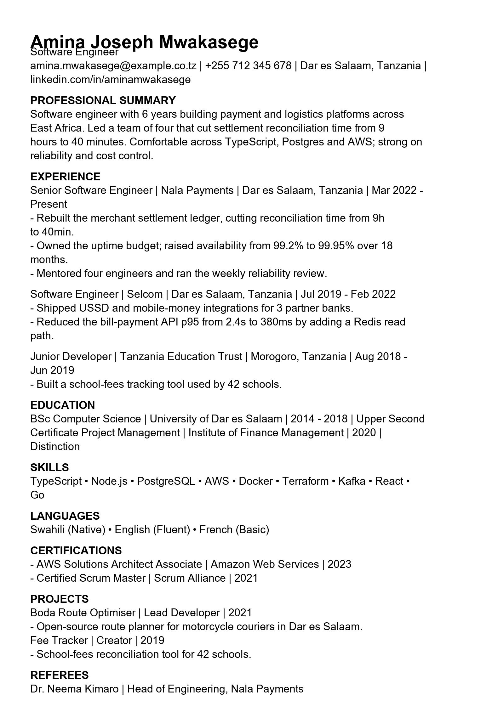

PROFESSIONAL SUMMARY
Software engineer with 6 years building payment and logistics platforms across East Africa. Led a team of four that cut settlement reconciliation time from 9 hours to 40 minutes.

EXPERIENCE
Senior Software Engineer — Nala Payments
Dar es Salaam, Tanzania • Mar 2022 - Present
- Rebuilt the merchant settlement ledger, cutting reconciliation time from 9h to 40min.
- Raised availability from 99.2% to 99.95% over 18 months.
Software Engineer — Selcom
Dar es Salaam, Tanzania • Jul 2019 - Feb 2022
- Shipped USSD and mobile-money integrations for 3 partner banks.
- Reduced bill-payment API p95 from 2.4s to 380ms.

EDUCATION
BSc, Computer Science
University of Dar es Salaam • 2014 - 2018 • Upper Second

SKILLS
TypeScript • Node.js • PostgreSQL • AWS • Docker • Terraform • Kafka

LANGUAGES
Swahili (Native) • English (Fluent)

CERTIFICATIONS
- AWS Solutions Architect Associate • Amazon Web Services • 2023

INTERESTS
Long-distance running, chess, and Swahili literature.

