THE STR ACQUISITION
ADVISORY GUIDE
Market Analysis, Cash Flow Underwriting & Long-Term Planning — Done For You
Your Company Name
Agent Referral · Mortgage · Permits · Furnishing · Listing — All Done For You

Buy the Numbers, Not the Listing Photos
The properties that look best in photos are rarely the ones that perform best as short-term rentals. A disciplined buyer evaluates a market and a property the same way an underwriter does — before falling in love with the kitchen island. This guide walks through how we evaluate a market, underwrite cash flow, review inspection findings, and build a long-term hold plan before you ever sign a purchase contract.
Bottom line: The single biggest driver of long-run STR returns isn't the property — it's whether the market and the numbers were right on day one. Good operations can improve a mediocre deal by a little. They can't fix a bad one.

The Acquisition Process
Five stages, run in order, before and through closing.
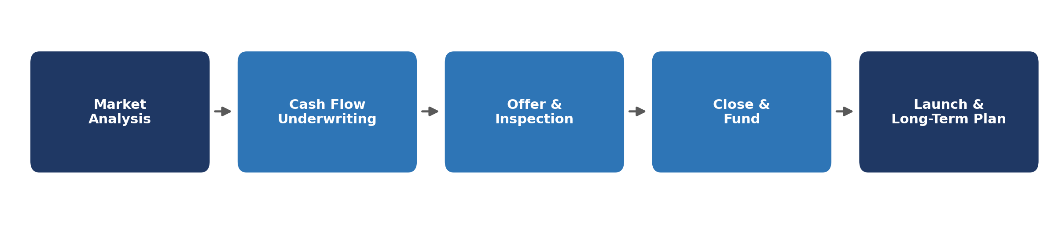

1. Market Analysis: Where to Buy
Not every STR-friendly city is a good investment market, and not every good investment market is STR-friendly. We screen on both dimensions before recommending any specific property.
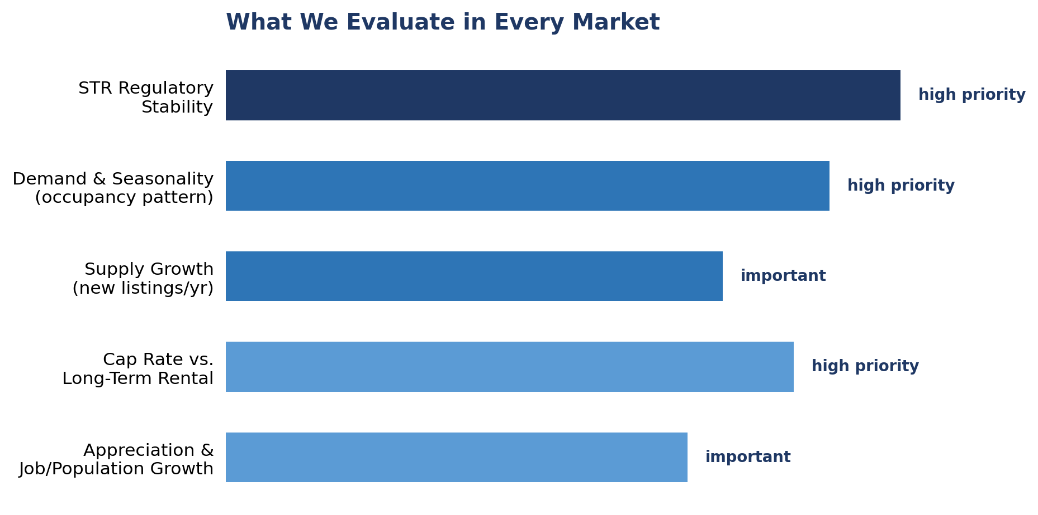
- Regulatory stability: a market with a 10% cap rate but an uncertain or worsening permit environment is a worse bet than a market with a 7% cap rate and stable, predictable rules.
- Demand seasonality: a market with one dominant season (ski, summer lake) carries more revenue risk than one with multiple demand drivers (events, business travel, year-round climate).
- Supply growth: rapid new-listing growth compresses ADR and occupancy even in a market with strong underlying demand — check permit issuance trends, not just current performance.

2. Cash Flow Underwriting: Will This Property Perform?
Every property we evaluate gets the same underwriting build, from gross revenue down to net cash flow after debt service.
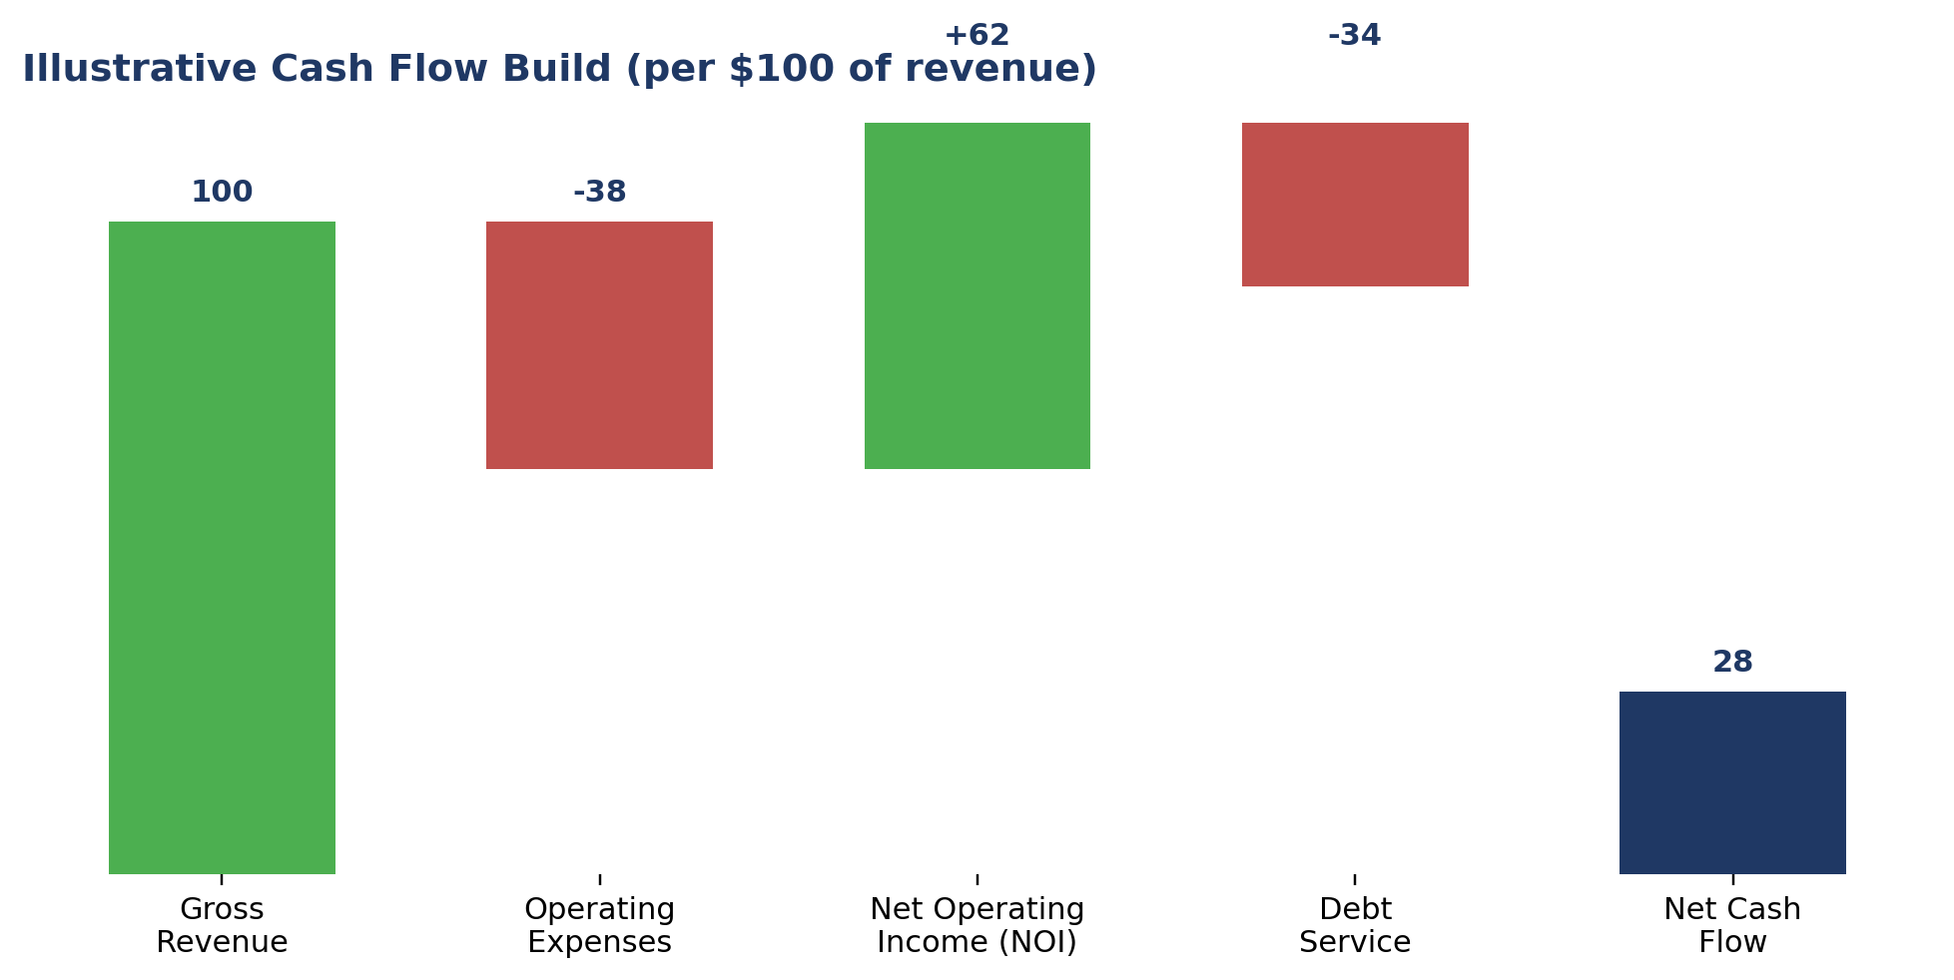
- Gross revenue: built from comparable STR data (AirDNA/PriceLabs), not the listing agent's optimistic estimate.
- Operating expenses: typically 35–45% of gross revenue for a professionally managed STR — cleaning, supplies, utilities, management fee, insurance, maintenance reserve, and platform fees.
- Debt service: sized to your actual financing terms (see our companion Mortgage Playbook), not a generic assumption.
Key metrics we calculate: Cash-on-cash return (annual cash flow ÷ cash invested), cap rate (NOI ÷ purchase price), and DSCR (NOI ÷ debt service) — the same three numbers a lender and a disciplined investor both look at first.

3. The Metrics That Actually Matter
Metric | How It's Calculated | Why It Matters
Cash-on-cash return | Annual pre-tax cash flow ÷ total cash invested | Tells you the actual yield on the money you put in — the number most relevant to you as a buyer
Cap rate | Net operating income ÷ purchase price | Compares deals independent of financing — useful for comparing markets or properties apples-to-apples
DSCR | Net operating income ÷ annual debt service | What your lender uses to qualify the loan — also a useful margin-of-safety check for you
RevPAR | Revenue ÷ available nights (ADR × occupancy) | The cleanest single number for comparing STR comps in a market
Break-even occupancy | Fixed costs ÷ (ADR − variable cost per booked night) | Shows how much cushion you have before the property loses money in a slow season

4. Inspection Review: What We Look For
An STR sees far more wear than a typical owner-occupied home — frequent turnovers, more guests per year, and less day-to-day oversight. We review every inspection report with that lens, not a standard residential one.
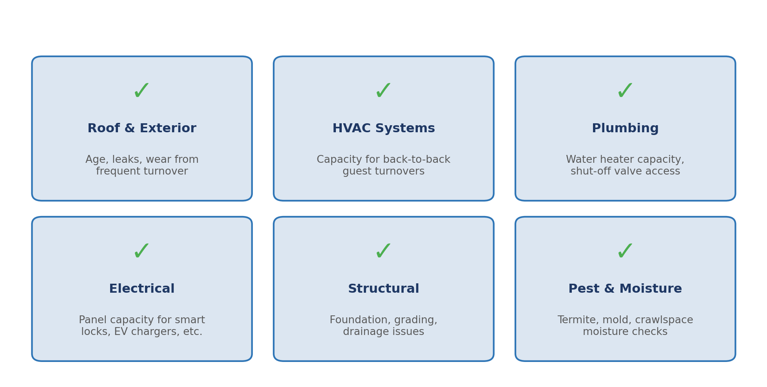
- Roof & exterior: STR turnover schedules leave little room for a mid-season repair — we flag anything with under 5 years of remaining life.
- HVAC: undersized systems struggle with back-to-back same-day turnovers in peak season — we check capacity against the property's bedroom/occupancy count.
- Electrical & plumbing: smart locks, mesh WiFi, and EV chargers all add panel load — we check for capacity to support a full STR tech stack.
How we help: We review the inspection report alongside you, translate technical findings into renovation-cost and timeline impact, and help you decide what to negotiate, repair before launch, or walk away from.

5. Long-Term Plan: Know Your Exit Before You Buy
A hold strategy decided after closing is really no strategy at all. We build a multi-year plan with you before you sign, so every decision afterward — pricing, refinancing, renovating — supports where you're actually headed.
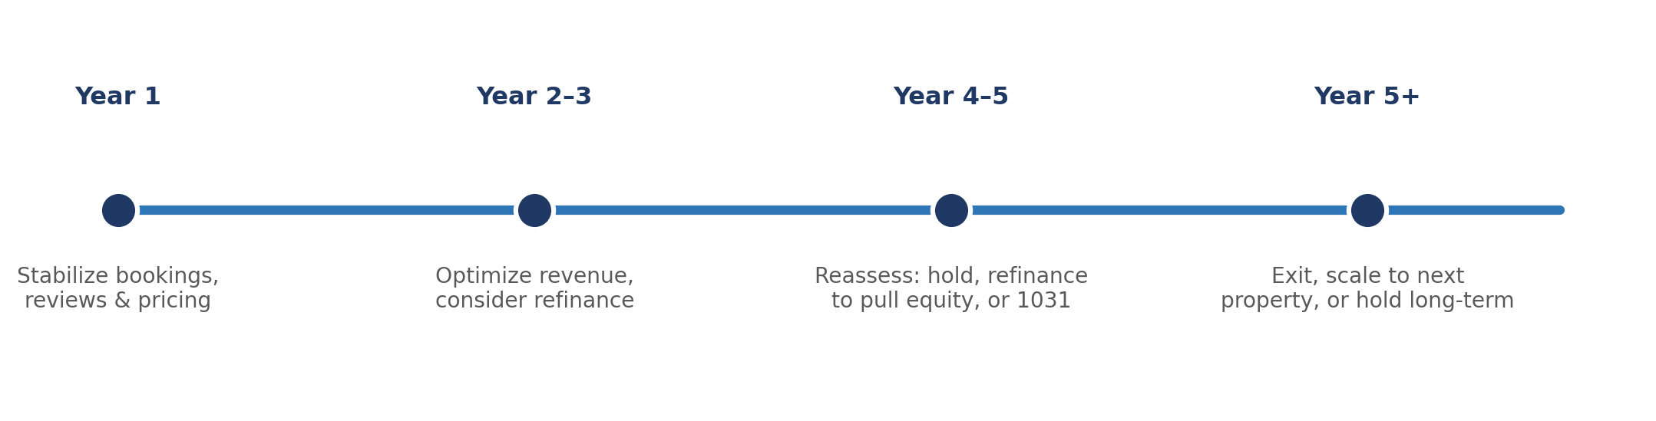
- Cash-flow hold: optimized for steady distributions — prioritize occupancy and expense discipline over aggressive ADR growth.
- Appreciation/value-add hold: targeted renovation or repositioning (e.g., adding a bedroom or amenity) to increase both NOI and resale value.
- Refinance-to-scale: use stabilized cash flow and appraised value after Year 1–2 to pull equity for the next acquisition.
- 1031 exchange / planned exit: structure the eventual sale and timing to defer or manage capital gains as part of a multi-property strategy.

6. Time & Effort: Doing It Yourself vs. Our Service
Evaluating a single STR investment properly — market research, comp pulls, a real underwriting model, inspection review, and a long-term plan — is a significant time investment if you do it yourself, especially the first time through.
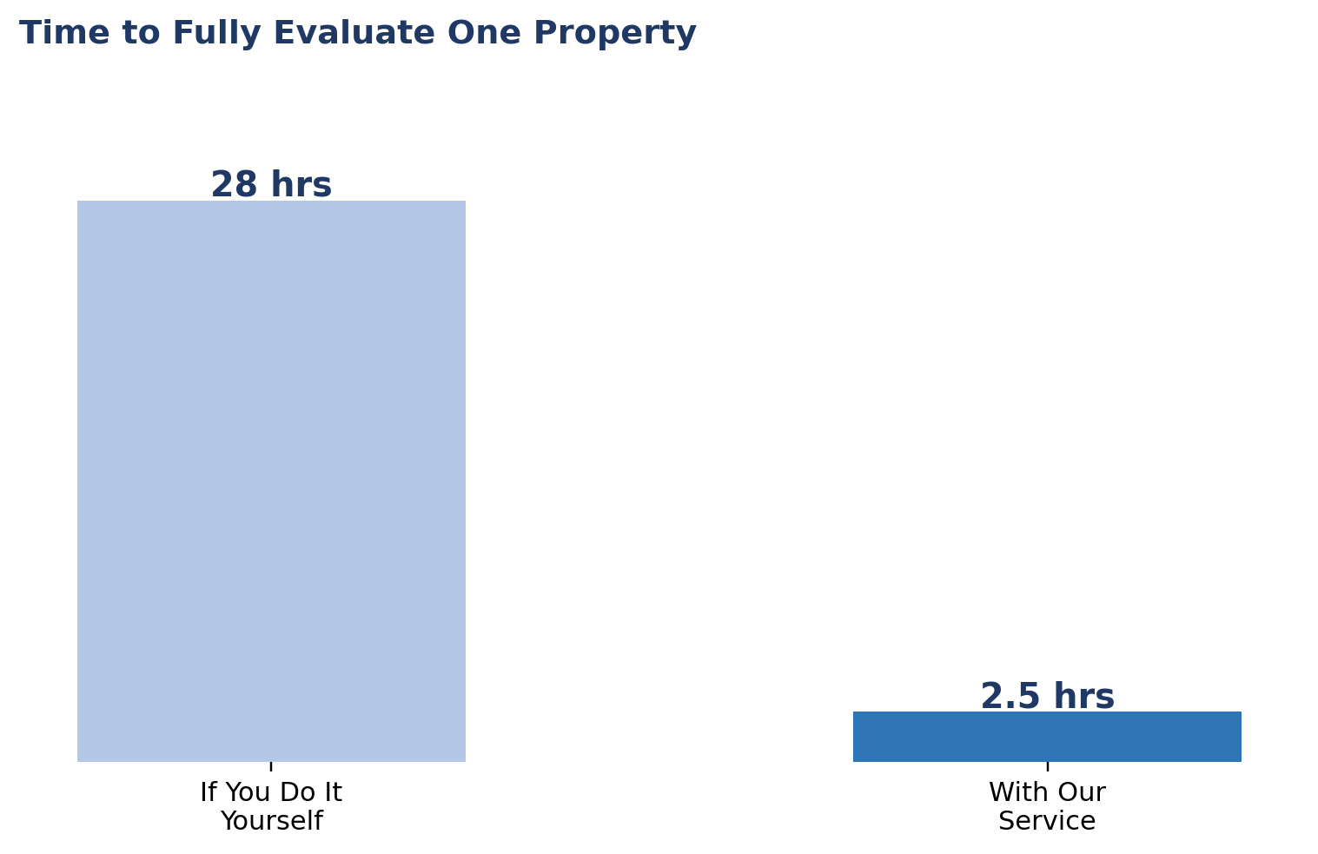
Task | If You Do It Yourself | With Our Service
Market screening & comp pull (per target market) | 8–12 hrs research across AirDNA/PriceLabs and local data | ~30 min review call — we deliver the analysis
Cash flow underwriting model (per property) | 3–5 hrs, plus a learning curve if you haven't built one before | 0 hrs — we deliver the completed model
Property tours & agent coordination | 2–4 hrs per property, plus scheduling back-and-forth | ~1 hr — just the tour itself; we handle scheduling
Inspection review & renovation cost translation | 3–6 hrs, plus your own contractor calls for quotes | ~30 min walkthrough review with us
Long-term hold / exit plan | 4–8 hrs of research and scenario planning | ~30 min planning session
Financing coordination & paperwork | 5–10 hrs (see our Mortgage Playbook) | ~1 hr — e-signatures and approvals only
Bottom line: Fully evaluating one property yourself realistically takes 25–35 hours, spread across research, modeling, touring, and planning. With our service, that drops to roughly 2–3 hours of your time — mostly approvals and a tour.

7. What We Handle vs. What We Need From You
We handle | We need from you
Market screening & comp pull (AirDNA/PriceLabs) | Target markets, budget range, and risk tolerance
Full cash flow underwriting model per property | Your financing terms (or let us coordinate financing too)
Inspection report review & renovation cost estimates | Access for inspection scheduling & your go/no-go decision
Long-term hold/exit plan tailored to your goals | Your timeline — cash flow now vs. appreciation later
Ongoing performance check-ins post-launch | Periodic review of whether the plan still fits your goals

8. Common Pitfalls We See
- Underwriting off the listing agent's revenue projection instead of independent STR comp data.
- Ignoring break-even occupancy — a property that only works at 75%+ occupancy has very little margin for a slow season or a regulatory change.
- Skipping a long-term plan — leads to reactive decisions (panic-selling in a slow month, over-renovating without a resale thesis).
- Treating the inspection as a formality rather than a renovation-budget tool — every finding should translate into a number, not just a checkbox.

9. Quick-Reference Checklist
- Confirm the market on regulatory stability, seasonality, and supply growth — not just current STR income.
- Underwrite cash flow from independent comp data, not the listing's projection.
- Calculate cash-on-cash return, cap rate, DSCR, and break-even occupancy before making an offer.
- Review the inspection with an STR lens — roof, HVAC, electrical, plumbing, structural, pest.
- Decide your long-term plan (cash flow, value-add, refinance-to-scale, or planned exit) before closing.
- Revisit the plan annually — markets, regulations, and your goals can all shift.
- Review the time comparison if deciding how hands-on to be in the process.
This guide is for general education and is not financial, investment, tax, or legal advice. Market conditions, regulations, and financing terms change — always verify current data and consult appropriate professionals before purchasing. Talk to us directly for guidance specific to your situation.

