THE 15-MINUTE
MORTGAGE GUIDE
For Busy Professionals Buying a Short-Term Rental
Your Company Name
Agent Referral · Mortgage · Permits · Furnishing · Listing — All Done For You

You Don't Have Time to Become a Mortgage Expert. You Don't Need To.
This guide gives you the handful of decisions that actually move the needle on your loan — in plain language, with simple visuals. Read it once in 15 minutes. Then hand the details to us; we run the process for you.
Bottom line: On a typical $500K investment loan, the difference between an average rate and a well-negotiated one is often $200–$400 per month — real cash flow, for the same property.

1. Which Loan Type Fits You?
Two questions decide almost everything:
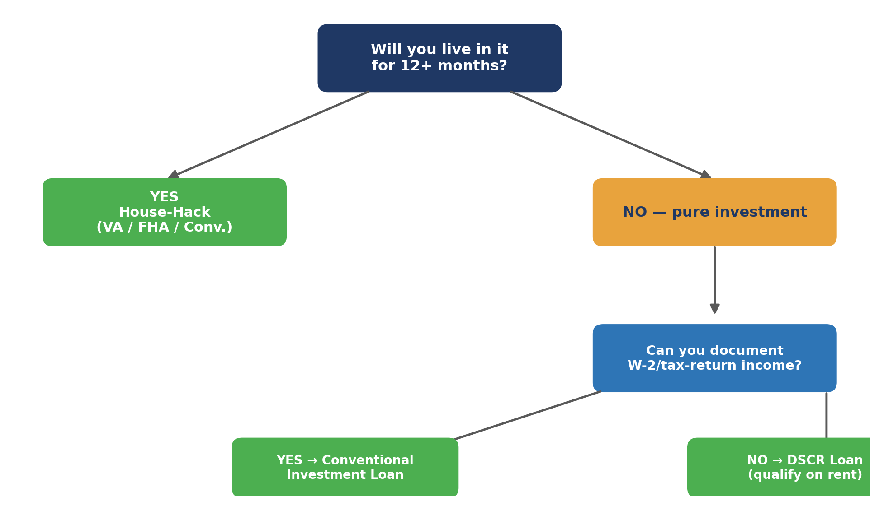
Most clients land here: If you're keeping your own income/tax filings simple and buying purely for rental income, a DSCR loan — which qualifies the property's rental income, not your paycheck — is usually the fastest, lowest-friction path.

2. What Actually Moves Your Rate
Lenders price risk. These five things explain almost all of the rate difference you'll ever see between two offers.
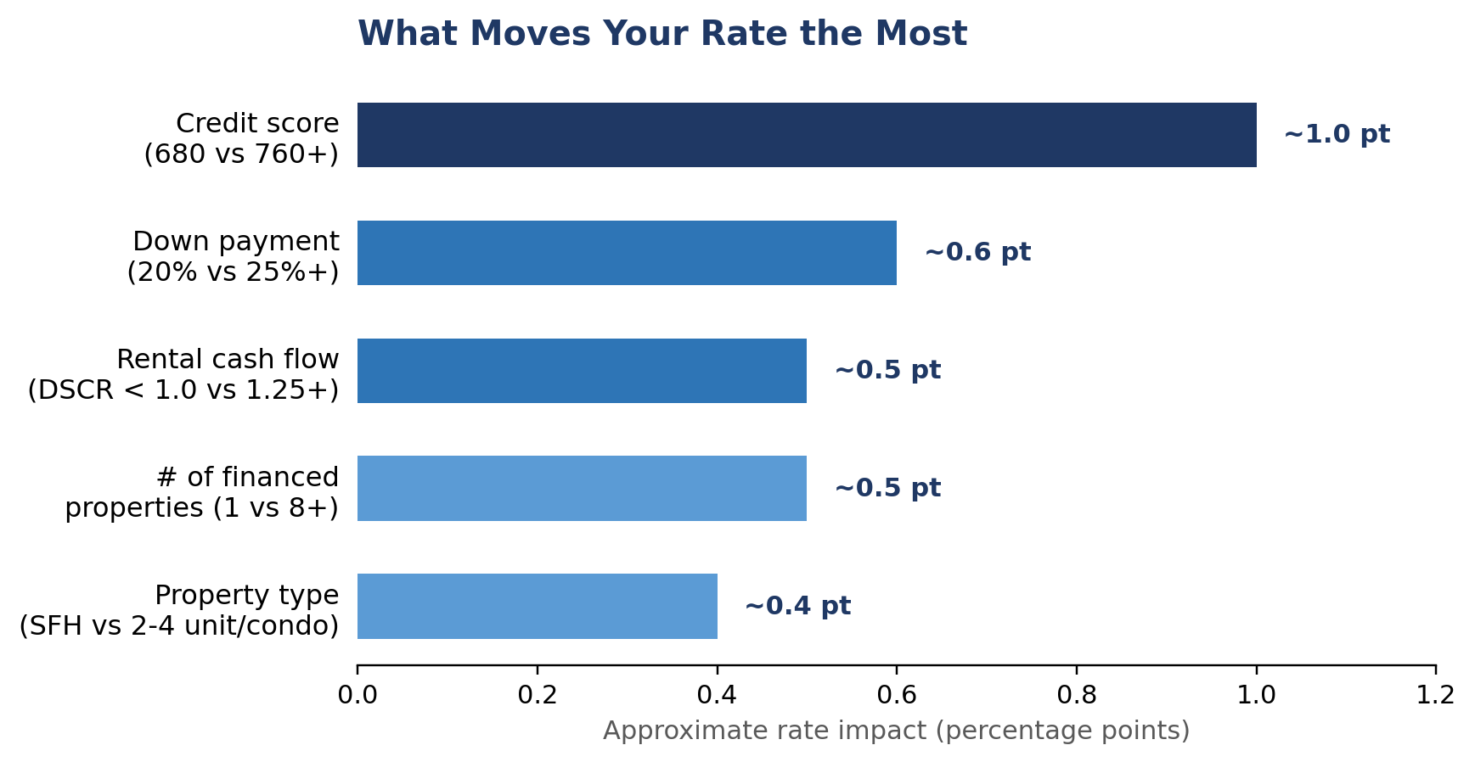
- Credit score: pay down credit cards below 30% (ideally 10%) utilization before applying.
- Down payment: 25%+ often unlocks a meaningfully better rate tier than 20%.
- Cash flow (DSCR): a property that more comfortably covers its own payment prices better.

3. The 90-Day Prep Timeline
If you're not yet under contract, this is the single highest-leverage thing you can do before you ever talk to a lender.
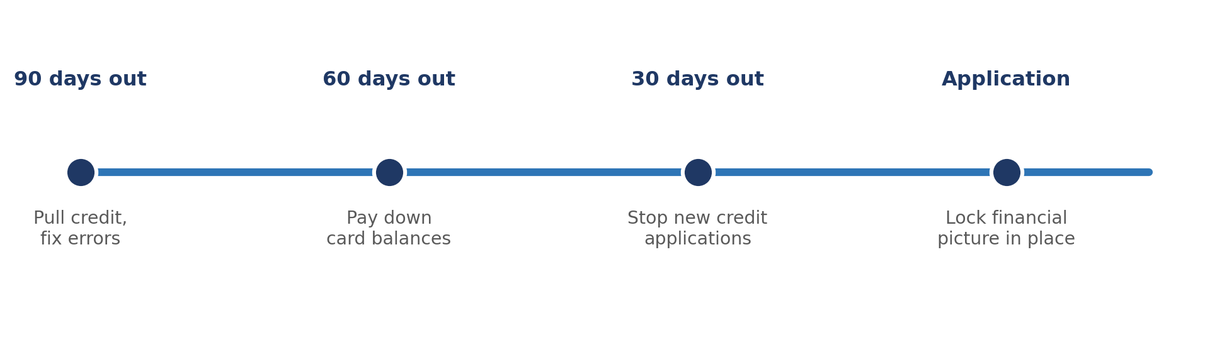
Already under contract or in a hurry? Skip to Section 4 — we'll run the comparison for you in parallel with your timeline.

4. How We Get You the Best Rate: The Lender Tournament
This is the core of our service. Most buyers accept the first quote they like. We never do — we make lenders compete for your loan, in writing, at the same time.
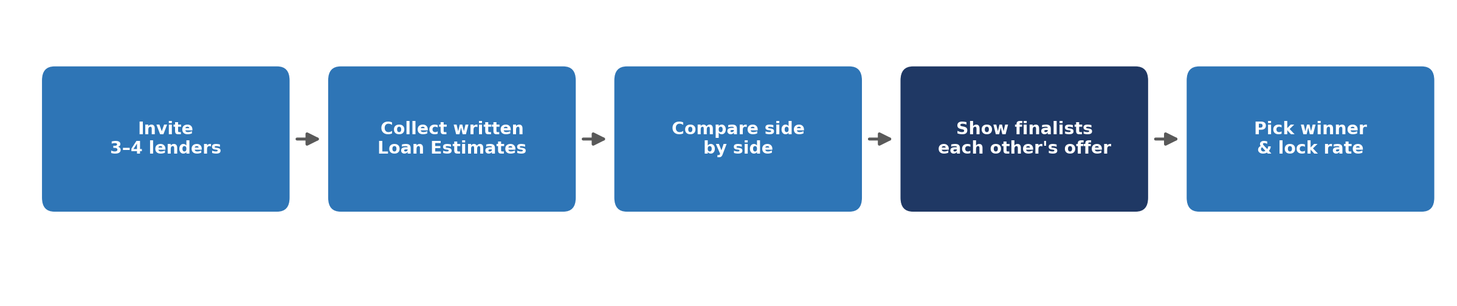
- We request a written Loan Estimate from 3–4 lenders for the exact same loan.
- We compare rate, fees, and penalty terms side by side (see the snapshot below).
- We show your top two finalists each other's numbers and ask them to beat it.
- You only sign and lock once there's a clear winner.
Why this works: Loan officers compete for volume. A verbal “we'll be competitive” means nothing; a real, written competing offer in their hand means everything.

5. What's Actually In Your Closing Costs
Your “cash to close” is more than just your down payment. Here's the typical breakdown so nothing surprises you.
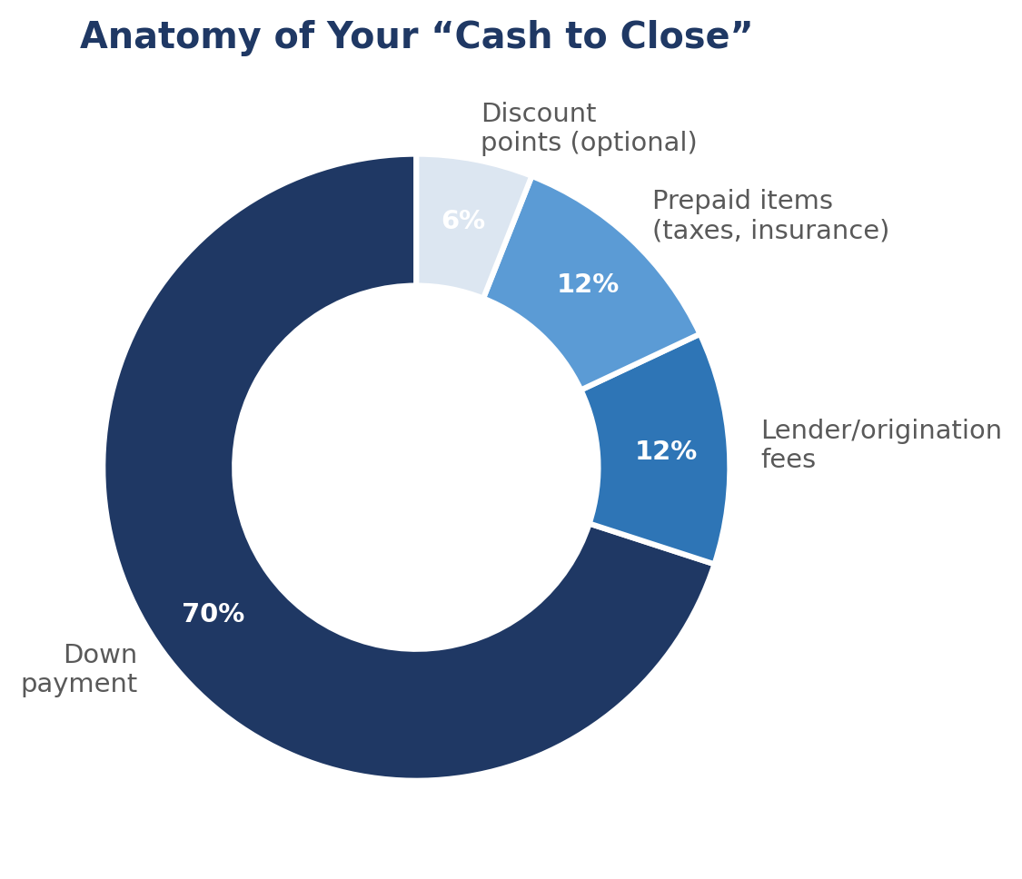
Watch for: Prepayment penalties on DSCR loans. If you might refinance or sell within a few years, ask us to negotiate a no-penalty option — usually available for a small rate trade-off.

6. Lender Snapshot — What We Track For You
This is the exact comparison we build behind the scenes on every deal. You'll never need to fill this out yourself — it's here so you know what “good” looks like.
Line Item | Lender A | Lender B | Lender C | Your Deal
Interest rate | 6.85% | 7.10% | 6.95% | —
Lender fees | $3,200 | $1,950 | $2,600 | —
Prepayment penalty | 3-yr step down | None | 2-yr step down | —
Cash to close | $128,400 | $126,900 | $127,650 | —
Sample comparison shown for illustration. Lender B wins here on fees and has no prepayment penalty — even though its rate is slightly higher, it may still be the better deal depending on your hold period.

7. Time & Effort: Doing It Yourself vs. Our Service
Shopping lenders, gathering documents, and tracking a loan through underwriting takes real hours — and most of it is hold-music and paperwork, not decisions you actually want to make yourself.
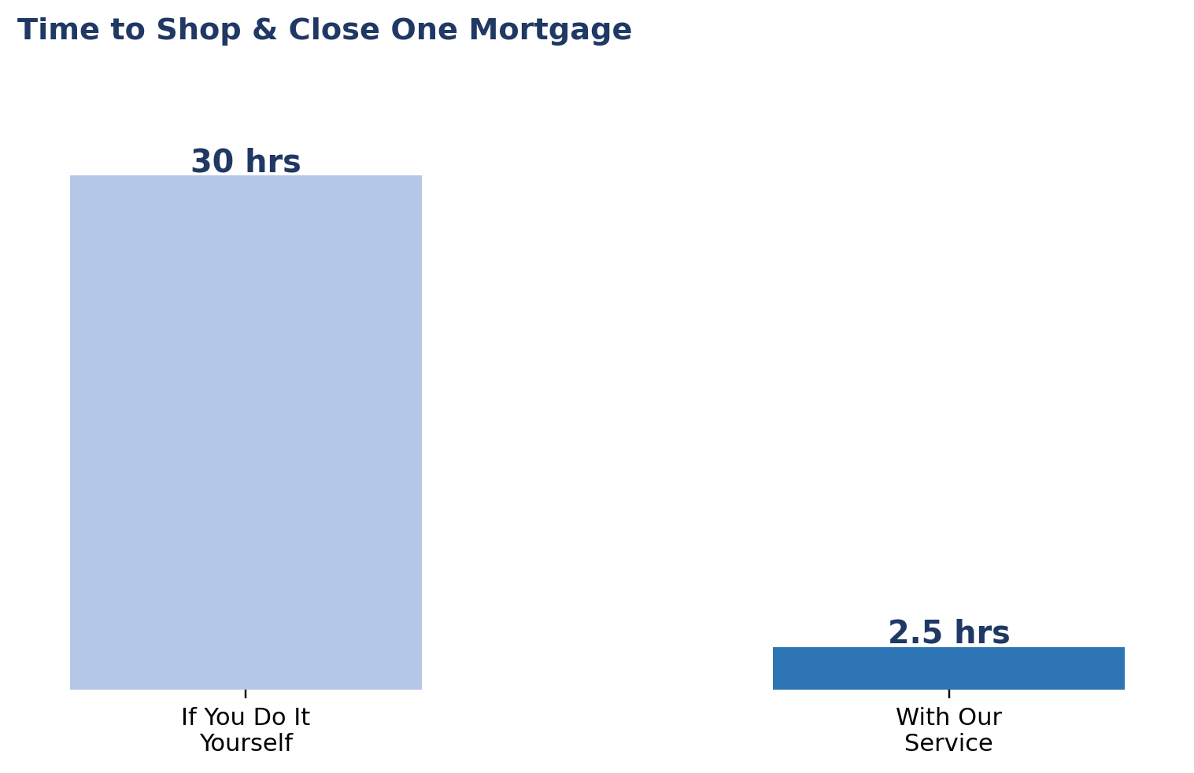
Task | If You Do It Yourself | With Our Service
Researching loan types & lenders | 5–8 hrs | ~30 min — we walk you through the right fit
Gathering documents (tax returns, statements, entity docs) | 3–5 hrs | ~30 min — upload once, we handle the rest
Shopping & comparing 3–4 lenders (the tournament) | 8–12 hrs of calls and paperwork | 0 hrs — we run the entire tournament for you
Negotiating rate & fees with finalists | 3–5 hrs, plus most owners skip this step entirely | 0 hrs — we negotiate on your behalf
Tracking underwriting conditions & deadlines | 4–6 hrs over several weeks | ~30 min — quick answers when we flag something
Closing coordination & disclosure review | 2–3 hrs | ~30 min — we coordinate, you review and sign
Bottom line: Shopping and closing a mortgage yourself realistically takes 25–40 hours, much of it spent on hold or chasing paperwork. With our service, that drops to roughly 2–3 hours — mostly document uploads and signatures.

8. What We Handle vs. What We Need From You
We handle | We need from you
Shopping & negotiating with 3–4 lenders | Two years of tax returns / bank statements
Comparing Loan Estimates line by line | A quick e-signature on disclosures
Tracking underwriting conditions & deadlines | Fast answers to occasional lender questions
Coordinating appraisal, title, and closing | Avoiding new credit cards/loans mid-process

9. Your Quick Checklist
- Decide: house-hack or pure investment property?
- Send us 2 years of tax returns / bank statements (or skip this for a DSCR loan).
- Let us run the lender tournament — no action needed from you beyond e-signatures.
- Review our side-by-side comparison and approve the winner.
- Avoid new credit, job changes, or large deposits until after closing.
- We coordinate the rest — you keep your calendar.
This guide is for general education and is not individualized financial, legal, or tax advice. Rates and terms shown are illustrative. Talk to us directly for guidance specific to your situation.

