THE STR PROPERTY
SETUP GUIDE
Utilities, Security & Life-Safety Compliance — Done For You
Your Company Name
Agent Referral · Mortgage · Permits · Furnishing · Listing — All Done For You

A Permit Lets You Operate. This Is What Makes It Safe to Open.
Once a property is permitted, the work shifts from paperwork to physical setup: utilities that can handle guest turnover, a security stack that protects the property without violating guest privacy, and life-safety equipment that meets fire code — not just standard residential code. This guide covers all three, and how we manage the install and final walkthrough for you.
Bottom line: Most post-launch STR incidents — lockouts, false alarms, failed inspections, insurance claim denials — trace back to a setup shortcut, not bad luck. This is the section of the launch process worth doing right the first time.

The Setup Roadmap
Four stages, run in order, between permit approval and your first guest.
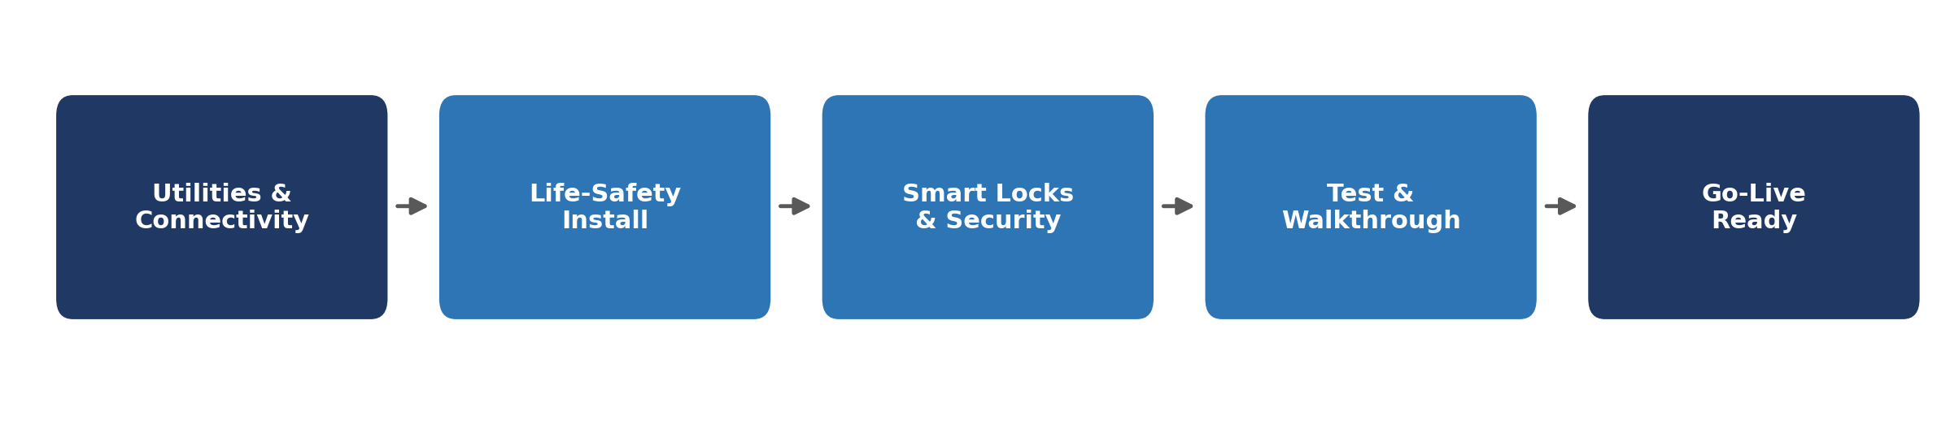

1. Utilities & Connectivity
Utilities need to be active, in the right name, and stress-tested before guests arrive — not discovered mid-stay.
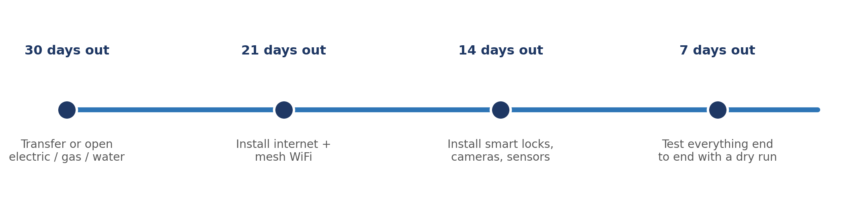
- Electric, gas, and water: open or transfer accounts into the owner/LLC name — never leave a prior owner's account active, which complicates billing and liability.
- Internet: install a business-grade connection with mesh WiFi sized to the home's square footage — multiple guests streaming simultaneously is the norm, not the exception.
- HVAC: service the system before launch; a mid-stay breakdown is one of the most common sources of bad reviews and refund requests.
Tip: Run a 48-hour dry run with WiFi, locks, and HVAC all active before your first real booking. It's the cheapest inspection you'll ever do.

2. Security: Cameras & Smart Locks
A simple four-layer stack covers connectivity, access, monitoring, and climate — installed in that order.
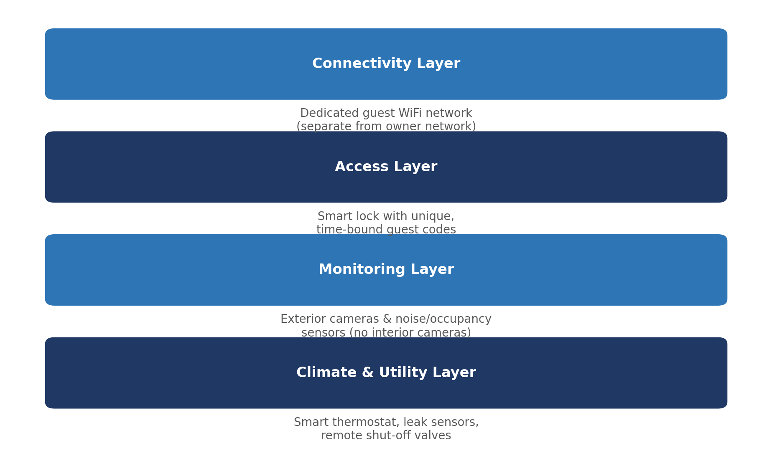
- Smart locks: issue a unique, time-bound code per reservation that auto-expires at checkout — never reuse a single static code across guests.
- Cameras: exterior-only, and clearly disclosed in your listing description before booking. Interior cameras are prohibited on most platforms and in many states regardless of disclosure.
- Noise & occupancy sensors: enforce guest-count and party policies without recording audio or video — a privacy-friendly alternative to interior cameras.
- Leak & smart shut-off sensors: a $150 sensor in kitchens, bathrooms, and laundry areas can prevent a five-figure water-damage claim.
Privacy disclosure: Most STR platforms legally require you to disclose any recording device, even exterior-only, in the listing description before a guest books — this is a platform policy violation risk, not just a courtesy.

3. Life-Safety Equipment & Fire Code
This is the section regulators, fire marshals, and insurers check first. Treat it as non-negotiable, not optional — and know that STR conversion often triggers stricter requirements than standard residential code.
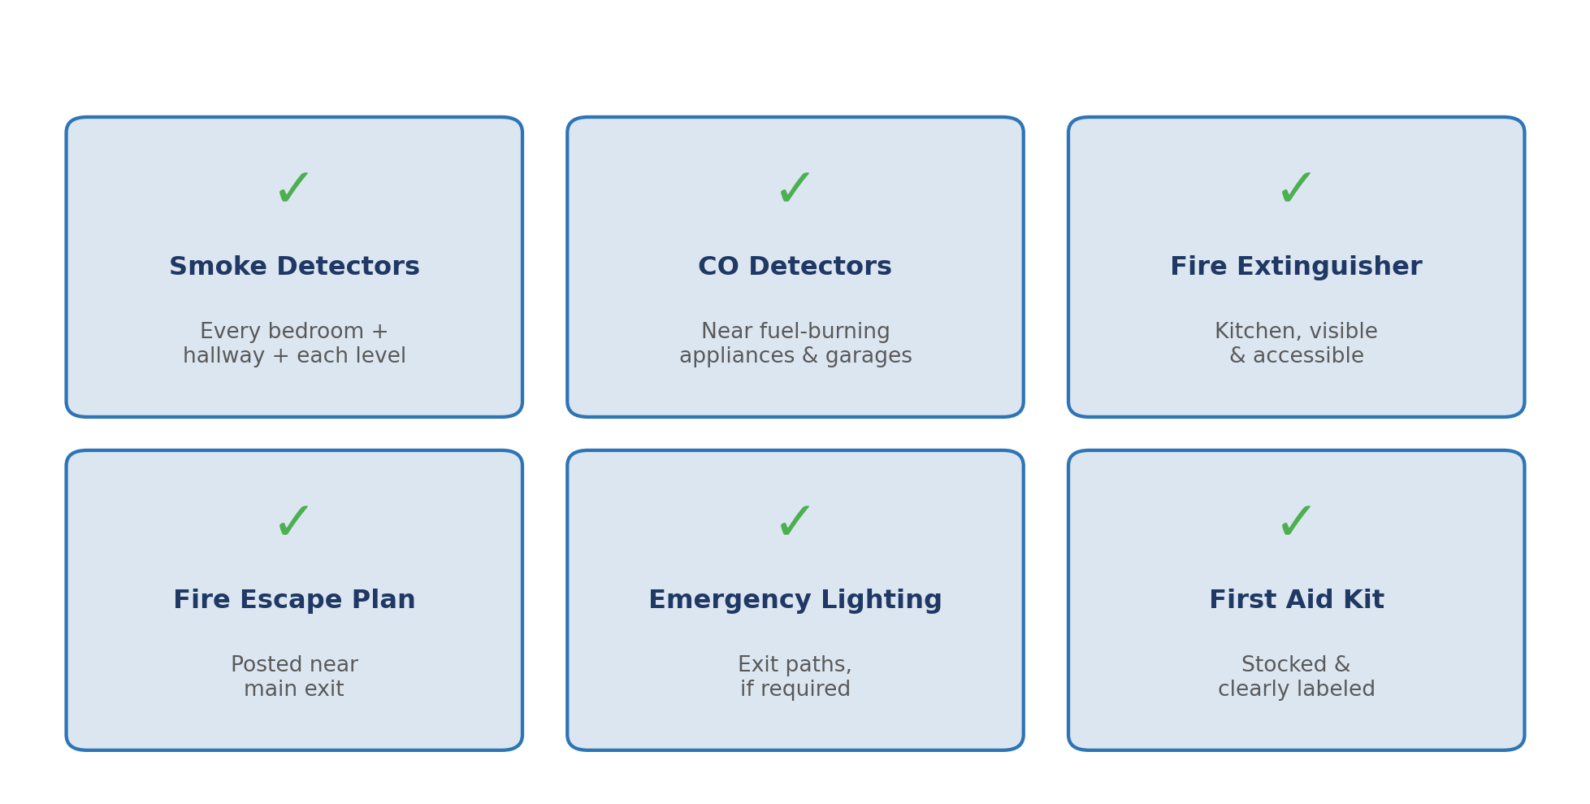
- Smoke detectors: required in every bedroom, every hallway leading to a bedroom, and on every level — some jurisdictions require hardwired, interconnected units once a home converts to STR use, even if it wasn't built that way.
- CO detectors: required near any fuel-burning appliance and attached garage.
- Fire extinguisher: kitchen-located, visible, and inspected/recharged on a schedule — not just present on day one.
- Fire escape plan: posted near the main exit, showing all egress routes from each bedroom.
Know your local code: Fire and building codes vary by city and by the age of the structure. Confirm exact smoke-detector placement counts and any hardwiring requirement with your local fire marshal or building department before your final inspection — not after a failed one.

4. Final Walkthrough Before Go-Live
Before listing, walk the property exactly as a fire inspector or insurance adjuster would.
- All smoke/CO detectors tested and dated within the last 6 months
- Fire extinguisher charged, visible, and not expired
- Fire escape plan posted near the main exit
- Smart lock codes tested end-to-end on a guest-facing device
- Guest WiFi network separate from any owner/admin network
- Exterior camera disclosure added to listing description
- Leak sensors installed and tested in kitchen, bathrooms, laundry
- Utilities confirmed active in the correct billing name
- 48-hour dry run completed with all systems live

5. Time & Effort: Doing It Yourself vs. Our Service
Utility transfers, internet/mesh WiFi install, smart lock and camera configuration, fire-code research, and a proper dry run all take real hours — and most of it involves phone holds, app setup, and code research that owners rarely enjoy.
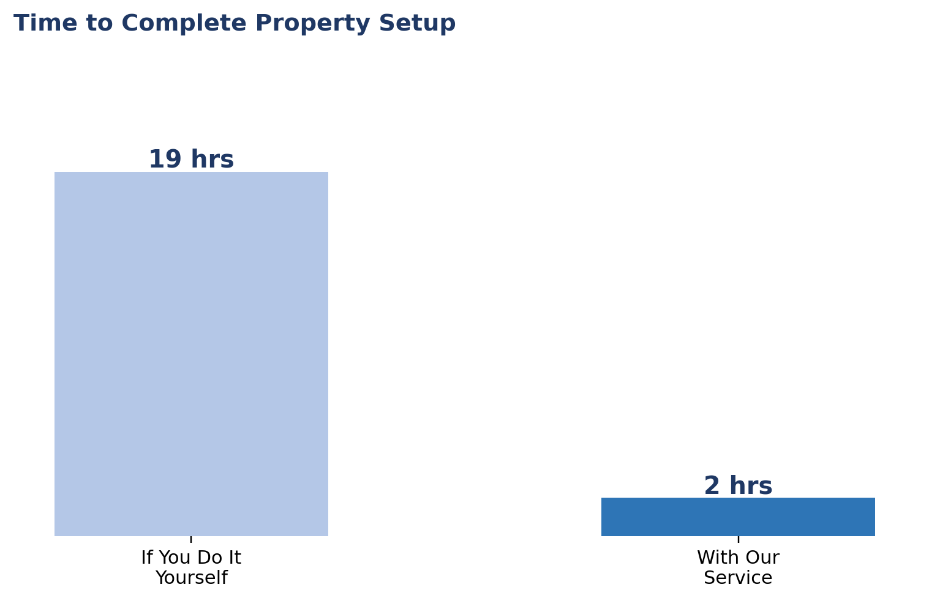
Task | If You Do It Yourself | With Our Service
Utility account setup & transfer (electric/gas/water/trash) | 3–5 hrs across multiple calls and hold times | ~15 min — you approve, we make the calls
Internet & mesh WiFi install + testing | 2–4 hrs, plus troubleshooting if signal is weak | ~15 min — we install, configure & test
Smart lock, camera & sensor install + app setup | 4–6 hrs across multiple devices and apps | ~15 min — we configure everything, you approve access policy
Fire code research & life-safety equipment install | 3–5 hrs researching local code plus install time | ~15 min — we confirm code and install for you
Final walkthrough & 48-hour dry run | 2–3 hrs | ~30 min — we run it, you get a go-live confirmation
Bottom line: Doing this yourself realistically takes 14–23 hours — most of it spent on hold or hunting down fire-code specifics. With our service, that drops to roughly 2 hours of approvals.

6. What We Handle vs. What We Need From You
We handle | We need from you
Utility account setup & transfers | Preferred provider names, if you have any
Internet/mesh WiFi install & testing | Access to the property for install day
Smart lock, camera & sensor configuration | Approval of guest-facing access policy
Life-safety equipment install & code check | Sign-off on any code-required upgrades
Final walkthrough & go-live confirmation | Final review before your first guest

7. Common Pitfalls We See
- Reusing the previous owner's WiFi or utility accounts, which complicates billing, security, and liability.
- Treating smart locks as "set and forget" — codes must be rotated every booking, not just at move-in.
- Skipping the fire-code review because "the house already has smoke detectors" — STR conversion often triggers stricter placement and hardwiring requirements than standard residential code.
- Installing interior cameras for "peace of mind" — this violates most platform policies and many state laws regardless of disclosure.
- Skipping the dry run — the cheapest possible inspection, and the one most owners skip under launch-date pressure.
This guide is for general education and is not legal, insurance, or fire-code advice. Requirements vary by city/county and change frequently — always confirm current fire code and platform policy requirements with local authorities, or talk to us directly before going live.

