THE COMPLETE STR
FURNISHING GUIDE
The Full Item List, Plus Ordering, Receiving & Assembly — Done For You
Your Company Name
Agent Referral · Mortgage · Permits · Furnishing · Listing — All Done For You

Furnishing Is What Turns a House Into a 5-Star Stay
Guests don't book a floor plan — they book a feeling. The right furniture, sized and styled for how guests actually use a short-term rental, is what turns a good listing into a fully booked one. This guide covers the complete room-by-room item list we use to furnish an STR, plus how we manage ordering, receiving, and assembly scheduling so you never have to track a single delivery yourself.
Bottom line: Furnishing an STR is different from furnishing a home you live in — every piece needs to survive frequent turnover, suit a wide range of guests, and photograph well. We build every list with that lens.

The Furnishing Process
Five stages, run on a tight timeline so your launch date never slips.
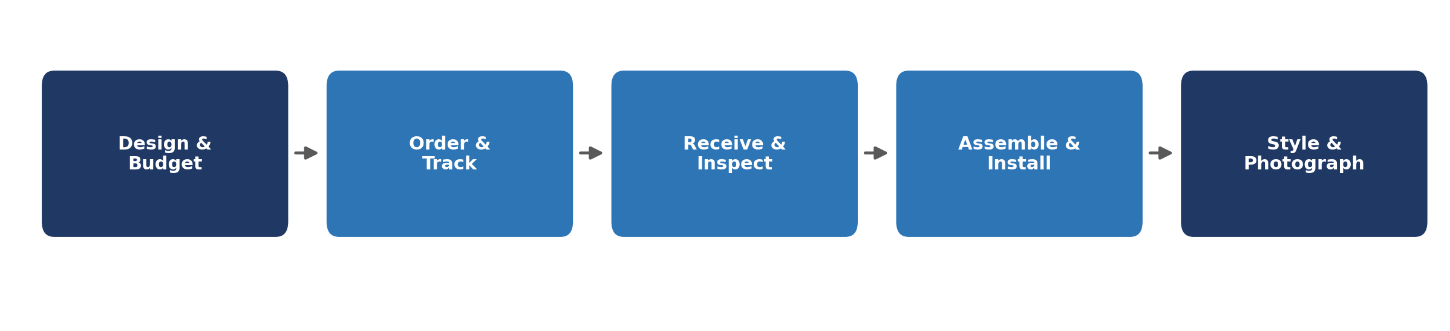

Where the Budget Goes
A useful starting allocation across categories — we adjust per property based on guest capacity and market positioning.
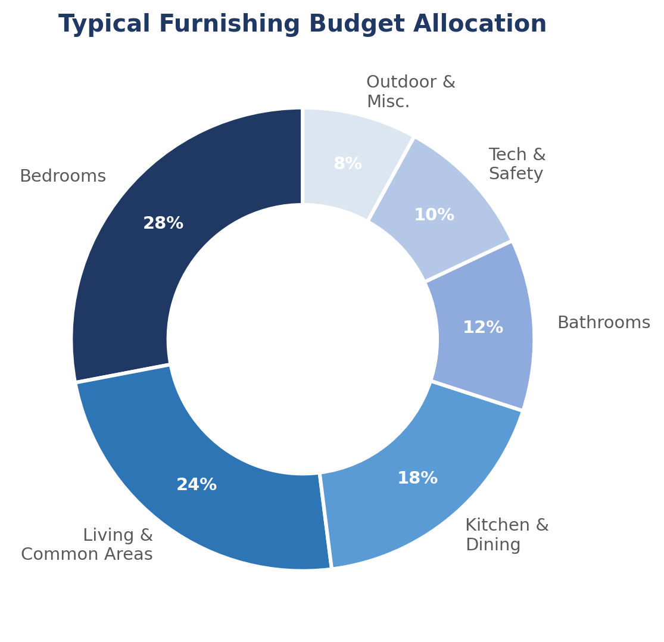

Two Ways to Source the Same Property
Every item on our list can be sourced two ways: standard retail/designer pricing, or our value-engineered sourcing — the same look and durability, at a meaningfully lower cost. We use our sourcing relationships and bulk purchasing to hit the second column on every project, without compromising on guest experience or durability.
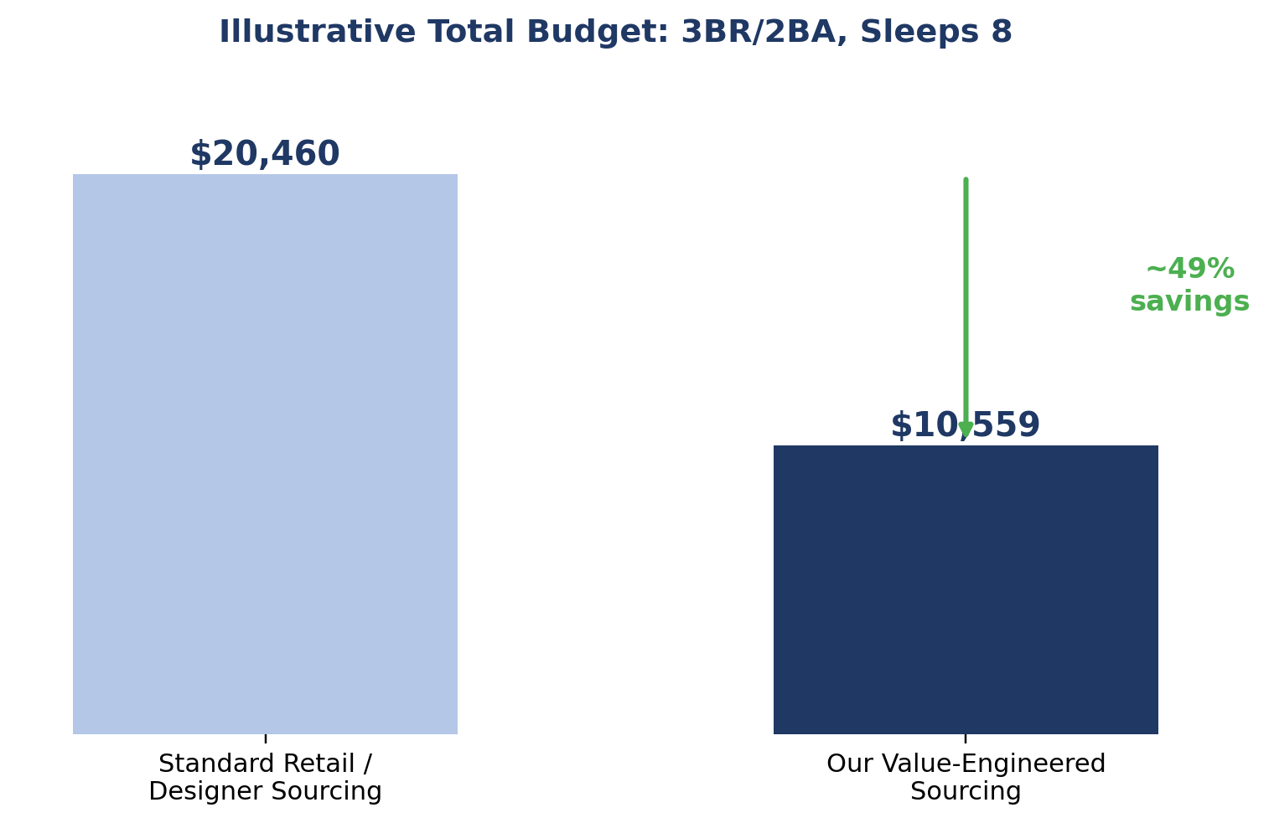
How this works: We don't cut corners on what guests actually feel — mattress quality, bedding, and anything safety-related stay at a quality bar regardless of sourcing. The savings come from smarter sourcing on items where brand name doesn't change the guest experience.

Cost Comparison by Category
The chart below shows the same illustrative 3BR/2BA, sleeps-8 property priced both ways, category by category.
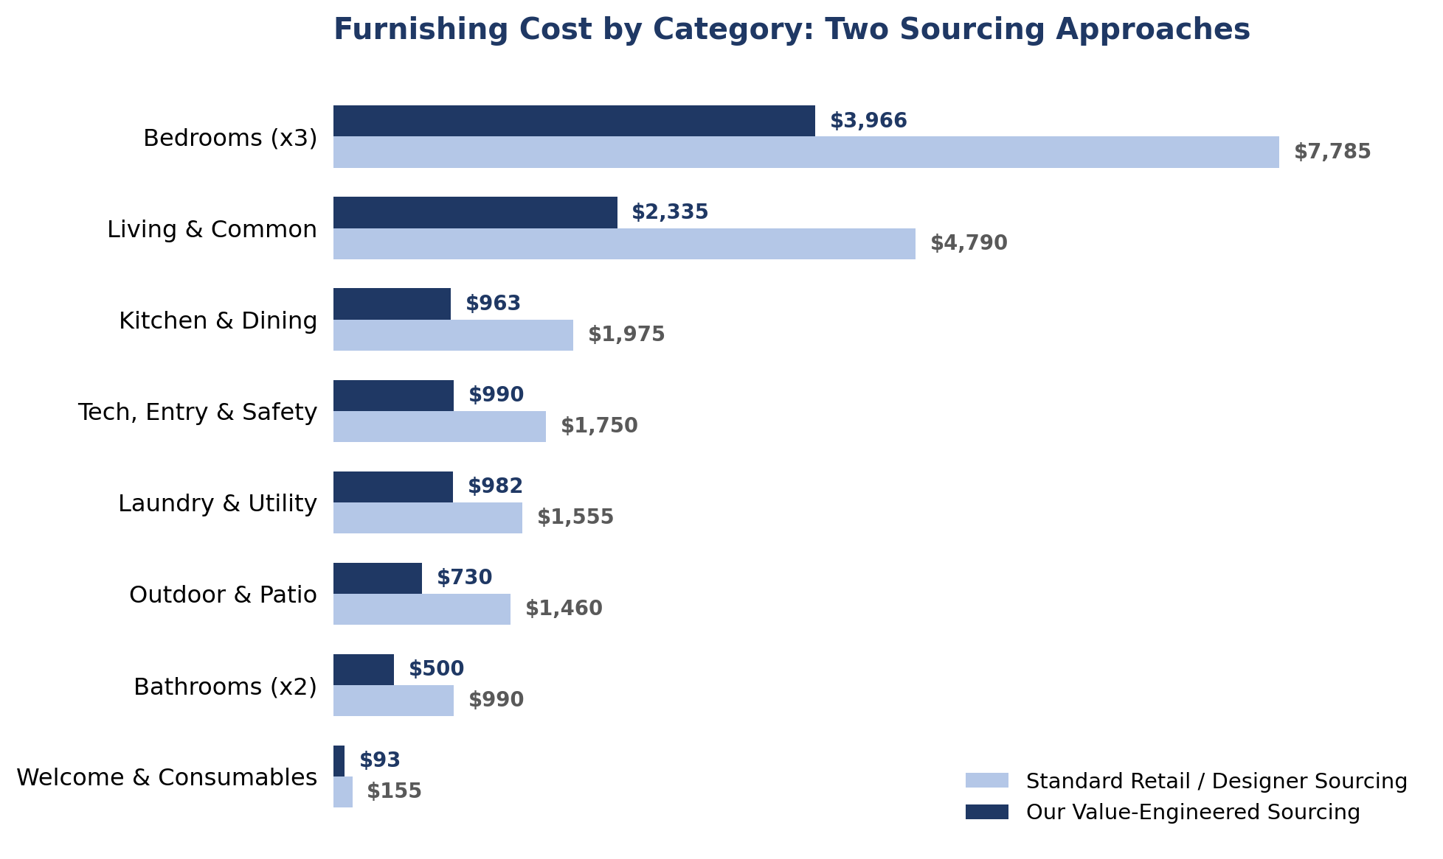

The Complete Room-by-Room Item List & Budget
This is the full list we work from on every furnishing project, with itemized cost for both sourcing approaches. Quantities scale with guest capacity and bedroom count — we finalize an exact list and budget with you before ordering.

Living & Common Areas
Item | Standard Sourcing | Our Sourcing
Sofa / sectional | $1,200 | $600
Coffee table | $350 | $150
TV (55") + wall mount | $600 | $400
Entertainment console | $400 | $180
Accent chairs (x2) | $500 | $240
Area rug | $300 | $130
Curtains / blinds (3 sets) | $450 | $210
Table & floor lamps (x3) | $240 | $105
Throw pillows & blankets (set) | $150 | $60
Wall art / decor (set) | $300 | $120
Side / end tables (x2) | $300 | $140
Category Subtotal | $4,790 | $2,335

Bedrooms (per room)
Item | Standard Sourcing | Our Sourcing
Bed frame | $500 | $250
Quality mattress | $700 | $400
Nightstands (x2) | $300 | $140
Lamps (x2) | $100 | $50
Dresser | $400 | $200
Full-length mirror | $100 | $50
Blackout curtains | $90 | $40
Bedding sets (x2 per bed) | $300 | $140
Hangers (set) | $25 | $12
Luggage rack | $80 | $40
Category Subtotal (per room — ×3 bedrooms = $7,785 / $3,966) | $2,595 | $1,322

Kitchen & Dining
Item | Standard Sourcing | Our Sourcing
Dining table + chairs | $900 | $450
Cookware set | $250 | $100
Dinnerware & glassware (service for 8+) | $200 | $90
Flatware set | $80 | $35
Small appliances (coffee, toaster, blender) | $200 | $110
Utensils & cutting boards | $60 | $30
Knife set | $90 | $45
Trash & recycling bins (x2) | $120 | $60
Pantry starter kit | $40 | $25
Dish towels & oven mitts | $35 | $18
Category Subtotal | $1,975 | $963

Bathrooms (per bathroom)
Item | Standard Sourcing | Our Sourcing
Shower curtain + liner | $40 | $20
Bath mats (x2) | $60 | $30
Towels (2 sets per capacity) | $240 | $110
Toilet brush & plunger | $25 | $15
Trash bin | $25 | $12
Toiletries | $35 | $20
Hair dryer | $40 | $25
First aid kit | $30 | $18
Category Subtotal (per bathroom — ×2 bathrooms = $990 / $500) | $495 | $250

Laundry & Utility
Item | Standard Sourcing | Our Sourcing
Washer / dryer (if not built-in) | $1,400 | $900
Iron + ironing board | $50 | $28
Laundry baskets (x2) | $50 | $24
Detergent & dryer sheets | $20 | $12
Drying rack | $35 | $18
Category Subtotal | $1,555 | $982

Outdoor & Patio (if applicable)
Item | Standard Sourcing | Our Sourcing
Outdoor furniture set | $700 | $350
BBQ grill | $300 | $150
Fire pit (where permitted) | $250 | $120
Pool / spa accessories | $150 | $80
Outdoor lighting | $60 | $30
Category Subtotal | $1,460 | $730

Tech, Entry & Safety
Item | Standard Sourcing | Our Sourcing
Smart locks (x2 doors) | $500 | $300
WiFi router / mesh system | $300 | $180
Smart thermostat | $250 | $130
Smoke & CO detectors (x5) | $200 | $125
Fire extinguisher | $40 | $25
Exterior security cameras (x2) | $400 | $200
Welcome mat & entry decor | $60 | $30
Category Subtotal | $1,750 | $990

Welcome Basket & Consumables
Item | Standard Sourcing | Our Sourcing
Toilet paper & paper towels | $30 | $20
Dish soap & sponge | $15 | $8
Trash bags | $15 | $10
Coffee / tea starter | $25 | $15
Welcome snacks or local treats | $30 | $20
House manual / guidebook | $40 | $20
Category Subtotal | $155 | $93

Illustrative grand total: For this example 3BR/2BA property: approximately $20,460 with standard retail/designer sourcing, versus approximately $10,559 with our value-engineered sourcing — roughly 49% lower, for the same room-by-room list. Actual totals depend on property size, guest capacity, and finish level.

Ordering, Receiving & Assembly — How We Run It
This is the part most owners underestimate. A furnishing list is easy; coordinating dozens of deliveries with different lead times, then getting everything assembled before your launch date, is the actual project.
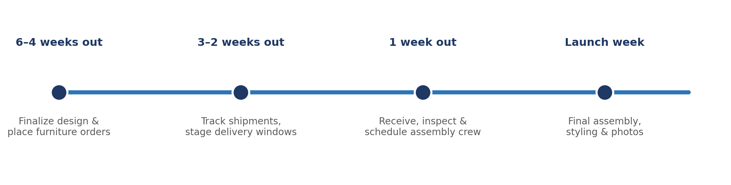
- Ordering: we place every order, track lead times, and flag anything with a delivery window that threatens your launch date — large furniture often ships separately from smaller items.
- Receiving: we inspect every delivery for damage before assembly day, not after — catching a damaged item with time to reorder is the difference between a minor delay and a missed launch.
- Scheduling assembly: we coordinate a single assembly contractor visit (or a short sequence of visits) once the bulk of the order has arrived, rather than piecemeal trips that waste labor hours and your time.
Why this matters: A missing or damaged item discovered the week of launch is a scramble. Discovered three weeks out, it's a simple reorder. The entire point of structured receiving is moving every problem as early as possible.

Assembly & Labor: Time and Cost
Assembly is real, billable labor — beds, dressers, dining sets, outdoor furniture, and tech installs all take skilled hands and time. Here's the labor breakdown for the same illustrative 3BR/2BA property.
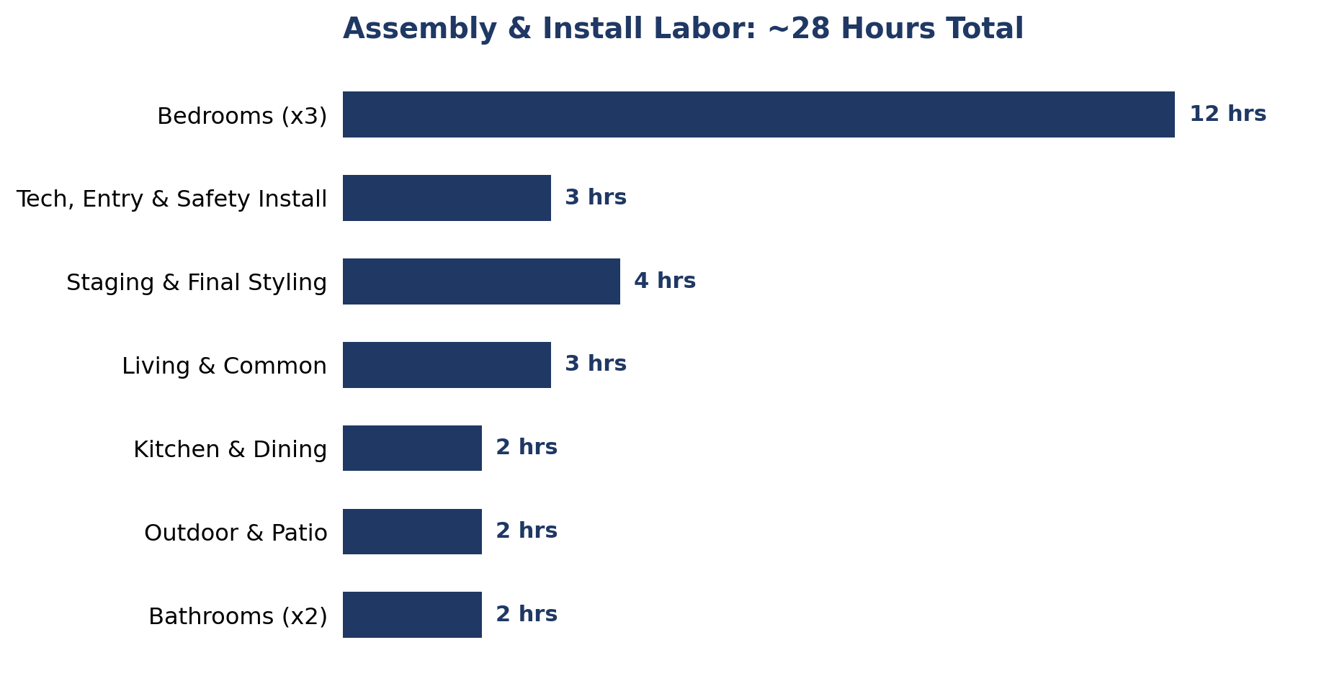
- Independent owners typically hire labor piecemeal — a furniture-assembly tasker for one visit, a locksmith or electrician for another, a stager for a third — paying a separate trip fee and full hourly rate each time.
- We bundle the same ~28 hours of skilled labor into a single coordinated crew visit (or a short back-to-back sequence), which is both faster and meaningfully cheaper per hour than piecemeal hiring.
Illustrative labor cost: Independent, separately-hired contractors: approximately $2,400 for this property (multiple trip fees + standard hourly rates). Our bundled crew: approximately $1,200 flat for the same scope of work.

The Full Picture: Doing It Yourself vs. Our Managed Service
Most independent STR owners underestimate the true cost of furnishing a property themselves — not just the sticker price of furniture, but the sourcing markup, the piecemeal labor, and the value of their own time.
Category | Independent Owner (DIY) | Our Managed Service
Furnishing sourcing cost | $20,460 (standard retail/designer pricing, no bulk leverage) | $10,559 (value-engineered sourcing)
Assembly & install labor | ~$2,400 (separate contractors, multiple trip fees) — or 40+ hours of the owner's own time | ~$1,200 (single bundled crew visit)
Staging & styling | Often DIY or skipped — inconsistent, no professional eye | Included — photo-ready guaranteed
Owner's personal time required | 45–60 hours (sourcing, receiving, assembling, styling) | 2–4 hours (approvals & walkthroughs only)
Typical timeline to launch | 4–8 weeks, often longer around the owner's schedule | 2–3 weeks, sequenced to your launch date
Risk of mistakes / damage | Higher — damage often discovered late, with no inspection step | Lower — every delivery inspected before assembly day

Adding sourcing and labor together gives the full cost-of-ownership picture for this illustrative property.
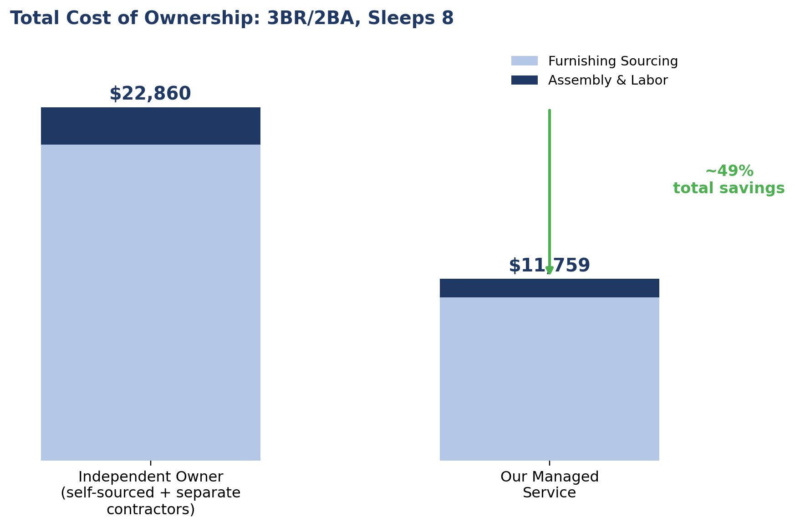
The real comparison: It's not just a 49% cost difference — it's also 40+ hours of the owner's own time back, a faster path to launch, and a professionally staged result on day one instead of a DIY result that may need restyling later.

What We Handle vs. What We Need From You
We handle | We need from you
Full item list & budget proposal | Design preferences, budget range & guest capacity
Placing & tracking all orders | Approval of the final item list before ordering
Receiving, inspection & damage claims | Property access for delivery windows
Scheduling & managing assembly contractor(s) | Sign-off once assembly is complete
Final styling & photo-ready walkthrough | Final review before photos/listing go live

Common Pitfalls We See
- Buying single sets of bedding/towels — same-day turnovers are impossible without a second set on hand.
- Underspending on the mattress — it's the single biggest driver of guest comfort complaints and refund requests.
- Ordering everything at once with no delivery sequencing — leads to a cluttered, undeliverable mess and wasted contractor trips.
- Skipping the damage inspection at receiving — discovering a cracked table leg on assembly day instead of delivery day costs you a week, not a few hours.
- Styling for the photos only — furniture that looks great but doesn't hold up to real guest use creates a maintenance and review problem within months.

Quick-Reference Checklist
- Approve the room-by-room item list and budget before ordering begins.
- Confirm guest capacity and bedroom count to finalize exact quantities.
- Let us place, track, and sequence all orders against your launch date.
- We inspect every delivery for damage before assembly day.
- We schedule and manage the assembly contractor visit(s).
- Final styling walkthrough and sign-off before listing photos.
- Review the DIY vs. managed-service comparison if deciding how hands-on to be.
This guide is for general education. Item lists, quantities, budget allocations, labor hours, and cost comparisons are illustrative estimates for a representative 3BR/2BA property and vary by property size, guest capacity, market, and finish level — we finalize a tailored list and budget with you before ordering.

