THE STR PERMIT
PROCESSING GUIDE
Navigating Zoning, Licensing & Local Rules — Done For You
Your Company Name
Agent Referral · Mortgage · Permits · Furnishing · Listing — All Done For You

The Permit Is the Gate. Everything Else Comes After.
More STR investments fail at the permit stage than at any other point in the launch process. A property that can't legally operate as a short-term rental in its zone — or that loses its permit to a cap, a lottery, or a residency requirement — is a different asset than the one you thought you were buying. This guide walks through how STR permitting actually works, what differs by jurisdiction, and how we manage the process for you from application to approval.
Bottom line: Permit rules are set city-by-city and county-by-county, not nationally or even state-wide. The same property type can be simple to permit in one city and effectively unpermittable two miles away. Always verify before you buy, not after.

How Permit Processing Works
Regardless of jurisdiction, every STR permit follows roughly the same five stages. What varies is how strict each stage is, and how long it takes.
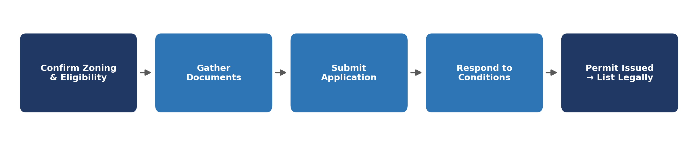

1. Confirm Zoning & Eligibility First
Before anything else: does the local code allow short-term rental use on this exact parcel? This single question eliminates more deals than financing or price ever will.
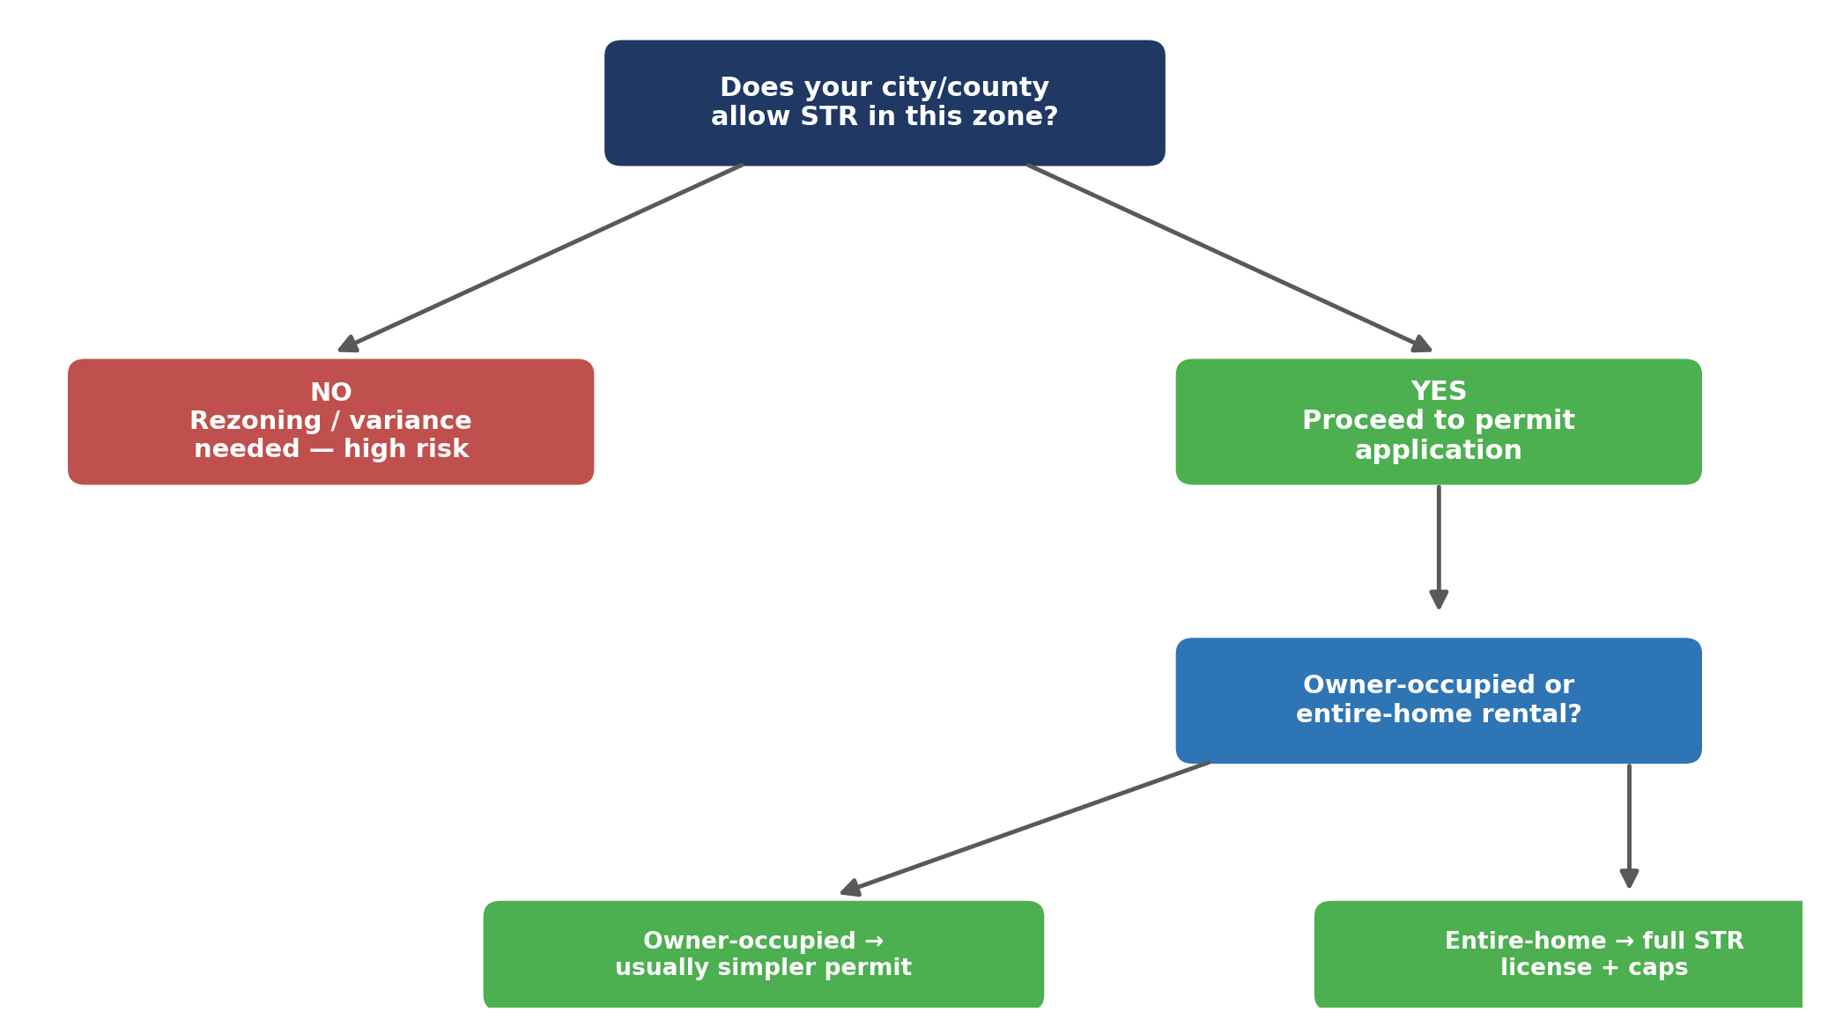
- Zoning maps and STR overlays differ block by block in many cities — never assume because a neighbor operates an STR that your parcel qualifies.
- Owner-occupied ("hosted") and entire-home ("unhosted") rentals are frequently regulated under entirely different rules, fees, and caps.
- Some jurisdictions cap total permits citywide and stop accepting new applications once the cap is reached — ask about waitlists and current permit counts before you commit to a purchase.

2. How Permit Rules Differ by Market
Permit frameworks vary enormously. Below is a snapshot comparison across four markets we frequently work in. Treat this as directional — verify current rules before purchasing or applying, since cities revise ordinances often.
 | South Lake Tahoe, CA | Los Angeles, CA | Phoenix, AZ | Oahu (Honolulu), HI
Permit type | Vacation Home Rental (VHR) Permit | Home-Sharing Registration (HSO) | STR Permit (SHAPE PHX portal) | Nonconforming Use Cert. (NUC) / TVU permit
Where allowed | Citywide, subject to permit cap | Primary residence only, citywide | Most residential zones; ADUs excluded | Resort zones only (non-resort needs legacy NUC)
Annual cap / limit | ~900 permits in residential areas | 120 days/yr unhosted (extended permit possible) | No citywide cap currently | Residential STR <30 days effectively phased out
Core requirements | Annual renewal, TOT registration, 1 VHR/parcel, guests 25+ | 6-month residency proof, registration # on listing, RSO/ADU excluded | TPT license, $500K liability insurance, neighbor notice, background check | $1M liability insurance, guest registry, in-unit info binder
Approx. fee | Permit + business license fee (varies) | $89 initial + $20/yr renewal | $250 initial + $250 renewal | $1,000 initial + $500/yr renewal
Processing path | First-come, first-served; no waitlist | Online portal (LADBS); registration # required before listing | SHAPE PHX online portal; certified-mail neighbor notice required | Dept. of Planning & Permitting (DPP) application; annual Sept–Oct renewal window
Typical fines | Permit revocation + back TOT owed | Up to ~$2,060/day per violation | $500–$3,500 scaling by repeat offense | Up to $10,000/day for unpermitted operation
Figures shown are illustrative snapshots based on published ordinances and may have changed. We confirm current fees, caps, and waitlist status directly with each jurisdiction before filing.
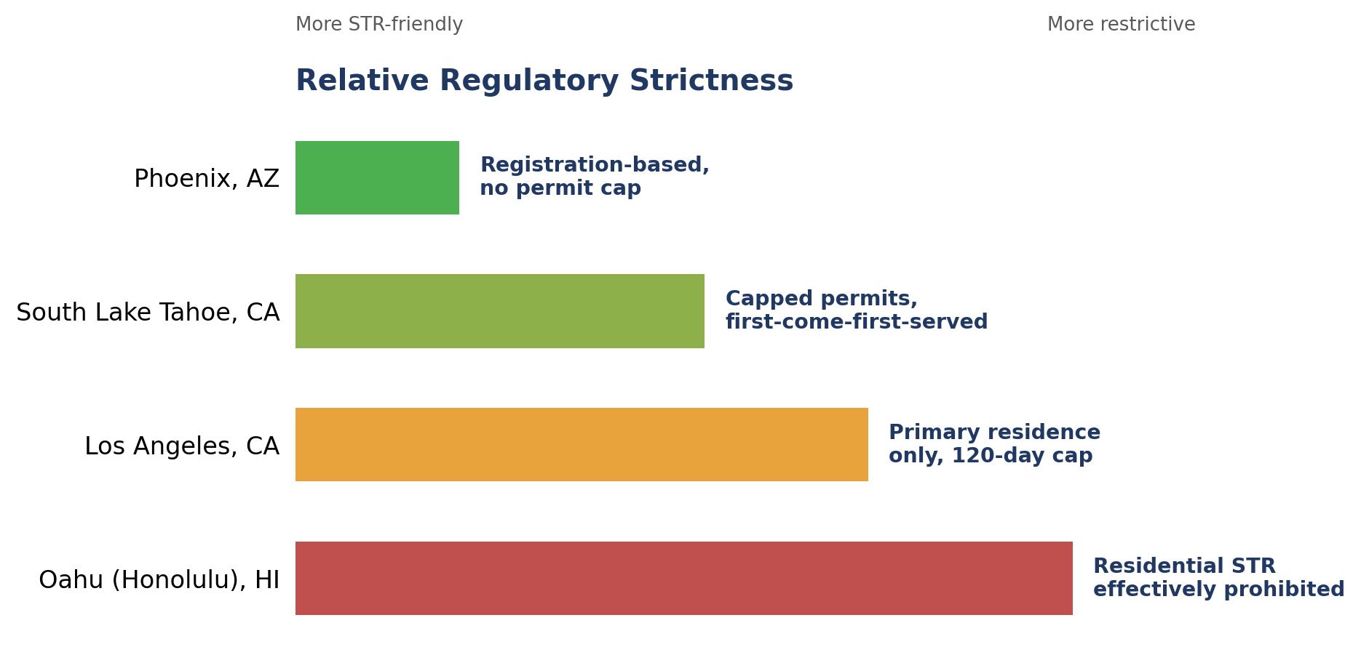
Reading the comparison: Phoenix is currently the most permissive of the four — registration-style, no cap, but with insurance and background-check requirements. Oahu is the most restrictive: outside resort zones, short-term (under 30-day) rental in residential areas is effectively phased out for any property without a grandfathered permit.

3. Documents & Information We'll Need From You
- Proof of ownership or purchase contract, and entity documents if titled to an LLC.
- Proof of primary residence (utility bill, driver's license) if the jurisdiction requires owner-occupancy.
- Liability insurance binder meeting the jurisdiction's minimum (commonly $500K–$1M).
- State tax registration where required (e.g., Arizona TPT license, Hawaii TAT number).
- Floor plan or bedroom/parking count, used to calculate maximum occupancy in several jurisdictions.
- Local contact / responsible-party information required to be posted or on file with the city.

4. What We Handle vs. What We Need From You
We handle | We need from you
Zoning & eligibility verification before you buy or apply | Property address & intended use (hosted vs. entire-home)
Permit application preparation & filing | Ownership/entity documents & insurance binder
Neighbor notice / certified mail, where required | Confirmation of who the on-site or local contact will be
Tracking permit status, caps, and waitlists | Timely response to any city information requests
Renewal tracking so your permit never lapses | Sign-off once the permit is issued

5. Common Pitfalls We See
- Buying a property before confirming zoning — the single most expensive mistake in this entire process, since it can leave you holding a property that cannot legally operate as an STR at all.
- Assuming a neighboring STR means your parcel qualifies — permit caps and grandfather clauses can make two nearly identical homes have completely different eligibility.
- Missing a renewal window — several jurisdictions (e.g., Oahu's NUC) only accept renewals during a narrow annual window; missing it can mean losing the permit entirely.
- Underestimating timeline — some markets process permits in days; others (with caps, waitlists, or public notice requirements) can take months.
- Not budgeting for insurance minimums — several cities now require $500K–$1M in liability coverage as a condition of the permit, which affects your operating cost model.

6. Quick-Reference Checklist
- Confirm zoning & STR eligibility for the exact parcel before purchase or application.
- Confirm whether the jurisdiction caps permits — and current waitlist status, if any.
- Gather ownership, insurance, and tax registration documents.
- Let us file the application and handle neighbor notice requirements.
- Track approval status and respond quickly to any city requests.
- Calendar the renewal window the moment the permit is issued.
This guide is for general education and is not legal advice. Permit rules, fees, caps, and ordinances vary by city/county and change frequently — always confirm current requirements with local planning or permitting authorities, or talk to us directly before purchasing or applying.

