THE FINAL LISTING
LAUNCH GUIDE
Walkthrough, Staging, Photography, Listing & Ongoing Management — Done For You
Your Company Name
Agent Referral · Mortgage · Permits · Furnishing · Listing — All Done For You

Everything Up to Now Was Preparation. This Is the Launch.
The permit, the furniture, the smart locks — none of it earns a booking until the property is captured well and presented well. The final listing step is where all of that prior work either gets translated into a fully booked calendar, or quietly undersold by a rushed photo set and a thin description. This guide covers the four steps between a finished property and a live, booking-ready listing.
Bottom line: Two identical properties, photographed and listed differently, can have a 30%+ gap in occupancy and ADR in their first 90 days. This is one of the highest-leverage steps in the entire launch process — and one of the easiest to underinvest in.

The Listing Launch Process
Four stages, run in the week before you go live.
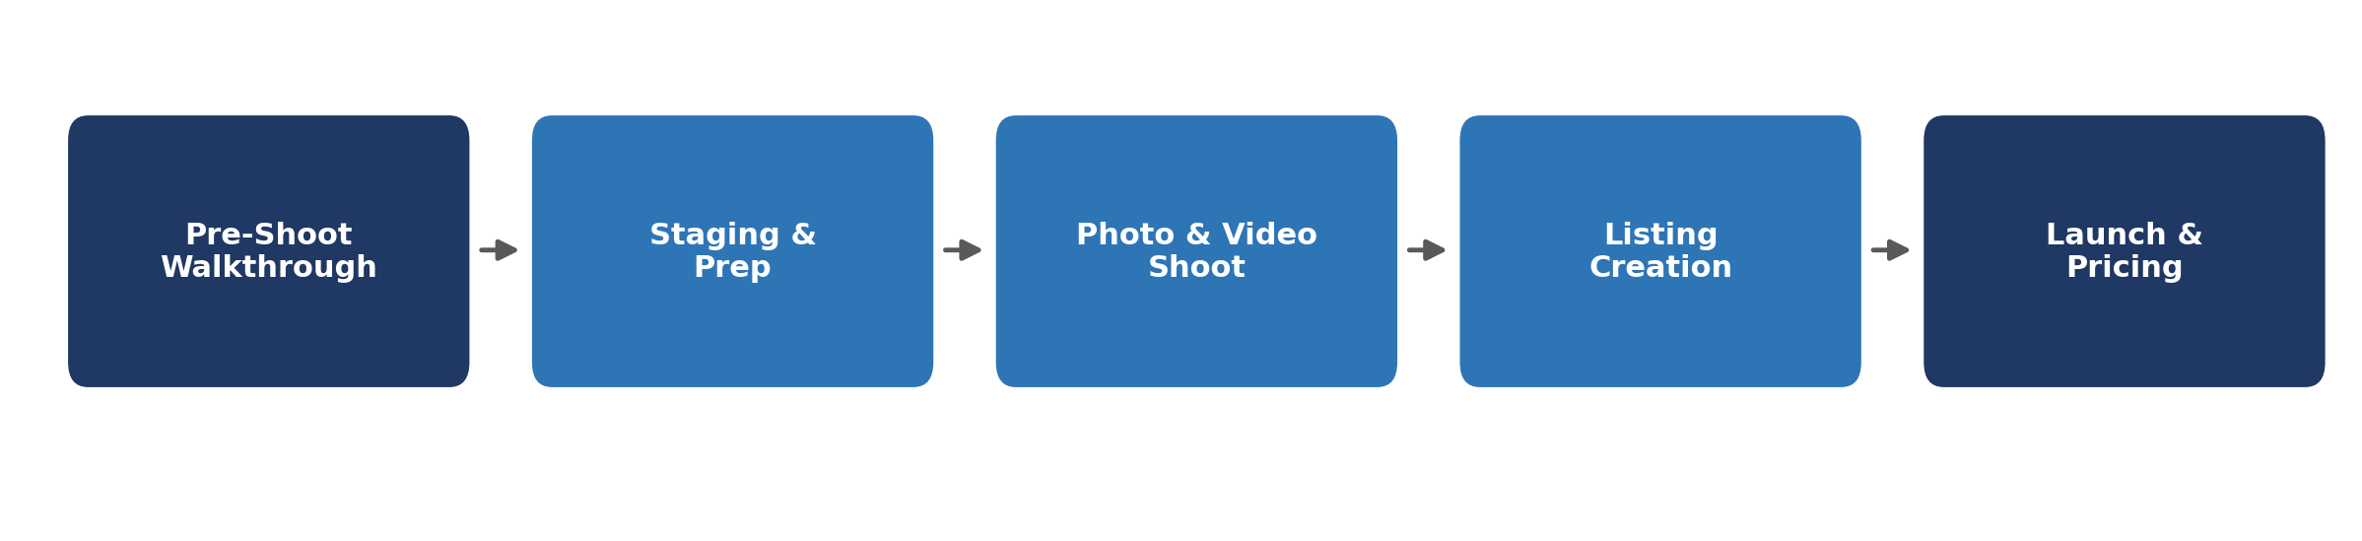

1. Pre-Shoot Walkthrough
Before a single photo is taken, we walk the property the way a guest would experience it for the first time — not the way an owner sees a familiar space.
- Confirm every item from the furnishing list is in place, undamaged, and positioned as designed.
- Check sightlines room by room — furniture placement that looks fine in person can look cluttered or awkward through a wide-angle lens.
- Test every light fixture and replace any bulb with inconsistent color temperature before the shoot, not during it.
- Confirm smart locks, WiFi, and thermostat are all functioning — a guest's first interaction with the property is digital, and the listing photos should match that smooth experience.
Tip: Walk the property at the same time of day you've scheduled the shoot. Light changes everything — what reads as bright and airy at 10am can look flat and grey at 4pm.

2. Staging: Dressing the Property for the Camera
Staging for an STR listing is different from staging a home for sale — it needs to read as inviting and lived-in, not aspirational and empty.
- Beds: hotel-corner-tucked sheets, layered with a duvet, 4–6 styled pillows per bed — every bed shown should look like it's about to be slept in tonight.
- Kitchen counters: clear of small appliances except 1–2 styled pieces (e.g., a coffee maker), plus a small bowl of fruit or a styled cutting board for warmth.
- Dining table: fully set for the property's max guest capacity where the room allows — this photo alone often drives booking decisions for groups.
- Living room: lamps on, a throw blanket draped (not folded flat), 1–2 books or a board game styled on the coffee table.
- Bathrooms: towels rolled or folded into a hotel-style display, counters cleared except 1–2 styled items.
- Outdoor spaces: cushions fluffed, any grill or fire pit staged as if mid-use, string lights on if shooting at dusk.
Avoid over-staging: Personal photos, excess decor, or anything that doesn't match the furnishing list should be removed — guests are booking the space we built for them, not a stylist's personal touches.

3. Photo & Video Shoot
A consistent shot list across every property keeps quality high regardless of which photographer is on site.
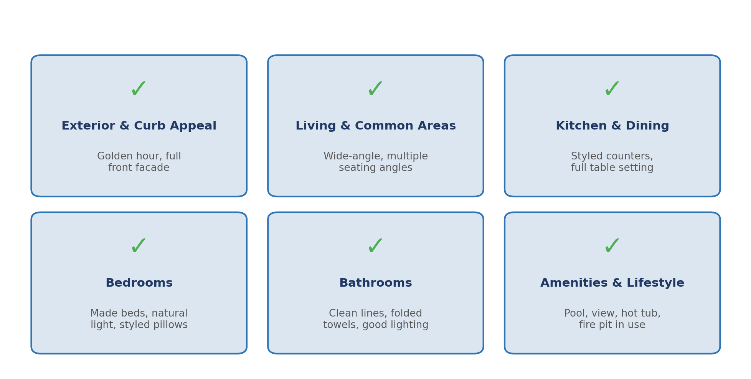
- Shoot during the golden hour (morning or late afternoon) for exterior and any window-facing interior shots.
- Use a wide-angle lens for all common areas, but avoid extreme distortion that misrepresents room size — platforms increasingly flag and penalize this.
- Capture a walkthrough video or virtual tour in addition to stills — listings with video consistently convert better, especially for higher-ADR properties.
- Get a strong, single "cover photo" candidate — usually the best exterior shot or the most striking interior view — since this is what determines whether a guest clicks into the listing at all.

4. Listing Creation & Optimization
With photos in hand, the listing itself needs the same level of care — title, description, amenities, and pricing all influence whether your property gets booked.
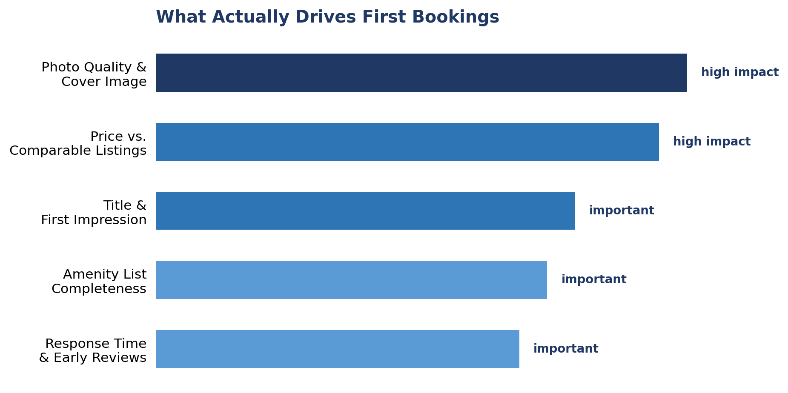
- Title: lead with what makes the property distinctive (view, location, standout amenity) rather than a generic description — "Modern Lake View Retreat" outperforms "3BR House Near Lake."
- Description: open with the experience, not a feature list — save bullet-point specs (bed count, square footage) for a clearly separated section further down.
- Amenity list: complete every applicable field on the platform — incomplete amenity lists hurt both search ranking and guest trust.
- Photo order: lead with the strongest exterior or hero interior shot, then follow the natural flow a guest would walk through the home.
- Pricing: launch with an introductory rate slightly below your long-term target to build initial reviews and search ranking, then adjust upward as bookings and reviews accumulate.
Platform-specific notes: Each platform (Airbnb, VRBO, Booking.com) has its own algorithm preferences — we tailor title length, photo count, and description structure to each platform rather than copy-pasting one listing everywhere.

5. Launch Timeline
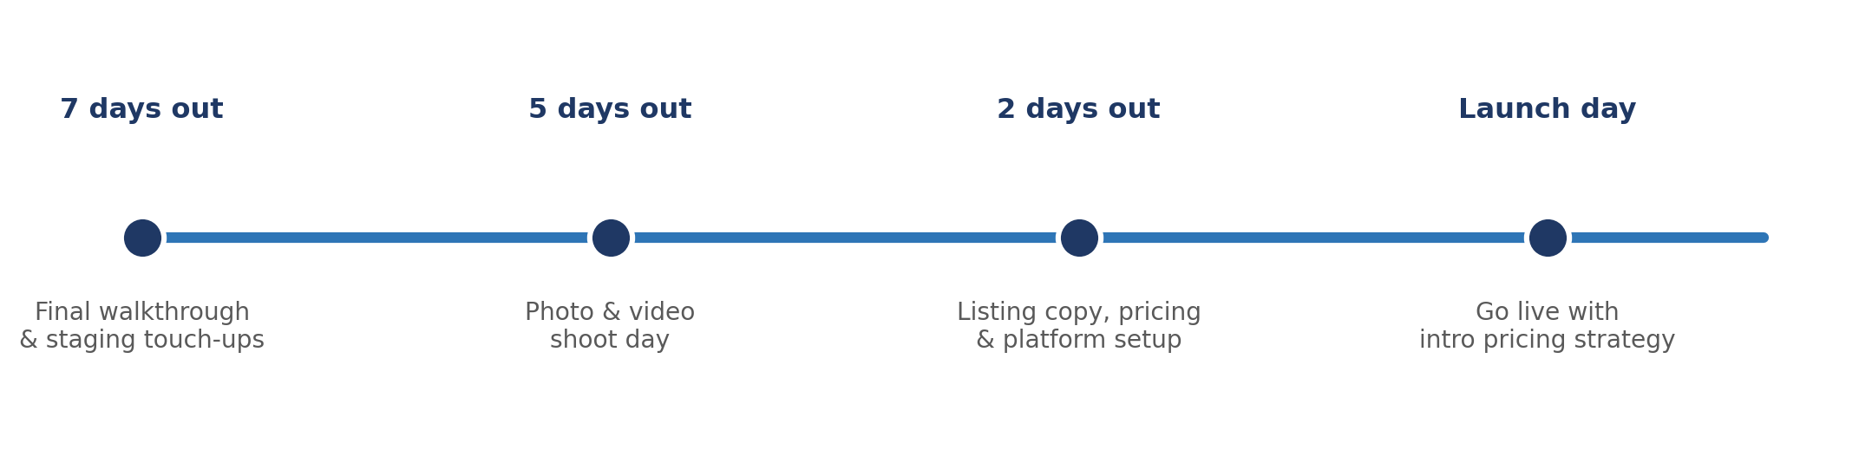

6. After You List: Ongoing Property Management
Going live is the start of a new job, not the end of one — guest messages at all hours, rate adjustments, cleaning crews to schedule, reviews to respond to. Most independent owners either burn 30+ hours a month running this themselves, or hand it all to a traditional full-service manager that charges 25–35% of every booking and locks them into a long contract. We built a third option, modeled on the leaner, technology-driven approach that's become the industry standard for owners who want their time back without giving up a third of their revenue.
How our model works: A low management fee charged only after a guest checks in — never a flat monthly charge, never owed on a cancelled or unbooked night — with no long-term contract. You can cancel with 30 days' notice, anytime.

7. Owner Time: Self-Managed vs. Our Service
This is the comparison that matters most to most owners considering management for the first time — not just the fee, but what self-managing actually costs in hours.
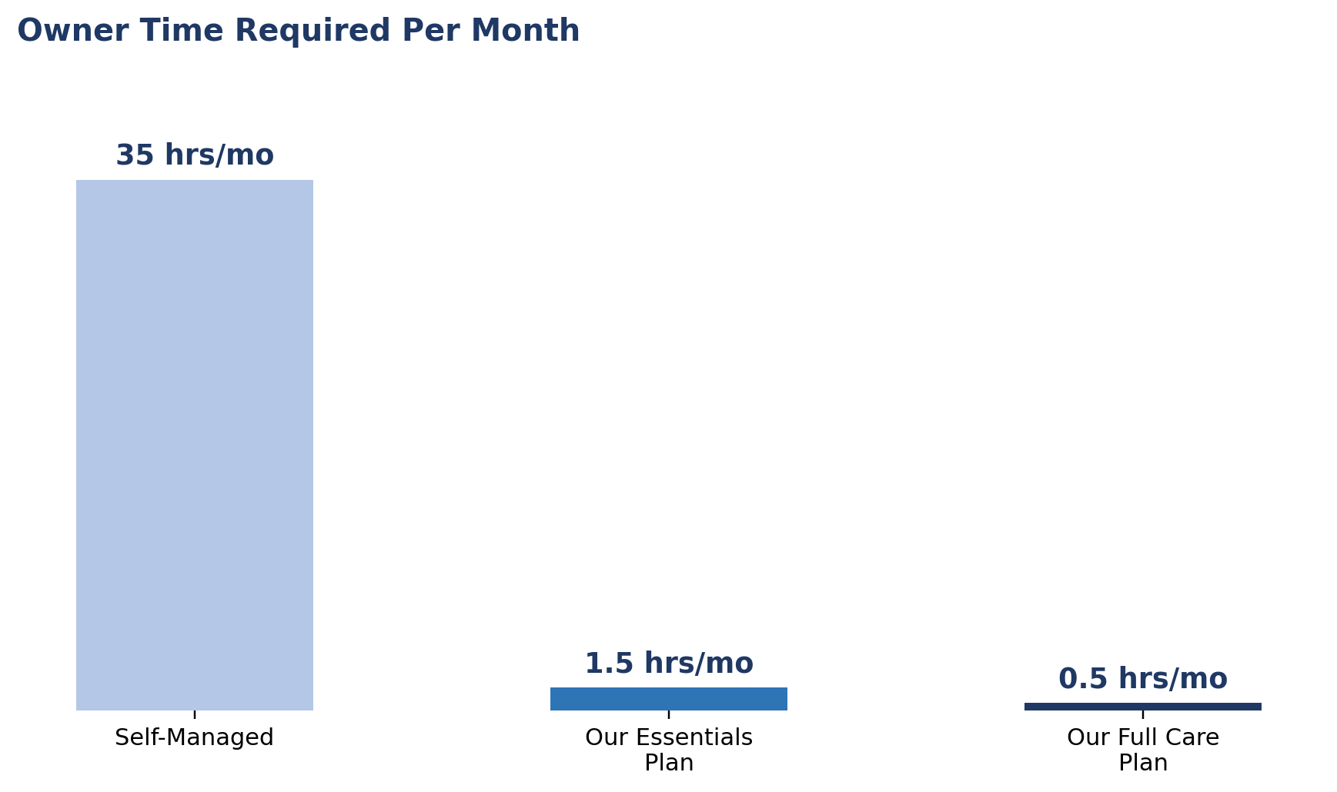
Task | If You Self-Manage | With Our Management
Multi-channel listing setup & sync | 4–6 hrs initial, 2 hrs/month ongoing | ~15 min/month — we maintain every channel
Dynamic pricing & rate adjustments | 3–4 hrs/week | 0 hrs — automated and reviewed by us daily
Guest messaging (pre/during/post-stay) | 8–12 hrs/week in season | 0 hrs — 24/7 coverage handled by our team
Review monitoring & response | 2 hrs/week | 0 hrs — we respond and follow up on every review
Cleaning & turnover scheduling | 2–3 hrs/week | ~15 min/week — we coordinate vetted local crews
Maintenance issue coordination | 2–5 hrs/month, plus on-call stress | ~10 min/month — you're notified, not tasked
Damage & incident handling | 3–6 hrs per incident | We manage the claim; you're kept informed
Monthly financial reporting & tax docs | 2–3 hrs/month | 0 hrs — statements delivered automatically
Bottom line: Self-managing this property realistically costs an owner around 35 hours a month, concentrated heavily in peak season. Our service brings that down to under two hours — just the occasional approval or check-in.

8. Management Plans & Fees
Two plans, both priced well below traditional full-service management, with the fee structured so we only get paid when you do.
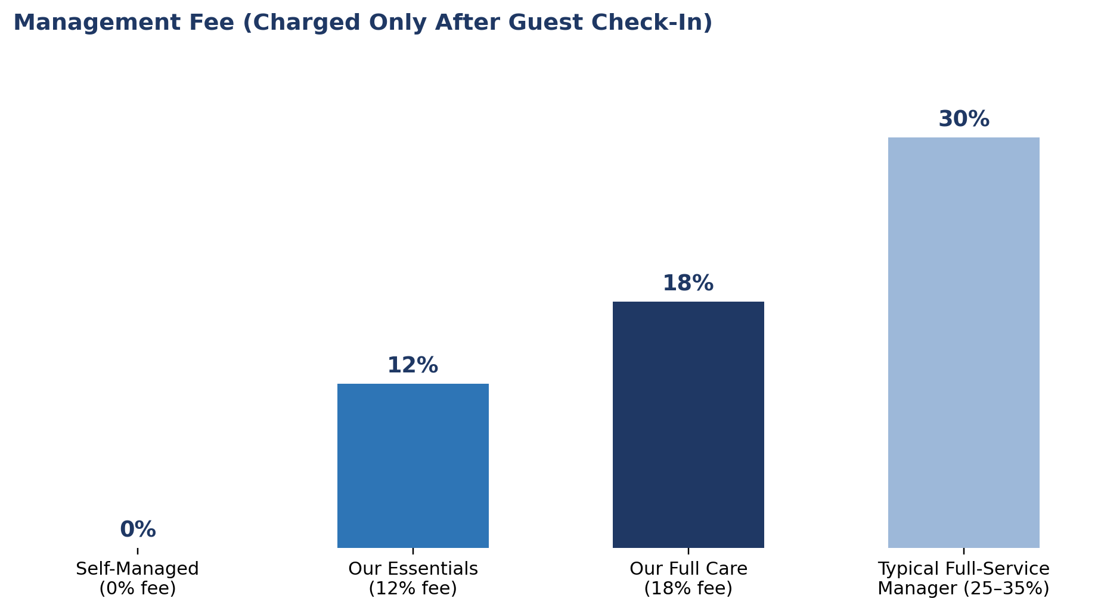
Plan | Fee | What's Included
Essentials | 12% | Multi-channel listing & distribution, dynamic pricing, 24/7 guest messaging, review management, calendar sync across platforms. Cleaning & maintenance coordinated with vetted local partners and billed directly to you.
Full Care | 18% | Everything in Essentials, plus a dedicated account manager, priority placement on major channels, fully coordinated and quality-checked cleaning & maintenance (cost passed through at vetted rates), damage/incident and insurance claim handling, and a quarterly performance review.
Owner Confidence Guarantee: Fee charged only after a guest checks in — never on an empty night. No long-term contract: cancel with 30 days' notice for any reason. You can switch between Essentials and Full Care at any time.

9. What We Handle vs. What We Need From You
We handle | We need from you
Pre-shoot walkthrough & staging | Final sign-off on furnishing & staging before shoot
Professional photo & video shoot | Property access during the scheduled shoot window
Listing copy, title & amenity setup | Brand/voice preferences, if any, beyond our standard
Platform-specific listing optimization | Approval of final listing before it goes live
Launch pricing strategy & ongoing revenue management | Your management plan choice (Essentials or Full Care)
24/7 guest messaging, reviews & turnover coordination | Occasional approvals — about 1–2 hours per month

10. Common Pitfalls We See
- Shooting before staging is finished — rushed photos rarely get reshot, and the listing lives with that first impression for months.
- Leading with a generic title or a weak cover photo — most guests never scroll past the first image if it doesn't earn the click.
- Leaving amenity fields incomplete — a missing "washer" or "workspace" checkbox can filter your listing out of a guest's search entirely.
- Pricing too high at launch — a brand-new listing with zero reviews needs to earn initial bookings and reviews before it can command top-of-market rates.
- Self-managing without budgeting real hours for it — most owners underestimate guest messaging volume until they're in peak season.
- Choosing a traditional full-service manager and a long-term contract before testing a lower-fee, cancel-anytime option first.

11. Quick-Reference Checklist
- Complete the pre-shoot walkthrough and confirm staging is shoot-ready.
- Schedule the photo/video shoot for the best light and confirm property access.
- Review the shot list to ensure every room and amenity is covered.
- Approve the listing title, description, and amenity list before it goes live.
- Confirm launch pricing strategy and platform-specific optimization.
- Choose a management plan (Essentials or Full Care) before or shortly after launch.
- Monitor early bookings and reviews, and adjust pricing as the listing matures.
This guide is for general education. Platform algorithms, photography standards, pricing strategy, and management fee structures evolve continuously — we tailor each listing's approach and management plan to current conditions at the time of launch. Time estimates for self-management are illustrative and vary by property size, guest volume, and season.

