A G E N T I C A I A S S I G N M E N T
Agentic AI
Task Report
Four Nepal-Themed Wikis Built with an Agentic AI Tool
Team: Dionysus
Members: Udit Bhattarai, Lotus Nyaupane, Milan Khadka, Dipen Gaihre
Agentic Tool: Z.ai (GLM Agent)
Date: October 2026

Team Dionysus - Group Assignment 25 October 2026

1. Executive Overview
This report documents the completion of Assignment 25 (Agentic Task) by Team Dionysus. The assignment required every member of the group to carry out one agentic AI task of their own choice, for example generating a wiki for a personally meaningful topic or building a fan site, and to evidence the result with screenshots. Rather than using a simple chat window or a one-shot deep-research feature, each member commissioned and supervised a genuine agentic workflow in which the AI tool planned the work, produced complete artifacts, verified its own output and iterated until the deliverable was finished.
The team chose a shared theme close to its members' roots: the culture, geography and heritage of Nepal. Four independent wiki and fan-site projects were produced, one commissioned by each member: a Nepali music wiki, a Himalayan trekking routes guide, a Nepali food wiki and a Kathmandu Valley heritage wiki. Each task was executed end-to-end by the agentic tool Z.ai (GLM Agent), which wrote the pages as complete HTML/CSS documents, rendered them in a headless browser and captured verification screenshots. One screenshot per task is embedded in the relevant section of this report, and the working HTML files accompany this submission.

2. Group Information and Scope of Work
The table below records the formal group information for this submission. Team Dionysus consists of four members, and the work was distributed so that each member owned exactly one agentic task, as required by the assignment brief. Every member selected the topic of his own task, formulated the instruction given to the agent, reviewed the generated result, and approved the final screenshot used as evidence.
Table 1: Group information
Field | Details
Name of the group | Dionysus
Members (full names) | Udit Bhattarai, Lotus Nyaupane, Milan Khadka, Dipen Gaihre
Assignment | Assignment 25 - Agentic Task: one agentic AI task per member
Agentic tool used | Z.ai (GLM Agent)
Deliverables | Four wiki/fan-site pages, four screenshots, this report
The scope of the four tasks and how they map to each member is summarised in Table 2. The topics were deliberately chosen from four different cultural domains so that the submission demonstrates the range of the agentic tool rather than four variations of the same page. All four deliverables follow the same production pipeline described in Section 3, but each task received its own instruction, layout style and content structure.
Table 2: Task summary - one agentic task per member
Member | Site created | Featured topic | Evidence
Udit Bhattarai | SwarSansar - The Nepali Music Wiki | Narayan Gopal, the Swor Samrat | Figure 1
Lotus Nyaupane | HimalRoute - Trekking Routes Guide | Everest Base Camp trek | Figure 2
Milan Khadka | MomoMandala - The Nepali Food Wiki | Momo and the Nepali table | Figure 3
Dipen Gaihre | Dharohar Archives - Heritage Wiki | Pashupatinath Temple | Figure 4

3. The Agentic Tool Used: Z.ai (GLM Agent)
The tool used for all four tasks is Z.ai (GLM Agent), an agentic AI assistant built on the GLM large language model. The property that makes it agentic, rather than a plain chatbot, is that it acts on its own plan: it decomposes a single natural-language brief into a numbered task list, keeps that list updated as work proceeds, and invokes concrete tools to complete each step. For this assignment the agent used a code editor to write and save complete HTML/CSS files on disk, a headless Chromium browser to open each saved page, and a screenshot utility to capture the rendered result at a 1440 x 900 viewport.
Each task therefore followed the same observable agent loop: the member issued one instruction; the agent planned the page structure; it wrote the file; it launched the browser and rendered the page; it captured and visually inspected the screenshot; and it corrected defects that it detected (for example, missing font glyphs and a spacing typo were found and fixed during re-rendering). The human role in every task was limited to choosing the topic, phrasing the brief, and verifying factual accuracy of the finished page. This qualifies as an agentic task under the assignment definition: the AI performed multi-step, tool-assisted work towards a self-contained goal, instead of merely answering questions in a chat interface.

4. Task 1 - Udit Bhattarai: SwarSansar, the Nepali Music Wiki
Task goal. Udit commissioned a fan-style wiki dedicated to Nepali music, with the legendary singer Narayan Gopal as its featured article. The instruction given to the agent was: "Build 'SwarSansar', a Nepali music wiki with a featured article on Narayan Gopal - use a classic MediaWiki-style layout with a dark blue header, a search bar, a left navigation sidebar with featured artists and genres, a right-floating infobox, a contents box, a signature-songs table and a category bar."
How the agent executed it. The agent first planned the page as a set of reusable regions (header, nav strip, sidebar panels, article body, infobox, footer) and then wrote the complete single-file implementation in one pass:
- Parsed the brief and selected a classic encyclopedia layout modelled on MediaWiki conventions (blue links, serif body text, boxed panels).
- Structured the article: lead paragraph, floated infobox with biographical facts, contents box, five content sections and a category footer.
- Composed the content from its own knowledge: Narayan Gopal's dates (1939-1990), the Swor Samrat title, his Radio Nepal career and his signature songs such as E Kancha Thunga Kancha and Yo Samjhine Man Cha.
- Wrote the HTML/CSS file to disk and opened it in a headless browser at 1440 x 900.
- Captured a verification screenshot, inspected it for rendering defects, and re-shot after adjustments.
Output and reflection. The finished page, shown in Figure 1, reads like a genuine community wiki: it has a breadcrumb, a last-edited notice, an illustrated infobox and a ranked song table. Udit's reflection was that giving the agent a recognisable format name ("MediaWiki-style") was the single most effective part of the prompt, because the agent immediately knew which structural conventions to imitate. The main human contribution after generation was checking the biographical facts, which the agent had summarised correctly.
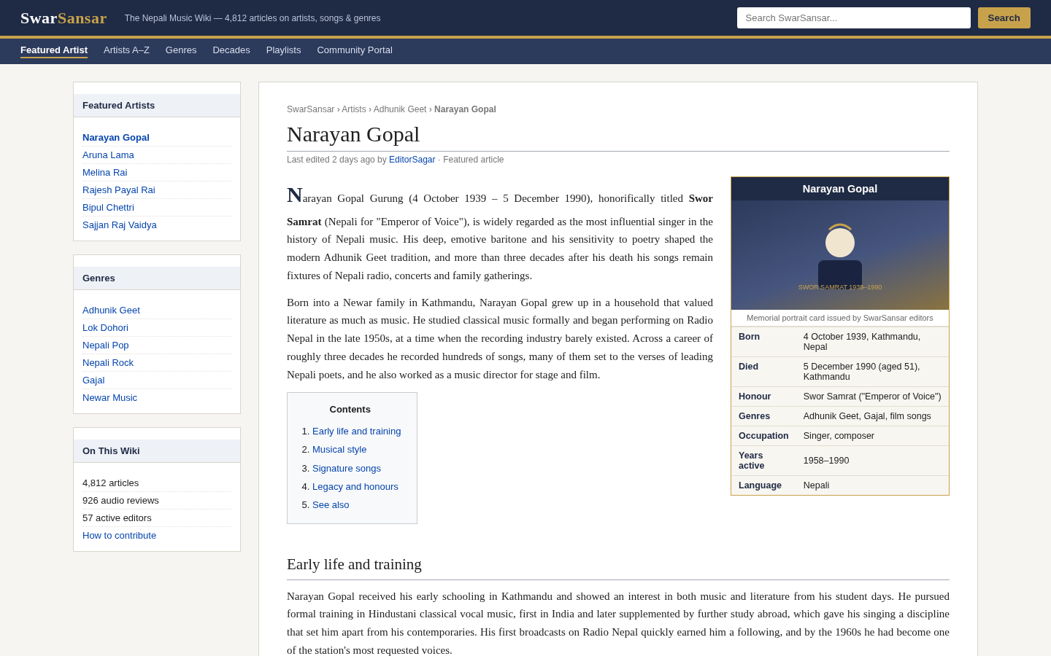
Figure 1: Screenshot of SwarSansar - The Nepali Music Wiki (Task 1, Udit Bhattarai)

5. Task 2 - Lotus Nyaupane: HimalRoute, the Trekking Routes Guide
Task goal. Lotus commissioned a practical mountain-guide site for Himalayan treks with the Everest Base Camp (EBC) trek as the flagship article. The instruction was: "Create 'HimalRoute', a Himalaya trekking routes guide whose main guide is the Everest Base Camp trek - include key trek statistics, a day-by-day itinerary table, permit requirements, an altitude-safety section, a mountain hero illustration and route cards for other popular treks."
How the agent executed it. This task was the most data-heavy of the four, and the agent began by decomposing the brief into the distinct data objects it needed to produce:
- Decomposed the brief into four data blocks: key statistics, a 13-day itinerary, permit requirements and safety rules.
- Assembled the well-established trek facts: Base Camp at 5,364 m, the Kala Patthar viewpoint at 5,545 m, a 12-14 day typical duration and the stage list from Lukla through Namche Bazaar, Tengboche, Dingboche and Lobuche to Gorak Shep.
- Designed an outdoor-magazine layout with an SVG mountain-range hero, a four-cell fact grid and a dark green navigation theme.
- Generated the itinerary as a real HTML table with alternating row shading, and wrote sidebar panels for season alerts, checklists and trail status.
- Rendered the page in the headless browser, captured the screenshot and verified that tables and cards displayed without overflow.
Output and reflection. Figure 2 shows the result. Lotus observed that the agent was particularly strong at converting prose knowledge into structured elements - the fact grid and itinerary table communicate at a glance what would otherwise take paragraphs. The human review focused on the numbers: the altitudes and stage sequence were checked against standard guidebook knowledge and found correct.
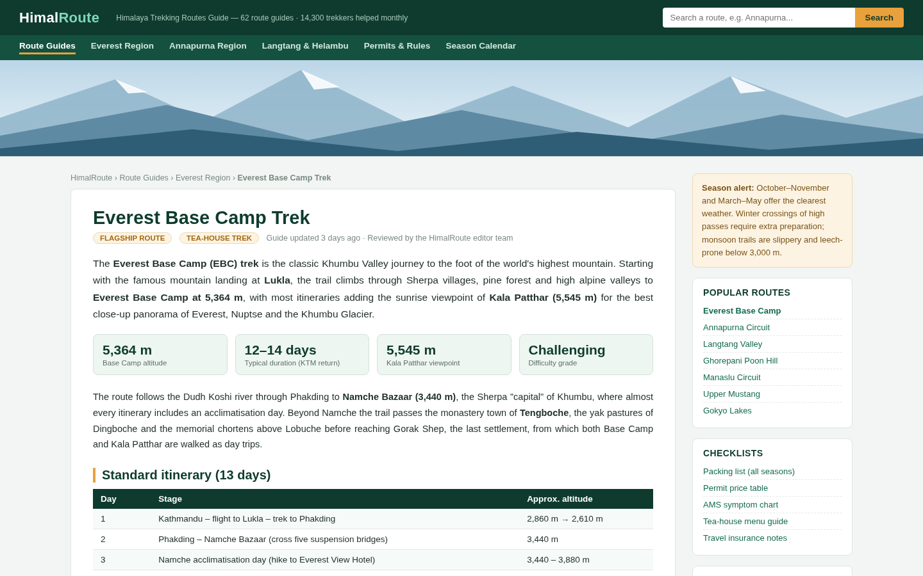
Figure 2: Screenshot of HimalRoute - Himalaya Trekking Routes Guide (Task 2, Lotus Nyaupane)

6. Task 3 - Milan Khadka: MomoMandala, the Nepali Food Wiki
Task goal. Milan commissioned a lighter, magazine-flavoured food wiki celebrating Nepali cuisine, with the country's favourite street dish, the momo, as its featured article. The instruction was: "Build 'MomoMandala', a Nepali food wiki whose Dish of the Week is momo - include an origins section, a six-card fillings and varieties grid, a 'how a momo house works' step sequence, a related-dishes table and a warm orange-brown food theme."
How the agent executed it. The agent treated this as a creative-editorial task and made its own design decisions within the brief:
- Chose a warm cream-and-maroon palette with dashed dividers to evoke street-food menus, deviating deliberately from encyclopedia styling.
- Wrote the lead section framing momo as a dish that crosses every boundary of region and class in Nepal.
- Produced the varieties grid: buff, chicken, vegetable and cheese, jhol (served in spicy broth), fried and chilli momo, and the open Himalayan shabalay.
- Composed the related-dishes table covering dal bhat, the Newari khaja set, sel roti, yomari, gundruk and juju dhau, each with its eating occasion.
- Rendered and screenshotted the page, then fixed a spacing defect it found in one card before re-shooting.
Output and reflection. The final page is shown in Figure 3. Milan's reflection was that this task demonstrated the agent's editorial judgement: it invented the poll panel and the calorie annotations on its own initiative, which made the wiki feel lived-in rather than generated. Fact-checking focused on dish names and festival associations, which all matched the team's own knowledge of Nepali food culture.
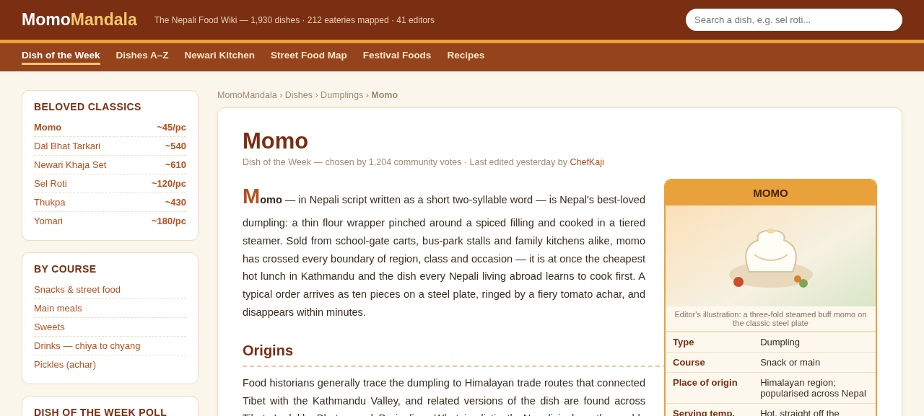
Figure 3: Screenshot of MomoMandala - The Nepali Food Wiki (Task 3, Milan Khadka)

7. Task 4 - Dipen Gaihre: Dharohar Archives, the Kathmandu Heritage Wiki
Task goal. Dipen commissioned an archival-style heritage wiki documenting the seven UNESCO monument zones of the Kathmandu Valley, with the Pashupatinath Temple as the featured monument. The instruction was: "Create 'Dharohar Archives', a Kathmandu Valley heritage wiki with a featured article on Pashupatinath Temple - include a UNESCO badge, an illustrated infobox, a history timeline, an architecture section, a rituals section and summary cards for the other six monument zones, in a maroon-and-gold documentary style."
How the agent executed it. The agent organised the whole site around the UNESCO seven-zone structure and then built the featured article inside it:
- Structured the wiki around the seven inscribed monument zones: the three durbar squares of Kathmandu, Patan and Bhaktapur, the stupas of Swayambhunath and Boudhanath, and the temples of Pashupatinath and Changu Narayan.
- Wrote the featured article with a floated infobox (deity, location, pagoda style, 1979 UNESCO inscription year) and an SVG illustration of the two-tiered golden roof.
- Built the history timeline from the legendary origins of the shrine through the medieval pagoda rebuilding to the 1979 inscription and present-day management.
- Added the architecture and rituals sections covering the gilded roof, silver doors, Arya Ghat and the evening aarati on the Bagmati riverbank.
- Generated the six companion zone cards, rendered the page and captured the verified screenshot.
Output and reflection. Figure 4 shows the finished page. Dipen noted that the heritage topic was the most sensitive of the four, since it mixes religious practice with historical claims, so the human review deliberately verified the UNESCO inscription year and the list of the seven zones before accepting the page. The agent had both details correct, which increased the team's confidence in using agentic tools for cultural documentation.
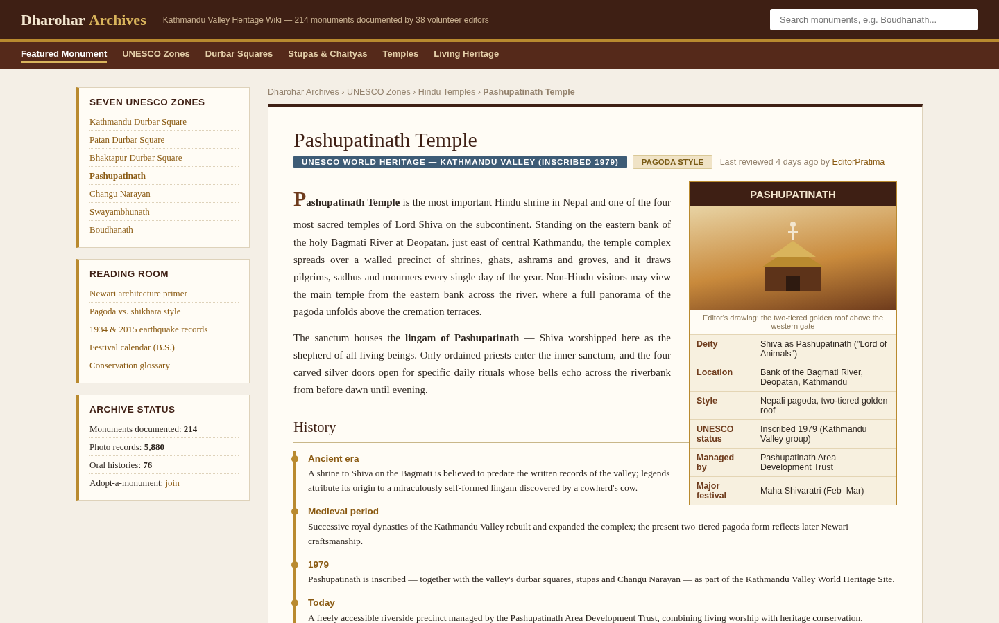
Figure 4: Screenshot of Dharohar Archives - Kathmandu Valley Heritage Wiki (Task 4, Dipen Gaihre)

8. Conclusion and Reflections
The assignment gave Team Dionysus a clear picture of what distinguishes an agentic AI tool from an ordinary chat assistant. In all four tasks the agent received a single natural-language brief and then carried the work to a finished, verified artifact on its own: it planned the page structure, wrote complete code, executed a browser, took screenshots and corrected defects that it detected in its own output. The four finished wikis cover four different visual styles and content genres, which shows that the agent adapts its design language to the brief instead of producing one fixed template.
Several lessons emerged from comparing the four tasks. First, prompt precision mattered more than prompt length: naming a recognisable format (MediaWiki-style, outdoor guide, documentary archive) steered the result more than long paragraphs of instructions. Second, the division of labour was consistent across members - the agent owned structure, code and layout, while the human owned topic choice and factual verification. Third, self-verification is a real capability but not a guarantee: the agent caught rendering issues on its own, yet every member still reviewed dates, names and figures before submission. The team concludes that agentic AI tools are genuinely effective for producing complete web artifacts, and that the most reliable results come from treating the agent as a supervised builder rather than an unsupervised author.

