THE STATE OF ARTIFICIAL INTELLIGENCE IN EUROPE
A 2026 Report
Main Actors • Legal Framework • Challenges • Future Prospects

April 2026

Contents

Executive Summary
1. The European AI Landscape
1.1 Market Size and Growth Trajectory
1.2 Key European AI Actors
1.3 Geographic Distribution
2. The Legal Framework
2.1 The EU AI Act
2.2 Implementation Timeline
2.3 GPAI Code of Practice
2.4 The European AI Office
2.5 The AI Pact
2.6 National Strategies
3. Investment and Funding Ecosystem
3.1 The InvestAI Initiative
3.2 Private Investment Landscape
3.3 Public Research Funding
4. Challenges and Structural Weaknesses
4.1 Compute Infrastructure Gap
4.2 Talent: Brain Drain and Shortage
4.3 Regulatory Burden on Startups
4.4 The Commercialization Gap
4.5 The Sovereignty Dilemma
5. Future Prospects and Strategic Outlook
5.1 Scenario Analysis
5.2 Key Determinants for the Next 24 Months
5.3 Strategic Recommendations
6. Conclusion
References

Main Actors, Legal Framework, Challenges, and Future Prospects

Executive Summary

Europe stands at a critical juncture in the global AI race. While the continent has achieved remarkable success in regulatory leadership — most notably through the EU AI Act, the world's first comprehensive AI law — it faces a widening gap with the United States and China in terms of compute infrastructure, frontier model development, and the commercialization of AI research.
European AI investment surged 58% year-on-year in 2025, reaching approximately €11 billion, yet this remains dwarfed by American private investment of nearly $70 billion in the same sector. The continent's strategy now hinges on three pillars: regulatory export (making the AI Act the global standard), sovereign infrastructure (the InvestAI initiative with €200 billion in mobilized capital), and the cultivation of flagship companies such as Mistral AI.
The coming 12 to 24 months will determine whether Europe becomes a "regulatory superpower" with limited technological agency, or successfully builds the infrastructure and companies necessary for genuine AI sovereignty.

1. The European AI Landscape: Current State

1.1 Market Size and Growth Trajectory
The European AI market is entering a high-growth phase. According to MarketsandMarkets, the European AI market is projected to grow from USD 86.24 billion in 2025 to USD 548.03 billion by 2032, representing a compound annual growth rate (CAGR) of 30.2%. Machine learning is expected to account for the largest market share, driven by rapid enterprise adoption across operations, supply chain, and manufacturing. If realized, this trajectory would position Europe as the third-largest AI market globally by the end of the decade, though it would still trail the combined US-China share by a substantial margin.

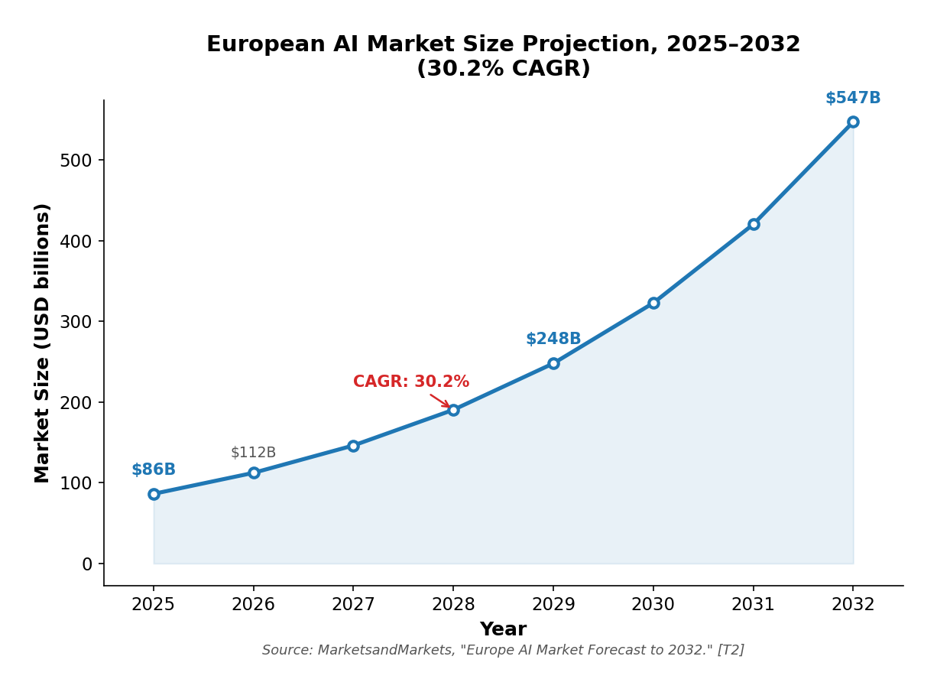
Figure 2: European AI Market Size Projection, 2025–2032 (30.2% CAGR). Source: MarketsandMarkets, "Europe Artificial Intelligence (AI) Market Forecast to 2032."
European AI startups raised approximately €13.2 billion cumulatively between 2021 and 2025, with France, Germany, and the UK emerging as the primary development hubs. In 2025 alone, European AI investment reached roughly €11 billion, up 58% from 2024. However, the scale of this growth must be contextualized against the broader investment landscape. Between 2020 and 2025, the US dedicated 34% of its €1.33 trillion in venture capital funding to AI, while Europe allocated just 18% of €252 billion. Private AI investment in the US reached nearly $70 billion in 2023, vastly outpacing European levels. The disparity is not merely a function of market size; it reflects deeper structural differences in how capital is allocated toward high-risk, high-reward AI ventures in the two regions.
The gap is not merely a matter of scale but of concentration. CB Insights' 2025 State of AI Report found that AI startups globally raised $211 billion in 2025, with five companies alone — OpenAI, Scale AI, Anthropic, Project Prometheus, and xAI — raising $84 billion, nearly half of all AI funding. European companies do not appear in this top-tier concentration, underscoring a structural weakness in late-stage capital mobilization. This concentration effect creates a Matthew phenomenon in which a handful of well-capitalized firms capture disproportionate talent, attention, and ecosystem benefits, while the broader field of European startups operates with significantly fewer resources.
McKinsey's analysis of European AI adoption found that Western Europe trails the US in AI and IT spending across sectors by 45–70%, a gap that has persisted despite recent investment surges. The EIB Investment Survey 2025, covering over 12,000 EU firms, found that while 37% of EU businesses now use generative AI — comparable to the 36% rate in the US — European firms invest relatively more in replacing existing assets and relatively less in growth and innovation compared to their US counterparts. This pattern suggests European firms are adopting AI for efficiency rather than transformation, which has important implications for the long-term competitiveness of the European AI ecosystem.
The investment disparity between Europe and the United States is stark: American private AI investment of approximately $70 billion dwarfs Europe's $12 billion, a gap of nearly six to one. China's estimated $15 billion, while substantially below US levels, still exceeds European investment. This funding gap is not merely a function of market size; it reflects deeper structural differences in how capital is allocated toward high-risk, high-reward AI ventures. The concentration of American investment in a handful of well-capitalized firms creates a Matthew effect that further widens the competitive divide.

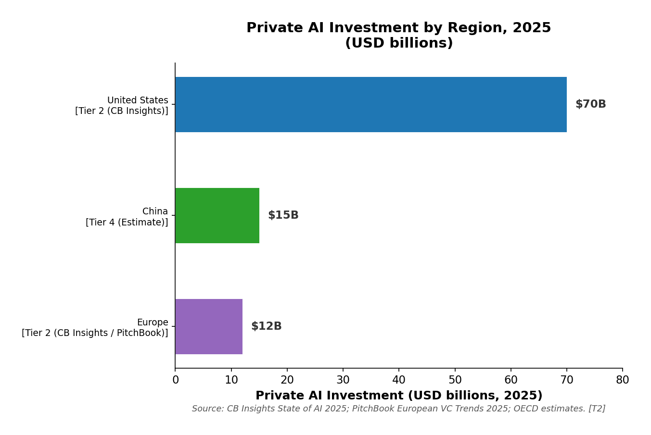
Figure 1: Private AI Investment by Region, 2025 (USD billions). Source: CB Insights State of AI 2025; PitchBook European VC Trends 2025; OECD estimates.

1.2 Key European AI Actors
EUROPEAN AI ECOSYSTEM
1. Frontier Model Developers — Mistral AI, Aleph Alpha
2. AI Infrastructure & Platforms — Hugging Face, DeepL, LightOn
3. Application-Layer Innovators — Helsing, Parloa, Sana, Nscale

Frontier Model Developers.. Mistral AI represents the undisputed flagship of European frontier AI research and development. Founded in 2023 by Arthur Mensch, Timothée Lacroix, and Guillaume Lample, Mistral has raised over $3 billion across multiple funding rounds, achieving a valuation of approximately $13.7 billion at its latest assessment. Its September 2025 Series C round of €1.7 billion was one of the largest ever for a European startup and signaled both investor confidence in European AI and the growing recognition that frontier model development requires capital on a scale previously thought impossible outside the United States. Mistral's strategic positioning centers on open-weight frontier models, which provide European enterprises with a sovereign alternative to US proprietary models while simultaneously building a global developer ecosystem. The company launched Mistral Forge — a platform for custom model training — and committed €1.2 billion toward a European data center in Sweden, demonstrating a vertically integrated approach that spans model development, training infrastructure, and enterprise deployment.
Aleph Alpha occupies a complementary position in the frontier model space, with a distinctly European sovereignty mandate. Based in Germany, Aleph Alpha focuses on sovereign AI stacks tailored for European enterprises, particularly in the public sector and defense. The company's emphasis on GDPR compliance, European data storage, and regional data sovereignty reflects a strategic differentiation from US frontier model providers, positioning itself as the trusted partner for European institutions that cannot or will not rely on American cloud infrastructure. While Aleph Alpha's market reach remains narrower than Mistral's, its focus on compliance and sovereignty addresses a growing demand among European public sector buyers who are increasingly concerned about data sovereignty and regulatory alignment.
AI Infrastructure and Platform Providers.. Hugging Face stands as the cornerstone of Europe's open-source AI infrastructure. Based in France, the platform hosts millions of models and datasets, serving as the de facto hub for the global open-source AI community. Its European base gives it strategic importance beyond its commercial value; Hugging Face functions as critical public infrastructure for the European AI ecosystem, providing the shared tools, models, and datasets that enable smaller European startups and research institutions to compete with well-funded American counterparts. The platform's role as an open-source intermediary is particularly valuable in a European context where fragmented national markets make it difficult for individual companies to achieve the scale necessary to build comprehensive AI tooling independently.
DeepL, originally a translation technology company based in the Netherlands, has expanded into the broader AI agent space, launching AI-powered productivity tools in 2025. DeepL's competitive advantage lies in multilingual natural language processing, a domain where Europe's linguistic diversity provides a natural advantage over US competitors who typically optimize for English-language markets first. This multilingual capability is not merely a product feature but a structural competitive advantage that reflects the continent's inherent complexity.
LightOn, a French startup specializing in frugal, energy-efficient AI, develops "Small Foundation Models" designed to operate with significantly less compute than traditional large models. This approach aligns with Europe's emphasis on sustainable, responsible AI and addresses one of the continent's most pressing constraints: compute availability. By developing models that deliver meaningful performance at a fraction of the computational cost, LightOn's technology offers a pathway for European organizations to deploy AI capabilities without requiring the massive infrastructure investments that US and Chinese competitors can afford. This frugal AI approach may prove increasingly relevant as energy constraints and environmental scrutiny intensify across European data center markets.
DEFENSE AI
€1.3B raised including €600M in June 2025 — all-domain defense technologies. Reflects growing European appetite for sovereign defense AI.

The broader application ecosystem includes Nscale, a UK-based AI data infrastructure company that raised €958 million in Series B and €377 million in Series C during 2025, positioning itself as critical infrastructure for AI workloads. Additional notable companies include Lovable (Sweden, AI-native app builder), Framer (Netherlands, AI-powered website builder), Poolside (France, foundation models for software engineering), and ElevenLabs (UK, voice AI research and deployment). Collectively, this diverse application layer reflects the European ecosystem's strength in building specialized, domain-specific AI tools rather than general-purpose frontier models.

1.3 Geographic Distribution
The European AI ecosystem is heavily concentrated. The UK (particularly London) and Germany anchor the continent's unicorn population, while France has emerged as the center of frontier model development through Mistral AI. Nordic countries — especially Sweden — have become hubs for AI-native application builders. This geographic concentration reflects both historical patterns of tech investment and the specific advantages each region brings to AI development: the UK's financial capital and talent pool, Germany's industrial base and engineering talent, France's government support for strategic technology, and the Nordics' culture of innovation and digital-first public services.
AI Watch, the European Commission's monitoring platform, confirms this geographic concentration through its investment dashboard, which shows that the UK, France, and Germany collectively account for approximately 65% of total European AI investment. This concentration creates structural vulnerabilities: the UK's post-Brexit regulatory divergence, France's centralized approach to technology policy, and Germany's bureaucratic complexity create a fragmented landscape that complicates pan-European scaling. A startup that succeeds in Paris may face entirely different regulatory, cultural, and market barriers when expanding to Berlin or Amsterdam, whereas a US startup faces a single, unified domestic market. This fragmentation is one of Europe's most persistent competitive disadvantages in the AI race.
GEOGRAPHIC CONCENTRATION
UK, France, and Germany together account for 65% of all European AI investment, creating structural vulnerabilities for pan-European scaling.

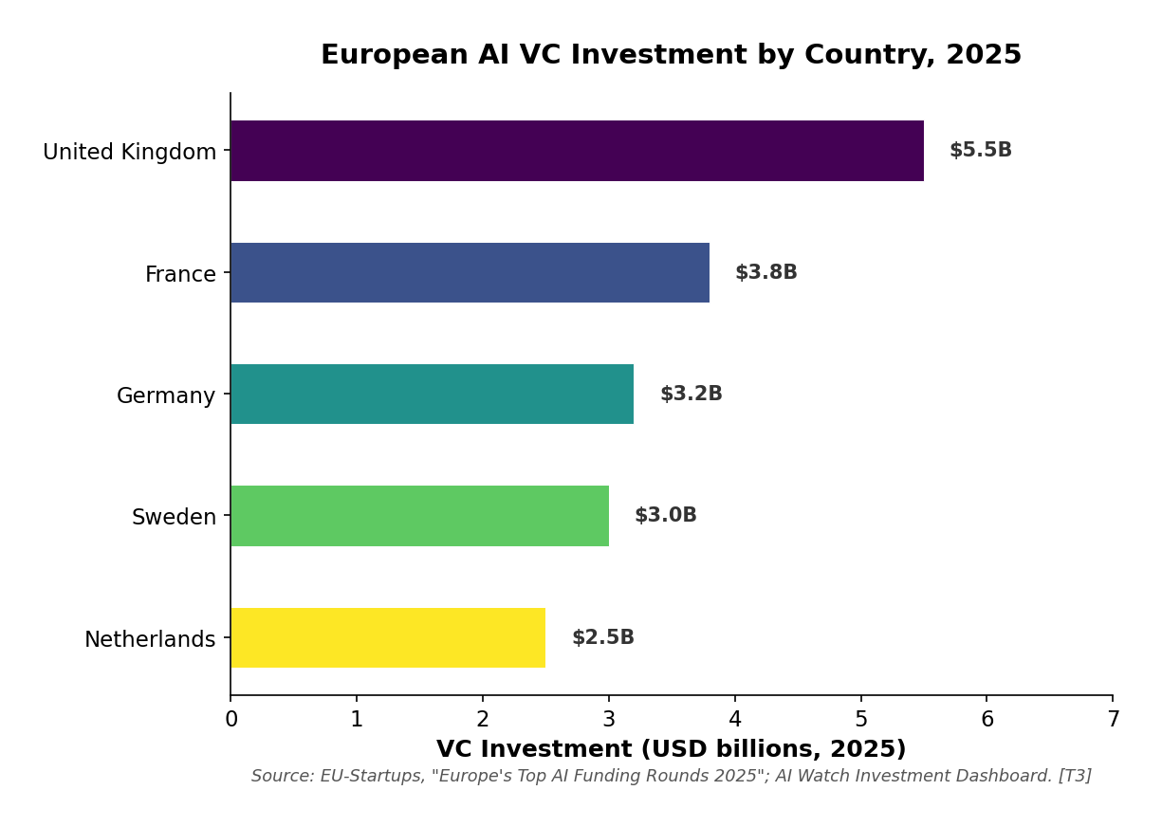
Figure 3: European AI VC Investment by Country, 2025. Source: EU-Startups, "Europe's Top AI Funding Rounds 2025"; AI Watch Investment Dashboard.
The geographic concentration of European AI investment reveals not only where talent and capital are accumulating, but also why the continent's regulatory framework matters so much for the future of its AI ecosystem. The legal architecture established by the EU AI Act and national strategies directly shapes the competitive environment in which these concentrated actors operate.

2. The Legal Framework: The EU AI Act and Beyond

2.1 The EU AI Act: World's First Comprehensive AI Regulation
The EU AI Act, adopted in 2024 and entering into force on August 1, 2024, represents the most ambitious regulatory framework for artificial intelligence globally. At its core, the Act establishes a risk-based approach that categorizes AI systems into four tiers, each with distinct compliance obligations.
The unacceptable risk tier bans AI practices that are considered fundamentally incompatible with EU fundamental rights values, including social scoring by governments, real-time biometric identification in public spaces (with narrow exceptions for law enforcement), cognitive manipulation techniques, and emotion recognition systems deployed in workplaces and educational institutions. These prohibitions reflect a precautionary stance toward AI applications that pose the greatest threat to democratic values and individual autonomy.
The high-risk tier applies to AI systems used in critical infrastructure, education, employment, law enforcement, migration management, and justice — domains where AI decisions can significantly affect individuals' life opportunities and fundamental rights. Systems in this category must undergo rigorous conformity assessments, maintain detailed documentation, ensure human oversight, and meet strict data quality requirements before deployment.
The limited-risk tier imposes transparency obligations on AI systems that interact with humans or generate content, requiring users to be informed when they are interacting with an AI system or when content has been AI-generated. The minimal-risk tier, which encompasses the vast majority of AI applications, carries no additional obligations under the Act, reflecting the EU's intent to foster innovation in low-risk domains while concentrating regulatory resources on higher-risk applications.
This risk-based approach has been widely cited as a model for other jurisdictions considering AI regulation, with the EU positioning itself as a global standard-setter in a manner analogous to its role in data protection through GDPR.

2.2 Implementation Timeline
The AI Act follows a staggered implementation schedule designed to give stakeholders time to adapt to the new requirements. The first enforcement provisions entered into force on February 2, 2025, including the establishment of the European AI Office and prohibitions on banned AI practices. The General-Purpose AI (GPAI) obligations took effect in August 2025, requiring GPAI model providers to comply with transparency and documentation requirements. The main body of the Act will apply to high-risk AI systems in August 2026, representing the critical compliance deadline for organizations deploying high-risk AI applications. Obligations for high-risk AI systems used as safety components of products will apply in August 2027, giving product manufacturers additional time to adapt their development processes.
Notably, there are reported discussions about extending the August 2026 deadline for high-risk AI systems compliance as part of the "Digital Omnibus VII" legislative package. However, this extension has not been formally adopted, and organizations should not assume the deadline will change. The potential for a deadline extension reflects the tension between regulatory ambition and practical implementation capacity, as many European companies and public institutions are still assessing what compliance will require in practice.

2.3 The General-Purpose AI Code of Practice
In August 2025, the European Commission published a GPAI Code of Practice — a voluntary compliance tool offering practical guidance for GPAI model providers on transparency, copyright, and safety and security. Major providers including Meta, Google, and xAI have engaged with this framework, signaling that even non-European companies recognize the importance of aligning with EU requirements to maintain market access. The Code of Practice represents an interim compliance mechanism, bridging the gap between GPAI model provider obligations coming into effect and the eventual adoption of harmonized European standards. Its voluntary nature reflects the EU's preference for collaborative compliance over purely punitive enforcement, though the Commission has signaled that non-compliance with the Code could inform future enforcement actions.

2.4 The European AI Office
Established within the European Commission, the AI Office is the central regulatory body responsible for overseeing AI Act implementation. It has 34 categories of enforcement activities at the EU level, including ex-post evaluations of the law's effectiveness. The Office also convenes the AI Board — a governance body comprising representatives from all member states — which ensures that enforcement is coordinated across the EU while respecting national competencies. The AI Office's dual role in both enforcement and ecosystem development reflects the EU's attempt to balance regulatory rigor with innovation support.

2.5 The AI Pact
Complementing the regulatory framework, the Commission launched the AI Pact — a voluntary initiative inviting AI providers and deployers from Europe and beyond to comply with key AI Act obligations ahead of the mandatory deadlines. This "soft law" approach aims to build compliance culture before hard enforcement begins, creating a collaborative environment where companies can learn from each other and receive guidance from the AI Office. The AI Pact reflects the EU's understanding that effective regulation requires not just legal compliance but a broader cultural shift toward responsible AI development.

2.6 National Strategies
Individual European nations have pursued their own AI strategies alongside the EU framework, creating a multi-layered regulatory landscape.
France has invested €1.3 billion in Phase I (until 2022) and €1.1 billion in Phase II (until 2025) of its national AI strategy, focusing on research centers of excellence, frugal AI, and trust. The French government has committed to supporting Mistral AI as a strategic asset, reflecting a state-capitalist approach to AI development that contrasts with the more market-driven US model.
Germany emphasizes industrial AI applications, particularly in manufacturing through its Industry 4.0 initiative, with strong involvement from companies like Siemens and SAP. This industrial focus reflects Germany's economic structure and its advantage in applied AI for manufacturing and supply chain optimization.
The UK, operating post-Brexit, launched a £500 million Sovereign AI Unit in April 2026, providing equity investments of up to £20 million per startup, 1 million GPU-hours of compute access, fast-tracked visas, and regulatory support. The UK follows a sector-led, principles-based regulatory approach rather than comprehensive legislation, reflecting a deliberate policy choice to maintain regulatory flexibility in competition with global AI hubs. The Sovereign AI Unit's first equity investment was announced in AI infrastructure startup Callosum, with six additional startups receiving access to the UK's AI Research Resource supercomputer network. This post-Brexit divergence creates both opportunities and risks for the UK: the ability to set its own AI policy trajectory without EU constraints, but also the loss of access to EU funding programs and regulatory harmonization.

3. Investment and Funding Ecosystem

3.1 The InvestAI Initiative
INVESTAI INITIATIVE
€20B for four AI "gigafactories" (100,000 AI chips each)
€20B for AI supercomputing factories
€150B from 60+ company commitments
€2.1B from Digital Europe Programme

STRATEGIC PILLARS
1. Regulatory export — making the AI Act the global standard
2. Sovereign infrastructure — InvestAI initiative with €200 billion in mobilized capital
3. Flagship companies — cultivation of Mistral AI and ecosystem champions

InvestAI's structure reflects a deliberate attempt to address Europe's structural weaknesses in capital mobilization by combining public funding with private sector commitments, leveraging the European Investment Bank as the primary financial intermediary, and creating institutional frameworks that reduce the risk premium associated with AI investment in Europe.
The initiative's core components form an integrated investment architecture. The €20 billion dedicated fund for four AI "gigafactories" — each equipped with approximately 100,000 next-generation AI chips and managed in partnership with the European Investment Bank — represents the initiative's most ambitious element. These facilities are designed to give startups, SMEs, and research institutions access to compute resources that have historically been limited to major American tech companies. Von der Leyen described them as "a CERN for AI," invoking the European model of large-scale collaborative scientific infrastructure. The parallel €20 billion allocation for AI factories providing supercomputing access tailored to AI needs creates a complementary infrastructure layer that addresses both training and inference requirements.
Beyond the infrastructure investment, the AI Champions Initiative has attracted commitments from over 60 companies that have pledged an additional €150 billion in investments over five years, supported by industry leaders ranging from Deutsche Bank to Spotify to Mistral AI. This public-private partnership model is designed to leverage private sector expertise and market discipline alongside public capital, creating a more sustainable investment framework than pure public funding. The Digital Europe Programme contributes €2.1 billion specifically earmarked for AI development from 2021 to 2027, providing a stable baseline of EU-level funding. The gigafactories are expected to be operational by late 2026, though their actual impact on Europe's compute gap remains pending construction progress and the ability to attract sufficient workload from European companies.

3.2 Private Investment Landscape
KEY METRIC
$3.4 billion in Q1 2025 alone (55% YoY increase) — total 2025 investment reached €11 billion across 106 active investors.

However, the late-stage funding gap remains a structural weakness that limits Europe's ability to compete with the United States. European deep-tech and AI startups typically face smaller and more cautious late-stage funding rounds than their US counterparts, reflecting a risk-averse investment culture that prioritizes capital preservation over high-risk, high-reward bets. This limitation restricts the ability of European companies to scale to global dominance, as the most successful AI companies typically require multiple large funding rounds to achieve the scale necessary to compete with American hyperscalers.
The EIB Investment Survey 2025 found that EU firms invest relatively more in replacing productive assets and relatively less in growth and innovation compared to US firms, suggesting a more cautious investment culture that has structural implications for AI development. This pattern is consistent with broader European economic trends and reflects institutional differences in how capital markets reward risk-taking, the availability of follow-on funding, and the cultural attitudes toward entrepreneurship that vary between European and American business environments.

3.3 Public Research Funding
The EU's Horizon Europe and European Innovation Council programs provide significant research funding that supports the European AI ecosystem at its foundation. However, the European Commission's recent cancellation of a €45 million Horizon Europe call for generative AI projects signals a recalibration of public spending priorities, potentially reflecting concerns about the effectiveness of current funding mechanisms or a strategic shift toward more targeted investment approaches. This recalibration may create short-term uncertainty for European AI researchers and startups that have come to rely on Horizon Europe funding as a source of early-stage capital.
The European Commission's Joint Research Centre (JRC) published a report in 2025 on AI adoption in European scientific research, finding that researchers who integrate AI into their workflows publish more and receive citations faster, though the report called for balanced policies to ensure technological progress aligns with EU values and legal standards. This finding has important implications for the European research ecosystem: AI adoption in research is not merely a technical question but a competitive one, as European researchers who fail to adopt AI tools risk falling behind their US and Chinese counterparts in research productivity and impact.

4. Challenges and Structural Weaknesses

4.1 The Compute Infrastructure Gap
Europe's most urgent challenge is compute infrastructure, a constraint that underlies and amplifies many of the continent's other AI-related weaknesses. The continent lacks the hyperscale data center capacity of the United States, with delays in scaling AI data centers that are increasingly visible against American and Chinese timelines. As analyst Brent Hoberman noted, "Europe's AI infrastructure strategy seems more like a leisurely Sunday drive than a race to the future," a characterization that captures the gap between European regulatory ambition and infrastructure execution.
This compute gap is not a single problem but a system of interconnected constraints:
Planning reform bottlenecks.. European environmental and zoning regulations, while important for protecting communities and the environment, create multi-year delays in data center construction that are intolerable in a field where compute capabilities evolve on 12- to 18-month cycles.
Energy constraints.. AI data centers require massive power capacity that Europe's energy grid upgrades are struggling to match. The energy density of modern AI workloads — particularly large language model training — requires power connections that many European regions simply do not have available, and building new power infrastructure takes longer than building the data centers themselves.
Grid infrastructure deficiencies.. Many European regions lack the electrical capacity to support hyperscale AI operations, and upgrading the grid requires coordination across multiple jurisdictions, regulatory bodies, and private utilities — a process that is inherently slower and more complex than the greenfield data center development that American companies can undertake in regions with available grid capacity. This grid constraint is particularly acute in Northern and Central Europe, where the combination of high electricity costs, strict environmental regulations, and limited grid capacity creates a perfect storm of infrastructure barriers.
Regulatory friction.. GDPR-related audit requirements for data centers, combined with the AI Act's compliance burden, create an investment environment that is materially less attractive than the United States, where federal and state governments have actively competed to attract AI infrastructure investment through tax incentives, streamlined permitting, and direct infrastructure support. The Economist Impact warned in February 2026 that "Europe risks irrelevance in the frontier AI race" if it does not close this compute gap, while the RAND Corporation analysis concluded that without sovereign ultra-dense compute, Europe does not own its AI future. McKinsey's analysis of European AI adoption projects that between 2025 and 2030, companies worldwide will need to invest $6.7 trillion into new data center capacity to keep up with AI demand, with Europe's share of this investment remaining disproportionately small relative to its economic weight.
These interconnected constraints suggest that closing the compute gap will require not just investment but a fundamental restructuring of how European jurisdictions approach AI infrastructure development.

4.2 The Talent Problem: Brain Drain and Shortage
THE TALENT PARADOX
Europe produces ~30% more AI talent per capita than the US and nearly 3x as many as China — yet experiences substantial net outflow of senior professionals.

The brain drain operates in multiple directions. The most significant flow is toward the United States, where senior AI engineers in Western and Northern Europe — who already earn $90,000 to $150,000 — find that US counterparts at frontier labs can earn significantly more, often with substantially greater resources and research freedom. The talent pipeline from European universities to US AI labs remains strong, with many of the most prominent European AI researchers having trained in Europe before moving to American institutions. This pipeline creates a paradox: Europe subsidizes the training of world-class AI talent that then contributes to American technological leadership.
Secondary brain drain flows toward the Middle East and Asia are growing as Gulf states and Singapore invest heavily in AI infrastructure and offer competitive packages that rival or exceed US compensation. Within Europe itself, the salary gap between Western and Northern Europe and Southern and Eastern Europe — where salaries often fall below $100,000 for senior AI roles — creates internal migration pressures that further concentrate talent in a handful of European tech hubs.
The BCG Henderson Institute report noted that stricter US immigration rules and academic funding cuts under the second Trump administration could redirect some talent toward Europe. However, the EU must also attract talent from Asia — where 85% of US-based foreign nationals in technical AI jobs hail from China or India. The Stanford HAI AI Index Report 2026 found that the number of AI researchers and developers moving to the US has dropped 89% since 2017, with an 80% decline in the last year alone, potentially creating opportunities for European recruitment if the continent can develop immigration and retention policies competitive enough to capture this redirected talent flow.

4.3 The Regulatory Burden on Startups
The EU AI Act, while well-intentioned, creates a compliance architecture that disproportionately disadvantages smaller AI companies relative to their larger counterparts. A three-person startup building an AI-powered CV screening tool faces the same Annex III high-risk requirements as a 10,000-person enterprise building an identical product, creating a compliance burden that is inversely proportional to the resources available to meet it.
The compliance burden manifests in three interconnected ways. First, the documentation requirements demand legal, technical, and compliance infrastructure that early-stage companies typically lack, requiring startups to hire specialized personnel or engage expensive external consultants before they have achieved product-market fit or revenue stability. Second, the risk classification logic does not scale proportionally with company size, meaning that a small startup faces the same classification obligations as a large enterprise even though the actual risk profile of their systems may be comparable. Third, the conformity assessment requirements represent existential costs for seed-stage companies, as the process of preparing for and undergoing a conformity assessment can consume the majority of a small startup's available resources and timeline.
Reuters reported in April 2025 that the European Commission acknowledged this problem and planned to seek feedback to lighten the regulatory burden for startups. The Commission proposed targeted amendments to the AI Act as part of the Digital Simplification Package in November 2025, which included provisions for simplified compliance pathways for smaller companies and proportionate risk assessments that account for company size and risk profile. These proposed amendments represent a recognition that the regulatory framework needs to evolve to accommodate the realities of the AI startup ecosystem.
At the same time, the AI Act's requirements serve an important purpose: they protect citizens, create legal certainty for businesses operating in the EU, and position Europe as a global standard-setter. Compliance costs are front-loaded but may create long-term competitive advantages in trust-sensitive markets such as healthcare, finance, and public sector applications, where European firms can leverage regulatory compliance as a differentiator. The OECD AI Policy Observatory has noted that the AI Act's clarity on risk categories has reduced uncertainty for investors, potentially offsetting some compliance costs. This perspective argues that the compliance burden, while real, is an investment in Europe's long-term competitive position as a provider of trustworthy AI solutions in markets where data protection and regulatory compliance are increasingly valued by customers and partners.

4.4 The Commercialization Gap
Europe has a persistent difficulty translating academic breakthroughs into commercial successes — a problem that Canada and the UK also face, suggesting it is a feature of sophisticated but risk-averse innovation ecosystems rather than a Europe-specific pathology. As Fortune noted, "European founders are obsessed with Silicon Valley," with many promising European startups choosing to incorporate and scale in the US rather than building globally from a European base. This commercialization gap is not merely a cultural preference but reflects structural realities: the size of the US market, the depth of US venture capital, the concentration of US tech talent, and the network effects that make Silicon Valley the default destination for ambitious tech founders.
The structural causes of this gap are multiple and mutually reinforcing. Smaller domestic markets are the most fundamental constraint: Europe's 27 languages and fragmented regulations make pan-European scaling more complex than US domestic scaling, meaning that a European startup must essentially build a multinational operation from day one rather than achieving domestic scale before expanding internationally. Risk-averse capital represents another critical factor, as European VC funds tend to be smaller and more cautious than their American counterparts, with investment thresholds that are insufficient for the capital-intensive AI sector. The exit ecosystem further compounds the problem, with fewer European IPO markets and a culture of selling to US acquirers rather than building to global scale, which creates a self-reinforcing cycle where the expectation of acquisition rather than independence shapes how European founders think about their companies' trajectories.
EUROPEAN ADVANTAGE
92% of EU companies invest in emissions-reducing resources — suggesting a more stakeholder-oriented approach to business that may yield more resilient outcomes.

4.5 The Sovereignty Dilemma
The push for "sovereign AI" creates a fundamental tension that lies at the heart of Europe's AI strategy. European companies and governments increasingly demand data sovereignty and local compute infrastructure, yet achieving sovereignty requires massive investment that Europe struggles to mobilize at the scale of US government spending. The US invested approximately $20.4 billion in AI-related contracts and grants through 2024, against $285.9 billion in private investment in 2025 alone, demonstrating that American AI leadership is driven not just by government policy but by the enormous scale of private sector capital. The question of whether Europe can achieve meaningful AI sovereignty without matching this level of investment is one of the most consequential strategic questions facing European policymakers.
STRATEGIC REFRAMING — BCG HENDERSON INSTITUTE
A more practical strategy: focus on domestic use, adaptation, and governance of AI at scale while minimizing strategic dependencies — shifting from aspirational sovereignty to pragmatic resilience.

5. Future Prospects and Strategic Outlook

5.1 Scenario Analysis
Most Likely Scenario (Base Case): Regulatory Superpower, Technological Follower
Europe successfully establishes the AI Act as the global regulatory standard — the "Brussels Effect" applied to AI. European companies like Mistral AI, DeepL, and Hugging Face maintain strong positions in their niches, but no European company challenges the US-China duopoly in frontier models. The InvestAI gigafactories provide meaningful compute access but do not close the infrastructure gap. Europe becomes the world's most important AI governance jurisdiction but a secondary player in AI technology development. This scenario represents the continuation of current trends: Europe's regulatory influence grows steadily while its technological position remains constrained by structural factors that are difficult to reverse in the short term.
Optimistic Scenario: Sovereign AI Power
The InvestAI initiative succeeds in building four competitive AI gigafactories, Mistral AI becomes a genuinely global frontier model provider (potentially through a strategic partnership or partial acquisition), and the European AI ecosystem develops a critical mass of scale-up companies. The regulatory framework becomes a competitive advantage, with European companies exporting both AI technology and governance frameworks. This would require sustained political commitment, massive capital mobilization, and successful talent retention strategies. While less probable than the base case, this scenario is not implausible given the pace of change in the AI field and the possibility of unexpected developments such as breakthroughs in frugal AI, sudden shifts in US immigration policy, or major geopolitical events that redirect talent and capital toward Europe.
Pessimistic Scenario: Irrelevance at the Frontier
The compute gap widens further as the US and China accelerate their infrastructure buildouts. European startups continue to migrate to the US for scale. The AI Act's compliance burden stifles innovation rather than protecting citizens. Europe becomes a consumer of AI technology developed elsewhere, with regulatory influence but no technological agency. The RAND Corporation's February 2026 warning captures this risk: "on its present trajectory, Europe will have little say over how this technology is built or governed." This scenario is unlikely to materialize in its full form, given Europe's significant existing capabilities and the growing awareness of the compute gap among policymakers, but it represents a real risk that should inform the urgency of European policy responses.
These scenarios are not mutually exclusive. Different outcomes may apply to different European countries — France may achieve frontier model sovereignty while Southern European countries remain primarily consumers. The UK's post-Brexit trajectory will likely diverge significantly from the EU27 path. Any analysis of Europe's AI future must account for significant internal variation rather than treating the continent as a single, homogeneous entity.

5.2 Key Determinants for the Next 24 Months
Several developments in the coming two years will be decisive for Europe's AI trajectory.
The AI Act's August 2026 deadline. represents the first major stress test of the regulatory framework. How the compliance burden actually plays out for startups will shape the ecosystem for years to come. If the compliance costs prove prohibitive, we may see a wave of European AI companies incorporating in the US or UK rather than operating under EU regulation.
Mistral AI's trajectory. will serve as a bellwether for the continent's ability to build and retain global AI champions. Whether Mistral remains independently European — or becomes a European subsidiary of a larger corporation — will signal to investors, talent, and policymakers about the viability of European AI sovereignty. The company's strategic decisions in the coming 12 to 18 months, including potential partnerships, funding rounds, and international expansion, will have implications far beyond Mistral itself.
Gigafactory construction pace and success. will determine whether Europe can provide meaningful sovereign compute capacity. The four AI gigafactories under InvestAI are the most concrete infrastructure commitment Europe has made toward closing the compute gap, and their delivery — or failure to deliver — will be a key indicator of Europe's ability to translate policy ambition into physical infrastructure.
Talent retention policies. represent another critical determinant: whether Europe can develop immigration pathways competitive enough to attract and retain top AI researchers from Asia and the Americas will determine whether the continent can reverse its brain drain trend.
Energy infrastructure development. will determine whether Europe can attract hyperscale investment. The ability to provide low-cost, reliable energy for AI data centers is a prerequisite for compute sovereignty and will require coordination across energy policy, climate policy, and technology policy.

5.3 Strategic Recommendations
For European policymakers:

Accelerate planning reform for AI data center construction, balancing environmental concerns with strategic urgency through streamlined permitting processes and designated AI infrastructure zones.

Develop a Europe-wide compute strategy with coordinated grid upgrades and nuclear energy investment, as the energy-compute nexus represents a binding constraint that cannot be addressed through sectoral policy alone.

Create proportionate compliance pathways for startups under the AI Act — potentially through simplified frameworks for companies below certain revenue or user thresholds — to reduce the disproportionate burden on smaller companies while maintaining protections for high-risk applications.

Invest in talent attraction with competitive visa pathways, research funding, and salary competitiveness to help reverse the brain drain trend that has long undermined European AI development.

Foster pan-European scaling by reducing regulatory fragmentation across member states, creating a single digital market for AI that matches the scale of the US domestic market.
For European AI companies:

Leverage the regulatory advantage by positioning GDPR-compliant, AI-Act-compliant European AI as a competitive differentiator in markets where data sovereignty matters — a strategic opportunity that many companies are not yet fully exploiting.

Pursue strategic partnerships with US hyperscalers for compute access while maintaining European operations, providing immediate compute capacity while building the domestic infrastructure needed for long-term sovereignty.

Focus on vertical applications where European domain expertise provides competitive advantage — in healthcare, manufacturing, and finance — to build defensible positions in high-value markets rather than competing directly with US frontier model providers.

Build open-source communities around European models to create network effects that compensate for smaller funding, following the successful model established by Hugging Face in the open-source AI ecosystem.

6. Conclusion

Europe's AI development in 2026 presents a paradox: the continent is simultaneously the world's most ambitious AI regulator and one of its most vulnerable AI laggards in terms of technological capability. The EU AI Act gives Europe a unique form of soft power — the ability to shape global AI governance — but this influence does not automatically translate into technological sovereignty. The regulatory framework that gives Europe its competitive advantage in governance also creates compliance burdens that may disadvantage smaller companies relative to their better-capitalized American and Chinese counterparts.
The InvestAI initiative, Mistral AI's emergence, and the growing awareness of compute infrastructure gaps represent genuine green shoots in what is otherwise a challenging competitive landscape. But the structural challenges — fragmented markets, risk-averse capital, regulatory burden on startups, energy constraints, and talent outflow — are deep and systemic, reflecting decades of economic and institutional patterns that cannot be reversed through short-term policy interventions. The compute gap, in particular, represents a binding constraint that amplifies all other weaknesses and must be addressed as a matter of strategic urgency.
The critical question is whether Europe can convert its regulatory advantage into technological agency. If the continent can build competitive AI infrastructure, retain its talent, and nurture global-scale companies, it could emerge as a distinctive model of AI development: one that prioritizes human rights, data sovereignty, and democratic governance without sacrificing technological competitiveness. This would represent a third way between the US market-driven model and the Chinese state-directed model, combining European regulatory rigor with technological ambition.
If it cannot, Europe risks becoming a regulatory superpower in a world where the technology itself is controlled by others — a scenario that would have profound implications not just for European competitiveness, but for the global balance of power in the age of artificial intelligence. The next 24 months will be decisive in determining which path Europe follows.

References

1. Aleph Alpha. "Sovereign AI Stacks for European Enterprises." 2025. aleph-alpha.com

2. BCG Henderson Institute. "AI Sovereignty Is an Illusion. Resilience Is Real." 2026. bcg.com/publications/2026/ai-sovereignty-is-an-illusion-resilience-is-real

3. CB Insights. "State of AI 2025 Report." 2025. cbinsights.com/research/report/ai-trends-2025/

4. CEPS. "EU Plans for AI (Giga)Factories: Sanctuaries of Innovation, or Cathedrals in the Desert?" November 2025. ceps.eu

5. DeepL. "DeepL AI-Powered Productivity Tools." 2025. deepl.com

6. Economist Impact. "Europe risks irrelevance in the frontier AI race" (Afek & Shamir, RAND Corporation). February 23, 2026. economistimpact.com

7. EU-Startups. "Europe's AI ecosystem: Rapid growth and rising global ambitions." November 4, 2025. eu-startups.com/2025/11/04/europes-ai-ecosystem

8. EU-Startups. "Record breakers: Europe's top 10 AI funding rounds of 2025." November 2025. eu-startups.com/2025/11/record-breakers

9. Euronews. "The AI brain drain: Why Europe can't keep the talent it trains." January 29, 2026. euronews.com

10. European Commission. "EU launches InvestAI initiative to mobilise €200 billion." February 11, 2025. digital-strategy.ec.europa.eu/news/eu-launches-investai-initiative-mobilise-e200-billion

11. European Commission. "European approach to artificial intelligence: The EU AI Act." digital-strategy.ec.europa.eu/en/policies/european-approach-artificial-intelligence

12. European Commission AI Watch. "AI Landscape." ai-watch.ec.europa.eu/topics/ai-landscape_en

13. European Commission Joint Research Centre (JRC). "AI Adoption in European Scientific Research." October 2025. joint-research-centre.ec.europa.eu/news/ai-adoption-european-scientific-research-2025

14. European Investment Bank. "EIB Investment Survey 2025: European Union Overview." February 2025. eib.org/en/publications/20250216-econ-eibis-2025-eu

15. European Parliament. "Towards an AI code of practice under the AI Act." EPRS_ATA(2025)775890. europarl.europa.eu

16. Fortune. "Why the EU's AI talent strategy needs a reality check." September 15, 2025. fortune.com/2025/09/15/eu-ai-talent-strategy

17. Hugging Face. "The Hugging Face Platform." 2025. huggingface.co

18. LightOn. "Frugal AI: Small Foundation Models for Sustainable Compute." 2025. lighton.ai

19. MarketsandMarkets. "Europe Artificial Intelligence (AI) Market Forecast to 2032." marketsandmarkets.com

20. McKinsey & Company. "Accelerating Europe's AI Adoption: The Role of Sovereign AI." 2025. mckinsey.com/industries/technology-media-and-telecommunications/our-insights/accelerating-europes-ai-adoption-the-role-of-sovereign-ai

21. Nature. "AI Race in 2025 Is Tighter Than Ever Before." 2025. nature.com/articles/d41586-025-01033-y

22. OECD AI Policy Observatory. "Venture Capital Investments in Artificial Intelligence through 2025." 2025. oecd.ai/en/ai-publications/venture-capital-investments-in-artificial-intelligence-through-2025

23. Reuters. "Europe wants to lighten AI compliance burden for startups." April 8, 2025. reuters.com/technology/europe-wants-lighten-ai-compliance-burden-startups-2025-04-08

24. Sifted. "These were the most active AI investors in 2025." March 16, 2026. thesifted.eu

25. Stanford HAI. "The 2026 AI Index Report." February 2026. hai.stanford.edu/ai-index/2026-ai-index-report

26. Stanford HAI. "The 2026 AI Index Report: Chapter 4 — Economy." February 2026. hai.stanford.edu/ai-index/2026-ai-index-report/economy

27. TechRound. "Experts Comment: The EU AI Act Comes Into Force This August." techround.co.uk

28. Trilateral Research. "EU AI Act Timeline: Key Dates You Must Know." 2025. trilateral-research.net/eu-ai-act-timeline

29. UK Department for Science, Innovation and Technology (DSIT). "AI Firms Pioneering Drug Discovery, Cheaper Supercomputing and More Get First Backing Through UK's Sovereign AI." April 16, 2026. gov.uk/government/news/ai-firms-pioneering-drug-discovery-cheaper-supercomputing-and-more-get-first-backing-through-uks-sovereign-ai

Report compiled April 28, 2026. All data reflects information available as of the date of compilation. Verify current status of regulatory developments and funding rounds.

