# Lab 4 – Mobile App

Create a mobile version (use jQuery mobile) of the Tweet ticker from Lab 1 – reading from the twitter API like we did for weather in Lab 2.

<https://dev.twitter.com/docs/api/1.1>

Alternatively, you can read from the Facebook graph API and print out some useful information: about a person’s profile, your profile, status etc, using the graph API: <https://developers.facebook.com/tools/explorer/145634995501895/?method=GET&path=590752203%3Ffields%3Did%2Cname>

The app should be responsive and change layout depending on whether the window size is a tablet’s screen size or a smartphone’s.

Viewing in the tablet/smartphone can be emulated by resizing the browser window.

Use CSS Media Queries to make the page responsive.

You will be graded on the following;

Formatting and coding quality : 10

Objective 1 – Processing API : 10

Objective 2 – Responsive output : 10

Creativity/Coding style : 10

Documentation/Read.me : 10

Example Implementation:

Desktop mode

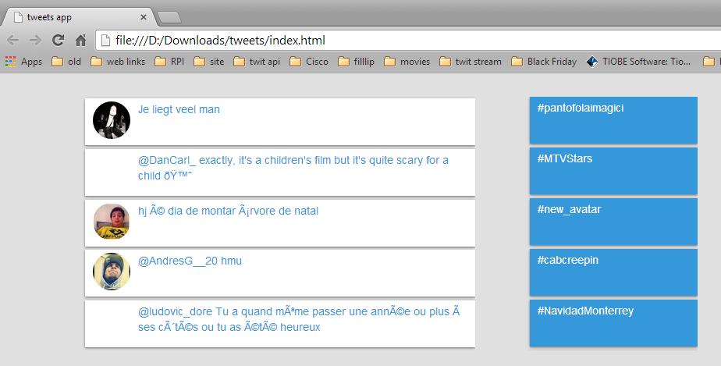

Mobile mode

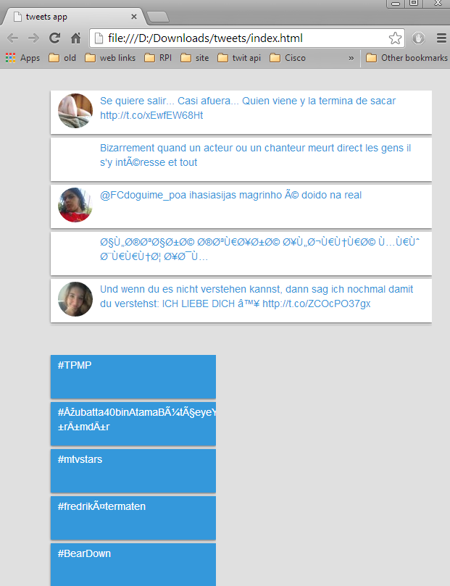

Example for responsive design:

Open <http://www.behance.net/> and resize the browser window manually to see different layouts for desktop, tablet and smartphone

Desktop

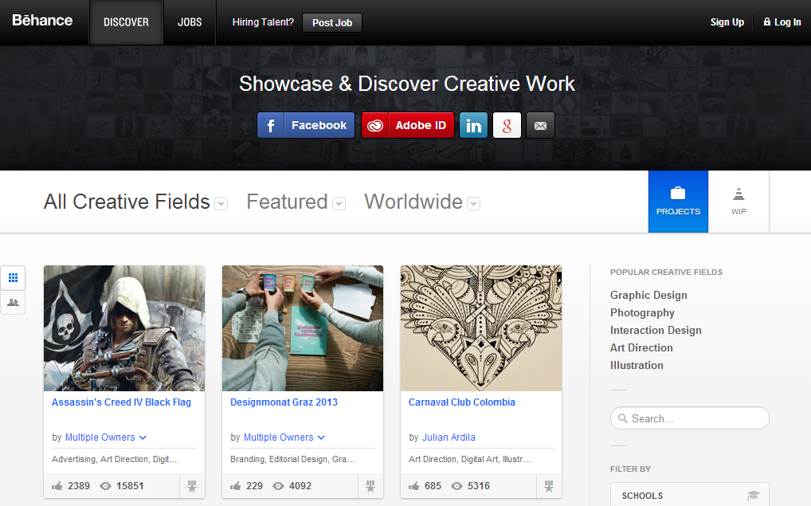

Tablet

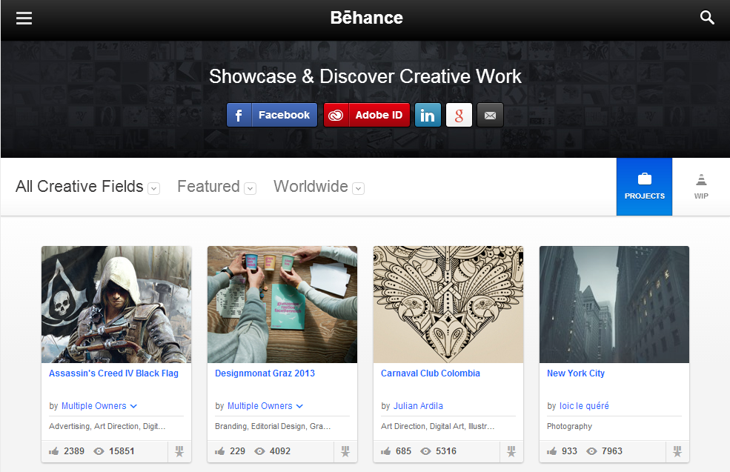

Smartphone

