Student Project Non-Disclosure Agreement (NDA)
Receiving Party (Students): Haroon Sajjad, Hammaad Butt, Muhammad Faryad, Umer Iqbal, Abdul Butt, Bushra Habib
- Purpose
The Receiving Party may have access to confidential information, data, software, or systems (the “Work”) while undertaking a student project. This Agreement ensures the confidentiality and protection of such information and sets out the obligations regarding intellectual property and publication.
- Confidential Information
“Confidential Information” includes:
  - All non-public information regarding the Work, including software, systems, documentation, business processes, or client data.
  - Any data or materials labelled as confidential or reasonably understood to be confidential.
The Receiving Party agrees to:
  - Use Confidential Information only for the purpose of the project.
  - Keep it strictly confidential and not disclose it to anyone outside the project team without written permission.
  - Follow data protection laws (e.g., GDPR) if handling personal data.
  - Return or securely delete all Confidential Information after the project ends or upon request.
- Intellectual Property
  - Any IP created by students during the project (“Foreground IP”) is owned by Client.
  - Students waive moral rights (e.g., to be identified as author) in Foreground IP in favour of the Client.
  - Students may not use Foreground IP outside the project without prior written consent.
- Publication and Communication
  - Any drafts of reports, papers, or presentations relating to the Work must be submitted to the Client for review before release.
  - Client may request:
o Modifications or deletions to protect IP or confidential information o Delay of publication up to [e.g., 18 months] for IP protection
- Duration
  - Confidentiality obligations continue indefinitely unless formally released in writing.
- Legal
  - This Agreement is governed by the laws of [Jurisdiction, e.g., England & Wales].
  - Breach may result in disciplinary action and/or legal consequences.
- Signatures
Receiving Party (Students):
Names: Haroon Sajjad, Hammaad Butt, Muhammad Faryad, Umer Iqbal, Abdul Butt, Bushra Habib

Signatures: 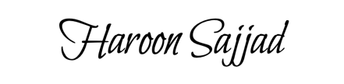 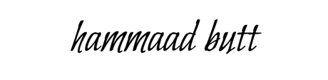 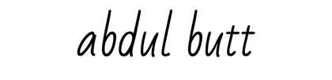

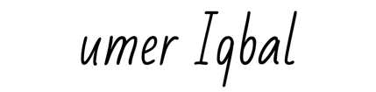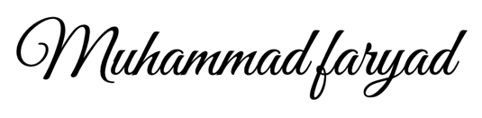

Date: 12/02/26

