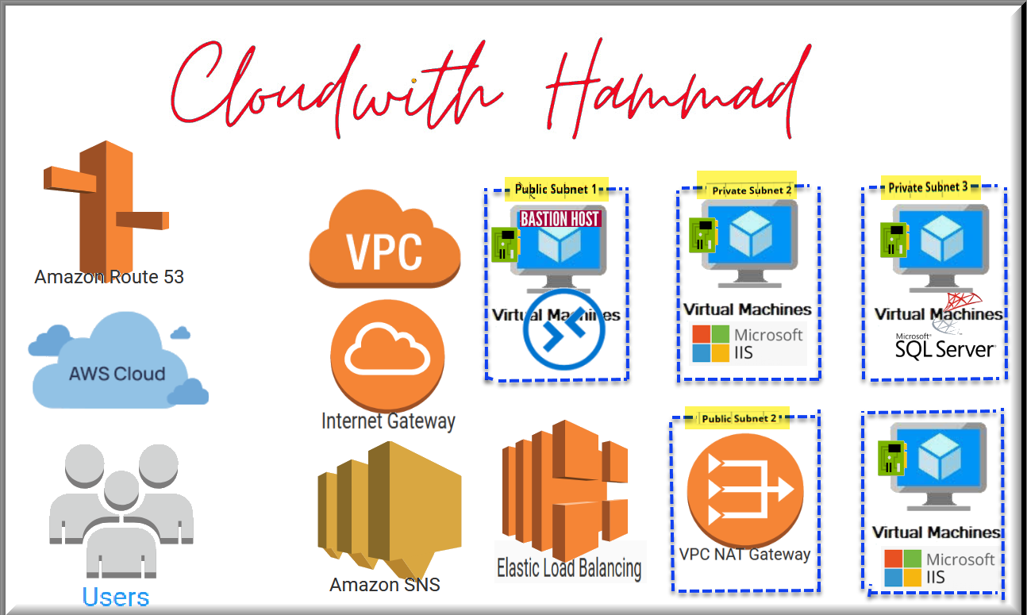

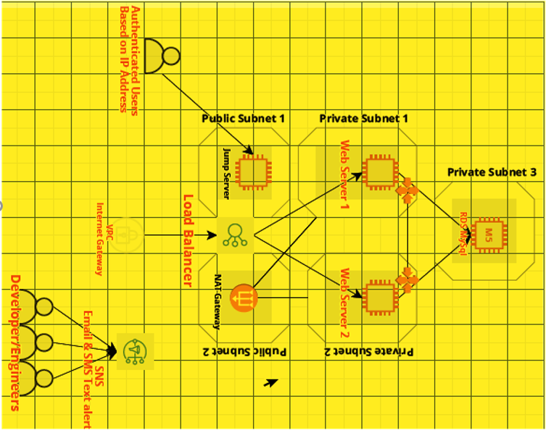

**Objective:** Deploy Web Application on the Amazon EC2 Windows instances with Elastic Load Balancer in front of web application servers & database. Use two Availability Zones for provision of two web application servers in separate private subnets and configure them for high availability.

**Note: Make use of Name Tags on each resource for identification**

**Region: North Virginia / Ohio only**

1. This deployment should include VPC with 2 Public & 3 Private subnets (**2 For WebSRV 1 For RDS**),Internet/NAT Gateway along with 1 CIDR block.

1. Create 2 EC2 Windows instances on private subnet and install IIS.(**Default Site should open on local host**)

1. Create an Internet facing **Elastic load balancer** along with **ELB Security Group** and add both EC2 Instances in the **Target Group** so that an internet user should be able to open http web server page (**Port 80**).

1. Create a separate **Security Group (SG**) for **EC2** to allow web traffic from **ELB** only.

1. Web servers should be accessible via **Bastion host** only.

1. Create **MySQL RDS** which should be accessible via web servers (**Just install MYSQL Client for Connectivity**).

1. You should receive notifications via Email/SMS.

1. Website should be accessible **via yourname.sherdilitacademy.net**

**Hint:** ELB, EC2, VPC, RDS, SNS & Route53

**Deployment time:** 2.5 Hours