QA Test Agent: Business Workflow
Automated testing of Redmine tasks for Rolustech projects (Savostore first)
Version 1.0, 8 Oct 2026. Owner: Sidney Karanja. Prepared by test tasks savostore.

1. Purpose
Testing a Redmine task by hand is slow and repetitive. A tester reads the task, its "Test Cases" child task and every comment, works out missing preconditions, finds the right environment and logins, clicks through the portal and the CRM, writes down numbers before and after, takes screenshots, decides pass or fail for each case, and writes a report with bug drafts. The same questions, like "where is staging?", "which login is the admin?" and "is this a bug or intended?", come up every time.
The QA Test Agent does that work. A tester gives it a Redmine task ID. The agent reads the task, plans the tests, asks once for anything it can't find, waits for a go-ahead, runs the tests in a browser, labels each case with evidence, and produces a report and bug drafts. People stay in control of every decision that matters: what runs, anything that changes data, and anything that gets posted.

2. Who is involved
Role | Responsibilities in the workflow
QA runner (Sidney first) | Starts a run, picks the environment and logins, answers the agent's questions, approves the plan and any data-changing steps, solves a login CAPTCHA when asked, and reviews the report.
Project lead | Reads the report and bug drafts, and decides which bugs go to Redmine.
QA Test Agent | Reads Redmine, plans, finds gaps, runs the browser tests, judges each case, restores what it changed, writes the report and bug drafts, and proposes lessons to remember.
Project onboarder | Adds a new project by writing a project pack (its URLs, apps and known facts). The agent itself needs no changes.

3. End-to-end workflow
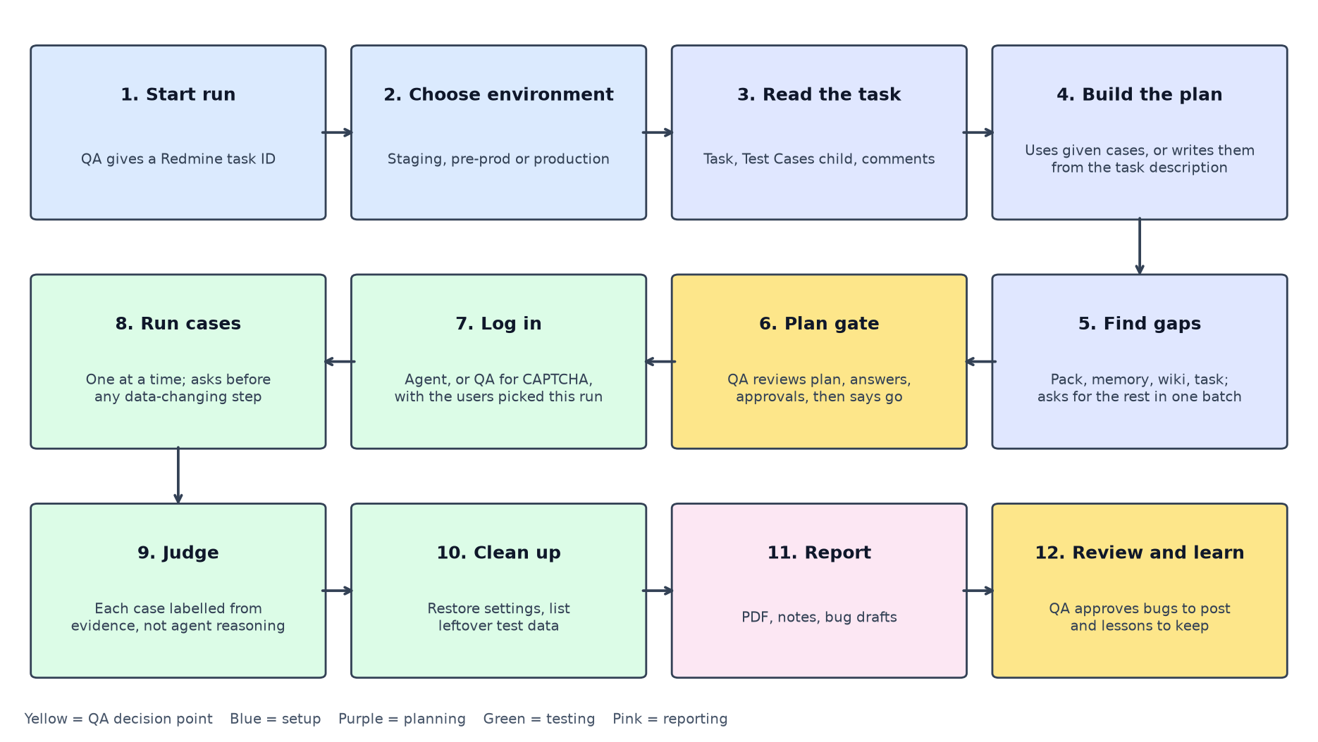
Step | What happens | Who | Output
1. Start run | The tester runs the agent with a Redmine task ID, for example #180966. | QA runner | A run folder for this run
2. Choose environment | The agent asks staging, pre-prod or production (staging is the default). Pre-prod URLs are asked for once and saved. Production needs an explicit yes. | QA runner | Environment for the run
3. Read the task | The agent reads the task, its "Test Cases" child, comments and attachments from Redmine. | Agent | Task details
4. Build the plan | The agent turns each test case into steps and an expected result. If the task has no Test Cases child, it writes cases from the task description, and every expected result must quote the task. Steps it had to add are marked "inferred" with the reason. | Agent | Draft test plan
5. Find gaps | The agent lists what the cases need (URLs, logins and roles, test data, settings). It looks in the project pack, its memory, the Redmine wiki and the task, checks what it finds, and collects the rest as questions. | Agent | One list of questions
6. Plan gate | The tester sees the plan, picks the portal and CRM users for this run, answers the questions (passwords go in a hidden prompt), can edit generated cases, and pre-approves repeat actions where allowed. Nothing runs until they say go. | QA runner | Approved plan
7. Log in | The agent logs in with the chosen users. If the portal shows a CAPTCHA, a visible browser opens, the tester logs in once, and the agent keeps that login for the whole run. | Agent, QA for CAPTCHA | Logged-in sessions
8. Run cases | Cases run one at a time. The agent records values before and after, and takes a screenshot at each check. Before any step that changes data, it asks unless that action was pre-approved. If a page sends the browser to a new site, like Stripe checkout, it asks first. | Agent, QA approvals | Evidence per case
9. Judge | Each case gets one label (see section 6) based on the expected result, the steps actually run and the evidence, not on the agent's own reasoning. A failure that matches a known open bug is reported as "still present: bug N". | Agent | Label and note per case
10. Clean up | The agent puts back any setting it changed, checks the restore, and lists test data it created. If something is still changed at the end, even after a failed case, it offers to put it back. | Agent, QA confirms | Clean environment and leftover list
11. Report | A PDF report with summary counts, each case's steps, values and screenshots, a plain-English note for every non-pass, and bug drafts. | Agent | Report and bug drafts
12. Review and learn | The tester reviews the report, approves which bugs to post (one by one), approves generated cases to post, and approves lessons for the agent to remember next time. | QA runner, project lead | Posted bugs and saved lessons

4. Decision points and approvals
The agent decides alone only when the action is read-only. Everything else goes through a person.
Action | Staging | Production
Reading pages and Redmine, logging in | Allowed | Allowed
Creating test orders, paying with the Stripe test card, moving order status | Asks first, or pre-approved for the run at the plan gate | Asks before every single action; nothing can be pre-approved; no real payments unless the tester says so
Changing admin settings (for example a threshold) | Asks before each change; always restored at the end | Asks before each change; must be restored
Going to a site outside the run's own URLs (for example a payment page) | Asks once, then allowed for the rest of the run | Same
Posting bugs or generated test cases to Redmine | Only after the tester approves each item | Same
Emailing the report | Only to the tester's own inbox unless they confirm another recipient | Same

5. What the tester provides
- Every run: the Redmine task ID.
- Every run: the environment and the portal and CRM users. Pressing Enter keeps the last ones used.
- First time for a new user: a password, entered in a hidden prompt and stored on the laptop only under that user's name.
- When the agent can't find something: answers to the gap questions, for example which client is "exempt" or which order to use. Confirmed answers are saved with their source so they aren't asked again.
- During the run: approvals at the plan gate and before data-changing steps, and a manual login if a CAPTCHA appears.

6. Result labels in plain English
Label | What it means for the business
PASS | The app did what the test case expects, and there's evidence.
FAIL | The app did something different. The report shows expected vs actual numbers and a screenshot. This is a likely bug.
PARTIAL | Some checks in the case passed and at least one failed or couldn't be checked.
BLOCKED | The app or environment stopped the test, for example a missing login, a missing admin role, only M-Pesa offered, or a skipped CAPTCHA.
NOT VERIFIED | The steps ran but the result can't be seen from the browser, for example webhooks or background jobs.
SKIPPED | Not run, by the tester's choice or because a needed earlier case was skipped.
AGENT INCOMPLETE | The agent itself broke down on this case (model reply, crash, ran out of room or time). It says nothing about the app and never counts as a bug. Rerun it.

Every label other than PASS comes with a "What this means" note covering what works, exactly where it breaks, the relevant numbers, and why it matters.

7. Exceptions and how they are handled
Situation | What the agent does | What the tester does
Model server (ai.rolustech.com) not reachable | Checks it before starting; if it drops mid-run, stops with a one-line message | Reconnect to the office network or VPN and rerun
Login shows a CAPTCHA | Opens a visible browser and waits | Log in once and press Enter; skipping marks those cases BLOCKED
A found login lacks the needed role | Raises it as a question at the plan gate | Give a login with the right role
Task has no Test Cases child | Writes cases from the task description, labelled as generated | Review and edit them at the gate; approve before posting
Model reply unreadable or too long | Repairs or retries up to 3 times; otherwise marks that case AGENT INCOMPLETE and carries on | Rerun the incomplete cases
Payment method can't be tested from the browser (for example M-Pesa) | Marks the case NOT VERIFIED or SKIPPED with the reason | Decide whether to test it by hand
Run interrupted | Can resume from the first unfinished case | Use resume, or start a fresh run if logins changed

8. Guardrails
- Nothing runs until the tester says go.
- Nothing is posted to Redmine or emailed without approval of each item.
- Passwords are never typed into chat or written to reports, memory or logs.
- The browser stays on the run's own sites unless the tester allows another.
- Settings are always restored, and leftover test data is listed.
- Each project's memory stays with that project.
- The agent never logs out of shared sessions.

9. Commands at a glance
Command | Use
python -m agent_tester check | Checks the model server and Redmine are reachable
python -m agent_tester test <task> --dry-run | Shows the plan and questions without running anything
python -m agent_tester test <task> | Full run (add --env pre-prod to skip the question, --headed to watch the browsers)
python -m agent_tester rerun <task> --cases TC2,TC5 | Reruns chosen cases with the existing plan
python -m agent_tester resume | Continues an interrupted run

Run from /var/www/html/qa-agent with the virtual environment active.

10. How success is measured
- Time per task compared with testing by hand.
- How often the agent's labels agree with a human review, and how often the tester overrides them (should fall).
- Questions asked per run (should fall as memory fills).
- Unnecessary approval prompts.
- Lessons reused across runs.

11. Open business decisions
- Whether production testing is allowed in v1, and with which accounts.
- Pre-prod URLs for Savostore.
- Whether the devs can turn off reCAPTCHA on staging or switch it to Google's test key, so no one has to log in by hand.
- Which project is onboarded second.
- Whether milestone emails are wanted, or only the final report.

