1) Read the readme.txt before running 2) Log in with the admin account

You can either register for a user account, Username: Admin, Password: password

login as an already registered user, or as a guest

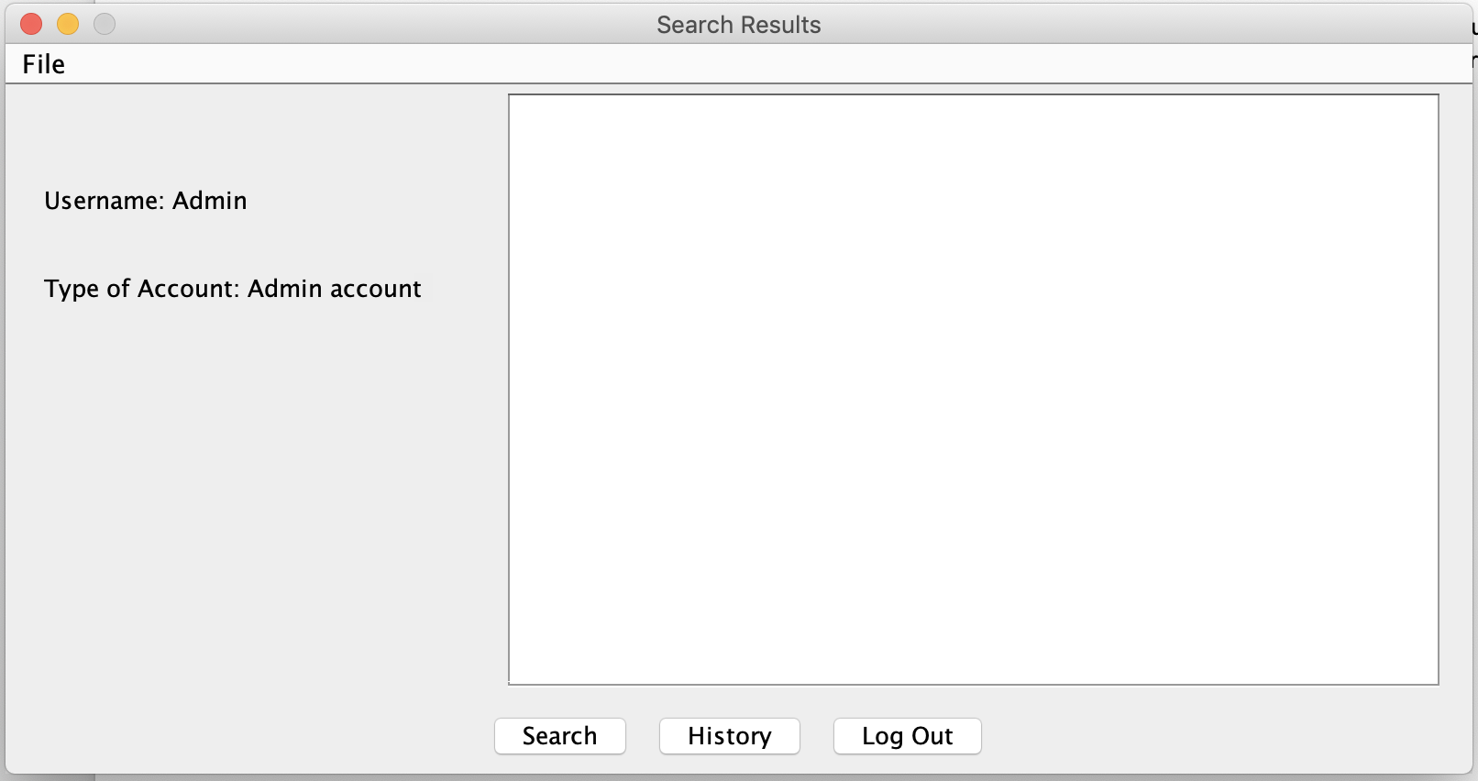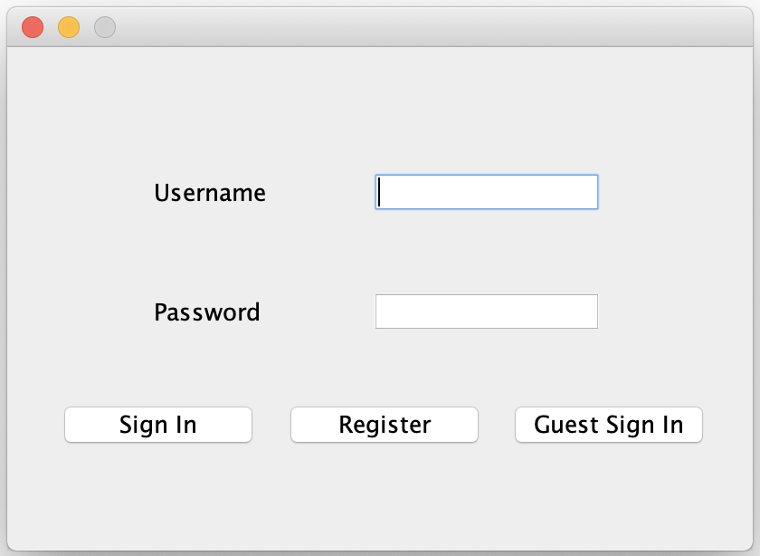

3) Click the search button to see this popup 4) Anything you enter, will be queried through webstore.com and be displayed on your screen

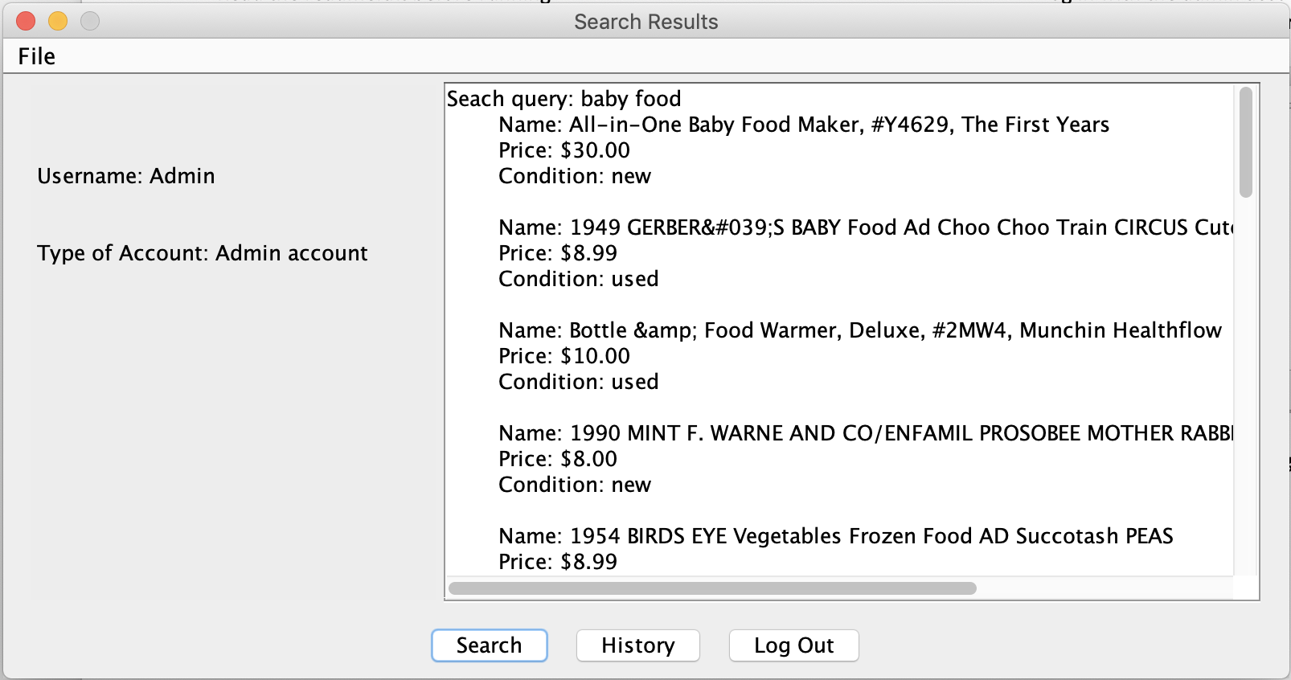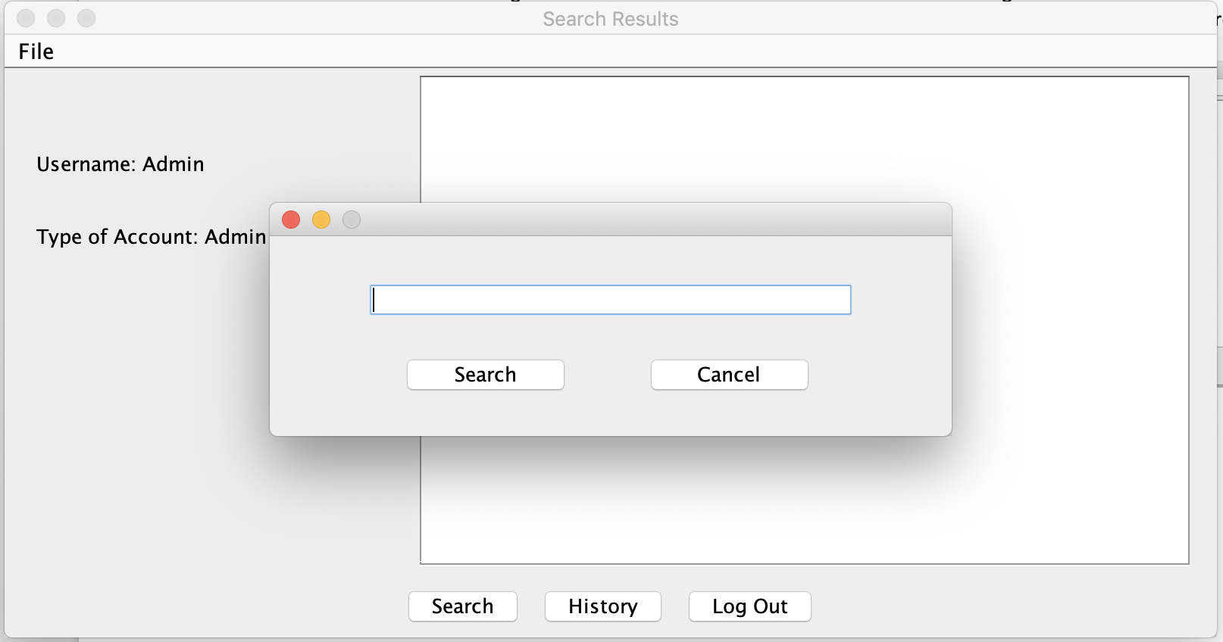

5) If a search is that made that is yet in the database, 6) Once you click yes, the image should be

you will be asked if you want to download an image downloaded in the folder the files are in

of the first item in the most recent auction search you

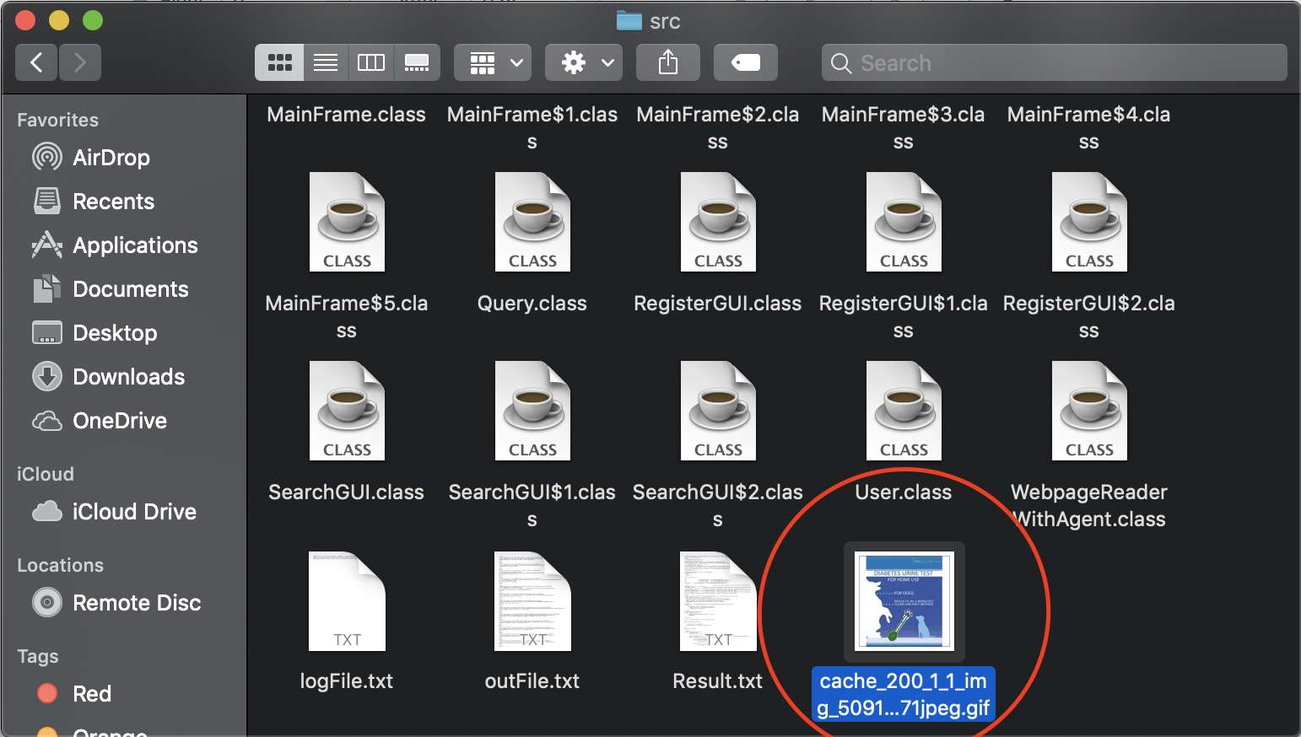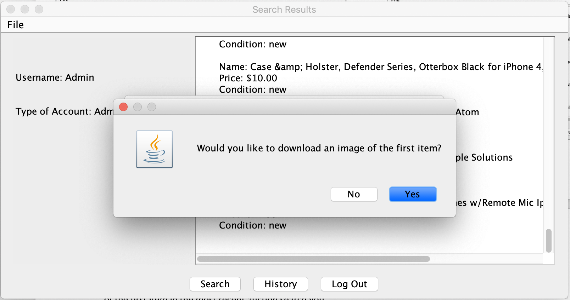 made

7) Every search you make will be added into the database 8) You can delete any of the searches you see in your

even if the program crashes/closes, you can see all your search history by clicking delete and following through

searched history by clicking history, but if you’re admin, and entering what you want to delete

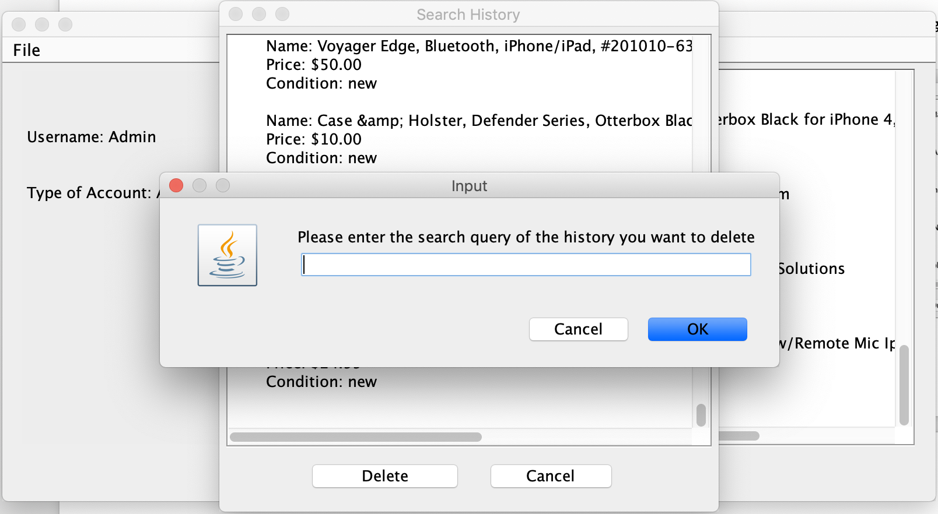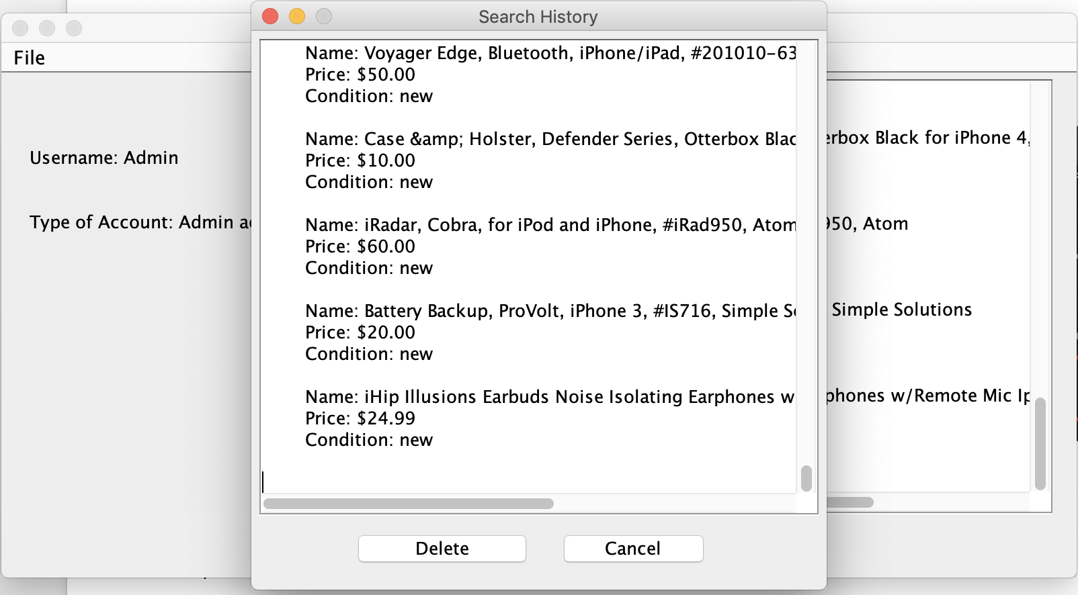 you can see everyones

9) You can also read in a file using the menu button

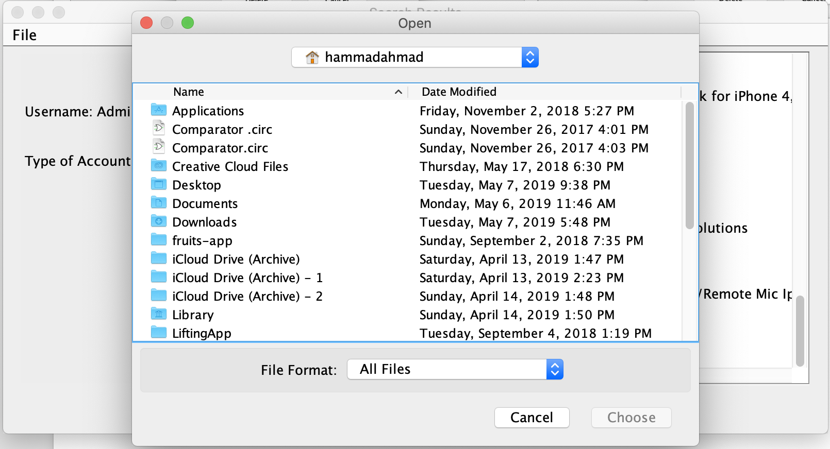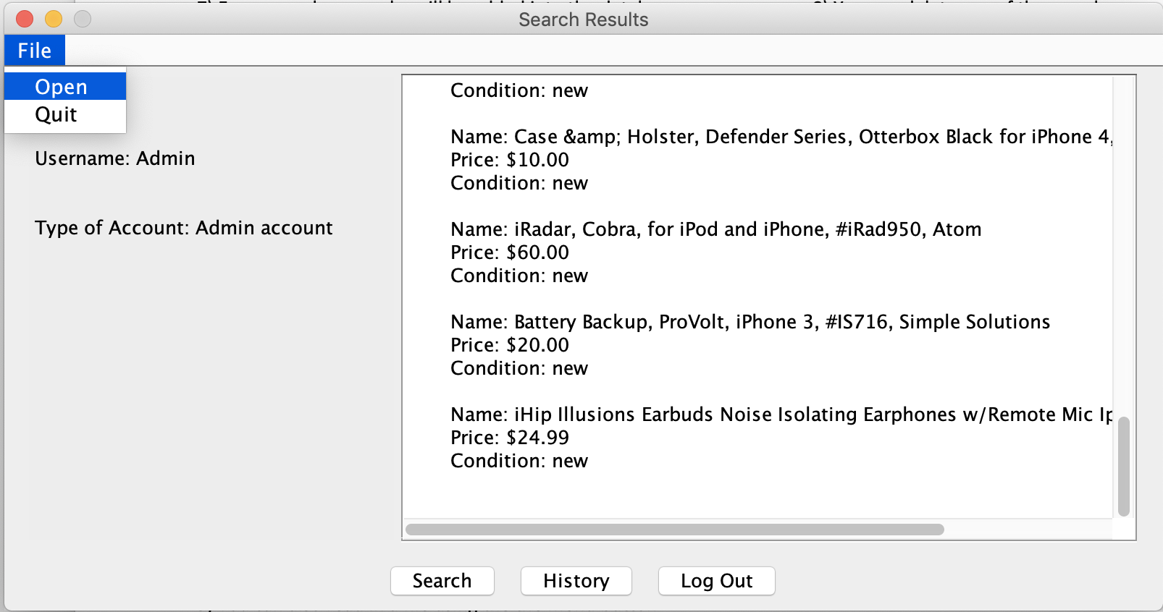

10) Log out once done, or when you want to switch your account