I am going to use SQL database for my web application. I am creating a crud application and I think relational database would be best for this and SQL is one of the famous relational databases.

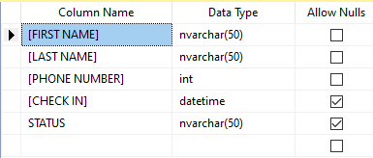

The above image is the database structure for my web application. I haven’t added any primary key to the table because I will handle this in the code to make First Name, Last Name, and Phone Number as primary key and the code will not allow the user to enter any duplicate records. The Check in and Status can be null because it will only be populated when a customer checks in. The Check In column will store datetime when the customer is checked in. The Status will be updated to waiting when a customer is waiting in the queue and it will be updated to in progress when a customer is getting the service. The Check in and Status columns will become null when a customer is checked out from the queue. The username and password I plan to create for the dB is:

User: test

Pass: test

Update to MVP: I am going to add an ID column to the current table which will be the primary key of the table. Before I did not create a primary key for the table but now this will take care of that.

Stretch Feature (After MVP): 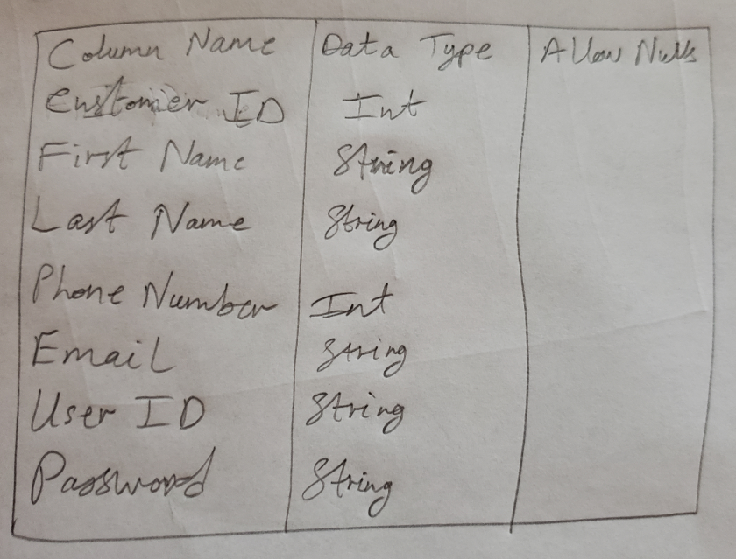

Adding the above new table to handle the Customer side data. Customer will enter their data into this database which will be called using a sql join statement in the grid view.