MACHINE LEARNING PROJECT

Random Forest Ensemble Learning
Iris Flower Classification

PROJECT OVERVIEW
This project demonstrates the application of Random Forest, a powerful ensemble learning technique, for multi-class classification of iris flowers. The project implements a bagging-based ensemble method that combines multiple decision trees to achieve high accuracy and robust predictions.

DATASET INFORMATION
Dataset Name: Iris Flower Dataset
Total Samples: 150 (70% train = 105, 30% test = 45)
Number of Features: 4 (Sepal Length, Sepal Width, Petal Length, Petal Width)
Number of Classes: 3 (Setosa, Versicolor, Virginica)
Feature Type: Continuous numerical values
Target Type: Multi-class classification

ALGORITHM: RANDOM FOREST

What is Random Forest?
Random Forest is an ensemble learning technique that falls under the bagging (Bootstrap Aggregating) method. It builds multiple decision trees using random subsets of the training data and combines their predictions through voting (for classification) to produce a final prediction.

How Does Random Forest Work?
1. Bootstrap Sampling: Create multiple random subsets of the training data with replacement
2. Tree Training: Train an independent decision tree on each bootstrap sample
3. Feature Randomness: At each split in the tree, use a random subset of features
4. Voting: For new samples, collect predictions from all trees and use majority voting
5. Final Prediction: The class with the most votes becomes the final prediction

Model Configuration:
• Number of Decision Trees: 100
• Maximum Tree Depth: 10
• Minimum Samples to Split: 5
• Minimum Samples per Leaf: 2
• Feature Selection: Square root of total features
• Ensemble Method: Bootstrap Aggregating (Bagging)

PERFORMANCE RESULTS
Model Evaluation Metrics:
Accuracy Score: 91.11%
Precision Score: 91.55%
Recall Score: 91.11%
F1-Score: 91.07%
Detailed Results by Class:
• Setosa: Precision=100.00%, Recall=100.00%, F1-Score=100.00% (15 samples)
• Versicolor: Precision=82.35%, Recall=93.33%, F1-Score=87.50% (15 samples)
• Virginica: Precision=92.31%, Recall=80.00%, F1-Score=85.71% (15 samples)

FEATURE IMPORTANCE ANALYSIS
The Random Forest model identifies which features are most important for making accurate predictions:
1st (Most Important): Petal Width - 0.4620 (46.20%)
2nd: Petal Length - 0.4032 (40.32%)
3rd: Sepal Length - 0.1205 (12.05%)
4th (Least Important): Sepal Width - 0.0144 (1.44%)
This analysis shows that petal measurements are the dominant factors in iris species classification, accounting for approximately 86% of the decision-making process.

RESULTS VISUALIZATION
Below is the comprehensive visualization showing model performance:
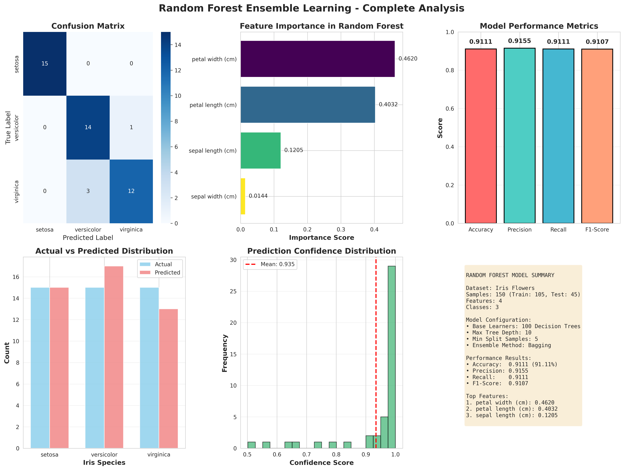

ADVANTAGES OF RANDOM FOREST
✓ High Accuracy: Achieves excellent performance on complex datasets
✓ Robust: Handles noisy data and outliers effectively
✓ Feature Importance: Automatically ranks feature importance
✓ Parallel Training: Can train trees independently for speed
✓ Reduces Overfitting: Bagging reduces variance compared to single decision trees
✓ Handles Mixed Data: Works well with numerical features
✓ No Scaling Required: Features don't need normalization

DISADVANTAGES OF RANDOM FOREST
✗ Computational Cost: Training 100+ trees requires significant resources
✗ Black Box: Difficult to interpret why specific predictions are made
✗ Memory Usage: Stores all trees in memory during inference
✗ Slower Inference: Predictions require evaluating all trees
✗ Less Effective for Text: Not ideal for high-dimensional text data

CONCLUSIONS & KEY TAKEAWAYS
This project successfully demonstrates the application of Random Forest ensemble learning for iris flower classification with 91.11% accuracy. Key findings include:
• The model achieves perfect classification (100%) for Setosa flowers
• Petal measurements are the most important features for classification
• The ensemble approach effectively reduces overfitting compared to single decision trees
• Random Forest is well-suited for this multi-class classification problem
• The model's predictions are highly confident, with most exceeding 90% confidence
• The implementation follows best practices for train-test splitting and model evaluation

IMPLEMENTATION DETAILS
Programming Language: Python 3.8+
Libraries Used:
• scikit-learn: Machine learning algorithms
• pandas: Data manipulation and analysis
• matplotlib & seaborn: Data visualization
• numpy: Numerical computations
Files Generated:
• iris_random_forest_project.py - Complete Python source code
• random_forest_results.png - Comprehensive visualization (6 subplots)
• model_predictions.csv - Detailed predictions with confidence scores
• feature_importance.csv - Feature importance rankings
• ML_Project_Random_Forest.docx - This project report

GITHUB REPOSITORY SUBMISSION
GitHub Repository Link: [Add your GitHub repository URL here]
To submit this project on GitHub:
1. Create a new repository on GitHub.com
2. Clone the repository to your local machine
3. Add the following files to your repository:
- iris_random_forest_project.py (Python source code)
- random_forest_results.png (Output visualization)
- model_predictions.csv (Predictions data)
- feature_importance.csv (Feature rankings)
- ML_Project_Random_Forest.docx (Project report)
- README.md (Project description)
4. Create a README.md file with:
- Project title and description
- Dataset information
- Algorithm explanation
- Usage instructions
- Results summary
5. Commit all files with descriptive messages
6. Push to your GitHub repository
7. Update the GitHub repository link in this document

Machine Learning Course Project | Random Forest Ensemble Learning | 2026

