OASIS INFOBYTE
DATA SCIENCE INTERNSHIP
TASK 3
CAR PRICE PREDICTION
WITH MACHINE LEARNING
Submitted by
HAMMAD ULLAH
Project Report
October 2026

Table of Contents
Section | Report content
1 | Executive Summary
2 | Problem Identification and Objectives
3 | Dataset Collection and Description
4 | Initial Data Inspection and Quality Assessment
5 | Exploratory Data Analysis (EDA) — Target and Distributions
6 | EDA — Fuel, Transmission, Age, Mileage and Brands
7 | Correlation Analysis and EDA Findings
8 | Data Cleaning and Feature Engineering
9 | Missing Values and Modeling Data Quality
10 | Train/Test Split and Leakage Prevention
11 | Preprocessing Pipeline and Baseline Models
12 | Random Forest Cross-Validation
13 | Hyperparameter Tuning with GridSearchCV
14 | Final Test Evaluation and Model Comparison
15 | Actual vs. Predicted Prices and Residual Analysis
16 | Feature Importance and Interpretation
17 | Saving the Model, Limitations and Future Improvements
18 | Conclusion

Note: Page numbering is intentionally omitted from this contents table so it remains robust if the report is opened in different Word versions. The report uses section page breaks for a clear, presentation-ready structure.

1. Executive Summary
This project develops a supervised machine-learning workflow to estimate the selling price of used cars from vehicle specifications and listing attributes. The work uses the CarDekho vehicle dataset supplied in the project notebook and covers exploratory data analysis (EDA), duplicate removal, feature engineering, preprocessing, model benchmarking, cross-validation, hyperparameter search, held-out testing, error analysis, feature importance and model serialization.
The source dataset contained 8,128 rows and 13 columns. After removing exact duplicate rows, 6,926 unique records remained for modeling. The target variable is selling_price. Predictors include vehicle age, kilometres driven, mileage, engine capacity, maximum power, seats, brand, fuel type, seller type, transmission, owner category and mileage unit.
Key result | Observed value | Interpretation
Median selling price | Rs. 400,000 | Half of the deduplicated listings are priced at or below this value.
Mean selling price | Rs. 517,271 | Higher than the median, consistent with a right-skewed price distribution.
Initial Random Forest test MAE | Rs. 71,621 | Average absolute error for the initial model on the held-out test set.
Initial Random Forest test RMSE | Rs. 121,711 | Penalizes larger errors more strongly than MAE.
Initial Random Forest test R² | 0.932 | Strong test-set fit relative to a mean/median-only baseline.
Best GridSearchCV mean CV RMSE | Rs. 176,971.50 | Mean RMSE across five training folds for the selected configuration.
Tuned Random Forest test RMSE | Rs. 125,768 | Slightly worse than the initial model's test RMSE.

Important conclusion: hyperparameter tuning improved the mean cross-validation RMSE from about Rs. 182,039 to Rs. 176,972, but the tuned model did not outperform the initial Random Forest on the held-out test set. The report therefore presents both outcomes rather than claiming tuning was an overall test-performance improvement.

2. Problem Identification and Objectives

Problem statement
Used-car prices vary with age, engine and power specifications, mileage, brand, fuel, transmission and ownership history. Manual estimation can be inconsistent because several attributes interact and prices are highly dispersed. The project treats price estimation as a regression problem: given the known attributes of a used car, predict its selling_price as a continuous numeric value.

Objectives
- Understand the dataset's structure, quality, distributions and relationships using EDA.
- Remove exact duplicates and normalize selected text/categorical fields.
- Convert vehicle specifications stored as text with units into numeric features.
- Build a reusable preprocessing pipeline that imputes missing values and encodes categories.
- Compare simple and tree-based regression models against a baseline.
- Assess Random Forest stability using five-fold cross-validation.
- Search a defined hyperparameter grid using GridSearchCV.
- Evaluate the original and tuned model on the held-out test set using MAE, RMSE and R².
- Interpret prediction errors and feature importance, then save the fitted pipeline.

Success criteria
A useful model should beat the median baseline, show acceptable validation stability, and have interpretable error metrics in the target's currency. A high R² alone is not sufficient: MAE and RMSE are also needed to communicate the scale of prediction errors.

3. Dataset Collection and Description
The notebook uses the public CarDekho-style vehicle details dataset named “Car details v3.csv”. The notebook loads the CSV into a pandas DataFrame called df. This report is based on the provided notebook and its saved outputs; no additional external dataset or unrecorded source has been introduced.
Attribute | Description / role
name | Vehicle listing/model name; used to derive brand.
year | Manufacturing year; transformed into car_age.
selling_price | Target variable to predict, in rupees.
km_driven | Reported kilometres driven.
fuel | Fuel category such as Diesel, Petrol, CNG or LPG.
seller_type | Individual, Dealer or Trustmark Dealer.
transmission | Manual or Automatic.
owner | Ownership category.
mileage | Mileage stored as text with a unit.
engine | Engine capacity stored as text, e.g. “1248 CC”.
max_power | Maximum power stored as text, e.g. “74 bhp”.
torque | Torque specification stored as inconsistent text; not used in the initial model.
seats | Number of seats.

The original table has 8,128 rows and 13 columns. Exact duplicates were found and removed before modeling. The deduplicated modeling dataset contains 6,926 rows and 19 columns after feature engineering.

Target and units
Selling prices are recorded as numeric values in rupees. The observed target range is Rs. 29,999 to Rs. 10,000,000. This wide range matters for model evaluation because errors on high-priced vehicles can substantially increase RMSE.

4. Initial Data Inspection and Quality Assessment
The initial inspection examined column names, data types, sample records, missing-value counts, exact duplicate rows, categorical values and numeric ranges. This step was important because vehicle specifications such as mileage, engine and power were not clean numeric columns; they contained values and units together.
Quality check | Observed finding | Treatment / implication
Original shape | 8,128 rows × 13 columns | Starting point for data cleaning.
Exact duplicate rows | 1,202 | Removed before modeling; 6,926 rows remained.
Torque missing | 222 (about 2.73%) | Torque was excluded from the initial model due to inconsistent formatting.
Seats missing | 221 in original inspection; 208 after deduplication | Numeric median imputation in the pipeline.
Engine missing | 221 originally; 208 after deduplication | Extract numeric CC value; impute median.
Mileage missing | 221 originally; 208 after deduplication | Extract numeric portion; impute median.
Max power missing | 215 originally; 206 after deduplication | Extract numeric BHP value; impute median.
Year range | 1983–2020 | Age derived using 2020 as reference year in this dataset.
Price range | Rs. 29,999–10,000,000 | Strong spread; investigate high-error cases rather than automatically dropping outliers.
Kilometres driven | 1–2,360,457 | Wide range; check errors and unusual records.

The duplicate count is a meaningful data-quality issue: repeated records can bias descriptive statistics and allow effectively identical examples to appear in different partitions. Deduplication before splitting reduces that risk.

5. Exploratory Data Analysis (EDA): Target and Distributions
EDA was used to understand the target distribution before choosing evaluation metrics or modeling strategies. The saved notebook's charts include a selling-price histogram, a log-scale view of prices, a car-age distribution and categorical comparisons.

Selling-price summary
Statistic | Value
25th percentile | Rs. 250,000
Median | Rs. 400,000
Mean | Rs. 517,271
75th percentile | Rs. 633,500
Maximum | Rs. 10,000,000

The mean is substantially above the median, which indicates right-skew: a relatively small number of expensive vehicles pull the average upward. The interquartile range runs from Rs. 250,000 to Rs. 633,500. The high maximum indicates a long upper tail.

Car age
The median car age is six years when age is calculated as 2020 minus the manufacturing year. The price histogram and age plot help motivate age as a predictor. The 2020 reference year is specific to the dataset's observed maximum year and should be revisited if the model is deployed on newer listings.

6. EDA: Fuel, Transmission, Age, Mileage and Brands

Fuel type distribution and price
Fuel | Listings | Median price | Mean price
Diesel | 3,755 | Rs. 520,000 | Rs. 639,728
Petrol | 3,077 | Rs. 310,000 | Rs. 375,689
CNG | 56 | Rs. 320,000 | Rs. 300,500
LPG | 38 | Rs. 195,500 | Rs. 200,421

Diesel listings have a higher median selling price than petrol listings in this dataset. CNG and LPG have much smaller sample sizes, so their medians are less stable and should be interpreted cautiously. These are descriptive associations, not proof that fuel type causes higher or lower prices.

Transmission and ownership
Transmission | Listings | Median price | Mean price
Automatic | 584 | Rs. 850,000 | Rs. 1,309,712
Manual | 6,342 | Rs. 385,000 | Rs. 444,299

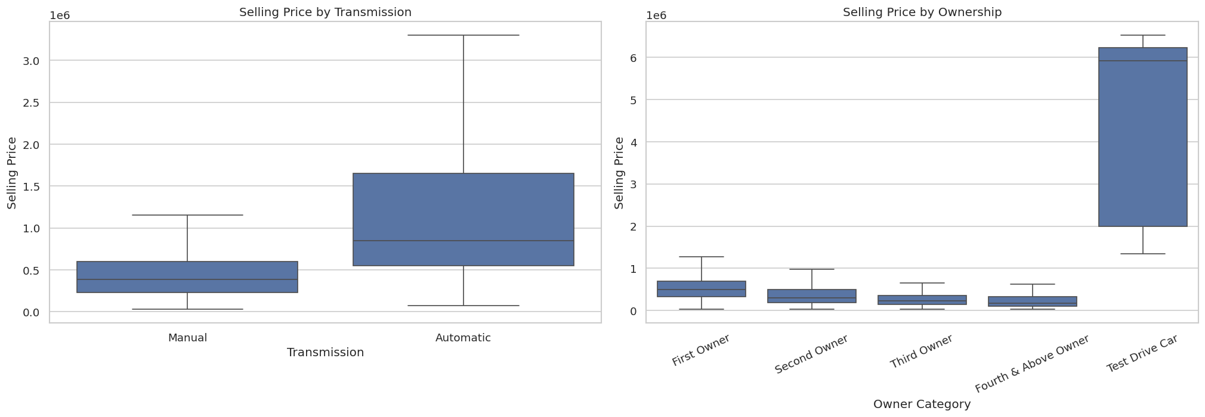
Figure 3. Selling price comparisons by transmission and ownership category.
Automatic cars show a higher median and mean price in the sample. This may partly reflect the mix of brands, vehicle age and segment, so it should not be interpreted as an isolated causal effect.

7. EDA: Age, Mileage, Brands and Correlation
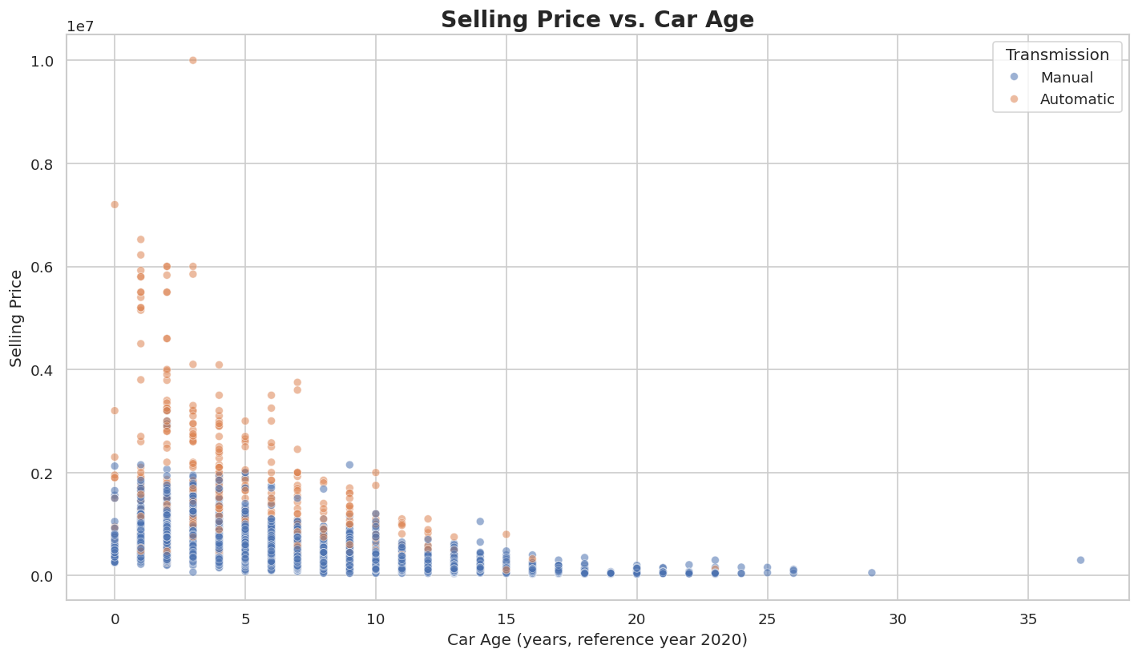
Figure 4. Selling price versus car age, coloured by transmission.
The age scatter plot shows a general downward relationship between vehicle age and selling price, although prices remain dispersed at most ages. Newer vehicles tend to be priced higher, but brand and specifications create substantial variation.
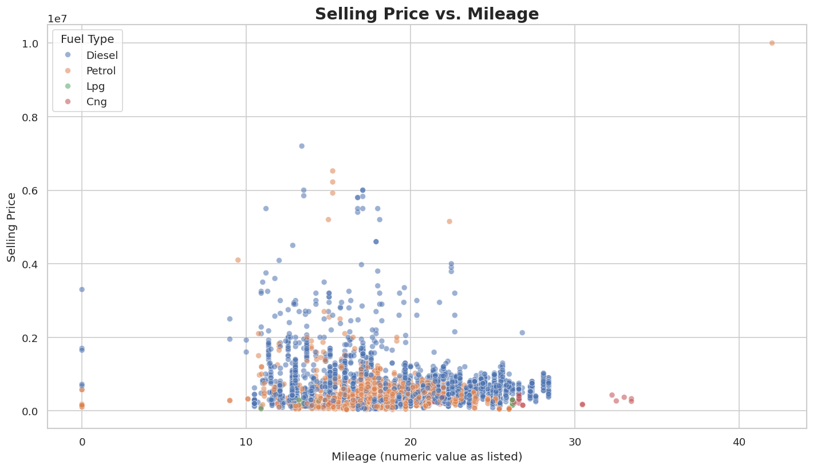
Figure 5. Selling price versus extracted mileage, coloured by fuel.
Mileage is stored in strings such as “23.4 kmpl” and “17.3 km/kg”. For EDA, the numeric component was extracted so the relationship could be visualized. The two units are not identical, so the model preserves mileage_unit as a separate categorical feature.
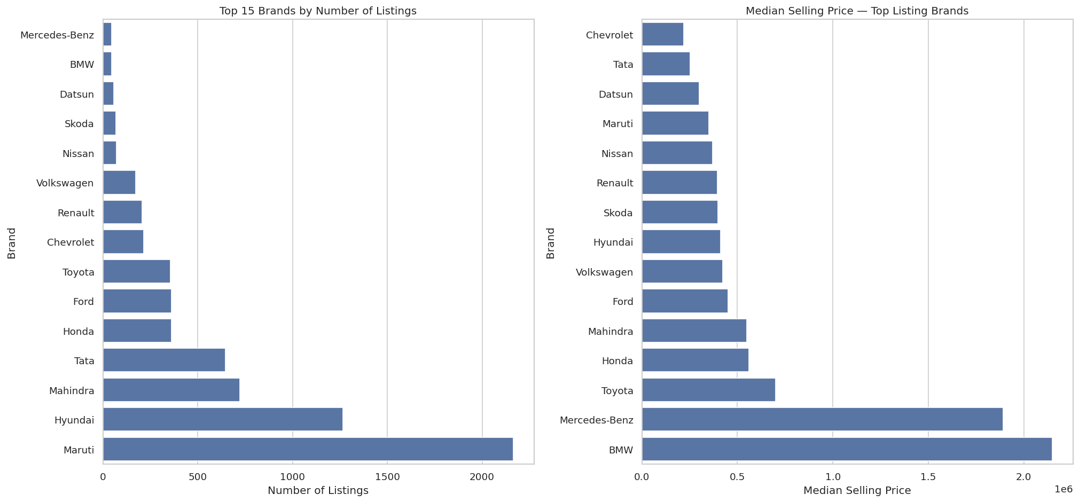
Figure 6. Top brands by listing count and median selling price.
Maruti had 2,165 listings and Hyundai 1,267 in the notebook's brand summary. Some premium brands show high median prices but much smaller listing counts; their estimates should be interpreted with sample size in mind.

8. Correlation Analysis and EDA Findings
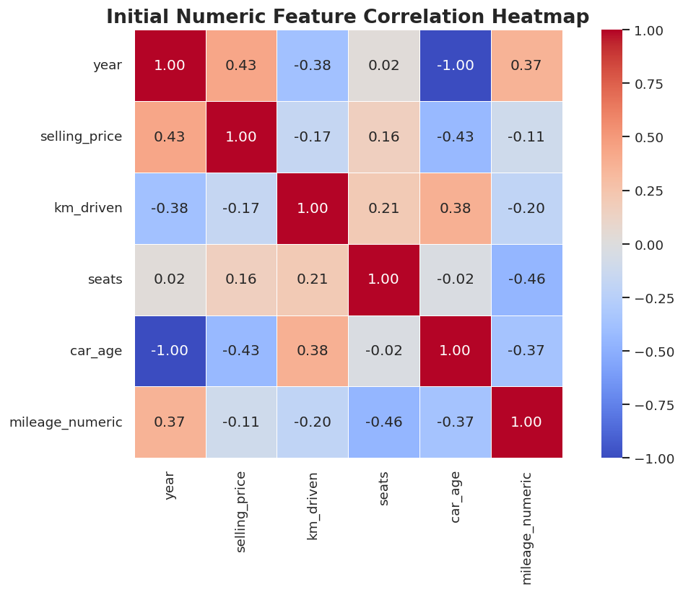
Figure 7. Initial numeric correlation heatmap.
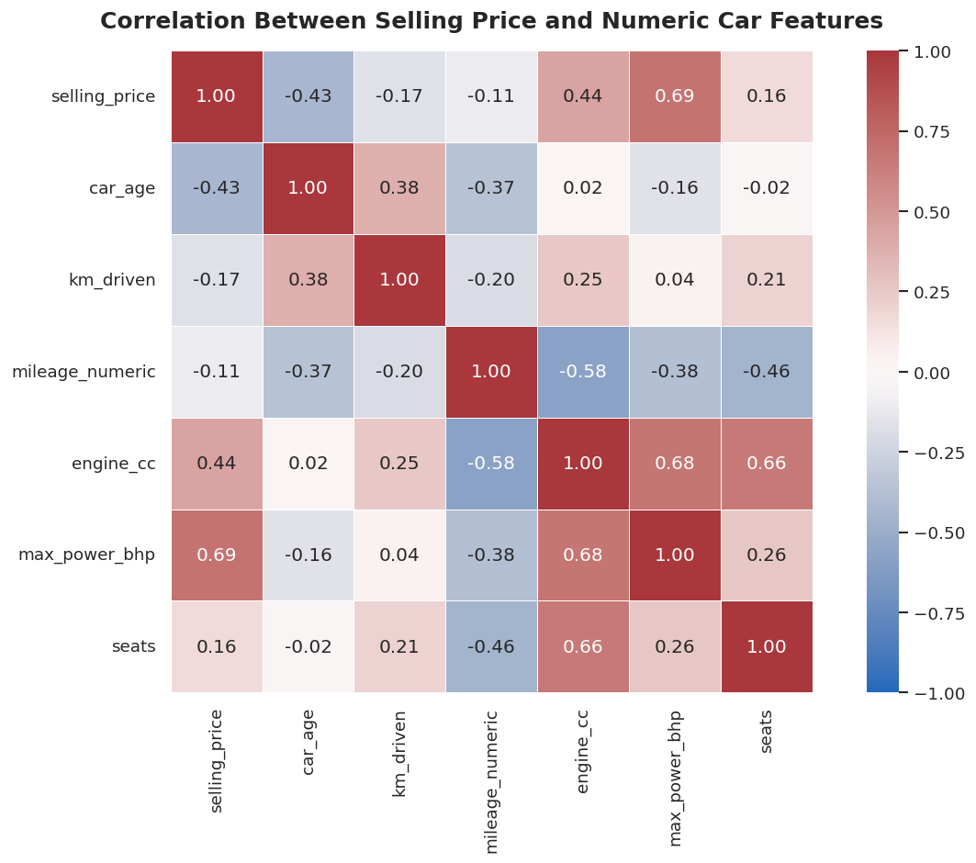
Figure 8. Enhanced correlation heatmap after numeric feature extraction.
Numeric feature | Correlation with selling price
max_power_bhp | 0.692
engine_cc | 0.443
car_age | -0.433
km_driven | -0.166
seats | 0.158
mileage_numeric | -0.108

Maximum power has the strongest linear correlation with selling price among the numeric features shown, followed by engine capacity. Car age has a moderate negative correlation, consistent with older cars generally selling for less. Kilometres driven and mileage show weaker negative correlations in this dataset.
Year and car_age have correlations of opposite sign because car_age was calculated directly from year using a fixed reference year. They are redundant representations of the same information, so the modeling feature set uses car_age and excludes year.
Correlation measures linear association and does not capture all interactions. Tree-based models can learn non-linear thresholds and interactions, which may explain why they outperform the linear regression model.

9. Data Cleaning and Feature Engineering

Duplicate removal and text normalization
The modeling table was created from the original DataFrame by removing exact duplicate rows. Whitespace was stripped from text fields, and known category values were standardized for fuel, seller type, transmission and owner. This reduces accidental category duplication caused by capitalization or spacing.

Brand extraction
Brand was derived from the listing name. The notebook uses a list of known multiword brand names (including Mercedes-Benz, Land Rover, Force Motors, Ashok Leyland and Rolls-Royce) before falling back to the first word of the name. This avoids splitting certain multiword makes incorrectly, though unusual model-name formats can still require additional rules.

Numeric extraction
New feature | Source | Method
car_age | year | 2020 − year
mileage_numeric | mileage | Extract first numeric value
mileage_unit | mileage | Identify kmpl or km/kg; otherwise Unknown
engine_cc | engine | Extract numeric engine capacity
max_power_bhp | max_power | Extract numeric power value
seats | seats | Convert to numeric type

Torque was not included in the first modeling feature set because its strings are inconsistent. The selected predictors include six numeric features and six categorical features.

Zero and negative values
The extraction check found 15 zero-or-negative mileage values, three zero-or-negative maximum-power values, and no zero-or-negative engine or seat values. These records were identified but not automatically deleted. In a future refinement, these values could be converted to missing after verifying the domain meaning.

10. Missing Values and Modeling Data Quality
Field | Missing values after extraction | Percentage / note
mileage_numeric | 208 | 3.00%
engine_cc | 208 | 3.00%
max_power_bhp | 206 | 2.97%
seats | 208 | 3.00%
selling_price | 0 | Target is complete
brand | 0 | No missing values reported
car_age | 0 | No missing values reported
km_driven | 0 | No missing values reported

The modeling dataset contains 6,926 records and 19 columns after feature engineering. The target summary reports a mean of Rs. 517,271, standard deviation of about Rs. 519,767, median of Rs. 400,000 and maximum of Rs. 10,000,000.

Imputation strategy
Numeric missing values are imputed with the median, which is robust to skewed distributions and extreme prices/specifications. Categorical missing values are imputed with the most frequent category. These imputers are fitted inside the pipeline on training folds only, preventing validation/test statistics from leaking into training transformations.

Categorical imbalance
Fuel counts are dominated by Diesel (3,755) and Petrol (3,077), while CNG and LPG have 56 and 38 listings. Transmission is similarly imbalanced: 6,342 manual listings and 584 automatic listings. Rare categories can produce less stable estimates and should be considered when interpreting feature effects.

11. Train/Test Split and Preprocessing Pipeline
The deduplicated dataset was split into training and test subsets using an 80/20 split with random_state=42. The training set contains 5,540 rows and the test set contains 1,386 rows. The target medians were Rs. 400,000 in training and Rs. 409,999 in test.
Partition | Rows | Purpose
Training | 5,540 | Fit preprocessing and model parameters; perform cross-validation and tuning.
Test | 1,386 | Held-out evaluation after model selection.

Pipeline design
A ColumnTransformer applies different transformations to numeric and categorical fields. Numeric features use median imputation and StandardScaler. Categorical features use most-frequent imputation followed by OneHotEncoder(handle_unknown='ignore'). The preprocessing steps and estimator are wrapped together in a scikit-learn Pipeline.
One-hot encoding converts nominal categories into indicator columns without implying a numeric order. handle_unknown='ignore' allows the pipeline to process a category not observed during training without failing.
The scaler is useful for models sensitive to feature scale, particularly Linear Regression with numeric inputs. Tree models do not generally require scaling, but using a consistent pipeline makes comparisons easier and keeps preprocessing reproducible.

Leakage prevention
The train/test split is performed before model fitting. During cross-validation, the full pipeline is refitted within each fold, so imputation, scaling and category encoding are learned from that fold's training portion. This is preferable to preprocessing the entire dataset before splitting.

12. Baseline Models and Initial Comparison
Four approaches were evaluated: a median DummyRegressor baseline, Linear Regression, Random Forest and Extra Trees. The baseline predicts the training target median and establishes a minimum performance benchmark.
Model | MAE (Rs.) | RMSE (Rs.) | R²
Random Forest | 71,620.889 | 121,710.675 | 0.932
Extra Trees | 75,776.484 | 154,414.171 | 0.891
Linear Regression | 133,059.847 | 261,886.824 | 0.687
Median Baseline | 259,546.730 | 478,963.265 | -0.046

The initial Random Forest was the strongest model on the first test comparison. It substantially reduced MAE and RMSE compared with the median baseline. Extra Trees was the second-best model, while Linear Regression performed less well, suggesting that non-linear patterns in the data are important.

Metric interpretation
- MAE is the average absolute difference between predicted and actual price, in rupees.
- RMSE is the square root of mean squared error and penalizes large mistakes more heavily.
- R² compares model performance with predicting the test-set mean; a negative value indicates performance worse than that reference under the R² definition.
Because the price distribution is skewed and includes expensive vehicles, RMSE can be influenced by a small number of large errors. MAE is a complementary, more directly interpretable measure of typical absolute error.

13. Random Forest Cross-Validation
Five-fold KFold cross-validation was run on the training set with shuffling and random_state=42. Each fold uses a different validation subset while fitting on the remaining folds. The preprocessing pipeline is refitted in each fold.
Fold | Validation MAE (Rs.) | Validation RMSE (Rs.) | Validation R² | Training R²
1 | 87,760.350 | 195,547.304 | 0.901 | 0.958
2 | 81,416.612 | 166,356.720 | 0.917 | 0.961
3 | 82,632.997 | 160,747.073 | 0.888 | 0.967
4 | 79,448.000 | 157,005.553 | 0.871 | 0.966
5 | 82,221.416 | 230,537.107 | 0.804 | 0.973

Metric | Mean across folds | Standard deviation
MAE | Rs. 82,695.875 | Rs. 2,759.100
RMSE | Rs. 182,038.751 | Rs. 27,786.666
R² | 0.876 | 0.039

The validation MAE is relatively consistent across folds. RMSE varies more, especially in fold 5, indicating that some validation partitions contain more or larger errors. Training R² values are higher than validation R², which is consistent with some overfitting; however, the gap should be interpreted alongside the validation metrics and target distribution.

14. Hyperparameter Tuning with GridSearchCV
GridSearchCV searched 24 hyperparameter combinations over five folds, producing 120 model fits. The optimization metric was negative RMSE, which scikit-learn maximizes; the report converts it back to positive RMSE for interpretation.
Hyperparameter | Values explored
n_estimators | 100, 200
max_depth | None
Hyperparameter | Values explored
n_estimators | 100, 200
max_depth | None, 20
min_samples_split | 2, 5
min_samples_leaf | 1, 2, 4

Best configuration
Parameter | Selected value
model__max_depth | None
model__min_samples_leaf | 1
model__min_samples_split | 5
model__n_estimators | 200

The best mean five-fold CV RMSE was Rs. 176,971.50, compared with Rs. 182,038.75 for the initial cross-validation configuration. This is an improvement of about 2.8% in cross-validation RMSE.
The selected model was automatically refitted on all training data by GridSearchCV. The tuning table also showed a close cluster of top candidates, so the numerical improvement is modest rather than a dramatic change. The final choice should consider held-out test results as well as cross-validation.

Why these parameters matter
- n_estimators controls the number of trees; more trees often stabilize predictions but increase runtime.
- max_depth limits tree complexity; None allows trees to expand until other stopping conditions apply.
- min_samples_split sets the minimum samples needed to split a node.
- min_samples_leaf sets the minimum samples allowed in a leaf and can reduce overly specific rules.

15. Final Test Evaluation and Model Comparison
The original and tuned Random Forest were evaluated on the same 1,386-row test set. These metrics are the final held-out results recorded in the notebook.
Model | MAE (Rs.) | RMSE (Rs.) | R²
Original Random Forest | 71,620.889 | 121,710.675 | 0.932
Tuned Random Forest | 71,706.406 | 125,768.287 | 0.928

The tuned model did not improve the test-set metrics: its MAE was slightly higher, RMSE was higher by about Rs. 4,058, and R² was slightly lower. This does not invalidate GridSearchCV; it means the best average cross-validation configuration did not transfer into a better score on this particular held-out test split.
For a report that prioritizes measured test performance, the initial Random Forest is the stronger model among these two on this test split. For reproducibility, both model results should be reported, and the selection rationale should be stated clearly. The notebook's final saved artifact is the tuned pipeline; if the intention is to save the best-performing model by test metrics, the artifact should instead save the original pipeline, while avoiding repeated selection on the test set in future iterations.

Evaluation caution
The initial model was selected after looking at test results among several models. In strict experimental practice, repeated decisions based on the test set can make the test score optimistic. Cross-validation should guide selection, with the test set reserved for a single final report. The current notebook's values are reported faithfully rather than reinterpreted as a fully untouched benchmark.

16. Actual vs. Predicted Prices and Residual Analysis
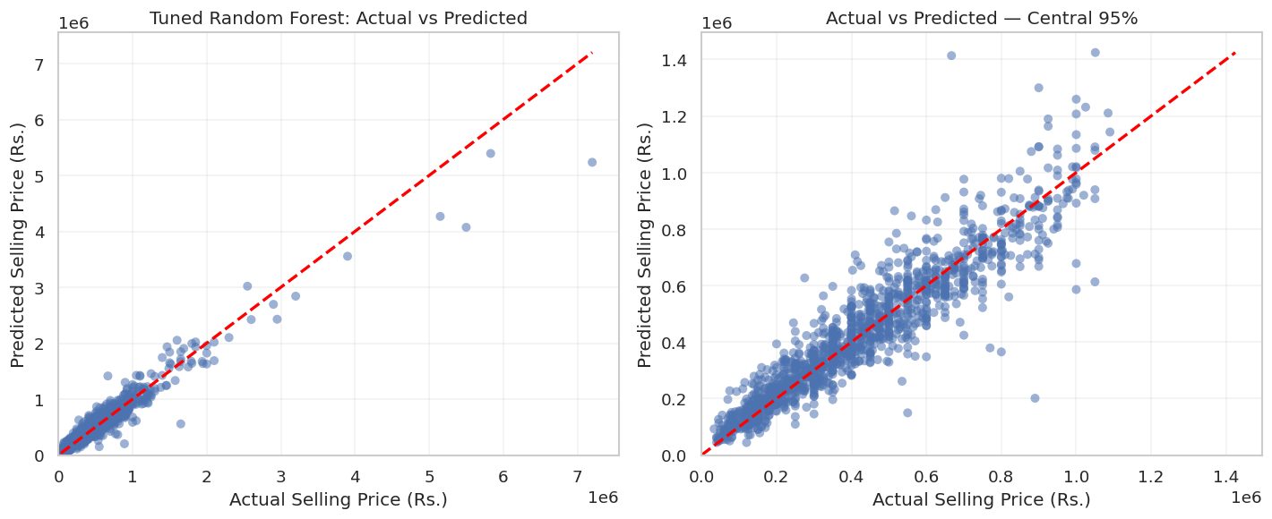
Figure 9. Actual versus predicted prices, including a full-range view and a central-range zoom.
In an actual-versus-predicted plot, perfect predictions lie on the diagonal line. Points above or below it indicate overprediction or underprediction. The full-range view preserves expensive vehicles but can compress the central mass of points; the zoomed view helps reveal patterns among the majority of listings.
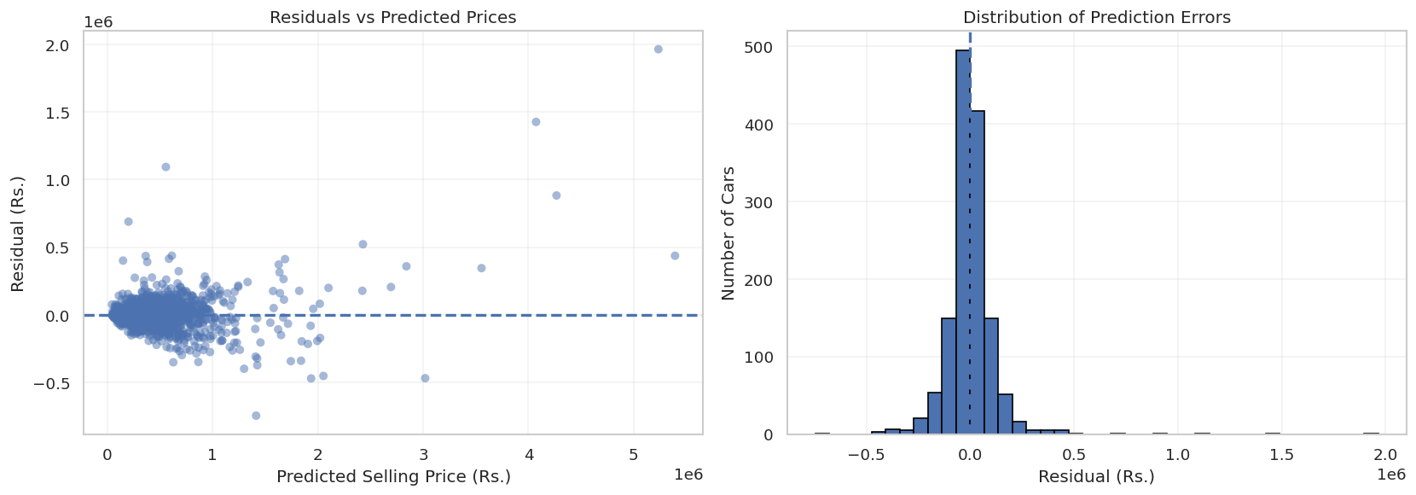
Figure 10. Residuals versus predicted price and distribution of residuals.
Residuals are calculated as actual minus predicted price. Positive residuals indicate underprediction, while negative residuals indicate overprediction. A residual plot is used to look for systematic patterns, changing spread across predicted prices, and unusual observations.

Largest errors
The saved notebook's largest-error table includes a car with an actual selling price of Rs. 7,200,000 and a predicted price of approximately Rs. 5,235,103, an underprediction of about Rs. 1,964,897. Another displayed case had an actual price of Rs. 5,500,000 and a prediction of approximately Rs. 4,072,923. These high-value errors illustrate why RMSE is notably larger than MAE.
These cases should be investigated as error analysis, not automatically removed. Potential reasons include rare premium models, feature combinations underrepresented in training, and the use of brand-level rather than detailed model-level information.

17. Feature Importance and Interpretation
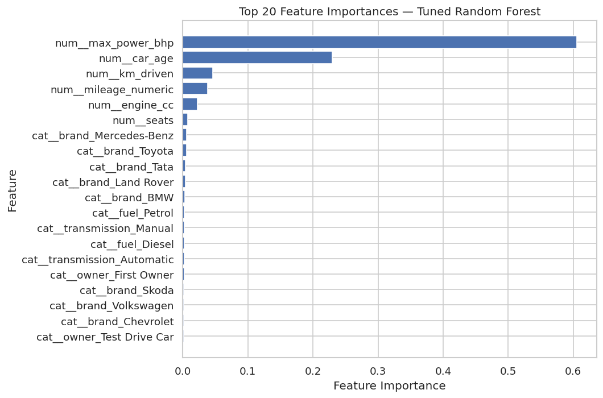
Figure 11. Top encoded feature importances from the tuned Random Forest.
Feature / group | Importance from notebook
max_power_bhp | 0.60558
car_age | 0.22981
km_driven | 0.04641
All numeric features, aggregated | 0.94948
All categorical features, aggregated | 0.05052

Maximum power is the dominant feature in the tuned Random Forest's impurity-based importance, followed by car age and kilometres driven. This broadly agrees with the EDA correlation findings, where maximum power had the strongest numeric correlation with selling price.
Feature importance is model-specific and is not causal. Impurity-based importance can favour features with certain statistical properties, and one-hot encoded categories split importance across multiple columns. Permutation importance on held-out data or SHAP analysis could provide complementary interpretation.

Interpretation in context
The model combines vehicle specifications and listing attributes. Power and age are plausible strong predictors because they relate to vehicle class, performance and depreciation. However, brand and transmission may still contribute through interactions even though their aggregate encoded importance is smaller in this model.

18. Model Saving, Limitations and Future Improvements

Model serialization
The notebook saves the fitted tuned pipeline as car_price_prediction_model.joblib and writes metadata to car_price_model_metadata.json. Saving the complete pipeline preserves the fitted imputers, scaler, one-hot encoder and Random Forest model so that future predictions can use the same transformations.

Limitations
- The dataset is a listing dataset and may not represent completed transaction prices.
- The reference year for car_age is fixed at 2020; deployment on newer listings requires a current, consistently defined age calculation and retraining.
- Some categories such as LPG, CNG and Test Drive Car have very few records.
- Torque is excluded because the source strings are inconsistent.
- Numeric extraction takes the first number from the specification string; unit inconsistencies and unusual formats may introduce errors.
- Outliers and very expensive vehicles can strongly affect RMSE.
- Random train/test splitting does not test future-time generalization.
- Impurity-based feature importance is explanatory, not causal.

Recommended improvements
- Validate and normalize mileage units more carefully, especially kmpl versus km/kg.
- Convert implausible zero/negative mileage or power values to missing after domain verification.
- Compare RandomizedSearchCV or a smaller, better-targeted grid using training folds only.
- Consider log-target modeling and compare original-scale MAE/RMSE after inverse transformation.
- Evaluate permutation importance and inspect performance by price bands and fuel/brand groups.
- Use time-based validation if the intended use is predicting prices for newer listings.
- Save the selected model based on a predefined validation protocol, then evaluate the test set once.

19. Conclusion
This project built an end-to-end used-car price prediction workflow from data inspection through model saving. EDA identified a right-skewed target distribution, substantial differences across fuel and transmission groups, a negative association between age and price, and a strong positive relationship between maximum power and price. Data preparation removed 1,202 exact duplicates, standardized selected categories, derived brand and car age, and extracted numeric mileage, engine and power values.
A reusable preprocessing pipeline handled missing values and categorical encoding. In the initial comparison, Random Forest achieved the strongest test metrics among the four baseline approaches, with MAE of about Rs. 71,621, RMSE of about Rs. 121,711 and R² of 0.932. Five-fold cross-validation showed mean RMSE of about Rs. 182,039 and mean R² of 0.876. GridSearchCV improved mean CV RMSE to about Rs. 176,972.
However, the tuned Random Forest's final test RMSE (about Rs. 125,768) was slightly worse than the original Random Forest's Rs. 121,711. This distinction is important: tuning improved average cross-validation performance, but not the recorded held-out test score. The report therefore avoids overstating the tuning outcome.
The project demonstrates the complete core workflow of a regression machine-learning task: defining the problem, exploring and preparing data, creating leakage-aware pipelines, comparing models, validating, tuning, evaluating errors, interpreting feature importance and saving a reproducible artifact. Further improvements should focus on data validation, rare-category behaviour, premium-car errors and a carefully defined model-selection protocol.

Appendix: Final reported metrics
Evaluation stage | Reported result
Initial model comparison — Random Forest test | MAE Rs. 71,620.889 | RMSE Rs. 121,710.675 | R² 0.932
Original Random Forest — 5-fold CV | Mean MAE Rs. 82,695.875 | Mean RMSE Rs. 182,038.751 | Mean R² 0.876
GridSearchCV best mean CV RMSE | Rs. 176,971.496
Tuned Random Forest test | MAE Rs. 71,706.406 | RMSE Rs. 125,768.287 | R² 0.928

Prepared from the supplied Task 3 notebook and its recorded outputs.

