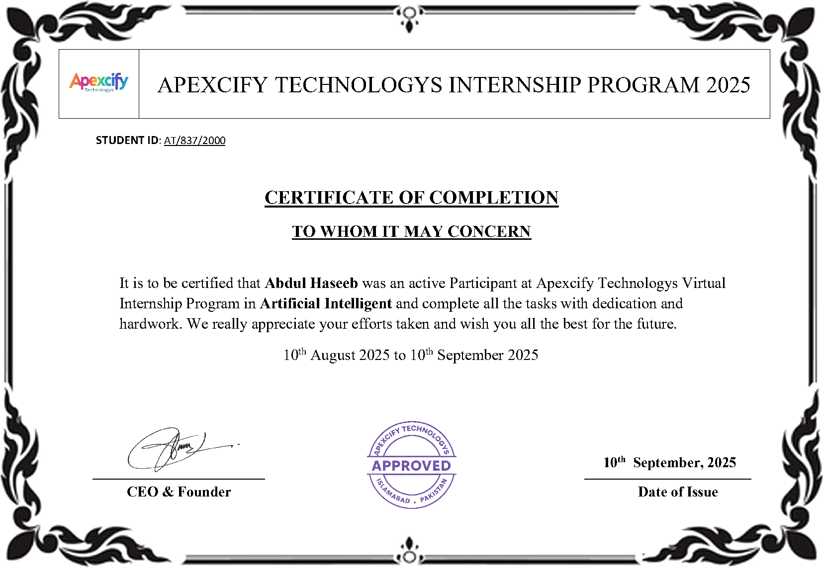

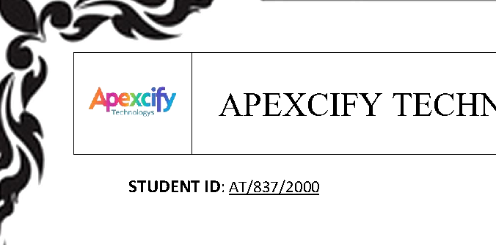



APEXCIFY TECHNOLOGYS INTERNSHIP PROGRAM 2025
STUDENTID :AT/837/2000
CERTIFICATE OF COMPLETION
TO WHOM IT MAY CONCERN
It is to be certified that was an active Participant at Apexcify Technologys Virtual Abdul Haseeb
Internship Program in and complete all the tasks with dedication and Artificial Intelligent
hardwork. We really appreciate your efforts taken and wish you all the best for the future.
th th 10 August 2025 to 10 September 2025




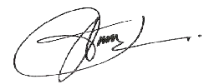

th 10 September, 2025
CEO & Founder Date of Issue

