
SmartSauda: A Real-Time Embedded System for Automated Retail Checkout and Billing

Prepared by:
- Muhammad Hammad Abdullah
- Aiyan Sheryar
- Shabia Sajjad
- Waleed Nadeem
Supervisor:
- Mr. Syed Noman Ali Shah
Co Supervisor:
- Mr. Asim Irshad
Department:
- School of Computer and IT
Semester:
- Fall 2025

Problem Statement
Retail stores in Pakistan still rely on traditional, manual shopping processes where customers pick items and wait in long queues. Billing is handled manually, which often leads to errors, especially during peak hours. Customers also do not have real-time visibility of their total spending, and issues such as theft or wrong billing occur when items are skipped during manual scanning. Products of the same category, such as rice, flour, or biscuits, have similar characteristics and can easily be confused, further complicating accurate billing. These issues result in queue congestion, human errors, lack of transparency, lower efficiency, and slow manual scanning. Existing solutions like self‑checkout kiosks and RFID‑based smart carts are either expensive or not accessible to local markets. NFC, however, provides a secure, low‑cost, short‑range, and highly suitable “tap to identify” method for retail applications.

Proposed Solution
Smart Sauda introduces an IoT‑enabled automated shopping cart system using NFC‑based item identification, load‑cell verification, QR‑code user pairing, and a real‑time mobile application. The customer taps an item on the NFC reader and the system immediately identifies it. The load cell ensures the correct weight is added, preventing tag mismatch. The mobile application displays a real‑time bill synchronized through the cloud. A central database stores product information and automatically updates totals whenever items are added or removed. The system uses NFC and weight as dual verification, ensuring high accuracy. ESP32 serves as the main controller, while ESP‑01 manages WiFi communication to maintain stable cloud synchronization. The hardware is portable and low‑power, making it suitable for supermarket carts.

Methodology
Agile methodology was adopted due to the project’s mixed hardware and software nature. Each development sprint included planning, hardware testing, software integration, user feedback, and sprint review. The research involved comparative analysis between RFID, NFC, and barcodes, testing sensor performance such as NFC read range and load cell accuracy, and conducting power‑consumption tests. Interviews with shoppers and store owners provided practical insights. Hardware development progressed from breadboard prototyping to stable PCB‑based implementation, followed by load‑cell calibration, shock testing, and field testing inside retail environments. Software development included backend schema design, API development for communication between ESP devices and the cloud, mobile app UI design, and real‑time synchronization using Firebase/MySQL. The software was structured into modular components such as NFC module, weight module, cart manager, and cloud communicator.

Requirement Analysis
The system needed to provide quick item detection, real‑time billing, accurate weight measurement, an easy‑to‑use mobile app, and low‑power consumption, while also offering seamless cloud integration for product management. Research revealed that NFC tags are affordable in Pakistan, with shorter read ranges that prevent accidental scans. Load cells required stabilization due to cart vibration, which was solved through the use of a metal plate. The requirements ensured the system was scalable, portable, cloud‑enabled, and capable of supporting supermarket environments.

Literature Review
Recent research shows a strong shift toward IoT‑based automation in smart retail between 2019 and 2024. NFC technology is increasingly preferred for secure, short‑range identification. Smart carts significantly reduce customer waiting time. A comparison of technologies demonstrates that RFID, while effective, is costly; barcode technology is cheap but slow; and NFC offers the best balance of security, cost, and suitability. International solutions such as Amazon Go rely on computer vision, which is far too expensive for local deployment. Pakistan currently lacks any deployed smart‑cart system, making Smart Sauda an innovative contribution.

User Studies
Observations from major stores such as Chase Up, Imtiaz, and Utility Stores showed long queues between 6pm and 10pm, with barcode scanning times averaging 4–6 seconds per item. Customers frequently asked staff about their running bill. Interviews showed that 92% of participants preferred real‑time billing, 89% faced issues with queues, and 86% trusted NFC-based scanning. A formal survey of 50 respondents revealed that customers prefer a scan time under one second, want automatic bill updates, and want to remove items as needed.

Key User Stories
Users expect instant item scanning, automatic bill updates, easy item removal, and real‑time visibility of their total. Store managers expect secure identification methods and real‑time sales analytics. These stories helped shape the functional flow of the system.

Functional and Non‑Functional Requirements
The system is required to pair carts with users via QR code, detect items using NFC, verify product weight, retrieve product details, update the bill, synchronize with the cloud, and remove items when weight decreases. Non‑functional requirements specify acceptable weight error under three grams, NFC detection under three hundred milliseconds, unique tag IDs, authenticated backend access, high reliability, scalability to handle large product sets, and at least two hours of battery life for portability.

Architecture
The system architecture consists of multiple layers. The sensor layer includes the NFC reader and load cell. The controller layer consists of the ESP32 for core logic and ESP‑01 for WiFi. The connectivity layer uses REST APIs for cloud communication, and the application layer includes the Flutter‑based mobile app and admin dashboard. Logical, deployment, data, and process views describe how components interact, where devices are located, how data flows, and how user actions are processed.

Class Diagram

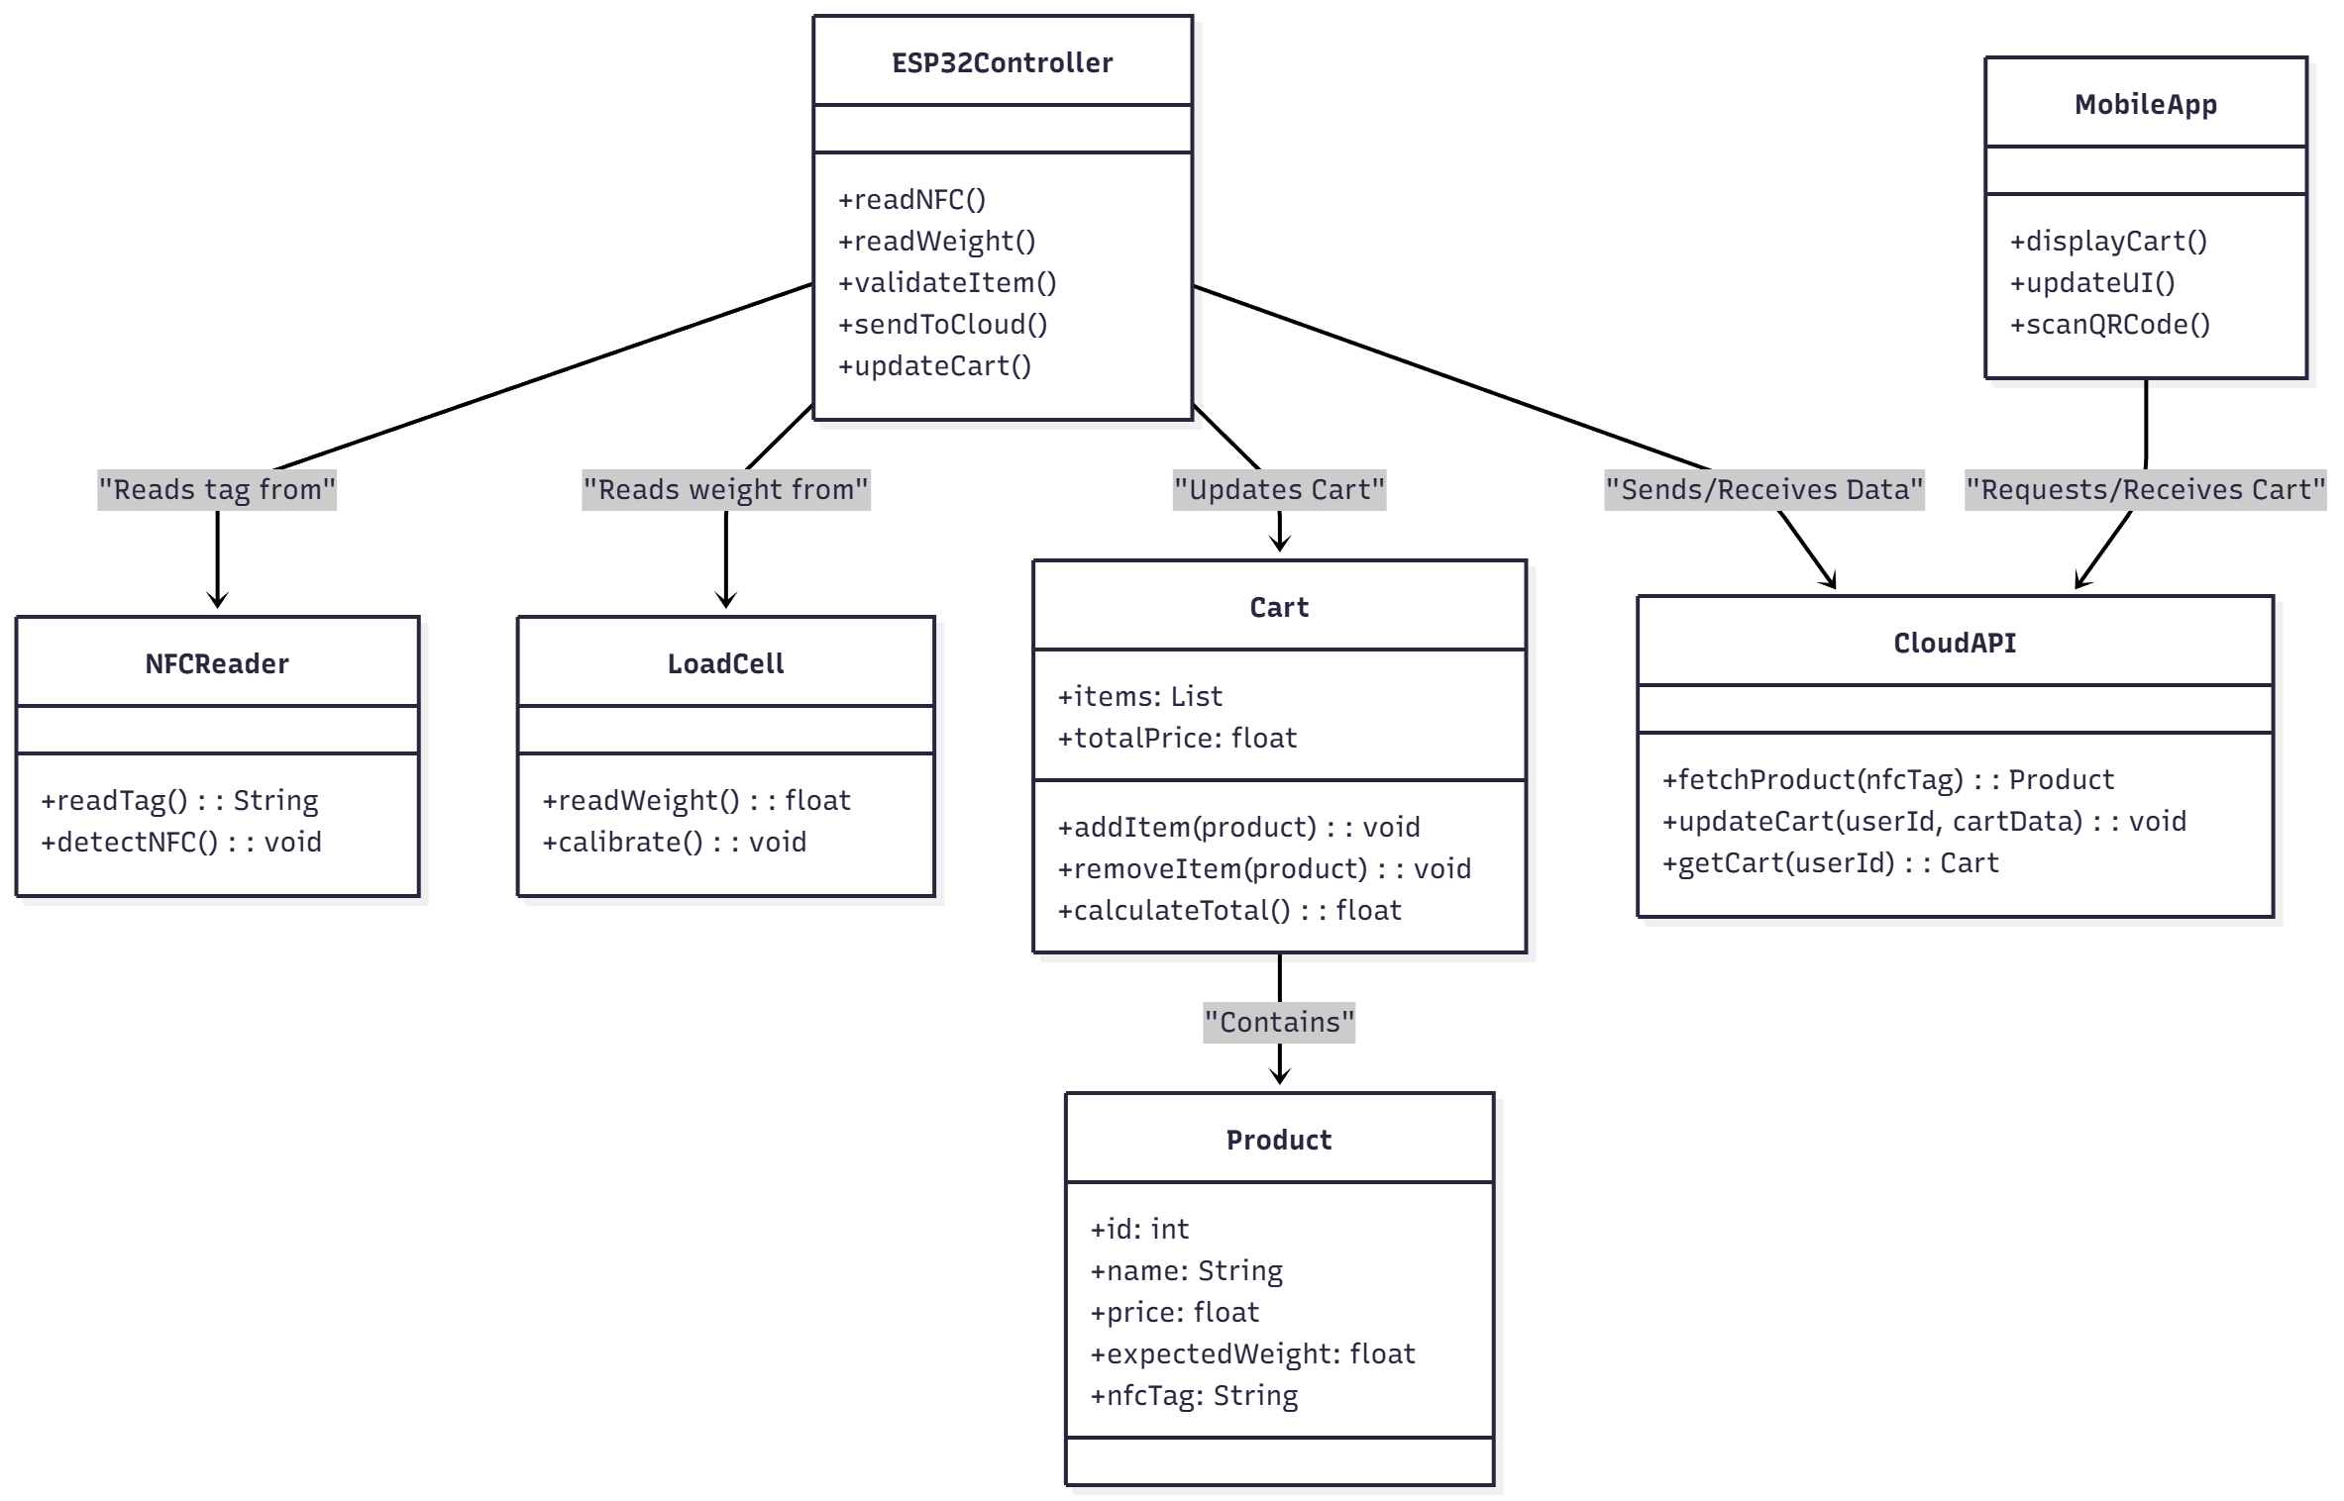

Sequence Diagram
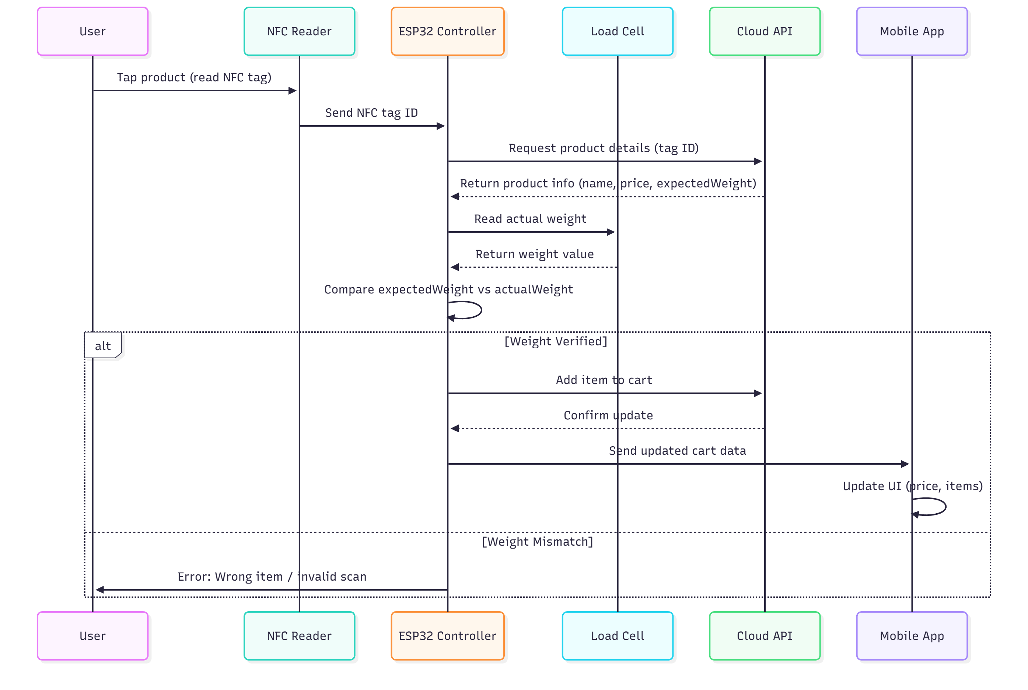

11.1 Item Removal (Sequence Diagram)

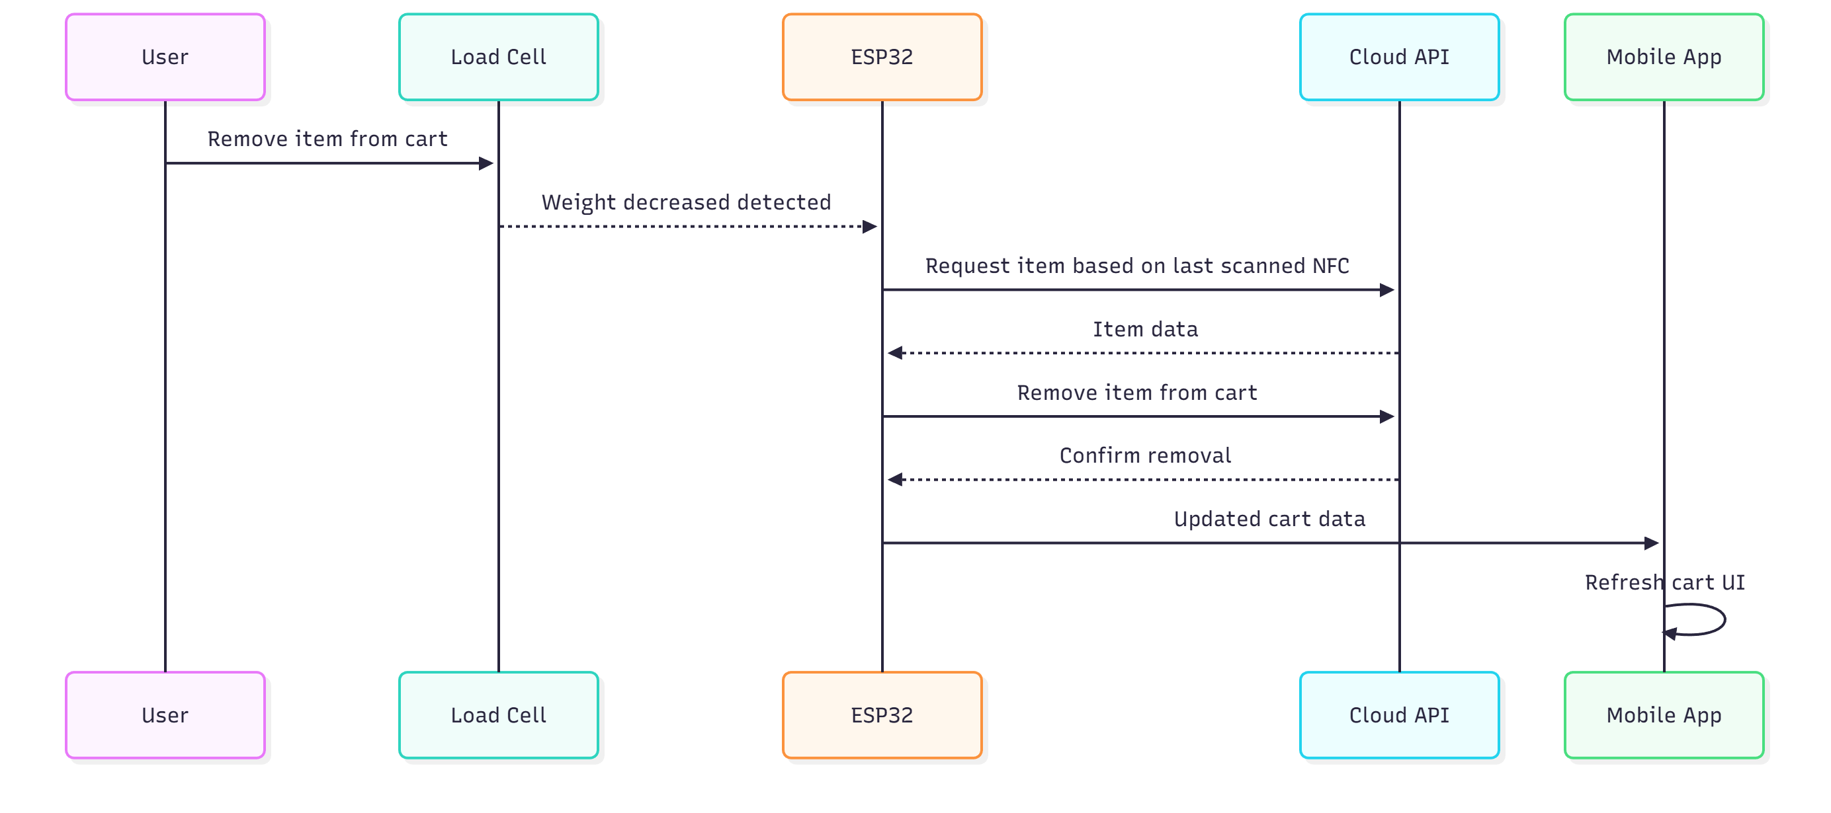

Design
The system design includes structured classes such as Item, Cart, Cart Manager, Weight Sensor, and NFC Reader. The sequence of adding an item involves tapping a product on the reader, retrieving product data, verifying weight, updating the cart, and synchronizing with the app and cloud. Data is organized into tables for products, carts, and users, with API endpoints for item addition, removal, and cart retrieval.

Development and Implementation
Hardware implementation included soldering the NFC module for noise reduction, stabilizing the load cell under an acrylic plate, calibrating with standard weights, and ensuring stable power delivery to the ESP‑01. Software implementation used the PN532 and HX711 libraries, JSON for communication, REST‑based cloud synchronization, and a real‑time Flutter interface using state management. ESP firmware was divided into separate modules for NFC handling, weight measurement, cloud sync, and cart management.

Testing and Evaluation
NFC read accuracy reached 98%, weight accuracy remained within ±3g, and system response time was between 250 and 350 milliseconds. Integration tests confirmed smooth communication between modules. User acceptance testing indicated that the majority found the system fast, intuitive, and helpful due to real‑time billing features.

Challenges and Solutions
WiFi instability on the ESP‑01 was resolved using a capacitor and regulated power supply. Load‑cell noise was minimized through software filtering and stable mounting. NFC range inconsistencies were fixed by adjusting the antenna. Power supply issues were solved using a power bank with a step‑down converter for 3.3V.

Future Work
The system can be extended toward automatic checkout with payments, anti‑theft mechanisms that compare cart weight with billed weight, voice‑assistant functionality in the cart, AI‑based recommendations, and heat‑map analytics to optimize store layout.

