FESTARA
Collaborative Event Planning and Expense Management

Anas Altaf (MC-331)
Hammad Ansar (MC-304)
Muhammad Sami Ullah (MC-336)
Supervised By
Tahira Iqbal
Submitted for the partial fulfillment of BS Computer Science degree to the Faculty of Engineering & CS
DEPARTMENT OF COMPUTER SCIENCE
NATIONAL UNIVERSITY OF MODERN LANGUAGES
ISLAMABAD
October, 2026
Abstract
Families, friend groups, and university societies regularly plan events together, yet most of them still coordinate through a mix of WhatsApp messages, spreadsheets, and memory. Guest lists live on one person's phone, expenses are mentioned in chat and then forgotten, and tasks are handed out verbally with no record of who agreed to do what. Existing tools each solve a slice of this problem: Eventbrite handles public ticketing, Splitwise settles shared debts after the fact, and professional wedding planners such as Aisle Planner are priced for businesses rather than households. No affordable tool brings event planning, shared expense tracking, and task management together for small private groups. Festara is a web application built to close that gap for groups of roughly 3 to 50 people.
Festara lets one person create an event, set a budget, and invite others through a shareable link with a specific role: Admin, Member, or Guest. The system is divided into eight modules: User Authentication, Event Management, Role-Based Access Control, Guest List and RSVP, Expense and Budget Tracking, Tasks and Arrangements, an Admin Dashboard, and an AI Features module planned for the second phase. The project follows the Scrum process model in two-week sprints. It is built with Next.js 16 and Tailwind CSS on the front end, Supabase (PostgreSQL, Auth, and Realtime) as the backend, and Vercel for hosting. Access rules are enforced inside the database through PostgreSQL Row Level Security, so a user can only read or change the rows that their role permits, regardless of what the client sends.
This report documents the project at the 40 percent milestone. The requirements, use cases, and complete system design for all modules are presented, together with the implementation of the three foundation modules: authentication, event management, and role-based access control with invite links. These modules are being validated through black-box functional testing, integration testing of the invite flow, and direct security tests against the database policies, using the test cases defined in this report. The remaining modules, including expense tracking with an 80 percent budget warning and the AI checklist and budget estimator, are scheduled in the project plan. Known limitations include the lack of in-app payments, the need for an internet connection, and link-only invitations in the first release.
Certificate
Dated: ____________________
Final Approval
It is certified that the project report titled "Festara: Collaborative Event Planning and Expense Management" submitted by Anas Altaf, Hammad Ansar, and Muhammad Sami Ullah for the partial fulfillment of the requirement of "Bachelors Degree in Computer Science" is approved.
COMMITTEE
Dr. Abdul Majid Somroo  HoD Computer Science | Signature: ______________
Syed Zain ul Abdin  Program Coordinator CS | Signature: ______________
Tahira Iqbal  FYP Coordinator CS | Signature: ______________
Tahira Iqbal  Supervisor | Signature: ______________

Declaration
We hereby declare that our dissertation is entirely our work and genuine/original. We understand that in case of discovery of any PLAGIARISM at any stage, our group will be assigned an F (FAIL) grade and it may result in withdrawal of our Bachelor's degree.

Group Members | Signature
1. Anas Altaf (MC-331) | ______________
2. Hammad Ansar (MC-304) | ______________
3. Muhammad Sami Ullah (MC-336) | ______________

Plagiarism Certificate
This is to certify that the project entitled "Festara: Collaborative Event Planning and Expense Management" is being submitted here for the award of the "Degree of Bachelor" in "Computer Science". This is the result of the original work by Anas Altaf, Hammad Ansar, and Muhammad Sami Ullah under my supervision and guidance. The work embodied in this project has not been done earlier for the basis of the award of any degree or compatible certificate or similar title of this for any other diploma/examining body or university to the best of my knowledge and belief.

Turnitin Originality Report | Processed on: ________ ID: ________
Word Count | __________
Similarity Index | ____ %
Similarity by Source | Internet Sources: _ % Publications: _ % Student Papers: ___ %

Date: ____________ | Tahira Iqbal  (Supervisor)

Turnitin Originality Report
"Festara: Collaborative Event Planning and Expense Management" by Anas Altaf, Hammad Ansar, and Muhammad Sami Ullah
From Tahira Iqbal

Processed on | __________
ID | __________
Word Count | __________
Similarity Index | ____ %
Internet Sources | ____ %
Publications | ____ %
Student Papers | ____ %

SOURCES: (Attach the source list from the Turnitin report here.)
Acknowledgment
We are grateful to Allah Almighty for giving us the ability to carry out this work. We thank our supervisor, Tahira Iqbal, for her guidance, her patience during our meetings, and the practical feedback that shaped Festara's scope and design. We also thank the faculty of the Department of Computer Science, National University of Modern Languages, Islamabad, for the knowledge and support they provided throughout our degree. Finally, we thank our families and friends, whose own weddings, trips, and society events gave us the problem this project tries to solve.
Table of Contents
Chapter 1: INTRODUCTION | 1
1.1 Introduction | 2
1.2 Motivation | 2
1.3 Problem Statement | 3
1.4 Goals and Objectives | 3
1.5 Scope of the Study | 4
1.6 Process Model | 4
1.7 Nature of the Project: A Cloud-Based Collaborative Web Application | 5
1.8 Overview / Organization of the Report | 5
Chapter 2: BACKGROUND AND EXISTING WORK | 6
2.1 Introduction | 7
2.2 Important Constructs of the Application Domain | 7
2.2.1 Collaborative Event Planning | 7
2.2.2 Shared Expense and Budget Management | 7
2.2.3 Role-Based Access Control | 7
2.2.4 Backend-as-a-Service and Row Level Security | 8
2.3 Existing Studies / Systems | 8
2.3.1 Related Literature Review | 8
2.3.2 Related Systems / Applications | 9
2.4 Comparison of Existing Systems | 10
2.5 Summary | 11
Chapter 3: REQUIREMENTS SPECIFICATION | 12
3.1 Introduction | 13
3.2 Interface Requirements | 13
3.2.1 Hardware Interface Requirements | 13
3.2.2 Software Interface Requirements | 13
3.3 Functional Requirements | 14
3.4 Use Case Model | 16
3.5 Use Cases | 17
3.5.1 Use Case 1: Create Event | 17
3.5.2 Use Case 2: Join Event via Invite Link | 18
3.5.3 Use Case 3: Manage Member Roles | 19
3.5.4 Use Case 4: Log Expense | 19
3.5.5 Use Case 5: Confirm RSVP | 20
3.6 Non-Functional Requirements | 21
3.6.1 Performance | 21
3.6.2 Reliability | 21
3.6.3 Security | 21
3.6.4 Usability | 22
3.6.5 Consistency | 22
3.6.6 Portability | 22
3.7 Resource Requirements | 22
3.7.1 Equipment | 22
3.7.2 Funds | 23
3.7.3 Human Effort | 23
3.8 Database Requirements | 24
3.9 Project Feasibility | 25
3.9.1 Technical Feasibility | 25
3.9.2 Operational Feasibility | 25
3.9.3 Economic Feasibility | 25
3.9.4 Legal and Ethical Feasibility | 25
3.10 Summary | 25
Chapter 4: SYSTEM MODELLING | 27
4.1 Introduction | 28
4.2 System Design | 28
4.3 Design Approach | 29
4.4 Interface Design | 29
4.4.1 High Fidelity Prototype | 29
4.5 Data Flow Diagrams | 30
4.6 4+1 View Model of Architecture | 32
4.6.1 Logical View | 32
4.6.2 Process View | 33
4.6.3 Development View | 35
4.6.4 Physical View | 36
4.7 Entity Relationship Diagram | 37
4.8 Summary | 38
Chapter 5: IMPLEMENTATION | 39
5.1 Introduction | 40
5.2 Development Environment and Project Structure | 40
5.3 Modules of the FYP | 40
5.3.1 User Authentication Module | 40
5.3.2 Event Management Module | 41
5.3.3 Role-Based Access Control Module | 42
5.3.4 Planned Implementation of Remaining Modules | 44
5.4 H/W Module Details | 45
5.5 Summary | 45
Chapter 6: RESULT / TESTING, ANALYSIS AND VALIDATION | 46
6.1 Introduction | 47
6.2 Testing Strategy | 47
6.2.1 Testing Environment | 47
6.2.2 Black Box Testing | 47
6.2.3 Unit Testing | 47
6.2.4 Integration Testing | 47
6.2.5 Security Testing of Access Policies | 48
6.3 Test Cases | 48
6.3.1 Test Case TC-07: Join Event via Valid Invite Link | 48
6.4 Validation of Non-Functional Requirements | 50
6.5 Summary | 50
Chapter 7: CONCLUSION AND FUTURE WORK | 52
7.1 Introduction | 53
7.2 Progress Review against Objectives | 53
7.3 Remaining Work and Timeline | 53
7.4 Limitations | 54
7.5 Future Work | 54
7.6 Summary | 55
APPENDIX I: DATA DICTIONARY | 56
profiles | 56
events | 56
event_members | 57
invitations | 57
guests | 57
expenses | 58
tasks | 58
activity_log | 58
APPENDIX II: USER MANUAL (COMPLETED MODULES) | 59
Registering and Logging In | 59
Creating an Event | 59
Inviting People | 59
REFERENCES | 60

List of Figures
Figure 1.1: Scrum process model adopted for Festara | 5
Figure 3.1: Use case diagram of Festara | 17
Figure 4.1: System architecture of Festara | 28
Figure 4.2: Prototype of the login and registration screen | 30
Figure 4.3: Prototype of the home dashboard | 30
Figure 4.4: Prototype of the members and invite screen | 30
Figure 4.5: DFD level 0 (context diagram) of Festara | 31
Figure 4.6: DFD level 1 of Festara | 32
Figure 4.7: Class diagram of Festara | 33
Figure 4.8: Activity diagram for creating an event and joining through an invite link | 34
Figure 4.9: State diagram of a task | 35
Figure 4.10: Sequence diagram for accepting an invitation | 35
Figure 4.11: Component diagram of Festara | 36
Figure 4.12: Deployment diagram of Festara | 37
Figure 4.13: Entity relationship diagram of Festara | 37
Figure 5.1: Implemented login screen | 41
Figure 5.2: Implemented create-event form | 42
Figure 5.3: Role helper function and Row Level Security policies on the events table | 43
Figure 5.4: Server action for accepting an invitation | 43
Figure 5.5: Implemented members and invite screen | 44
Figure 7.1: Project timeline showing completed and planned work | 54

List of Tables
Table 2.1: Summary of Reviewed Literature | 9
Table 2.2: Summary of Existing Systems | 10
Table 2.3: Feature Comparison of Existing Systems and Festara | 11
Table 3.1: Hardware Interface Requirements | 13
Table 3.2: Software Interface Requirements | 14
Table 3.3: Functional Requirements | 14
Table 3.4: Full Dress Use Case for Create Event | 17
Table 3.5: Full Dress Use Case for Join Event via Invite Link | 18
Table 3.6: Full Dress Use Case for Manage Member Roles | 19
Table 3.7: Full Dress Use Case for Log Expense | 20
Table 3.8: Full Dress Use Case for Confirm RSVP | 20
Table 3.9: Equipment and Tools with Justification | 23
Table 3.10: Task Division and Human Effort | 24
Table 5.1: Project Folder Structure | 40
Table 5.2: Role Permission Matrix | 42
Table 6.1: Test Case TC-07 in Full Format | 48
Table 6.2: Summary of Test Cases | 49
Table 6.3: Non-Functional Requirement Validation Plan | 50
Table 7.1: Progress against Project Objectives | 53

Chapter 1
INTRODUCTION

1.1 Introduction
People have always organized events together. A wedding pulls in the whole family, a road trip needs everyone to agree on plans and split costs, and a university society event runs on a committee where a dozen people each handle a different job. The difficulty is rarely that people do not know how to plan. It is that they have no shared place to plan in. Coordination happens across chat groups, phone contacts, paper lists, and spreadsheets, and the person in charge ends up holding the whole picture in their head.
Software for events has grown quickly, but it has grown in separate directions. Ticketing platforms such as Eventbrite serve public events with paying attendees [5], [9]. Expense-splitting tools such as Splitwise settle who owes whom once money has already been spent [10]. Full wedding-planning suites cover almost everything, but they are priced and designed for professional planners rather than for a father organizing his daughter's wedding [7]. Industry surveys report that budget control is the most cited pain point in event planning, with 95 percent of planners naming rising costs as a top concern [5], and that 89 percent of buyers of collaboration software rate access control and expense tracking as important or highly important [8].
Festara is a web application that brings event planning, shared expense tracking, and task management into one place for small private groups [1], [2]. A group creates an event, sets a budget, and invites members with defined roles. From that point everyone works from the same screen: guests are added and tracked, expenses are logged by whoever spends the money, tasks are assigned with deadlines, and the Admin sees the overall state of the event on a single dashboard. The application runs in any modern browser, needs no installation, and is free for basic personal use.

1.2 Motivation
The idea for Festara came from the team's own experience. In the months before this project, members of the team took part in family weddings, a northern-areas road trip with friends, and a society event at the university. Each one ran into the same problems. On the trip, five people paid for petrol, food, and rooms at different times, and at the end nobody could reconstruct who had paid for what. At the wedding, the guest list existed in three versions held by three relatives. At the society event, two committee members both assumed the other had booked the sound system.
None of these problems needed advanced technology to solve. They needed a single shared record with clear ownership: one list of guests, one ledger of expenses against one budget, and one list of tasks with a named person and a date next to each. The motivation for Festara is to give ordinary groups that shared record without a subscription fee or the learning curve of professional tools.

1.3 Problem Statement
Small groups that organize private events, such as families, friend circles, and student societies, lack a single, affordable tool for coordinating their guests, shared spending, and responsibilities. Existing applications cover only part of the work, so groups fall back on chat messages and spreadsheets that have no structure, no role-based control, and no live view of the budget. As a result, expenses go untracked, tasks are missed, guest responses are lost, and the burden of coordination falls on one person. The problem this project addresses is the design and development of a browser-based system in which a group can plan an event collaboratively, with each participant's permissions defined by their role, and with spending and progress visible to the organizer in real time.

1.4 Goals and Objectives
The overall goal of the project is to deliver a working web application that a non-technical group can use to plan a private event from start to finish. The specific objectives are:
- To provide secure registration, login, password reset, and profile management for users.
- To allow a user to create, edit, and delete events with a name, type, date, location, description, and total budget.
- To enforce three roles, Admin, Member, and Guest, so that every action in the system is permitted or denied according to the user's role in that event.
- To let organizers add guests, share invite links, and track each guest's RSVP status as Pending, Confirmed, or Declined.
- To let any member log expenses against the event budget by category, and to warn the group when spending crosses 80 percent of the budget.
- To let organizers create tasks with an assignee and deadline, and to track each task through To Do, In Progress, and Done.
- To give the Admin a dashboard that summarizes days remaining, members, guests, task completion, budget usage, and recent activity.
- In the second phase, to use a large language model to generate preparation checklists and suggested budget splits for a given event type and guest count.

1.5 Scope of the Study
Festara is limited to private, invitation-only events for groups of roughly 3 to 50 people. It covers family events such as weddings, engagements, Mehndi, Walima, Eid gatherings, and birthdays; friend-group activities such as road trips, vacations, and outings; university society events such as tech fests, seminars, and annual functions; and small professional use by independent planners who manage client events without custom software.
The following are outside the scope of this project: public ticketing or paid registration, in-app money transfers or payment processing between users, virtual event hosting or video streaming, and enterprise features such as CRM, contracts, or marketing automation. This report covers the work completed up to the 40 percent milestone, which consists of the full requirements and design for every module and the implementation of the User Authentication, Event Management, and Role-Based Access Control modules.

1.6 Process Model
The project follows Scrum, an iterative and incremental framework in which work is delivered in short, fixed-length sprints [16]. Scrum was chosen over the Waterfall model for three reasons. First, the requirements of a social, user-facing product are best refined by showing working screens to users and to the supervisor, and Scrum builds that review into every sprint. Second, the modules of Festara depend on each other in a clear order (authentication before events, events before roles, roles before guests and expenses), which maps naturally onto a sequence of sprints. Third, the team is small, and Scrum's lightweight ceremonies suit three students working alongside their coursework.
Each sprint lasts two weeks. At the start of a sprint the team selects items from the product backlog into a sprint backlog. During the sprint the team holds short daily check-ins over WhatsApp or in person. At the end of the sprint the working increment is deployed to Vercel and demonstrated to the supervisor in the review meeting, and the team holds a short retrospective. Feedback from the review is added back to the product backlog. The cycle is shown in Figure 1.1.
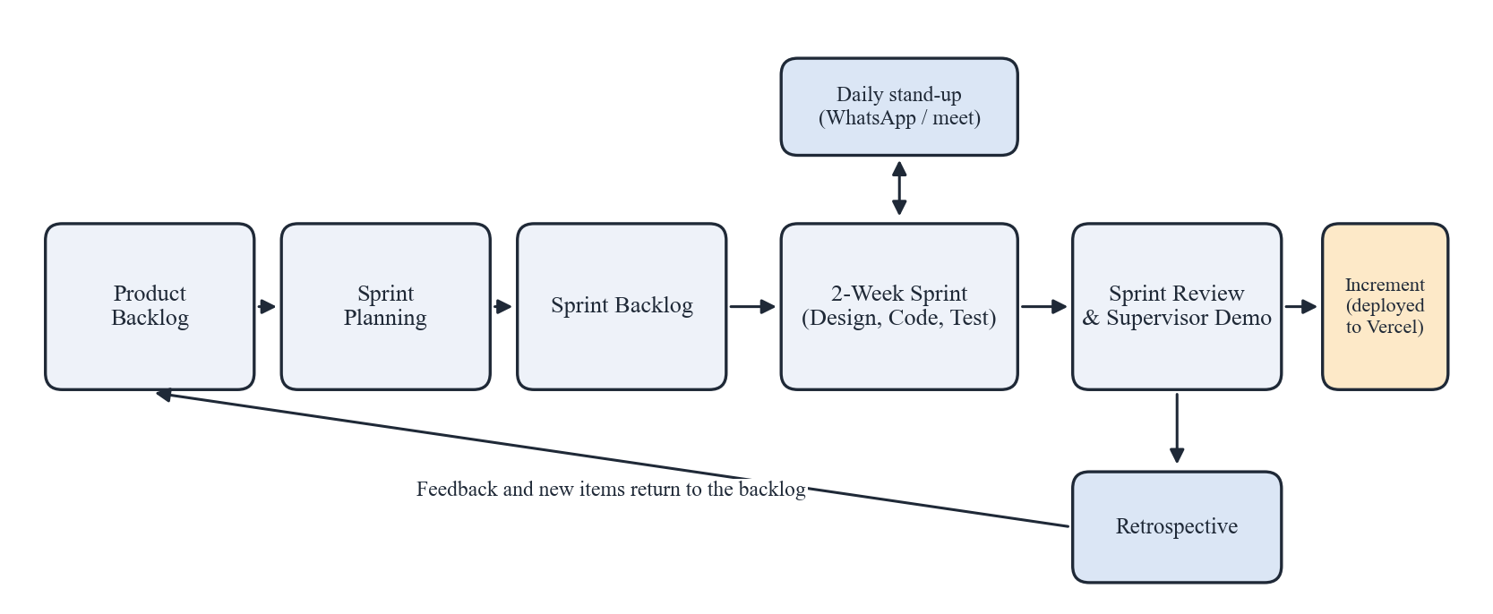
Figure 1.1: Scrum process model adopted for Festara

1.7 Nature of the Project: A Cloud-Based Collaborative Web Application
Festara is a web application built on a serverless, cloud-hosted architecture. The front end is written in Next.js 16 using the App Router with React Server Components, and styled with Tailwind CSS [2]. The backend is provided by Supabase, a Backend-as-a-Service platform that supplies a managed PostgreSQL database, user authentication, and real-time change subscriptions [1]. The application is deployed on Vercel. In the second phase, an AI module will call the OpenAI API through the Vercel AI SDK to generate checklists and budget estimates [3], [4]. The project therefore combines web engineering, database security design, and applied AI.

1.8 Overview / Organization of the Report
The rest of this report is organized as follows. Chapter 2 explains the domain of collaborative event planning, reviews related research and existing applications, and compares them with Festara. Chapter 3 specifies the system's interface, functional, and non-functional requirements, use cases, resource needs, and feasibility. Chapter 4 presents the system model, including the architecture, interface design, data flow diagrams, the 4+1 architectural views, and the entity relationship diagram. Chapter 5 describes the implementation of the modules completed at the 40 percent milestone and the plan for the remaining modules. Chapter 6 defines the testing approach and test cases. Chapter 7 reviews progress against the objectives and outlines the remaining work, limitations, and future directions.

Chapter 2
BACKGROUND AND EXISTING WORK

2.1 Introduction
Festara sits where three areas meet: group event planning, shared expense management, and access control for multi-user applications. This chapter first explains the key concepts of that domain. It then reviews published research on collaborative planning and role-based access control, describes the existing applications that groups use today, and compares them against the features Festara provides.

2.2 Important Constructs of the Application Domain

2.2.1 Collaborative Event Planning
Collaborative event planning is the process by which several people jointly decide and carry out the arrangements for an event: who is invited, where and when it happens, what it costs, and who does each job. Research on group event scheduling shows that the outcome depends heavily on how input from participants is gathered and how decisions are made visible to the group [11]. Planning also changes over time: a guest list grows, a venue is booked, and costs accumulate as the date approaches. A planning tool must therefore support continuous updates from many people rather than a single form filled in once.

2.2.2 Shared Expense and Budget Management
Group events are usually paid for by several people at different times. Shared expense management means recording each payment with its amount, category, payer, and date, so that the group can see total spending against an agreed budget and each member's contribution. Two views matter: a budget view, which compares spending with the planned total, and a contribution view, which shows who has paid for what. Consumer research shows growing demand for budgeting tools that give this kind of visibility [6].

2.2.3 Role-Based Access Control
Role-Based Access Control (RBAC) is an access control model in which permissions are attached to roles and users are assigned to roles, rather than permissions being granted to each user directly [14]. The NIST RBAC standard formalizes this into core RBAC (users, roles, permissions, and sessions), role hierarchies, and separation-of-duty constraints [15]. In Festara, roles are scoped to a single event: the same person can be the Admin of their own wedding and a Member of a friend's trip. This per-event assignment is a direct application of core RBAC, with the event acting as the context in which a role applies.

2.2.4 Backend-as-a-Service and Row Level Security
Backend-as-a-Service (BaaS) platforms provide ready-made database, authentication, and storage services so that developers can focus on application logic. Supabase is an open-source BaaS built on PostgreSQL [1]. A key feature it exposes is Row Level Security (RLS), a PostgreSQL mechanism that attaches policies to tables so that each query only returns or modifies the rows the current user is allowed to access [17]. Because the policy runs inside the database, a user cannot bypass it by calling the API directly. Festara relies on RLS to enforce its role rules.

2.3 Existing Studies / Systems

2.3.1 Related Literature Review
OutWithFriendz (Zhang et al.) [11]. This study built a mobile application that lets a host invite friends, suggest times and venues, and let the group vote. The authors deployed it on iOS and Android and analyzed more than 500 users and 300 real group events. They found that participants' mobility patterns, individual preferences, the host's own preferences, and the dynamics of voting all influence the final decision. The work shows that structured group input improves planning, but it focuses only on choosing a time and place. It does not handle budgets, expenses, guest RSVPs, or task assignment after the decision is made.
Cobi (Kim et al.) [12]. Cobi is a community-informed scheduling tool used to plan the CHI 2013 conference. It collected preferences, constraints, and affinity data from authors through community-sourcing applications, then combined that data with constraint solving in a visual interface for organizers. In the live deployment, organizers considered input from 645 authors and resolved 168 scheduling conflicts. Cobi demonstrates the value of giving organizers one shared view built from many contributors' input. However, it is designed for a large academic conference with professional organizers, not for small private groups, and it does not address money or individual task ownership.
Takeplace (Škrabálek et al.) [13]. This case study describes the analysis, design, and implementation of Takeplace, a web-based service for planning, managing, and promoting professional and academic events. The authors discuss how Web 2.0 technologies allow rich internet applications for event management and online professional communities. The system shows that a browser-based platform can serve as the single workspace for an event's organizing team. Its focus, however, is on public professional events, registration, and promotion, rather than private family or friend events with shared spending.
RBAC models (Sandhu et al.) [14] and the NIST RBAC standard (Ferraiolo et al.) [15]. Sandhu and colleagues defined a family of RBAC models that separates users, roles, and permissions and introduces role hierarchies and constraints. Ferraiolo and colleagues later proposed a unified NIST standard built on that work, defining core RBAC, hierarchical RBAC, and separation-of-duty relations. These papers provide the theoretical basis for Festara's Admin, Member, and Guest roles. Their limitation for this project is that they describe enterprise-wide roles; they do not directly address roles that are scoped to an individual shared object, such as one event, which Festara must support. Table 2.1 summarizes the reviewed literature.
Table 2.1: Summary of Reviewed Literature
Year | Authors | Contribution | Techniques | Limitations
2018 | Zhang et al. [11] | Mobile app for group event scheduling; study of 500+ users and 300 events | Invitations, time/venue suggestions, group voting, usage-log analysis | Covers only time and venue decisions; no budget, expenses, or tasks
2013 | Kim et al. [12] | Community-informed conference scheduling (Cobi) | Community-sourcing, constraint solving, visual scheduling interface | Built for large academic conferences and professional organizers
2010 | Škrabálek et al. [13] | Web service for collaborative organization of academic events (Takeplace) | Rich internet application, Web 2.0, online project management | Aimed at public professional events; no shared expense tracking
1996 | Sandhu et al. [14] | Family of RBAC reference models | Users-roles-permissions separation, role hierarchies, constraints | Enterprise-wide roles; no per-object role scoping
2001 | Ferraiolo et al. [15] | Proposed NIST RBAC standard | Core, hierarchical, and constrained RBAC | Specification only; leaves enforcement mechanism to implementers

2.3.2 Related Systems / Applications
Eventbrite [5], [9]. Launched in 2006, Eventbrite is a large platform for publishing public events, selling tickets, and tracking registrations. Its strengths are wide reach and polished ticketing and check-in tools. It has no shared expense tracking or task management, and its model is built around public attendees rather than a private family or friend group coordinating internally.
Splitwise [10]. Released in 2011, Splitwise records shared expenses within a group and calculates who owes whom, with support for multiple currencies. It settles debts well, but it has no concept of an event with a date, guests, or tasks, and many convenience features on its free tier are limited.
Aisle Planner [7]. Aisle Planner, available since 2013, is a professional wedding-planning suite with vendor coordination, budgeting, guest management, and timelines. It is comprehensive, but it is priced and designed for professional planners, has a steep learning curve for ordinary families, and is limited to weddings.
WhatsApp and Google Sheets [6]. In practice, most groups combine a WhatsApp group with a shared spreadsheet. These tools are free, familiar, and need no setup. However, they provide no structure: decisions are buried in long message threads, anyone with the sheet link can change anything, and there is no automatic budget total, RSVP tracking, or task status. Table 2.2 summarizes these systems.
Table 2.2: Summary of Existing Systems
System | Year | Features | Strength | Limitations
Eventbrite [5], [9] | 2006 | Public event ticketing, registration, attendee tracking | Large reach, polished ticketing infrastructure | No expense tracking or task management; built for public, not private, events
Splitwise [10] | 2011 | Shared expense tracking, debt splitting, group finance | Clean debt settlement, multi-currency support | No events, guest lists, or tasks; free tier limited
Aisle Planner [7] | 2013 | Wedding planning, vendor coordination, budget, guest management | Comprehensive, professional-grade tools | Priced for professionals; steep learning curve; weddings only
WhatsApp + Google Sheets [6] | N/A | Messaging, manual data entry, file sharing | Free, familiar, no setup | No structure or role control; decisions get lost; data easily overwritten

2.4 Comparison of Existing Systems
Table 2.3 compares the existing systems with Festara across the features that matter most to a small group planning a private event. No single existing system offers event creation, per-event roles, guest RSVP, shared expense tracking against a budget, and task assignment together at no cost to the group.
Table 2.3: Feature Comparison of Existing Systems and Festara
Feature | Eventbrite | Splitwise | Aisle Planner | WhatsApp + Sheets | Festara
Private event creation | Partial | No | Yes | Manual | Yes
Per-event roles (Admin / Member / Guest) | Organizer only | No | Planner / client | No | Yes
Guest list and RSVP via link | Yes (tickets) | No | Yes | Manual | Yes
Shared expense logging | No | Yes | Partial | Manual | Yes
Budget vs. spending with warning | No | No | Yes | Manual | Yes (80% alert)
Task assignment with deadlines | No | No | Yes | No | Yes
AI checklist / budget suggestion | No | No | No | No | Phase 2
Free for personal use | Free events only | Limited | No | Yes | Yes

2.5 Summary
The research reviewed shows that structured input from all participants improves group planning [11], [12], and that a single web workspace can serve an organizing team [13]. RBAC theory gives a sound basis for controlling who can do what [14], [15]. Existing applications, however, each handle only one part of the problem or are aimed at professionals. Festara's boundary is therefore set as a free, browser-based workspace for private events that combines guests, expenses, tasks, and per-event roles, enforced at the database level, with AI guidance added in the second phase.

Chapter 3
REQUIREMENTS SPECIFICATION

3.1 Introduction
This chapter specifies what Festara must do and the qualities it must have. It begins with the hardware and software interfaces the system depends on, then lists the functional requirements of every module, and presents the use case model with detailed descriptions of the most important use cases. It then defines measurable non-functional requirements, the resources required to build the system, the database requirements, and the feasibility of the project. Requirements for all eight modules are specified here, even though only the first three are implemented at this milestone, so that the design in Chapter 4 covers the complete system.

3.2 Interface Requirements
Festara is a pure web application. It has no custom hardware, so its interface requirements describe the devices that run the browser and the development tools, and the external software services that the application communicates with.

3.2.1 Hardware Interface Requirements
End users need only a device with a modern web browser and an internet connection. Development requires an ordinary laptop. Server hardware is fully managed by Vercel and Supabase. Table 3.1 lists the hardware requirements.
Table 3.1: Hardware Interface Requirements
Component | Minimum Specification | Purpose
Development machine | Intel Core i5 / Ryzen 5 or equivalent, 8 GB RAM, 256 GB SSD | Running the Next.js development server, code editor, and browser testing
End-user device | Any desktop, laptop, tablet, or smartphone with a current browser; screen width 360 px or more | Accessing Festara
Network | Stable internet connection (4G or broadband) | All data is stored in the cloud; no offline mode in the first release
Server infrastructure | Managed by Vercel and Supabase | Hosting, database, authentication; no dedicated hardware

3.2.2 Software Interface Requirements
The software stack and the external services the application connects to are listed in Table 3.2. Communication with Supabase uses the official supabase-js client over HTTPS, and real-time updates use a WebSocket connection [1].
Table 3.2: Software Interface Requirements
Software / Service | Version / Type | Role in Festara
Next.js [2] | 16 (App Router) | Web framework: routing, server components, server actions
React | 19 | User interface library used by Next.js
TypeScript | 5.x | Typed language for application code
Tailwind CSS | 4.x | Utility-first styling and responsive layout
Supabase [1] | Managed cloud | PostgreSQL database, Auth, Realtime, Row Level Security
Vercel [2] | Hobby / cloud | Build, hosting, and continuous deployment from GitHub
Node.js | 18 or above | JavaScript runtime for development and builds
OpenAI API [3] | Chat Completions / Structured Outputs | AI checklist and budget estimator (Phase 2)
Vercel AI SDK [4] | Latest | Streaming AI responses to the interface (Phase 2)
Git and GitHub | Latest | Version control and collaboration
Web browser | Chrome, Edge, Firefox, Safari (current versions) | Client runtime

3.3 Functional Requirements
Functional requirements describe what the system must do. They were derived from the modules defined in the project proposal and refined in meetings with the supervisor. Each requirement has an identifier that is reused in the use cases and test cases. Table 3.3 lists all functional requirements with their status at the 40 percent milestone.
Table 3.3: Functional Requirements
ID | Module | Requirement | Status
FR-01 | Authentication | The system shall allow a user to register with full name, email, and password. | Completed
FR-02 | Authentication | The system shall authenticate users with email and password and maintain a secure session. | Completed
FR-03 | Authentication | The system shall allow a user to reset a forgotten password through an emailed link. | Completed
FR-04 | Authentication | The system shall allow a user to view and update their name and contact number. | Completed
FR-05 | Event Management | The system shall allow a logged-in user to create an event with name, type, date, location, description, and total budget. | Completed
FR-06 | Event Management | The system shall add the creator of an event as its Admin automatically. | Completed
FR-07 | Event Management | The system shall allow only the Admin to edit event details. | Completed
FR-08 | Event Management | The system shall allow only the Admin to delete an event, after a confirmation prompt. | Completed
FR-09 | Event Management | The system shall show a home dashboard listing every event the user belongs to with their role. | Completed
FR-10 | Access Control | The system shall allow the Admin to generate an invite link that assigns a chosen role (Member or Guest). | Completed
FR-11 | Access Control | The system shall add a logged-in user to the event with the link's role when they open a valid invite link. | Completed
FR-12 | Access Control | The system shall reject expired or unknown invite links with a clear message. | Completed
FR-13 | Access Control | The system shall allow the Admin to change a member's role or remove them from the event. | Completed
FR-14 | Access Control | The system shall restrict every read and write operation according to the user's role in that event. | Completed
FR-15 | Guests & RSVP | The system shall allow Admins and Members to add guests with name, contact number, and family side. | Planned
FR-16 | Guests & RSVP | The system shall let guests confirm or decline attendance through an invite link. | Planned
FR-17 | Guests & RSVP | The system shall show totals of invited, confirmed, declined, and pending guests, and filter by side or status. | Planned
FR-18 | Expenses & Budget | The system shall allow Admins and Members to log an expense with amount, category, description, and date. | Planned
FR-19 | Expenses & Budget | The system shall display total budget, total spent, and remaining balance, updated in real time. | Planned
FR-20 | Expenses & Budget | The system shall display a warning when total spending crosses 80 percent of the budget. | Planned
FR-21 | Expenses & Budget | The system shall show an expense breakdown by member and by category. | Planned
FR-22 | Tasks | The system shall allow the Admin to create tasks with title, description, assignee, and deadline. | Planned
FR-23 | Tasks | The system shall allow the assignee to move a task between To Do, In Progress, and Done. | Planned
FR-24 | Tasks | The system shall show each member a personal view of their assigned tasks. | Planned
FR-25 | Admin Dashboard | The system shall show event name, date, days remaining, member count, guest count, task completion, and budget usage on one screen. | Planned
FR-26 | Admin Dashboard | The system shall record and display a recent activity log of who changed what and when. | Planned
FR-27 | AI Features | The system shall generate a preparation checklist with suggested timelines from an event type and guest count. | Phase 2
FR-28 | AI Features | The system shall suggest a budget split by category for an event type and expected attendance. | Phase 2
FR-29 | AI Features | The system shall flag a category whose spending is significantly above typical levels for the event type. | Phase 2

3.4 Use Case Model
Festara has three actors. The Admin is the user who created an event, or who has been promoted to Admin; they control the event, its members, its budget, and its settings. The Member contributes to the event by adding guests, logging expenses, and updating their tasks. The Guest is invited only to confirm attendance and view basic event details. Every Admin can also perform all Member use cases. Figure 3.1 shows the use case diagram for the complete system; use cases marked with an asterisk belong to the second phase.
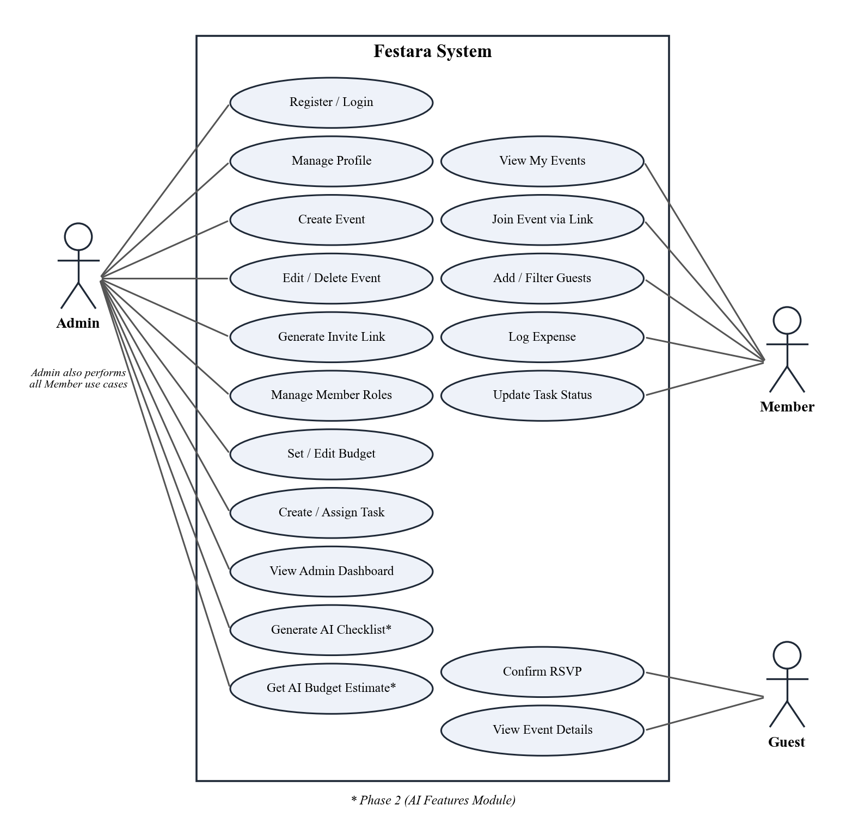
Figure 3.1: Use case diagram of Festara

3.5 Use Cases
Simple use cases such as login and profile update do not need full descriptions. The five use cases below were selected for full-dress description because they carry the core logic of the system: creating the event that everything else depends on, granting access through invite links, controlling roles, logging money against the budget, and recording guest responses.

3.5.1 Use Case 1: Create Event
Creating an event is the starting point for every other feature, and it is where the first role assignment happens. Table 3.4 describes it.
Table 3.4: Full Dress Use Case for Create Event
Use Case ID / Name | UC-01: Create Event
Scope | Festara web application
Level | User goal
Primary Actor | Registered user (becomes Admin)
Stakeholders and Interests | Organizer: wants a shared space ready quickly.  Future members: want accurate event details.
Preconditions | User is logged in.
Success Guarantee | A new event is stored and the user is recorded as its Admin in event_members.
Main Success Scenario | 1. User selects "Create Event" on the home dashboard.  2. System shows the event form.  3. User enters name, type, date, location, description, and total budget.  4. System validates the input.  5. System saves the event and adds the user as Admin.  6. System opens the new event's page.
Extensions | 4a. A required field is empty or the budget is negative: system highlights the field and keeps the entered data.  4b. The date is in the past: system shows a warning and asks the user to confirm.
Special Requirements | Form must work on a 360 px wide screen; save must complete within 2 seconds on a 4G connection.
Related Requirements | FR-05, FR-06, FR-09

3.5.2 Use Case 2: Join Event via Invite Link
Invite links are the only way users gain access to an event, so this use case is central to access control. It is detailed in Table 3.5.
Table 3.5: Full Dress Use Case for Join Event via Invite Link
Use Case ID / Name | UC-02: Join Event via Invite Link
Scope | Festara web application
Level | User goal
Primary Actor | Invitee (future Member or Guest)
Stakeholders and Interests | Admin: wants only invited people to join, with the right role.  Invitee: wants to join with as little effort as possible.
Preconditions | Admin has generated an invite link for a role; invitee has the link.
Success Guarantee | Invitee is a member of the event with the role encoded in the link.
Main Success Scenario | 1. Invitee opens the invite link.  2. System asks the invitee to log in or register if they are not signed in.  3. System checks that the token exists and has not expired.  4. System adds the invitee to event_members with the link's role.  5. System redirects the invitee to the event page showing the features allowed for that role.
Extensions | 3a. Token unknown or expired: system shows "This invite link is invalid or has expired" and asks the user to contact the Admin.  4a. Invitee is already a member: system keeps the existing role and opens the event.
Special Requirements | Tokens must be random and unguessable; links expire after 7 days by default.
Related Requirements | FR-10, FR-11, FR-12

3.5.3 Use Case 3: Manage Member Roles
Admins must be able to correct mistakes and respond to changes, such as promoting a trusted relative or removing someone who left the trip. Table 3.6 describes this use case.
Table 3.6: Full Dress Use Case for Manage Member Roles
Use Case ID / Name | UC-03: Manage Member Roles
Scope | Festara web application
Level | User goal
Primary Actor | Admin
Stakeholders and Interests | Admin: wants control over who can change event data.  Members: want their access to be fair and predictable.
Preconditions | Admin is logged in and is Admin of the event.
Success Guarantee | The member's role is updated or the member is removed, and the change takes effect on their next request.
Main Success Scenario | 1. Admin opens the Members page of the event.  2. System lists members with their roles.  3. Admin selects a new role for a member, or selects Remove.  4. System asks for confirmation when removing.  5. System saves the change and refreshes the list.
Extensions | 3a. Admin tries to demote or remove the last remaining Admin: system blocks the action and explains that every event needs at least one Admin.  5a. A non-Admin calls the action directly: the database policy rejects it.
Special Requirements | Role changes must be enforced by the database, not only hidden in the interface.
Related Requirements | FR-13, FR-14

3.5.4 Use Case 4: Log Expense
Expense logging is the most frequent action during an event and drives the budget warning. Its detailed description is given in Table 3.7.
Table 3.7: Full Dress Use Case for Log Expense
Use Case ID / Name | UC-04: Log Expense
Scope | Festara web application
Level | User goal
Primary Actor | Member or Admin
Stakeholders and Interests | Member: wants a quick record of what they paid.  Admin: wants accurate totals and early warning of overspending.
Preconditions | User is a Member or Admin of the event; the event has a budget.
Success Guarantee | Expense is stored with the user as payer; totals and remaining balance are updated for all viewers.
Main Success Scenario | 1. User opens the Expenses page.  2. User selects "Add Expense".  3. User enters amount, category, description, and date.  4. System validates and saves the expense.  5. System recalculates total spent and remaining balance.  6. System pushes the update to other open sessions in real time.
Extensions | 4a. Amount is zero or negative: system rejects the entry.  5a. Total spent crosses 80 percent of the budget: system shows a warning banner to all members.  5b. Total spent exceeds the budget: system shows the overspent amount in red.
Special Requirements | Totals must be computed from stored data, never from client-side values.
Related Requirements | FR-18, FR-19, FR-20, FR-21

3.5.5 Use Case 5: Confirm RSVP
Guests interact with Festara only through this use case, so it must be simple. It is described in Table 3.8.
Table 3.8: Full Dress Use Case for Confirm RSVP
Use Case ID / Name | UC-05: Confirm RSVP
Scope | Festara web application
Level | User goal
Primary Actor | Guest
Stakeholders and Interests | Guest: wants to reply quickly.  Admin: wants an accurate headcount for catering and seating.
Preconditions | Guest has a valid guest invite link.
Success Guarantee | Guest's RSVP status is stored as Confirmed or Declined and reflected in the guest summary.
Main Success Scenario | 1. Guest opens the invite link.  2. System shows event name, date, and location.  3. Guest selects Confirm or Decline.  4. System saves the response and shows a thank-you message.
Extensions | 3a. Guest changes their mind later: guest reopens the link and changes the response before the event date.
Special Requirements | Page must load and be usable on a low-end smartphone.
Related Requirements | FR-16, FR-17

3.6 Non-Functional Requirements
Non-functional requirements describe how well the system performs its functions. Only the qualities relevant to Festara are listed, and each one has a measurable target so that it can be verified in Chapter 6.

3.6.1 Performance
Groups often use Festara on mobile data during the event itself, so pages must load quickly. The event dashboard shall reach Largest Contentful Paint in under 2.5 seconds on a simulated 4G connection, and create, update, and delete actions shall complete in under 1 second at the 95th percentile, measured with Lighthouse and Vercel analytics.

3.6.2 Reliability
Lost expense records would undermine trust in the whole system. Festara inherits the availability of Vercel and Supabase and targets at least 99.5 percent monthly availability. Every write shall either complete fully or fail with a visible error message, with no partially saved records; multi-step operations such as accepting an invite run inside a single database function.

3.6.3 Security
Festara stores personal data such as phone numbers and spending. All traffic shall use HTTPS. Passwords are hashed and managed by Supabase Auth and are never stored by the application [1]. Row Level Security shall be enabled on 100 percent of application tables, and a user who is not a member of an event shall receive zero rows when querying it directly. Invite tokens shall contain at least 128 bits of randomness and expire after 7 days by default.

3.6.4 Usability
Many users will be first-time, non-technical organizers. A new user shall be able to register, create an event, and share an invite link within 3 minutes without help, and the system shall achieve a System Usability Scale score of at least 70 in a trial with at least 10 users.

3.6.5 Consistency
All members must see the same numbers. Budget totals, guest counts, and task completion percentages shall be calculated from the database on each request or through real-time subscriptions, never cached on one client, so that two members viewing the same event at the same time see identical values within 2 seconds of a change.

3.6.6 Portability
The application shall work on the current versions of Chrome, Edge, Firefox, and Safari, and its layout shall remain usable on screen widths from 360 px to 1920 px, with no horizontal scrolling.

3.7 Resource Requirements

3.7.1 Equipment
The hardware and software tools used by the team, with the reason each was chosen, are given in Table 3.9.
Table 3.9: Equipment and Tools with Justification
Resource | Justification
Laptops (8 GB RAM or more), one per member | Sufficient for the Next.js dev server, editor, and browser; already owned by the team
Next.js 16 with TypeScript | Server components reduce client-side JavaScript; server actions remove the need for a separate API layer; types catch errors early
Supabase | Provides PostgreSQL, Auth, Realtime, and RLS in one free tier, removing the need to build and host a custom backend
Vercel | Native hosting for Next.js with automatic preview deployments for every pull request
Tailwind CSS | Fast, consistent, responsive styling without writing large stylesheets
GitHub | Shared repository, pull requests, and issue tracking for the backlog
Figma | High-fidelity prototypes reviewed with the supervisor before coding
OpenAI API (Phase 2) | Structured outputs return checklists and budget splits as reliable JSON [3]

3.7.2 Funds
The project is designed to run within free tiers. Supabase's free plan and Vercel's Hobby plan cover development and the expected demo usage. The only expected cost is OpenAI API usage in the second phase, which is billed per request and is expected to stay within a few US dollars during development and testing. A custom domain is optional.

3.7.3 Human Effort
The work is divided among the three team members as shown in Table 3.10. The total effort is estimated at 7.5 person-months over the two semesters of the project.
Table 3.10: Task Division and Human Effort
Team Member | Responsibilities | Effort (person-months)
Anas Altaf (MC-331), Team Lead | Architecture, database schema and RLS policies, RBAC and invite links, deployment, Expense and Budget module, sprint planning | 2.5
Hammad Ansar (MC-304) | Authentication module, UI design in Figma, Tailwind components, Guest List and RSVP module, Admin Dashboard | 2.5
Muhammad Sami Ullah (MC-336) | Event Management module, Task module, AI Features module, testing, and documentation | 2.5
Total |  | 7.5

3.8 Database Requirements
Festara needs a relational database because its data is highly connected: every guest, expense, task, and invitation belongs to an event, and every membership links a user to an event with a role. PostgreSQL, provided by Supabase, was selected because it supports foreign keys, enumerated types, transactions, and Row Level Security. The database shall:
- store user profiles linked one-to-one with Supabase Auth users;
- store events and the role of each user in each event, with a unique constraint so that a user holds only one role per event;
- store invitations with a unique random token, the role granted, and an expiry date;
- store guests, expenses, and tasks, each linked to an event by a foreign key with cascading delete, so that deleting an event removes all its data;
- use enumerated types for event type, role, RSVP status, expense category, and task status, so that invalid values cannot be stored;
- enforce access through RLS policies on every table, using a helper function that checks the current user's role in the event.
The complete schema is shown in the entity relationship diagram in Section 4.7, and each table is described in the data dictionary in Appendix I.

3.9 Project Feasibility

3.9.1 Technical Feasibility
The project is technically feasible. Every component uses mature, well-documented technology [1]–[4]. Supabase removes the need to build authentication and database hosting from scratch, and Next.js server actions remove the need for a separate API server. The team has prior coursework experience with React, SQL, and JavaScript. The system runs in any modern browser and does not need a powerful machine on either the development or the user side.

3.9.2 Operational Feasibility
Operationally, Festara replaces habits users already have rather than asking them to learn a new process. An organizer creates an event, shares a link in the family WhatsApp group as they already do, and members log expenses the moment they pay. The three roles mirror how groups already organize themselves. Because the application is web-based, there is nothing to install, which removes the largest barrier for older family members.

3.9.3 Economic Feasibility
Development uses free tiers of Supabase and Vercel and free open-source frameworks. The only variable cost, AI requests in the second phase, is small and can be limited per event. Festara is therefore economically feasible for a student project and remains free to its end users.

3.9.4 Legal and Ethical Feasibility
The system is legally and ethically feasible. It does not process payments, so it is not subject to financial licensing. It collects only the personal data needed to coordinate an event (name, email, phone number, and spending entries) and makes that data visible only to members of the same event through database-enforced policies. Users can delete their events, which removes all related records. Users with strict privacy requirements are informed that data is stored on cloud servers. The system is designed to help people and contains no feature that could be used to harm them.

3.10 Summary
This chapter defined 29 functional requirements across eight modules, of which the 14 requirements for authentication, event management, and access control are complete. Five use cases were described in full, and six measurable non-functional requirements were set for performance, reliability, security, usability, consistency, and portability. The resource, database, and feasibility analysis shows that the project can be completed with free tools and the team's existing skills.

Chapter 4
SYSTEM MODELLING

4.1 Introduction
System modelling turns the requirements of Chapter 3 into a design that can be built and checked. Diagrams make it possible to find gaps, such as a missing permission check or an orphaned table, before any code is written, and they give all three team members the same picture of the system. This chapter presents the overall architecture, the design approach, the interface design, data flow diagrams at levels 0 and 1, the 4+1 architectural views (logical, process, development, and physical), and the entity relationship diagram. The models cover the complete system, including modules that will be implemented after the 40 percent milestone.

4.2 System Design
Festara uses a three-tier, serverless architecture, shown in Figure 4.1. The presentation tier is the user's browser, which renders pages produced by Next.js. The application tier is the Next.js application hosted on Vercel; React Server Components fetch data on the server, and server actions handle every create, update, and delete request after validating input. The data tier is Supabase, which provides authentication, the PostgreSQL database protected by Row Level Security, and a Realtime service that pushes changes to open browser sessions. In the second phase, an AI route in the application tier will call the OpenAI API and stream responses back through the Vercel AI SDK [3], [4].
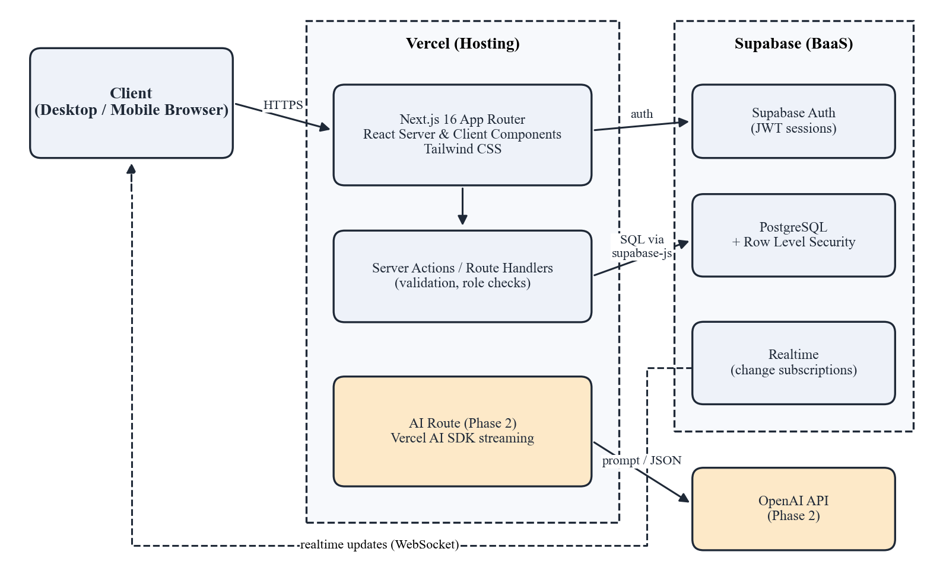
Figure 4.1: System architecture of Festara
A key design decision is that authorization lives in the data tier. The application tier also checks roles to show helpful messages, but the final decision is made by the database policies. This means that even if a user calls the Supabase API directly with their own session token, they cannot read or change data in an event they do not belong to [17].

4.3 Design Approach
The team adopted a top-down design approach. The system was first defined as a whole in the proposal, then decomposed into eight modules, then each module was broken into pages, server actions, and database tables. This approach suits Festara because the modules share a common core, the event and its members, that had to be designed first so that every later module could attach to it. Shared building blocks such as the Supabase client, the role-checking helper, and form validation schemas were identified during this decomposition and built once in a common library folder.

4.4 Interface Design
The interface was designed mobile-first, because most members will log expenses and check tasks on their phones. Navigation within an event uses a tab bar for Overview, Guests, Expenses, Tasks, and Members, and the tabs a user sees depend on their role. The visual style uses a light background, a single accent color, and large touch targets of at least 44 px.

4.4.1 High Fidelity Prototype
High-fidelity prototypes of the key screens were created in Figma and reviewed with the supervisor before development. Figure 4.2 shows the login and registration screen, Figure 4.3 shows the home dashboard listing the user's events, and Figure 4.4 shows the members and invite screen used by the Admin.
[ Insert screenshot: Figma prototype – Login / Register screen ]
Figure 4.2: Prototype of the login and registration screen
[ Insert screenshot: Figma prototype – Home dashboard (My Events) ]
Figure 4.3: Prototype of the home dashboard
[ Insert screenshot: Figma prototype – Event members and invite link ]
Figure 4.4: Prototype of the members and invite screen

4.5 Data Flow Diagrams
Data flow diagrams show how information moves between external entities, processes, and data stores, without showing control logic. Figure 4.5 is the level 0 (context) diagram. It treats Festara as a single process exchanging data with four external entities: the Admin, who supplies event details, budgets, role changes, and invites; the Member, who supplies guests, expenses, and task updates; the Guest, who returns RSVP responses; and the OpenAI API, which returns checklists and estimates in the second phase.
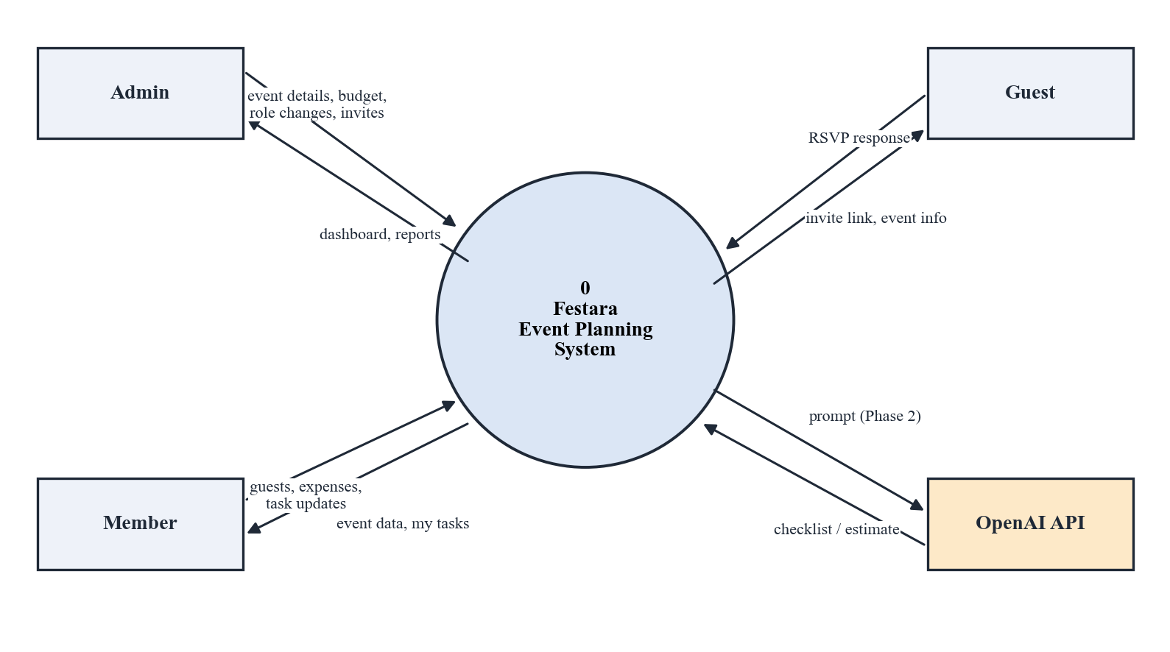
Figure 4.5: DFD level 0 (context diagram) of Festara
Figure 4.6 decomposes the system into six level 1 processes: authenticate user, manage event, manage roles and invites, manage guests and RSVP, track expenses and budget, and manage tasks. Each process reads from and writes to its own data store, and processes 4.0, 5.0, and 6.0 first perform a role check against the event_members store before accepting data.
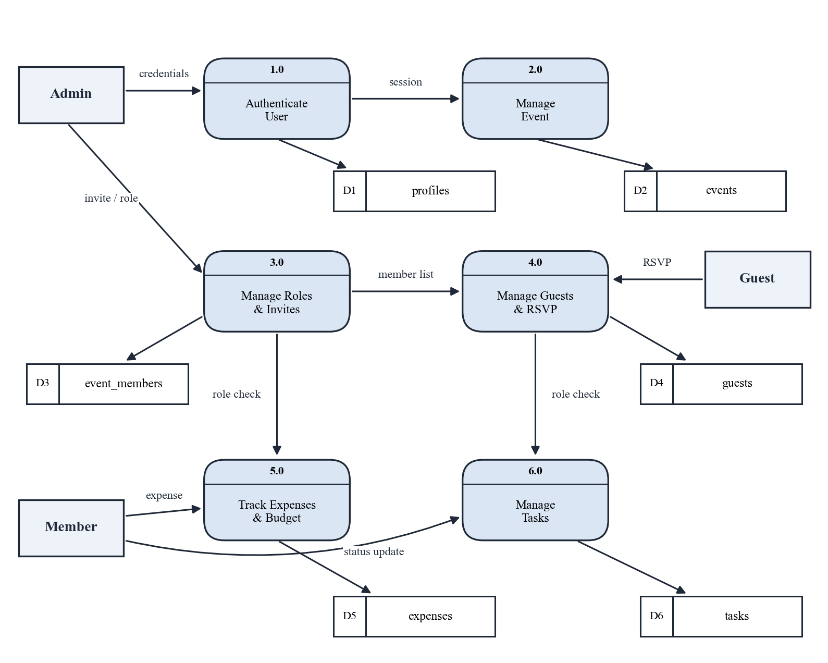
Figure 4.6: DFD level 1 of Festara

4.6 4+1 View Model of Architecture
The 4+1 view model describes a system's architecture from several viewpoints, each aimed at a different concern, tied together by the use case scenarios of Section 3.5. The logical, process, development, and physical views of Festara are presented below; the use case view was given in Figure 3.1.

4.6.1 Logical View
The logical view shows the main classes of the domain and their relationships. As shown in Figure 4.7, a User creates many Events, and the link between them is the EventMember class, which holds the user's role and provides the can(action) check used throughout the system. An Event issues Invitations and owns its Guests, Expenses, and Tasks. BudgetSummary is a computed class that aggregates expenses to give the remaining balance and the usage percentage that triggers the 80 percent warning. ActivityLog records every change for the Admin dashboard.
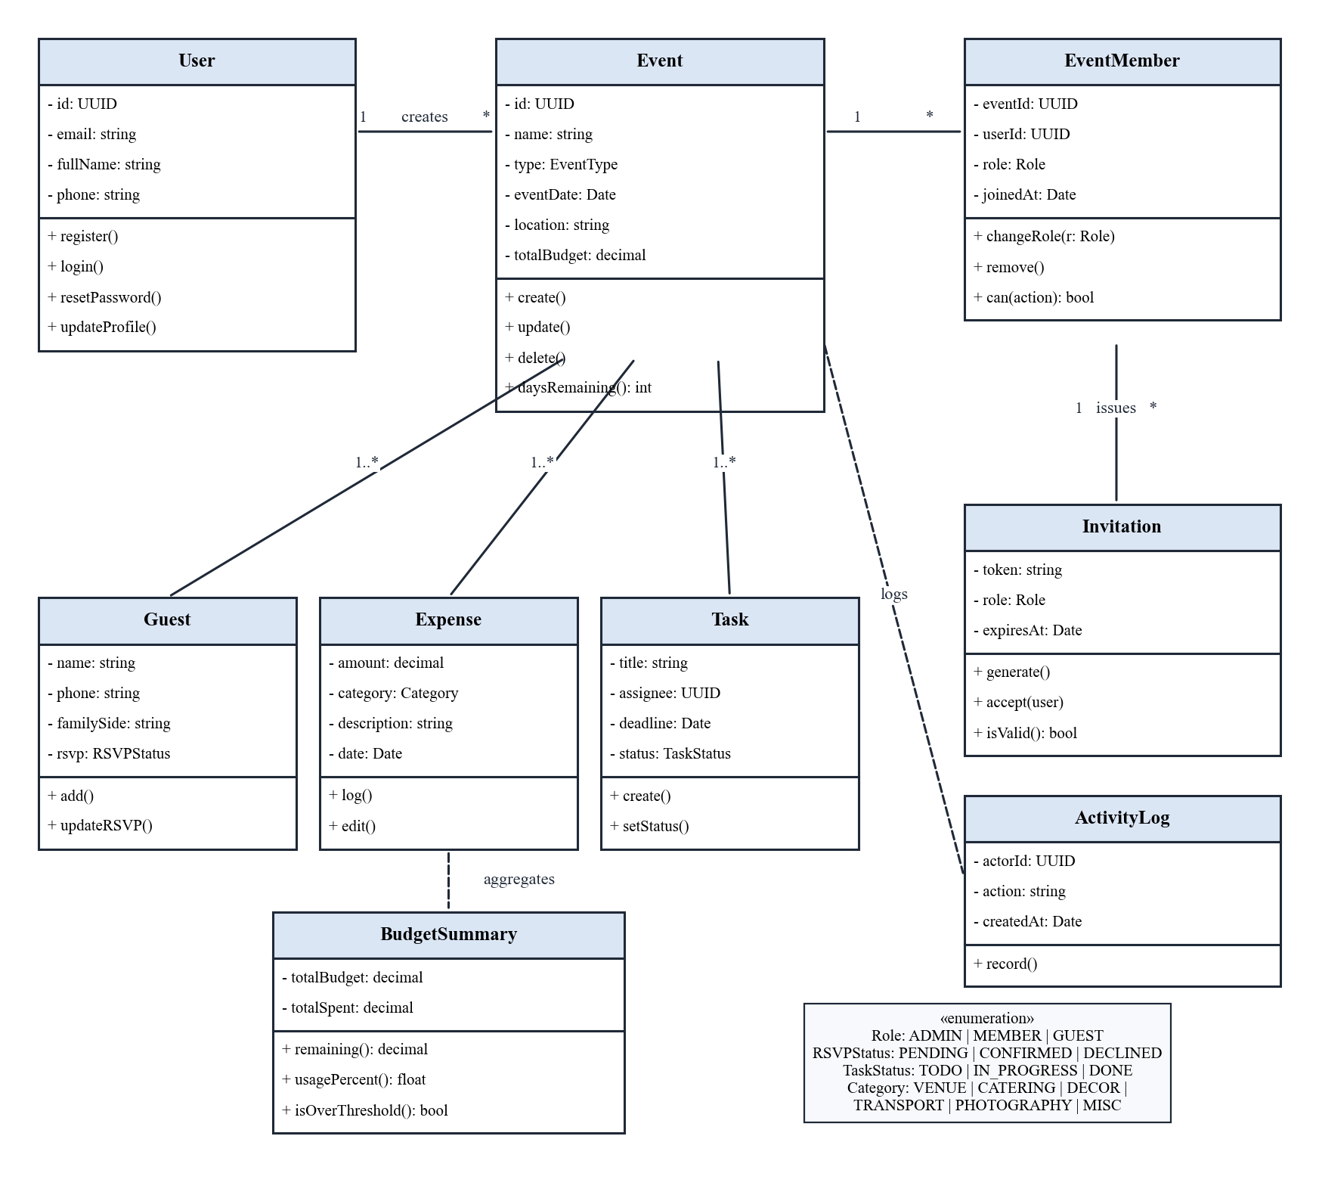
Figure 4.7: Class diagram of Festara

4.6.2 Process View
The process view describes the system's behavior at run time. Figure 4.8 is an activity diagram of the most important workflow at this milestone: an Admin creating an event and an invitee joining it through a link. It shows the two decision points, form validation and token validation, and the alternate paths when either fails.
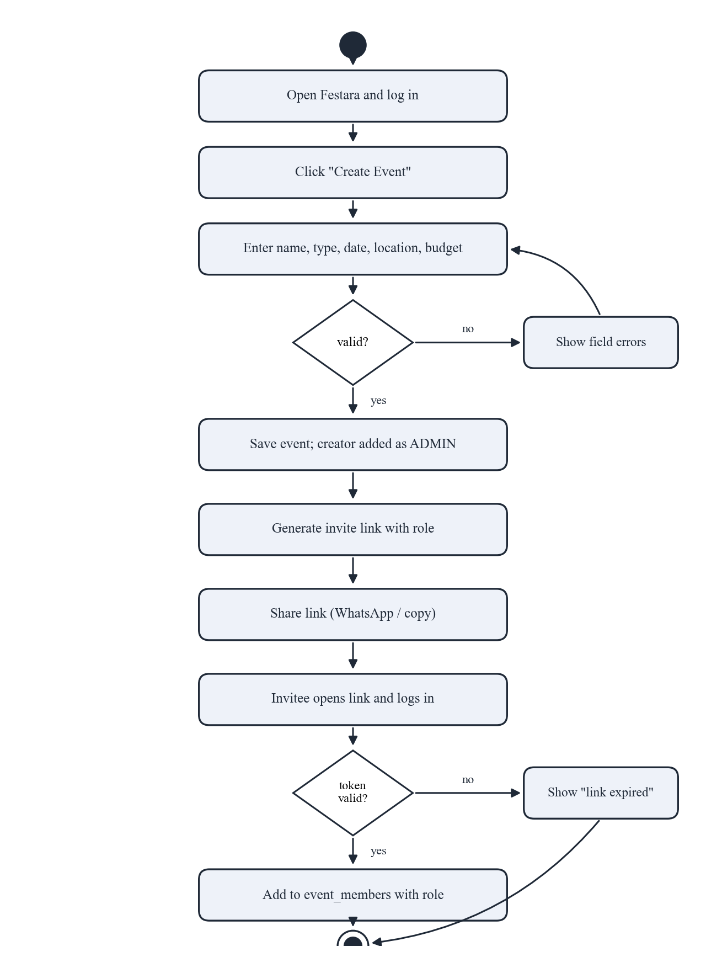
Figure 4.8: Activity diagram for creating an event and joining through an invite link
Figure 4.9 is a state diagram for a task. A task is created in the To Do state, moves to In Progress when the assigned member starts it, can move back if paused, and reaches Done when completed. An Admin can reopen a completed task.
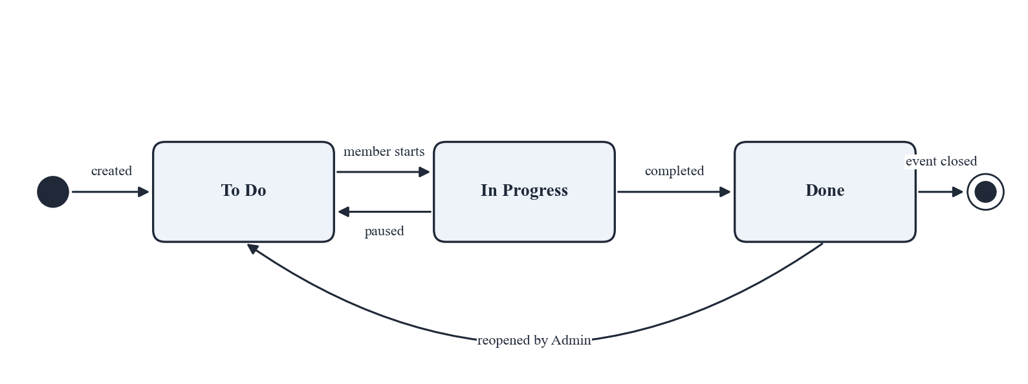
Figure 4.9: State diagram of a task
Figure 4.10 is a sequence diagram for accepting an invitation. The browser sends the token to a server action, which obtains the current user from Supabase Auth and then calls a database function. The function looks up the invitation, checks its expiry, and inserts the membership in one transaction. Row Level Security confirms the insert before the user is redirected to the event.
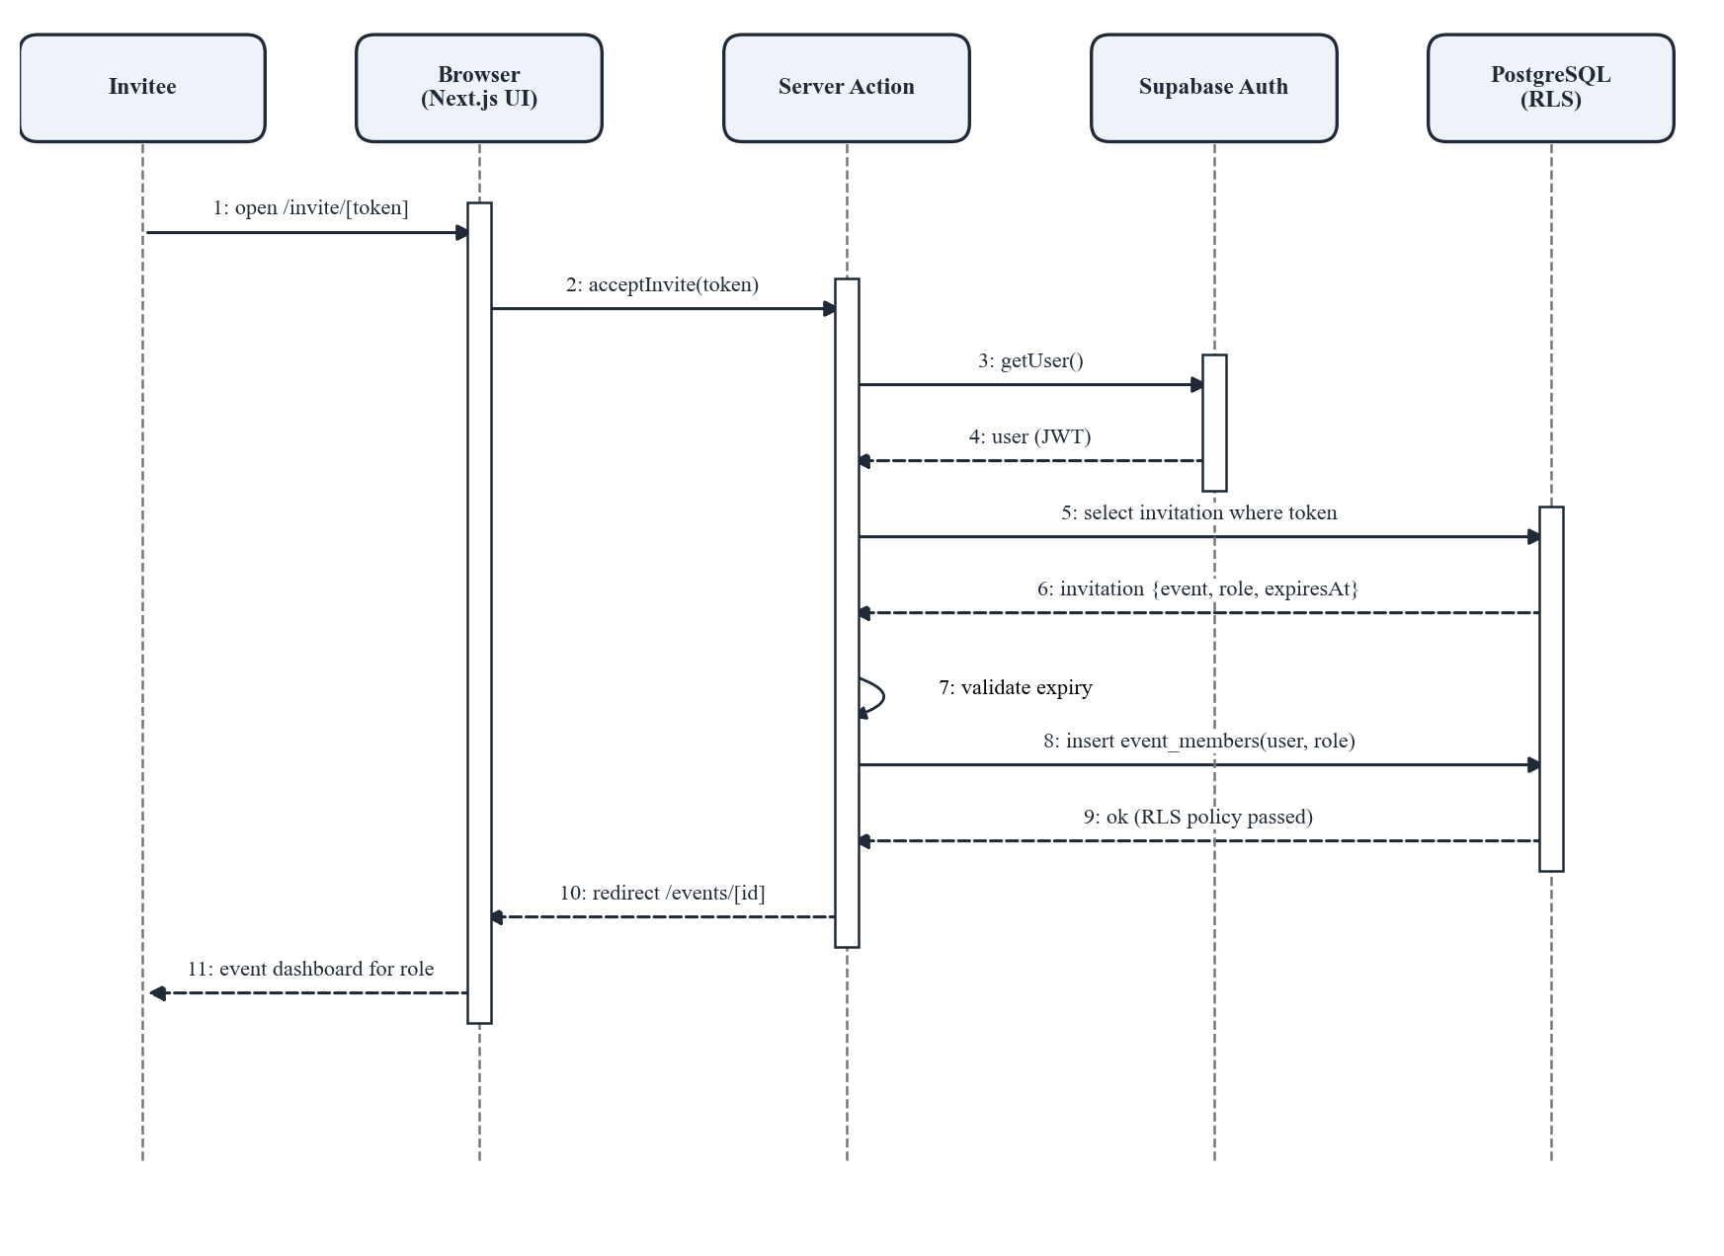
Figure 4.10: Sequence diagram for accepting an invitation

4.6.3 Development View
The development view shows how the software is organized into components. As Figure 4.11 shows, the Next.js application is split into user interface components for each module, which all depend on a shared library containing the Supabase client, the role guard, validation schemas, and server actions. The library is the only component that talks to Supabase Auth and the database. The AI module is a separate component that will call the OpenAI API.
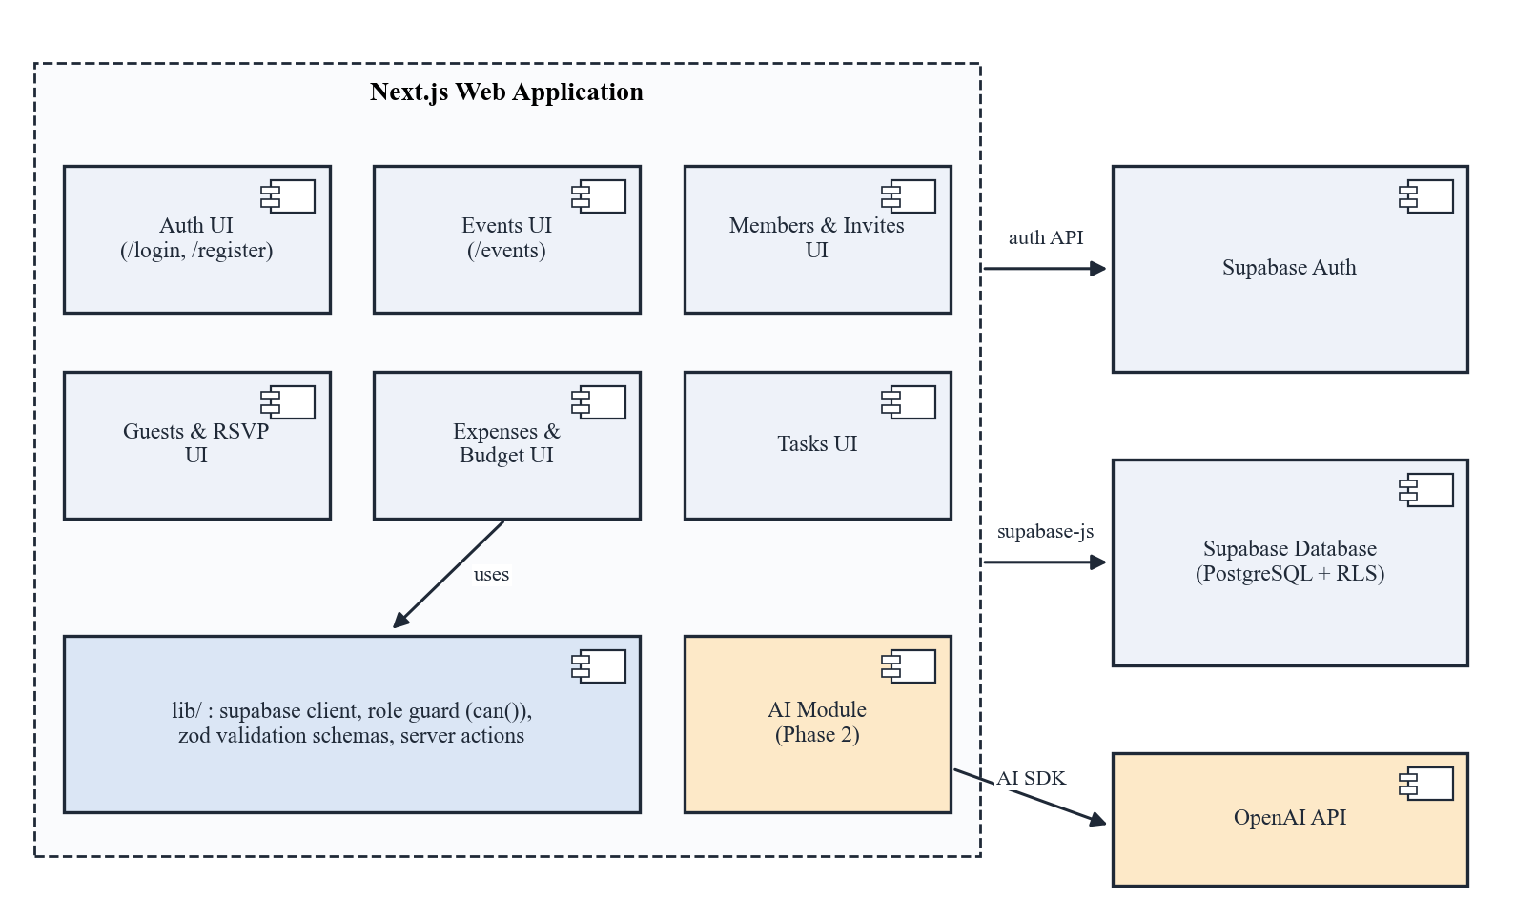
Figure 4.11: Component diagram of Festara

4.6.4 Physical View
The physical view shows where the software runs. As Figure 4.12 shows, the user's browser downloads the Festara interface from Vercel, where the Next.js build and server actions run on Vercel's edge and serverless infrastructure. Server actions communicate with the managed Supabase project over HTTPS, and browsers keep a secure WebSocket connection to Supabase Realtime for live updates.
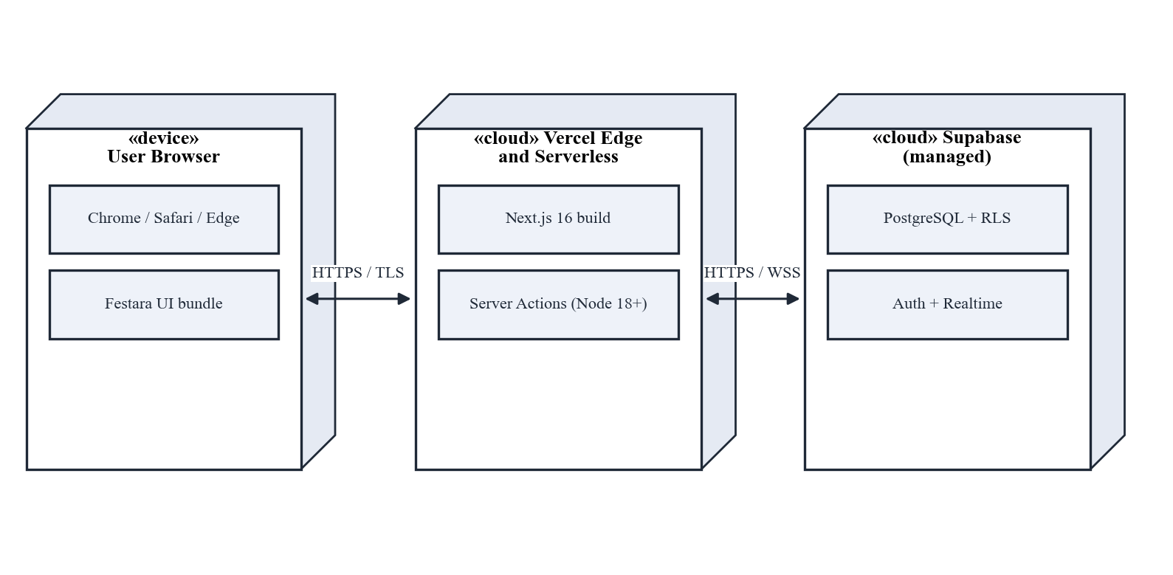
Figure 4.12: Deployment diagram of Festara

4.7 Entity Relationship Diagram
Figure 4.13 shows the database schema. The events table is the hub: event_members, invitations, guests, expenses, tasks, and activity_log each reference it through an event_id foreign key with cascading delete. The profiles table extends Supabase's built-in auth.users table and is referenced by the creator, member, payer, assignee, and actor columns. The pair (event_id, user_id) in event_members is unique, which guarantees a single role per user per event.
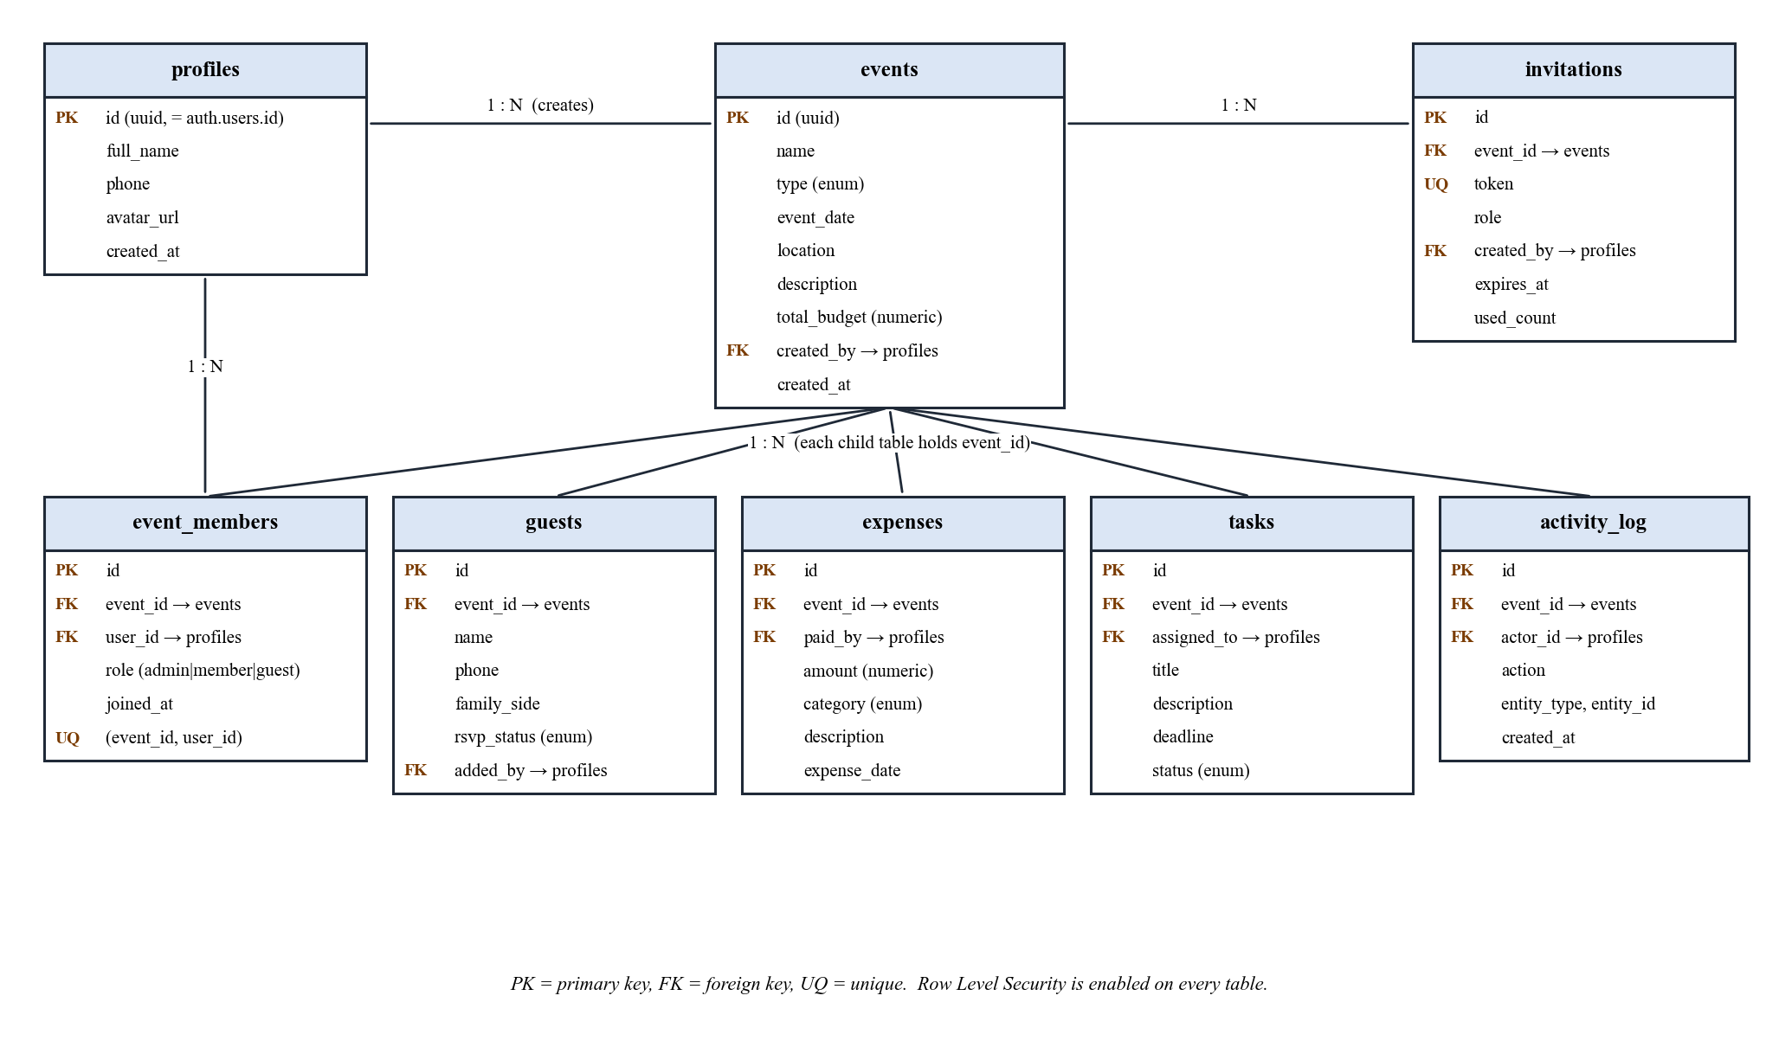
Figure 4.13: Entity relationship diagram of Festara

4.8 Summary
This chapter presented Festara's three-tier serverless architecture and the top-down design approach used to decompose it. The interface design was shown through high-fidelity prototypes, data movement through level 0 and level 1 DFDs, and the architecture through the logical, process, development, and physical views. The entity relationship diagram defines a schema in which every record belongs to an event and every access is checked against the user's role in that event.

Chapter 5
IMPLEMENTATION

5.1 Introduction
This chapter describes how the design of Chapter 4 has been implemented up to the 40 percent milestone. It first describes the development environment and project structure, then explains the three completed modules, User Authentication, Event Management, and Role-Based Access Control, including the key algorithms and the libraries and services used. It then summarizes the implementation plan for the remaining modules.

5.2 Development Environment and Project Structure
The application is a single Next.js 16 project written in TypeScript and kept in a shared GitHub repository. Every push to the main branch deploys automatically to Vercel, and every pull request receives its own preview URL that the team uses for review. The database schema is managed as SQL migration files in the repository, so that the schema can be recreated in a fresh Supabase project. Table 5.1 shows the main folders.
Table 5.1: Project Folder Structure
Folder | Contents
app/(auth)/ | Login, register, forgot-password, and reset-password pages
app/events/ | Home dashboard, create-event form, and the [id] route for each event with its tabs
app/invite/[token]/ | Invite acceptance page
components/ | Reusable UI components: buttons, forms, cards, dialogs, role badges
lib/supabase/ | Server and browser Supabase clients and the session middleware
lib/actions/ | Server actions for profiles, events, invitations, and members
lib/validation/ | Zod schemas shared by forms and server actions
supabase/migrations/ | SQL files for tables, enums, functions, and RLS policies

5.3 Modules of the FYP

5.3.1 User Authentication Module
Authentication is implemented with Supabase Auth using email and password [1]. When a user registers, Supabase creates a record in auth.users and sends a confirmation email; a database trigger then creates a matching row in the profiles table with the user's full name. Login returns a session that is stored in secure, HTTP-only cookies by the @supabase/ssr helper, and a Next.js middleware refreshes the session on each request so that server components always know the current user. Pages under /events redirect to /login when there is no session, and the original destination is kept so the user returns to it after logging in. Password reset uses Supabase's emailed recovery link, which opens the reset page where the user sets a new password. The profile page lets users update their name and phone number through a server action that validates the input with a Zod schema. Figure 5.1 shows the implemented login screen.
[ Insert screenshot: Implemented login page ]
Figure 5.1: Implemented login screen

5.3.2 Event Management Module
The home dashboard is a server component that queries the events joined through event_members for the current user and displays each event as a card with its name, type, date, days remaining, and the user's role badge. Because of Row Level Security, the query only ever returns the user's own events, so no filtering by user is needed in the application code.
The create-event form collects the name, type, date, location, description, and total budget. Event type is selected from a fixed list (Wedding, Engagement, Mehndi, Walima, Birthday, Eid Gathering, Trip, University Event, and Other) that matches a PostgreSQL enumerated type. The server action validates the input, inserts the event, and inserts the creator into event_members as Admin. Both inserts run in a single database function so that an event can never exist without an Admin. Editing and deleting are available only to Admins; deletion asks for confirmation by having the user type the event name, and cascading foreign keys remove all related data. Figure 5.2 shows the create-event form.
[ Insert screenshot: Implemented create-event form ]
Figure 5.2: Implemented create-event form

5.3.3 Role-Based Access Control Module
Access control follows core RBAC [15], with roles scoped to an event. The permissions of each role are given in Table 5.2. Permissions are enforced in two layers: a can(role, action) helper in the application decides which buttons and tabs to show, and PostgreSQL Row Level Security policies make the final decision in the database [17].
Table 5.2: Role Permission Matrix
Action | Admin | Member | Guest
View event details | Yes | Yes | Basic only
Edit or delete event, set budget | Yes | No | No
Generate invite links | Yes | No | No
Change roles or remove members | Yes | No | No
Add guests | Yes | Yes | No
Log expenses | Yes | Yes | No
Create and assign tasks | Yes | No | No
Update status of own tasks | Yes | Yes | No
Confirm own RSVP | Yes | Yes | Yes
View admin dashboard and activity log | Yes | No | No
All policies use a single helper function, has_role, which checks whether the current user holds a given role in a given event. The function runs with security definer rights so that it can read event_members without triggering that table's own policies recursively. Figure 5.3 shows the function and two of the policies on the events table.
create function public.has_role(eid uuid, r public.member_role)
returns boolean language sql stable security definer
set search_path = public as $$
select exists (
select 1 from event_members
where event_id = eid and user_id = auth.uid()
and (role = r or role = 'admin'));
$$;

alter table events enable row level security;

create policy "members read their events" on events
for select using (exists (select 1 from event_members m
where m.event_id = events.id and m.user_id = auth.uid()));

create policy "only admins update events" on events
for update using (public.has_role(id, 'admin'));
Figure 5.3: Role helper function and Row Level Security policies on the events table
Invite link algorithm. When an Admin generates an invite, the server creates a token from 16 cryptographically random bytes (128 bits) encoded as a URL-safe string, stores it in the invitations table with the chosen role and an expiry 7 days ahead, and returns the link /invite/[token]. When the invitee opens the link, the steps are:
- If the visitor is not logged in, redirect to /login and keep the invite URL as the return destination.
- Call the database function accept_invitation(token), which looks up the invitation and locks the row.
- If no row is found, or expires_at is in the past, return an error; the page shows "This invite link is invalid or has expired."
- If the user is already a member, keep their current role; otherwise insert a row into event_members with the invitation's role.
- Increment used_count, commit the transaction, and redirect to the event page.
Running steps 2 to 5 in one database function keeps the operation atomic, so two people opening the link at the same moment cannot create inconsistent data. Figure 5.4 shows the server action that starts the process.
export async function acceptInvite(token: string) {
const supabase = await createClient();
const { data: { user } } = await supabase.auth.getUser();
if (!user) redirect(`/login?next=/invite/${token}`);

const { data: eventId, error } = await supabase
.rpc("accept_invitation", { p_token: token });
if (error) return { error: "This invite link is invalid or has expired." };

redirect(`/events/${eventId}`);
}
Figure 5.4: Server action for accepting an invitation
On the Members page, the Admin sees every member with a role selector and a remove button. The change-role and remove actions refuse to demote or remove the last Admin of an event; this rule is checked both in the server action and in a database trigger. Figure 5.5 shows the implemented members screen.
[ Insert screenshot: Implemented members and invite page ]
Figure 5.5: Implemented members and invite screen

5.3.4 Planned Implementation of Remaining Modules
The remaining modules reuse the same pattern of server actions, validation schemas, and RLS policies, so most of the infrastructure is already in place. Their planned implementation is summarized below.
- Guest List and RSVP: a guests table with RLS allowing Admins and Members to insert; a guest invite link that opens a public RSVP page; summary counts computed with a grouped SQL query; filters by family side and status.
- Expense and Budget Tracking: an expenses table with paid_by set from the session; a database view that returns total spent, remaining balance, and usage percentage; the warning appears when usage is at least 80 percent; Supabase Realtime subscriptions refresh totals on every open screen; breakdown charts by member and category.
- Tasks and Arrangements: a tasks table with a status enum; an update policy that lets the assignee change only the status column; a personal "My Tasks" view; completion percentage calculated as Done tasks divided by all tasks.
- Admin Dashboard: a single server component that runs the summary queries in parallel; an activity_log table filled by database triggers on insert, update, and delete.
- AI Features (Phase 2): a route handler that sends the event type and guest count to the OpenAI API with a JSON schema for structured output [3], streams the checklist to the browser with the Vercel AI SDK [4], and lets the Admin turn items into tasks with one click.

5.4 H/W Module Details
Festara is a software-only system and has no hardware module.

5.5 Summary
The foundation of Festara is in place. Users can register, log in, reset their password, and manage their profile; they can create, edit, and delete events; and access to every event is controlled by per-event roles, invite links, and database-enforced Row Level Security policies. The remaining modules will be built on this foundation using the same structure.

Chapter 6
RESULT / TESTING, ANALYSIS AND VALIDATION

6.1 Introduction
This chapter describes how the implemented modules are tested and how the results are recorded. It explains the testing techniques chosen and the reason for each, presents the test cases for the authentication, event management, and access control modules, and sets out how the non-functional requirements of Section 3.6 will be measured. Test cases are traced to the functional requirements of Table 3.3.

6.2 Testing Strategy

6.2.1 Testing Environment
Tests are run on the deployed Vercel preview of each pull request, connected to a separate Supabase test project so that test data never mixes with demo data. Functional tests are run on a laptop with an Intel Core i5 processor and 8 GB RAM in the latest Chrome browser, and on an Android smartphone in Chrome to check mobile layouts.

6.2.2 Black Box Testing
Black box testing checks the system's behavior against its requirements without looking at the code. It is the main technique for Festara because the requirements in Table 3.3 describe visible behavior, such as a validation message or a redirect, that a tester can check directly. Each test case is executed by a team member who did not write the feature, using equivalence partitioning and boundary values for inputs such as the budget and the invite expiry date.

6.2.3 Unit Testing
Unit testing checks individual functions in isolation. The Zod validation schemas and the can(role, action) permission helper are tested with Vitest, because a mistake in these small functions would affect every module. Each role and action pair in Table 5.2 has a unit test.

6.2.4 Integration Testing
Integration testing checks that components work correctly together. The invite flow is the main target, because it crosses the browser, a server action, Supabase Auth, and a database function. The test creates two users, generates an invite as the first user, accepts it as the second, and checks the resulting membership and visible pages.

6.2.5 Security Testing of Access Policies
Because authorization is enforced by Row Level Security, the policies are tested directly against the database rather than only through the interface. A script signs in as users with each role, and as a user outside the event, and attempts every select, insert, update, and delete on each table using the Supabase client. The expected outcome for every attempt is derived from Table 5.2; any attempt that succeeds when it should fail is recorded as a defect.

6.3 Test Cases
Eleven test cases were designed for the modules completed at this milestone, prioritized by risk: tests for access control and invite handling were written first because a failure there would expose private data. Table 6.1 shows one test case in the full department format, and Table 6.2 summarizes all test cases. The Actual Result and Status columns are filled in as each test is executed.

6.3.1 Test Case TC-07: Join Event via Valid Invite Link
This test case verifies the most important flow at this milestone: that a second user can join an event with exactly the role chosen by the Admin. Its details are given in Table 6.1.
Table 6.1: Test Case TC-07 in Full Format
Test Stage | Integration
Test Date | __//____
Tester | Muhammad Sami Ullah
Test Case Number | TC-07
Test Case Description | Verifies that a user opening a valid Member invite link is added to the event as a Member.
Requirement(s) Tested | FR-10, FR-11, FR-14
Roles and Responsibilities | Tester executes steps; Anas Altaf (Team Lead) verifies database rows.
Set Up Procedures | Two registered test accounts (User A, User B) on the Supabase test project; User A has created an event.
Stop Procedures | Log out both users; delete the test event.
Hardware | Laptop (Core i5, 8 GB RAM)
Software | Chrome (latest), Vercel preview deployment, Supabase test project
Input Specifications | Event created by User A; invite role = Member; expiry = 7 days.
Procedural Steps | 1. Log in as User A and open the event's Members page.  2. Generate a Member invite link and copy it.  3. Log out and log in as User B.  4. Open the copied link.  5. Check User B's dashboard and the event's Members page.
Expected Results | User B is redirected to the event; the event appears on User B's dashboard with a Member badge; User A sees User B listed as Member; User B cannot see the Edit Event button.
Actual Results
Status (Pass / Fail)
Table 6.2: Summary of Test Cases
ID | Req. | Test Case | Steps / Input | Expected Result | Actual Result | Status
TC-01 | FR-01 | Register with valid details | Enter new name, email, password (8+ chars); submit | Account created; confirmation email sent; profile row created
TC-02 | FR-02 | Login with wrong password | Enter registered email and wrong password | Error "Invalid login credentials"; no session created
TC-03 | FR-03 | Password reset | Request reset; open emailed link; set new password | Login succeeds with the new password only
TC-04 | FR-05, FR-06 | Create event with valid data | Fill all fields; budget 50,000; submit | Event saved; creator listed as Admin; event page opens
TC-05 | FR-05 | Create event with negative budget | Enter budget -100; submit | Validation error on budget field; nothing saved
TC-06 | FR-07, FR-14 | Member tries to edit event | Log in as Member; call update action directly | Request rejected; event unchanged
TC-07 | FR-10, FR-11 | Join event via valid invite link | Admin creates Member link; second user opens it | Second user added as Member; event visible on their dashboard
TC-08 | FR-12 | Open expired invite link | Set expires_at in the past; open link | Message "invalid or has expired"; no membership created
TC-09 | FR-13 | Admin demotes the last Admin | Sole Admin selects Member for themself | Action blocked with explanation; role unchanged
TC-10 | FR-14 | Non-member reads event directly | Using a valid session of a non-member, query events by id via Supabase API | Zero rows returned
TC-11 | FR-08 | Admin deletes event | Admin deletes event and confirms with event name | Event and all member rows removed; event gone from all dashboards

6.4 Validation of Non-Functional Requirements
Each non-functional requirement from Section 3.6 is validated with a specific tool and target, as listed in Table 6.3. Performance and portability are measured at this milestone on the implemented screens; usability will be measured in a user trial once the guest, expense, and task modules are complete, because a meaningful trial needs the full planning workflow.
Table 6.3: Non-Functional Requirement Validation Plan
Requirement | Metric | Target | Method / Tool
Performance | Largest Contentful Paint; action response time (p95) | < 2.5 s on 4G; < 1 s | Lighthouse (mobile, simulated 4G); Vercel analytics
Reliability | Monthly availability; partial writes | >= 99.5%; 0 | Vercel / Supabase status; transaction tests
Security | Tables with RLS; rows leaked to non-members | 100%; 0 | Supabase security advisor; policy test script (Section 6.2.5)
Usability | Time to create event and share invite; SUS score | < 3 min; >= 70 | Timed trial and SUS questionnaire with 10+ users
Consistency | Delay before change appears for another member | < 2 s | Two browsers observing the same event
Portability | Supported browsers; usable widths | 4 browsers; 360–1920 px | Manual test in Chrome, Edge, Firefox, Safari; responsive mode

6.5 Summary
Festara is tested with black box, unit, integration, and direct database security testing. Eleven test cases cover the completed modules and trace back to fourteen functional requirements, with particular attention to the invite flow and Row Level Security, where a defect would have the greatest impact. Each non-functional requirement has a measurable target and a defined method of validation. The test results will be recorded in Table 6.2 and summarized in the final report.

Chapter 7
CONCLUSION AND FUTURE WORK

7.1 Introduction
This chapter reviews the progress of Festara against the objectives set in Chapter 1, presents the plan for the remaining work, and states the limitations of the system and directions for future development.

7.2 Progress Review against Objectives
At the 40 percent milestone, the requirements and the design of the complete system are finished, and the three foundation modules on which all other modules depend are implemented and deployed. Table 7.1 compares each objective from Section 1.4 with its current status.
Table 7.1: Progress against Project Objectives
# | Objective | Status
1 | Secure registration, login, password reset, and profile management | Completed
2 | Create, edit, and delete events with budget | Completed
3 | Admin, Member, and Guest roles enforced on every action | Completed (database-enforced through RLS)
4 | Guest list, invite links, and RSVP tracking | Invite links completed; guest list and RSVP planned
5 | Expense logging with 80 percent budget warning | Designed; implementation planned
6 | Task assignment with deadlines and status | Designed; implementation planned
7 | Admin dashboard with summary and activity log | Designed; implementation planned
8 | AI checklist and budget estimator | Phase 2

7.3 Remaining Work and Timeline
The remaining work is scheduled in two-week sprints, as shown in Figure 7.1. Guest List and RSVP is next, because it extends the invite links already built. Expense and Budget Tracking follows, since it is the feature users asked about most. Tasks and the Admin Dashboard come after that, and the AI features are developed last, followed by a final round of testing, the usability trial, and the final report.
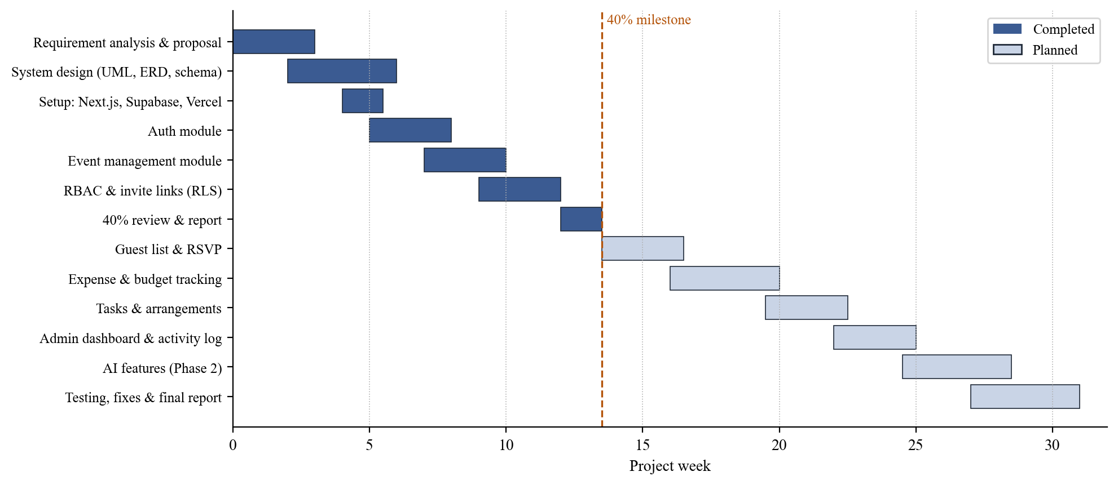
Figure 7.1: Project timeline showing completed and planned work

7.4 Limitations
- Festara records spending but does not transfer money between users; settling up still happens outside the app.
- An active internet connection is required; there is no offline mode in the first release.
- Guest invitations are link-based only; there is no direct SMS or WhatsApp sending in the first phase.
- The system is a web application only; there is no dedicated iOS or Android app in the initial release.
- The AI features depend on the availability of the OpenAI API and carry a per-request cost [3].
- Data is stored on cloud servers, so users with strict data-residency requirements must review the privacy policy before use.

7.5 Future Work
- Integrate WhatsApp Business messaging to send invites and RSVP reminders directly.
- Add a settle-up view that calculates the minimum set of payments between members, similar to Splitwise [10].
- Make the application installable as a Progressive Web App with offline caching of the guest list and task list.
- Add Urdu language support and right-to-left layout for wider use by Pakistani families.
- Offer reusable event templates, such as a standard Mehndi or trip checklist, based on anonymized data from completed events.

7.6 Summary
Festara has reached its 40 percent milestone with a complete specification and design and a deployed foundation of authentication, event management, and database-enforced role-based access. The remaining modules have a clear plan and reuse the patterns already in place. When complete, Festara will give families, friend groups, and student societies a free, shared workspace for planning events together, which the existing tools reviewed in Chapter 2 do not provide.

APPENDIX I: DATA DICTIONARY
This appendix describes the columns of each table in the Festara database. All tables have Row Level Security enabled. Timestamps use the timestamptz type and default to now().

profiles
Column | Type | Constraints | Description
id | uuid | PK, FK → auth.users | Same id as the Supabase Auth user
full_name | text | not null | Display name
phone | text | nullable | Contact number
avatar_url | text | nullable | Profile picture URL
created_at | timestamptz | default now() | Creation time

events
Column | Type | Constraints | Description
id | uuid | PK | Event identifier
name | text | not null | Event name
type | event_type | enum | Wedding, Engagement, Mehndi, Walima, Birthday, Eid Gathering, Trip, University Event, Other
event_date | date | not null | Date of the event
location | text | nullable | Venue or destination
description | text | nullable | Free-text details
total_budget | numeric(12,2) | >= 0 | Planned budget in PKR
created_by | uuid | FK → profiles | Creator
created_at, updated_at | timestamptz |  | Audit times

event_members
Column | Type | Constraints | Description
id | uuid | PK
event_id | uuid | FK → events, cascade
user_id | uuid | FK → profiles
role | member_role | enum: admin, member, guest | Role in this event
joined_at | timestamptz
(event_id, user_id) |  | unique | One role per user per event

invitations
Column | Type | Constraints | Description
id | uuid | PK
event_id | uuid | FK → events, cascade
token | text | unique, not null | 128-bit random URL-safe token
role | member_role | member or guest | Role granted on acceptance
created_by | uuid | FK → profiles | Admin who generated it
expires_at | timestamptz | default now() + 7 days
used_count | integer | default 0 | Times accepted

guests
Column | Type | Constraints | Description
id | uuid | PK
event_id | uuid | FK → events, cascade
name | text | not null
phone | text | nullable
family_side | text | nullable | e.g. bride's family, groom's family
rsvp_status | rsvp_status | enum, default pending | pending, confirmed, declined
added_by | uuid | FK → profiles

expenses
Column | Type | Constraints | Description
id | uuid | PK
event_id | uuid | FK → events, cascade
paid_by | uuid | FK → profiles | Set from the session
amount | numeric(12,2) | > 0 | Amount in PKR
category | expense_category | enum | venue, catering, decor, transport, photography, misc
description | text | nullable
expense_date | date | not null

tasks
Column | Type | Constraints | Description
id | uuid | PK
event_id | uuid | FK → events, cascade
assigned_to | uuid | FK → profiles, nullable
title | text | not null
description | text | nullable
deadline | date | nullable
status | task_status | enum, default todo | todo, in_progress, done

activity_log
Column | Type | Constraints | Description
id | bigint | PK, identity
event_id | uuid | FK → events, cascade
actor_id | uuid | FK → profiles | Who made the change
action | text | not null | insert, update, delete
entity_type, entity_id | text, uuid |  | Which record changed
created_at | timestamptz | default now()

APPENDIX II: USER MANUAL (COMPLETED MODULES)

Registering and Logging In
- Open the Festara website and select Register.
- Enter your full name, email, and a password of at least 8 characters, then select Create Account.
- Open the confirmation email and select the link. You can now log in with your email and password.
- If you forget your password, select Forgot Password on the login page and follow the emailed link.

Creating an Event
- On the My Events page, select Create Event.
- Enter the event name, choose its type, and enter the date, location, description, and total budget.
- Select Save. You are now the Admin of the event.

Inviting People
- Open the event and go to the Members tab.
- Choose the role (Member or Guest) and select Generate Link.
- Copy the link and share it, for example in your family WhatsApp group. The link works for 7 days.
- To change someone's role, choose a new role next to their name. To remove them, select Remove and confirm.

REFERENCES
[1] Supabase Inc., "Supabase Documentation - Database, Auth, and Realtime," 2024. [Online]. Available: https://supabase.com/docs. [Accessed: Apr. 2025].
[2] Vercel Inc., "Next.js Documentation - App Router and Server Components," 2024. [Online]. Available: https://nextjs.org/docs. [Accessed: Apr. 2025].
[3] OpenAI, "OpenAI API Reference - Chat Completions and Structured Outputs," 2024. [Online]. Available: https://platform.openai.com/docs. [Accessed: Apr. 2025].
[4] Vercel Inc., "Vercel AI SDK Documentation," 2024. [Online]. Available: https://sdk.vercel.ai/docs. [Accessed: Apr. 2025].
[5] Associate Events, "The Biggest Pain Points in Event Planning and How to Overcome Them," Aug. 2025. [Online]. Available: https://www.associate-events.com/post/the-biggest-pain-points-in-event-planning-and-how-to-overcome-them.
[6] PYMNTS Intelligence, "Financial Anxiety Spurs Demand for Consumer Budgeting Apps," Jun. 2025. [Online]. Available: https://www.pymnts.com/personal-finance/2025/financial-anxiety-spurs-demand-for-consumer-budgeting-apps.
[7] Seated with Love, "Wedding Venue Software: What It Is and Why Generic Event Tools Do Not Work," Apr. 2025. [Online]. Available: https://blog.seatedwithlove.com/what-is-wedding-venue-software-and-why-generic-event-tools-dont-work.
[8] GetApp, "Best Collaboration Software with Time and Expense Tracking 2025," 2025. [Online]. Available: https://www.getapp.com/collaboration-software/web-collaboration/f/time-expense-tracking.
[9] ChecklistGuro, "The 5 Best Event Planning Management Software of 2025," Dec. 2025. [Online]. Available: https://checklistguro.com/blog/the-5-best-event-planning-management-software-of-2025.
[10] Splitwise Inc., "Splitwise - Split Expenses with Friends," 2024. [Online]. Available: https://www.splitwise.com. [Accessed: Apr. 2025].
[11] S. Zhang, K. Alanezi, M. Gartrell, R. Han, Q. Lv, and S. Mishra, "Understanding group event scheduling via the OutWithFriendz mobile application," Proc. ACM Interact. Mob. Wearable Ubiquitous Technol., vol. 1, no. 4, 2018. [Online]. Available: https://arxiv.org/abs/1710.02609.
[12] J. Kim, H. Zhang, P. André, L. B. Chilton, W. Mackay, M. Beaudouin-Lafon, R. C. Miller, and S. P. Dow, "Cobi: A community-informed conference scheduling tool," in Proc. 26th Annu. ACM Symp. User Interface Software and Technology (UIST '13), St Andrews, U.K., 2013, pp. 173–182.
[13] J. Škrabálek, T. Ludík, J. Slabý, and T. Pitner, "Web-based service for collaborative organization of academic events – Case study of 'Takeplace'," in Proc. 12th Int. Symp. Symbolic and Numeric Algorithms for Scientific Computing (SYNASC), Timisoara, Romania, 2010, doi: 10.1109/SYNASC.2010.66.
[14] R. S. Sandhu, E. J. Coyne, H. L. Feinstein, and C. E. Youman, "Role-based access control models," Computer, vol. 29, no. 2, pp. 38–47, Feb. 1996.
[15] D. F. Ferraiolo, R. Sandhu, S. Gavrila, D. R. Kuhn, and R. Chandramouli, "Proposed NIST standard for role-based access control," ACM Trans. Inf. Syst. Secur., vol. 4, no. 3, pp. 224–274, Aug. 2001.
[16] K. Schwaber and J. Sutherland, "The Scrum Guide," Nov. 2020. [Online]. Available: https://scrumguides.org/scrum-guide.html.
[17] The PostgreSQL Global Development Group, "Row Security Policies," PostgreSQL Documentation. [Online]. Available: https://www.postgresql.org/docs/current/ddl-rowsecurity.html.

