

**DATABASE SYSTEMS PROJECT**

**PROPOSAL DOCUMENT**

**Facebook**

**PHASE-1**

**Group Members**

|  |  |
| --- | --- |
| **Name** | **Enrollment No** |
| Ali Sehran | L1F17BSCS0344 |
| Waleed Kamran | L1F17BSCS0328 |
| Hammad Chaudhary | L1F17BSCS0499 |

**Project description:**

Facebook:

Whole database is splitted into various entities such as user, page, group and post etc. Project will be primarily initialized with 25 user’s data, allowing us to perform almost all basic Facebook features. With the help of our designed relation between each table, we can fetch any desired information.

**List of Entities & Attributes:**

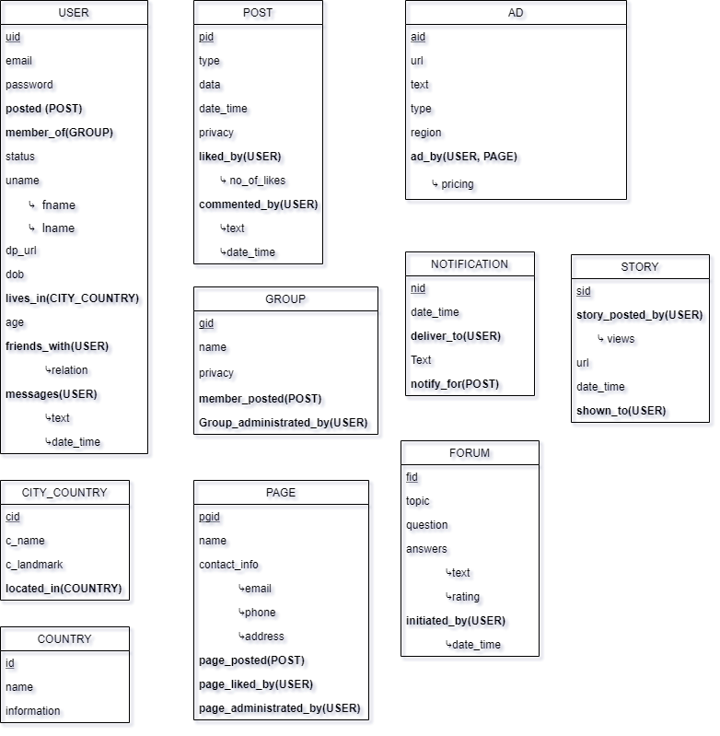

**Proposed Technologies:**

DBMS will be created using MySQL, while front-end will be created using bootstrap powering it with php as our server-side language. All media content such as images will be on cloud, only reference (URL) will be provided in database, this will make our database much lighter in weight.



**DATABASE SYSTEMS PROJECT**

**Facebook**

**Group Members**

|  |  |
| --- | --- |
| **Name** | **Enrollment No** |
| Ali Sehran | L1F17BSCS0344 |
| Waleed Kamran | L1F17BSCS0328 |
| Hammad Chaudhary | L1F17BSCS0499 |

**PHASE -2**

Assumptions:

1. Each post have different URL therefore no one can post the same post more than once.
2. Each group must have at least one admin, admin will also be a member of the same group but will be treated differently.
3. Each user will have some specific city.
4. Every country will have at least one city.
5. Each advertisement have different URL therefore one ad cannot be posted more than once.
6. Each notification will be created against some post, whereas it’s not necessary that each new post will trigger new notification.
7. Only images can be posted in story.
8. It’s necessary for an ad, story, post or forum that someone (USER) initiate it.
9. Ad can be shown in different regions and can be posted only by users.
10. Answers in forums will be posted anonymously.

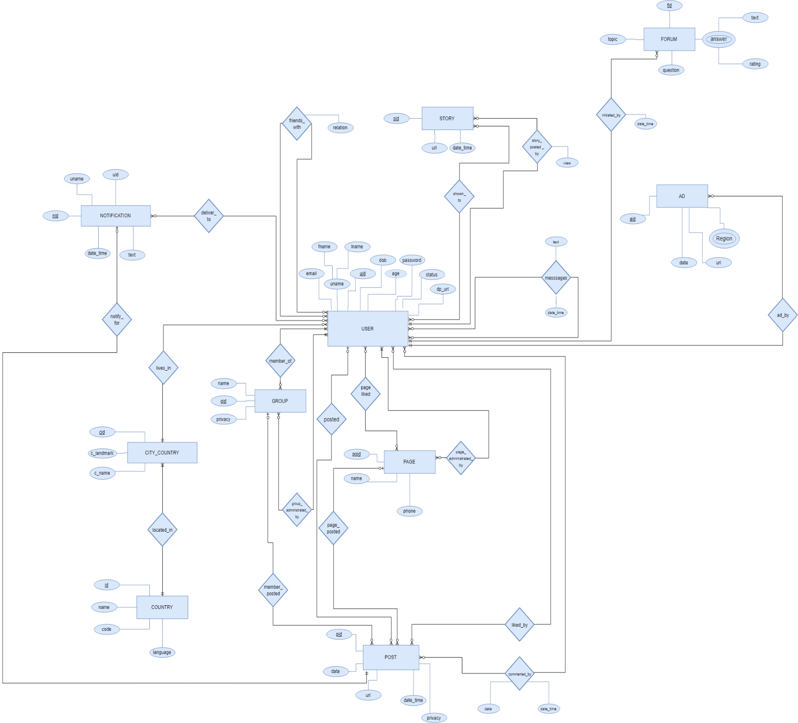 **ERD-Diagram**

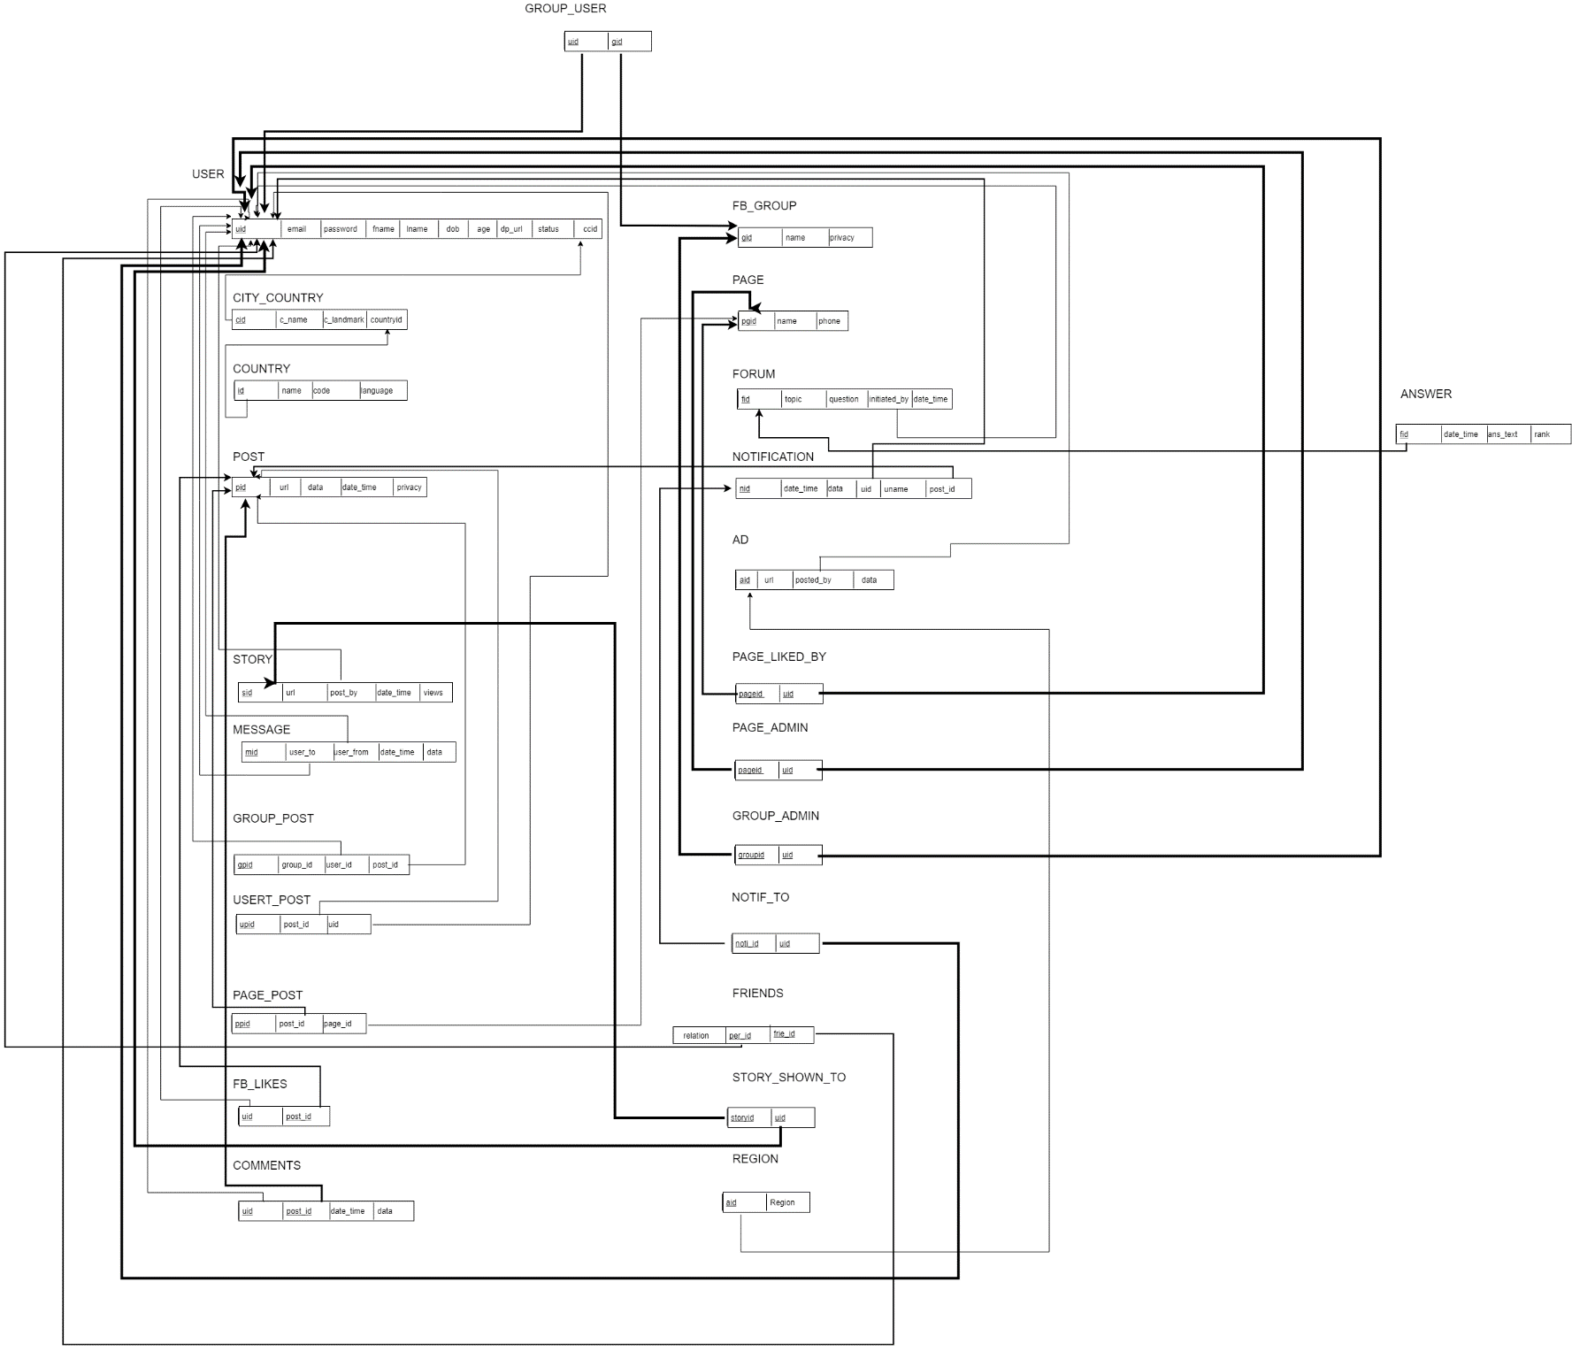  
Content: Drive_LINK ->





**DATABASE SYSTEMS PROJECT**

**Facebook**

**Group Members**

|  |  |
| --- | --- |
| **Name** | **Enrollment No** |
| Ali Sehran | L1F17BSCS0344 |
| Waleed Kamran | L1F17BSCS0328 |
| Hammad Chaudhary | L1F17BSCS0499 |

**PHASE -3**

Joins

**Question**-1

**Name of users who are notified for any post that is posted in Group25?**

**Query:**

select concat(u.fname,' ',u.lname) as Name from fb_group fbg join group_post gp on fbg.gid=gp.group_id

join post p on gp.post_id=p.pid

join notification n on p.pid=n.post_id

join notif_to nto on n.nid = nto.noti_id

join user u on nto.userid = u.uid where fbg.name='Group25';

**Screenshot:**

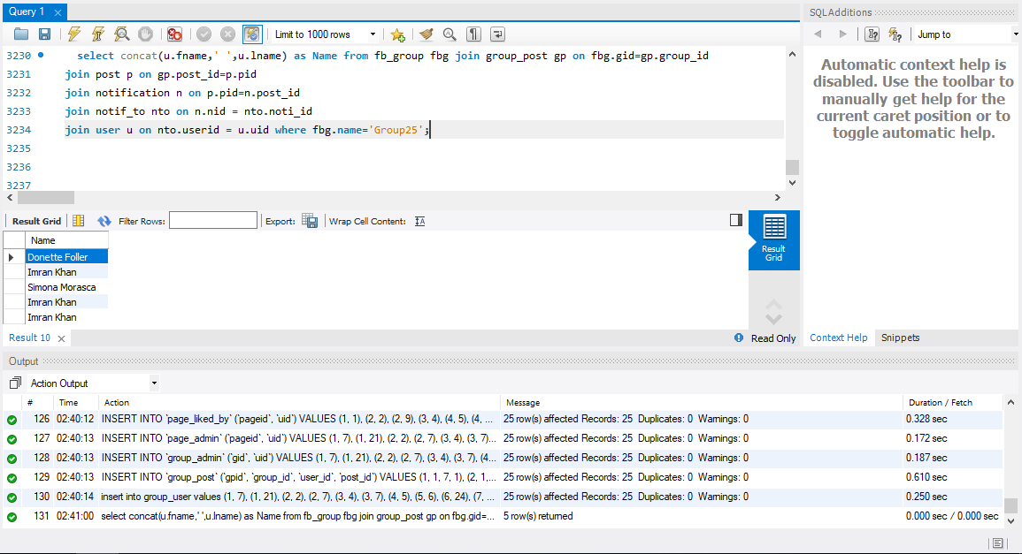

**Question**-2

**Showing all the cities and countries and names of all user who have posted any ad?**

**Query:**

select concat(u.fname,' ',u.lname) as Name, cc.c_name as City_Name, c.name as Country_Name from ad a join user u on a.posted_by=u.uid join city_country cc on u.ccid=cc.cid

join country c on cc.countryID=c.id;

**Screenshot:**

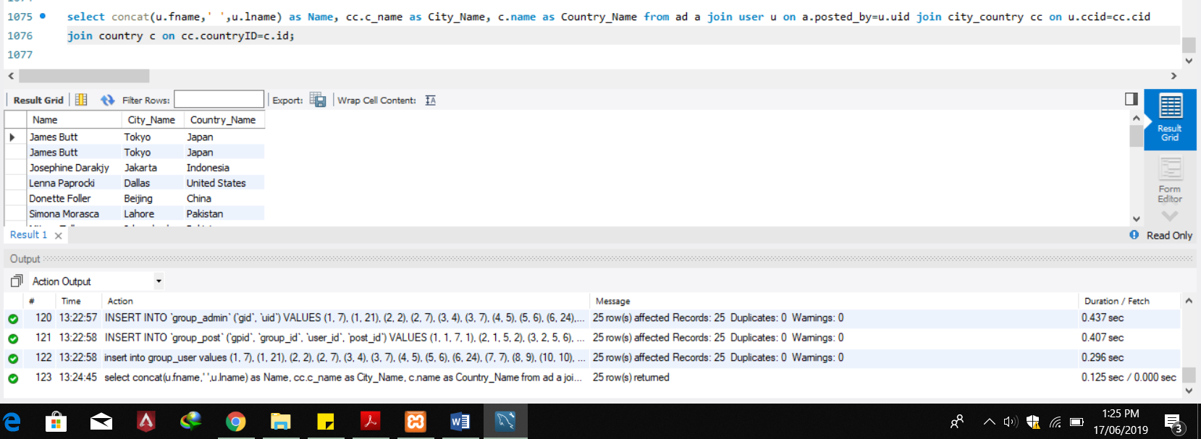

**Question**-3

**Showing posts of all pages which are public and page is liked by James?**

**Query:**

select p.data as Post from user u join page_liked_by lb on u.uid = lb.uid

join fb_page fp on lb.pageid = fp.pgid

join page_post pp on fp.pgid=pp.page_id

join post p on pp.post_id=p.pid where u.fname='james' and p.privacy='Public';

**Screenshot:**

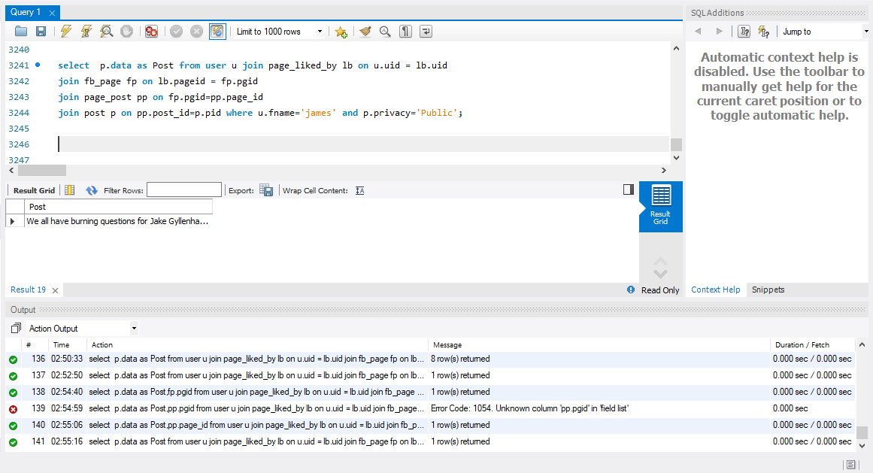

**Question**-4

**Showing comments of all the groups which are commented by user Valentine?**

**Query**

select concat(u.fname,' ',u.lname) as Name,c.data as Comment,fbg.name as Group_Name from fb_group fbg

join group_post gp on fbg.gid=gp.group_id

join post p on gp.post_id=p.pid

join comments c on p.pid=c.post_id

join user u on c.uid = u.uid where u.fname='Valentine';

**Screenshot:**

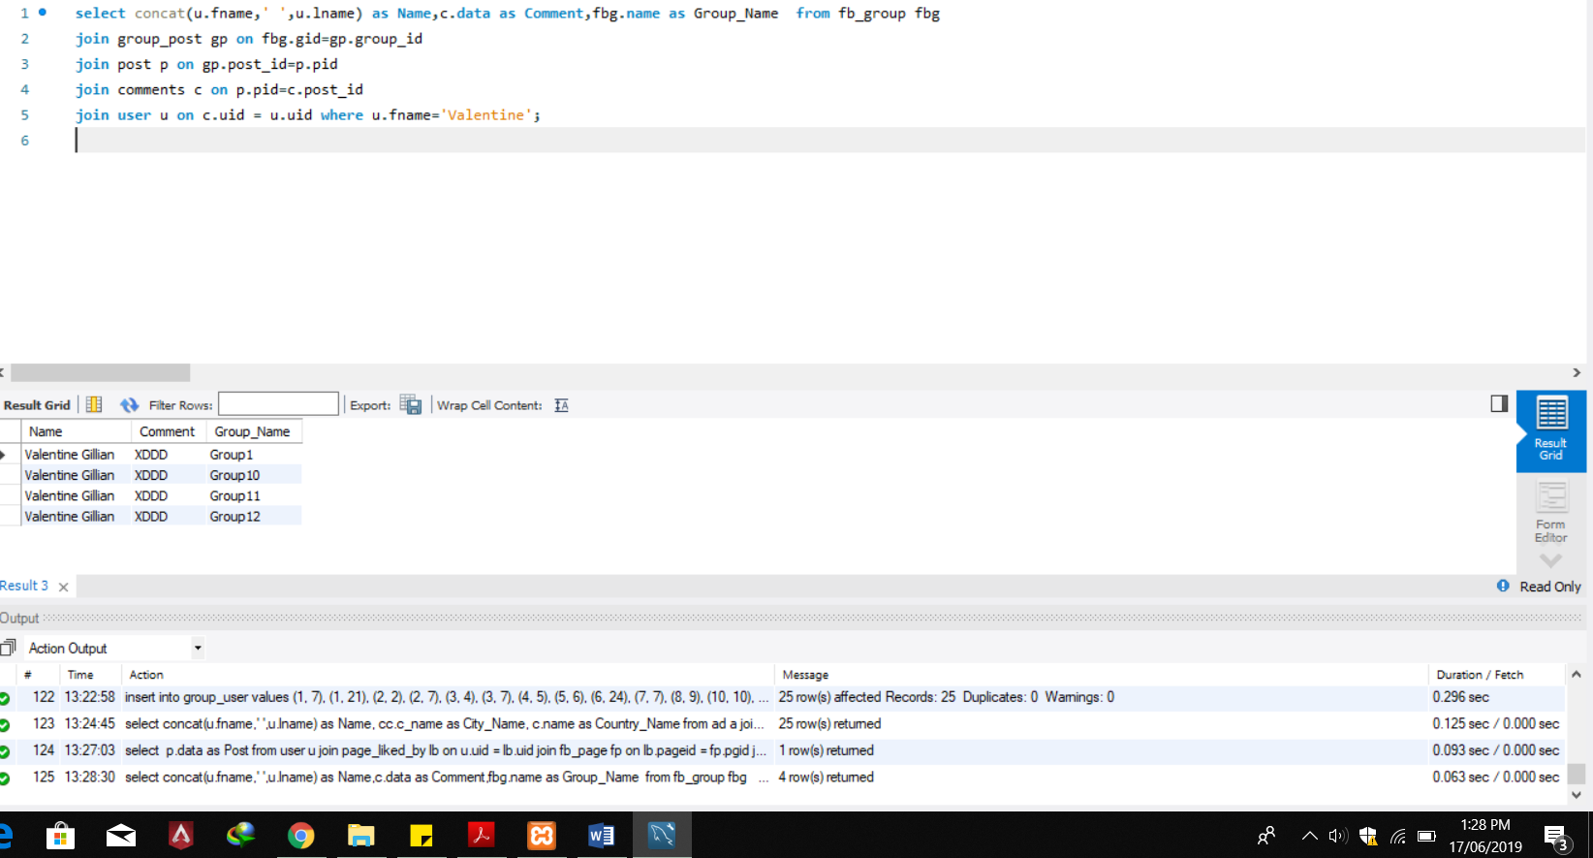

**Question**-5

**Show Name, Email, City and LandMark of Admins of Page1?**

**Query:**

select concat(u.fname,' ',u.lname) as Name, u.email as Email,cc.c_name as City, cc.c_landmark as LandMark

from fb_page fp join page_admin pa on fp.pgid=pa.pageid

join user u on pa.uid=u.uid join city_country cc on u.ccid=cc.cid where fp.name='Page1';

**Screenshot:**

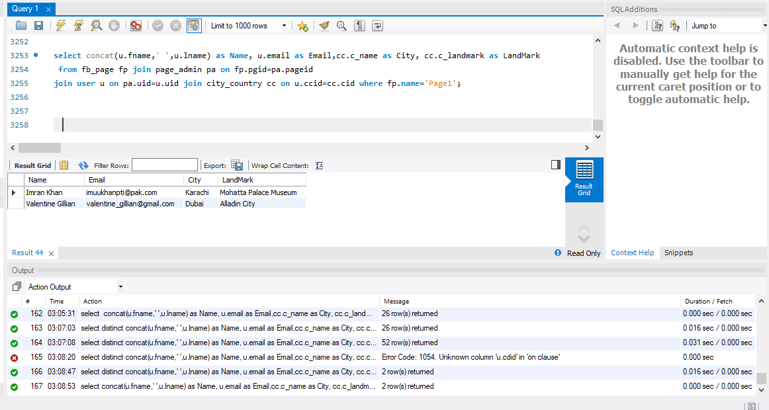

Co-Related

**Question**-6

**Print Username and their country whose friends are more than 1**.

**Query**:

select concat (fname,’ ‘,lname) as UserName,(select c.name from COUNTRY c where id=(select CountryID from City_Country

where u.ccid=cid)) as Country,(select count(*) from friends where per_id=uid) as No_of_Friend

from User u having No_of_Friend>1;

**Screenshot**:

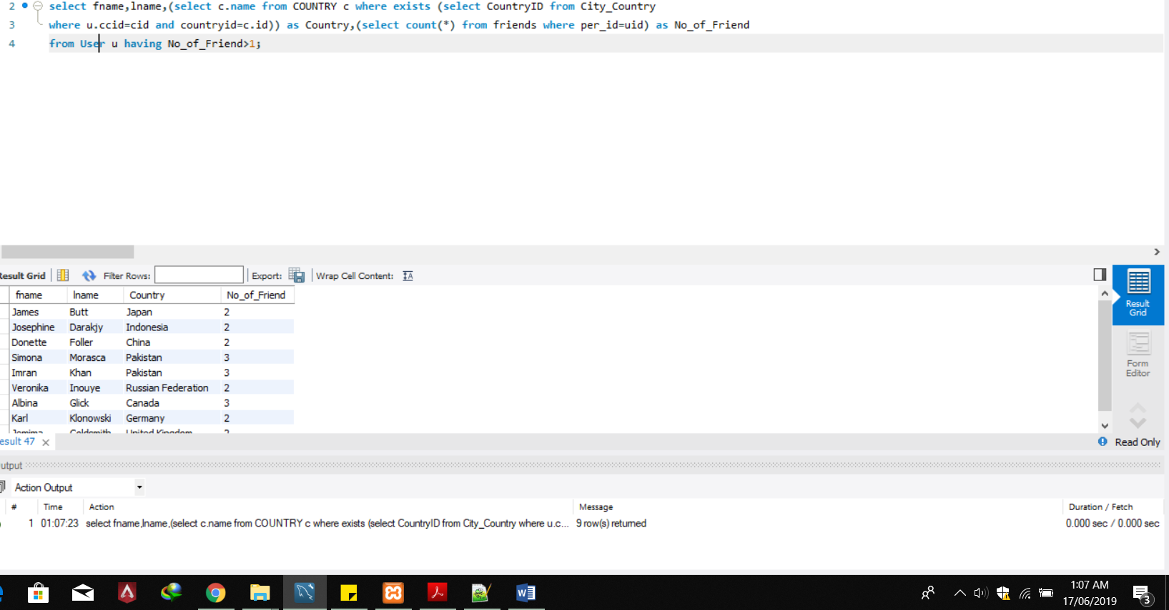

**Question**- 7

**Show all those posts whose notification is delivered to User having fname='Imran'**

**Query**:

select p.* from post p where exists

(select * from notification where exists

(select * from notif_to nt where exists(select * from user where nt.userid=uid and fname='Imran') and nid=noti_id)

and p.pid=post_id);

**Screenshot**:

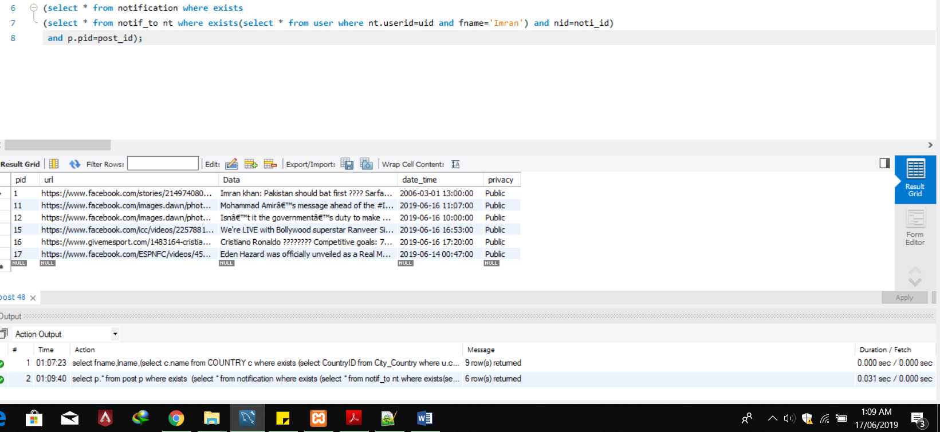

**Question-8**

**Fetch countries data from where any user posted any ad.**

**Query:**

select * from country c where exists(select * from user u where exists(select * from city_country

where countryid=c.id and u.ccid=cid and exists (select * from ad where posted_by=u.uid)));

**Screenshot:**

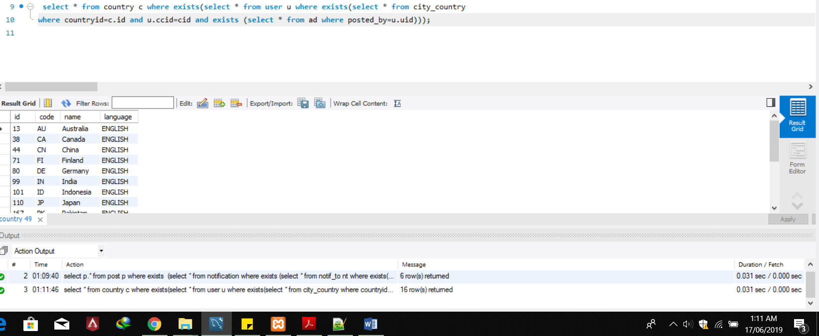

**Question- 9**

**Find all those people who lives in India and have no friends**

**Query:**

select u.* from user u where Not exists (select * from friends where per_id=u.uid) and exists( select * from city_country where u.ccid=cid and exists (select * from country c where countryid=id and c.name='india' ));

**Screenshot:**

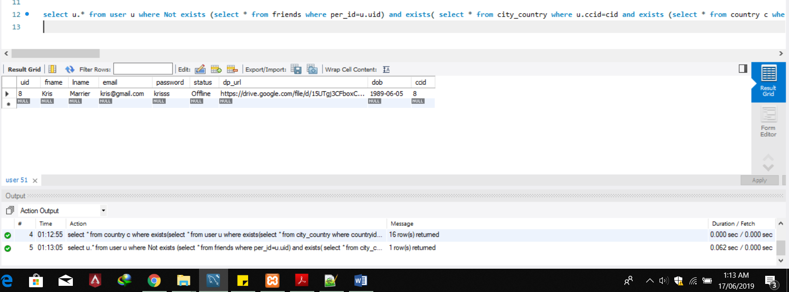

**Question- 10**

**Find user’s data who posted an ad for Asia region.**

**Query:**

select u.* from user u where exists (select * from ad a where uid=posted_by and exists (select * from regions r where a.aid=r.aid and region='ASIA'));

**Screenshot:**

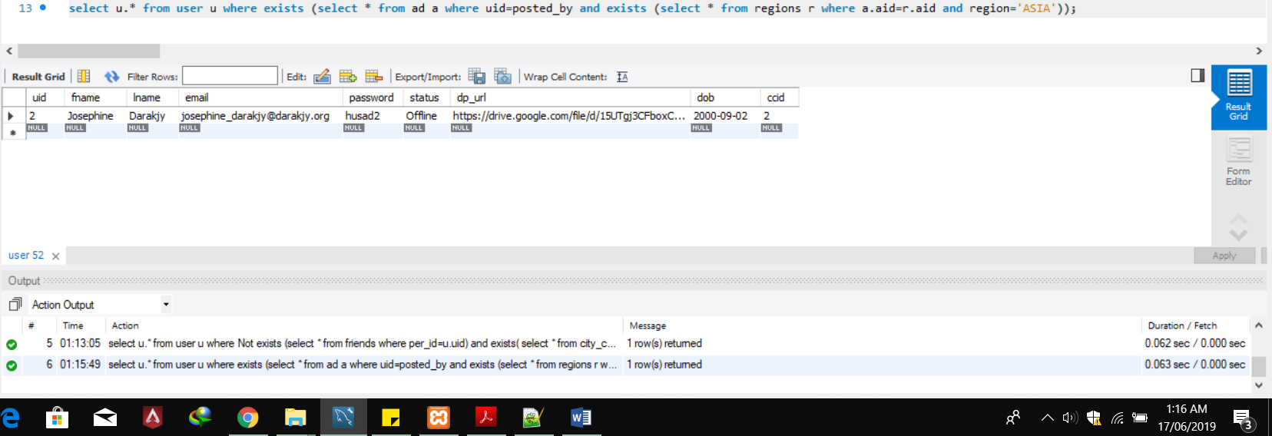

**Question- 11**

**Find the name/s of city/ies all around the world from where user posted maximum number of post.**

**Query:**

select c_name as CityName from City_country cc where exists

(select *,

(select count(*) as Count from User_Post up1 where u.uid=up1.uid) as PostNumber from user u

where Ccid=cc.cid

having postNumber = (select max(Tb.cnt) from (select count(*) as cnt from User_Post UP group by UP.uid)as Tb));

**Screenshot:**

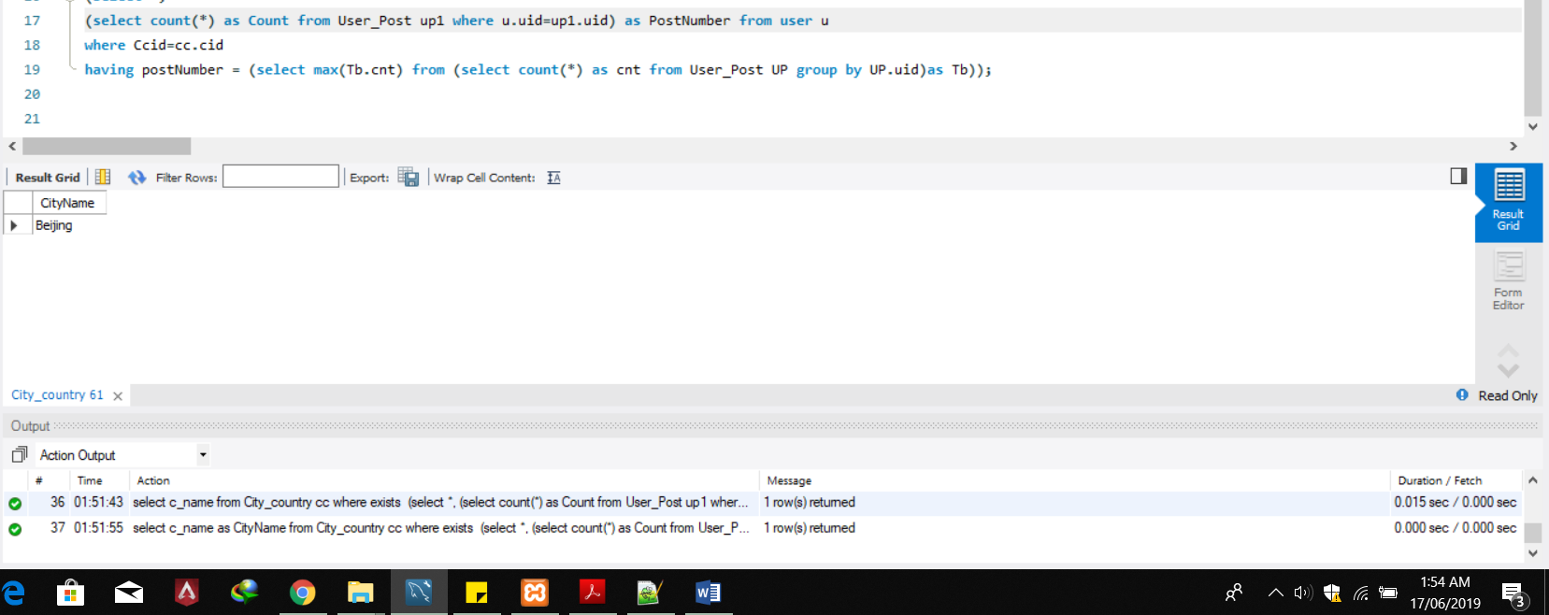

Scan for rest file: