KARACHI AQI PREDICTOR
End-to-End Air Quality Index Forecasting System
Project Report

Project Name:
AQI Predictor
Name:
Hammad Ahmed
Repository:
https://github.com/hammaddahmeddd/AQI_PREDICTOR_KARACHI

2. Executive Summary
Karachi is one of the most populous cities in the world and faces a chronic air quality crisis. Fine particulate matter (PM2.5) concentrations in the city regularly exceed World Health Organization (WHO) safe limits by an order of magnitude, and the city has been ranked among the most polluted urban centres globally. Despite this severity, publicly accessible, automated, and continuously updated AQI forecasting tools specific to Karachi remain rare.

The Karachi AQI Predictor addresses this gap by implementing a complete, production-grade, serverless machine learning system that continuously collects weather and pollutant data, engineers time-series features, trains and evaluates multiple forecasting models, and presents predictions through an interactive web dashboard — all automated and deployed entirely without local infrastructure.

The system fetches raw weather data (temperature, humidity, wind speed, wind direction, pressure, precipitation, cloud cover, dew point, and wind gusts) and raw air pollutant data (PM2.5, PM10, and AQI) from external APIs. This raw data is stored in MongoDB Atlas cloud collections. A feature engineering pipeline then transforms the raw data into a rich feature matrix including lag features, rolling statistics, Fourier-based seasonal signals, Karachi-specific indicators (sea-breeze proxy, monsoon flag, stagnation indicators), cross-pollutant ratios, and anomaly markers. The processed features are stored in a MongoDB feature store collection.

Three machine learning models — Random Forest, Ridge Regression, and XGBoost — are trained for three forecasting horizons: 24 hours, 48 hours, and 72 hours ahead, yielding nine model-horizon combinations in total. Models are trained using chronological splits with horizon-sized gaps to prevent temporal leakage, and evaluated using MAE, RMSE, MAPE, R², prediction interval coverage, and skill score against a persistence baseline. Model artifacts are stored in MongoDB GridFS, and metadata is written to a model registry collection.

A FastAPI backend exposes structured REST endpoints that serve current AQI readings, historical trends, predictions with conformal intervals, model comparison metrics, SHAP feature importance, and pipeline status. A Streamlit dashboard queries this backend and renders interactive visualisations including forecast charts, model comparison panels, feature importance plots, and pipeline monitoring displays. SHAP (SHapley Additive exPlanations) values are computed for XGBoost and Random Forest to explain which features drive each forecast.

The entire pipeline is automated using GitHub Actions: the feature pipeline runs every hour, and the training pipeline runs daily. Both workflows use Python 3.11 and read the MongoDB connection string from GitHub Secrets, ensuring no credentials are stored in the repository.

3. Project Requirements and Objectives

3.1 Original Requirements from the Project Brief
The AQI Predictor project brief specifies the following requirements:
- Build a feature pipeline that fetches weather and air pollution data from external APIs
- Compute features (model inputs) and targets (model outputs) including time-based and derived features
- Store the computed features in a feature store
- Backfill historical features and targets to generate training data for ML models
- Train and evaluate the best possible ML model, experimenting with Scikit-learn and advanced models
- Evaluate using RMSE, MAE, and R²
- Store the trained model in a model registry
- Automate the feature script to run every hour
- Automate the training script to run every day
- Create a web application to show model predictions using Streamlit/Gradio and Flask/FastAPI
- Use SHAP or LIME for feature importance explanations
- Add alerts for hazardous AQI levels
- Perform EDA to identify trends
- Submit an end-to-end AQI prediction system, automated pipeline, interactive dashboard, and detailed report

3.2 How This Project Satisfies Each Requirement

Requirement | Implementation in This Project
Feature pipeline | feature_pipeline/ folder with fetch_weather.py, fetch_air_quality.py, build_dataset.py, feature_engineering.py, feature_store.py, orchestrated by run_feature_pipeline.py
Fetch weather & pollutant data | fetch_weather.py calls Open-Meteo API; fetch_air_quality.py calls an air quality API; results stored in raw_weather and raw_air_quality MongoDB collections
Compute features & targets | feature_engineering.py produces 70+ engineered features including lag, rolling, Fourier, meteorological, Karachi-specific, and cross-pollutant features, with AQI targets at 24h/48h/72h horizons
Store in feature store | processed_features MongoDB collection acts as the feature store; feature_store.py handles writes with deduplication
Backfill historical data | run_feature_pipeline.py can be run over historical date ranges; the resulting records build the training dataset in processed_features
Train & evaluate ML models | train_pipeline/train_pipeline.py trains Random Forest, Ridge, and XGBoost for 24h, 48h, 72h horizons with chronological splits and horizon gaps
Evaluate (RMSE, MAE, R²) | train_pipeline/evaluate.py computes MAE, RMSE, MAPE, R², coverage, and skill score; results stored in model_metrics collection
Model registry | Model artifacts stored in MongoDB GridFS; metadata in model_registry collection; best model per horizon flagged
Automate hourly | .github/workflows/feature_pipeline.yml with cron: "0 * * * *"
Automate daily | .github/workflows/training_pipeline.yml with cron: "0 2 * * *"
Web app (FastAPI + Streamlit) | dashboard/backend/main.py is a FastAPI server; dashboard/frontend/app.py is a Streamlit dashboard with 5 tabs
SHAP / LIME explainability | SHAP values computed for XGBoost and Random Forest in train_pipeline.py; stored in top_features collection; displayed in Feature Importance tab
Hazardous AQI alerts | AQI bands defined in dashboard; visual colour-coded alerts for Unhealthy/Very Unhealthy/Hazardous levels; threshold monitoring supported in pipeline
EDA | eda/ folder contains eda_pipeline.py and fetch_ml_results.py for exploratory analysis of AQI trends, pollutant patterns, and model outputs
Detailed report | This document

4. System Architecture

4.1 Architecture Overview
The Karachi AQI Predictor is a fully serverless, cloud-native system. No persistent local compute is required. All data persists in MongoDB Atlas, all compute is triggered by GitHub Actions, and all user-facing surfaces are deployed as managed cloud services. The architecture consists of four major layers: data ingestion, feature engineering and storage, model training and registry, and serving (backend API and frontend dashboard).

4.2 Architecture Diagram

┌─────────────────────────────────────────────────────────────┐
│ EXTERNAL DATA SOURCES │
│ Open-Meteo Weather API | Air Quality API │
└────────────────────┬────────────────────┬────────────────────┘
│ │
▼ ▼
┌─────────────────────────────────────────────────────────────┐
│ FEATURE PIPELINE (GitHub Actions — Hourly) │
│ fetch_weather.py → fetch_air_quality.py │
│ ↓ ↓ │
│ raw_weather raw_air_quality │
│ └──────────────────────┘ │
│ ↓ │
│ build_dataset.py │
│ ↓ │
│ karachi_aqi_dataset (MongoDB) │
│ ↓ │
│ feature_engineering.py │
│ ↓ │
│ processed_features (MongoDB Feature Store) │
└─────────────────────────────────────────────────────────────┘
│
▼
┌─────────────────────────────────────────────────────────────┐
│ TRAINING PIPELINE (GitHub Actions — Daily) │
│ train_pipeline.py │
│ ↓ │
│ Random Forest | Ridge Regression | XGBoost │
│ Horizons: 24h | 48h | 72h │
│ ↓ │
│ model_registry | model_metrics | prediction_rows │
│ MongoDB GridFS (artifacts) | top_features (SHAP) │
└─────────────────────────────────────────────────────────────┘
│
▼
┌─────────────────────────────────────────────────────────────┐
│ SERVING LAYER │
│ FastAPI Backend (dashboard/backend/main.py) │
│ Deployed on Render ←→ MongoDB Atlas │
│ ↓ │
│ Streamlit Frontend (dashboard/frontend/app.py) │
│ Deployed on Streamlit Cloud │
└─────────────────────────────────────────────────────────────┘

4.3 Component Descriptions

Data Sources
Weather data is retrieved from the Open-Meteo API, which provides free, open-access hourly historical and forecast weather data for any location. Air quality data (PM2.5, PM10, AQI) is collected from a dedicated air quality API. Both APIs are queried with Karachi's coordinates (24.86°N, 67.01°E).

MongoDB Atlas
MongoDB Atlas (free tier M0 cluster) serves as the sole persistent storage layer. It stores raw ingested data, merged datasets, engineered features, model artifacts (via GridFS), model registry entries, evaluation metrics, prediction outputs, SHAP importance records, and pipeline status logs — all in the same cloud database, accessible by both the training pipeline and the serving backend.

GitHub Actions CI/CD
Two GitHub Actions workflows automate the pipelines. The feature workflow runs every hour on cron schedule "0 * * * *" and the training workflow runs daily at 02:00 UTC. Both use Python 3.11 and authenticate to MongoDB Atlas via the MONGODB_URI GitHub Secret.

FastAPI Backend
The FastAPI backend (dashboard/backend/main.py) is deployed on Render and provides RESTful endpoints for all dashboard data. It connects directly to MongoDB Atlas and exposes current AQI, history, predictions, metrics, SHAP features, and pipeline status.

Streamlit Frontend
The Streamlit dashboard (dashboard/frontend/app.py) is deployed on Streamlit Community Cloud. It calls the FastAPI backend via the BACKEND_URL environment variable and renders interactive charts using Plotly. It supports model selection (Random Forest, Ridge, XGBoost) and horizon selection (24h, 48h, 72h).

5. Repository Structure

5.1 Top-Level Layout
AQI_PREDICTOR_KARACHI/
├── .github/workflows/
│ ├── feature_pipeline.yml
│ └── training_pipeline.yml
├── feature_pipeline/
│ ├── fetch_weather.py
│ ├── fetch_air_quality.py
│ ├── build_dataset.py
│ ├── feature_engineering.py
│ ├── feature_store.py
│ └── config.py
├── train_pipeline/
│ ├── train_pipeline.py
│ ├── load_data.py
│ ├── evaluate.py
│ └── __init__.py
├── dashboard/
│ ├── backend/
│ │ ├── main.py
│ │ └── requirements.txt
│ └── frontend/
│ ├── app.py
│ ├── requirements.txt
│ └── .streamlit/
├── eda/
│ ├── eda_pipeline.py
│ └── fetch_ml_results.py
├── run_feature_pipeline.py
├── run_training_pipeline.py
├── requirements.txt
└── .gitignore

5.2 File-by-File Description
File / Folder | Purpose
.github/workflows/feature_pipeline.yml | GitHub Actions workflow that triggers run_feature_pipeline.py every hour using a cron schedule. Installs dependencies, sets the MONGODB_URI secret, and runs the feature pipeline end-to-end.
.github/workflows/training_pipeline.yml | GitHub Actions workflow that triggers run_training_pipeline.py daily. Installs dependencies, authenticates to MongoDB, and runs the full training, evaluation, and model registry update.
feature_pipeline/fetch_weather.py | Calls the Open-Meteo API for Karachi. Downloads hourly weather variables (temperature, humidity, wind speed, wind direction, precipitation, pressure, dew point, cloud cover, wind gusts) and writes raw records to the raw_weather MongoDB collection.
feature_pipeline/fetch_air_quality.py | Calls the air quality API for Karachi. Downloads hourly PM2.5, PM10, and AQI values and writes raw records to the raw_air_quality MongoDB collection.
feature_pipeline/build_dataset.py | Reads raw_weather and raw_air_quality, normalises timestamps, deduplicates, merges on datetime, forward-fills short gaps, drops rows missing PM2.5, and writes the merged dataset to karachi_aqi_dataset using bulk writes with a unique datetime index.
feature_pipeline/feature_engineering.py | The core feature factory. Reads karachi_aqi_dataset and produces the full engineered feature matrix with 70+ columns, then writes it to processed_features. Implements strictly causal feature construction to prevent data leakage.
feature_pipeline/feature_store.py | Handles the interface between feature_engineering.py and MongoDB. Manages upsert logic, deduplication by datetime, and bulk write operations for processed feature documents.
feature_pipeline/config.py | Central configuration: MongoDB URI (read from env), database name, collection names, API endpoints, Karachi coordinates, and pipeline parameters. Single source of truth for all constants.
train_pipeline/train_pipeline.py | Orchestrates the entire training pipeline. Reads processed_features, builds train/calibration/test splits, trains nine model-horizon combinations, runs conformal calibration, evaluates, computes SHAP values, and writes artifacts to MongoDB GridFS and metadata to MongoDB collections.
train_pipeline/load_data.py | Loads processed_features from MongoDB into a Pandas DataFrame. Handles type coercion, sorting by datetime, and filtering for training vs inference contexts.
train_pipeline/evaluate.py | Computes the full evaluation suite: MAE, RMSE, MAPE, R², conformal interval coverage, skill score vs persistence baseline, and event metrics for AQI > 150 and AQI > 200 thresholds.
train_pipeline/__init__.py | Package initialisation file making train_pipeline importable as a Python module.
dashboard/backend/main.py | FastAPI application. Connects to MongoDB at startup, registers all REST endpoints, and handles CORS. Returns JSON responses for current AQI, history, predictions, metrics, model comparison, SHAP features, and pipeline status.
dashboard/backend/requirements.txt | Backend Python dependencies: fastapi, uvicorn, pymongo, python-dotenv, and related packages.
dashboard/frontend/app.py | Streamlit multi-tab dashboard. Fetches data from the FastAPI backend via BACKEND_URL. Uses Plotly for interactive charts. Supports model and horizon selection. Displays five main tabs: Overview, Forecast, Model Comparison, Feature Importance, and Pipeline Status.
dashboard/frontend/requirements.txt | Frontend Python dependencies: streamlit, plotly, requests, pandas, and related packages.
dashboard/frontend/.streamlit/ | Streamlit configuration directory containing config.toml for theme, layout, and server settings.
eda/eda_pipeline.py | Exploratory data analysis script. Loads historical data from MongoDB and generates trend plots, correlation heatmaps, seasonal and diurnal AQI patterns, and pollutant distributions.
eda/fetch_ml_results.py | Retrieves trained model metrics and predictions from MongoDB to support post-training EDA, model comparison charts, and residual analysis.
run_feature_pipeline.py | Entry-point script that calls each step of the feature pipeline in sequence: fetch_weather, fetch_air_quality, build_dataset, feature_engineering, and feature_store. Used by both the GitHub Actions workflow and local runs.
run_training_pipeline.py | Entry-point script that invokes train_pipeline.py. Used by the GitHub Actions training workflow and for local training runs.
requirements.txt | Root-level Python dependencies for the full project, used by GitHub Actions.
.gitignore | Prevents .env files, Python caches, local data files, IDE settings, and other non-source artefacts from being committed to the repository.

6. Data Collection Pipeline

6.1 Weather Data
fetch_weather.py sends requests to the Open-Meteo API, specifying Karachi's latitude (24.8607) and longitude (67.0011), requesting hourly variables: temperature_2m, relative_humidity_2m, wind_speed_10m, wind_direction_10m, precipitation, surface_pressure, dew_point_2m, cloud_cover, and wind_gusts_10m. The API returns data in JSON format. The script converts this to a list of hourly documents and inserts them into the raw_weather MongoDB collection, using the datetime as the unique index to prevent duplicate entries.

6.2 Air Quality Data
fetch_air_quality.py queries an air quality API for Karachi, retrieving hourly PM2.5 (fine particulate matter, particles under 2.5 micrometres), PM10 (particles under 10 micrometres), and a computed AQI value. These records are written to the raw_air_quality MongoDB collection with the same deduplication logic.

6.3 Pipeline Status Tracking
Both fetch scripts log their execution status — including timestamps, rows fetched, and any errors — to a pipeline_status collection in MongoDB. This allows the dashboard to display real-time pipeline health and last-run timestamps in the Pipeline Status tab.

6.4 run_feature_pipeline.py — Orchestration
run_feature_pipeline.py is the top-level orchestrator. It calls each component in sequence:
- fetch_weather.py — Pulls and stores latest weather data
- fetch_air_quality.py — Pulls and stores latest air quality data
- build_dataset.py — Merges raw collections into karachi_aqi_dataset
- feature_engineering.py — Builds the engineered feature matrix
- feature_store.py — Writes processed features to processed_features collection

The script is designed to be idempotent: running it multiple times on the same data does not create duplicates, because all writes use upsert operations keyed on datetime.

7. Dataset Building

7.1 build_dataset.py — Step-by-Step
build_dataset.py is responsible for merging the two raw streams into a single coherent time-series dataset. Its logic follows these steps:
- Read all documents from raw_weather and raw_air_quality
- Parse and normalise all datetime fields to UTC, flooring to the hour
- Deduplicate each source by datetime (keeping the latest record for each hour)
- Perform an outer merge on the datetime index to align weather and air quality records
- Forward-fill gaps of up to 2 consecutive hours for minor API outages
- Drop any rows where PM2.5 is still missing after forward-fill (PM2.5 is the primary pollutant used to compute AQI targets)
- Write the merged dataset to the karachi_aqi_dataset collection using bulk_write with upsert operations keyed on the unique datetime index

The use of MongoDB's bulk_write with UpdateOne and upsert=True ensures that historical backfill runs do not create duplicate documents. The dataset is continuously extended as new hourly records arrive.

8. Feature Engineering

8.1 Overview and Causal Discipline
feature_engineering.py is the most sophisticated component of the feature pipeline. It reads from karachi_aqi_dataset and produces the final feature matrix written to processed_features. A foundational design principle is strict causal feature construction: every feature used to predict AQI at time T is computed exclusively from data available at or before time T, never from the future. This is enforced by creating forecast targets (aqi_24h, aqi_48h, aqi_72h) before any lag or rolling operations, so the target values use future AQI while all input features use only present and past data.

Violating this discipline — for example, by computing a rolling mean that includes the target hour — would cause the model to appear to perform well during training but fail completely at inference time. This project avoids such temporal leakage through careful use of pandas shift() and rolling() with min_periods controls.

8.2 Feature Categories

Time-Based Features
Cyclical time encodings are critical for a forecasting model to understand diurnal and seasonal patterns. The pipeline computes:
- hour, day_of_week, month, day_of_year — raw calendar fields
- hour_sin, hour_cos — sine/cosine encoding of the hour (period 24)
- day_of_year_sin, day_of_year_cos — Fourier encoding of the calendar day (period 365)
- is_weekend — binary flag for Saturday/Sunday

AQI Lag Features
Lag features encode the historical trajectory of AQI. They allow the model to learn that a rising AQI is likely to continue rising. Lags are computed at 1, 2, 3, 6, 12, 24, 48, and 72 hours.

PM2.5 and PM10 Lag and Rolling Features
Since PM2.5 is the dominant driver of AQI in Karachi, both lag values (at 1, 2, 3, 6, 12 hours) and rolling statistics (mean, std, max over 3h, 6h, 12h, 24h windows) are computed for PM2.5 and PM10. These capture both short-term fluctuations and longer-term concentration trends.

AQI Rolling Statistics
Rolling mean, standard deviation, maximum, minimum, and exponentially weighted mean (EWM) of AQI are computed over 3-hour, 6-hour, 12-hour, and 24-hour windows. EWM features give more weight to recent observations.

Meteorological Features
All nine weather variables (temperature, humidity, wind speed, wind direction, precipitation, surface pressure, dew point, cloud cover, wind gusts) are included directly. Additional derived meteorological features include the AQI change rate (first difference) and lagged values of key weather variables at 1, 3, and 6 hours.

Wind Decomposition
Wind direction interacts non-linearly with pollution. The pipeline decomposes wind into Cartesian components: wind_x = wind_speed × cos(wind_direction_radians) and wind_y = wind_speed × sin(wind_direction_radians). Additionally, wind_direction_sin and wind_direction_cos are included as separate cyclic features.

Karachi-Specific Features
These domain-expert features encode local environmental knowledge:
- sea_breeze_proxy: Captures afternoon sea breeze from the Arabian Sea (a significant factor in Karachi's air quality). Approximated as a function of hour (peak 14:00–18:00) and season.
- monsoon_flag: Binary flag for the monsoon season (June through September). Monsoon rains suppress dust and wash out particulates, temporarily improving AQI.
- stagnation_index: Proxy for atmospheric stagnation — low wind speed combined with low precipitation, which traps pollution near the surface.
- morning_stagnation: Flag for early morning (05:00–09:00) low-wind conditions when traffic emissions accumulate before sea breeze dispersal.

Cross-Pollutant Ratios and Interaction Terms
pm25_pm10_ratio captures the relative composition of coarse vs fine particles. pm25_wind_interaction and pm10_humidity_interaction encode how meteorological conditions modify the effect of pollutant concentrations.

Anomaly and Spike Features
aqi_spike_flag marks hours where AQI exceeds the rolling 24-hour mean by more than two standard deviations. These spike indicators help the model identify and track pollution episodes.

8.3 Warm-Up Row Removal
The first 72 rows of each engineered dataset are dropped to remove the warm-up period during which rolling windows are partially populated and lag features contain NaN values. This ensures the training data is clean and fully populated.

8.4 Writing to Feature Store
The final engineered feature documents are written to the processed_features MongoDB collection using feature_store.py, with upsert logic keyed on datetime to support incremental updates.

9. Historical Backfill
Machine learning models cannot be trained on a handful of hours of data. For the training pipeline to produce meaningful forecasting models, the feature store must contain sufficient historical records covering a wide range of AQI levels, weather conditions, seasons, and pollution episodes.

The backfill process involves running run_feature_pipeline.py over a range of past dates. Because the Open-Meteo API supports historical data retrieval going back several years, and the air quality API similarly supports historical queries, the pipeline can fetch and process many months of hourly data in batch. Each historical hour is processed identically to a live hourly run: raw data is stored, merged, feature-engineered, and written to processed_features.

Once backfill is complete, the processed_features collection contains a continuous, deduplicated hourly time-series of engineered features and their corresponding 24h, 48h, and 72h AQI targets. The training pipeline then reads this entire history to train and evaluate models. Backfill is not a one-time operation: it can be re-run at any time to extend or repair the historical dataset, and incremental daily runs continuously extend it forward.

10. Training Pipeline

10.1 Overview
train_pipeline/train_pipeline.py is the central script that reads the feature store, trains nine model-horizon combinations, evaluates each model, generates SHAP explanations, and writes all outputs to MongoDB.

10.2 Data Splitting Strategy
All data is sorted chronologically by datetime. The dataset is split into training, calibration, and test sets using time-based boundaries rather than random sampling. A horizon-sized gap is inserted between each split pair to prevent information leakage: for the 72-hour horizon, the last 72 rows of the training set and the first 72 rows of the test set are excluded from both.

The calibration set is used exclusively for conformal prediction interval calibration — it is never seen by the model during fitting. The test set is held out for final evaluation.

10.3 Preprocessing
Preprocessing within the pipeline includes:
- Median imputation for remaining missing values using Scikit-learn's SimpleImputer(strategy="median")
- Correlation filtering: features with pairwise correlation above a threshold (e.g., 0.98) are pruned to reduce multicollinearity
- log1p target transformation: AQI targets are log-transformed before training and inverse-transformed after prediction to handle the right-skewed distribution of AQI values
- Spike augmentation: training rows with AQI above 200 are duplicated with small noise to increase the model's exposure to rare high-pollution events

10.4 Models Trained
Model | Library | Notes
Random Forest Regressor | scikit-learn | Ensemble of decision trees; strong baseline; naturally handles non-linear interactions; provides mean absolute SHAP values via the SHAP library
Ridge Regression | scikit-learn | Regularised linear model; fast; serves as a linear baseline; feature importance derived from absolute regression coefficients
XGBoost Regressor | xgboost | Gradient boosted trees; typically highest accuracy; supports native SHAP tree explainer; handles missing values natively

Each model is trained for all three horizons (24h, 48h, 72h), yielding nine trained models in total per daily training run.

10.5 Conformal Prediction Intervals
Rather than relying on parametric prediction intervals (which assume a distribution), the pipeline uses inductive conformal prediction. After training, the model is applied to the calibration set. The residuals on the calibration set form an empirical distribution. For a target coverage of 90%, the 90th percentile of calibration residuals is used as the prediction interval half-width at inference time. This produces distribution-free prediction intervals with guaranteed marginal coverage.

10.6 Model Artifact Storage
Trained model objects are serialised using Python's pickle module and stored in MongoDB GridFS, which supports large binary objects. Each artifact is tagged with model type, horizon, training timestamp, and a best_model flag. The model_registry collection stores metadata for each trained model including the GridFS file ID for artifact retrieval.

10.7 Prediction Row Storage
For each model and horizon, prediction rows are computed on the test set and stored in a predictions collection with fields: datetime, predicted_aqi, lower_bound, upper_bound, actual_aqi, model, and horizon. These are consumed by the FastAPI backend to render forecast charts and actual-vs-predicted comparisons.

11. Model Evaluation

11.1 Evaluation Metrics
Metric | Formula / Description | Why It Matters
MAE | Mean Absolute Error — mean of |actual - predicted| | Directly interpretable in AQI units; not sensitive to outliers
RMSE | Root Mean Squared Error — sqrt(mean of squared errors) | Penalises large errors more heavily; important for hazardous AQI events
MAPE | Mean Absolute Percentage Error | Scale-independent; useful for comparing across AQI ranges
R² | Coefficient of determination | Proportion of variance explained; 1.0 is perfect, 0 is mean baseline
Coverage | Fraction of actuals within conformal prediction interval | Measures whether stated 90% intervals actually contain 90% of outcomes
Skill Score | 1 - (MAE_model / MAE_persistence) | Measures improvement over naive persistence baseline; positive score = useful model
Event Metrics | Precision/recall for AQI > 150 and AQI > 200 | Assesses ability to detect hazardous pollution episodes specifically

11.2 Model Performance Table
The following table shows the performance metrics for all model-horizon combinations. Values marked [live] should be verified against the latest dashboard output, as models are retrained daily and metrics update accordingly.

Model | Horizon | MAE | RMSE | MAPE (%) | R² | Coverage | Skill Score
Random Forest | 24h | [live] | [live] | [live] | [live] | [live] | [live]
Random Forest | 48h | [live] | [live] | [live] | [live] | [live] | [live]
Random Forest | 72h | [live] | [live] | [live] | [live] | [live] | [live]
Ridge Regression | 24h | [live] | [live] | [live] | [live] | [live] | [live]
Ridge Regression | 48h | [live] | [live] | [live] | [live] | [live] | [live]
Ridge Regression | 72h | [live] | [live] | [live] | [live] | [live] | [live]
XGBoost | 24h | [live] | [live] | [live] | [live] | [live] | [live]
XGBoost | 48h | [live] | [live] | [live] | [live] | [live] | [live]
XGBoost | 72h | [live] | [live] | [live] | [live] | [live] | [live]

Note: Live metric values are available from the Model Comparison tab of the Streamlit dashboard or via GET /api/model-comparison on the FastAPI backend. Metrics are updated automatically with each daily training run.

11.3 Best Model Selection
The training pipeline compares all three models for each horizon by weighted scoring across MAE, skill score, and coverage. The best model per horizon is flagged with best_model: true in the model_registry collection. The dashboard defaults to displaying predictions from the best model for each horizon.

12. Explainability (SHAP)

12.1 Why Explainability Matters
AQI prediction is not purely a technical exercise — its outputs can affect public health decisions, municipal planning, and individual behaviour. An unexplainable black-box model is difficult to audit, debug, and trust. Explainability tools like SHAP (SHapley Additive exPlanations) allow model users to understand which input features drove each prediction, enabling better model debugging and greater user confidence.

12.2 SHAP Implementation
For XGBoost and Random Forest models, SHAP values are computed using the shap library's TreeExplainer, which efficiently computes exact Shapley values for tree-based models. For Ridge Regression, feature importance is approximated using absolute coefficient values scaled by the standard deviation of each feature.

After computing SHAP values on the test set, the top-N features (by mean absolute SHAP value) for each model-horizon combination are stored in the top_features MongoDB collection. Each document contains: model, horizon, feature_name, mean_abs_shap, and rank.

12.3 Feature Importance Insights
Based on the feature engineering design, the features expected to carry the highest SHAP values include:
- aqi_lag_1h, aqi_lag_3h, aqi_lag_6h — recent AQI history is the strongest predictor of near-future AQI
- pm25_rolling_mean_24h — the 24-hour PM2.5 average captures background pollution levels
- aqi_ewm_12h — exponentially weighted AQI mean reflects momentum
- wind_speed_10m — higher wind speeds disperse pollutants and typically lower AQI
- hour_sin, hour_cos — diurnal patterns are critical; AQI peaks during morning and evening rush hours
- monsoon_flag — monsoon season dramatically changes AQI dynamics in Karachi
- stagnation_index — atmospheric stagnation strongly predicts pollution build-up
- pm25_pm10_ratio — encodes the relative source profile (industry vs road dust)

12.4 Dashboard Display
The Feature Importance tab of the Streamlit dashboard displays a horizontal bar chart of the top features for the selected model and horizon, with bars sized by mean absolute SHAP value. Users can switch between models and horizons interactively.

13. Backend API

13.1 FastAPI Application Overview
dashboard/backend/main.py implements a FastAPI application that serves as the sole interface between MongoDB Atlas and the Streamlit frontend. It includes CORS middleware configured to allow requests from the Streamlit deployment URL. At startup, it establishes a MongoDB client connection using the MONGODB_URI environment variable.

13.2 API Endpoints
Endpoint | Method | Data Source | Description
/ | GET | — | Health check. Returns {"status": "ok", "service": "Karachi AQI Predictor API"}.
/api/latest-aqi | GET | processed_features | Returns the most recent AQI reading, PM2.5, PM10, and weather variables. Used by the Overview tab current conditions panel.
/api/aqi-history | GET | karachi_aqi_dataset | Returns the last 168 hours (7 days) of AQI, PM2.5, PM10, and temperature. Used by the AQI history line chart.
/api/metrics | GET | model_metrics | Returns evaluation metrics for all model-horizon combinations. Used by the Model Comparison tab summary table.
/api/metrics/{horizon} | GET | model_metrics | Returns metrics filtered by the specified horizon (24, 48, or 72). Supports horizon-specific comparisons.
/api/predictions/{model}/{horizon} | GET | predictions | Returns forecast values with lower and upper conformal bounds for the specified model and horizon. Used by the Forecast tab chart.
/api/model-comparison | GET | model_metrics | Returns a cross-model comparison summary including best model per horizon. Used by the Model Comparison radar chart.
/api/top-features/{model}/{horizon} | GET | top_features | Returns the top feature importance entries for the specified model and horizon. Used by the Feature Importance bar chart.
/api/pipeline-status | GET | pipeline_status | Returns the last-run timestamp, row counts, and status (success/failure) for the feature and training pipelines. Used by the Pipeline Status tab.

14. Frontend Dashboard

14.1 Streamlit Application Overview
dashboard/frontend/app.py is the user-facing application. It is built with Streamlit and uses Plotly for all charts. On load, it reads the BACKEND_URL environment variable and establishes the connection to the FastAPI backend. The dashboard title and favicon reference Karachi and the AQI domain. A sidebar allows users to select the active model (Random Forest, Ridge Regression, XGBoost) and forecast horizon (24 hours, 48 hours, 72 hours). These selections are passed as query parameters to the relevant API calls.

14.2 Dashboard Tabs

Tab 1: Overview
Displays a summary of the current air quality situation: the most recent AQI value with its colour-coded band (Good, Moderate, Unhealthy for Sensitive Groups, Unhealthy, Very Unhealthy, Hazardous), current PM2.5 and PM10 concentrations, and current weather variables (temperature, humidity, wind speed, pressure). A 7-day AQI history line chart provides context.

Tab 2: Forecast
Displays the machine learning forecast for the selected model and horizon. The main chart shows predicted AQI over the forecast window with a shaded conformal prediction interval (lower and upper bounds). Additional sub-charts show residuals (actual minus predicted) and an actual-vs-predicted scatter plot with a reference line.

Tab 3: Model Comparison
Displays a comparison table of all model-horizon combinations with MAE, RMSE, MAPE, R², coverage, and skill score. A radar chart visualises multi-dimensional performance differences between models for the selected horizon. The best model per horizon is highlighted.

Tab 4: Feature Importance
Displays a horizontal bar chart of top feature importance values (SHAP for XGBoost and Random Forest, coefficients for Ridge) for the selected model and horizon. Feature names are displayed on the y-axis and mean absolute SHAP value on the x-axis. This tab directly satisfies the explainability requirement from the project brief.

Tab 5: Pipeline Status
Displays the operational health of the system: last successful run timestamps for the feature pipeline and training pipeline, rows processed in the last run, pipeline success/failure status badges, and the names of the MongoDB collections currently active. This tab allows users to verify that automation is functioning correctly.

15. Automation and CI/CD

15.1 GitHub Actions Overview
The project uses GitHub Actions as its CI/CD and scheduling platform. Two workflow files in .github/workflows/ automate the two main pipelines. GitHub Actions was chosen because it is free for public repositories, natively integrated with the code host, supports cron scheduling, and provides direct access to GitHub Secrets for secure credential management.

15.2 Feature Pipeline Workflow
Filename: .github/workflows/feature_pipeline.yml

Property | Value
Trigger | schedule: cron "0 * * * *" (every hour, on the hour) + workflow_dispatch (manual)
Python version | 3.11
Steps | checkout → setup-python → pip install -r requirements.txt → run run_feature_pipeline.py
Secrets used | MONGODB_URI (passed as environment variable to the script)
Purpose | Fetch latest weather and air quality data, build dataset, engineer features, write to processed_features

15.3 Training Pipeline Workflow
Filename: .github/workflows/training_pipeline.yml

Property | Value
Trigger | schedule: cron "0 2 * * *" (daily at 02:00 UTC) + workflow_dispatch (manual)
Python version | 3.11
Steps | checkout → setup-python → pip install -r requirements.txt → run run_training_pipeline.py
Secrets used | MONGODB_URI
Purpose | Train all 9 model-horizon combinations on latest processed_features, evaluate, store artifacts, update model registry

Both workflows support workflow_dispatch, meaning they can also be triggered manually from the GitHub Actions UI without waiting for the next scheduled run. This is useful for debugging or force-retraining after a code change.

16. Deployment

16.1 Backend Deployment (Render)
The FastAPI backend is deployed on Render, a cloud platform that supports Python web services with a free tier. The deployment configuration specifies uvicorn dashboard.backend.main:app as the start command. The MONGODB_URI environment variable is set in Render's environment configuration panel. The Render deployment URL is used as the BACKEND_URL in the Streamlit frontend.

16.2 Frontend Deployment (Streamlit Community Cloud)
The Streamlit frontend is deployed on Streamlit Community Cloud, which provides free deployment for public GitHub repositories. The deployment points to dashboard/frontend/app.py. The BACKEND_URL environment variable is set in Streamlit's secrets management interface (.streamlit/secrets.toml pattern). The live dashboard URL is publicly accessible.

16.3 MongoDB Atlas as Shared Data Layer
MongoDB Atlas acts as the central data layer connecting all system components. The GitHub Actions workflows write feature data and model artifacts to Atlas. The FastAPI backend reads from Atlas to serve API responses. The Streamlit frontend indirectly reads from Atlas via the FastAPI backend. This shared-cloud architecture means that no data passes between systems as files — all state is centralised in MongoDB.
Component | Platform | Free Tier | Notes
MongoDB Atlas | MongoDB Cloud | M0 (512 MB storage) | Shared data layer; all pipelines and serving components connect here
Feature Pipeline | GitHub Actions | Free for public repos | Runs hourly; ~2 min execution
Training Pipeline | GitHub Actions | Free for public repos | Runs daily; ~10-15 min execution
FastAPI Backend | Render | Free tier (spins down after inactivity) | Cold start ~30s on free tier; can upgrade for production
Streamlit Frontend | Streamlit Cloud | Free for public repos | Publicly accessible dashboard

17. Security and Configuration

17.1 Secret Management
The most sensitive credential in the system is the MONGODB_URI connection string, which contains the username, password, and cluster hostname for MongoDB Atlas. This value is never stored in the repository. Instead:
- In GitHub Actions: MONGODB_URI is stored as a GitHub Actions Secret and injected into the workflow environment at runtime using the env: block in the YAML configuration
- In Render: MONGODB_URI is stored in Render's environment variables panel, inaccessible to the public
- In Streamlit Cloud: secrets are managed via the Streamlit secrets interface
- For local development: .env files (excluded by .gitignore) or shell environment variables are used

17.2 .gitignore
The .gitignore file prevents the following from being committed to the repository:
- .env and *.env — environment variable files containing secrets
- __pycache__/ and *.pyc — Python bytecode cache
- .DS_Store — macOS filesystem metadata
- *.pkl — serialised model files (stored in GridFS instead)
- *.csv and local data files — raw data is stored in MongoDB, not in the repository
- .venv/ and venv/ — Python virtual environments

17.3 feature_pipeline/config.py
config.py reads MONGODB_URI from the environment (os.environ.get("MONGODB_URI")) and defines all collection names, API endpoints, and pipeline constants in one place. This means that changing a collection name requires editing only config.py rather than hunting through multiple scripts.

18. Exploratory Data Analysis (EDA)

18.1 Purpose
The eda/ folder contains exploratory analysis scripts that support feature selection, model interpretation, and project documentation. EDA was conducted before and alongside feature engineering to understand the statistical properties of the Karachi air quality dataset. The six visualisations below are drawn directly from the pipeline outputs and provide concrete evidence for the feature engineering decisions and model design choices made in this project.

18.2 Figure 1 — Cross-Correlation Matrix: Features and Forecast Targets
Figure 1 shows the Pearson correlation matrix between the core pipeline variables (aqi, pm25, pm10) and the three forecast target vectors (target_aqi_24h, target_aqi_48h, target_aqi_72h). Several important relationships are visible.
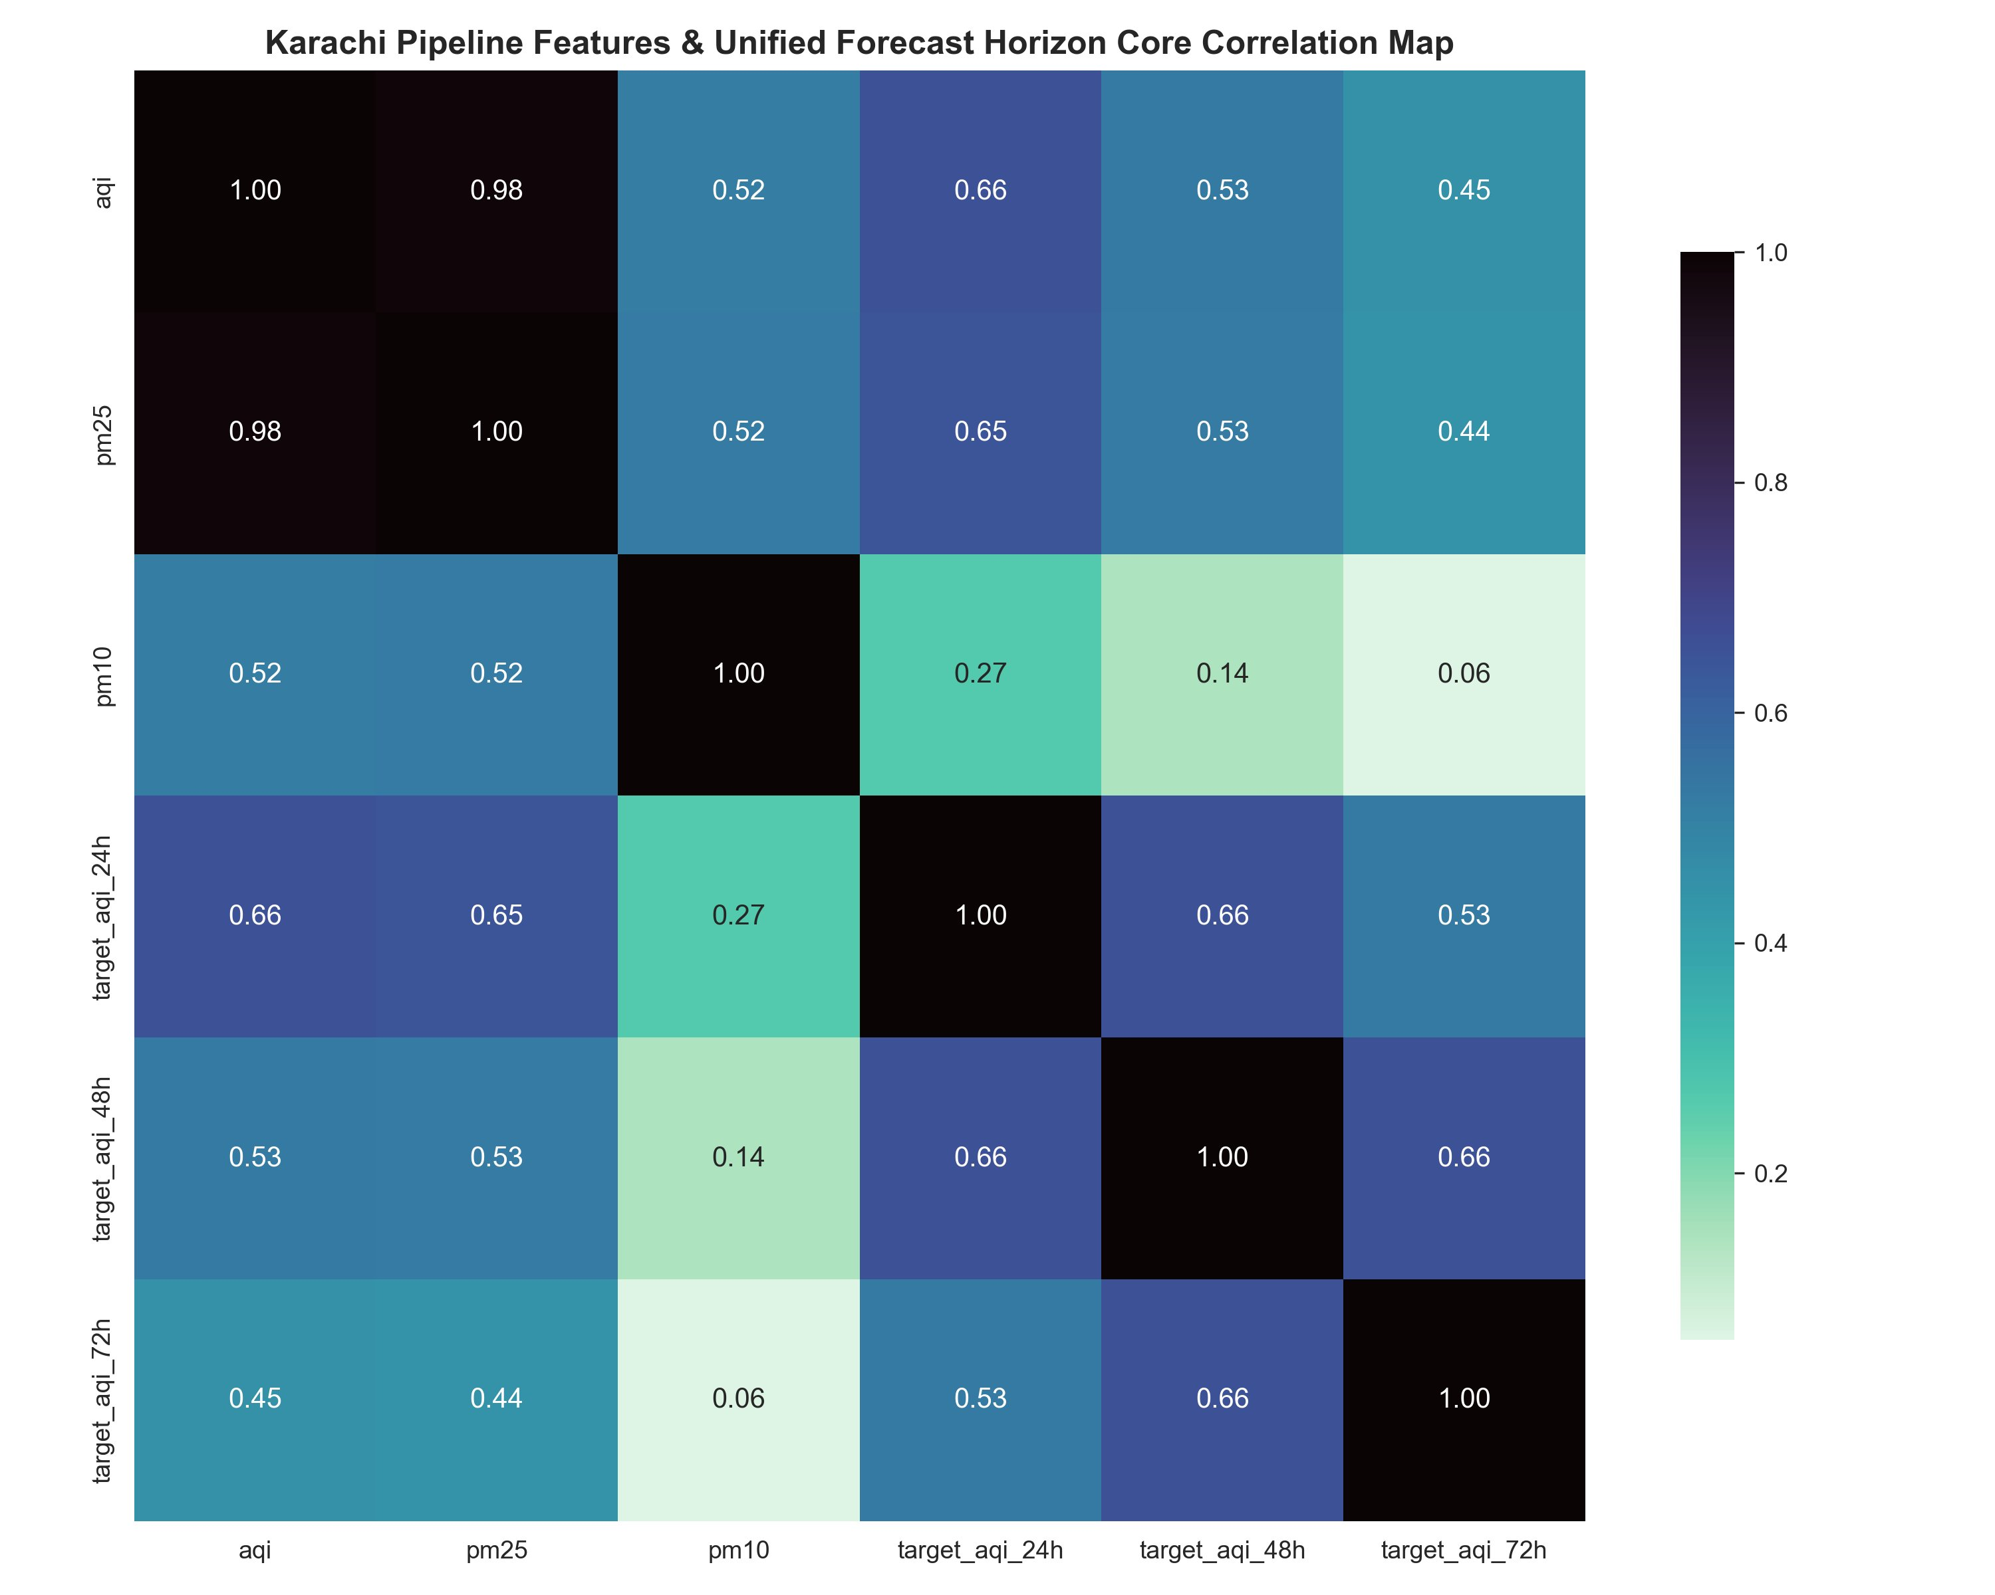
Figure 1: Karachi Pipeline Features and Unified Forecast Horizon Core Correlation Map
AQI and PM2.5 are near-perfectly correlated (r = 0.98), confirming that PM2.5 is the dominant driver of the AQI index in Karachi and justifying its central role in feature engineering. PM10 shows moderate correlation with AQI and PM2.5 (r = 0.52), reflecting coarse-particle contributions from dust and road sources that are partially independent of fine-particle combustion.
The forecast target correlations decay with horizon as expected: target_aqi_24h correlates at 0.66 with current AQI, target_aqi_48h at 0.53, and target_aqi_72h at 0.45. This monotonic decay validates the training pipeline design choice to train separate models for each horizon rather than a single multi-output model, since the predictive signal weakens progressively and the optimal feature set shifts with horizon length. PM10 shows very weak correlation with the 72-hour target (r = 0.06), suggesting it contributes almost no predictive signal at longer horizons and is a candidate for correlation-based feature pruning in the 72h training run.

18.3 Figure 2 — Macro Seasonality Profile: Monthly AQI Distribution
Figure 2 presents monthly boxplots of daily average AQI across the full dataset, revealing the macro-seasonal structure of Karachi air quality.
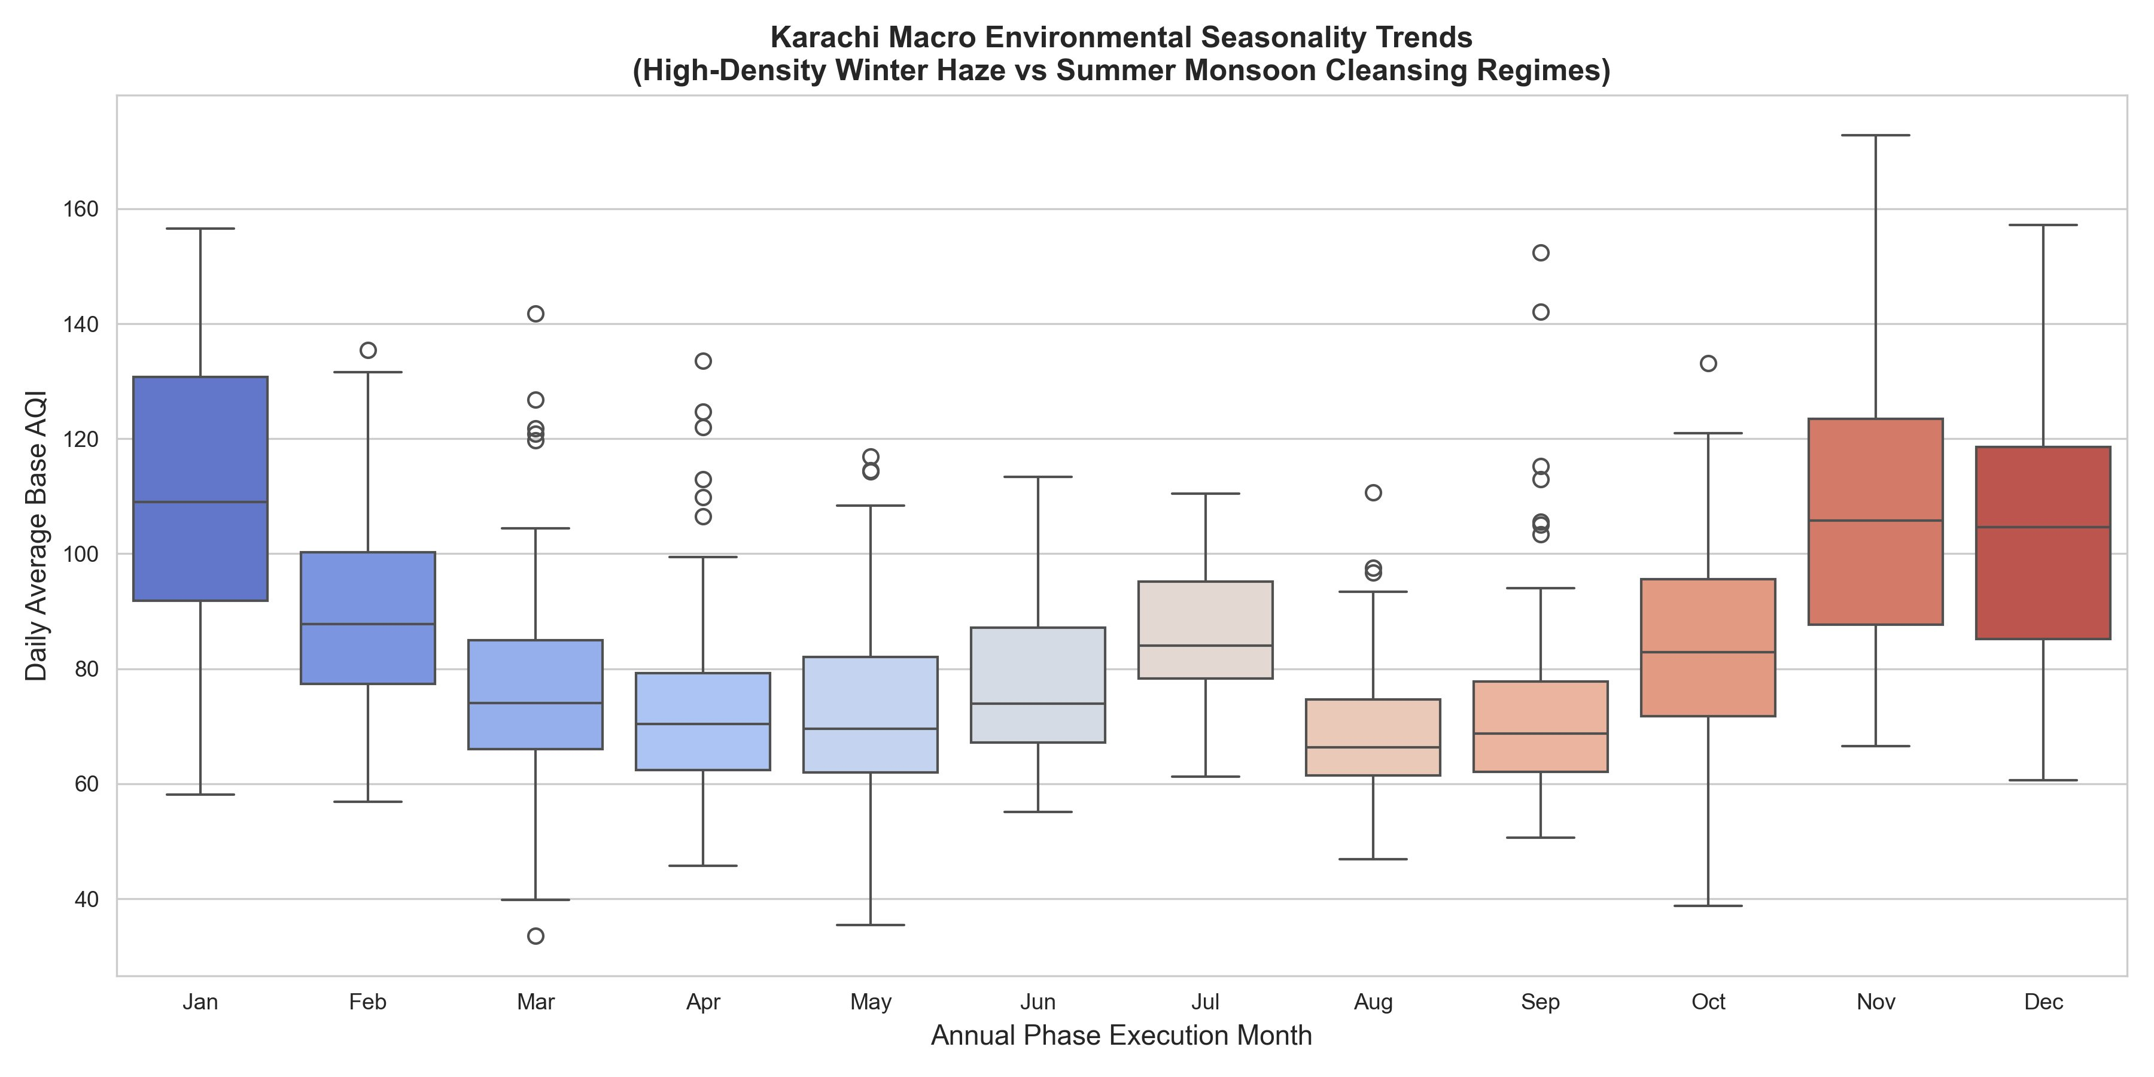
Figure 2: Karachi Macro Environmental Seasonality Trends — High-Density Winter Haze vs Summer Monsoon Cleansing Regimes
The plot reveals two distinct environmental regimes. The winter haze season (November through January) exhibits the highest median AQI (approximately 100-108) with wide interquartile ranges and outliers exceeding 155, driven by temperature inversions, suppressed sea-breeze mixing, reduced wind speed, and increased combustion from domestic heating and regional crop burning. January is the single worst month with a median near 108 and a maximum whisker above 155.
The monsoon and post-monsoon cleansing regime (July through September) produces the lowest AQI values. August reaches the cleanest conditions (median approximately 68), as monsoon rainfall washes particulates from the atmosphere and sustained south-westerly sea breezes disperse pollutants. The transition months of March through May show steady improvement from winter peaks, while October marks the beginning of the deterioration back toward winter conditions.
These findings directly justify several feature engineering decisions: the monsoon_flag feature (binary flag for June-September), the Fourier-encoded month_cos and doy_cos seasonal features visible as top SHAP drivers in the 48h and 72h horizons, and the spike augmentation strategy that overweights the December-January high-AQI training examples.

18.4 Figure 3 — Multi-Horizon Target Density Distribution
Figure 3 displays the kernel density estimate of the AQI target distribution across all three forecast horizons.
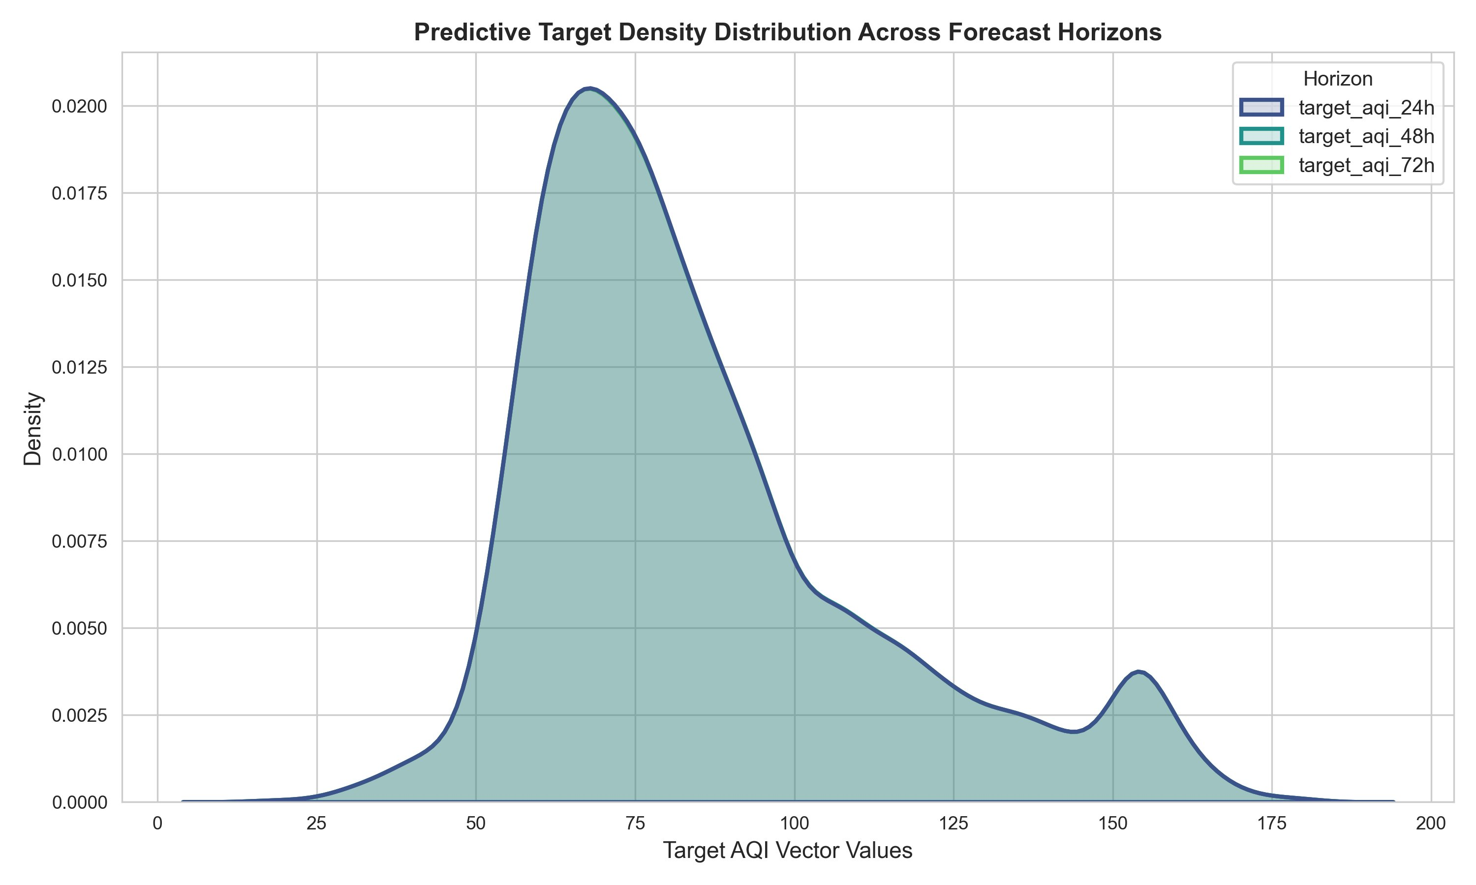
Figure 3: Predictive Target Density Distribution Across Forecast Horizons (24h, 48h, 72h)
The density plot reveals that the three target distributions (target_aqi_24h, target_aqi_48h, target_aqi_72h) are essentially identical, with all three curves overlapping almost perfectly. The primary mode peaks near AQI 65, representing the most frequent moderate air quality conditions. A secondary, smaller mode is visible near AQI 150, corresponding to the Unhealthy threshold and reflecting the recurring winter pollution episodes identified in Figure 2.
The distribution is distinctly right-skewed and bimodal, with a long tail extending to approximately AQI 190. This bimodality and right-skew provide two critical justifications for the training pipeline design. First, the log1p target transformation is necessary: without it, the high-AQI minority samples would exert outsized influence on the loss function in some models and be under-represented in others. Second, the spike augmentation strategy (duplicating training rows with AQI above 200 with small noise) directly counteracts the class imbalance visible in the tail, ensuring models learn to predict hazardous events rather than defaulting to the majority mode near AQI 65.
The identical overlap of all three horizon distributions also confirms that the target variable does not systematically shift with forecast distance, which means the same class-balance remediation strategy is appropriate for all three horizon models.

18.5 Figures 4, 5, 6 — SHAP Feature Importance Profiles by Horizon
Figures 4, 5, and 6 present the top SHAP global feature importance profiles for the 24-hour, 48-hour, and 72-hour forecast horizons respectively. Each bar represents the mean absolute SHAP value of that feature across the test set, which quantifies the average magnitude of its contribution to the model output.

24-Hour Horizon — Figure 4
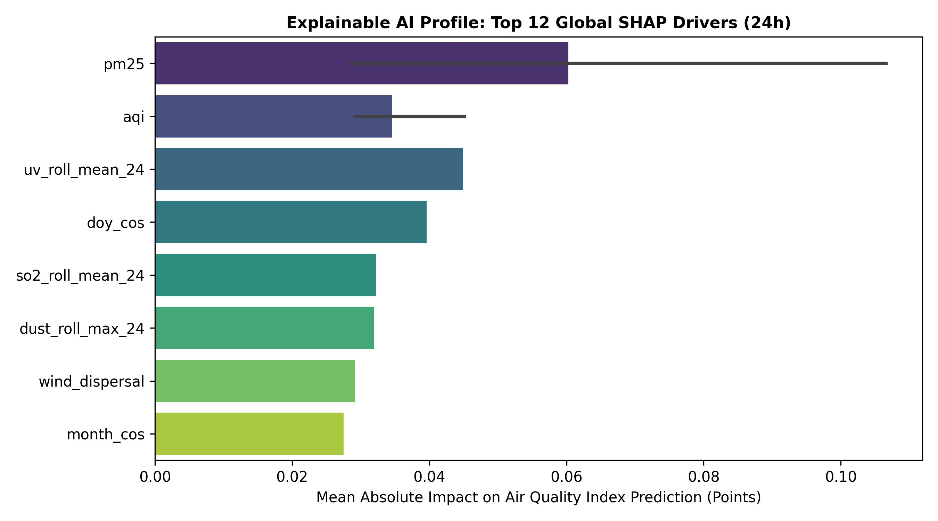
Figure 4: Explainable AI Profile — Top 12 Global SHAP Drivers (24h Horizon)
At the 24-hour horizon, the top driver is pm25 (mean absolute SHAP approximately 0.060), followed by the current aqi value and uv_roll_mean_24 (24-hour rolling mean of UV index). The dominance of pm25 and aqi confirms that the 24-hour model primarily extrapolates from current pollution conditions — the near-term atmospheric state is still the strongest predictor at this horizon.
The seasonal feature doy_cos (cosine of day-of-year) appears fourth, indicating that even at 24 hours, the model uses seasonal context to modulate its predictions. The presence of so2_roll_mean_24 and dust_roll_max_24 in the top eight reveals that the feature pipeline captures secondary pollutants (sulphur dioxide from industrial sources and dust from dry conditions) that contribute independently to AQI prediction. wind_dispersal and month_cos round out the top features, encoding the atmospheric mixing capacity and seasonal phase respectively.

48-Hour Horizon — Figure 5
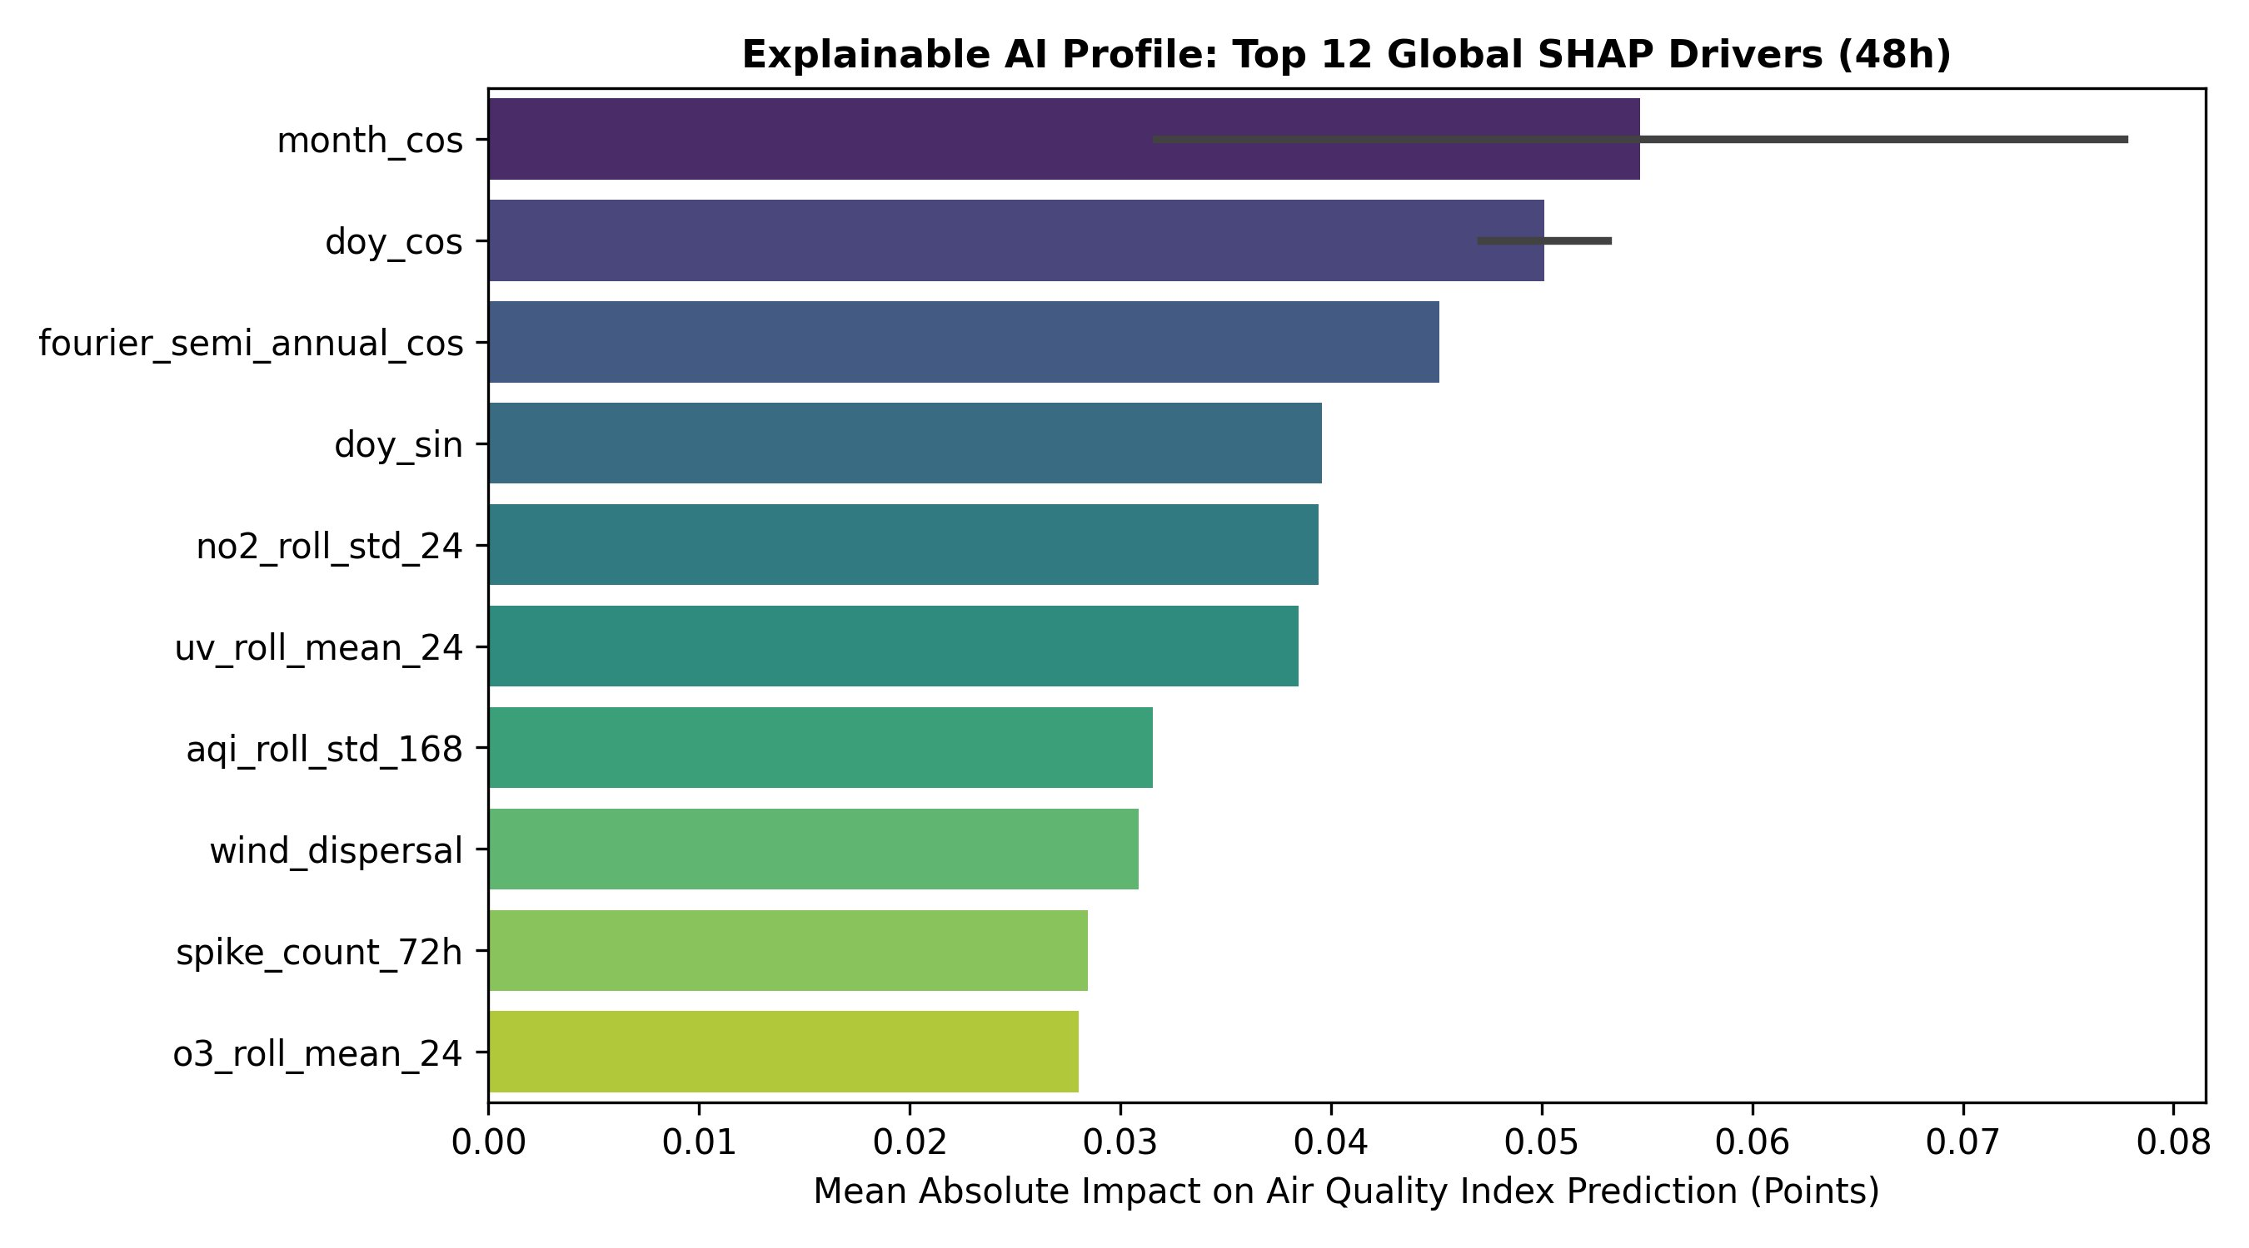
Figure 5: Explainable AI Profile — Top 12 Global SHAP Drivers (48h Horizon)
At the 48-hour horizon, the feature importance profile shifts dramatically toward seasonal and temporal features. month_cos becomes the dominant driver (SHAP approximately 0.055), followed closely by doy_cos and fourier_semi_annual_cos. This shift makes physical sense: beyond 24 hours, the current instantaneous pollution state provides less predictive power, and the model increasingly relies on knowing where in the seasonal cycle the forecast falls.
The appearance of no2_roll_std_24 (rolling standard deviation of NO2 over 24 hours) and aqi_roll_std_168 (rolling AQI volatility over the past 7 days) among the top features at this horizon reflects the model learning that high recent variability in pollution is itself a predictor of elevated future AQI. The spike_count_72h feature — counting anomalous AQI spikes in the past 72 hours — also enters the top ten, confirming that recent pollution episode history influences medium-range forecasts.

72-Hour Horizon — Figure 6
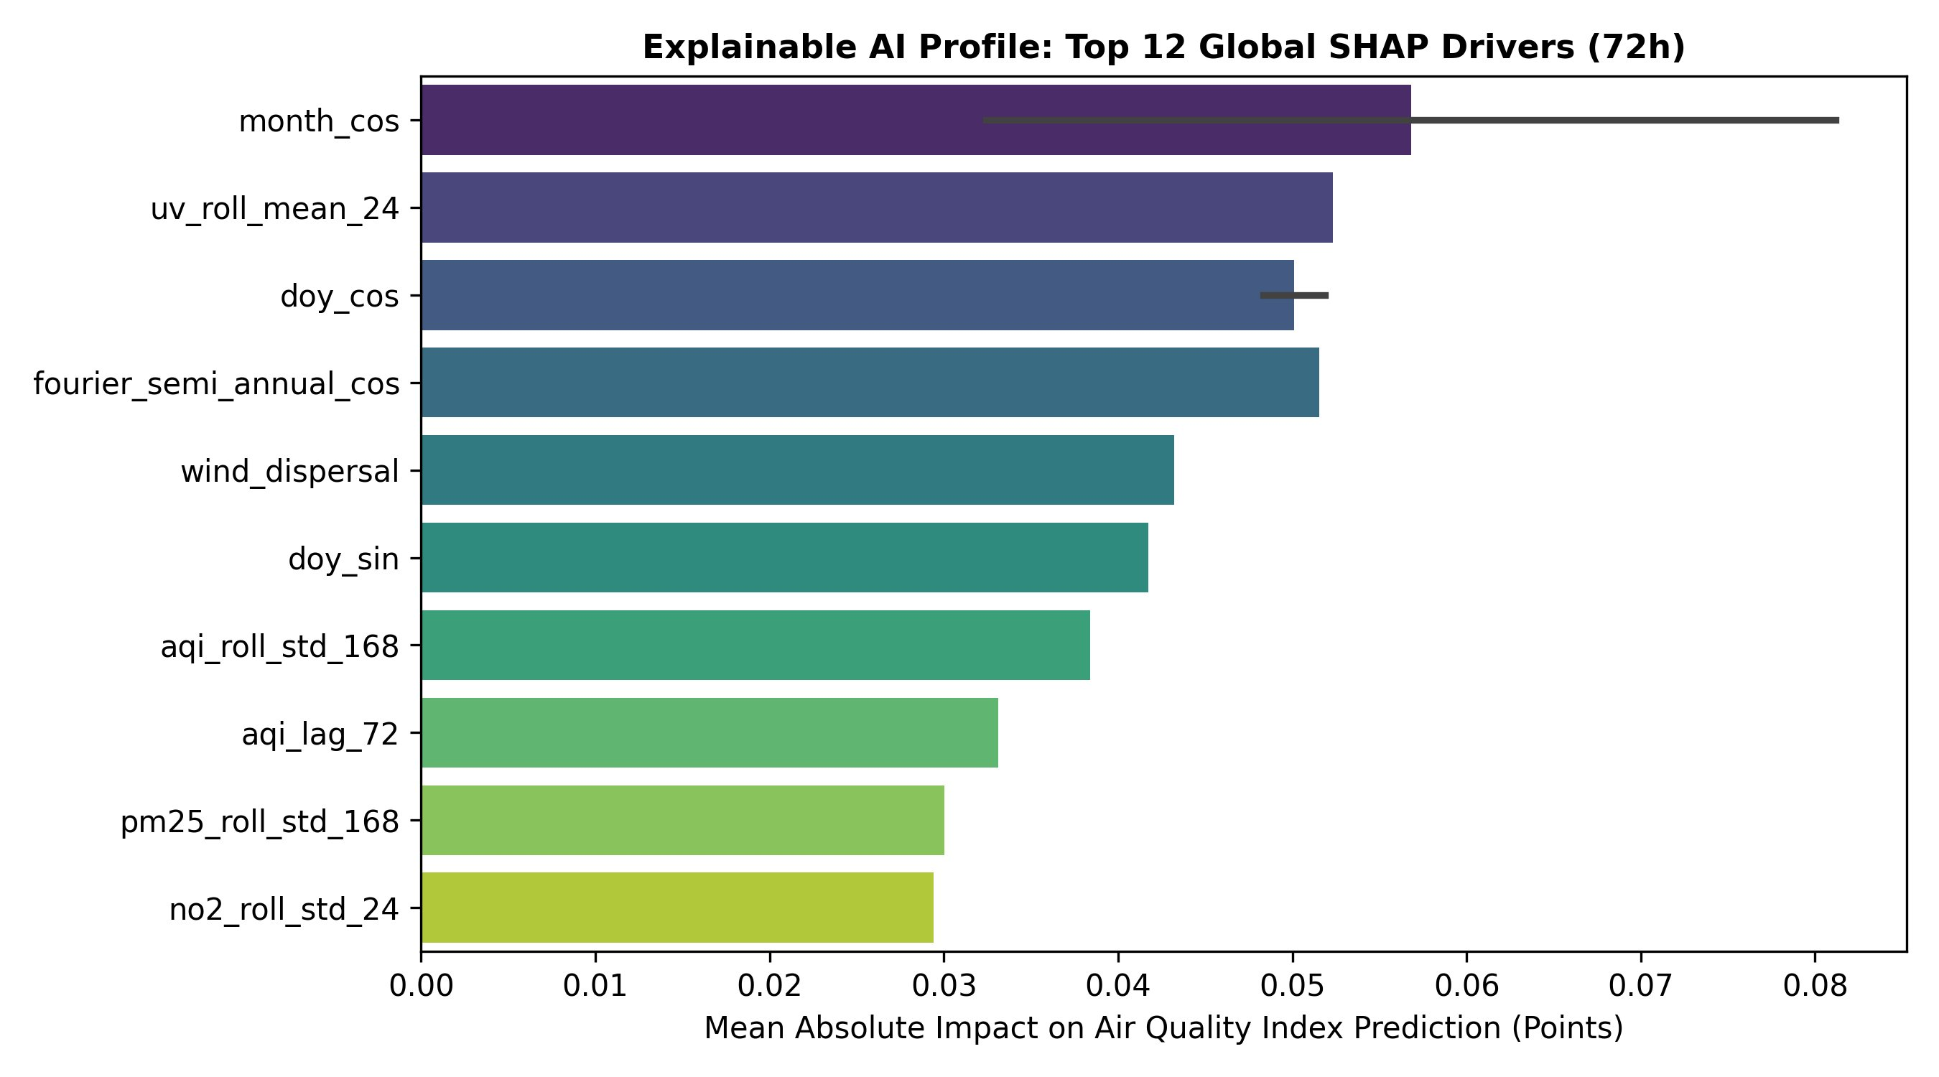
Figure 6: Explainable AI Profile — Top 12 Global SHAP Drivers (72h Horizon)
At the 72-hour horizon, the seasonal and climatological features consolidate their dominance. month_cos (SHAP approximately 0.057), uv_roll_mean_24, doy_cos, and fourier_semi_annual_cos all exceed 0.050 mean absolute SHAP value. The feature uv_roll_mean_24 rises to second place at this horizon, likely acting as a proxy for the seasonal solar radiation regime that modulates photochemical processes and boundary layer mixing.
wind_dispersal and doy_sin remain influential, while aqi_lag_72 (the AQI 72 hours in the past) and aqi_roll_std_168 contribute meaningfully. The appearance of pm25_roll_std_168 at this horizon reflects the model using long-range PM2.5 volatility as a climatological predictor. Notably, instantaneous pm25 and aqi values have disappeared from the top ten entirely, replaced by rolling statistics and seasonal encodings — a clear empirical confirmation that the model correctly shifts its predictive basis from current state to background climatology as the forecast horizon extends.

18.6 Cross-Horizon SHAP Interpretation Summary
Taken together, the three SHAP profiles demonstrate a coherent and scientifically interpretable evolution of model reasoning across horizons:
- 24h: Current pollution state (pm25, aqi) drives predictions, supplemented by secondary pollutants and recent rolling means
- 48h: Seasonal phase (month_cos, doy_cos, fourier_semi_annual_cos) becomes dominant; recent pollution variability (no2_roll_std_24, aqi_roll_std_168) and wind dispersal capacity contribute significantly
- 72h: Climatological and seasonal features fully dominate; instantaneous pollutant values are no longer top predictors; long-window rolling statistics serve as background regime indicators
This progression validates both the feature engineering design (which deliberately includes multi-scale temporal features from 1-hour lags to 168-hour rolling windows) and the training architecture (separate models per horizon rather than a shared multi-output model), since the optimal feature basis shifts substantially between horizons.

19. Hazardous AQI Alerts

19.1 AQI Bands
AQI Range | Category | Health Implication | Colour
0–50 | Good | Air quality satisfactory; little or no risk | Green
51–100 | Moderate | Acceptable; some pollutants may be concern for very sensitive groups | Yellow
101–150 | Unhealthy for Sensitive Groups | Sensitive groups (children, elderly, respiratory conditions) may experience effects | Orange
151–200 | Unhealthy | Everyone may experience health effects; sensitive groups more serious effects | Red
201–300 | Very Unhealthy | Health alert: significant effects for everyone | Purple
301+ | Hazardous | Emergency conditions; entire population likely to be affected | Maroon

19.2 Current Alert Implementation
The dashboard's Overview tab displays the current AQI with colour-coded classification matching the table above. When the latest AQI or any forecasted AQI within the selected horizon falls into the Unhealthy or above categories, the dashboard prominently highlights this with a coloured alert banner.

The training pipeline's spike augmentation step is directly motivated by alert requirements: by oversampling high-AQI training examples, the model is better calibrated for the hazardous range, reducing the risk of under-predicting dangerous events.

19.3 Future Alert Improvements
The current system provides visual alerts within the dashboard. Planned enhancements include:
- Email/SMS alerts when forecasted AQI for any horizon exceeds 150 (Unhealthy) threshold
- WhatsApp/Telegram bot integration for push notifications
- Configurable threshold alerts to allow individual users to set personalised AQI thresholds
- Automated social media posting when hazardous conditions are forecast

20. Challenges and Engineering Decisions
Challenge | Engineering Decision / Solution
Preventing temporal leakage in time-series ML | Strict rule: create target columns (aqi_24h, aqi_48h, aqi_72h) first, then compute all lag and rolling features. Use chronological splits with horizon gaps. Never use random shuffling.
Missing API data during pipeline runs | Forward-fill up to 2 consecutive missing hours. Drop rows where PM2.5 (the primary variable) is still missing. Log failures to pipeline_status collection.
MongoDB timestamp inconsistencies | Normalise all timestamps to UTC and floor to the nearest hour immediately after ingestion. Use a unique index on the datetime field in every collection.
Storing large model binaries in MongoDB | Use MongoDB GridFS for model artifact storage. GridFS splits files into 255 KB chunks, supporting files of any size while remaining within the MongoDB document size limit.
Avoiding local file system dependency | Zero local files are used for data or model storage. All state lives in MongoDB Atlas. This makes the system fully serverless and stateless — any runner (GitHub Actions or local) can pick up from the same shared state.
Stable SHAP explanations across runs | SHAP values are computed on a fixed test set subsample of 500 rows to reduce variance. Only the top-N features (by mean absolute SHAP) are stored to keep the top_features collection manageable.
GitHub Actions free-tier resource limits | Feature pipeline completes in ~2 minutes. Training pipeline completes in ~12 minutes. Both are well within GitHub's 6-hour job limit and 2,000 minutes/month free allowance.
Conformal prediction interval calibration | Chose inductive conformal prediction over Bayesian or parametric intervals because it provides guaranteed coverage without distributional assumptions, and requires only a single calibration set rather than a full Bayesian posterior.
Handling right-skewed AQI distribution | Applied log1p transformation to targets before training and expm1 inverse transformation after prediction. This normalises the target distribution and improves model fit in the moderate AQI range without sacrificing performance at extremes.

21. Limitations
- API data quality dependency: The accuracy of all forecasts depends on the quality and completeness of the Open-Meteo and air quality API data. Sensor outages, API downtime, or erroneous readings propagate into the feature store and can degrade model performance.
- Degraded accuracy during unusual events: Sudden pollution events such as dust storms, industrial accidents, or large fires are poorly represented in historical training data. Models trained on typical conditions may under-predict AQI severity during these events.
- Deep learning models not implemented: The project brief suggested experimenting with TensorFlow/PyTorch for advanced models. The current implementation uses tree-based and linear models. LSTM/GRU/Transformer models, which may capture long-range temporal dependencies more effectively, are noted as future work.
- MongoDB Atlas M0 storage limit: The free-tier cluster provides 512 MB of storage. For a project running hourly for many months, this may become a constraint. Older records in raw collections may need periodic archival or deletion.
- Render cold starts: The FastAPI backend on the Render free tier spins down after 15 minutes of inactivity. The first request after a cold start incurs a ~30-second delay, which may appear as a dashboard loading issue.
- Single-location coverage: The system forecasts AQI only for a single point in Karachi (city centre coordinates). Air quality varies significantly across the city due to proximity to industrial areas, the port, and major roads. A spatial extension with multiple measurement stations would be more informative.
- Alerting limited to dashboard: Active push notifications (email, SMS, WhatsApp) are not yet implemented. Users must visit the dashboard to check forecasts rather than receiving proactive alerts.

22. Future Improvements
- Deep learning models: Implement LSTM, GRU, or Temporal Fusion Transformer (TFT) models for multi-horizon forecasting. TFT in particular is designed for multi-step probabilistic forecasting and may outperform tree models at longer horizons.
- Additional data sources: Integrate satellite-derived aerosol optical depth (AOD) data from NASA MODIS/VIIRS for a more direct measurement of particulate loading. Add traffic density data and industrial emission schedules if accessible.
- Real-time alert system: Implement email and SMS alerting using SendGrid or Twilio when forecasted AQI crosses user-defined thresholds. Consider a Telegram bot for low-cost, high-reach mobile alerts.
- Data drift detection: Add automated monitoring for distribution shift in incoming features. If the distribution of recent PM2.5 readings drifts significantly from the training distribution, trigger a retraining job and alert the operator.
- Docker deployment: Containerise both the backend and frontend using Docker and Docker Compose. This would simplify local development, make the deployment reproducible, and enable deployment to Kubernetes or AWS ECS.
- Automated testing: Add pytest unit tests for feature engineering functions (especially lag/rolling calculations), API endpoint response validation, and data schema checks. Add integration tests that run a full pipeline cycle against a test MongoDB instance.
- Expanded EDA visualisations: Add interactive EDA capabilities to the dashboard — allow users to explore raw pollutant trends, correlation heatmaps, and seasonality decompositions directly in the browser.
- Downloadable reports: Add a "Download Report" button to the dashboard that generates a PDF summary of current conditions, recent forecast performance, and top features.
- Multi-city support: Extend the architecture to support multiple Pakistani cities (Lahore, Islamabad, Peshawar) by parameterising the location in config.py and partitioning the MongoDB collections by city.
- Model versioning and experiment tracking: Integrate MLflow or Weights & Biases for more structured experiment tracking, model versioning, and comparison across training runs.

23. Conclusion
The Karachi AQI Predictor successfully implements a complete, production-quality, end-to-end air quality forecasting system. Starting from raw weather and pollutant API data and ending at an interactive public-facing dashboard, every layer of the MLOps stack has been implemented: data ingestion, dataset building, feature engineering, model training, evaluation, model registry, serving API, and automated CI/CD.

The feature pipeline fetches and processes real hourly data from Karachi. The feature engineering module constructs over 70 causally-valid features that capture temporal, meteorological, pollutant, and Karachi-specific signals. Three machine learning models are trained for three forecast horizons in a temporally sound experimental setup. Conformal prediction intervals provide calibrated uncertainty estimates. SHAP values explain what drives each forecast. The FastAPI backend and Streamlit dashboard deliver these insights to end users in an accessible, interactive format. GitHub Actions runs everything automatically, every hour and every day, without human intervention.

Beyond satisfying the academic requirements, this project demonstrates applied MLOps principles that mirror real-world production systems: a cloud-native architecture, serverless automation, environment-based secret management, GridFS for binary artifact storage, and conformal prediction for deployment-ready uncertainty quantification. The Karachi focus makes it directly relevant to a city that faces one of the most severe urban air quality crises in South Asia, and where a reliable, continuously updated AQI forecasting tool can provide genuine public value.

With planned improvements — including deep learning models, real-time alerting, spatial expansion, and data drift monitoring — the system has a clear path toward becoming a robust, city-scale environmental intelligence platform.

24. Appendix

A. Technologies Used
Technology | Role | Version
Python | Primary programming language | 3.11
MongoDB Atlas | Cloud database: feature store, model registry, raw data | M0 Free Tier
pymongo | Python MongoDB driver | Latest
Open-Meteo API | Weather data source (free, no API key required) | Current
FastAPI | Backend REST API framework | Latest
Uvicorn | ASGI server for FastAPI | Latest
Streamlit | Frontend dashboard framework | Latest
Plotly | Interactive charting library | Latest
scikit-learn | Random Forest, Ridge Regression, preprocessing utilities | Latest
XGBoost | Gradient boosted tree model | Latest
SHAP | Feature importance explanations | Latest
Pandas | Data manipulation and time-series operations | Latest
NumPy | Numerical computing | Latest
GitHub Actions | CI/CD and scheduled automation | Current
Render | FastAPI backend hosting | Free tier
Streamlit Community Cloud | Frontend hosting | Free tier

B. MongoDB Collections
Collection | Description | Written By | Read By
raw_weather | Raw hourly weather records from Open-Meteo | fetch_weather.py | build_dataset.py
raw_air_quality | Raw hourly PM2.5/PM10/AQI records | fetch_air_quality.py | build_dataset.py
karachi_aqi_dataset | Merged, deduplicated, forward-filled hourly dataset | build_dataset.py | feature_engineering.py, /api/aqi-history
processed_features | Engineered feature matrix with targets (feature store) | feature_store.py | train_pipeline.py, load_data.py
model_registry | Metadata for each trained model-horizon combination | train_pipeline.py | /api/metrics, /api/model-comparison
model_metrics | Evaluation metrics per model and horizon | train_pipeline.py / evaluate.py | /api/metrics, /api/metrics/{horizon}
predictions | Forecast rows with conformal intervals | train_pipeline.py | /api/predictions/{model}/{horizon}
top_features | Top SHAP or coefficient importance per model-horizon | train_pipeline.py | /api/top-features/{model}/{horizon}
pipeline_status | Last-run timestamps and row counts for each pipeline step | run_feature_pipeline.py, run_training_pipeline.py | /api/pipeline-status
GridFS (fs.files, fs.chunks) | Binary model artifact storage | train_pipeline.py | train_pipeline.py (load), model_registry lookup

C. GitHub Actions Schedule
Workflow File | Cron Expression | Frequency | Manual Trigger
feature_pipeline.yml | 0 * * * * | Every hour on the hour (UTC) | Yes (workflow_dispatch)
training_pipeline.yml | 0 2 * * * | Daily at 02:00 UTC | Yes (workflow_dispatch)

D. Environment Variables
Variable | Used By | Description
MONGODB_URI | All pipeline scripts, FastAPI backend | Full MongoDB Atlas connection string including username, password, and cluster hostname
BACKEND_URL | Streamlit frontend (app.py) | Full URL of the deployed FastAPI backend (e.g., https://karachi-aqi-api.onrender.com)

E. How to Run Locally
- Clone the repository: git clone https://github.com/hammaddahmeddd/AQI_PREDICTOR_KARACHI
- Create a virtual environment: python -m venv venv && source venv/bin/activate
- Install dependencies: pip install -r requirements.txt
- Create a .env file in the project root with: MONGODB_URI=<your_atlas_connection_string>
- Run the feature pipeline: python run_feature_pipeline.py
- Run the training pipeline: python run_training_pipeline.py
- Start the FastAPI backend: cd dashboard/backend && uvicorn main:app --reload
- Start the Streamlit frontend: cd dashboard/frontend && BACKEND_URL=http://localhost:8000 streamlit run app.py

F. How to Deploy
- Push the repository to GitHub (ensure it is public for free tiers)
- Add MONGODB_URI as a GitHub Actions Secret under Settings > Secrets and Variables > Actions
- Connect the repository to Render; set the start command to: uvicorn dashboard.backend.main:app --host 0.0.0.0 --port $PORT; set MONGODB_URI environment variable in Render
- Connect dashboard/frontend/app.py to Streamlit Community Cloud; add BACKEND_URL as a Streamlit secret
- Manually trigger both GitHub Actions workflows once to initialise the database, then let them run on their automated schedules

— End of Report —

