MESMER APP
Admin panel: issues found while uploading exercises
7 August 2026
Hi Raja,
Thanks for getting me the admin access. I started loading the exercises in today and hit a few things that stop me going any further, so here they are with screenshots.
The first two are blocking uploading which I was hoping to start asap.
1. Exercises will not load
Manage Exercises shows "Failed to load exercises / Failed to fetch exercises". Try Again does not fix it. Nothing shows under My Exercises. This happened after I loaded the first exercise into Social Anxiety.
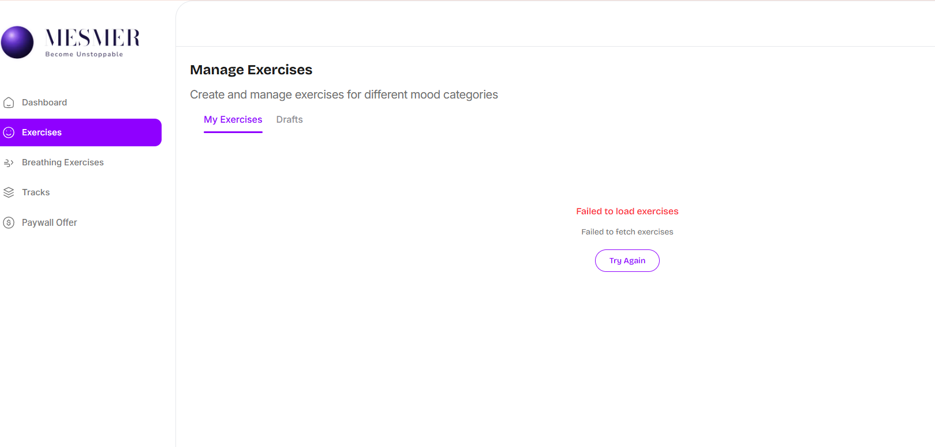
2. The exercise I added did not save
I created an exercise under Social Anxiety. After logging out and back in it was gone. So either it is not saving, or it is saving and cannot be read back.
I have stopped uploading until you have looked at 1 and 2, in case half-saved records are being left behind.
3. Audio and video uploads fail
- Audio: the field only accepts .mp3. All my files are m4a, can you confirm that you can add .m4a.
- Converted file also fails: I converted one to a mp3 and it still errored, so the format may not be the real problem.
- Video: upload fails as well.
4. Category fixes
- Typo: "Social Anixety" should be "Social Anxiety".
- Names: "School & Exam" should be "School & Exams". "Self Esteem & Body Image" should be "Self-Esteem & Body Image".
- Colours: please make the two sets different colours so I can tell them apart when tagging.
Mood: Confident, Calm, Motivated, Accepted, Focused, Free.
Improve On: Sleep, Friendships & Relationships, School & Exams, Social Anxiety, Self-Esteem & Body Image, Stress & Overthinking.
- Restricted Choice: Many exercises sit in both sets, so I need to be able to pick as many categories as I want when uploading an exercise.
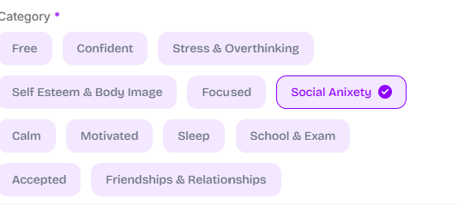
5. The form does not match how the exercises are built
Every exercise follows the same format, so the form needs to match it. At the moment WHY, HOW and WHEN are all in one Description box.
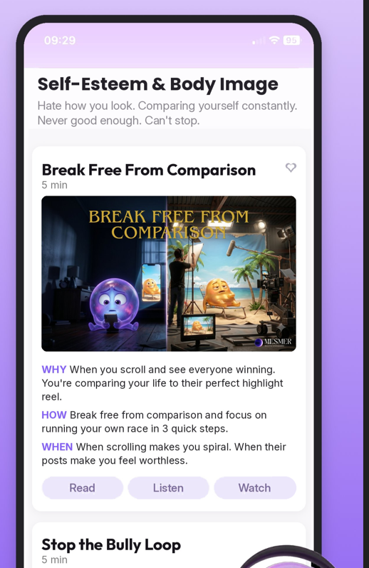
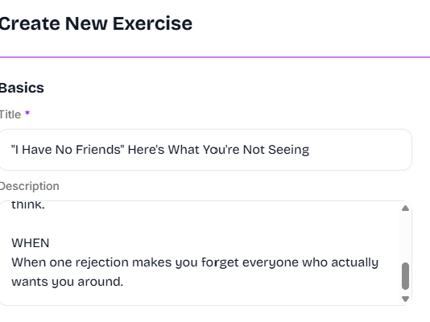

This is how the exercise should show in the App.

- Image at the top, then WHY, HOW and WHEN underneath as three separate fields. These are what make a teen open the exercise, so they need to show as their own blocks rather than sitting inside one Description box.
- Result field is missing. Every exercise ends with a Result section and there is nowhere to put it. It shows at the bottom, after the steps.
- "Read" field: what is this for? The full exercise content sits below it, so it looks like a duplicate.
Thanks,
Alicia

