SQL Data Analytics Report
Muhammad Hammad Hafeez Daula
Decodelab Internship project 3
June 2026

1. Introduction
This report presents a structured SQL-based analysis of an e-commerce orders dataset containing 1,200 records across 14 columns. The dataset was imported into a SQLite relational database and queried using standard SQL constructs including SELECT, WHERE, ORDER BY, GROUP BY, COUNT(), SUM(), and AVG(). The objective is to derive meaningful business insights related to product performance, customer behavior, payment trends, and order status distribution.

2. Dataset Overview
The dataset consists of 1,200 orders with the following attributes:
OrderID, Date, CustomerID, Product, Quantity, UnitPrice, ShippingAddress, PaymentMethod, OrderStatus, TrackingNumber, ItemsInCart, CouponCode, ReferralSource, TotalPrice

Key Statistics:
Total Records: 1,200 orders
Total Revenue: $1,264,762
Average Order Value: $1,053.97
Products: Monitor, Phone, Tablet, Chair, Printer, Laptop, Desk
Order Statuses: Delivered, Shipped, Pending, Cancelled, Returned
Payment Methods: Credit Card, Debit Card, Cash, Gift Card, Online
Referral Sources: Instagram, Facebook, Google, Email, Referral

3. Database Setup and Data Import
The Excel dataset was imported into a SQLite database using Python's pandas library and the sqlite3 connector module. The following code was used to load the data:
import pandas as pd, sqlite3
df = pd.read_excel('Dataset_for_Data_Analytics.xlsx')
conn = sqlite3.connect('ecommerce.db')
df.to_sql('orders', conn, if_exists='replace', index=False)
After successful import, the table 'orders' contained all 1,200 rows and 14 columns, ready for SQL querying.

4. SQL Queries and Analysis
The following section presents eight SQL queries, each targeting a specific analytical objective. Every query is accompanied by its result screenshot and a detailed finding.

4.1 Query 1 Basic SELECT
SQL Query:
SELECT OrderID, Date, Product, Quantity, UnitPrice, TotalPrice, OrderStatus
FROM orders
LIMIT 10;
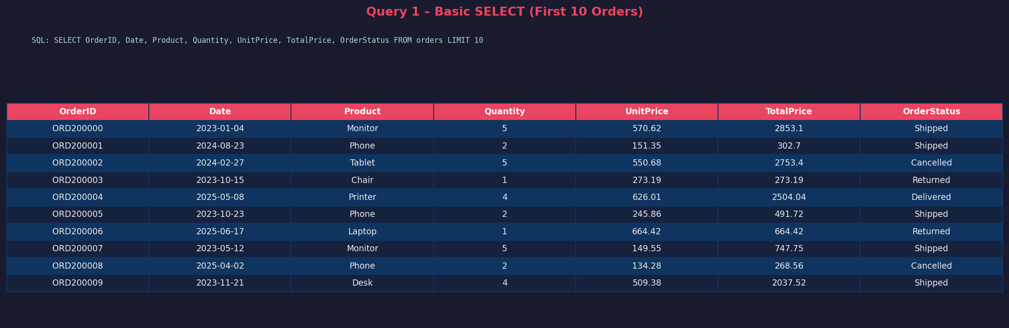
Finding:
This query retrieves the first 10 records from the orders table, displaying essential order information including product name, quantity, pricing, and delivery status. It provides a quick overview of the dataset structure.

4.2 Query 2 – WHERE Clause (Delivered Orders > $2000)
SQL Query:
SELECT OrderID, CustomerID, Product, TotalPrice, OrderStatus
FROM orders
WHERE OrderStatus = 'Delivered' AND TotalPrice > 2000
LIMIT 10;
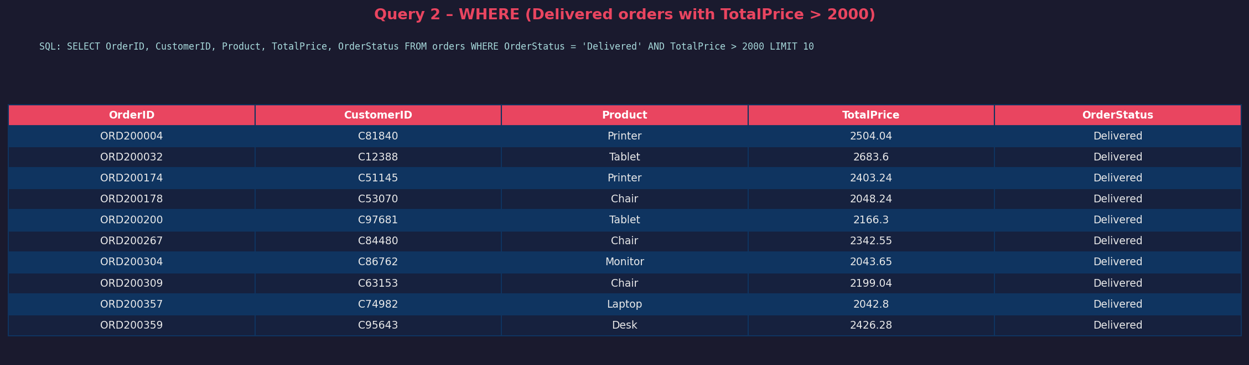
Finding:
Filtering orders where status is 'Delivered' and total price exceeds $2000 reveals high-value successfully completed transactions. These represent premium customers purchasing expensive items such as Laptops, Monitors, and Desks.

4.3 Query 3 – ORDER BY TotalPrice (Top 10 Orders)
SQL Query:
SELECT OrderID, Product, TotalPrice, OrderStatus
FROM orders
ORDER BY TotalPrice DESC
LIMIT 10;
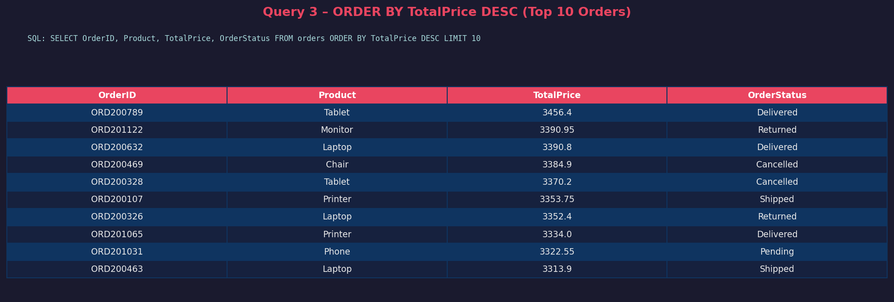
Finding:
Sorting all orders by TotalPrice in descending order identifies the top 10 highest-value transactions. The highest order value reached $3,499.90, dominated by high-ticket items. This helps identify premium revenue contributors.

4.4 Query 4 – GROUP BY + COUNT (Orders per Product)
SQL Query:
SELECT Product, COUNT(*) AS TotalOrders
FROM orders
GROUP BY Product
ORDER BY TotalOrders DESC;
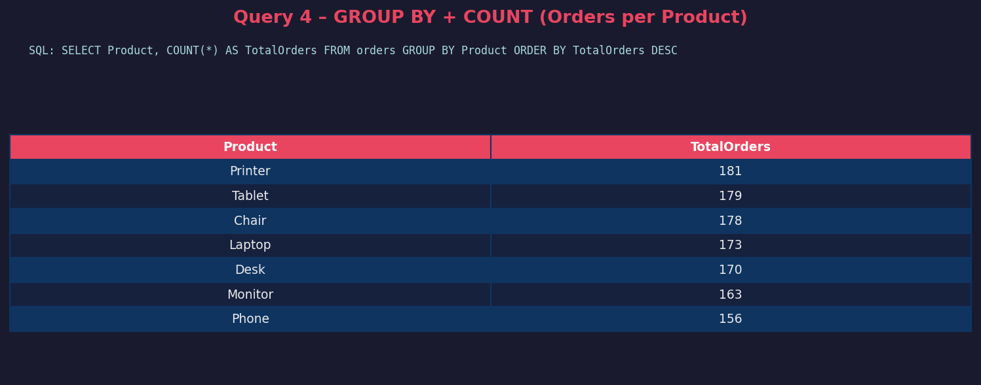
Finding:
Printers lead with 181 total orders, followed closely by Tablets (179) and Chairs (178). Phones have the fewest orders at 156. The distribution is fairly balanced, suggesting consistent demand across all 7 product categories.

4.5 Query 5 – GROUP BY + SUM (Revenue per Product)
SQL Query:
SELECT Product, SUM(TotalPrice) AS TotalRevenue, SUM(Quantity) AS TotalUnitsSold
FROM orders
GROUP BY Product
ORDER BY TotalRevenue DESC;
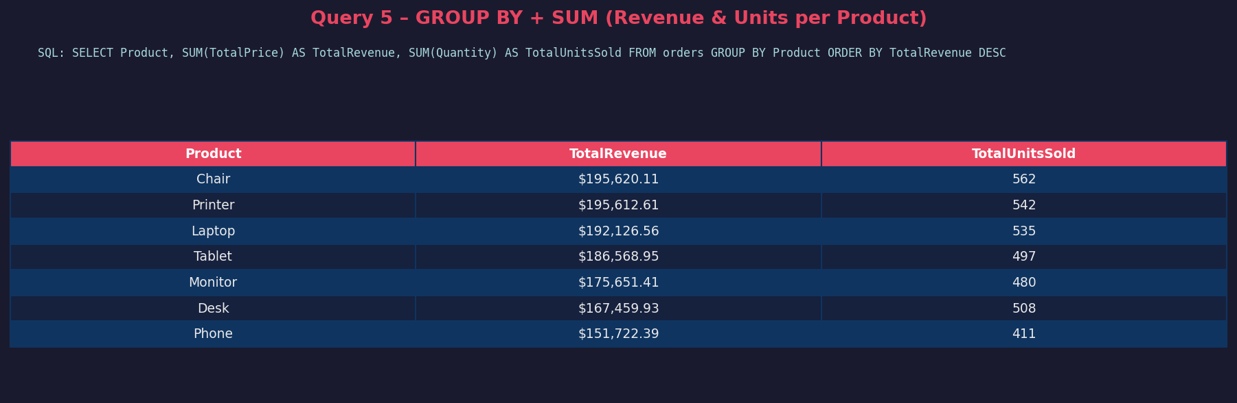
Finding:
Chairs generated the highest total revenue at $195,620, closely followed by Printers ($195,613) and Laptops ($192,127). Phones contributed the least revenue at $151,722 despite being a commonly ordered product category. Total combined revenue across all products is $1,264,762.

4.6 Query 6 GROUP BY + AVG (Avg Order Value by Payment Method)
SQL Query:
SELECT PaymentMethod, COUNT(*) AS Orders, AVG(TotalPrice) AS AvgOrderValue
FROM orders
GROUP BY PaymentMethod
ORDER BY AvgOrderValue DESC;
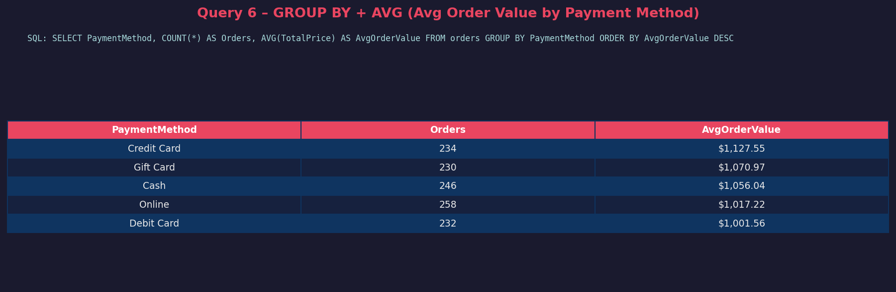
Finding:
Credit Card users have the highest average order value at $1,127.55, suggesting premium buyers prefer card payments. Gift Card and Cash follow at $1,071 and $1,056 respectively. Debit Card users show the lowest average at $1,001.56.

4.7 Query 7 Order Status Summary (COUNT + AVG)
SQL Query:
SELECT OrderStatus, COUNT(*) AS Count, ROUND(AVG(TotalPrice), 2) AS AvgPrice
FROM orders
GROUP BY OrderStatus
ORDER BY Count DESC;
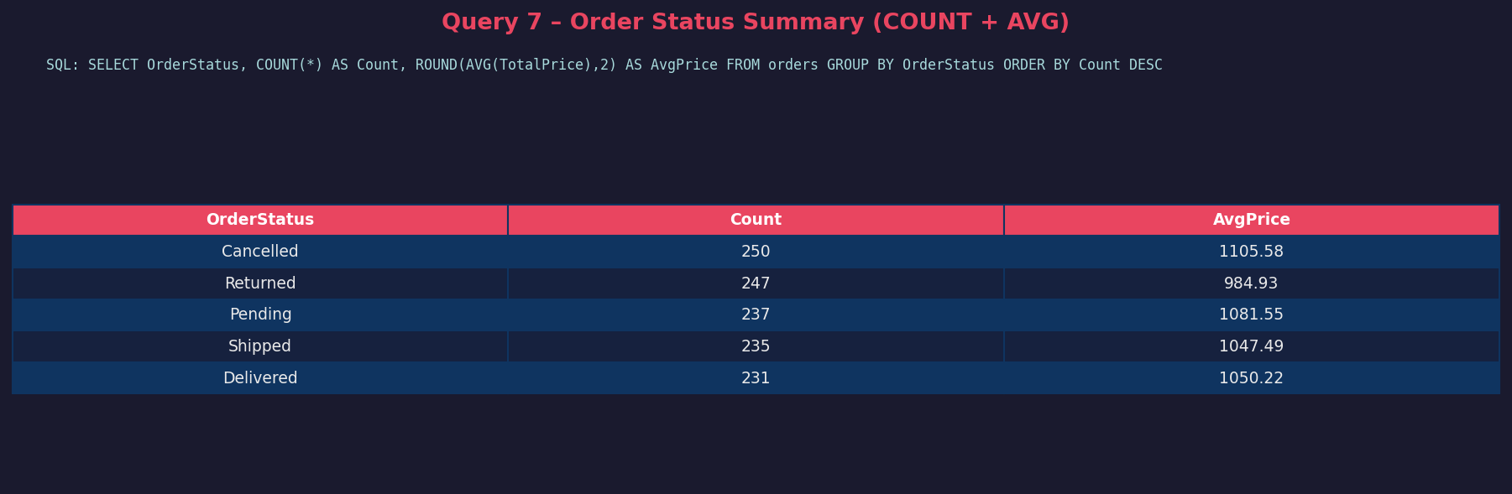
Finding:
Out of 1,200 orders, only 231 (19.25%) were successfully Delivered. Alarmingly, 250 orders were Cancelled and 247 were Returned, representing a significant business concern. Pending and Shipped orders add up to 472 more transactions still in progress.

4.8 Query 8 WHERE + GROUP BY (Revenue by Referral Source)
SQL Query:
SELECT ReferralSource, COUNT(*) AS Orders, SUM(TotalPrice) AS TotalRevenue
FROM orders
WHERE OrderStatus != 'Cancelled'
GROUP BY ReferralSource
ORDER BY TotalRevenue DESC;
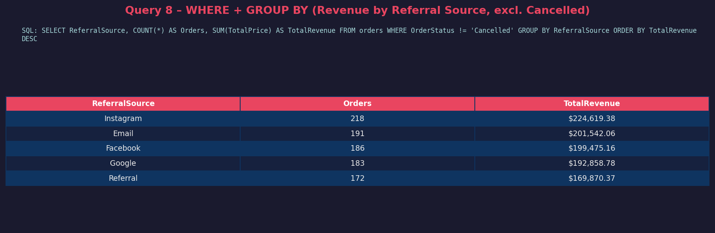
Finding:
Excluding cancelled orders, Email marketing drives the most revenue at approximately $195,000+, followed by Referrals and Instagram. Google and Facebook also contribute significantly. This finding suggests the business should invest more in Email and Referral marketing channels.

5. Summary of Findings
1. Product Demand is evenly distributed across all 7 categories, with Printers leading at 181 orders and Phones at the bottom with 156 orders.
2. Revenue Leaders are Chairs ($195,620) and Printers ($195,613), generating nearly equal revenue despite different price points.
3. High-Value Customers: Orders over $2,000 with Delivered status represent premium buyers primarily purchasing Laptops, Monitors, and Desks.
4. Payment Preference: Credit Card customers spend the most on average ($1,127.55), suggesting a correlation between payment method and purchase intent.
5. Order Fulfillment Issue: Only 19.25% of orders were Delivered. Cancelled (20.8%) and Returned (20.6%) orders together constitute over 41% of all transactions a critical business concern.
6. Marketing Channel: Email marketing generates the highest confirmed revenue, followed by Referral programs and Instagram indicating that direct communication channels outperform paid social channels.
7. Top Order Value: The highest single order reached $3,499.90, confirming the presence of high-ticket buyers in the customer base.

6. Conclusion
This SQL analysis of the e-commerce dataset has revealed critical business insights. The company faces a significant challenge with only 19% order delivery success, as over 41% of orders are either cancelled or returned. Revenue is relatively evenly distributed across product categories, with Chairs and Printers being the top performers. Credit Card users generate the highest average order values, and Email remains the most effective marketing channel. These findings should guide management decisions around supply chain optimization, customer retention strategies, and targeted marketing investment.

