### Name:Mohammad Asim Khan Reg no:FA21-BCS-037 Compiler Construction Lab Terminal Question 2: Two Core Function of Mini compiler Answer:****Two Core Functions of Mini Compiler****

**Lexical Analysis** (Core Function 1):

* 1. **Files**:
     1. Lexer.cs: This file is the core for tokenizing the input.
     2. Token.cs: Defines how tokens are structured and used.

Code:

Lexer.cs

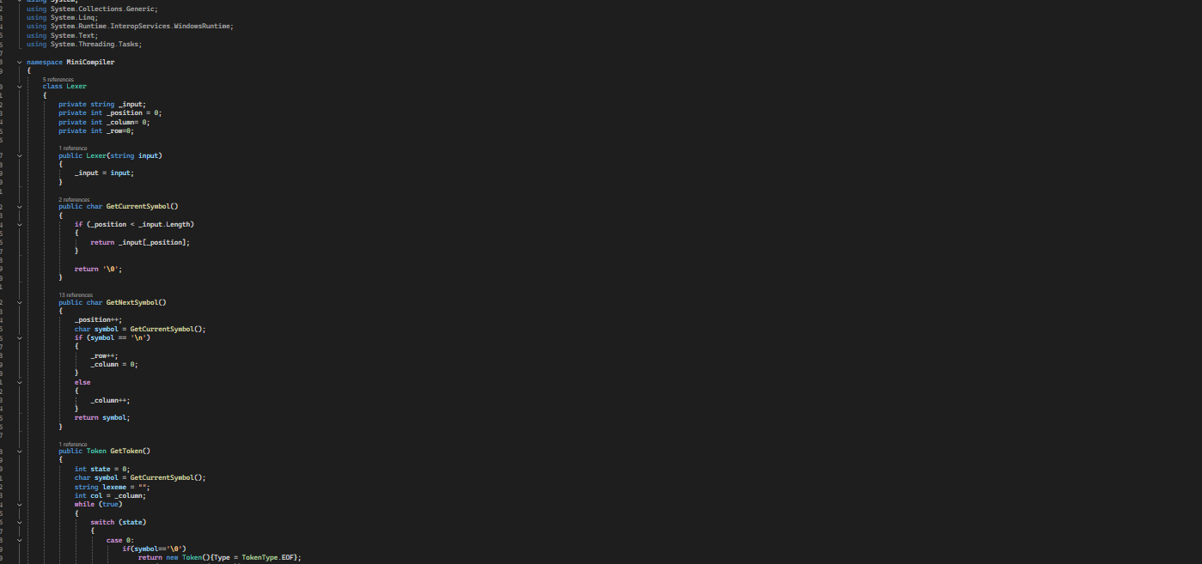

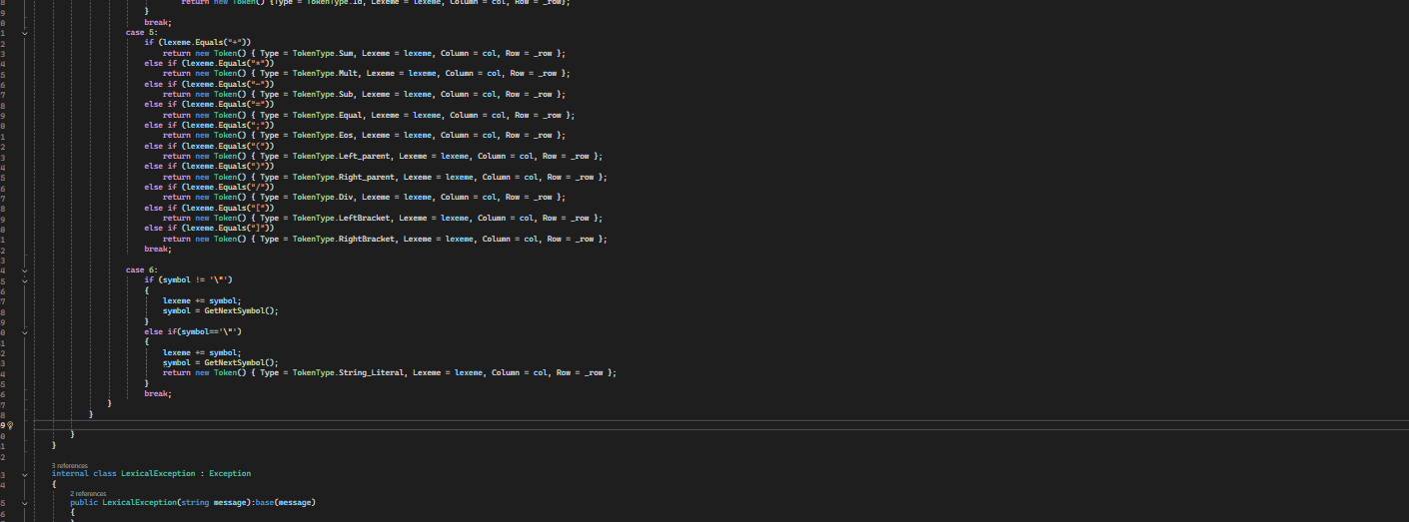

Token.cs

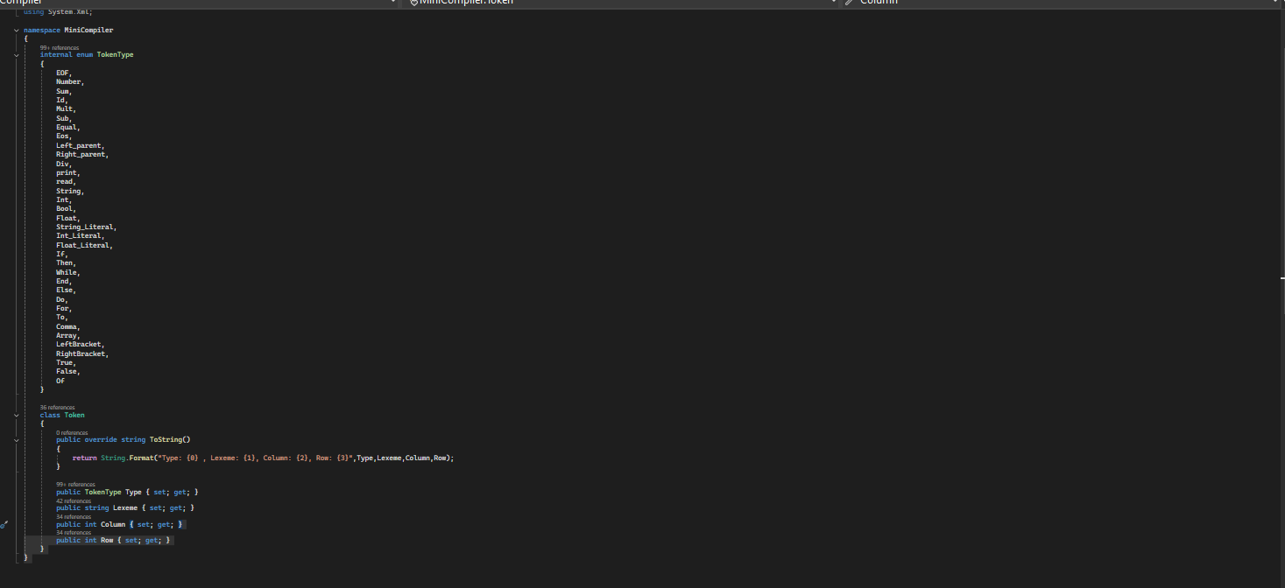

**Syntax Analysis** (Core Function 2):

* 1. **Files**:
     1. Parser.cs: Builds the AST or parse tree from the tokens.
     2. ExpressionNode.cs, BinaryOperationNode.cs, etc.: Represents the syntax elements used in the parsing process.

Parser.cs

