**Name:Mohammad Asim Khan  
Reg no:FA21-BCS-037  
Compiler Construction Lab Terminal**

**Question 4: Input and output of mini compiler**

**Answer: **Input to the Mini Compiler****

* The input to the mini compiler is a **custom programming language** written as a string.
* This input string is passed to the Lexer class, which tokenizes the source code into smaller pieces like keywords, identifiers, literals, and operators.

#### ****Example Input Code****

int a,b,c;

float d;

string a2;

array[10,10] of int arreglo;

bool e;

string j;

for a=3 to 5

print a;

End

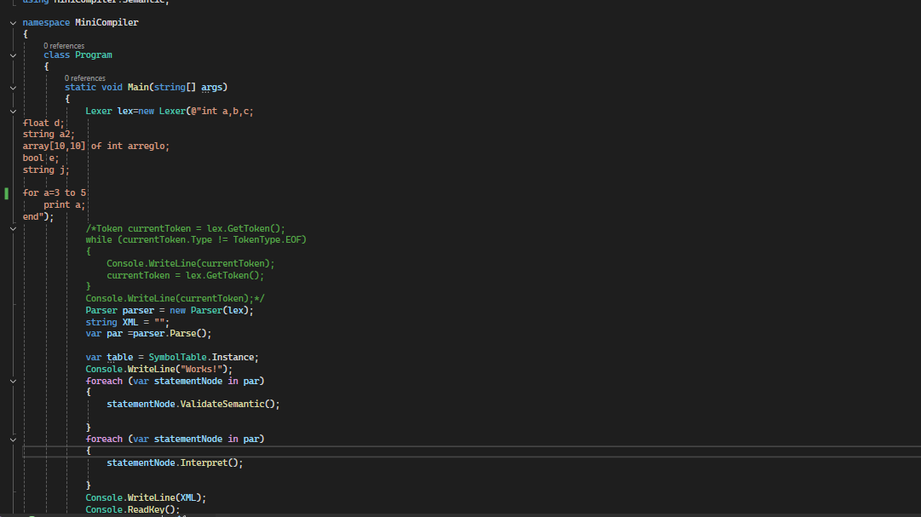

**Output of Program:**

It will output the if program is correct or not and also output of input program

And if error in input code then error in output.

* 1. **Validation:**
     + The semantic analyzer (ValidateSemantic) checks for errors like undeclared variables or type mismatches. If an issue is found, it throws a SemanticException.
  2. **Execution Results:**
     + The interpreter (Interpret) executes the parsed code, producing outputs such as variable values or printed results.

