**Lab # 1**

**HTML and CSS Fundamentals**

**OBJECTIVE**

To get familiar with HTML, and CSS fundamentals.

**LAB TASK**

# Task#1

Create a website that at minimum satisfies the following requirements:

* It should include different HTML elements e.g. headings, paragraph(s), lists, images, text hyperlinks, image hyperlinks, bookmarks, image maps, tables, text formatting, forms, etc.

* It should include appropriate and rich content such as short biography, education and training courses, projects that you have a major role in it, summer training, skills, and useful web links, contacts, etc.

* Be consistent in all styles and make it user-friendly with an appealing layout.

* You can use any style of CSS like Inline CSS, External CSS, or Inpage CSS.

**SOLUTION:**

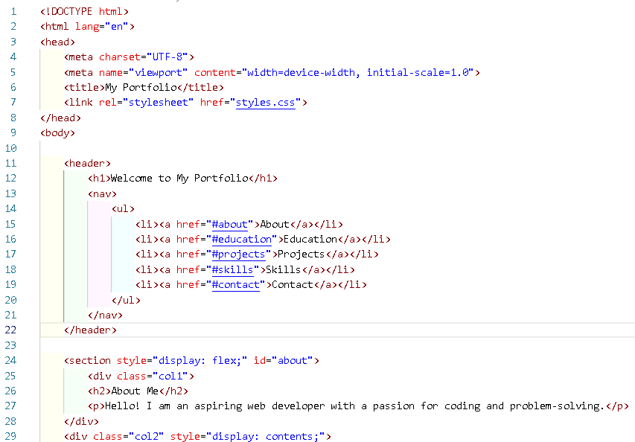

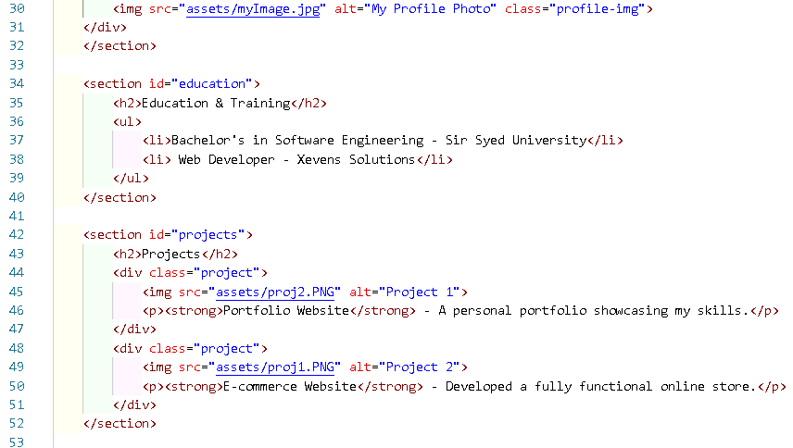

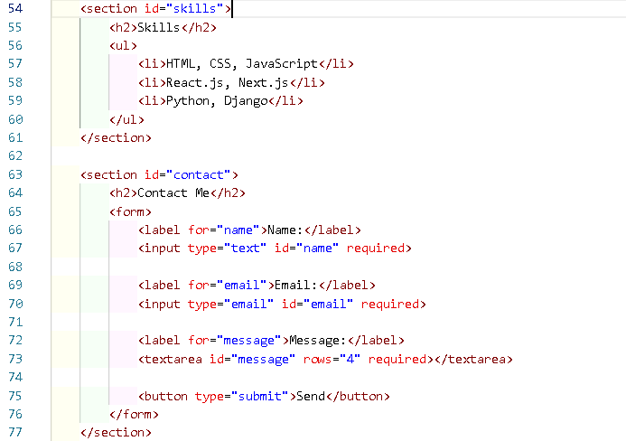

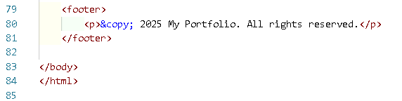

2)Styles.css  
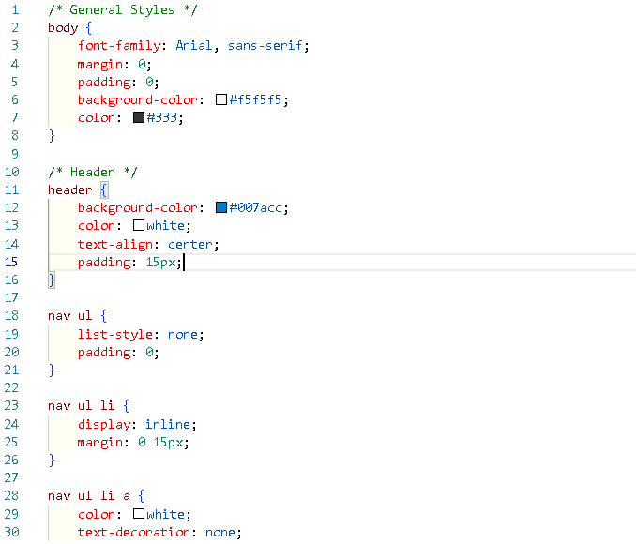

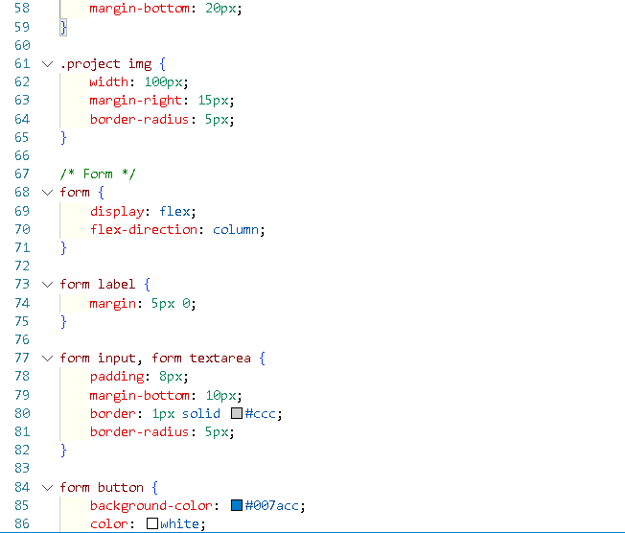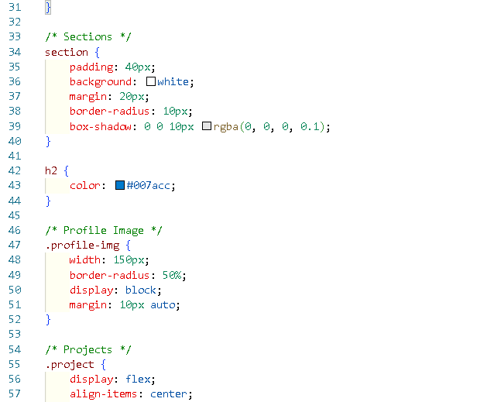

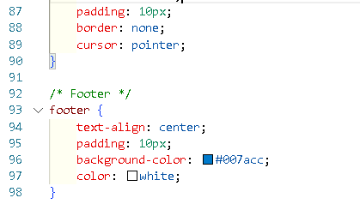

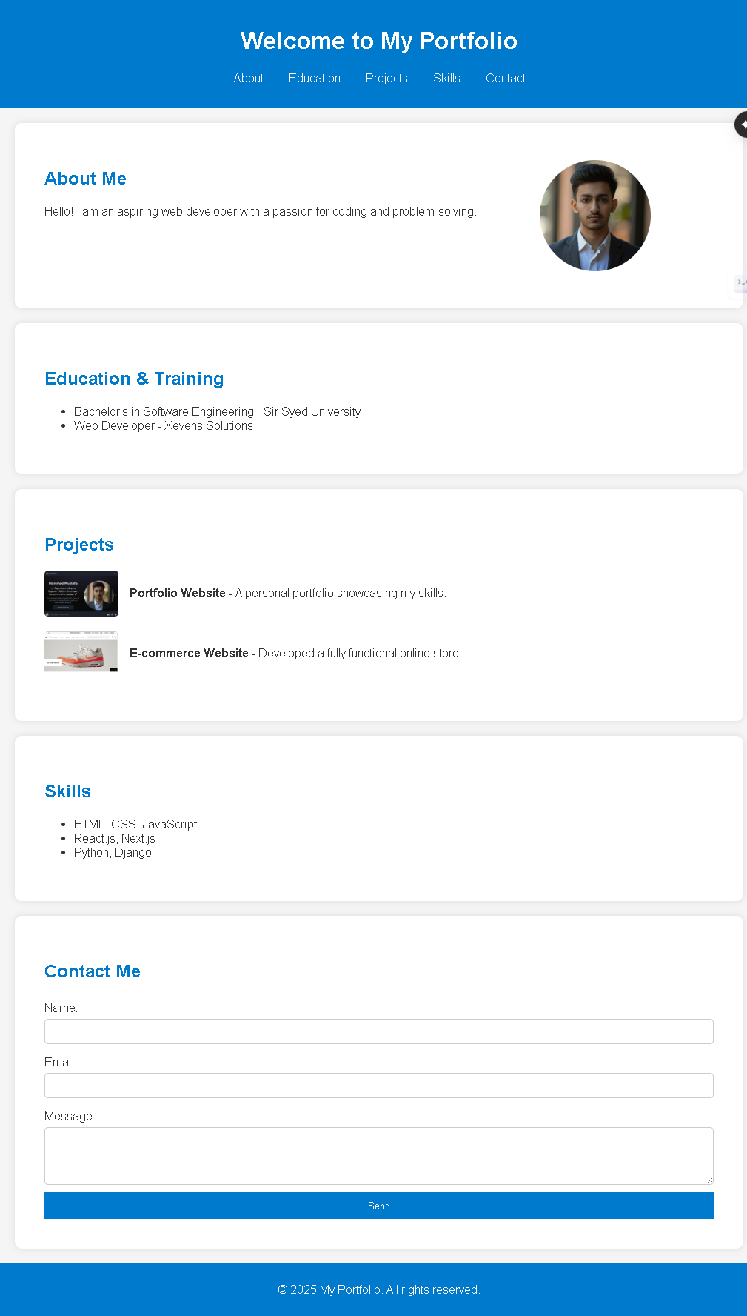OUTPUT:



**Task#2:**

Use HTML and CSS to create your own personal resume, using the following example as a template.

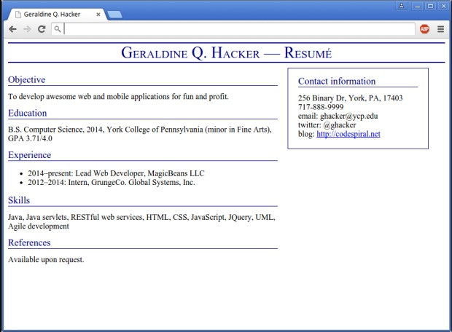

* The text in the page title should be rendered in small caps.
* The page title and the text of section headers should be dark blue.
* The resume should have a title running across the top (with dark blue bars above and below).
* The content area should be to the left and the sidebar (contact info) should be to the right.
* Use div and span elements with id and class attributes to specify the body of the HTML document.
* All visual styling should be done separately in CSS rules.

1)index.html:  
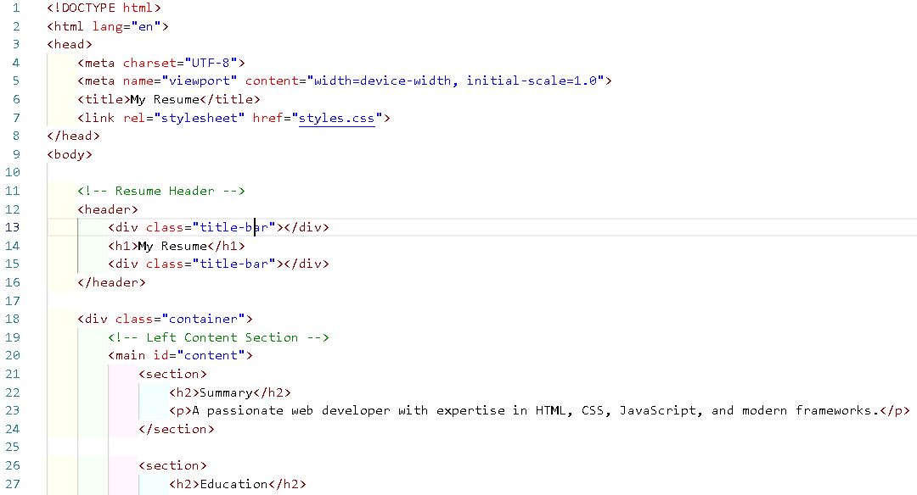

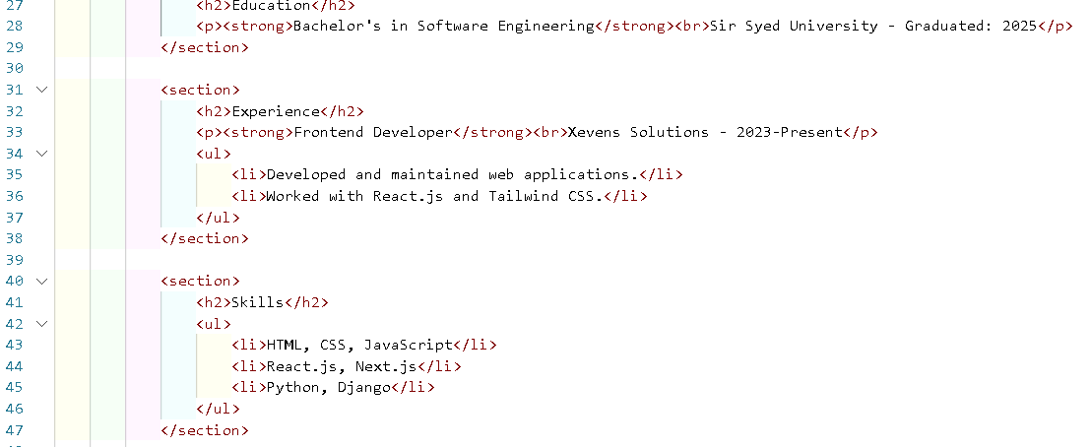

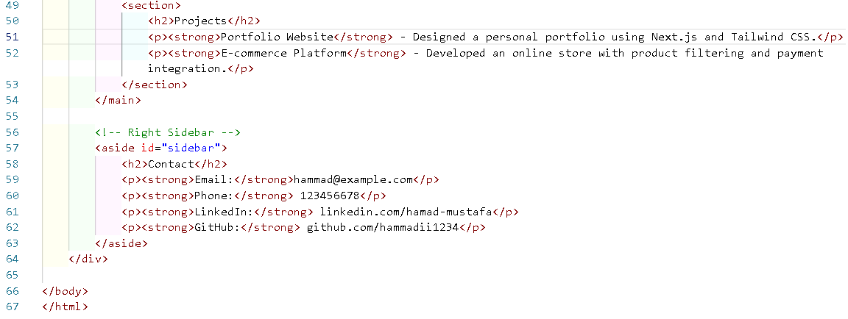

style.css:  
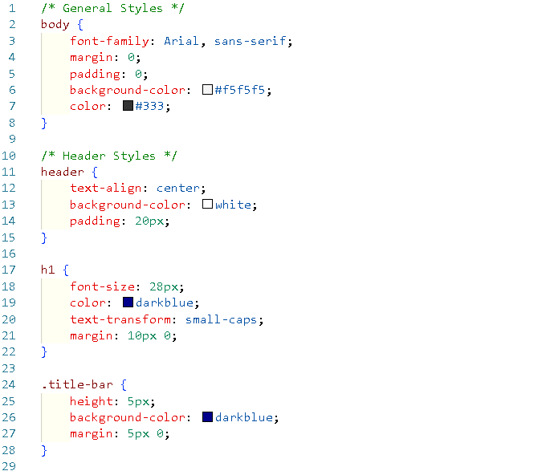

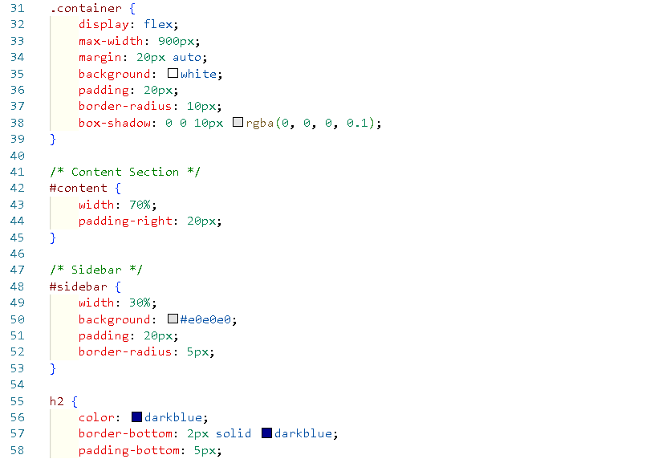

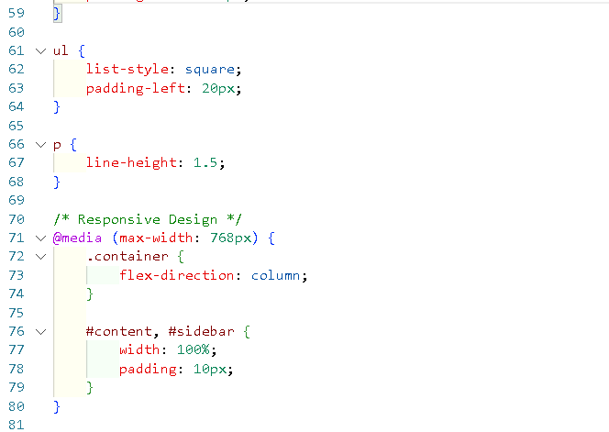

OUTPUT:  
